Table S1. Results of the marginal tests performed by distance-based linear model (DistLM) analysis for assessment of soil properties as explanatory variables for prokaryotic, fungal, and protistan communities among ecosystems along a water gradient such as desert grassland (DG), shrub steppe (SS), forest (FO), and marsh (MA) in the Altai region of Xinjiang, China.
 | Variable | SS(trace) | Pseudo-F | P | Prop.
Prokaryote | Water | 12957 | 5.581 | 0.0000 | 0.202
 | pH | 16914 | 7.898 | 0.0000 | 0.264
 | C | 14312 | 6.333 | 0.0000 | 0.224
 | N | 15368 | 6.947 | 0.0000 | 0.240
 | P | 9325 | 3.750 | 0.0015 | 0.146
 | NH₄⁺ | 16000 | 7.328 | 0.0000 | 0.250
 | NO₃- | 8662 | 3.442 | 0.0046 | 0.135
 | AP | 11496 | 4.814 | 0.0006 | 0.180
 | CEC | 10257 | 4.196 | 0.0015 | 0.160
Fungi | Water | 9491 | 2.832 | 0.0000 | 0.114
 | pH | 11440 | 3.506 | 0.0000 | 0.137
 | C | 10645 | 3.227 | 0.0000 | 0.128
 | N | 11832 | 3.647 | 0.0000 | 0.142
 | P | 7377 | 2.140 | 0.0036 | 0.089
 | NH₄⁺ | 11549 | 3.546 | 0.0000 | 0.139
 | NO₃- | 7735 | 2.255 | 0.0029 | 0.093
 | AP | 9694 | 2.901 | 0.0003 | 0.116
 | CEC | 9276 | 2.760 | 0.0003 | 0.111
Protist | Water | 9326 | 4.422 | 0.0000 | 0.167
 | pH | 9948 | 4.780 | 0.0000 | 0.179
 | C | 9300 | 4.407 | 0.0000 | 0.167
 | N | 10281 | 4.976 | 0.0000 | 0.184
 | P | 7348 | 3.341 | 0.0004 | 0.132
 | NH₄⁺ | 10802 | 5.290 | 0.0000 | 0.194
 | NO₃- | 6166 | 2.737 | 0.0045 | 0.111
 | AP | 8017 | 3.696 | 0.0004 | 0.144
 | CEC | 7495 | 3.418 | 0.0007 | 0.134
#Prop. denotes the proportion of explained variation.
Table S2. Topological properties of prokaryotic communities among ecosystems along a water gradient such as desert grassland (DG), shrub steppe (SS), forest (FO), and marsh (MA) in the Altai region of Xinjiang, China.
 | Prokaryote
Network Indexes | DG | SS | FO | MA
Nodes | 368 | 745 | 469 | 469
Links | 1123 | 1473 | 845 | 860
Positive links | 478 | 698 | 561 | 626
Negative links | 645 | 775 | 284 | 234
Average degree (avgK) | 6.103 | 6.819 | 3.603 | 3.667
Average clustering coefficient (avgCC) | 0.219 | 0.275 | 0.151 | 0.182
Average path distance (GD) | 4.097 | 7.434 | 5.443 | 6.395
Geodesic efficiency (E) | 0.335 | 0.172 | 0.228 | 0.206
Harmonic geodesic distance (HD) | 2.985 | 5.811 | 4.379 | 4.851
Density (D) | 0.017 | 0.009 | 0.008 | 0.008
Connectedness (Con) | 0.237 | 0.716 | 0.427 | 0.577
Modularity (numbers of modules) | 0.55(54) | 0.65(53) | 0.74(79) | 0.75(60)

Table S3. Topological properties of fungal communities among ecosystems along a water gradient such as desert grassland (DG), shrub steppe (SS), forest (FO), and marsh (MA) in the Altai region of Xinjiang, China.
 | Fungi
Network Indexes | DG | SS | FO | MA
Nodes | 374 | 442 | 472 | 387
Links | 704 | 728 | 842 | 797
Positive links | 316 | 217 | 221 | 293
Negative links | 388 | 511 | 621 | 504
Average degree (avgK) | 3.765 | 3.294 | 3.568 | 4.119
Average clustering coefficient (avgCC) | 0.227 | 0.102 | 0.152 | 0.22
Average path distance (GD) | 9.049 | 7.944 | 6.417 | 7.514
Geodesic efficiency (E) | 0.207 | 0.169 | 0.197 | 0.194
Harmonic geodesic distance (HD) | 4.835 | 5.916 | 5.076 | 5.159
Density (D) | 0.01 | 0.007 | 0.008 | 0.011
Connectedness (Con) | 0.235 | 0.579 | 0.519 | 0.388
Modularity (numbers of modules) | 0.73(54) | 0.84(52) | 0.81(49) | 0.86(39)

Table S4. Topological properties of protistan communities among ecosystems along a water gradient such as desert grassland (DG), shrub steppe (SS), forest (FO), and marsh (MA) in the Altai region of Xinjiang, China.
 | Protist
Network Indexes | DG | SS | FO | MA
Nodes | 301 | 396 | 468 | 402
Links | 1605 | 349 | 580 | 393
Positive links | 835 | 188 | 356 | 220
Negative links | 770 | 161 | 224 | 173
Average degree (avgK) | 13.561 | 2.545 | 3.603 | 3.05
Average clustering coefficient (avgCC) | 0.229 | 0.123 | 0.122 | 0.134
Average path distance (GD) | 4.249 | 10.367 | 6.558 | 8.301
Geodesic efficiency (E) | 0.313 | 0.15 | 0.194 | 0.157
Harmonic geodesic distance (HD) | 3.191 | 6.65 | 5.153 | 6.389
Density (D) | 0.045 | 0.006 | 0.008 | 0.008
Connectedness (Con) | 0.746 | 0.301 | 0.573 | 0.603
Modularity (numbers of modules) | 0.33(11) | 0.87(39) | 0.72(49) | 0.83(31)

Table S5. Results of the marginal tests performed by distance-based linear model (DistLM) analysis for assessment of soil properties as explanatory variables for metagenomic taxonomy and function among ecosystems along a water gradient such as desert grassland (DG), shrub steppe (SS), forest (FO), and marsh (MA) in the Altai region of Xinjiang, China.
 | Variable | SS(trace) | Pseudo-F | P | Prop.
Taxonomy | Water | 1233 | 11.482 | 0.0000 | 0.343
 | pH | 1525 | 16.200 | 0.0000 | 0.424
 | C | 1438 | 14.661 | 0.0000 | 0.400
 | N | 1497 | 15.687 | 0.0000 | 0.416
 | P | 835 | 6.653 | 0.0016 | 0.232
 | NH₄⁺ | 1411 | 14.202 | 0.0000 | 0.392
 | NO₃- | 808 | 6.378 | 0.0047 | 0.225
 | AP | 868 | 6.995 | 0.0044 | 0.241
 | CEC | 933 | 7.704 | 0.0023 | 0.259
Function | Water | 869 | 5.485 | 0.0029 | 0.200
 | pH | 1546 | 12.106 | 0.0001 | 0.355
 | C | 1250 | 8.859 | 0.0003 | 0.287
 | N | 1337 | 9.749 | 0.0002 | 0.307
 | P | 504 | 2.880 | 0.0451 | 0.116
 | NH₄⁺ | 1166 | 8.047 | 0.0007 | 0.268
 | NO₃- | 779 | 4.796 | 0.0078 | 0.179
 | AP | 533 | 3.071 | 0.0424 | 0.123
 | CEC | 1133 | 7.737 | 0.0008 | 0.260
#Prop. denotes the proportion of explained variation.
Table S6. Topological properties of metagenomic taxonomy among ecosystems along a water gradient such as desert grassland (DG), shrub steppe (SS), forest (FO), and marsh (MA) in the Altai region of Xinjiang, China.
 | Taxonomy
Network Indexes | DG | SS | FO | MA
Nodes | 394 | 409 | 380 | 203
Links | 978 | 1393 | 1312 | 209
Positive links | 669 | 1176 | 306 | 170
Negative links | 309 | 217 | 1006 | 39
Average degree (avgK) | 4.964 | 6.812 | 6.905 | 2.059
Average clustering coefficient (avgCC) | 0.38 | 0.446 | 0.411 | 0.313
Average path distance (GD) | 6.011 | 13.026 | 7.505 | 2.409
Geodesic efficiency (E) | 0.244 | 0.171 | 0.195 | 0.595
Harmonic geodesic distance (HD) | 4.091 | 5.841 | 5.118 | 1.68
Density (D) | 0.013 | 0.017 | 0.018 | 0.01
Connectedness (Con) | 0.341 | 0.46 | 0.675 | 0.028
Modularity (numbers of modules) | 0.69(50) | 0.69(33) | 0.70(35) | 0.93(56)

Table S7. Topological properties of metagenomic function among ecosystems along a water gradient such as desert grassland (DG), shrub steppe (SS), forest (FO), and marsh (MA) in the Altai region of Xinjiang, China.
 | Function
Network Indexes | DG | SS | FO | MA
Nodes | 444 | 672 | 628 | 597
Links | 1112 | 2640 | 4692 | 2275
Positive links | 880 | 1998 | 3926 | 1728
Negative links | 232 | 642 | 766 | 547
Average degree (avgK) | 5.009 | 17.03 | 14.943 | 17.243
Average clustering coefficient (avgCC) | 0.235 | 0.73 | 0.615 | 0.565
Average path distance (GD) | 3.065 | 2.07 | 2.423 | 2.766
Geodesic efficiency (E) | 0.375 | 0.497 | 0.444 | 0.405
Harmonic geodesic distance (HD) | 2.666 | 2.012 | 2.25 | 2.47
Density (D) | 0.011 | 0.025 | 0.024 | 0.029
Connectedness (Con) | 0.748 | 1 | 0.968 | 0.889
Modularity (numbers of modules) | 0.68(42) | 0.31(2) | 0.36(13) | 0.29(27)

Table S8. Results of the marginal tests performed by distance-based linear model (DistLM) analysis for assessment of soil properties as explanatory variables for metabolites among ecosystems along a water gradient such as desert grassland (DG), shrub steppe (SS), forest (FO), and marsh (MA) in the Altai region of Xinjiang, China.
Variable | SS(trace) | Pseudo-F | P | Prop.
Water | 23490 | 5.778 | 0.0000 | 0.208
pH | 31721 | 8.593 | 0.0000 | 0.281
C | 28505 | 7.428 | 0.0000 | 0.252
N | 31292 | 8.432 | 0.0000 | 0.277
P | 14549 | 3.253 | 0.0084 | 0.129
NH₄⁺ | 31814 | 8.628 | 0.0000 | 0.282
NO₃- | 19544 | 4.604 | 0.0014 | 0.173
AP | 9608 | 2.046 | 0.0665 | 0.085
CEC | 21723 | 5.239 | 0.0007 | 0.192
#Prop. denotes the proportion of explained variation.
Table S9. Topological properties of metabolites among ecosystems along a water gradient such as desert grassland (DG), shrub steppe (SS), forest (FO), and marsh (MA) in the Altai region of Xinjiang, China.
 | Metabolomics
Network Indexes | DG | SS | FO | MA
Nodes | 592 | 641 | 628 | 619
Links | 2421 | 3001 | 2170 | 1666
Positive links | 1348 | 1356 | 1491 | 1005
Negative links | 1073 | 1645 | 679 | 661
Average degree (avgK) | 8.179 | 9.363 | 10.621 | 8.64
Average clustering coefficient (avgCC) | 0.691 | 0.736 | 0.426 | 0.479
Average path distance (GD) | 2.006 | 2.05 | 2.509 | 2.369
Geodesic efficiency (E) | 0.504 | 0.497 | 0.429 | 0.447
Harmonic geodesic distance (HD) | 1.985 | 2.013 | 2.33 | 2.235
Density (D) | 0.014 | 0.015 | 0.017 | 0.014
Connectedness (Con) | 1 | 1 | 0.994 | 0.984
Modularity (numbers of modules) | 0.38(13) | 0.46(11) | 0.41(25) | 0.50(29)
Supplementary figure captions
Fig. S1. Linear discriminant analysis effect size (LEfSe) showing the significant differences in the relative abundances of major prokaryotic taxonomic groups among ecosystems along a water gradient such as desert grassland (DG), shrub steppe (SS), forest (FO), and marsh (MA) in the Altai region of Xinjiang, China. From the center outward, each circle represents the domain, phylum, class, order, family, and genus level, respectively. The taxonomic groups with significant differences are labeled by color.
Fig. S2. Linear discriminant analysis effect size (LEfSe) showing the significant differences in the relative abundances of major fungal taxonomic groups among ecosystems along a water gradient such as desert grassland (DG), shrub steppe (SS), forest (FO), and marsh (MA) in the Altai region of Xinjiang, China. From the center outward, each circle represents the domain, phylum, class, order, family, and genus level, respectively. The taxonomic groups with significant differences are labeled by color.
Fig. S3. Linear discriminant analysis effect size (LEfSe) showing the significant differences in the relative abundances of major protistan taxonomic groups among ecosystems along a water gradient such as desert grassland (DG), shrub steppe (SS), forest (FO), and marsh (MA) in the Altai region of Xinjiang, China. From the center outward, each circle represents the domain, phylum, class, order, family, and genus level, respectively. The taxonomic groups with significant differences are labeled by color.
Fig. S4 Co-occurrence networks of microbe based on the most abundant OTUs (Relative abundance > 0.01%) in the four different ecosystems (DG: desert grassland, SS: shrub steppe, FO: forest, MA: marsh), and the network indexes are also given.
Fig. S5. Co-occurrence networks of the most abundant taxonomic composition annotated in RefSeq (phylum level) database, functional composition annotated in SEED Subsystems (level 1), and metabolomics in the four different ecosystems (DG: desert grassland, SS: shrub steppe, FO: forest, MA: marsh). The network indexes are also given.
Fig. S1
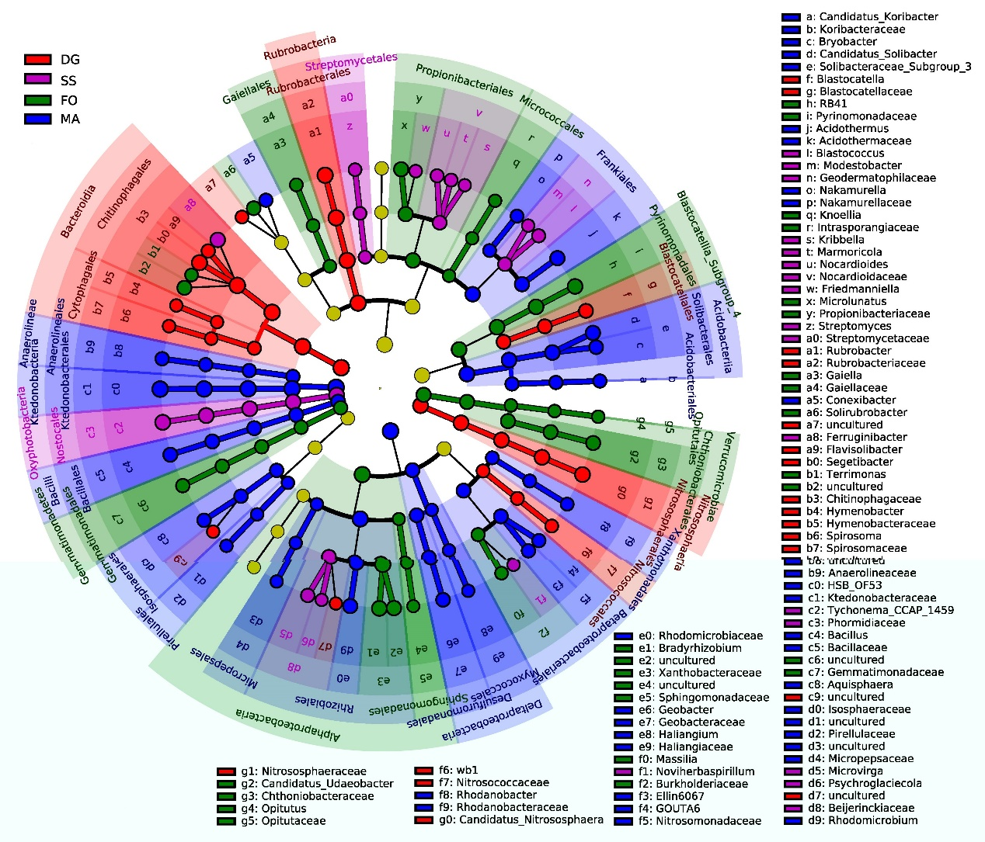
Fig. S2
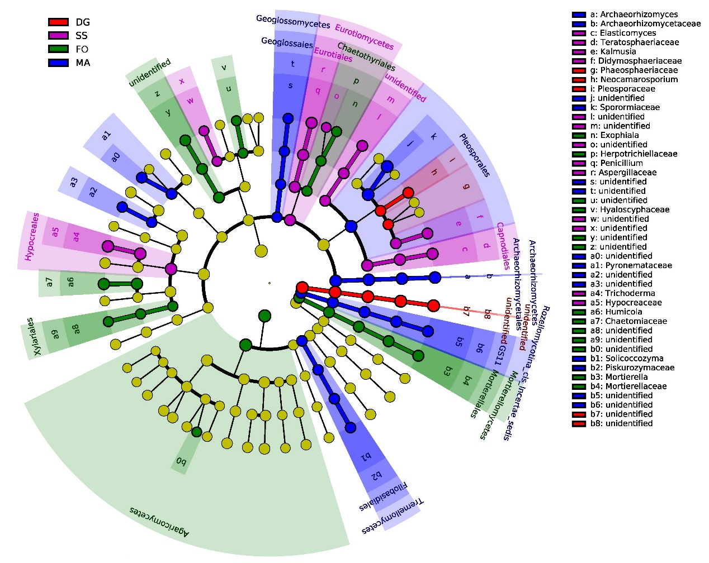
Fig. S3
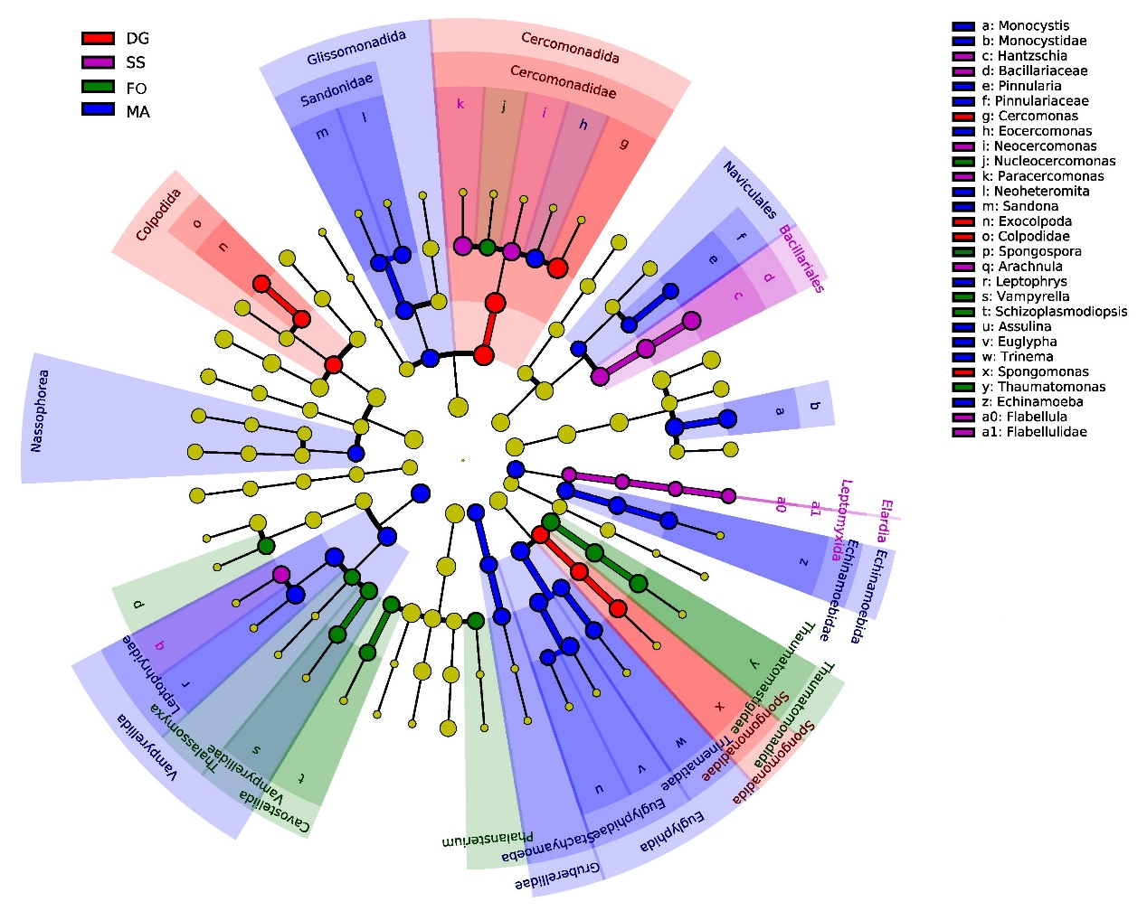
Fig. S4
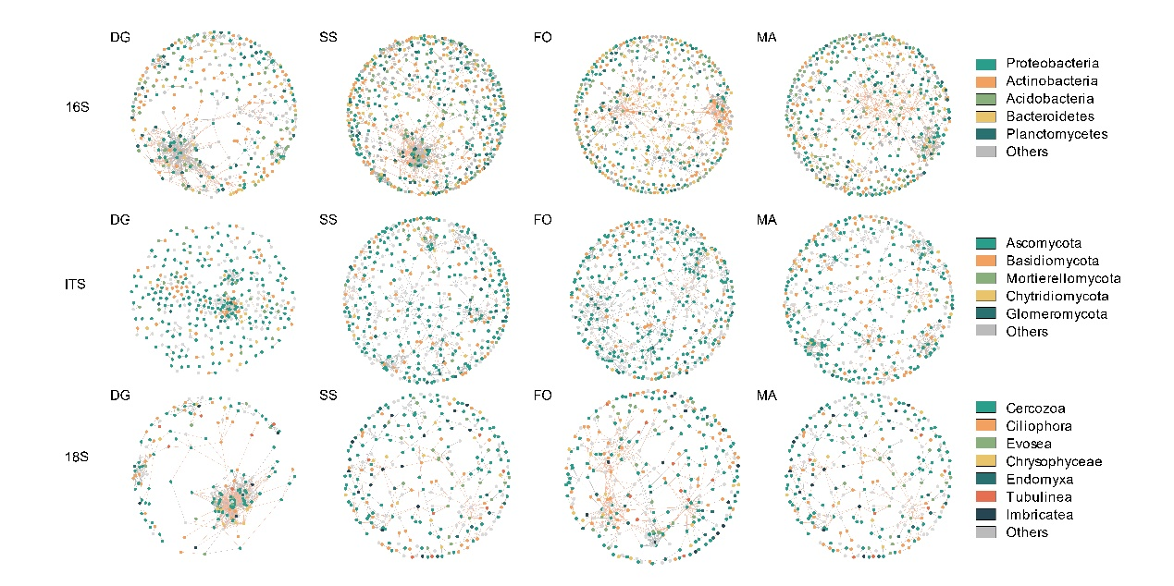
Fig. S5