SUPPLEMENTARY INFORMATION

Demystifying the phase diagrams of deep eutectic solvents within an extensive chemical space

Adroit T.N. Fajar¹, Takafumi Hanada², Aditya D. Hartono³, Masahiro Goto^{1,}*

¹Department of Applied Chemistry, Graduate School of Engineering, Kyushu University, 744 Motooka, Fukuoka 819-0395, Japan.
²Department of Applied Chemistry, Graduate School of Technology, Industrial and Social Science, Tokushima University, 2-1 Minamijosanjima, Tokushima 770-8506, Japan.
³Mathematical Modeling Laboratory, Department of Agro-environmental Sciences, Faculty of Agriculture, Kyushu University, 744 Motooka, Fukuoka 819-0395, Japan.

*Corresponding author. Email address: m-goto@mail.cstm.kyushu-u.ac.jp

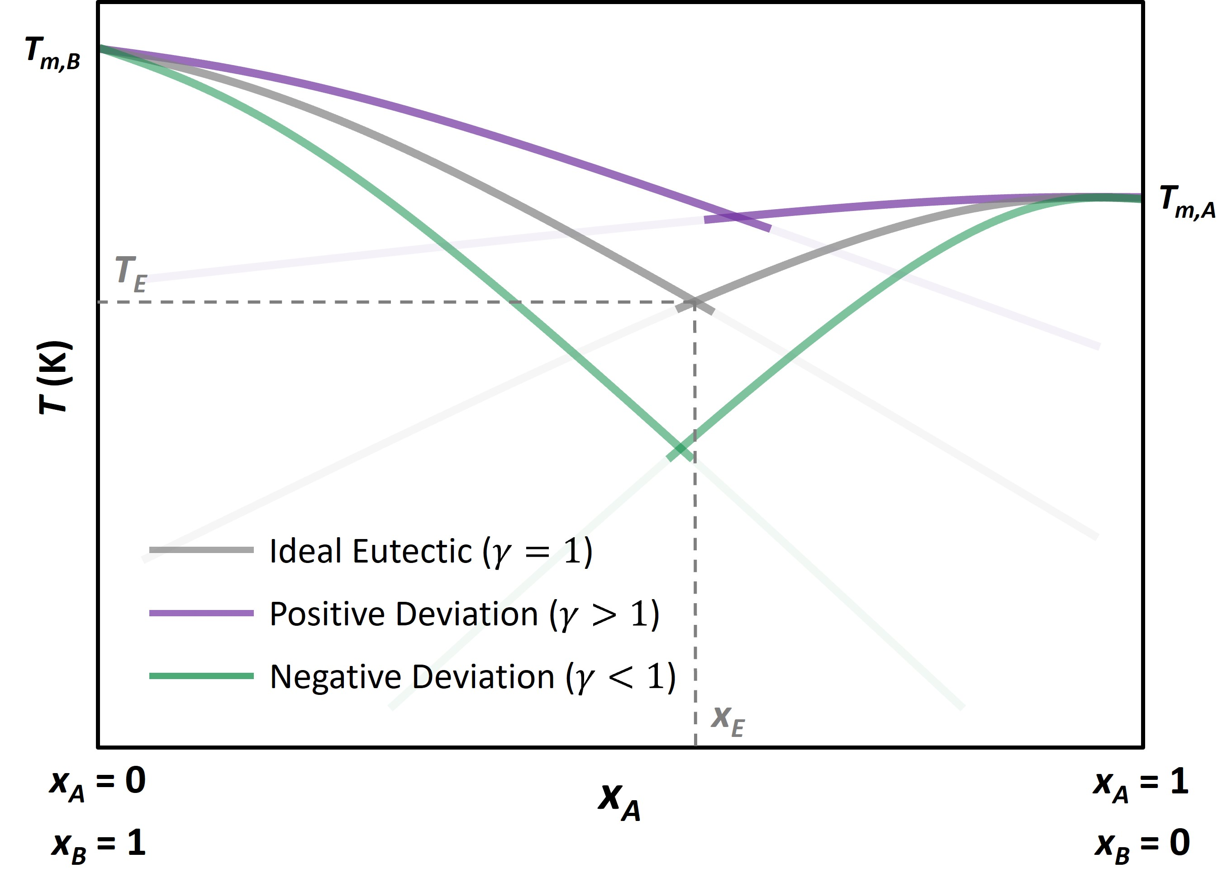
Figure S1. A schematic SLE phase diagram for a binary mixture consisting of compound A and compound B.

Equation S1
If the molar heat capacity parameter was taken into account, equation (1) would expand as follows:
$$ln\left(x_{i}γ_{i}\right)=\frac{∆_{fus}H_{i}}{R}\left(\frac{1}{T_{m,i}}-\frac{1}{T_{i}}\right)+\frac{∆_{m}C_{i}}{R}\left(\frac{T_{m,i}}{T_{i}}-ln\frac{T_{m,i}}{T_{i}}-1\right)$$
However, the contribution of molar heat capacity $∆_{m}C_{i}$ (J mol⁻¹ K⁻¹) is negligible compared to that of the fusion enthalpy parameter. Thus, the present study uses equation (1) to determine the melting curves in SLE phase diagrams.

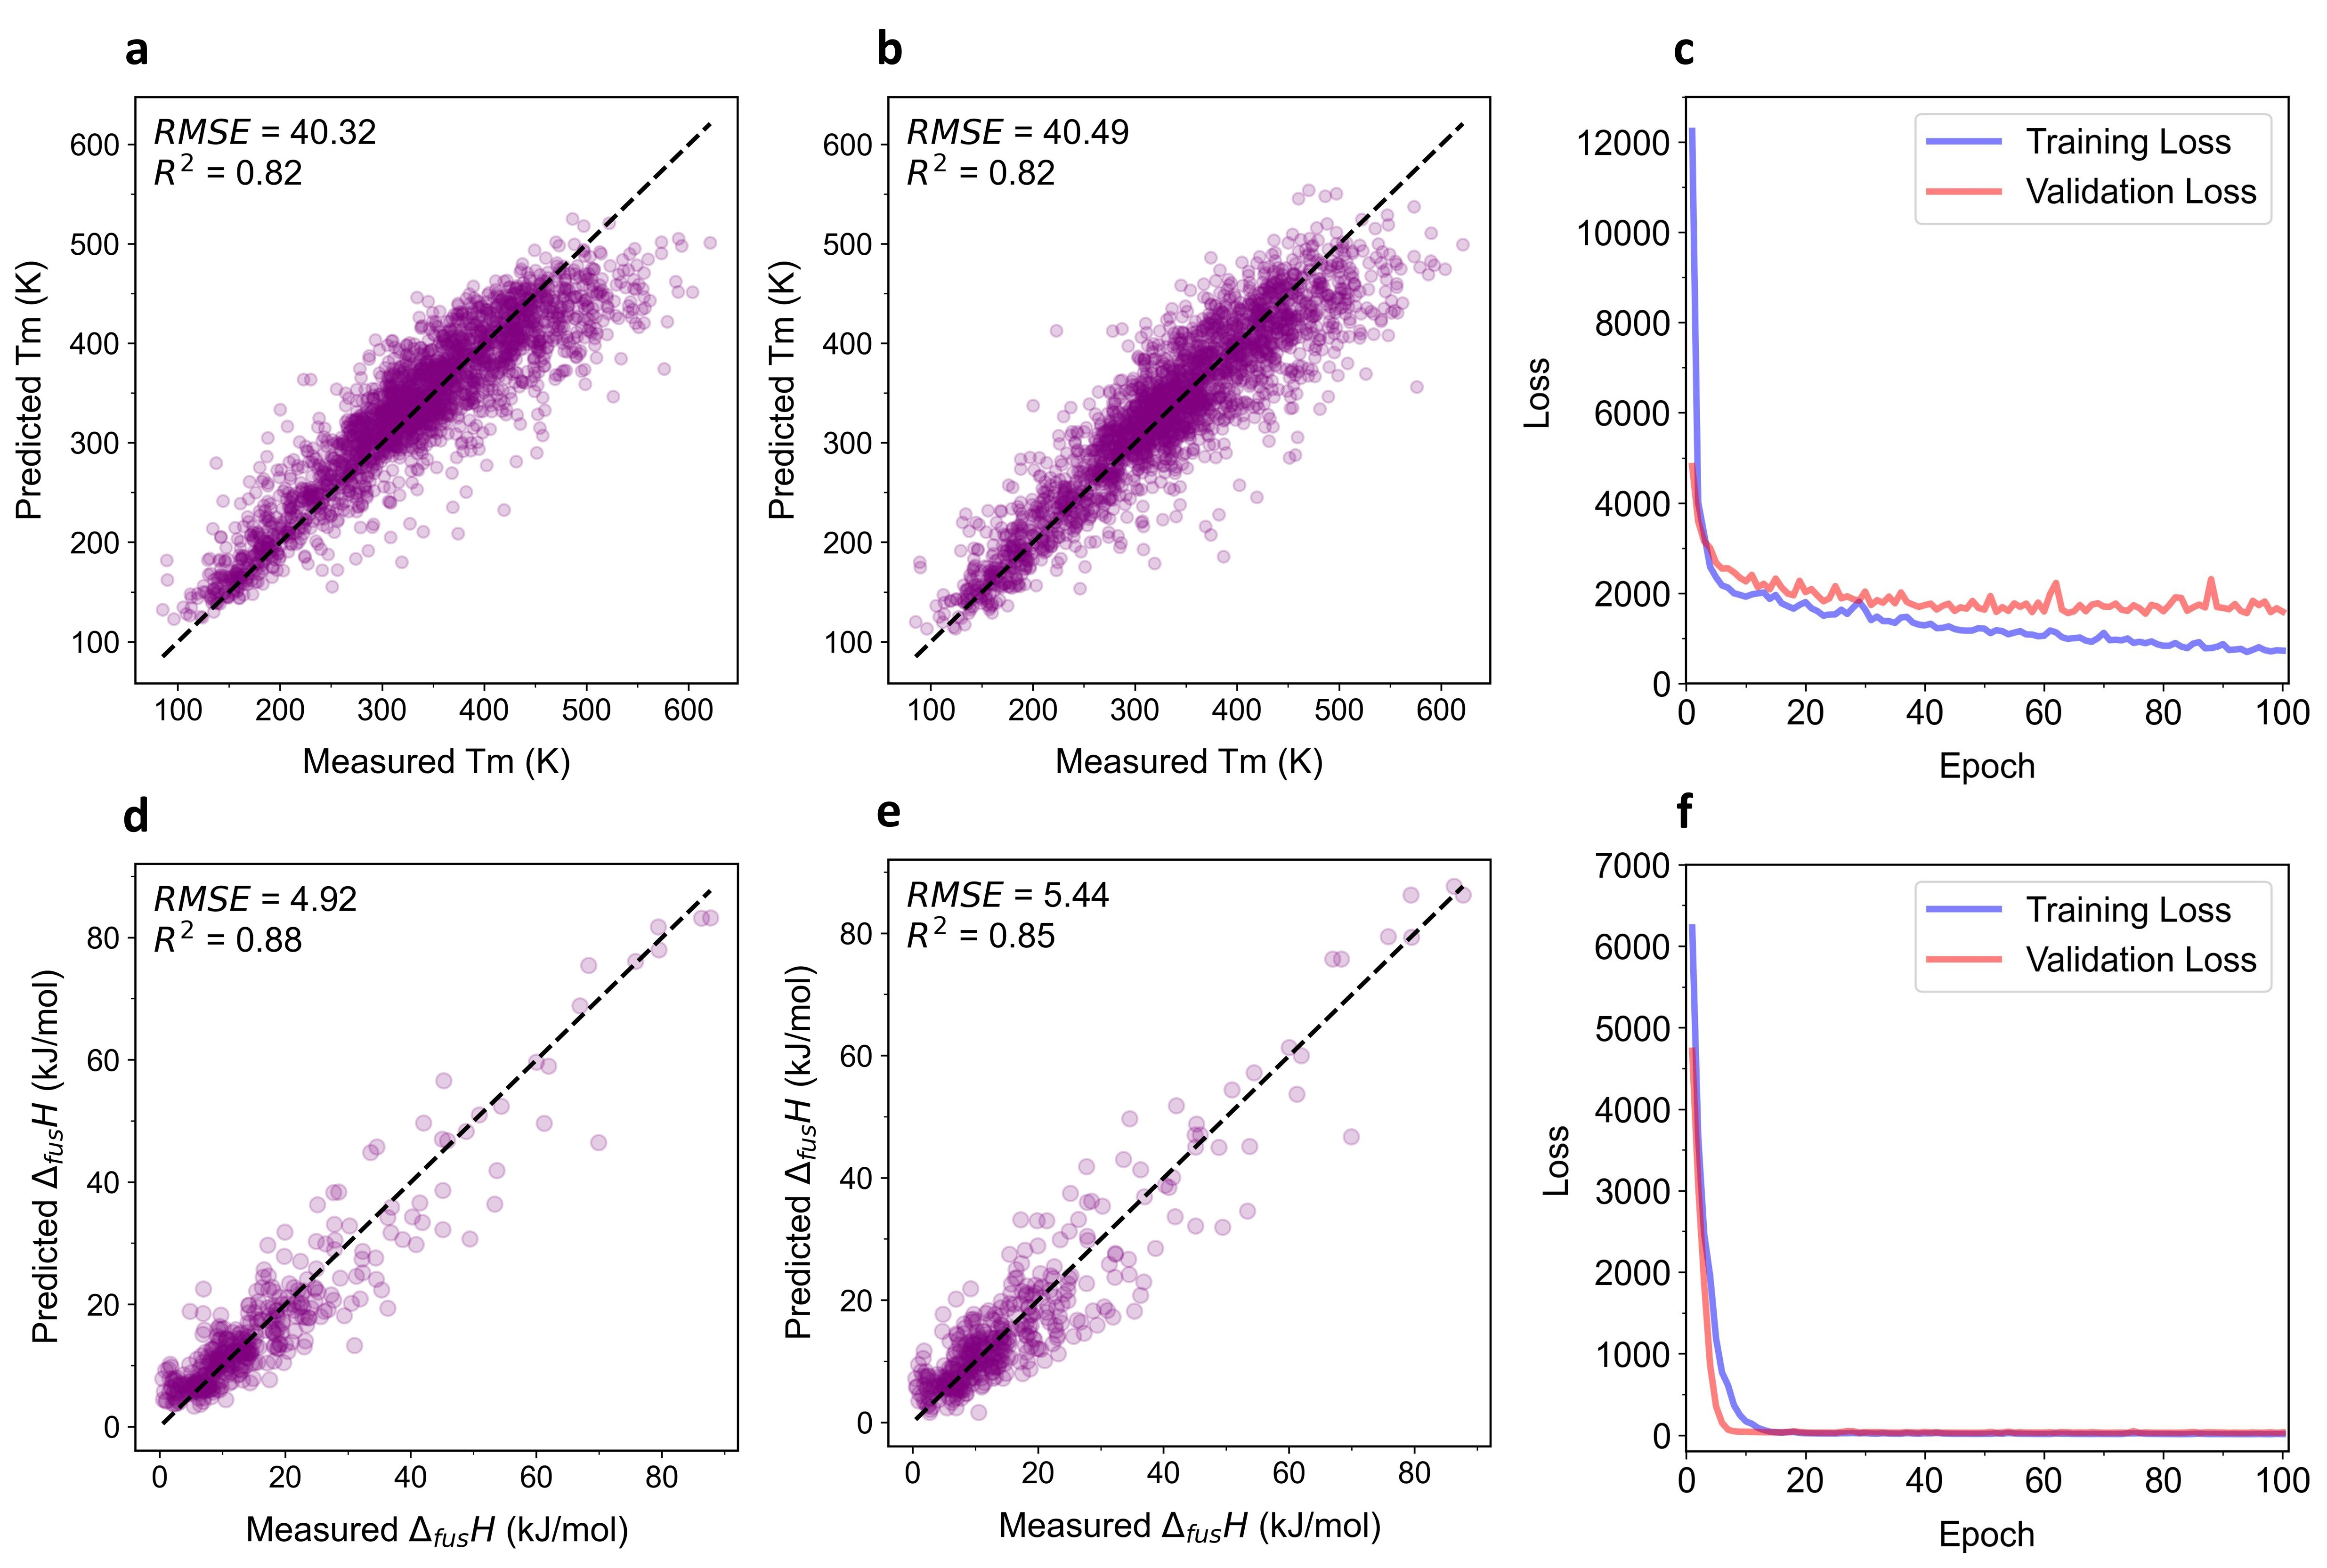
Figure S2. Parity plots corresponding to cross-validation analysis of ML models to predict $T_{m,i}$ value: (a) RF and (b) XGB. (c) The learning history of the MLP model to predict $T_{m,i}$ value. Parity plots corresponding to cross-validation analysis of ML models to predict $∆_{fus}H_{i}$ value: (d) RF and (e) XGB. (f) The learning history of the MLP model to predict $∆_{fus}H_{i}$ value.

Table S1. Names and SMILES representations of the proposed compounds.
HBA | SMILES
trimethylphosphine oxide | CP(C)(C)=O
triethylphosphine oxide | O=P(CC)(CC)CC
tripropylphosphine oxide | O=P(CCC)(CCC)CCC
tributylphosphine oxide | O=P(CCCC)(CCCC)CCCC
tripentylphosphine oxide | O=P(CCCCC)(CCCCC)CCCCC
trihexylphosphine oxide | O=P(CCCCCC)(CCCCCC)CCCCCC
triheptylphosphine oxide | O=P(CCCCCCC)(CCCCCCC)CCCCCCC
trioctylphosphine oxide | O=P(CCCCCCCC)(CCCCCCCC)CCCCCCCC
trinonylphosphine oxide | O=P(CCCCCCCCC)(CCCCCCCCC)CCCCCCCCC
tris(decyl)phosphine oxide | O=P(CCCCCCCCCC)(CCCCCCCCCC)CCCCCCCCCC
(methylsulfinyl)methane | CS(C)=O
(methylsulfinyl)ethane | CS(CC)=O
1-(methylsulfinyl)propane | CS(CCC)=O
1-(methylsulfinyl)butane | CS(CCCC)=O
1-(methylsulfinyl)pentane | CS(CCCCC)=O
1-(methylsulfinyl)hexane | CS(CCCCCC)=O
1-(methylsulfinyl)heptane | CS(CCCCCCC)=O
1-(methylsulfinyl)octane | CS(CCCCCCCC)=O
1-(methylsulfinyl)nonane | CS(CCCCCCCCC)=O
1-(methylsulfinyl)decane | CS(CCCCCCCCCC)=O
1-(methylsulfinyl)undecane | CS(CCCCCCCCCCC)=O
1-(methylsulfinyl)dodecane | CS(CCCCCCCCCCCC)=O
1-(methylsulfinyl)tridecane | CS(CCCCCCCCCCCCC)=O
(ethylsulfinyl)ethane | O=S(CC)CC
1-(propylsulfinyl)propane | O=S(CCC)CCC
1-(butylsulfinyl)butane | O=S(CCCC)CCCC
1-(pentylsulfinyl)pentane | O=S(CCCCC)CCCCC
1-(hexylsulfinyl)hexane | O=S(CCCCCC)CCCCCC
1-(heptylsulfinyl)heptane | O=S(CCCCCCC)CCCCCCC
1-(octylsulfinyl)octane | O=S(CCCCCCCC)CCCCCCCC
1-(nonylsulfinyl)nonane | O=S(CCCCCCCCC)CCCCCCCCC
1-(decylsulfinyl)decane | O=S(CCCCCCCCCC)CCCCCCCCCC
1-(undecylsulfinyl)undecane | O=S(CCCCCCCCCCC)CCCCCCCCCCC
1-(dodecylsulfinyl)dodecane | O=S(CCCCCCCCCCCC)CCCCCCCCCCCC
1-(tridecylsulfinyl)tridecane | O=S(CCCCCCCCCCCCC)CCCCCCCCCCCCC
1,1,3,3-tetramethylurea | O=C(N(C)C)N(C)C
1,3-diethyl-1,3-dimethylurea | O=C(N(C)CC)N(C)CC
1,1,3,3-tetraethylurea | O=C(N(CC)CC)N(CC)CC
1,3-diethyl-1,3-dipropylurea | O=C(N(CC)CCC)N(CC)CCC
1,1,3,3-tetrapropylurea | O=C(N(CCC)CCC)N(CCC)CCC
1,3-dibutyl-1,3-dipropylurea | O=C(N(CCC)CCCC)N(CCC)CCCC
1,1,3,3-tetrabutylurea | O=C(N(CCCC)CCCC)N(CCCC)CCCC
1,3-dibutyl-1,3-dipentylurea | O=C(N(CCCC)CCCCC)N(CCCC)CCCCC
1,1,3,3-tetrapentylurea | O=C(N(CCCCC)CCCCC)N(CCCCC)CCCCC
1,3-dihexyl-1,3-dipentylurea | O=C(N(CCCCC)CCCCCC)N(CCCCC)CCCCCC
1,1,3,3-tetrahexylurea | O=C(N(CCCCCC)CCCCCC)N(CCCCCC)CCCCCC
1,3-diheptyl-1,3-dihexylurea | O=C(N(CCCCCC)CCCCCCC)N(CCCCCC)CCCCCCC
1,1,3,3-tetramethylthiourea | S=C(N(C)C)N(C)C
1,3-diethyl-1,3-dimethylthiourea | S=C(N(CC)C)N(C)CC
1,3-dimethyl-1,3-dipropylthiourea | S=C(N(CCC)C)N(C)CCC
1,3-dibutyl-1,3-dimethylthiourea | S=C(N(CCCC)C)N(C)CCCC
1,3-dimethyl-1,3-dipentylthiourea | S=C(N(CCCCC)C)N(C)CCCCC
1,3-dihexyl-1,3-dimethylthiourea | S=C(N(CCCCCC)C)N(C)CCCCCC
1,3-diheptyl-1,3-dimethylthiourea | S=C(N(CCCCCCC)C)N(C)CCCCCCC
1,3-dimethyl-1,3-dioctylthiourea | S=C(N(CCCCCCCC)C)N(C)CCCCCCCC
1-ethyl-1,3,3-trimethylthiourea | S=C(N(CC)C)N(C)C
1,1,3-trimethyl-3-propylthiourea | S=C(N(CCC)C)N(C)C
1-butyl-1,3,3-trimethylthiourea | S=C(N(CCCC)C)N(C)C
1,1,3-trimethyl-3-pentylthiourea | S=C(N(CCCCC)C)N(C)C
1-hexyl-1,3,3-trimethylthiourea | S=C(N(CCCCCC)C)N(C)C
HBD | SMILES
Glycine | NCC(O)=O
Alanine | N[C@@H](C)C(O)=O
Proline | O=C(O)[C@H]1NCCC1
Valine | N[C@@H](C(C)C)C(O)=O
Leucine | N[C@@H](CC(C)C)C(O)=O
Isoleucine | N[C@@H]([C@@H](C)CC)C(O)=O
Methionine | N[C@@H](CCSC)C(O)=O
Phenylalanine | N[C@@H](CC1=CC=CC=C1)C(O)=O
Tyrosine | N[C@@H](CC1=CC=C(O)C=C1)C(O)=O
Tryptophan | N[C@@H](CC1=CNC2=C1C=CC=C2)C(O)=O
Serine | N[C@@H](CO)C(O)=O
Threonine | N[C@@H]([C@H](O)C)C(O)=O
Cysteine | N[C@@H](CS)C(O)=O
Asparagine | N[C@@H](CC(N)=O)C(O)=O
Glutamine | N[C@@H](CCC(N)=O)C(O)=O
Lysine | N[C@@H](CCCCN)C(O)=O
Histidine | N[C@@H](CC1=CNC=N1)C(O)=O
Arginine | N[C@@H](CCCNC(N)=N)C(O)=O
Aspartic acid | N[C@@H](CC(O)=O)C(O)=O
Glutamic acid | N[C@@H](CCC(O)=O)C(O)=O
Glyceraldehyde | OC(CO)C=O
Erythrose | O=C[C@@H]([C@@H](CO)O)O
Threose | O=C[C@H]([C@@H](CO)O)O
Ribose | O=C[C@@H]([C@@H]([C@@H](CO)O)O)O
Arabinose | O=C[C@H]([C@@H]([C@@H](CO)O)O)O
Xylose | O=C[C@@H]([C@H]([C@@H](CO)O)O)O
Lyxose | O=C[C@H]([C@H]([C@@H](CO)O)O)O
Allose | O=C[C@@H]([C@@H]([C@@H]([C@@H](CO)O)O)O)O
Altrose | O=C[C@H]([C@@H]([C@@H]([C@@H](CO)O)O)O)O
Glucose | O=C[C@@H]([C@H]([C@@H]([C@@H](CO)O)O)O)O
Mannose | O=C[C@H]([C@H]([C@@H]([C@@H](CO)O)O)O)O
Gulose | O=C[C@@H]([C@@H]([C@H]([C@@H](CO)O)O)O)O
Idose | O=C[C@H]([C@@H]([C@H]([C@@H](CO)O)O)O)O
Galactose | O=C[C@@H]([C@H]([C@H]([C@@H](CO)O)O)O)O
Talose | O=C[C@H]([C@H]([C@H]([C@@H](CO)O)O)O)O
Dihydroxyacetone | O=C(CO)CO
Erythrulose | OCC([C@@H](CO)O)=O
Ribulose | OCC([C@@H]([C@@H](CO)O)O)=O
Xylulose | OCC([C@H]([C@@H](CO)O)O)=O
Psicose | OCC([C@@H]([C@@H]([C@@H](CO)O)O)O)=O
Fructose | OCC([C@H]([C@@H]([C@@H](CO)O)O)O)=O
Sorbose | OCC([C@@H]([C@H]([C@@H](CO)O)O)O)=O
Tagatose | OCC([C@H]([C@H]([C@@H](CO)O)O)O)=O
Lauric acid | CCCCCCCCCCCC(O)=O
Myristic acid | CCCCCCCCCCCCCC(O)=O
Palmitic acid | CCCCCCCCCCCCCCCC(O)=O
Stearic acid | CCCCCCCCCCCCCCCCCC(O)=O
Arachidic acid | CCCCCCCCCCCCCCCCCCCC(O)=O
Lignoceric acid | CCCCCCCCCCCCCCCCCCCCCCCC(O)=O
Cholesterol | CC(C)CCC[C@@H](C)[C@H]1CC[C@@]2([H])[C@]3([H])CC=C4C[C@@H](O)CC[C@]4(C)[C@@]3([H])CC[C@]12C

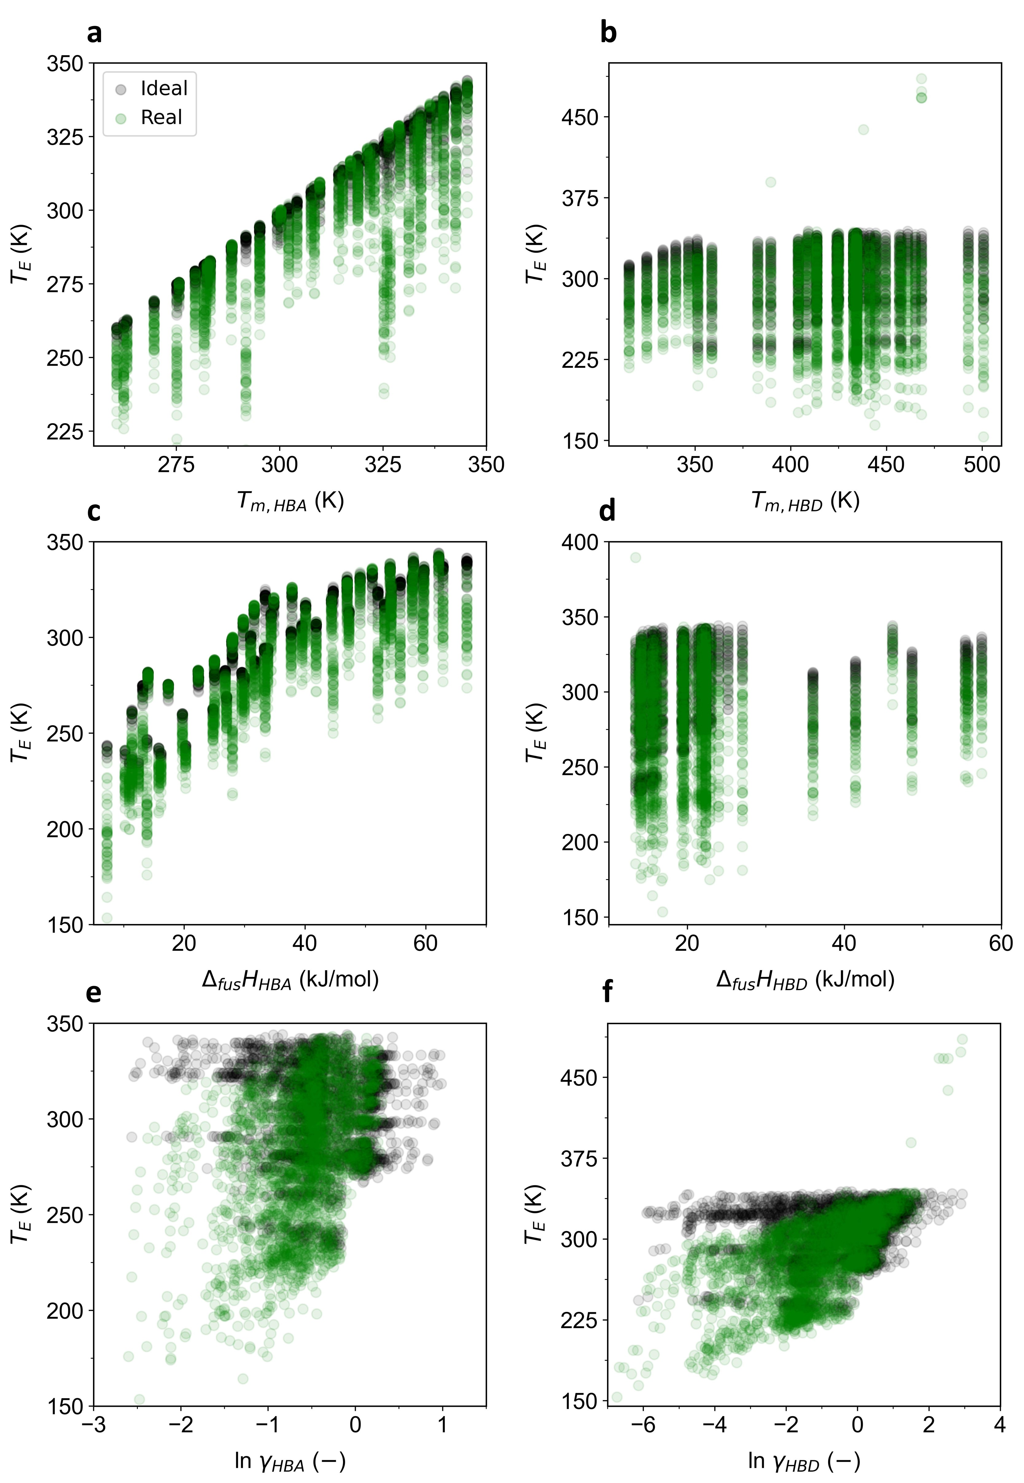
Figure S3. Correlations between (a) $T_{m,HBA}$, (b) $T_{m,HBD}$, (c) $∆_{fus}H_{HBA}$, (d) $∆_{fus}H_{HBD}$, (e) $\ln{γ_{HBA}}$, and (f) $\ln{γ_{HBD}}$ values and the $T_{E}$ values of the mixtures.
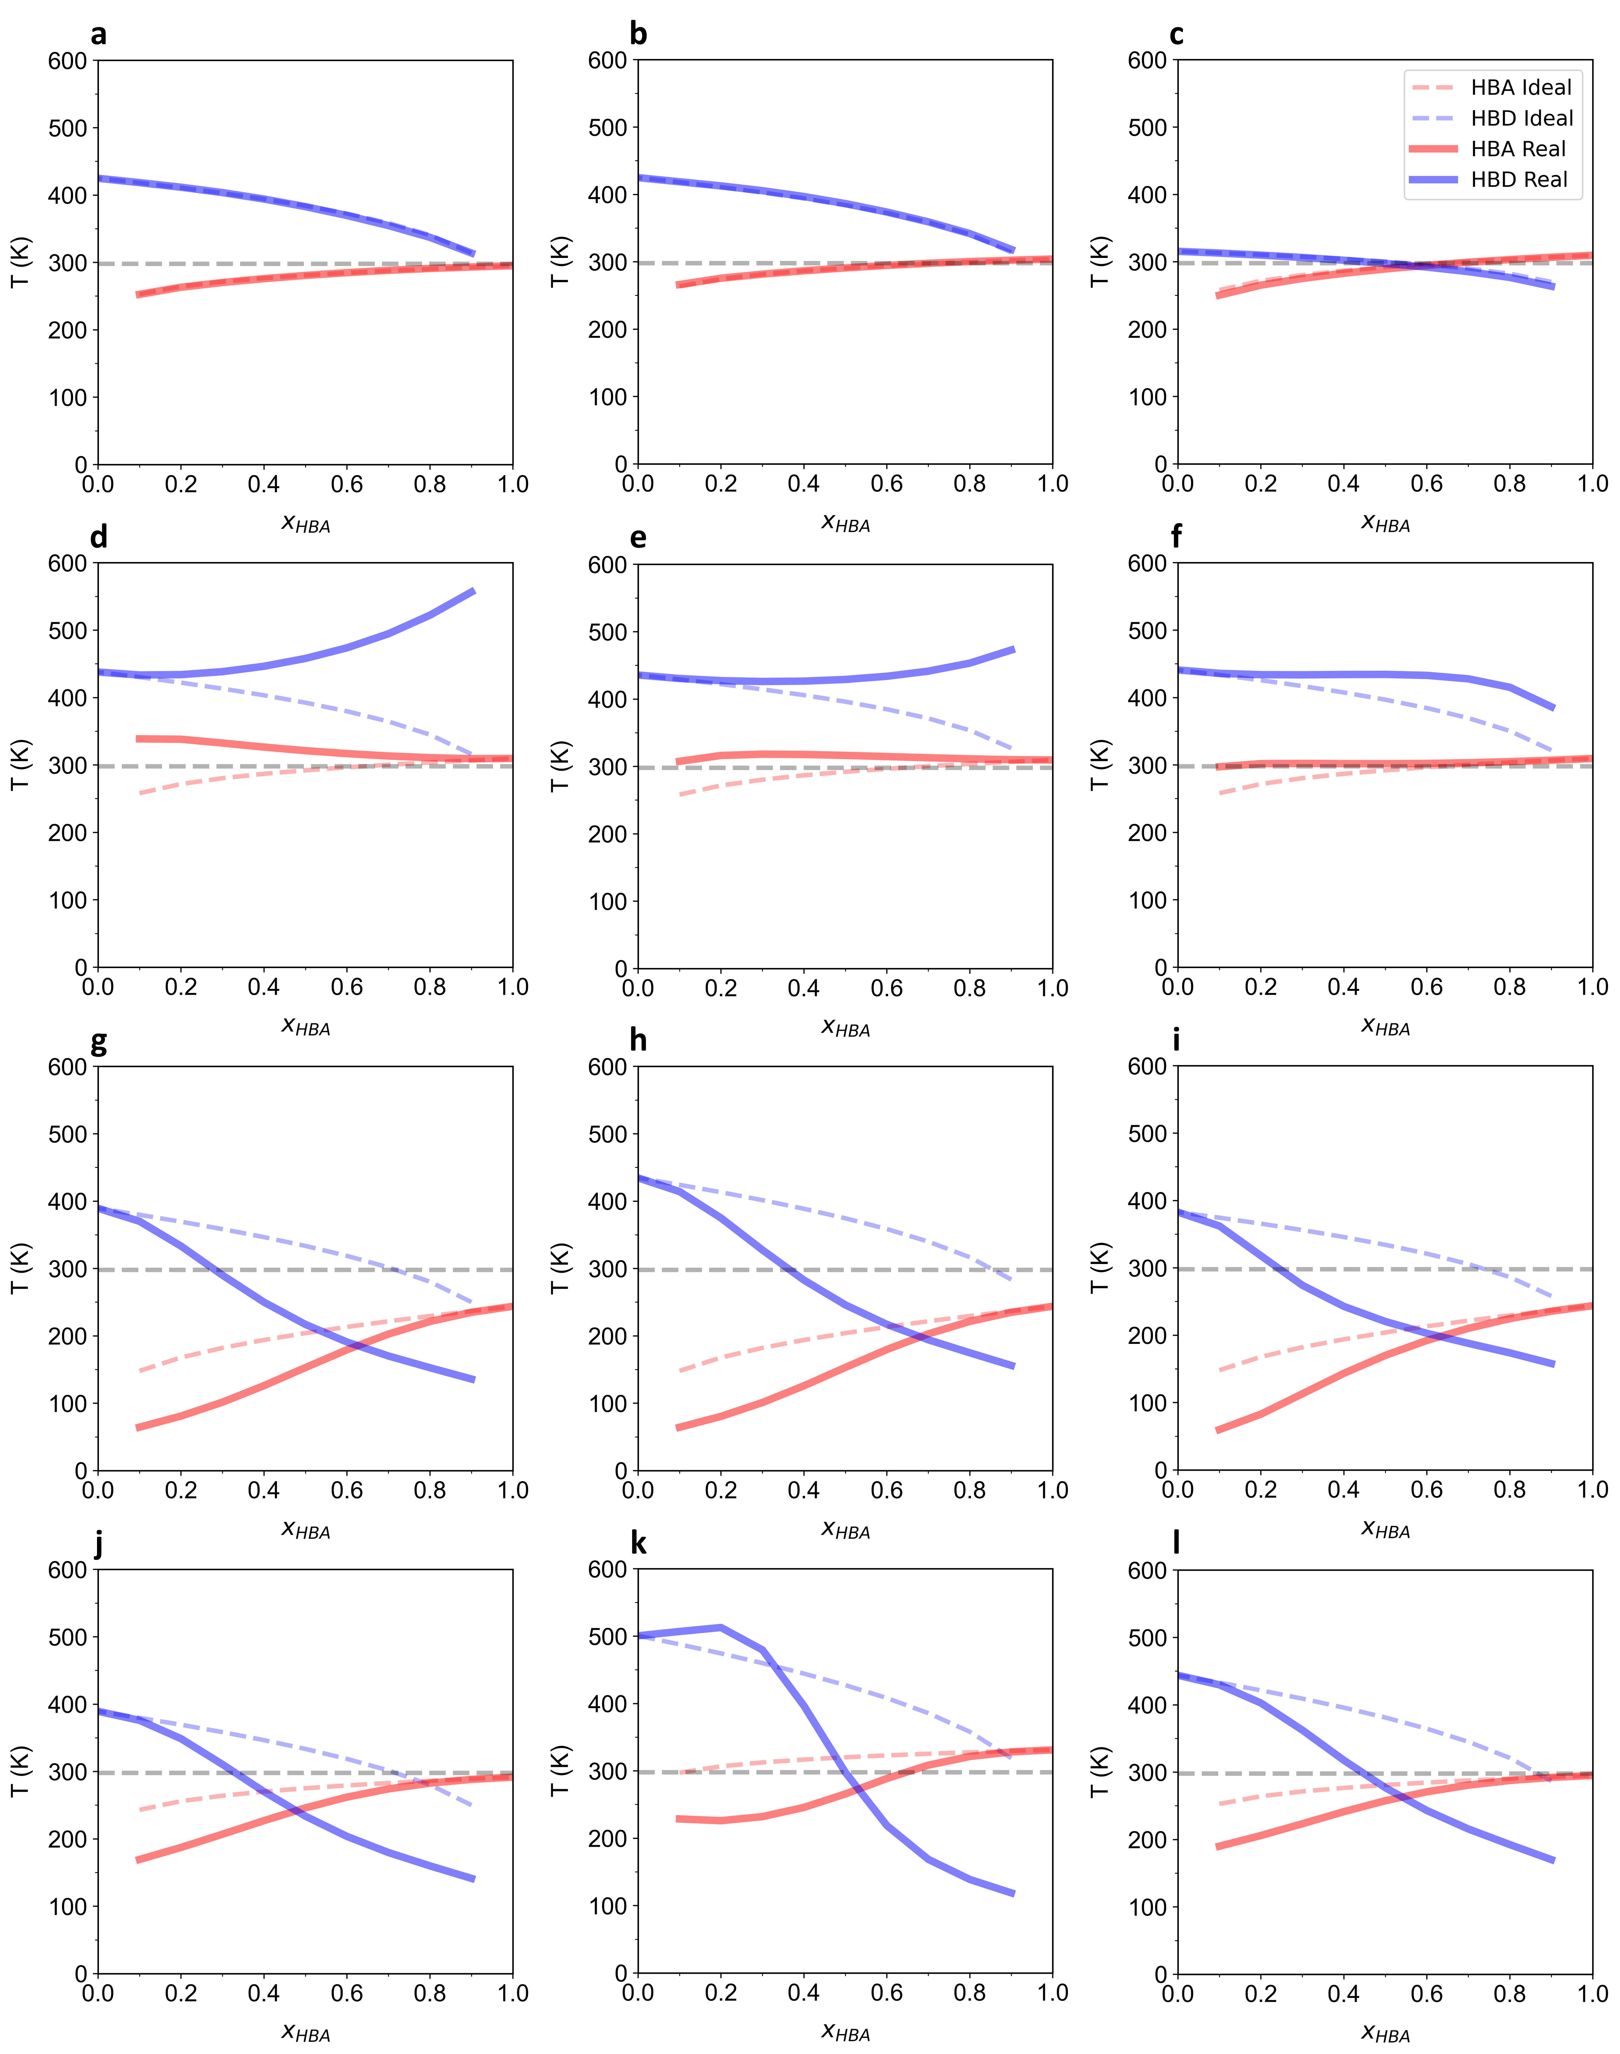
Figure S4. Additional examples of SLE phase diagrams with melting curves that (a–c) behave ideally, (d–f) exhibit positive deviations, and (g–l) show negative deviations. (a) Mixture 1015, (b) Mixture 1065, (c) Mixture 2993, (d) Mixture 2964, (e) Mixture 2967, (f) Mixture 2969, (g) Mixture 0, (h) Mixture 1, (i) Mixture 2, (j) Mixture 100, (k) Mixture 318, (l) Mixture 1012. Key details of these mixtures are given in Table S2.
Table S2. Key information on the mixtures in Figure S4.
Mixture | HBA | HBD | $T_{E}$ ideal (K) | $T_{E}$ real (K)
1015 | 1-(methylsulfinyl)undecane | lysine | 294 | 294
1065 | 1-(methylsulfinyl)dodecane | lysine | 303 | 303
2993 | 1-hexyl-1,3,3-trimethylthiourea | lauric acid | 296 | 294
2964 | 1-hexyl-1,3,3-trimethylthiourea | glutamine | 307 | n.a.
2967 | 1-hexyl-1,3,3-trimethylthiourea | arginine | 308 | n.a.
2969 | 1-hexyl-1,3,3-trimethylthiourea | glutamic acid | 308 | n.a.
0 | trimethylphosphine oxide | glycine | 239 | 185
1 | trimethylphosphine oxide | alanine | 243 | 199
2 | trimethylphosphine oxide | proline | 240 | 198
100 | tripropylphosphine oxide | glycine | 285 | 242
318 | triheptylphosphine oxide | aspartic acid | 329 | 272
1012 | 1-(methylsulfinyl)undecane | cysteine | 292 | 263
n.a.: not available

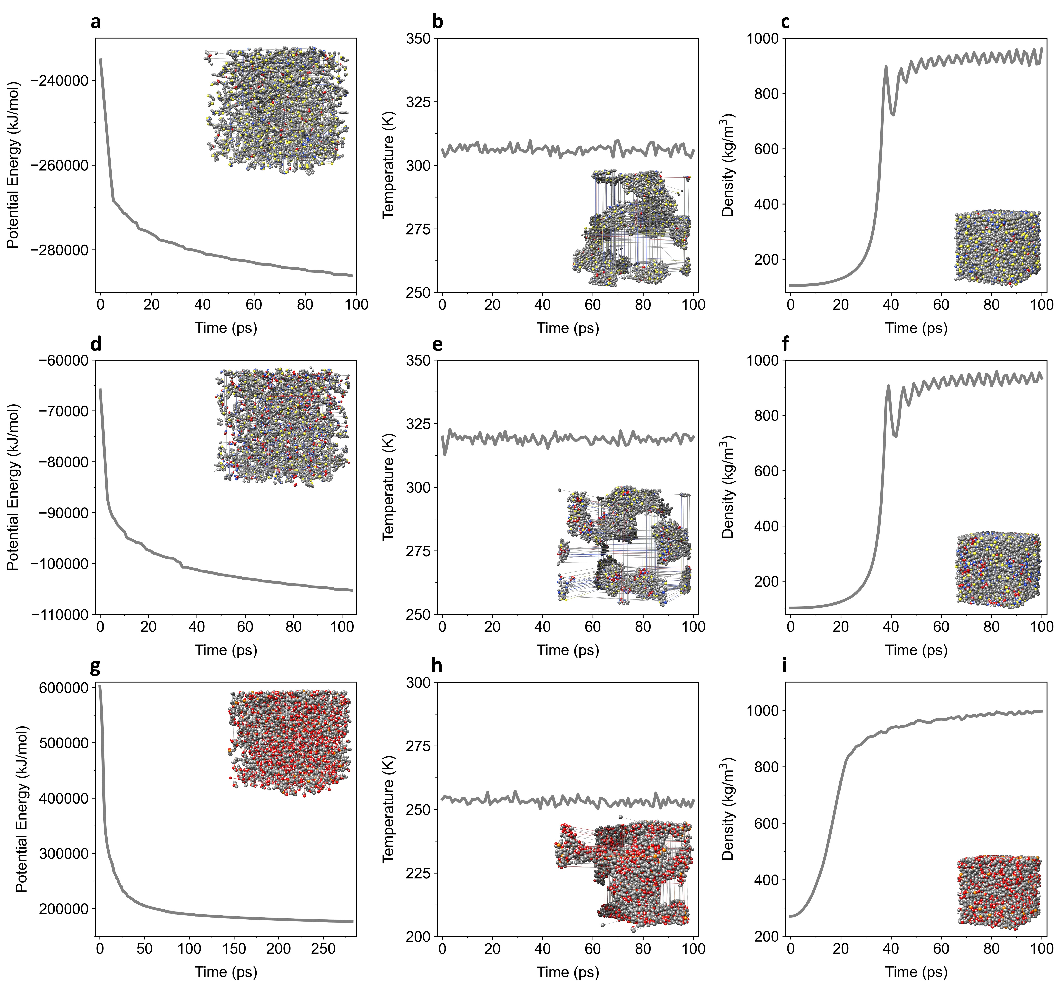
Figure S5. Setup of the simulation systems prior to the MD productions. (a) energy minimization, (b) NVT equilibration, and (c) NPT equilibration of Mixture 2996. (d) energy minimization, (e) NVT equilibration, and (f) NPT equilibration of Mixture 2650. (g) energy minimization, (h) NVT equilibration, and (i) NPT equilibration of Mixture 171. The inset depicts molecular visualizations at the end of each simulation step.

