ZnO-incorporated chitin hydrogels for infected wound therapy
Hongli Zhang#, Mengqing Xu#, Liang Wang#, Haihua Luo, Shuangquan Wu, Tian Gao*, Qiong Wu*, Huan Xu*

H. Zhang, M. Xu, H. Luo, T. Gao, Q. Wu, H. Xu
Key Laboratory of Coal Conversion and New Carbon Materials of Hubei Province & Institute of Advanced Materials and Nanotechnology, School of Chemistry and Chemical Engineering, Medical College, Wuhan 430081, China
E-mail: xuhuan@wust.edu.cn
L. Wang
Department of Radiology, Wuhan No.1 Hospital, Wuhan, China
S. Wu
Zhongnan Hospital of Wuhan University, Institute of Hepatobiliary Diseases of Wuhan University, Transplant Center of Wuhan University, National Quality Control Center for Donated Organ Procurement, Hubei Key Laboratory of Medical Technology on Transplantation, Hubei Clinical Research Center for Natural Polymer Biological Liver, Hubei Engineering Center of Natural Polymer-based Medical Materials, Wuhan 430071, China

Supplementary material
- Experimental section
1.1. Characterizations
Before measurements, all the samples were freeze-dried in a conventional freezer dryer (Scan Vac Coolsafe55-4, Denmark), and then were cut into powders. Fourier-transform infrared spectroscopy was obtained using a FTIR spectrometer (VERTEX70 FTIR Spectrometer, Bruker, Germany) in the region of 4000–400 cm⁻¹, the test specimens were prepared by the KBr-disk method. X-ray diffraction (XRD) in reflection mode was performed on a diffractometer (ZSX Primus IV, Neo-Confucianism, Japan). The XRD patterns with CuKα radiation (λ = 0.15406 nm) at 40 kV and 30 mA were recorded in the region of 2θ from 5° to 80° at a scanning speed of 3°/min. X-ray photoelectron spectra (XPS) were recorded using the machine (AXIS SUPRA+, Kratos, Japan). The binding energy was corrected to 284.6 eV for C 1s. Thermogravimetric analysis (TGA) was carried out using a TA Q500 instrument (TA Instruments, USA), the sample was placed in a platinum pan and heated from 80 °C to 800 °C at a rate of 10 °C/min under an air atmosphere. Scanning electron microscope (SEM) images of hydrogels were obtained on a BAOER microscope (Q Series, USA) using the back scattered electron imaging (BSE) mode and an accelerating voltage at 5 kV. The wet hydrogels were frozen in liquid nitrogen, immediately snapped, and freeze-dried, then the surface and cross-section of the samples were sputtered with gold for SEM measurements.
1.2. Antibacterial test
For colony-forming count method, single colonies of S. aureus, E. coli, MRSA and MDR E. coli were cultured separately in 20 mL LB liquid culture medium and incubated at 37 °C under shaking at 250 rpm overnight to reach the mid-log phase. Then, the bacterial suspensions were diluted to 10⁶ CFU/mL in fresh broth, respectively. After the hydrogels were added to a 24-well plate, 180 μL of PBS and 20 μL of bacterial suspension were added, and the mixture was incubated at 37 °C under shaking at 150 rpm for 12 h. Next, 100 μL of the mixture was diluted 7 times, then 100 μL of the diluent mixture was spread onto solid agar plates. The plates were incubated at 37 °C for 24 h, and the number of viable cells was counted. Bacterial suspensions with CG hydrogels were used as control.
For SEM observation, E. coli and S. aureus were treated with CG/CZG hydrogels for 12 h at 37 °C. Then bacteria were collected into centrifuge tubes and centrifuged at 8000 rpm for 1 minute and washed three times with PBS. After fixation with 2.5% glutaraldehyde for 5 h, the bacteria were dehydrated using different concentrations of ethanol (10, 20, 30, 50, 70, 60, 90 and 100%), then freeze-dried. Lyophilized powders were sputtered with gold for SEM measurements.
For bacterial fluorescent assay, CZG-2 hydrogels were added to 24-well plates and 200 µL of bacterial suspension (10⁷ CFU/mL) was spread on the surface. Then bacteria cells were co-stained with Calcein-AM (green)/PI (red) for 20 min in the dark, followed by washing thrice with PBS. The images were captured with an inverted fluorescent microscope (Olympus, FV1000).
For inhibition biofilm formation, specifically, 100 µL of the bacteria (S. aureus or E. coli, 10⁷ CFU/mL) in LB medium was added on the surface of CG, CZG-1, CZG-2, and CZG-3 hydrogels and cultured at 37 °C for 24 h without shaking. S. aureus or E. coli suspensions with PBS were used as control. Then the medium was removed and the unattached bacteria were gently washed away with PBS, and the resulting biofilms on 24-well plates were harvested, then 100 µL of the diluted suspension was spread onto agar plates and then incubated at 37 °C for 20 h. The colony-forming units (CFUs) on different plates were imaged and counted.
For crystal violet staining, 100 µL of bacteria suspension was treated with five groups: PBS, CG, CZG-1, CZG-2, and CZG-3, then cultured at 37 °C for 24 h without shaking. Afterward the medium was removed and the unattached bacteria were gently washed away with PBS. The biofilms were stained with 200 µL of crystal violet (0.1% in PBS) for 10 min, and washed with PBS twice. Then the crystal violet was dissolved into 500 µL of ethanol, finally the biomass of the biofilm was quantified by observing the absorbance at 620 nm.
The growth curves of E. coli and S. aureus after exposure to the CZG-2 hydrogels were plotted with the optical density (OD) value versus time. E. coli and S. aureus were inoculated in 10 mL (10⁵∼10⁷ CFU/mL) of a fresh LB medium supplemented with 2.5g of the CZG-2 hydrogels. The mixtures were then incubated in a rotary shaker at 150 rpm at 37 °C. The growth was monitored at an interval of 4 h for 24 h by measuring the OD value at 600 nm using an UV−vis spectrophotometer (U-3010, Hitachi, Japan).
For evaluating the long-lasting antibacterial activity of the CG/CZG-2 hydrogels, the hydrogels were soaked in 1 mL PBS and replaced by fresh PBS every day, and then the bacterial suspensions were added on the surface of the 1st-7th day treated hydrogels, respectively. All of the experiments were performed in triplicate.
1.3. Biocompatibility test
Cytocompatibility studies were assessed using MTT assay and carried out using NIH-3T3 cells. Each hydrogel with diameter of 10 mm and height of 2 mm was immersed in 1 mL cell growth media at 37 °C for 72 h, the cell growth media (negative) were treated with the same condition. 200 μL of cells suspension was seeded in 96-well plates with 4 × 10³ cells per well and cultured to adhere at 37 °C for 24 h in 5% CO₂ atmosphere in DMEM supplemented with 10% FBS and 1% streptomycin/penicillin. 60 μL culture media was replaced with 60 μL treated cell growth media (negative) or 60 μL liquid extracts of hydrogels (experiment) labelled as 30% (v/v) extract containing complete growth media. Next, they were incubated for an additional 24, 48 and 72 h to expose the cells to the extract. To evaluate the viability, the media was replaced by 200 μL of 10% MTT solution and further incubated for 4 h at 37 °C. 150 μL supernatant liquid incubated media were transferred to fresh 96-well plates for colorimetric assessment using a microplate reader at 490 nm. Cell viability was calculated using the flowing formula:
Cell viability (%) = (A_{test} – A₀) / (A_{control} – A₀) × 100
Where the A_{test} and the A_{control} were the absorbance of the experimental groups and the control group, A₀ was the absorbance of MTT in culture medium without cells. The data of sextuplicate samples are expressed as mean ± the standard deviation.
Additionally, the cell biocompatibility was evaluated by the Calcein-AM/ PI staining. At first, 1 mL fresh NIH 3T3 cells suspension with 2.5 × 10⁴ cells/mL were seeded in 24-well plates, then 300 μL of the liquid hydrogel extracts were placed in the 24-well plates and cultured with NIH 3T3 cells at 37 °C for 24, 48 and 72 h, with the culture medium itself without samples as a control. After washing by PBS, 200 µL Calcein-AM (green)/PI (red) solution was added and followed by incubation at 37 ℃ for 20 min. Then they were washed with PBS to remove unstained fluorescence dye and immediately observed by a fluorescence microscope.
For hemolysis assay, CG, CZG-1, CZG-2, and CZG-3 hydrogels with diameter of 10 mm and height of 2 mm were incubated with red blood cells (RBCs) from rabbits and the hemolysis ratio was calculated. The prewashed (5% v/v in PBS) RBCs (0.1 mL) was incubated with CG, CZG-1, CZG-2, and CZG-3 hydrogels at 37 °C for 4 h. Then 150 μL of the supernatant was transferred to a 96-well plate, and the absorbance was measured at 545 nm. PBS was used as negative control group and DW as positive control, respectively. The hemolysis ratio was calculated as follows:
Hemolysis ratio (%) = (A_{test} – A₀) / (A₁₀₀ – A₀) × 100
Where A_{test}, A₀ and A₁₀₀ represent the absorbance of the experimental groups, negative and positive controls, respectively.
1.4. Animal experiments
For in vivo experiment, all animal procedures were in accordance with the protocols and regulations of Wuhan University of Science and Technology and complied with all relevant ethical regulations. Female Kunming mice with the average bodyweight around 20 g (Wuhan Centers for Disease Prevention & Control, China) were used for animal tests, a severely infected wound model was constructed to assess the effectiveness of antibacterial property based on CZG-2 hydrogels in vivo. First, to construct the animal model with infected wound, the mouse was first anesthetized. Before wound fabrication, the dorsal side of the mice was shaved, depilated, and disinfected. Then, two oval wounds (about 0.8 cm in diameter) were created on the dorsum of the mouse, and each wound was inoculated with S. aureus (10⁷ CFUs per wound). The models were randomly divided into three groups (PBS, CG, and CZG-2), respectively. To evaluate the in vivo antibacterial activity of CZG-2 hydrogels, wound tissues were placed into sterile PBS (2 mL) and the tissues of wounds were obtained for further analysis at day 3, then a standard plate counting assay was performed. For wound healing process, on day 0, 3, 6, 9, 12 and 15, images of wound were recorded using a digital camera, and wound closure rates were further calculated. Moreover, the body weight was measured every day. For histological evaluation, on the 15th day, all remaining mice were euthanized, and the surrounding tissues of wounds were obtained for further histomorphology analysis. Before being embedded in paraffin and sliced, all wound tissues were fixed with 4% paraformaldehyde solution. The sections of different wounds were subsequently conducted with H&E staining and Masson’s trichrome staining. For quantitative analysis of the histopathological changes, the proportion of collagen-occupied area was measured on histological skin samples by ImageJ (Media Cybernetics, Inc., Rockville, MD, USA).
- Supporting figures
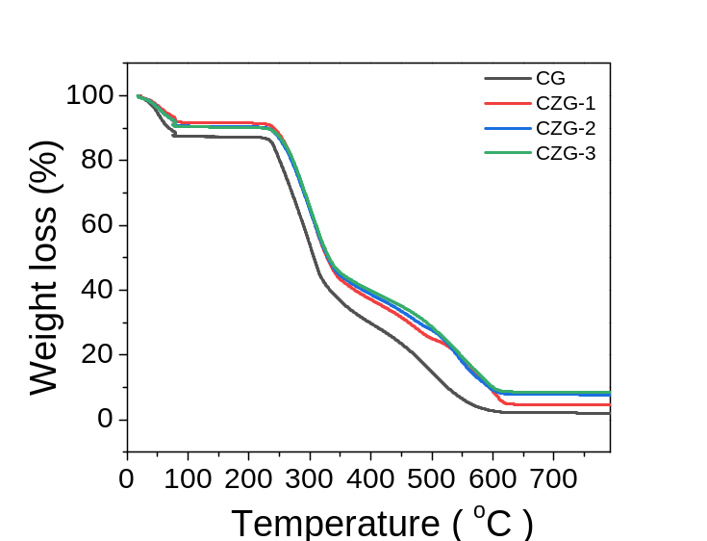
Figure S1. TGA curves of CG, CZG-1, CZG-2, and CZG-3.
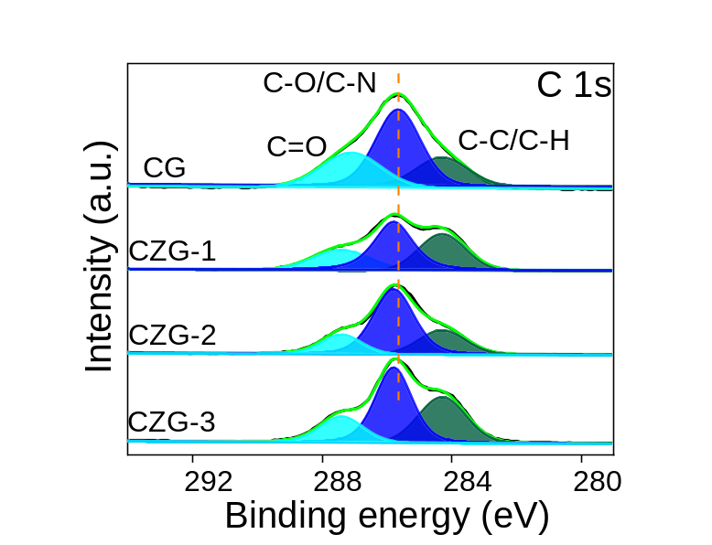
Figure S2. XPS high-resolution spectra: C 1s of CG, CZG-1, CZG-2, and CZG-3, respectively.

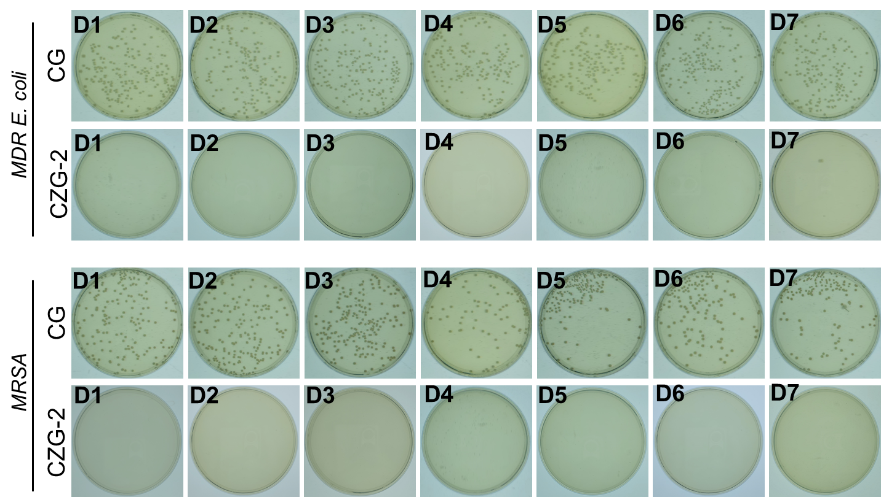
Figure S3. Representative plates of MDR E. coli and MRSA colonies after treated with CG/CZG-2 hydrogels for 7 consecutive days.
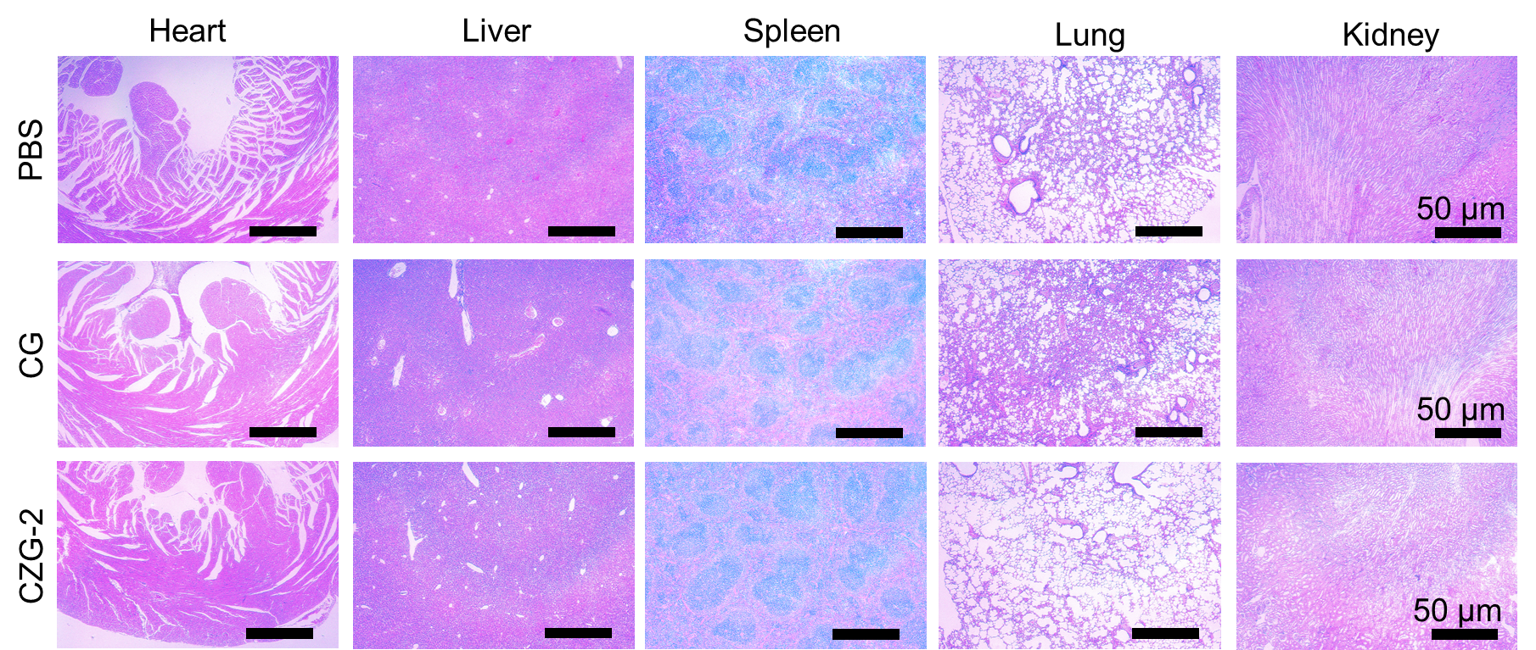
Figure S4. H&E staining of major organs, including heart, liver, spleen, lung, and kidney.

