SUPPLEMENTARY MATERIAL 1

Location of all High-priority Important Plant Areas of frailejones (Espeletiinae, Asteraceae) in the Northern Andes.

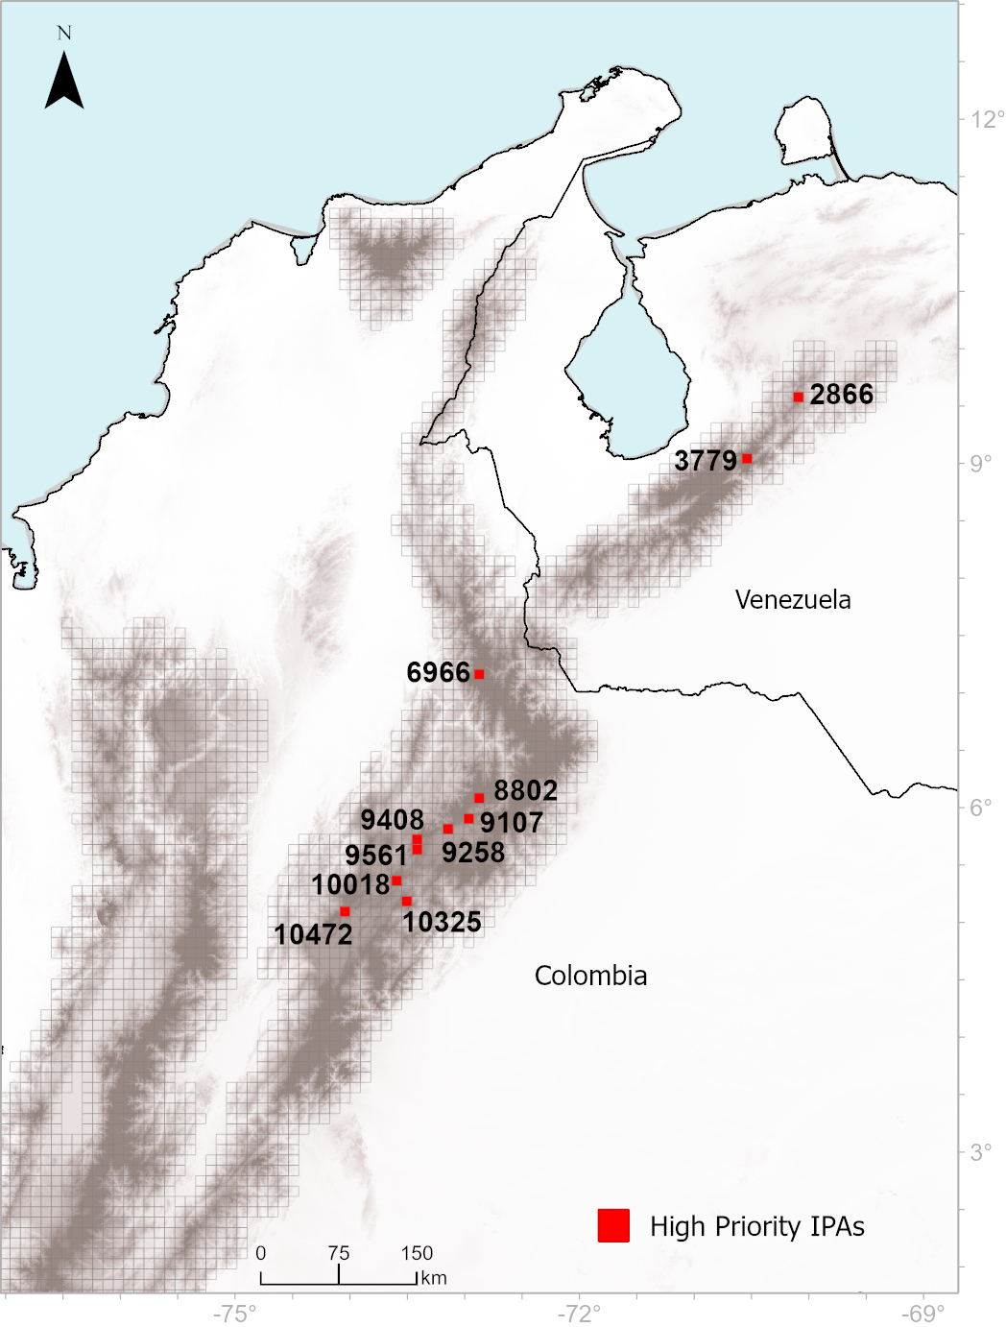

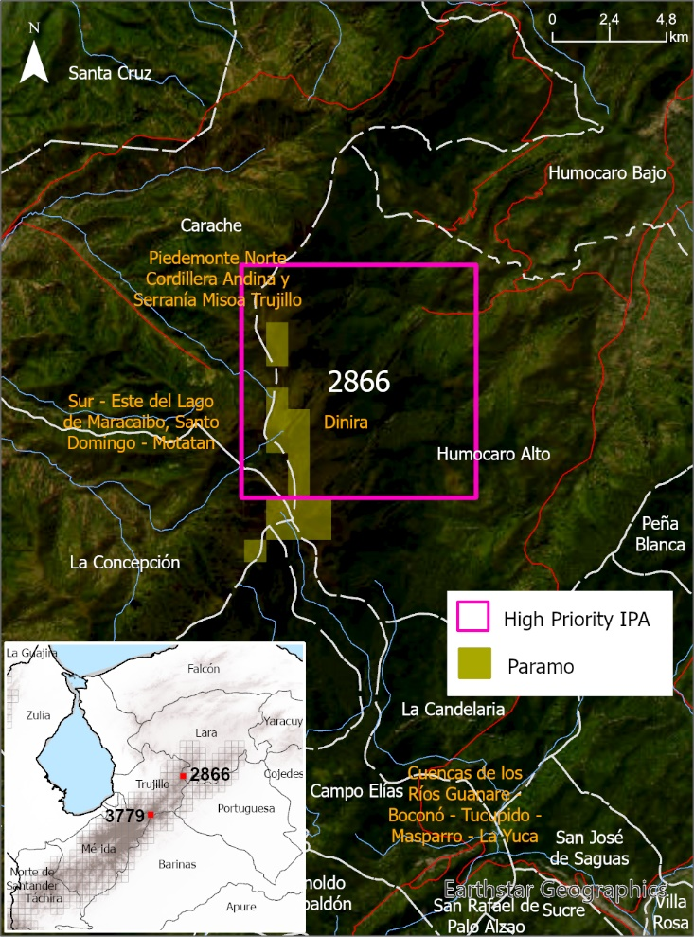  Basemap Esri – World Imagery. Grupo Ingeolan C.A., Esri, HERE, Garmin, FAO, NOAA, USGS; Earthstar Geographics; Esri, USGS. | UA High Priority – 2866  Technical description  Area Páramos in IPAS: 21,58 km²  Country: Venezuela. Sierra Nevada.  Administrative region:  - Municipio Morán, Parroquia Humocaro Alto, Estado Lara.  - Municipio Carache, Parroquia Carache, Estado Trujillo  Closet urban area: Carache  Ecological unit: Andean Páramo
Accepted species that met the threshold of each criterion | cA1 | cA3 | cA4 | cA5 | cB
Carramboa trujillensis | Yes |  |  |  | Yes
Espeletia ulotricha |  |  | Yes | Yes | Yes
Libanothamnus arboreus | Yes |  |  |  | Yes
Libanothamnus liscanoanus | Yes |  |  |  | Yes
Libanothamnus parvulus |  |  | Yes | Yes | Yes
Ruilopezia emmanuelis |  |  | Yes | Yes | Yes

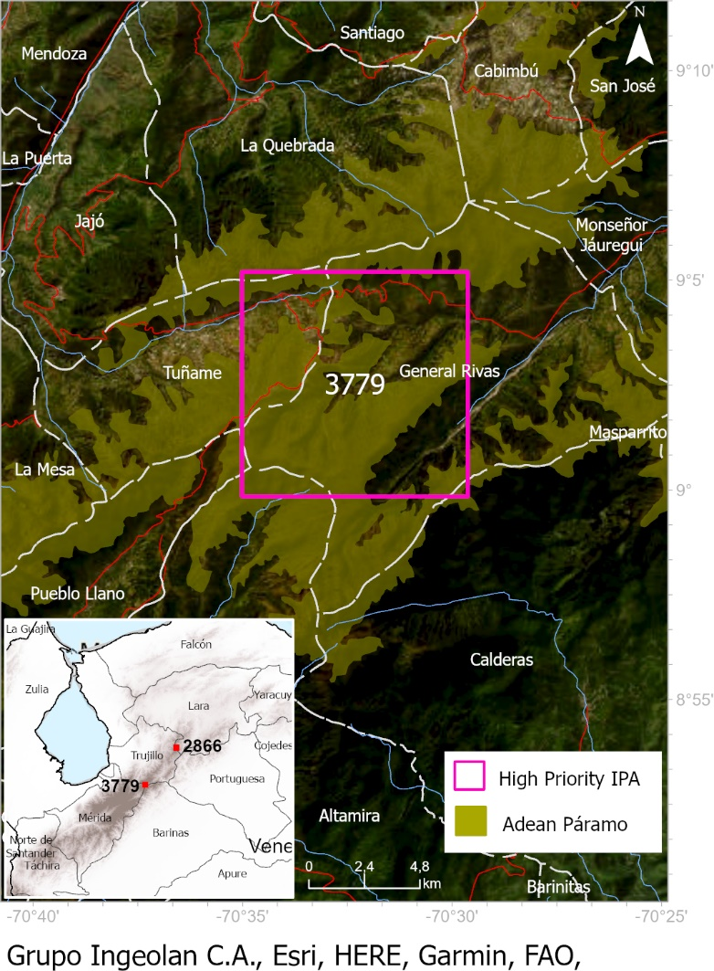  Grupo Ingeolan C.A., Esri, HERE, Garmin, FAO, NOAA, USGS; Earthstar Geographics; Esri, USGS. | UA High Priority – 3779  Technical description  Area Páramos in IPAS: 58,31 km²  Country: Venezuela. Sierra Nevada.  Administrative region:  - Municipio Boconó, Parroquia General Rivas, Estado Trujillo.  - Municipio Urdaneta, Parroquia Tuñame, Estado Trujillo.  - Municipio Cardenal Quintero, Parroquia Las Piedras, Estado Mérida.  Closet urban area: La Puerta, Jajó, Tuñame, Pueblo Llano  Ecological unit: Andean Páramo  Ecosystem: Cool Temperate Moist Grassland on Mountains
Accepted species that met the threshold of each criterion | cA1 | cA3 | cA4 | cA5 | cB
Espeletia marthae |  |  | Yes | Yes | Yes
Espeletia schultzii |  |  |  |  | Yes
Espeletia tenorae |  |  | Yes | Yes | Yes
Espeletia weddellii |  |  |  |  | Yes
Libanothamnus arboreus | Yes |  |  |  | Yes
Libanothamnus banksiifolius |  |  | Yes | Yes | Yes
Ruilopezia bracteosa |  |  |  |  | Yes
Ruilopezia floccosa |  |  |  |  | Yes

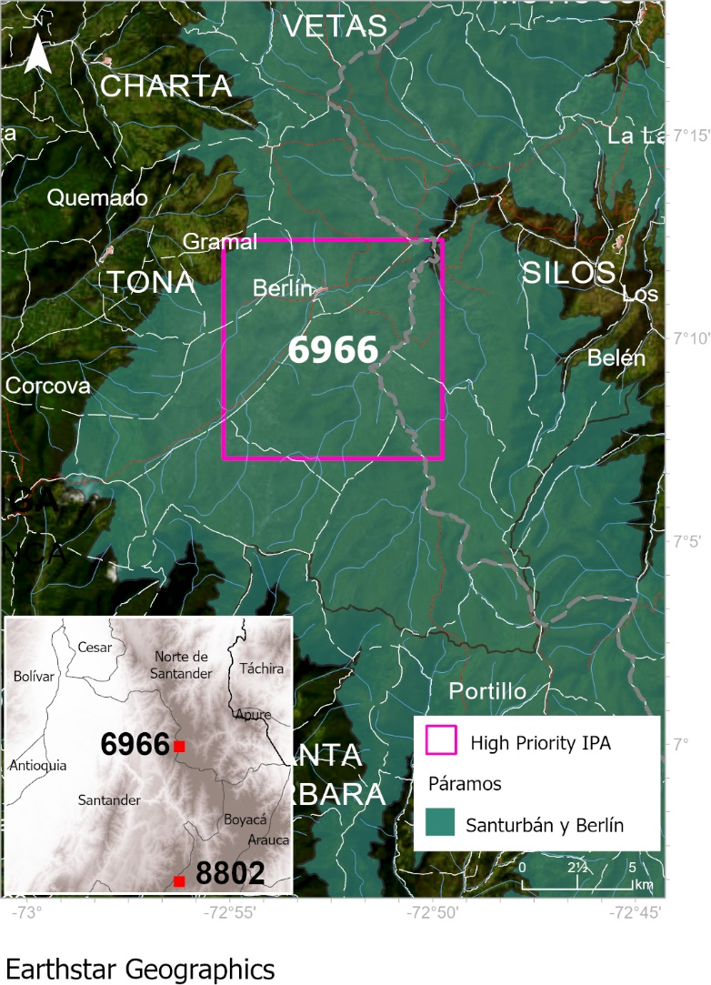  Grupo Ingeolan C.A., Esri, HERE, Garmin, FAO, NOAA, USGS; Earthstar Geographics; Esri, USGS | UA High Priority – 6966  Technical description  Area Páramos in IPAS: 99,13 km²  Country: Colombia. Eastern Cordillera.  Administrative region:  - Departamento Santander. Veredas Saladito, Ucatá, Tembladal y Cuesta Boba.  - Departamento Norte de Santander. Veredas Antala y Leuta.  Closet urban area: Berlín  Ecological unit: Complex: Santurbán y Berlín  Ecosystem: Cool Temperate Moist Grassland on Mountains
Accepted species that met the threshold of each criterion | cA1 | cA3 | cA4 | cA5 | cB
Espeletia brassicoidea | Yes |  |  |  | Yes
Espeletia conglomerata | Yes |  |  |  | Yes
Espeletia estanislana | Yes |  |  |  | Yes
Espeletia rositae | Yes | Yes |  |  | Yes
Espeletia standleyana | Yes | Yes |  |  | Yes
Espeletiopsis caldasii | Yes | Yes |  |  | Yes
Espeletiopsis corymbosa |  |  |  |  | Yes
Espeletiopsis funckii | Yes |  |  |  | Yes
Espeletiopsis santanderensis |  |  |  |  | Yes

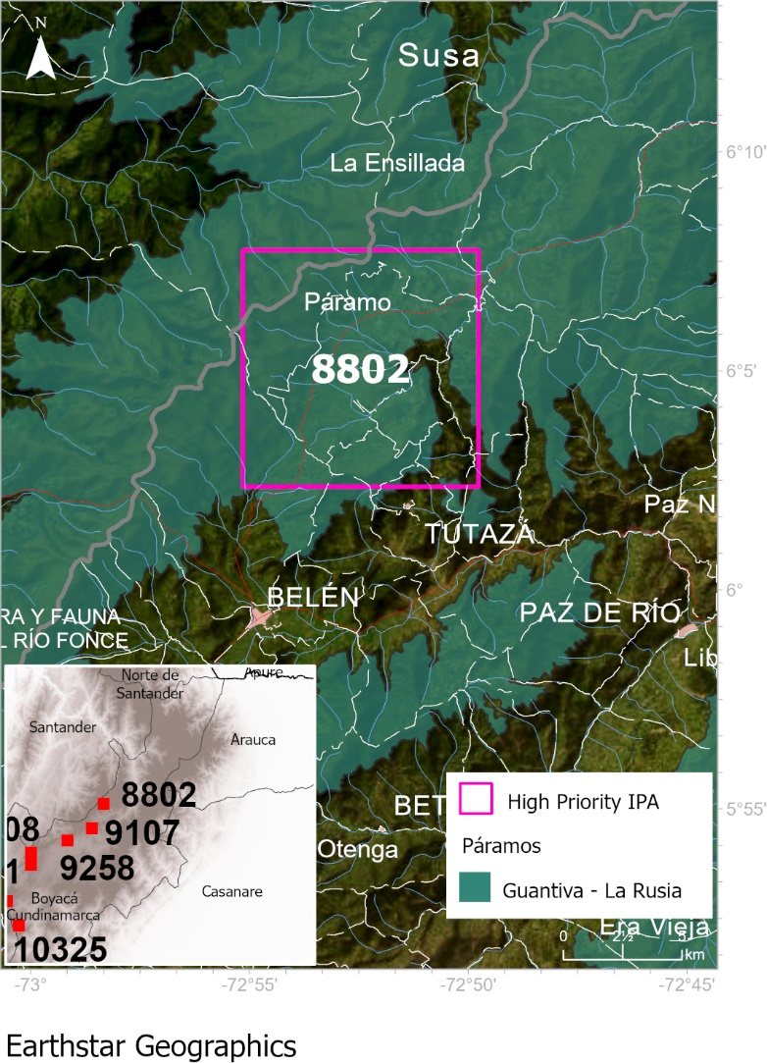  Grupo Ingeolan C.A., Esri, HERE, Garmin, FAO, NOAA, USGS; Earthstar Geographics; Esri, USGS | UA High Priority – 8802  Technical description  Area Páramos in IPAS: 89,39 km²  Country: Colombia. Eastern Cordillera.  Administrative region:  - Departamento Santander. Municipio Coromoro. Vereda Ture.  - Departamento Boyacá. Veredas Páramo, Llano del Carmen, Tobal, Carrizal, Peña Negra, Cartavita y Pargua.  Closet urban area: Tutazá  Ecological unit: Complex: Guantiva - La Rusia  Ecosystem: Cool Temperate Moist Grassland on Mountains
Accepted species that met the threshold of each criterion | cA1 | cA3 | cA4 | cA5 | cB
Espeletia arbelaezii | Yes |  |  |  | Yes
Espeletia argentea |  |  |  |  | Yes
Espeletia azucarina | Yes | Yes | Yes | Yes | Yes
Espeletia brachyaxiantha | Yes |  |  |  | Yes
Espeletia congestiflora |  |  |  |  | Yes
Espeletia discoidea | Yes | Yes | Yes | Yes | Yes
Espeletia rositae | Yes | Yes |  |  | Yes

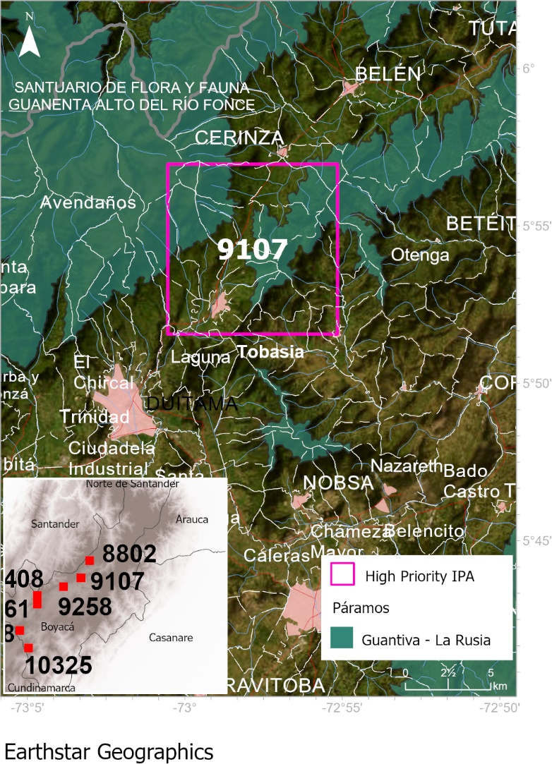  Grupo Ingeolan C.A., Esri, HERE, Garmin, FAO, NOAA, USGS; Earthstar Geographics; Esri, USGS | UA High Priority – 9107  Technical description  Area Páramos in IPAS: 38,6 km²  Country: Colombia. Eastern Cordillera.  Administrative region:  - Departamento de Boyacá. Some Veredas: Quebrada arriba, El Olivo, Siraquita, Egipto, Portachuelo.  Closet urban area: Duitama  Ecological unit: Complex: Guantiva - La Rusia  Ecosystem: Cool Temperate Moist Grassland on Mountains
Accepted species that met the threshold of each criterion | cA1 | cA3 | cA4 | cA5 | cB
Espeletia arbelaezii | Yes |  |  |  | Yes
Espeletia boyacensis |  |  |  |  | Yes
Espeletia brachyaxiantha | Yes | Yes |  |  | Yes
Espeletia congestiflora |  |  |  |  | Yes
Espeletia incana | Yes |  |  |  | Yes
Espeletia murilloi |  |  |  |  | Yes
Espeletia nemekenei | Yes |  |  |  | Yes
Espeletia tunjana | Yes |  |  |  | Yes
Espeletiopsis guacharaca |  |  |  |  | Yes
Espeletiopsis muiska |  |  |  |  | Yes
Paramiflos glandulosus | Yes |  |  |  | Yes

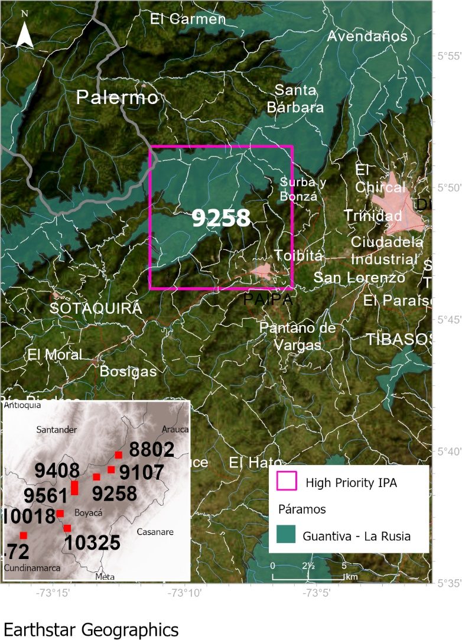  Grupo Ingeolan C.A., Esri, HERE, Garmin, FAO, NOAA, USGS; Earthstar Geographics; Esri, USGS | UA High Priority – 9258  Technical description  Area Páramos in IPAS: 54,08 km²  Country: Colombia. Eastern Cordillera  Administrative region:  - Departamento de Boyacá. Some Veredas: Carrizal Alto, Carrizal, La Bolsa, Marcura, Medios.  Closet urban area: Paipa  Ecological unit: Complex: Guantiva - La Rusia  Ecosystem: Cool Temperate Moist Grassland on Mountains
Accepted species that met the threshold of each criterion | cA1 | cA3 | cA4 | cA5 | cB
Espeletia arbelaezii | Yes |  |  |  | Yes
Espeletia boyacensis |  |  |  |  | Yes
Espeletia cachaluensis | Yes | Yes |  |  | Yes
Espeletia congestiflora |  |  |  |  | Yes
Espeletia incana | Yes | Yes |  |  | Yes
Espeletia murilloi |  |  |  |  | Yes
Espeletia nemekenei | Yes | Yes |  |  | Yes
Espeletia paipana | Yes | Yes | Yes | Yes | Yes
Espeletia tunjana | Yes |  |  |  | Yes
Espeletiopsis corymbosa |  |  |  |  | Yes
Espeletiopsis guacharaca |  |  |  |  | Yes
Espeletiopsis jimenez-quesadae | Yes |  |  |  | Yes
Espeletiopsis muiska |  |  |  |  | Yes
Espeletiopsis pleiochasia |  |  |  |  | Yes
Paramiflos glandulosus | Yes |  |  |  | Yes

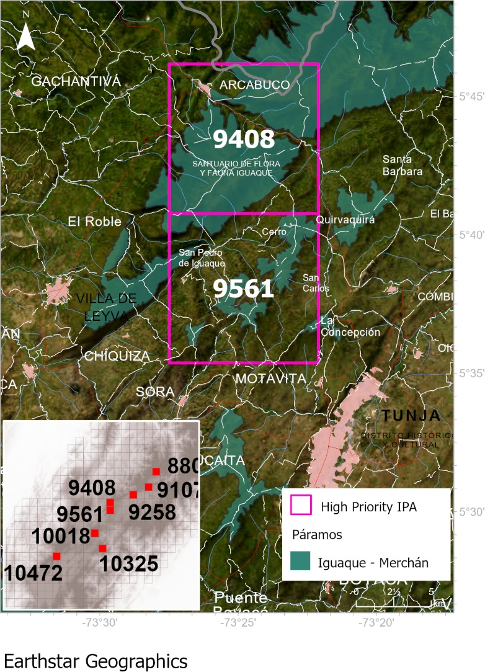  Grupo Ingeolan C.A., Esri, HERE, Garmin, FAO, NOAA, USGS; Earthstar Geographics; Esri, USGS | UA High Priority – 9408  Technical description  Area Páramos in IPAS: 63,60 km²  Country: Colombia. Eastern Cordillera  Administrative region:  - Departamento de Santander. Municipio de Gámbita, Vereda de Guausa.  - Departamento de Boyacá. Some Veredas: Centro, Rupavita, El Cerro, Quirbaquirá, Santa Barbara.  Closet urban area: Arcabuco  Ecological unit: Complex: Iguaque - Merchán  Ecosystem: Cool Temperate Moist Grassland on Mountains
Accepted species that met the threshold of each criterion | cA1 | cA3 | cA4 | cA5 | cB
Espeletia arbelaezii | Yes | Yes |  |  | Yes
Espeletia barclayana |  |  |  |  | Yes
Espeletia boyacensis |  |  |  |  | Yes
Espeletia murilloi |  |  |  |  | Yes
Espeletia nemekenei | Yes | Yes |  |  | Yes
Espeletia tunjana | Yes | Yes |  |  | Yes
Espeletiopsis corymbosa |  |  |  |  | Yes
Espeletiopsis garciae | Yes |  |  |  | Yes
Espeletiopsis muiska |  |  |  |  | Yes
Paramiflos glandulosus | Yes | Yes |  |  | Yes

Grupo Ingeolan C.A., Esri, HERE, Garmin, FAO, NOAA, USGS; Earthstar Geographics; Esri, USGS | UA High Priority – 9561  Technical description  Area Páramos in IPAS: 23,03 km²  Country: Colombia. Eastern Cordillera  Administrative region:  - Departamento de Boyacá. Some Veredas: Sote, Carrizal, Corregidor, Llano Grande, Patiecitos, Turmal.  Closet urban area: San Pedro De Iguaque  Ecological unit: Complex: Iguaque - Merchán  Ecosystem: Cool Temperate Moist Grassland on Mountains
Accepted species that met the threshold of each criterion | cA1 | cA3 | cA4 | cA5 | cB
Espeletia barclayana |  |  |  |  | Yes
Espeletia boyacensis |  |  |  |  | Yes
Espeletia cayetana | Yes | Yes |  |  | Yes
Espeletia grandiflora |  |  |  |  | Yes
Espeletia incana | Yes |  |  |  | Yes
Espeletia murilloi |  |  |  |  | Yes
Espeletiopsis garciae | Yes |  |  |  | Yes
Espeletiopsis guacharaca |  |  |  |  | Yes
Espeletiopsis jimenez-quesadae | Yes |  |  |  | Yes
Espeletiopsis pleiochasia |  |  |  |  | Yes
Paramiflos glandulosus | Yes |  |  |  | Yes

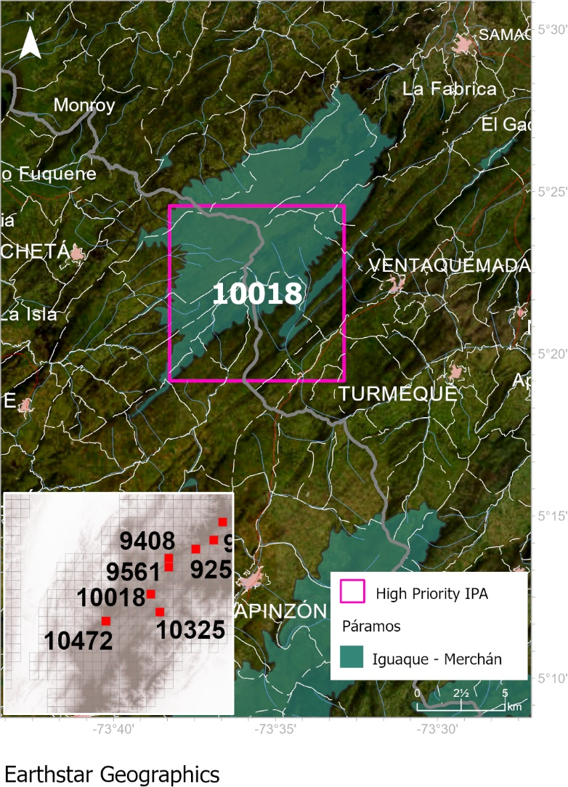  Grupo Ingeolan C.A., Esri, HERE, Garmin, FAO, NOAA, USGS; Earthstar Geographics; Esri, USGS | UA High Priority – 10018  Technical description  Area Páramos in IPAS: 63,51 km²  Country: Colombia. Eastern Cordillera  Administrative region:  - Departamento de Cundinamarca. Some Veredas: San Antonio, Peñas, Tabita El Carmen, Gachaneca.  - Departamento de Boyacá. Some Veredas: Boqueron, Parroquia Vieja, Estancia Grande.  Closet urban area: Guachetá, Ventaquemada, Turmeque  Ecological unit: Complex: Iguaque - Merchán  Ecosystem: Cool Temperate Moist Grassland on Mountains
Accepted species that met the threshold of each criterion | cA1 | cA3 | cA4 | cA5 | cB
Espeletia argentea |  |  |  |  | Yes
Espeletia barclayana |  |  |  |  | Yes
Espeletia boyacensis |  |  |  |  | Yes
Espeletia congestiflora |  |  |  |  | Yes
Espeletia killipii |  |  |  |  | Yes
Espeletia murilloi |  |  |  |  | Yes
Espeletia raquirensis | Yes | Yes | Yes | Yes | Yes
Espeletiopsis corymbosa |  |  |  |  | Yes
Espeletiopsis guacharaca |  |  |  |  | Yes
Espeletiopsis pleiochasia |  |  |  |  | Yes
Espeletiopsis rabanalensis | Yes | Yes |  |  | Yes

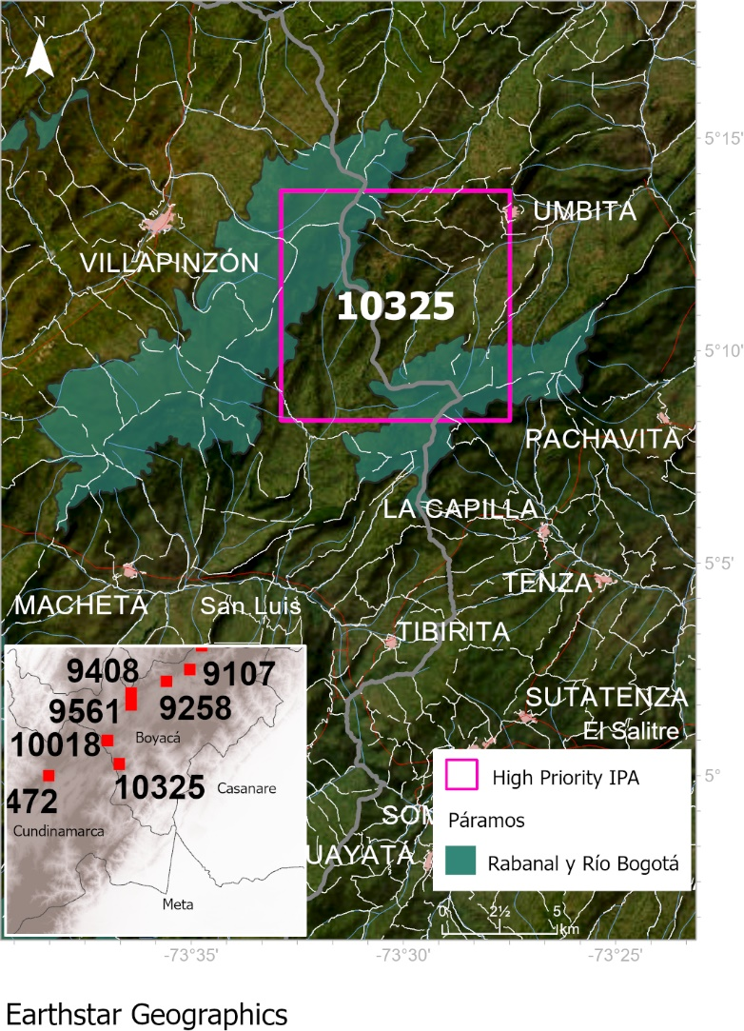  Grupo Ingeolan C.A., Esri, HERE, Garmin, FAO, NOAA, USGS; Earthstar Geographics; Esri, USGS | UA High Priority – 10325  Technical description  Area Páramos in IPAS: 34,57 km²  Country: Colombia. Eastern Cordillera  Administrative region:  - Departamento de Cundinamarca. Some Veredas: Soatama, Chasquez, La Merced.  - Departamento de Boyacá. Some Veredas: Loma Gorda, Jupal, Bosque, Rosal.  Closet urban area: Úmbita  Ecological unit: Complex: Rabanal y Río Bogotá  Ecosystem: Cool Temperate Moist Grassland on Mountains
Accepted species that met the threshold of each criterion | cA1 | cA3 | cA4 | cA5 | cB
Espeletia arbelaezii | Yes |  |  |  | Yes
Espeletia argentea |  |  |  |  | Yes
Espeletia barclayana |  |  |  |  | Yes
Espeletia chocontana | Yes | Yes |  |  | Yes
Espeletia murilloi |  |  |  |  | Yes
Espeletiopsis corymbosa |  |  |  |  | Yes
Espeletiopsis rabanalensis | Yes | Yes |  |  | Yes

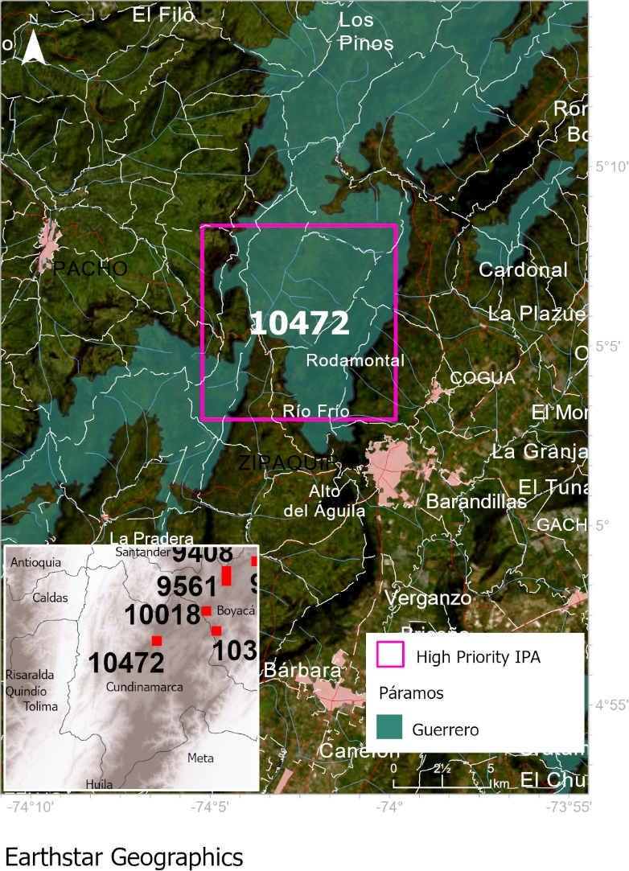  Grupo Ingeolan C.A., Esri, HERE, Garmin, FAO, NOAA, USGS; Earthstar Geographics; Esri, USGS | UA High Priority – 10472  Technical description  Area Páramos in IPAS: 69,01 km2  Country: Colombia. Eastern Cordillera  Administrative region:  - Departamento de Cundinamarca. Some Veredas: Páramo de Guerrero, Ventalarga, El Empaladizo, Rodamontal, Páramo Alto.  Closet urban area: Zipaquirá  Ecological unit: Complex: Guerrero  Ecosystem: Cool Temperate Moist Grassland on Mountains
Accepted species that met the threshold of each criterion | cA1 | cA3 | cA4 | cA5 | cB
Espeletia argentea |  |  |  |  | Yes
Espeletia barclayana |  |  |  |  | Yes
Espeletia cayetana | Yes |  |  |  | Yes
Espeletia chocontana | Yes |  |  |  | Yes
Espeletia grandiflora |  |  |  |  | Yes
Espeletiopsis corymbosa |  |  |  |  | Yes
Espeletiopsis garciae | Yes |  |  |  | Yes

