Supplementary Material
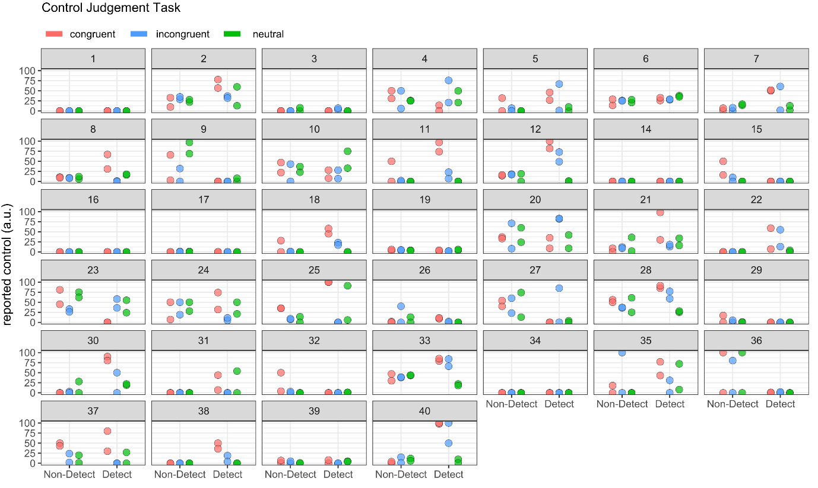Figure S1. Results for Experiment 1. Control Judgement Task. Plot depicting each control judgement (12 per participant) of each participant (N = 39), subdivided into congruent, incongruent, neutral (colored) and visible versus non-visible priming conditions.
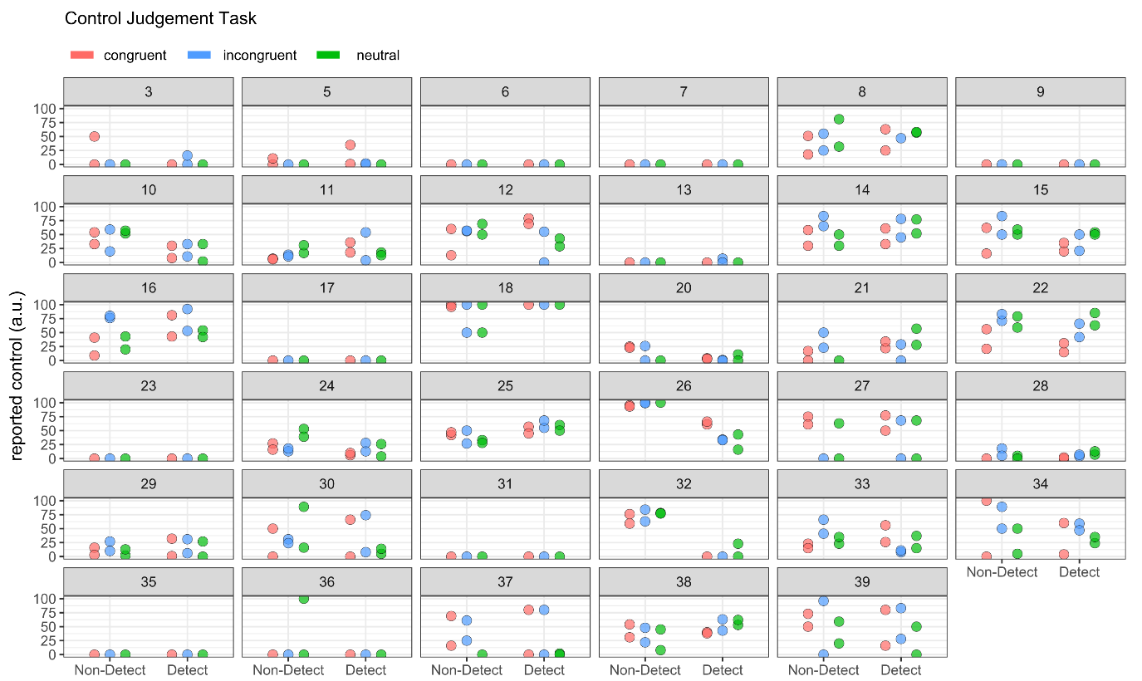Figure S2. Results for Experiment 2. Control Judgement Task. Plot depicting each control judgement (12 per participant) of each participant (N = 35), subdivided into congruent, incongruent, neutral (colored) and visible versus non-visible priming conditions.
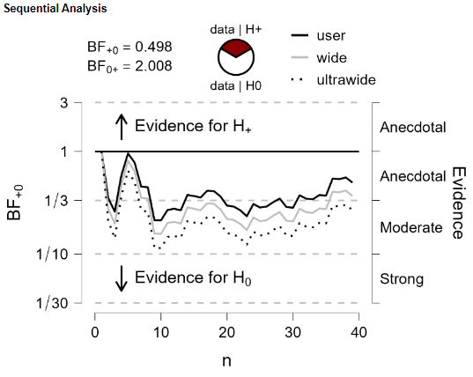
Figure S3. Experiment 1. Sequential BF analysis of the reported amount of control between the conditions "prime unaware - congruent" and "prime unaware - neutral", using a one-sided Bayesian paired t-test in JASP 0.16.3 (prior: default Cauchy prior with the scale parameter r = .707).

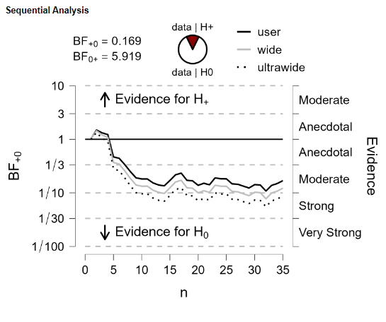
Figure S4. Experiment 2. Sequential BF analysis of the reported amount of control between the conditions "prime unaware - congruent" and "prime unaware - neutral", using a one-sided Bayesian paired t-test in JASP 0.16.3 (prior: default Cauchy prior with the scale parameter r = .707).

Table S1. Experiment 1: ANOVA table for Control Judgment Task. Results of the 2x3 repeated measures ANOVA (N=39) with factors “prime visibility” and “congruency”. The effect size parameter “pes” denotes the partial eta squared (η_{p}²). 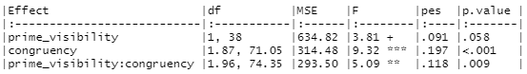

Table S2. Experiment 1: ANOVA table for Semantic Priming Task. Results of the 2x3 repeated measures ANOVA (N=39) with factors “prime visibility” and “congruency”. The effect size parameter “pes” denotes the partial eta squared (η_{p}²). 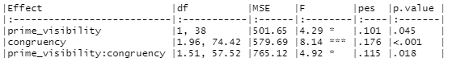

Table S3. Experiment 2: ANOVA table for Control Judgment Task. Results of the 2x3 repeated measures ANOVA (N=35) with factors “prime visibility” and “congruency”. The effect size parameter “pes” denotes the partial eta squared (η_{p}²). 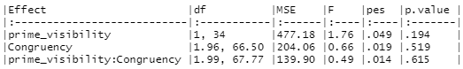

Table S4. Experiment 2: ANOVA table for Response Priming Task. Results of the 2x3 repeated measures ANOVA (N=35) with factors “prime visibility” and “congruency”. The effect size parameter “pes” denotes the partial eta squared (η_{p}²). 