SUPPLEMENTARY INFORMATION
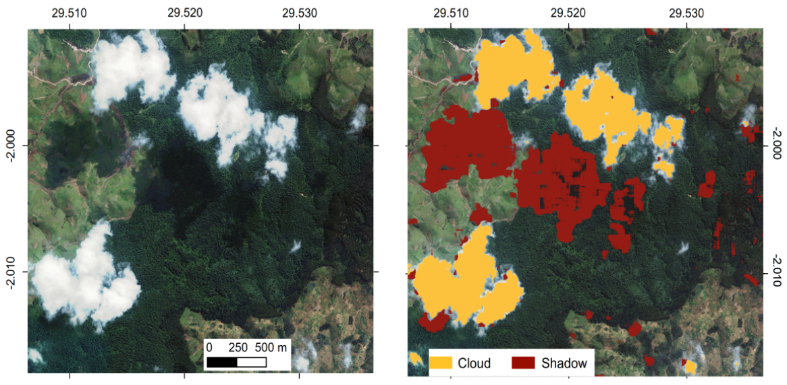
Supplementary Figure 1. Example of cloud and shadow detection and masking. A deep learning model was trained to detect areas covered by clouds and shadow in the 2019 satellite images. The detected cloudy and shadow pixels were then masked out of both the 2008 and 2019 images before further analyses, using overlay spatial analysis.

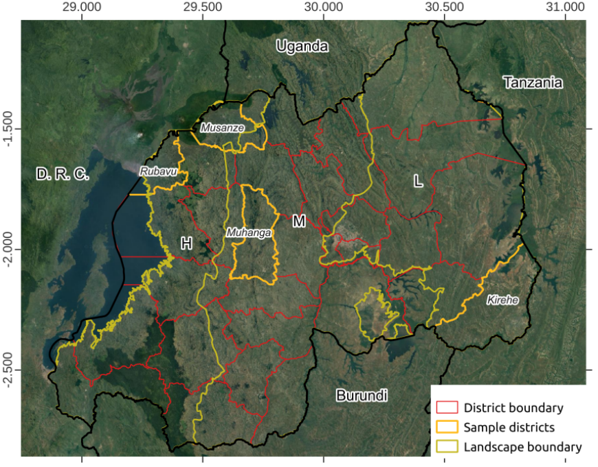
Supplementary Figure 2. Location of sample districts to analyse carbon gains in smallholder farms. We collected all (100%) plots in the districts (n=2,468,648) and selected only agricultural plots with at least one tree (n=942,081). The four sample districts (Rubavu in Western province of Rwanda, Musanze in Northern province, Muhanga in Southern province, and Kirehe in Eastern province) represent the three major landscapes of the country, H: Highlands, M: Midlands, L: Lowlands.

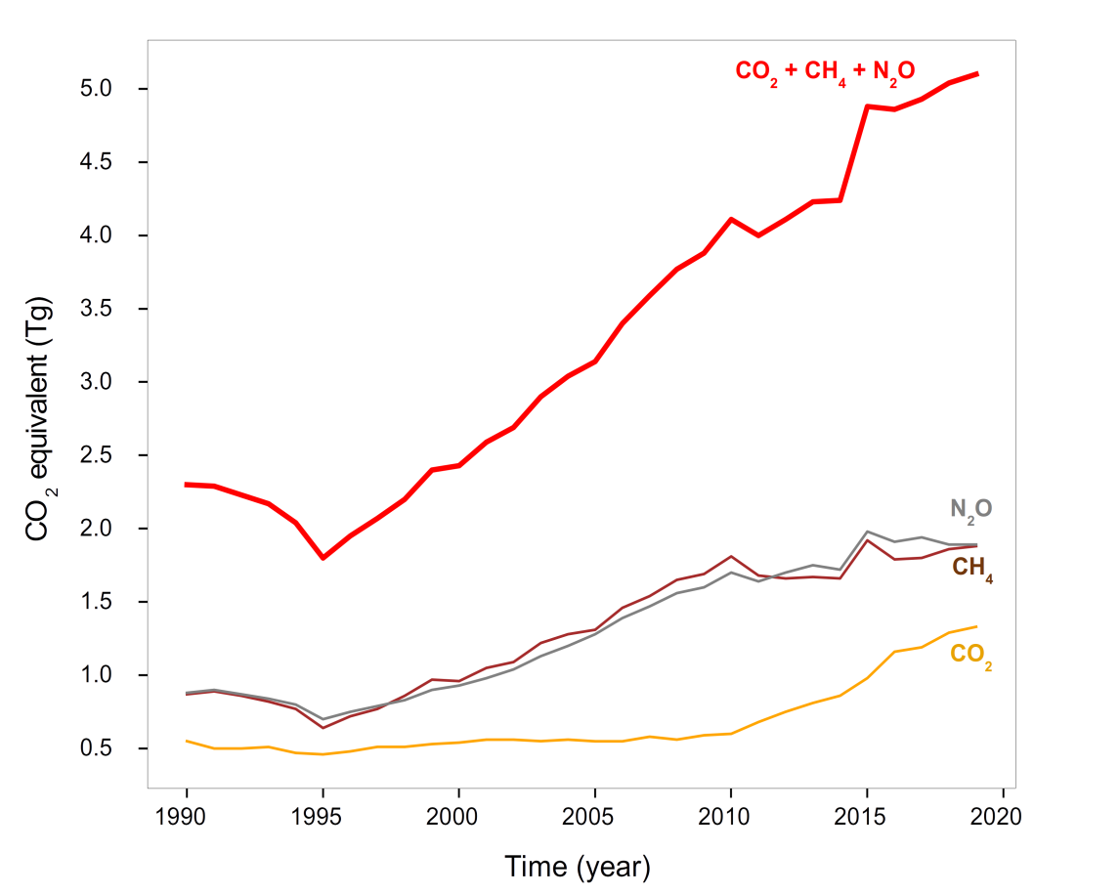
Supplementary Figure 3. Historical greenhouse gas emissions (CO₂ equivalent) of Rwanda since 1990. The data is from ref.⁴⁷. CO₂ emissions are mainly from the burning of fossil fuels and the cement manufacturing (produced, especially, during consumption of solid, liquid, and gas fuels and gas flaring). Methane (CH₄) emissions area from anthropocentric activities especially agriculture and industrial methane production (here presented in CO₂ equivalent units). Nitrous oxide (N₂O) emissions are mainly from the burning of agricultural biomass, industrial activities, and livestock management (here presented in CO₂ equivalent units).
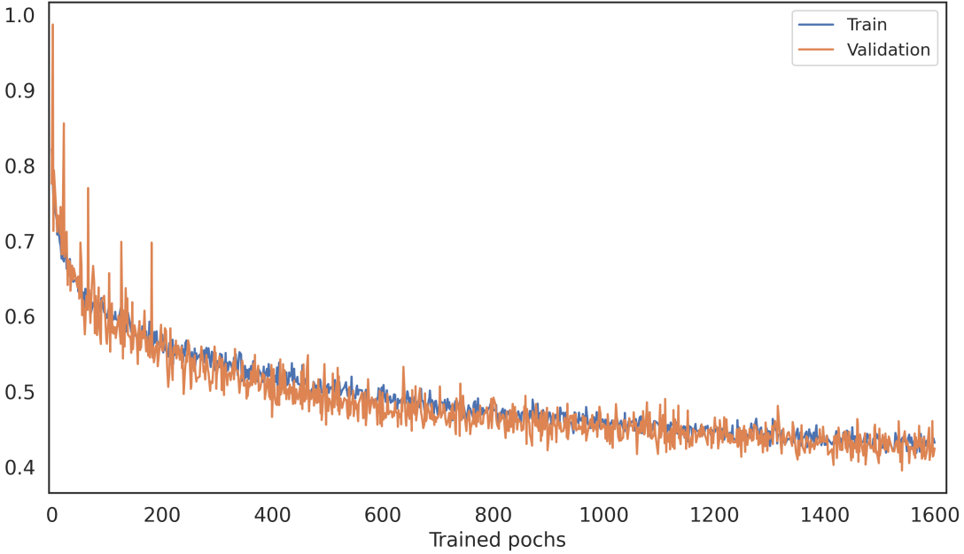
Supplementary Figure 4. The changes in loss values for both training and validation samples during a training session for a cloud detection and segmentation deep learning model. The decrease in loss values indicate a lack of overfitting.

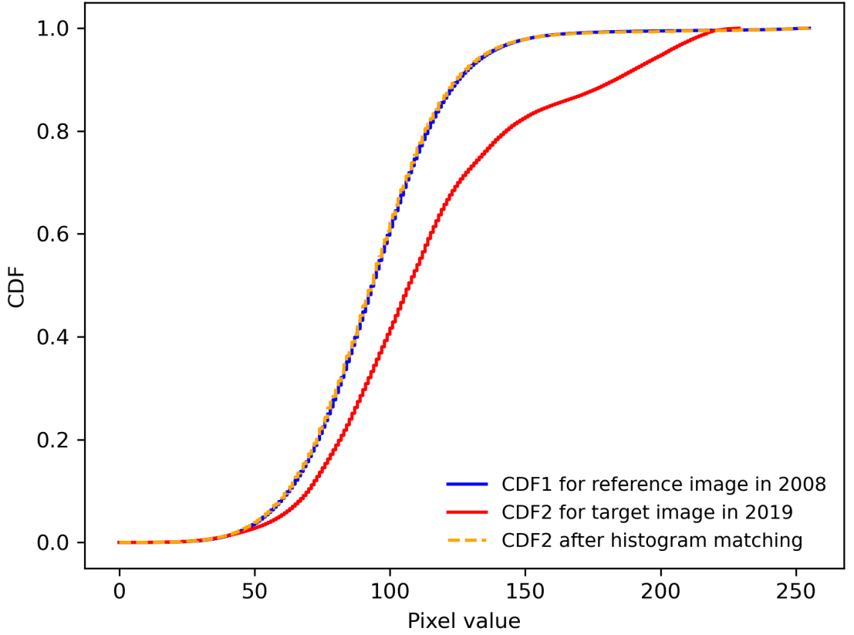
Supplementary Figure 5. An example of the Cumulative Distribution Function (CDF) of pixel values from an image composed of 202,514,256 pixels in 2008 (after adjusting to 50 cm spatial resolution), and the CDF of the corresponding pixels of a target image in 2019 before and after histogram matching.

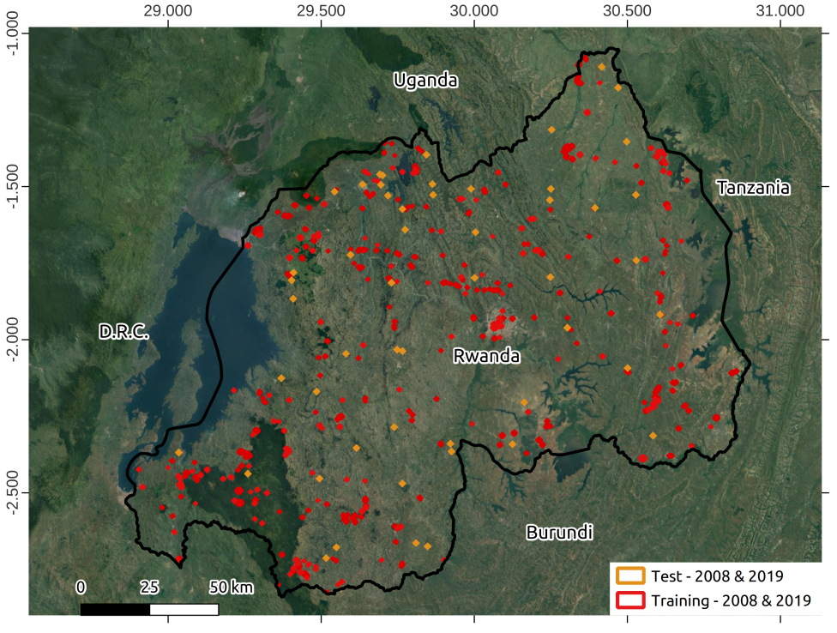
Supplementary Figure 6. Location of areas for manual data labels/training for 2008 (n=207 areas covering about 1,698.8 ha, split into 4,039 patches with a size of 256 x 256 pixels); and areas for manual data labels for 2019 (n=400 covering about 3,133.9 ha, split into 7,390 patches with a size of 256 x 256 for 2019). Independent test dataset for 2008 is composed of 52 areas of 1 ha each containing 6,639 manually delineated tree crowns; while the test set for 2019 is composed also of 52 areas with 10,667 manually delineated tree crowns. Background map:
Google Earth satellite basemaps.

Supplementary Information | Location and distribution of sample plots and sampling strategy
Fieldwork was conducted in 10 Districts of Eastern province and peri-urban of Kigali in different agroforestry systems. Overall, 365 field plots were randomly sampled across the area. The spatial distribution of the sample plots is illustrated in the following Supplementary Figure 7.
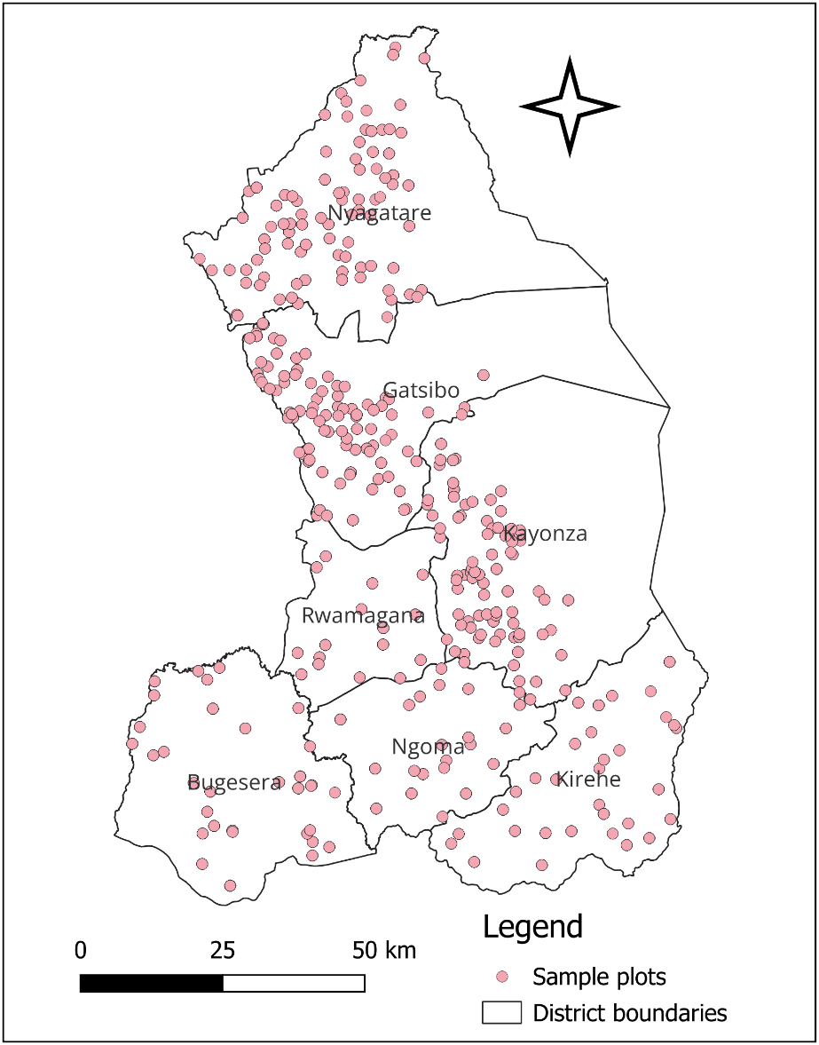
Supplementary Figure 7. Sample plot distribution in agroforestry landscapes and degraded forests of the Eastern province and peri-urban Kigali city in Rwanda. The number in the map indicates the number of sample plots.

Sample plots demarcation and tree marking

The standard sample plots used are circular shaped with a radius of 40 m (equivalent to 0.5 ha). The location information of the plots was recorded GPS or GPS-enabled tablets. The plot boundaries were marked by a red paint for identification, and any tree with a centre point at DBH level falling outside of the plot was excluded from measurements.

Data recording

The collected data were recorded using Open Data Kit (ODK) tool incorporated in the tablets for plot and tree characteristics, tree growth measurements with DBH ≥ 5cm within sample plots. The data recorded were general description of the area included geographic coordinates and administrative locations (province, sector, cell, village), latitude, longitude, altitude; topographic information (slope %), slope orientation and soil type, soil erosion, land ownership; tree age; tree canopy density; vegetation cover; litter cover; human activities (fire evidence, grazing, wood harvesting). For tree growth measurements, the following data were collected:tree number, species name, species code, tree origin, tree position, reference diameter (DBH) in cm and total height (m). The following Supplementary Table 1 provides description for the recorded information.

Recorded tree measurements

Diameter at Breast Height (DBH)

Diameter at breast height above the bark (DBH), at a point 1.3 m above ground level in full centimeter approximation was measured for all sampled trees, with a diameter tape (cm). A straight measuring stick of 1.3 m was utilized to assure homogeneity and accuracy of the point of measurement.

Position for correct DBH measurement and particular situation were respected as: if tree forks immediately above breast height, the tree was counted as a single tree and DBH was measured just under any swelling that could inflate the DBH. In this case coppice was considered in the same way as forked trees. Coppice shoots originating below 1.3 m were measured as a single tree; if a tree forks below breast height, the stems are considered as separate trees and recorded separately; if bulges, swellings, depressions, branches or other abnormalities occur at breast height, the DBH was measured just below or above the abnormality at a point where it ceases to affect normal stem form, and computed as the average of the two measurements.

Total height

Total height (H) in m was measured in full meters approximation for three trees within every sample plot. The closest tree to the plot center, the trees with the smallest and with the largest DBH were measured. The total tree height was measured by using Silver and Haga clinometers.

Tree crown canopy measurement

The ellipse representing a tree crown canopy with long diameter (LD) and short diameter (SD) were measured. In the field, the measurement was measured using meter tape by standing at the edge of crown pulling measuring tape (or laying it on the ground to avoid that it bends), and record the distances (both SD and LD) in centimeters. More tree measurements recorded on the field include GPS location of a tree, and management techniques.

