Extended Data | Table 1. Evaluation with field data and error propagation. Different sources of uncertainty and how they were evaluated and quantified (source: ref.³²).
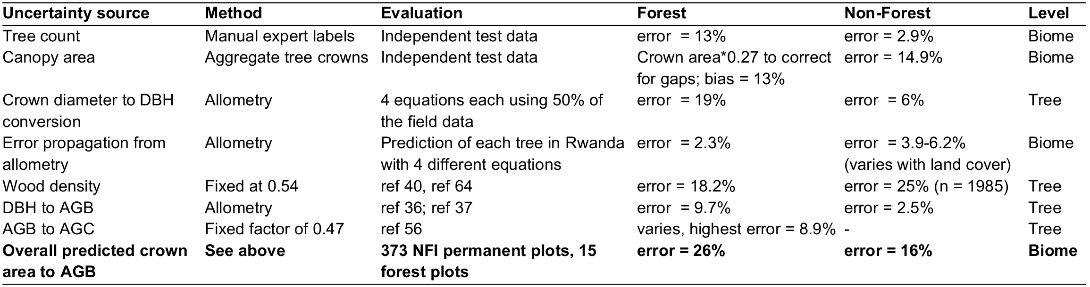

Extended data | Table 2. Different scenarios for optimal contribution of agroforestry to the net zero emissions target in Rwanda
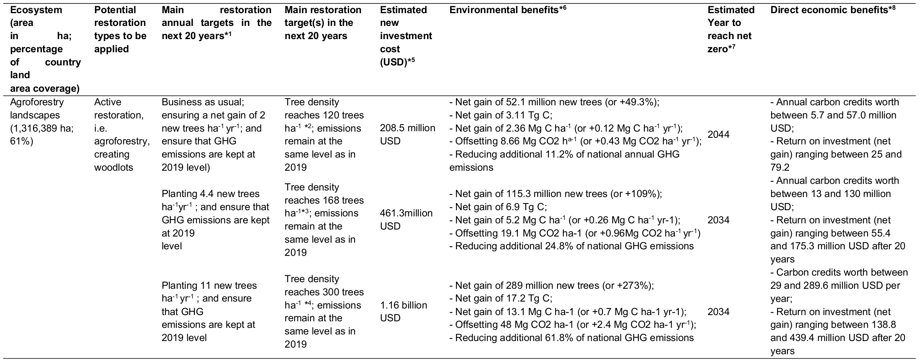
*¹ Restoration targets are based on ref.³⁸, and ref.²². *² The target tree density is a density that could be attained in a 20-year period by keeping the same pace observed in this study. *³ The target tree density is the maximum on-farm tree density observed in a survey from 457 farm plots surveyed in 2007 and 2008 across all the 3 major altitudinal gradients of Rwanda (44; 45). *⁴ The target tree density is the optimal on-farm tree density recommended by the Ministry of Environment of Rwanda to optimise both restoration and food security benefits from the country's agricultural plots (38). *⁵ We use the restoration cost ha⁻¹ estimated by the ministry of environment of Rwanda in 2014: about 1,200 USD required to restore 1 ha in farmlands of Rwanda to reach a density of 300 trees ha⁻¹ in a 20-year period, while leaving enough space for crops (38). *⁶ The environmental benefits are estimated by the approach from both this study and one adapted from ref.³². *⁷ The year when tree cover could maximally contribute to country’s net zero emissions target of the GHG emissions remain at the same levels as in 2019. Note that we assume no net gain until 10 years after plantation to ensure uncompromised carbon sink in a forest during the growth (Mill et al. 2023). *⁸ We estimate the value of carbon credits using the range of 10 to 100 USD per tonne of CO₂ (or 1 Mg CO₂) according to ref.⁴⁰; ref.⁴¹; and ref.⁴²). The high cost range is due to the current high volatility and speculations in the carbon market (41). Note that all of the scenarios presented here would have the same baseline. The baseline includes all actions and effort already carried out, which would lay a foundation for the start of the suggested scenarios. Examples include: investment of about 530.7 million USD that the government of Rwanda has invested in 44 known restoration projects from 2011 up to 2018, which brought over 700 thousand hectares of land under restoration²²; policies in place to support the restoration scenarios such as: the “Green Growth and Climate Resilience Strategy”, through which the country has committed to reduce 38% of the current emissions by 2030²⁴; commitment to restore 2 million hectares by 2030 under RED+; among others.

Extended data | Table 3. Different scenarios for optimal contribution of degraded natural forests to the net zero emissions target in Rwanda
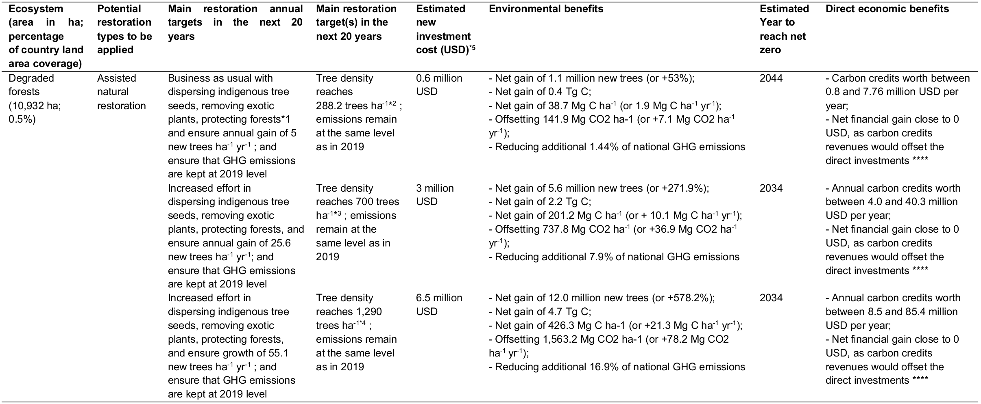
*¹ These are some of the restoration activities that have been implemented in the past in restoring degraded natural forests in Rwanda²⁸. *² The target tree density is a density that could be attained in a 20-year period by continuing the assisted natural regeneration in degraded forest and ensure growth of at least 5 trees ha⁻¹ yr⁻¹ during the restoration period, as it has been observed during the period between 2008 and 2019 by this study. *³ The target density is 70% (survival rate) of the recommended average number of trees to plant for an optimal forest restoration in the tropics (ref.³⁹). *⁴ The target density is 70% (survival rate) of the maximum number of trees with a diameter at breast height (DBH) smaller than 5 cm observed in 15 surveyed plots (plot size = 0.5 ha) in the African montane tropical rainforest in Rwanda in (46). *⁵ We use the recommended cost of about 375 USD to restore 1 ha of natural forests via regeneration in a 20-year period in Rwanda (38).

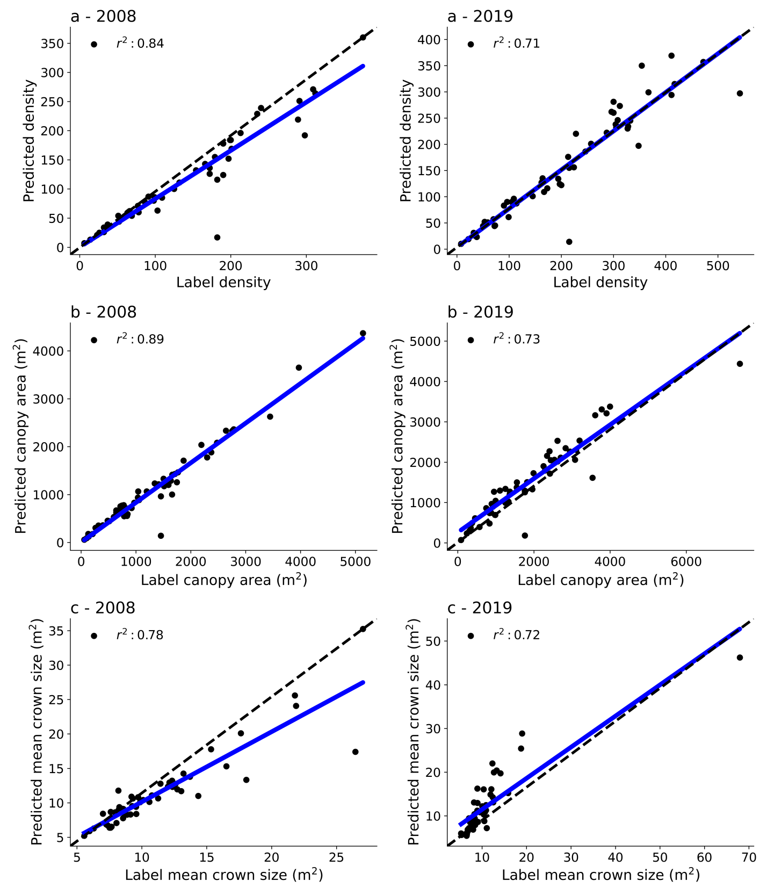
Extended Data Fig. 1 | Plot-level evaluation of tree crown segmentation model. We set aside 52 randomly selected patches containing 17,306 manual labels of individual trees (over 5% of the total manual labels) as an independent test set to select the best model. We compared the predictions and manual labels at each plot. a, Tree density for 2008 and 2019, b, canopy area for 2008 and 2019, c, mean crown size for 2008 and 2019. Each point represents one 100 x 100 m grid, n = 52.

Extended data | Table 4. Accuracy assessment of the deep learning tree segmentation model
a. Validating with independent test for 2008
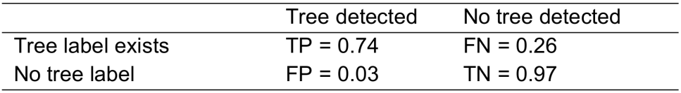

b. Validating with independent test for 2019
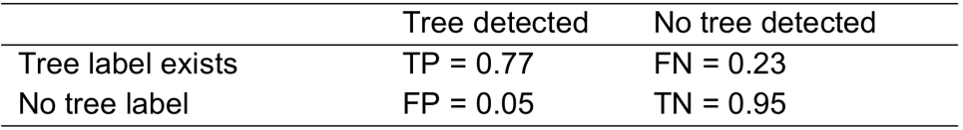

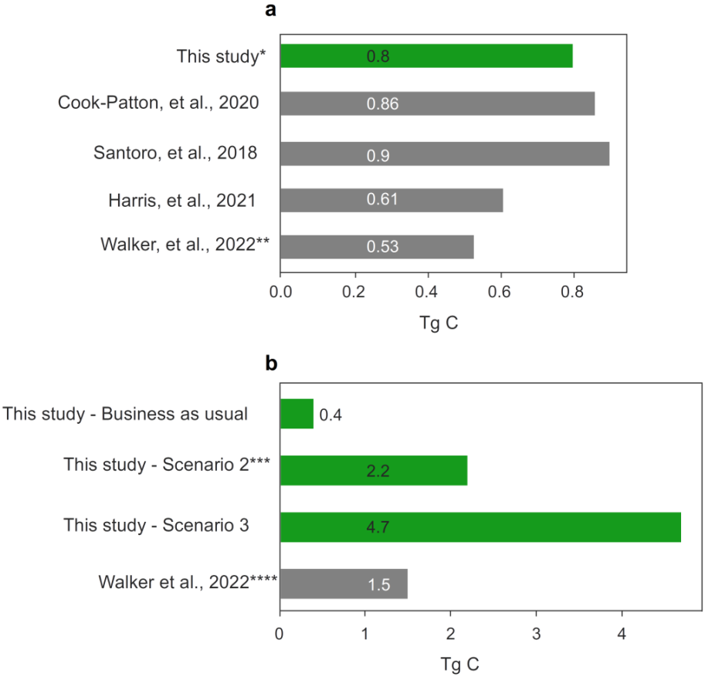
Extended Data Fig. 2 | Comparison of current and potential C stock estimates in degraded forests at country scale. a, Comparison of predicted total aboveground woody C stocks by this study and previous studies with global coverage. *We selected predictions for 2019. **We estimate C stock using the “Current (ca. 2016) aboveground biomass density (megagrams carbon per hectare) under baseline climate” from ref.⁴³. b, Comparison of potential aboveground C stock in degraded forests of Rwanda. We present values for three scenarios presented in this study (see Extended Data | Table 1) and compare them with potential C stock estimated from ref.⁴³. ***This is the scenario we recommend in this study. ****We estimate C stock using the “potential aboveground biomass density (megagrams carbon per hectare) under baseline climate” from ref.⁴³.

