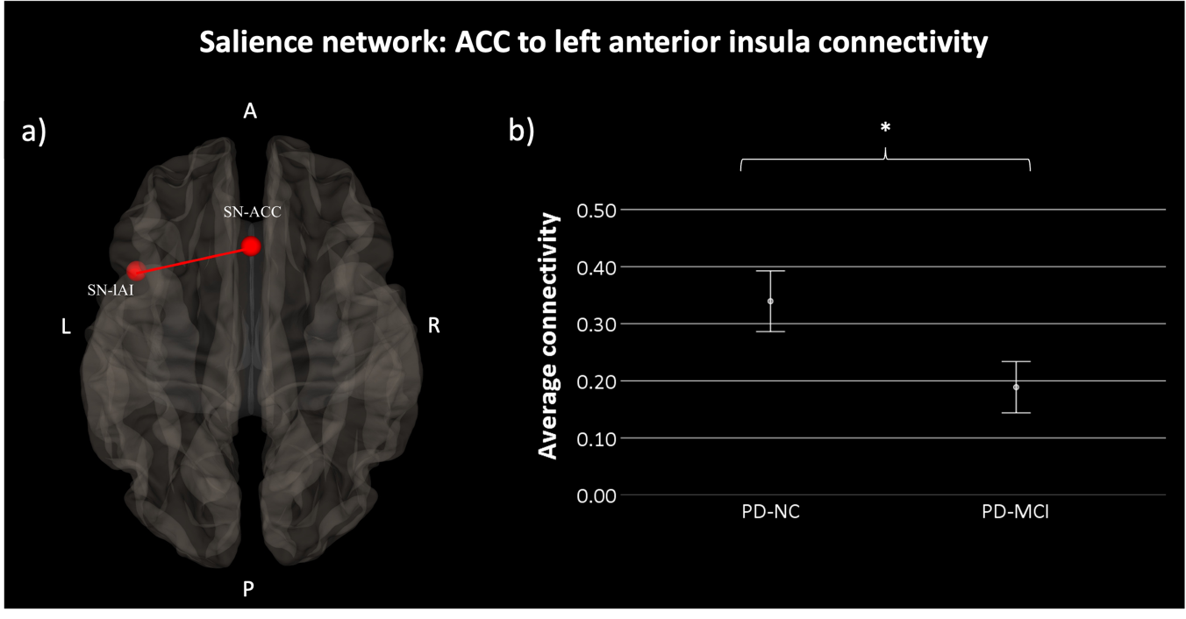
Supplementary figure 3. a) Anatomical localization of nodes of Salience Network-SN- Anterior Cingulate Cortex (x, y, z MNI coordinates: 0, 22, 35) and Left Anterior Insula (x, y, z MNI coordinates: -44, 13, 1); b) Connectivity of the anterior cingulate cortex to the left anterior insula of SN in the PD-MCI patient group compared to the PC-NC (p < .035). PD-NC, Parkinson’s Disease with normal cognition (n = 29); PD-MCI, Parkinson’s Disease with Mild Cognitive Impairment (n = 25). *p < .05. Standard error is shown in the error bars (95% CI: Confidence interval). Abbreviations: A: anterior, P: posterior, L: left, R: right, S: superior, I: inferior.

