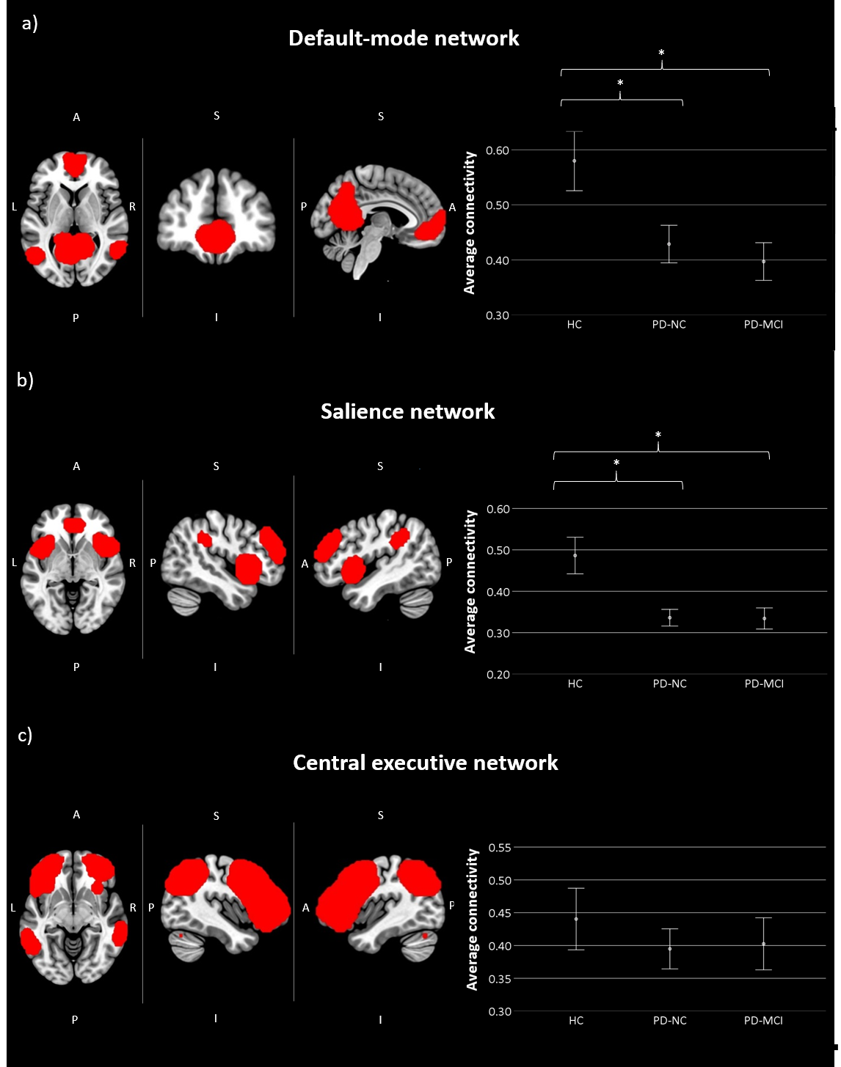

Supplementary figure 2. Comparison of RSNs. a) Average DMN connectivity by groups. b) Average SN connectivity by groups. c) No differences in average CEN connectivity between the groups. HC, Healthy control (n = 13); PD-NC, Parkinson’s Disease with normal cognition (n = 29); PD-MCI, Parkinson’s Disease with Mild Cognitive Impairment (n = 25). *p < .05 vs HC. The error bars (95% CI) show the standard error. Panel a) (left) axial, coronal and sagittal view of the Default Mode Network-DMN-, regions of the DMN are MPFC: Medial Prefrontal Cortex (x, y, z MNI coordinates: 1, 55, -3), lPL: Left Parietal Lateral (x, y, z MNI coordinates: -39, -77, 33), rPL: Right Parietal Lateral (x, y, z MNI coordinates: 47, -67, 29) , and PCC: Posterior Cingulate Cortex (x, y, z MNI coordinates: 1, -61, 38); (right) DMN average functional connectivity by groups. Panel b) (left) axial, right sagittal and left sagittal view of the Salience Network-SN-, regions of SN are ACC: Anterior Cingulate Cortex (x, y, z MNI coordinates: 0, 22, 35), lAI: Left Anterior Insula (x, y, z MNI coordinates: -44, 13, 1), rAI: Right Anterior Insula (x, y, z MNI coordinates: 47, 14, 0), LRPFC: Left Rostral PreFrontal Cortex (x, y, z MNI coordinates: -32, 45, 27), rRPFC: Right Rostral PreFrontal Cortex (x, y, z MNI coordinates: 32, 46, 27), lSMG: Left SupraMarginal Gyrus (x, y, z MNI coordinates: -60, -39, 31), rSMG: Right SupraMarginal Gyrus (x, y, z MNI coordinates: 62, -35, 32); (right) SN average functional connectivity by groups. Panel c) (left) axial, right sagittal and left sagittal view of the Central Executive Network-CEN-, regions of CEN are lLPFC: Left Lateral PreFrontal Cortex (x, y, z MNI coordinates: -43, 33, 28), rLPFC: Right Lateral PreFrontal Cortex (x, y, z MNI coordinates: 41, 38, 30), lPPC: Left Posterior Parietal Cortex (x, y, z MNI coordinates: -46, 58, 49), rPPC: Right Posterior Parietal Cortex (x, y, z MNI coordinates: 52, -52, 45). Abbreviations: A: anterior, P: posterior, L: left, R: right, S: superior, I: inferior. ICN’s templates were obtained from Avants, Brian (2015): fmri network templates. figshare dataset. https://doi.org/10.6084/m9.figshare.2059257.v2

