Additional file for
Title: Spatially Distinct Immunothrombotic Signatures in Patients with Pneumonia-Related Acute Respiratory Distress Syndrome: Insights from Lung Alveolar and Blood Circulation Profiles

This file includes:
Figure S1. Study flow chart.
Figure S2. Comparisons of BALF and serum biomarker concentrations in patients with p-ARDS and pneumonia controls.
Table S1. Microbiological documentation for p-ARDS patients and pneumonia controls.
Table S2. Summary of Results: ROC analysis of interested biomarkers and combination for discriminating between p-ARDS and Pneumonia.
Table S3. Spearman correlation matrix among the investigated biomarkers, laboratory findings, and clinical scores in patients with p-ARDS.

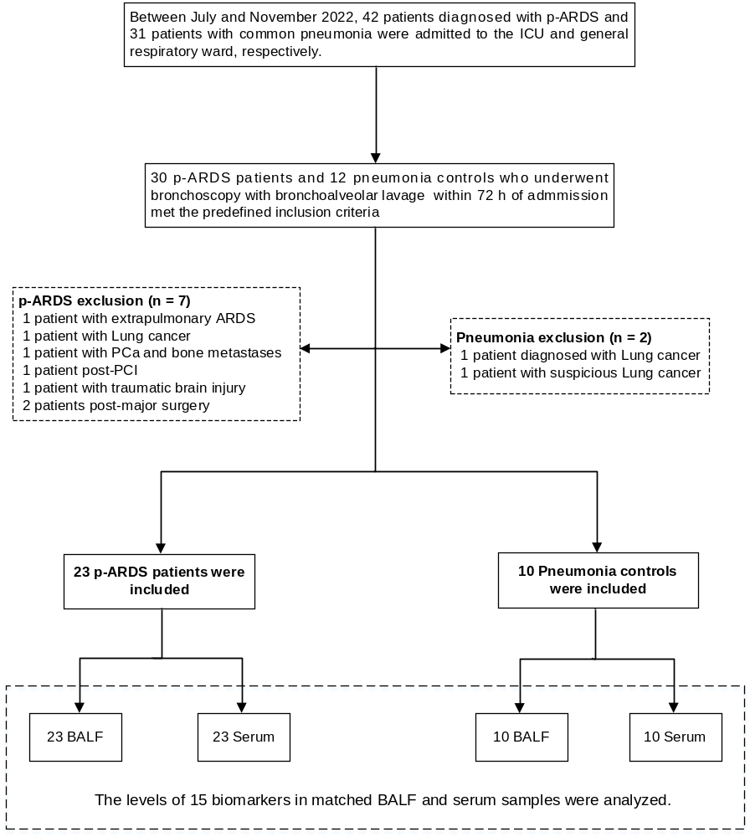
Figure S1. Study flow chart. p-ARDS: Pneumonia-induced acute respiratory distress syndrome; BAL: Bronchoalveolar lavage; BALF: Bronchoalveolar lavage fluid; PCa: Prostate cancer; PCI: Percutaneous coronary intervention.

Figure S2. Comparisons of BALF and serum biomarker concentrations in patients with p-ARDS and pneumonia controls. Horizontal bars indicate the median and interquartile range. Statistical differences were assessed by unpaired, two-tailed Mann-Whitney U tests, * P< 0.05, **P< 0.01. Note that some of the subfigures are presented with a log scale. ADAMTS-13: a disintegrin and metalloproteinase with thrombospondin type 1 motif, 13; H3cit: citrullinated histone H3; IL-1β/6/8: interleukin-1β/6/8; MPO: myeloperoxidase; PF4: platelet factor 4; PR3: proteinase 3; SP-D: surfactant protein D; TPO: thrombopoietin; TM: thrombomodulin; TNF-α: tumor necrosis factor α; vWF-A2: von Willebrand Factor-A2.

Table S1. Microbiological documentation for p-ARDS patients and pneumonia controls
 | p-ARDS (n =23) | Pneumonia (n =10) | P value
 |  |  | 0.248
Bacteria | 20 (87%) | 8 (80%)
Enterobacteriaceae | 12 | 4
Streptococcus pneumoniae | 2 | 1
Staphylococcus aures | 2 | 1
Candida | 1
Group A streptococcus | 1 | 1
Pneumocystis | 1 | 1
Mould | 1
Virus | 1 (4.3%) | 2 (20%)
Influenza A |  | 2
Respiratory syncytial virus | 1
Undetermined | 2 (8.7%)

Table S2. Summary of Results: ROC analysis of interested biomarkers and combination for discriminating between p-ARDS and Pneumonia
Area Under the Curve
Variables | Area | Std. Error | P value | 95% Confidence Intervals
 |  |  |  | Lower Bound | Upper Bound
IL-6 + s-TM | 0.913 | 0.050 | 0.000 | 0.816 | 1.000
s-TM | 0.861 | 0.065 | 0.001 | 0.734 | 0.988
IL-6 | 0.830 | 0.083 | 0.003 | 0.668 | 0.995
s-ADAMTS-13 | 0.796 | 0.083 | 0.008 | 0.634 | 0.958
S100A8 | 0.780 | 0.102 | 0.012 | 0.580 | 0.979
IL-8 | 0.777 | 0.102 | 0.013 | 0.578 | 0.977
s-MPO | 0.765 | 0.083 | 0.017 | 0.602 | 0.929
PF4 | 0.764 | 0.097 | 0.018 | 0.574 | 0.953
TNFα | 0.759 | 0.112 | 0.020 | 0.539 | 0.979
SP-D | 0.745 | 0.087 | 0.028 | 0.576 | 0.915
P-selectin | 0.745 | 0.104 | 0.028 | 0.541 | 0.950
IL-1β | 0.732 | 0.104 | 0.038 | 0.528 | 0.935
H3cit | 0.726 | 0.086 | 0.042 | 0.557 | 0.895
PR3 | 0.713 | 0.107 | 0.055 | 0.503 | 0.923

Note: “s-” denotes serum, for instance s-ADAMTS-13 refers to ADAMTS-13 present in the serum.

Table S3. Spearman correlation matrix among the investigated biomarkers, laboratory findings, and clinical scores in patients with p-ARDS.
 | s-ADAMTS-13 | s-TM | IL-6 | PF4 | H3cit | P/F ratio | SOFA | DIC score | D-dimer | PLT counts
s-ADAMTS-13 | 1
s−TM | −0.43  (−0.72~ −0.01)  P = 0.041 | 1
IL−6 | −0.11  (−0.51~0.33)  P = 0.609 | 0.12  (−0.32~0.51)  P = 0.596 | 1
PF4 | 0.11  (−0.33~0.51)  P = 0.618 | −0.06  (−0.47~0.37)  P = 0.785 | 0.47  (0.06~0.75)  P = 0.023 | 1
H3cit | −0.20  (−0.57~0.25)  P = 0.368 | −0.02  (−0.44~0.41)  P = 0.932 | 0.38  (−0.05~0.69)  P = 0.073 | 0.31  (−0.13~0.65)  P = 0.152 | 1
P/F ratio | 0.16  (−0.28~0.55)  P = 0.468 | −0.28  (−0.63~0.16)  P = 0.200 | −0.67  (−0.85~ −0.35)  P = 0.000 | −0.51  (−0.77~ −0.11)  P = 0.013 | −0.17  (−0.55~0.27)  P = 0.438 | 1
SOFA | −0.59  (−0.81~ −0.23)  P = 0.003 | 0.53  (0.14~0.78)  P = 0.009 | 0.37  (−0.06~0.69)  P = 0.082 | −0.07  (−0.48~0.36)  P = 0.738 | 0.32  (−0.12~0.65)  P = 0.137 | −0.38  (−0.69~0.05)  P = 0.072 | 1
DIC score | −0.29  (−0.63~0.16)  P = 0.187 | 0.35  (−0.08~0.67)  P = 0.101 | 0.01  (−0.42~0.43)  P = 0.969 | 0.06  (−0.37~0.47)  P = 0.784 | 0.28  (−0.17~0.63)  P = 0.201 | −0.07  (−0.48~0.37)  P = 0.764 | 0.39  (−0.04~0.69)  P = 0.064 | 1
D−dimer | −0.24  (−0.60~0.21)  P = 0.274 | 0.34  (−0.10~0.67)  P = 0.113 | 0.26  (−0.19~0.61)  P = 0.239 | −0.08  (−0.48~0.35)  P = 0.710 | 0.30  (−0.14~0.64)  P = 0.168 | −0.16  (−0.54~0.28)  P = 0.471 | 0.16  (−0.28~0.55)  P = 0.466 | 0.23  (−0.22~0.59)  P = 0.297 | 1
PLT counts | 0.32  (−0.13~0.66)  P = 0.142 | −0.54  (−0.79~ −0.14)  P = 0.009 | −0.23  (−0.60~0.23)  P = 0.306 | 0.01  (−0.43~0.43)  P = 0.970 | −0.28  (−0.63~0.18)  P = 0.214 | 0.18  (−0.27~0.57)  P = 0.414 | −0.58  (−0.81~ −0.20)  P = 0.005 | −0.60  (−0.82~ −0.22)  P = 0.003 | −0.46  (−0.75~ −0.04)  P = 0.031 | 1
Data represent the value of Spearman r, (95%CI), and P value, respectively. The prefix "s-" indicates serum, e.g., s-ADAMTS-13 refers to ADAMTS-13 present in serum. Results in bold are significant at P<0.05.

