Supplementary Information
Anti-Biofilm Properties of Laser-Synthesized, Ultrapure Silver-Gold-Alloy Nanoparticles against Staphylococcus aureus

Nils Heine^{1,2}*, Katharina Doll-Nikutta^{1,2}, Frederic Stein³, Jurij Jakobi³, Alexandra Ingendoh-Tsakmakidis^{1,2}, Christoph Rehbock³, Andreas Winkel^{1,2}, Stephan Barcikowski³, Meike Stiesch^{1,2}*

¹Department of Prosthetic Dentistry and Biomedical Materials Science, Hannover Medical School, Carl-Neuberg-Straße 1, 30625 Hannover, Germany
²Lower Saxony Centre of Biomedical Engineering, Implant Research and Development, Stadtfelddamm 34, 30625 Hannover, Germany
³Technical Chemistry I, University of Duisburg Essen, Universitaetsstr. 7, 45141 Essen, Germany
*Corresponding author: meike.stiesch@mh-hannover.de, heine.nils@mh-hannover.de
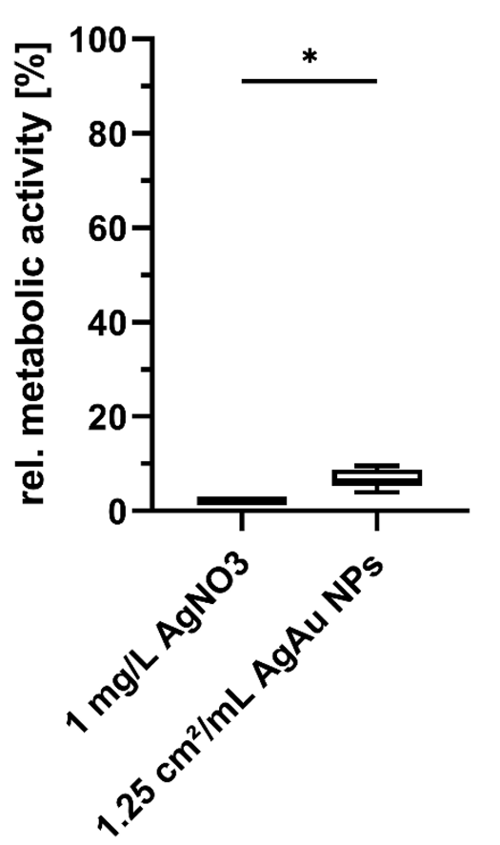
Supplementary Figure 1: Relative metabolic activity of planktonic S. aureus treated with AgNO₃ or nanoparticles consisting of 80 mol% silver and 20 mol% gold in binding buffer. Statistically significant difference with p ≤ 0.05 is indicated by (*) and was determined by an unpaired t test.

Primer | Sequence (5’ to 3’)
rrsA forward | GCCCCTTAGTGCTGCAGCTA
rrsA reverse | AGTTTCAACCTTGCGGTCGTA
pfkA forward | GTCCAGAGTTTAAGGAGCAAGA
pfkA reverse | ACTACCGTCACCACCAATAAC
ahpD forward | GTCTGTAATGAGCCAAGGTGAA
ahpD reverse | GGATATCAACACAATAATGACAACCG
icaR forward | TCGAACTATTCAATTGATGCTTTA
icaR reverse | CAGAAAATTCCTCAGGCGTA
Supplementary Table 1: Primers for qRT-PCR.
Gene | Temperature [°C] | Elongation Time [s] | Number of cycles
rrsA | 60 | 30 | 40
pfkA | 60 | 30 | 40
ahpD | 63 | 30 | 40
icaR | 55 | 30 | 40
Supplementary Table 2: qRT-PCR annealing temperatures, elongation times, and number of cycles for each gene.

