Supplementary Figures (Fig. S1 – S3)

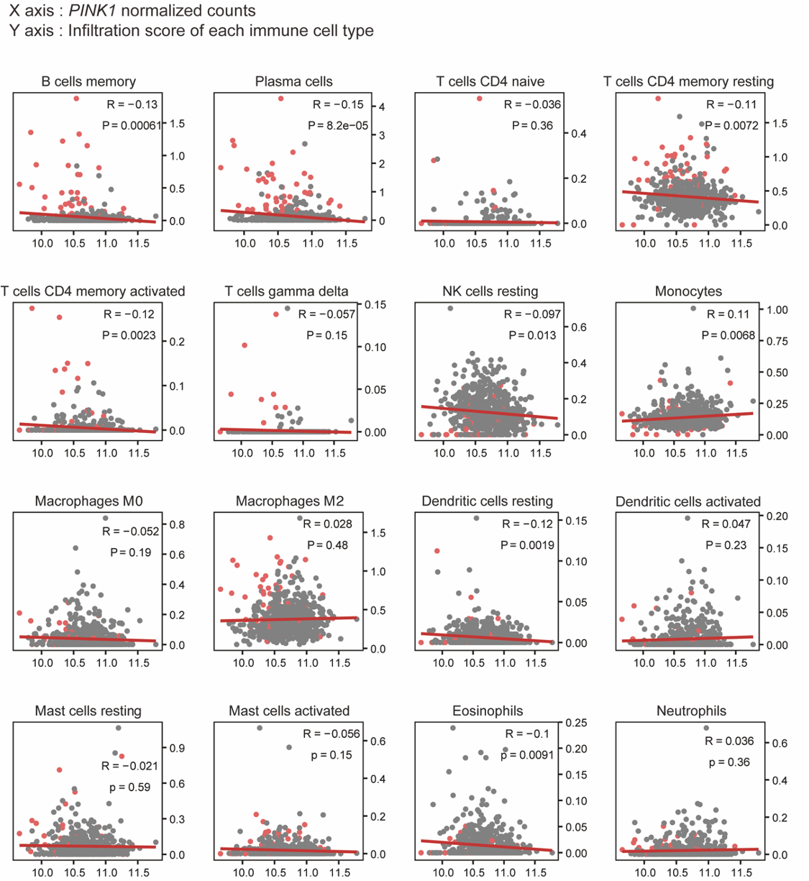

Fig. S1
Scatter plot with Pearson’s correlation between PINK1 normalized counts and CIBERSORTx score of 16 types of immune cells in human LT (n = 653; No LT = 589, LT = 64). Gray dots and pink dots represent thyroids without/with LT

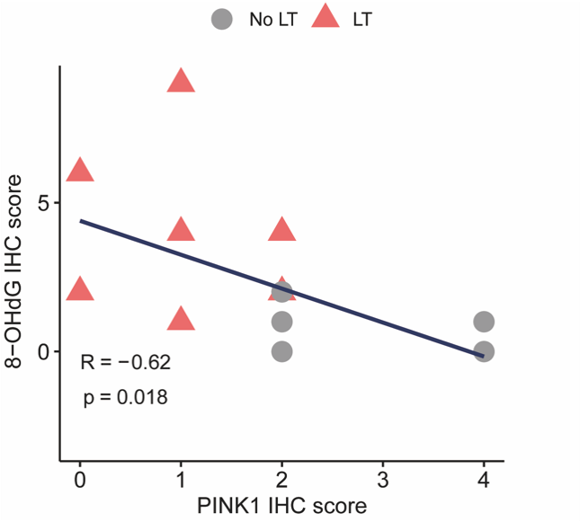

Fig. S2
Scatter plot with Spearman’s correlation of IHC intensity scores of PINK1 and 8-OHdG. (n = 7/each)

Fig. S3
(A) Microscopic image of 24-month-old Pink1 KO mice’s thyroid gland (400×). Black and gray arrow represented thyroid follicle cells with/without oncocytic changes, respectively. Boxplots of (B) Lmp2 expression and (C) IFNγ response score which is molecular marker of oncocytic change (n = 5/each). (D) Microscopic image of human thyroid gland with LT. Black and gray arrows represent thyroid follicle cells with and without oncocytic changes, respectively. Boxplots of (E) LMP2 expression and (F) IFNγ response score which is molecular marker of oncocytic change (n = 5/each). IFNγ response gene set was derived from MsigDB. Scale bars are as indicated. Data in bar plots are presented as mean ± SEM.

