Supplementary Figures (Fig. S4 – S7)

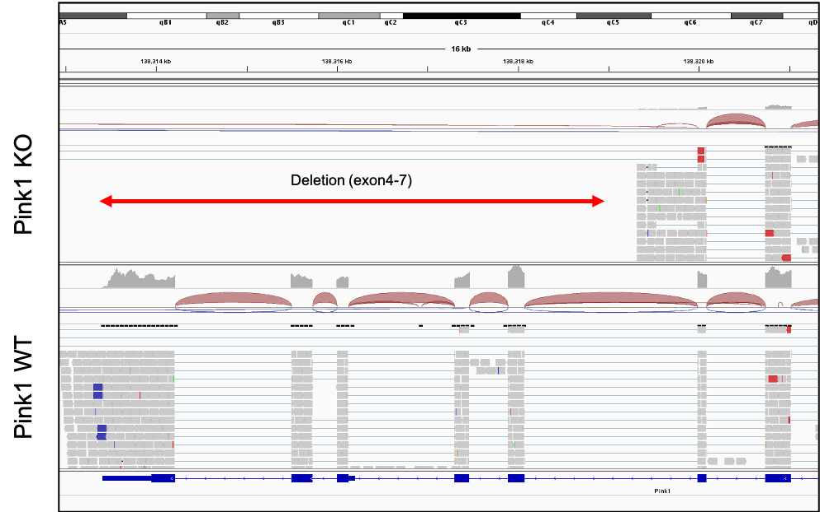

Fig. S4
Integrative genome viewer image Pink1 exon 4-7 region of Pink1 KO mouse (Top panel) and Pink1 WT mouse (Bottom panel).

Fig. S5
Box plots with heatmap of mitochondrial DAMP related pathways scores, which include (A) NLRP3 inflammasome (B) TLR9 (C) STING (D) NFkB pathway, of human thyroid with/without LT (n = 653/each). All gene were derived from MsigDB. heatmaps of genes that make up of those pathways. (F) Bar plots represent quantitative PCR results of pro-inflammatory cytokines in HTori-3 cell lysates after PINK1- and control-siRNA treatment. (G) Bar plots represent quantitative PCR results of pro-inflammatory cytokines in HTori-3 cell lysates after treatment of control (0.5% DMSO) and Midivi-1 (5μM). (H) conditioned medium of PINK1-siRNA treated human thyroid cells (HTori-3) presented higher infiltrated cell number of human Jurkat cell (n = 6/each). Data in bar plots are presented as mean ± SEM.

Fig. S6
Correlation plots of human thyroid AREG mRNA expression and hypoxia gene set in (A) human thyroid and (B) mice thyroid (Pearson’s correlation; n = 653; n = 10, respectively). (C) Representative western blotting band images of Pink1 KO and Pink1 WT 24-month-old mice (n = 5/each). Bar plots represented β-actin–normalized relative protein expressions of (D) PINK1, CREB, and HIF1A compared to that of Pink1 WT (n = 5/each). Hypoxia gene set was derived from MsigDB. Data in bar plots are presented as mean ± SEM.

Fig. S7
Box plots with heatmap of EGFR signaling pathways scores, which include (A) EGFR, (B) PI3K/AKT/mTOR, (C) RAS/RAF/MEK/ERK and (D) cell cycle pathway, of human thyroid with/without LT (n = 653/each). All gene set came from MsigDB. heatmaps of genes that make up of those pathways. Bar plots represent proliferation rate assay results of HTori-3 cells. Treatment of (E) conditioned medium of PINK1-siRNA treated HTori-3 cells, (F) human AREG protein (control- CM of control-siRNA treated HTori-3 cells, and 0 ng/ml AREG, respectively) (n = 6/each). Data in bar plots are presented as mean ± SEM.

