SUPPORTING INFORMATION
Taurine an ecofriendly bioorganic catalyst for the synthesis of dihydropyrido [2,3-d] pyrimidine and pyrimido[4,5-b]quinoline derivatives under ultrasonication
Bhavana G. Polke, Manisha R. Bhosle, Giribala M. Bondle*
Department of chemistry, Dr. Babasaheb Ambedkar Marathwada University, Aurangabad 431004, Maharashtra, India; Email: gbondle.chemistry@bamu.ac.in

Table of contents
1. Spectral data…………………………………………………SI-2-SI-6
2. Copies of IR, LCMS, ¹H and ¹³C NMR Spectra……………SI-7-SI-24

Recycling of Taurine
After completion of the reaction, the products were easily separated by simple filtration. The filtered solution was evaporated and thus obtained taurine reused for next two consecutive cycles for the synthesis of (4m), without any significant loss in yield and activity.

Spectral data of compounds

5-(4-ethoxyphenyl)-5,6-dihydropyrido[2,3-d]pyrimidine-2,4,7(1H,3H,8H)-trione (4a)
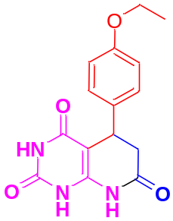

IR (ATR, υ cm-1) Characteristic absorptions:1600.42 (C=O stretching), 3267.83 (N-H stretching), 1509.13 (C=C aromatic stretching), 2872.35 (C-H stretching), 2986.15 (O-CH₂-CH₃ stretching), ¹H NMR (300 MHz, DMSO-d₆ δ ppm): 3.95 (d, J = 15.2 Hz, 1H, CH₂), 3.98 (d, 1H, CH₂), 5.23 (t, 1H, diastereotopic C-H), 4.41 (q, 2H, CH₂), 1.37 (t, 3H, CH₃) 6.33 (s, 1H, NH), 7.34 (m, J = 8 Hz, 1H, Ar-H), 6.85 (d, J = 7.2 Hz, 1H, Ar-H), 6.92 (m, 1H, Ar-H), 7.87 (dd, J = 7.2 Hz, 1H, Ar-H), 8.30 (s, 1H, N-H), 10.29 (s, 1H, NH); ¹³C NMR (75 MHz, DMSO-d6, δ ppm): 10.02, 31.72, 38.67, 50.92, 88.7, 113.10, 114.80, 127.55, 129.02, 131.09, 149.82, 156.86, 160.02, 170.08 Mass (Scanning mode, ES⁺) (LCMS) m/z: 301, found: 301 (M+1). Anal.Calcd.for C₁₅H₁₅N₃O₄
5-(p-tolyl)-5,6-dihydropyrido[2,3-d]pyrimidine-2,4,7(1H,3H,8H)-trione (4b)
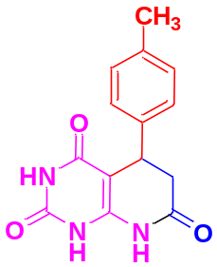

IR (ATR, υ cm-1) Characteristic absorptions: 1628.27 (C=O stretching), 3260.89 (N-H stretching), 1519.74 (C=C aromatic stretching), 2927.83(C-H stretching). 3049.43 (C-CH₃ aromaticstretching),¹H NMR (300 MHz, DMSO-d₆ δ ppm): 2.50 (d, J = 15.2 Hz, 1H, CH₂), 2.23 (d, 1H, CH₂), 5.25 (t, 1H, diastereotopic CH), 2.23 (s, 3H, CH₃) 6.70 (s, 1H, NH), 7.04 (m, J = 8 Hz, 1H, Ar-H), 6.92 (d, J = 7.2 Hz, 1H, Ar-H), 6.99 (m, 1H, Ar-H), 7.79 (dd, J = 7.2 Hz, 1H, Ar-H), 9.94 (s, 1H, N-H), 10.90 (s, 1H, NH); ¹³CNMR (75 MHz, DMSO-d6, δ ppm): 21.42, 32.11, 38.67, 88.09, 126.51, 128.31, 129.45, 129.77, 133.66, 145.30, 149.84, 192.70 Mass (Scanning mode, ES⁺) (LCMS) m/z :271, found: 271 (M+1). Anal.Calcd.for C₁₄H₁₃N₃O₃
5-(2-nitrophenyl)-5,6-dihydropyrido[2,3-d]pyrimidine-2,4,7(1H,3H,8H)-trione (4c)
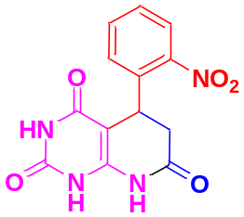

IR (ATR, υ cm-1) Characteristic absorptions: 1628.36 (C=O stretching), 3140.28 (N-H stretching), 1594.07 (C=C aromatic stretching), 2905.38 (C-H stretching), ¹H NMR (300 MHz, DMSO-d₆ δ ppm): 3.48 (d, J=15.2 Hz, 1H, CH₂), 3.50 (d, 1H, CH₂), 4.50 (t, 1H, diastereotopic CH), 5.84 (s, 1H, NH), 7.33 (m, J = 8 Hz, 1H, Ar-H), 7.36 (d, J=7.2 Hz, 1H, Ar-H), 7.49 (m, 1H, Ar-H), 7.51 (dd, J=7.2 Hz, 1H, Ar-H), 8.61 (s, 1H, N-H), 10.50 (s, 1H, NH); ¹³CNMR (75 MHz, DMSO-d6, δ ppm): 29.32, 37.84, 88.23, 120.58, 124.97, 128.58, 131.82, 136.84, 146.34, 149.70, 150.39, 162.54, 168.87 Mass (Scanning mode, ES⁺) (LCMS) m/z: 302, found: 303 (M+1). Anal.Calcd.for C₁₃H₁₀N₄O₅
5-(2-hydroxyphenyl)-5,6-dihydropyrido[2,3-d]pyrimidine-2,4,7(1H,3H,8H)-trione (4d)
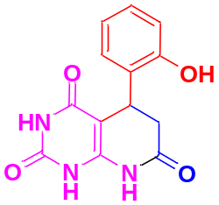

IR (ATR, υ cm-1) Characteristic absorptions: 1522.92 (C=O stretching), 3262.88 (N-H stretching), 1585.74 (C=C aromatic stretching), 2900.06(C-H stretching), 3262.88 (O-H stretching), ¹H NMR (300 MHz, DMSO-d₆ δ ppm): 2.94 (d, J = 15.2 Hz, 1H, CH₂), 2.96 (d, 1H, CH₂), 4.91 (t, 1H, diastereotopic CH), 4.21 (s, 1H, OH) 6.54 (s, 1H, NH), 7.07 (m, J = 8 Hz, 1H, Ar-H), 6.96 (d, J = 7.2 Hz, 1H, Ar-H), 7.17 (m, 1H, Ar-H), 7.41 (dd, J = 7.2 Hz, 1H, Ar-H), 9.75 (s, 1H, N-H), 10.86 (s, 1H, NH); ¹³CNMR (75 MHz, DMSO-d6, δ ppm): 27.90, 38.67, 89.85, 115.20, 124.67, 127.44, 129.68, 133.27, 145.42, 150.37, 154.75, 163.15, 165.97 Mass (Scanning mode, ES⁺) (LCMS) m/z: 273, found: 273 (M+1). Anal.Calcd.for C₁₃H₁₁N₃O₄

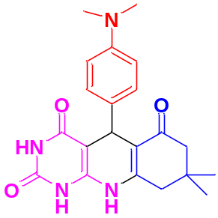5-(4-(dimethylamino)phenyl)-8,8-dimethyl-7,8,9,10-tetrahydropyrimido[4,5-b]quinoline-2,4,6(1H,3H,5H)-trione (6a)

IR (ATR, υ cm-1) Characteristic absorptions: 1621.81 (C=O stretching), 3284.85 (N-H stretching), 1466.58 (C=C aromatic stretching), 2928.82 (C-H stretching), 3410.61(N-CH₃ stretching), ¹H NMR (300 MHz, DMSO-d₆ δ ppm): 1.03 (s, 3H, CH₃),1.01 (s, 3H, CH₃), 2.29 (d, J = 16.2 Hz, 1H, CH₂), 2.29 (d, J = 16.2 Hz, 1H, CH₂), 4.21 (s, 1H) 2.79 (d, J = 18.0 Hz, 1H, CH₂), 2.81 (d, J = 18.0 Hz, 1H, CH₂), 3.82 (s, 3H, N-CH₃), 3.84 (s, 3H, N-CH₃), 6.31 (s, 1H, NH), 6.54 (m, J = 8 Hz, 1H, Ar-H), 6.58 (d, J = 7.2 Hz, 1H, Ar-H), 6.81 (m, 1H, Ar-H), 6. 89 (dd, J = 7.2 Hz, 1H, Ar-H), 10.08 (s, 1H, N-H), 10.26 (s, 1H, NH); ¹³CNMR (75 MHz, DMSO-d6, δ ppm): 27.89, 27.89, 31.35, 38.68, 39.23, 39.51, 40.34, 46.64, 74.17, 110.15, 114.96, 126.10, 127.10, 148.27, 151.09, 155.23, 164.41, 187.48 Mass (Scanning mode, ES⁺) (LCMS) m/z :381, found: 381 (M+1). Anal.Calcd.for C₂₁H₂₄N₄O₃

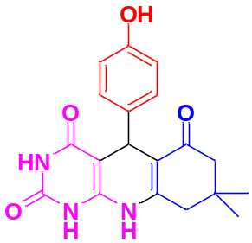5-(4-hydroxyphenyl)-8,8-dimethyl-7,8,9,10-tetrahydropyrimido[4,5-b]quinoline-2,4,6(1H,3H,5H)-trione (6b)

IR (ATR, υ cm-1) Characteristic absorptions: 1633.33 (C=O stretching), 3244.51 (N-H stretching), 1479.32 (C=C aromatic stretching), 2944.78 (C-H stretching), 3346.96 (O-H stretching), ¹H NMR (300 MHz, DMSO-d₆ δ ppm): 1.01 (s, 3H, CH₃),1.09 (s, 3H, CH₃), 2.03 (d, J = 16.2 Hz, 1H, CH₂), 2.06 (d, J = 16.2 Hz, 1H, CH₂), 4.41 (s, 1H) 2.41 (d, J = 18.0 Hz, 1H, CH₂), 2.43 (d, J = 18.0 Hz, 1H, CH₂), 4.63 (s, 1H, O-H), 6.48 (s, 1H, NH), 6.72 (m, J = 8 Hz, 1H, Ar-H), 6.97 (d, J = 7.2 Hz, 1H, Ar-H), 8.72 (m, 1H, Ar-H), 8.92 (dd, J = 7.2 Hz, 1H, Ar-H), 9.42 (s, 1H, N-H), 10.08 (s, 1H, NH); ¹³CNMR (75 MHz, DMSO-d6, δ ppm): 26.47, 29.05, 32.17, 38.67, 40.05, 40.35, 90.09, 111.71, 114.46, 128.43, 137.19, 143.60, 148.77, 151.05, 155.20, 162.79, 164.37, 194341 Mass (Scanning mode, ES⁺) (LCMS) m/z : 354, found: 354 (M+1). Anal.Calcd.for C₁₉H₁₉N₃O₄

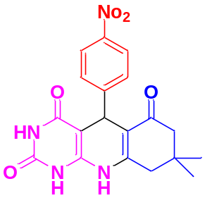8,8-dimethyl-5-(4-nitrophenyl)-7,8,9,10-tetrahydropyrimido[4,5-b]quinolone 2,4,6(1H,3H,5H)-trione (6c)

IR (ATR, υ cm-1) Characteristic absorptions: 1591.21 (C=O stretching), 3270.58 (N-H stretching), 1456.18 (C=C aromatic stretching), 29280.56 (C-H stretching), 2292.42 (C-N stretching), ¹H NMR (300 MHz, DMSO-d₆ δ ppm): 1.01 (s, 3H, CH₃),1.05 (s, 3H, CH₃), 2.15 (d, J = 16.2 Hz, 1H, CH₂), 2.17 (d, J = 16.2 Hz, 1H, CH₂), 4.67 (s, 1H) 2.44 (d, J = 18.0 Hz, 1H, CH₂), 2.51 (d, J = 18.0 Hz, 1H, CH₂), 6.63 (s, 1H, NH), 6.93 (m, J = 8 Hz, 1H, Ar-H), 8.77 (d, J = 3 Hz, 1H, Ar-H), 9.14 (d, 1H, Ar-H), 9.22 (s, J = 3 Hz, 1H, Ar-H), 9.97 (s, 1H, N-H), 10.83 (s, 1H, NH); ¹³CNMR (75 MHz, DMSO-d6, δ ppm): 26.57, 29.06, 32.77, 38.67, 39.23, 40.06, 50.23, 89.71, 111.41, 118.25, 128.68, 147.86, 150.02, 162.11, 192.22 Mass (Scanning mode, ES⁺) (LCMS) m/z : 382, found: 381 (M+1). Anal.Calcd.for C₁₉H₁₈N₄O₅

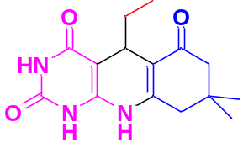5-ethyl-8,8-dimethyl-7,8,9,10-tetrahydropyrimido[4,5-b]quinoline-2,4,6(1H,3H,5H)-trione (6d)

IR (ATR, υ cm-1) Characteristic absorptions: 1628.28 (C=O stretching), 3271.88 (N-H stretching), 1451.42 (C=C aromatic stretching), 2928.05 (C-H stretching), 3034.33 (C-CH₃ aromatic stretching), ¹H NMR (300 MHz, DMSO-d₆ δ ppm): 1.02 (s, 3H, CH₃), 0.95 (s, 3H, CH₃), 1.34 (t, 3H, CH₂-CH₃), 1.99 (q, 3H, CH₂-CH₃), 2.17 (d, J = 16.2 Hz, 1H, CH₂), 2.22 (d, J = 16.2 Hz, 1H, CH₂), 4.41 (s, 1H) 6.49 (s, 1H, NH), 10.17 (s, 1H, NH); ¹³CNMR (75 MHz, DMSO-d6, δ ppm): 13.37, 27.64, 31.07, 38.67, 38.95, 39.23, 40.35, 50.29, 74.18, 115.50, 149.79, 151.08, 155.24, 164.42, 196.50 Mass (Scanning mode, ES⁺) (LCMS) m/z : 290, found: 291 (M+1). Anal.Calcd.for C₁₅H₁₉N₃O₃
8,8-dimethyl-5-(thiophen-2-yl)-7,8,9,10-tetrahydropyrimido[4,5-b]quinoline-2,4,6(1H,3H,5H)-trione (6e)
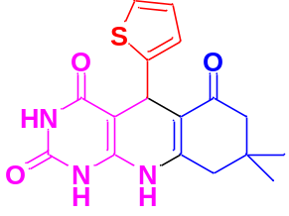

IR (ATR, υ cm-1) Characteristic absorptions: 1711.16 (C=O stretching), 3130.70 (N-H stretching), 1458.18 (C=C aromatic stretching), 2982.96 (C-H stretching), 789.33 (C-S aromatic stretching), ¹H NMR (300 MHz, DMSO-d₆ δ ppm): 1.02 (s, 3H, CH₃), 0.96 (s, 3H, CH₃), 2.36 (d, J = 16.2 Hz, 1H, CH₂), 4.85 (s, 1H) 2.42 (d, J = 16.2 Hz, 1H, CH₂),6.01 (s, 1H, NH), 7.52 (m, J = 8 Hz, 1H, Ar-H), 7.77 (d, J = 3 Hz, 1H, Ar-H), 8.22 (d, 1H, Ar-H), 10.09 (s, 1H, N-H), 10.64 (s, 1H, NH); ¹³CNMR (75 MHz, DMSO-d6, δ ppm): 26.47, 27.13, 31.08, 38.67, 39.95, 40.34, 88.03, 110.80, 119.23, 121.47, 132.05, 147.41, 150.67, 161.36, 194348 Mass (Scanning mode, ES⁺) (LCMS) m/z : 343, found: 343 (M+1). Anal.Calcd.for C₁₇H₁₇N₃O₃S

IR spectrum of Compound (4a)
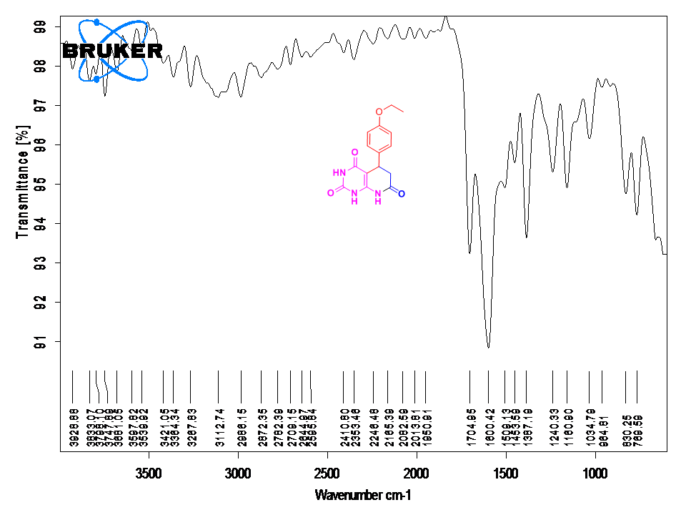
¹H NMR of Compound (4a)
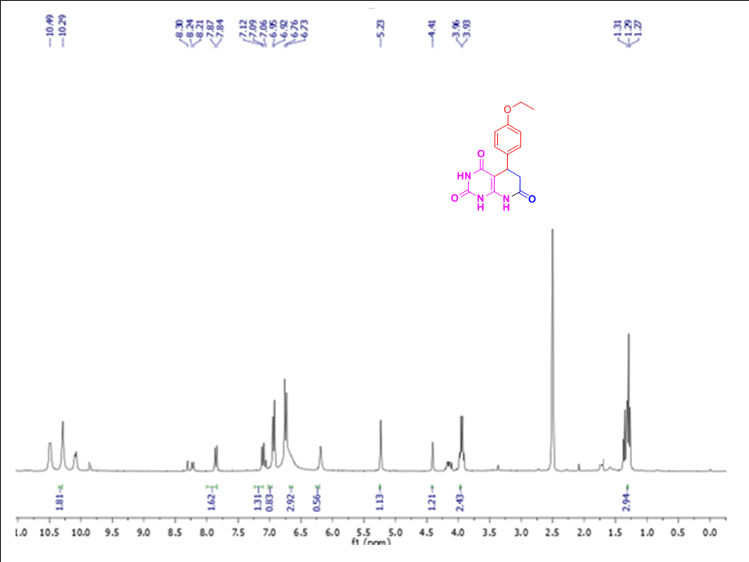
¹³C NMR of Compound (4a)
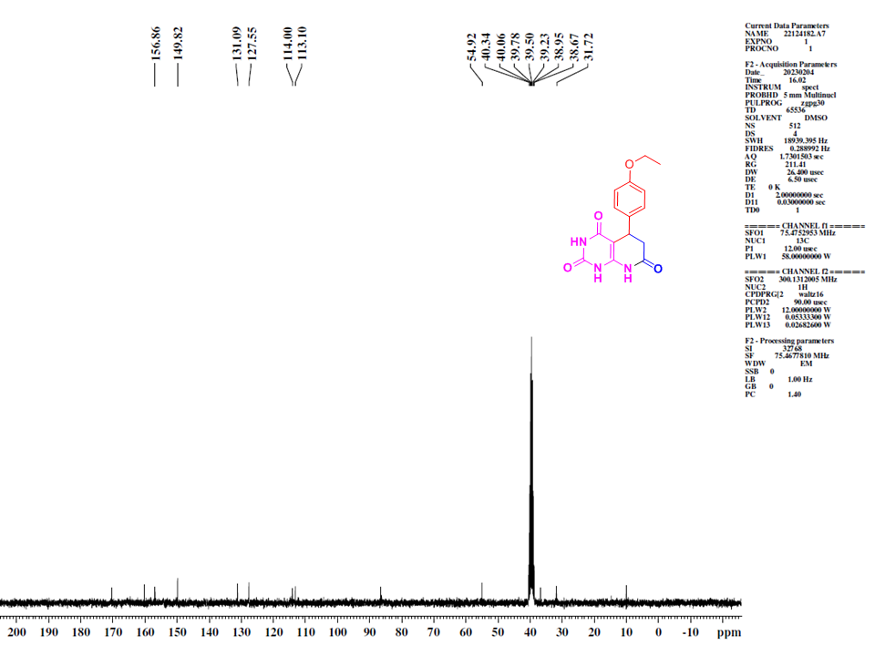
Mass of Compound (4a)
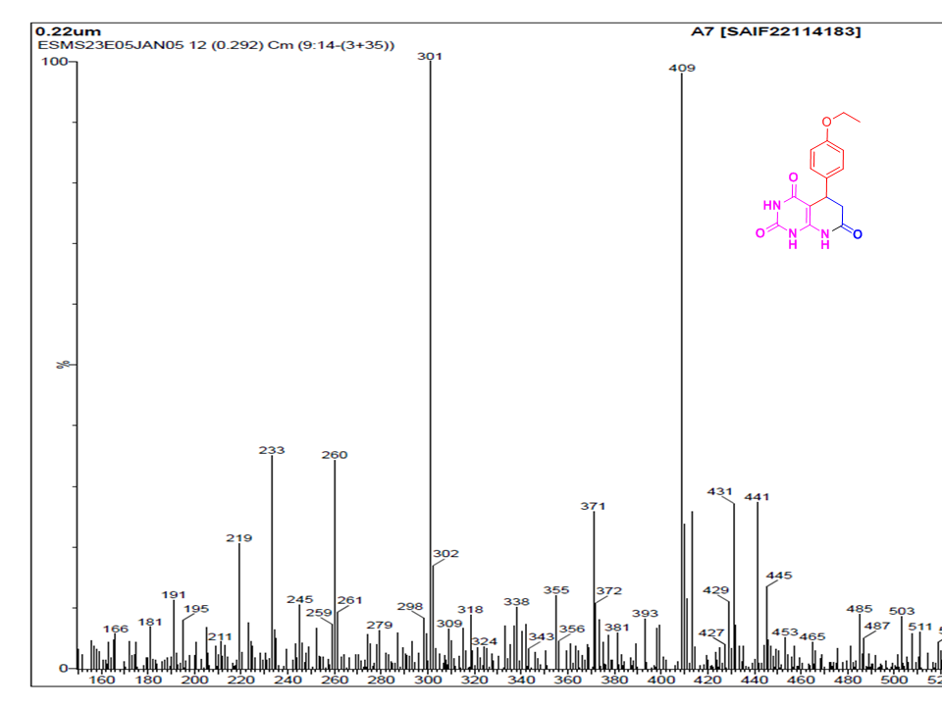
IR spectrum of Compound (4b)
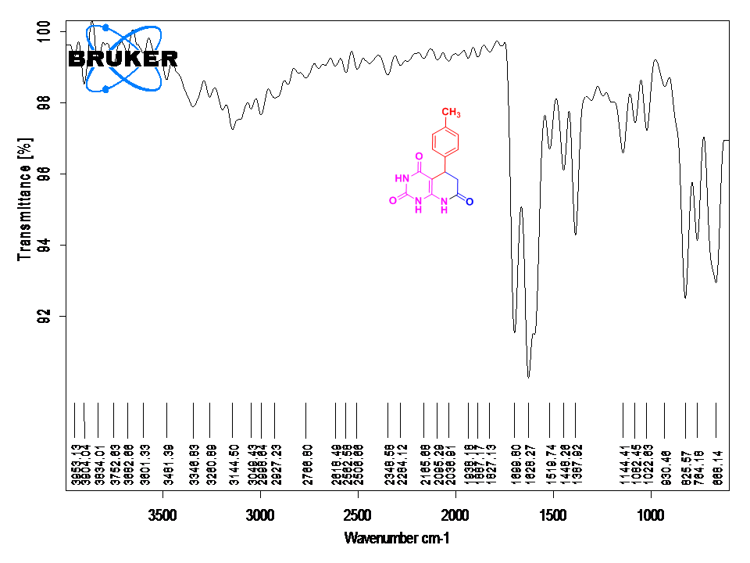
¹H NMR of Compound (4b)
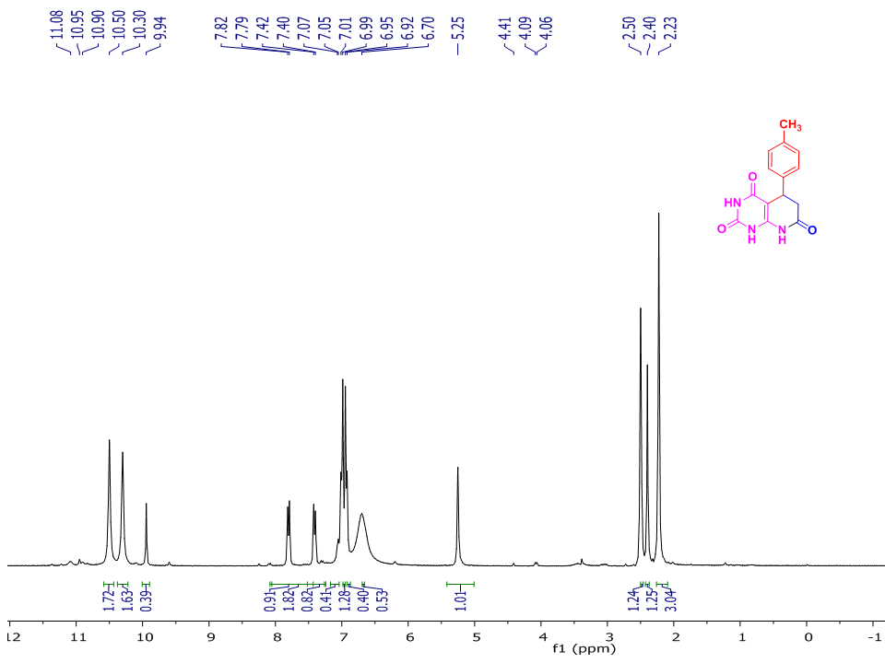
¹³C NMR of Compound (4b)
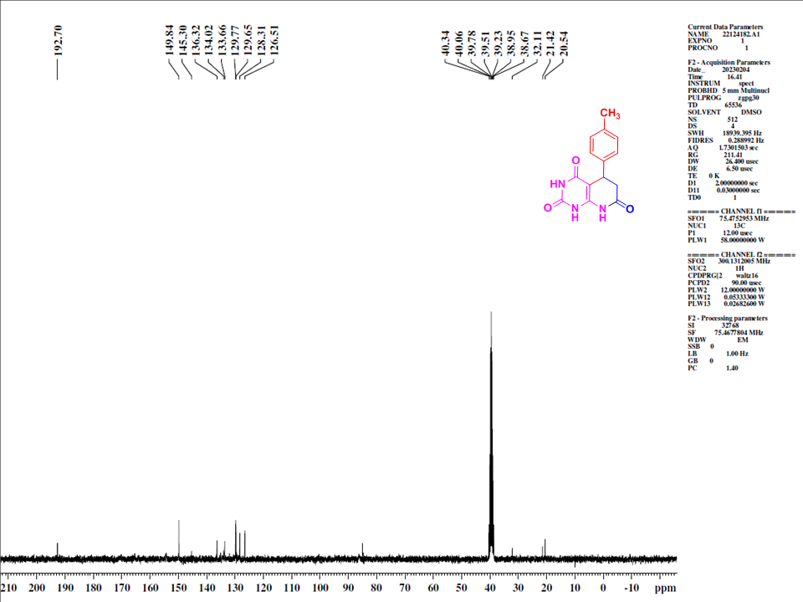
Mass of Compound (4b)
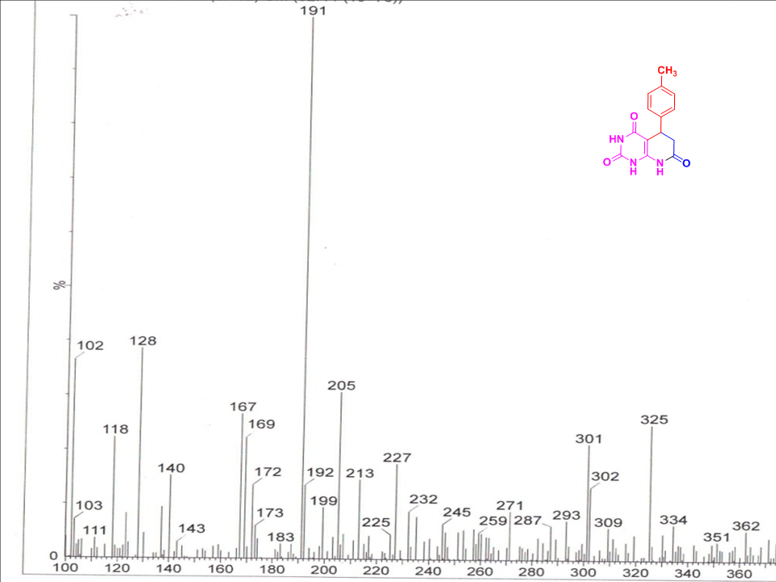
IR spectrum of Compound (4c)
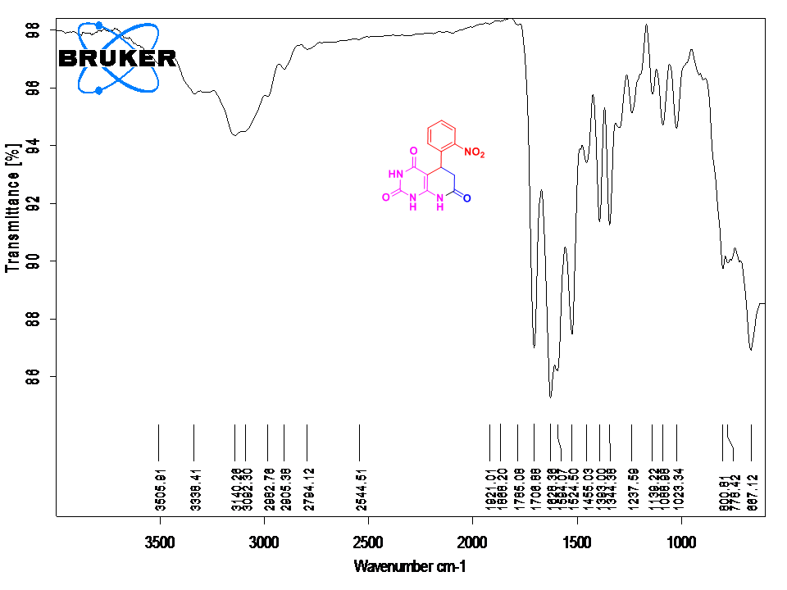
¹H NMR of Compound (4c)
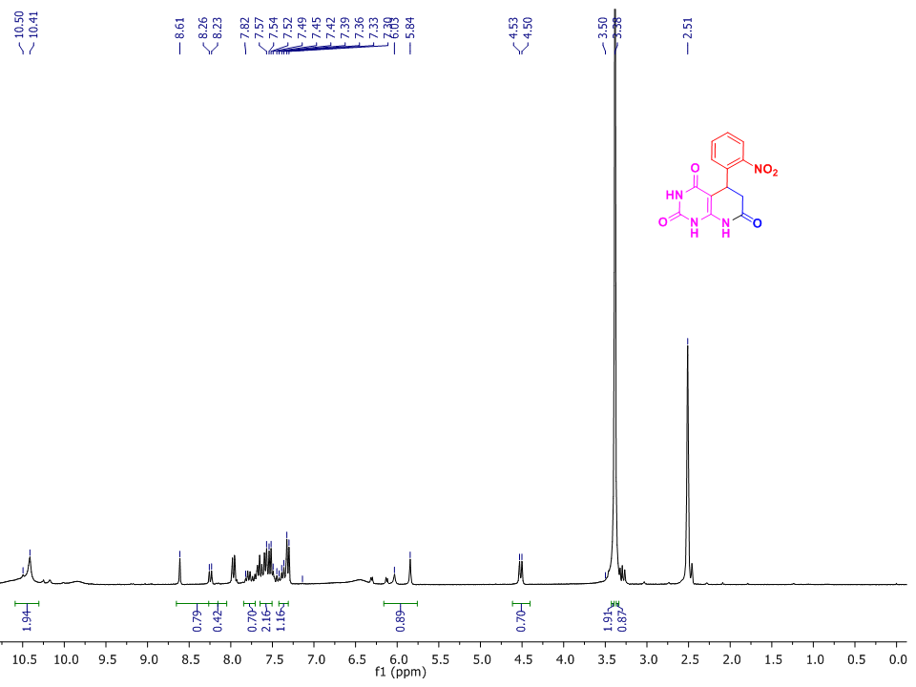
¹³C NMR of Compound (4c)
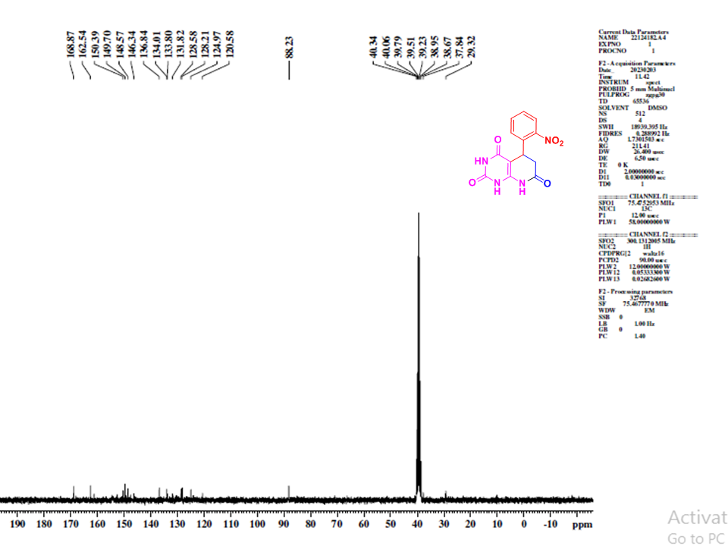
Mass of Compound (4c)
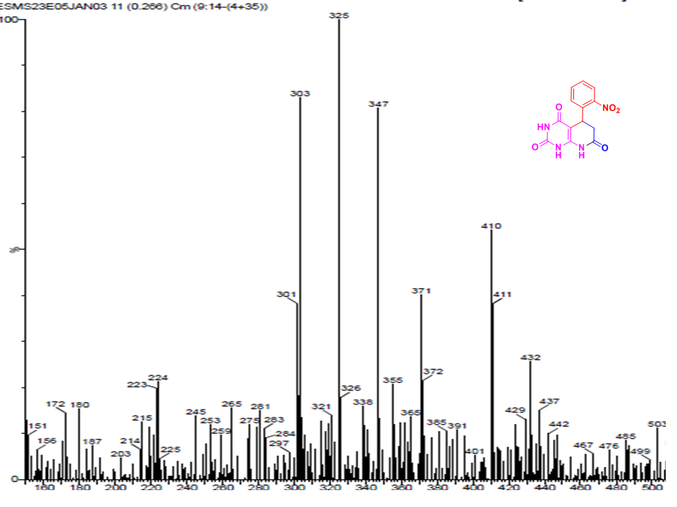
IR spectrum of Compound (4d)
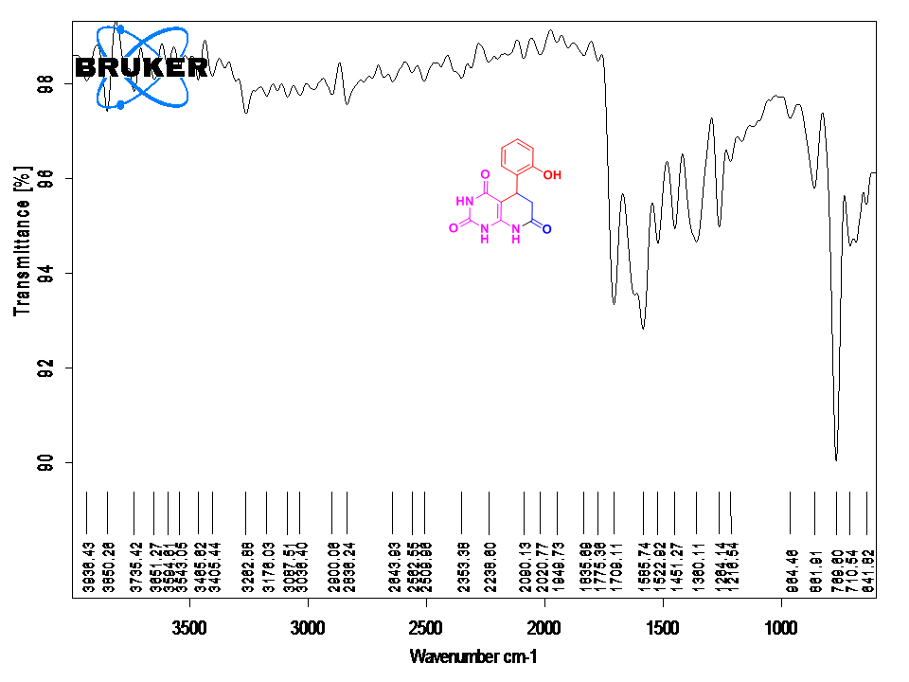
¹H NMR of Compound (4d)
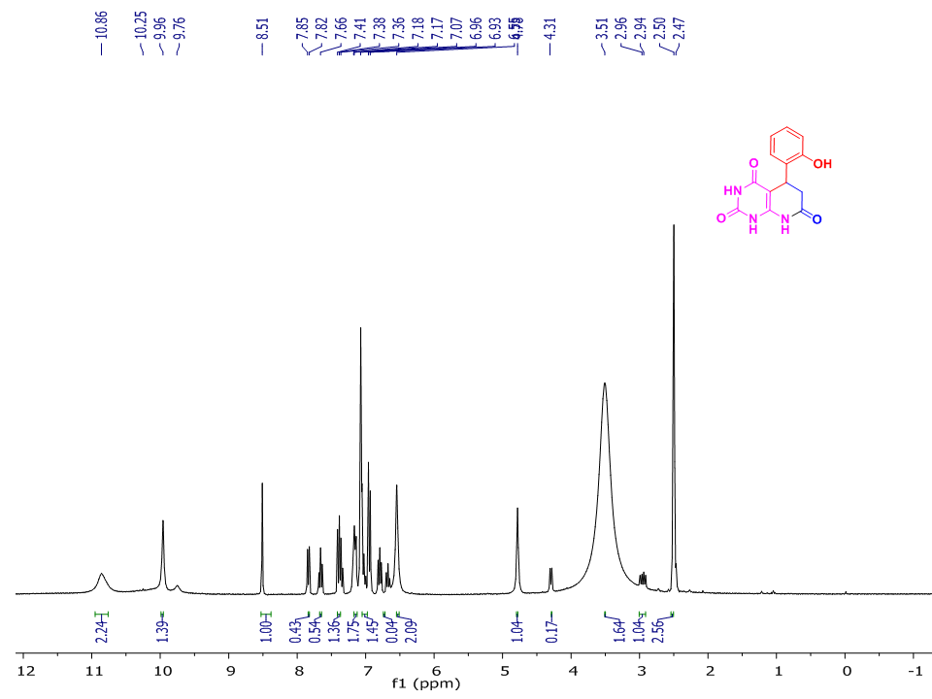
¹³C NMR of Compound (4d)
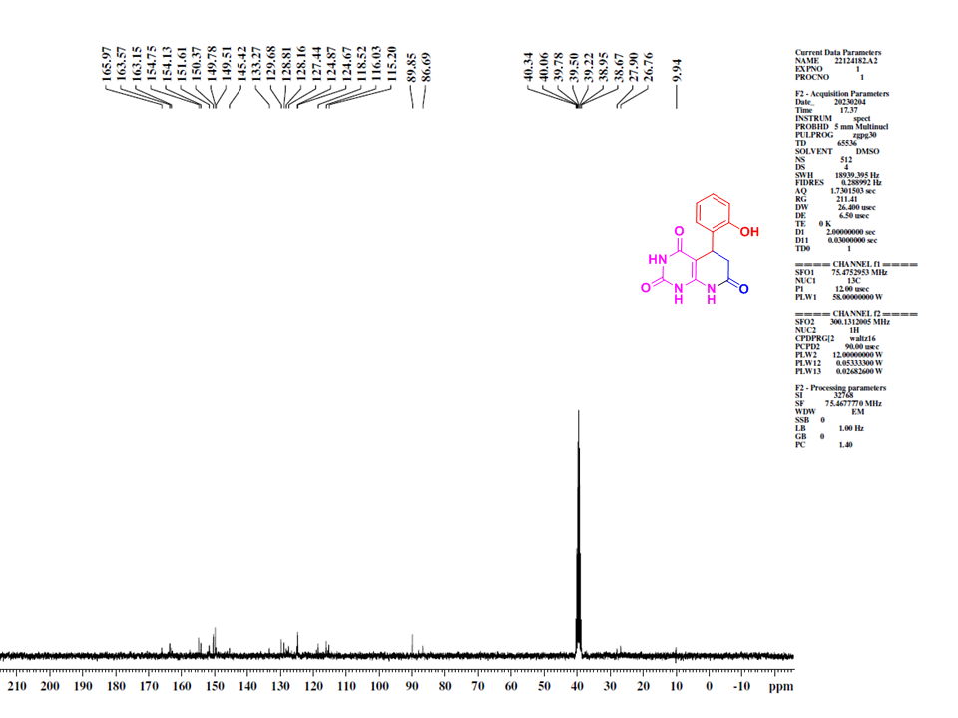
Mass of Compound (4d)
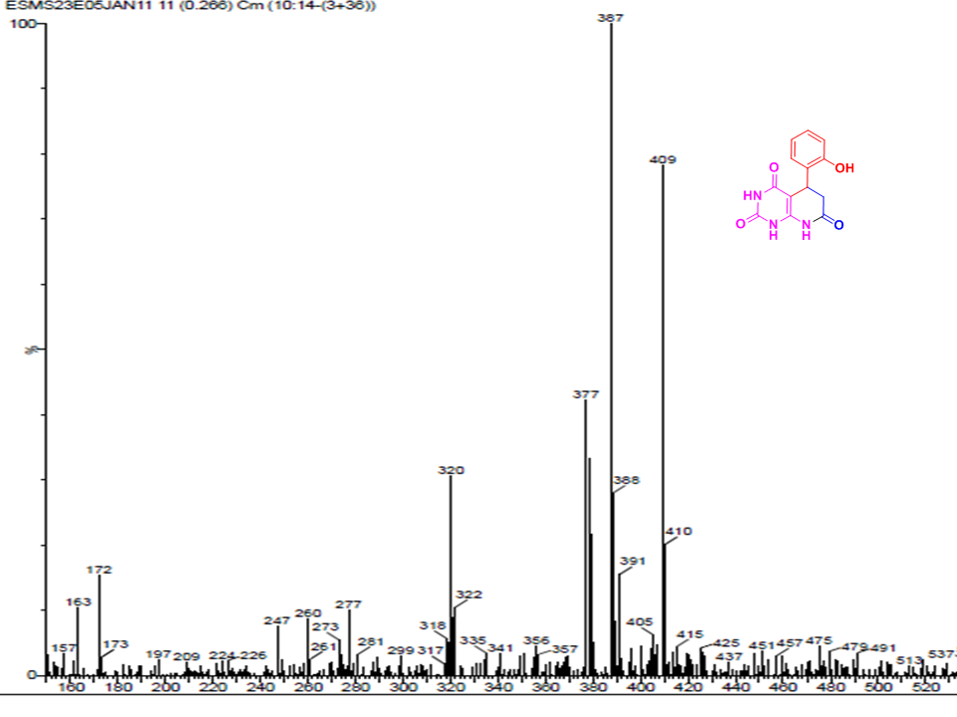
IR spectrum of Compound (6a)
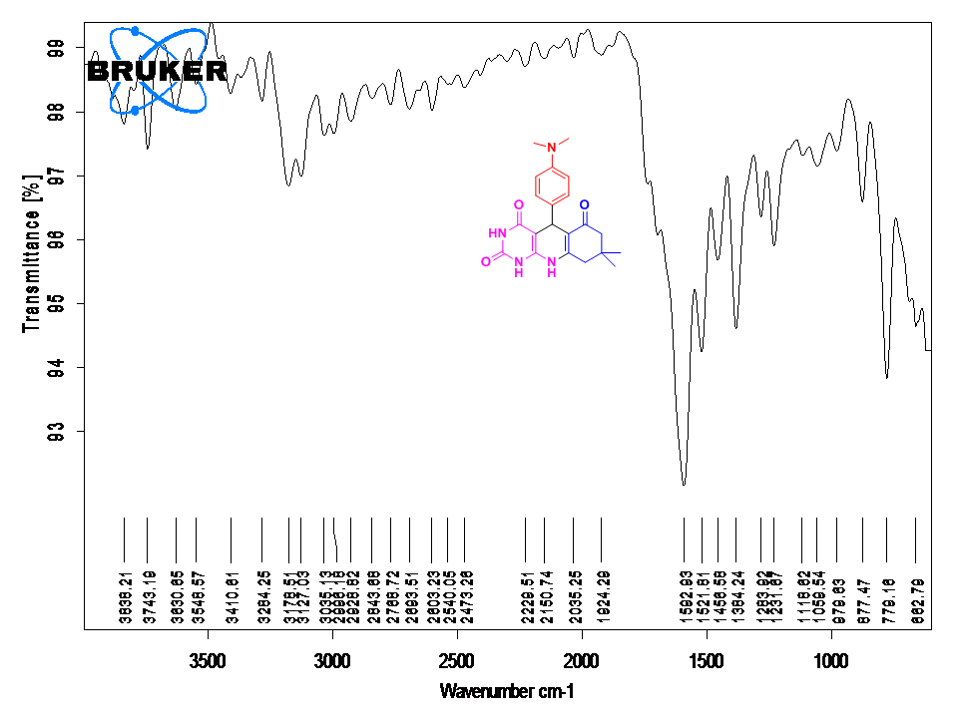
¹H NMR of Compound (6a)
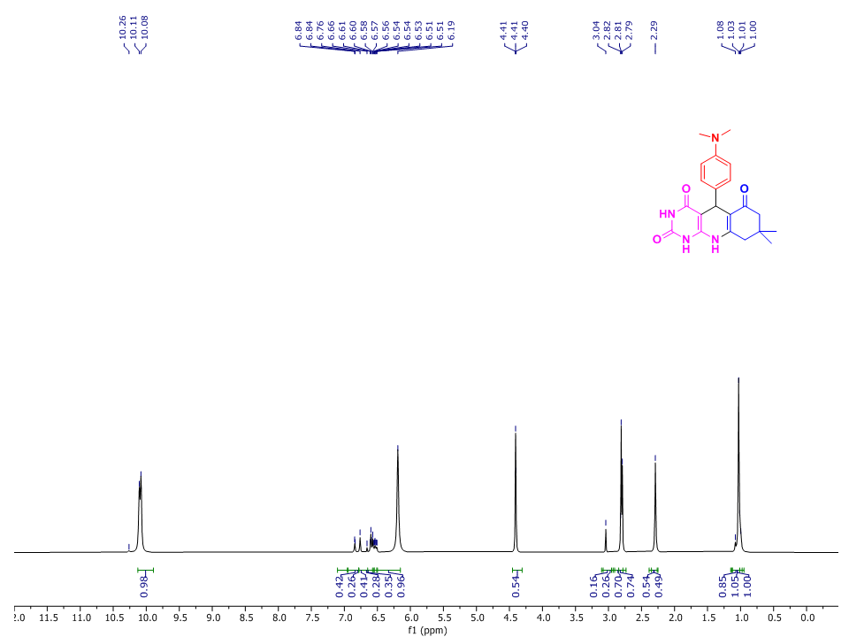
¹³C NMR of Compound (6a)
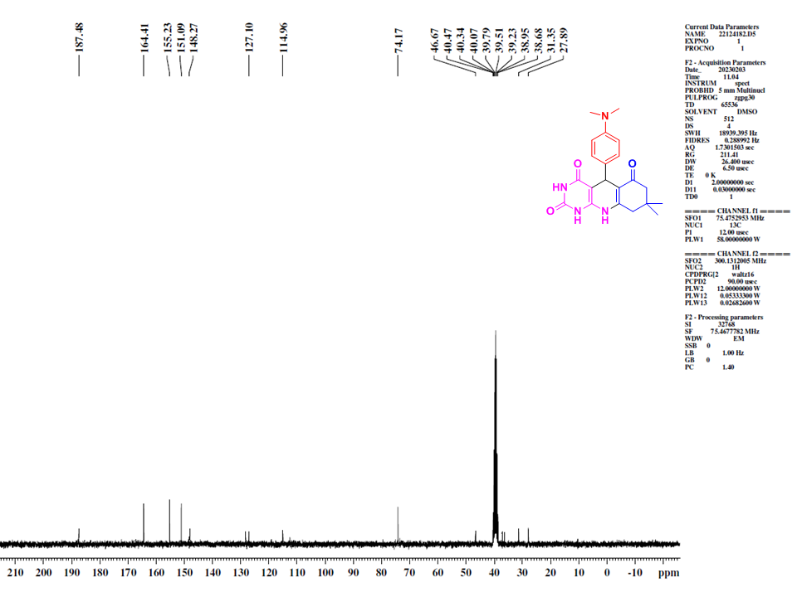
Mass of Compound (6a)
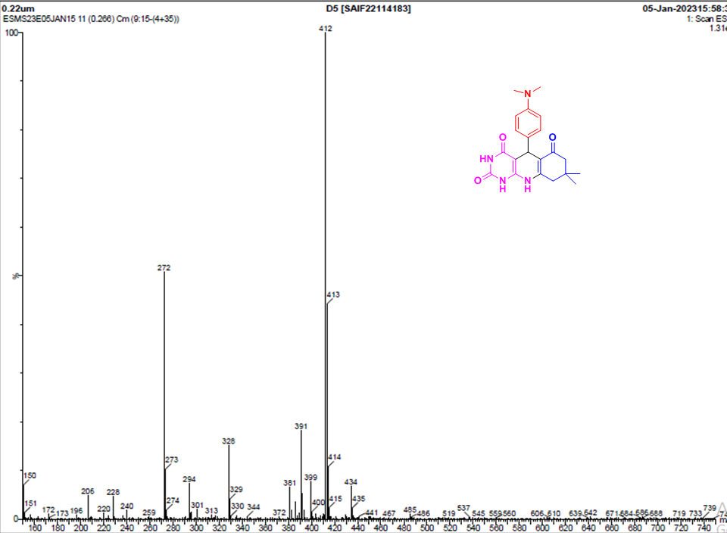
IR spectrum of Compound (6b)
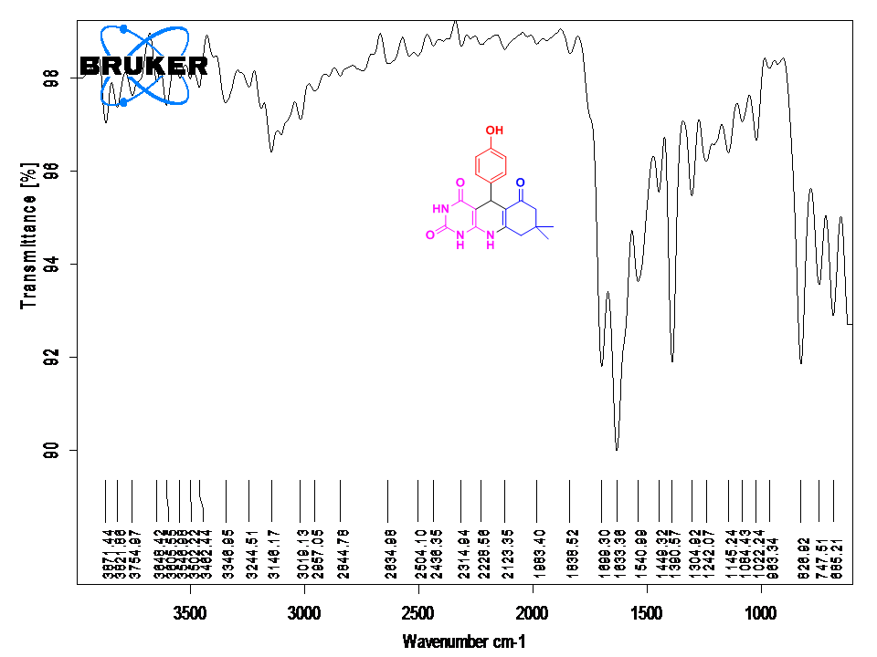
¹H NMR of Compound (6b)
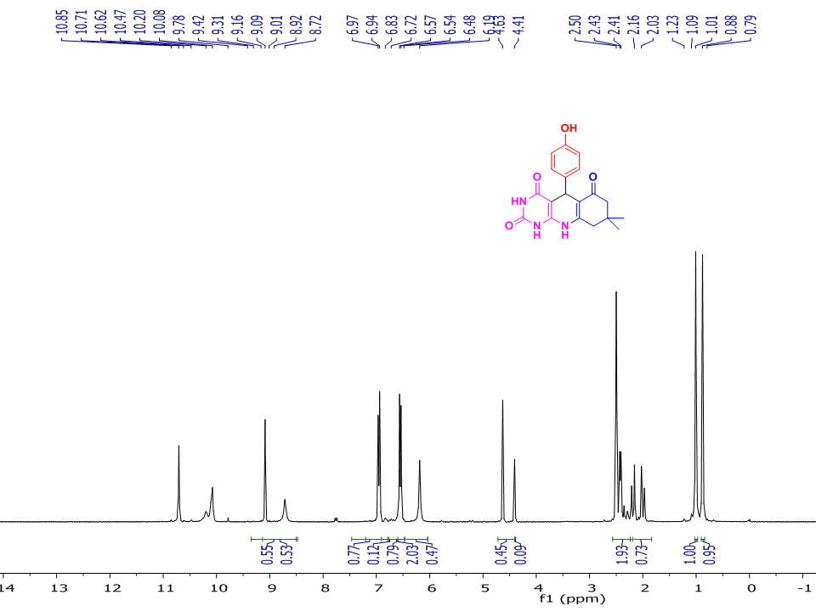
¹³C NMR of Compound (6b)
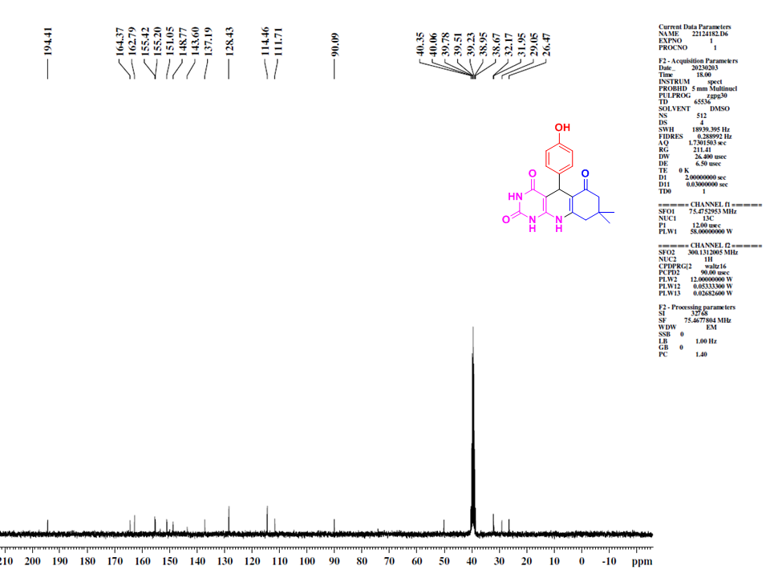
Mass of Compound (6b)
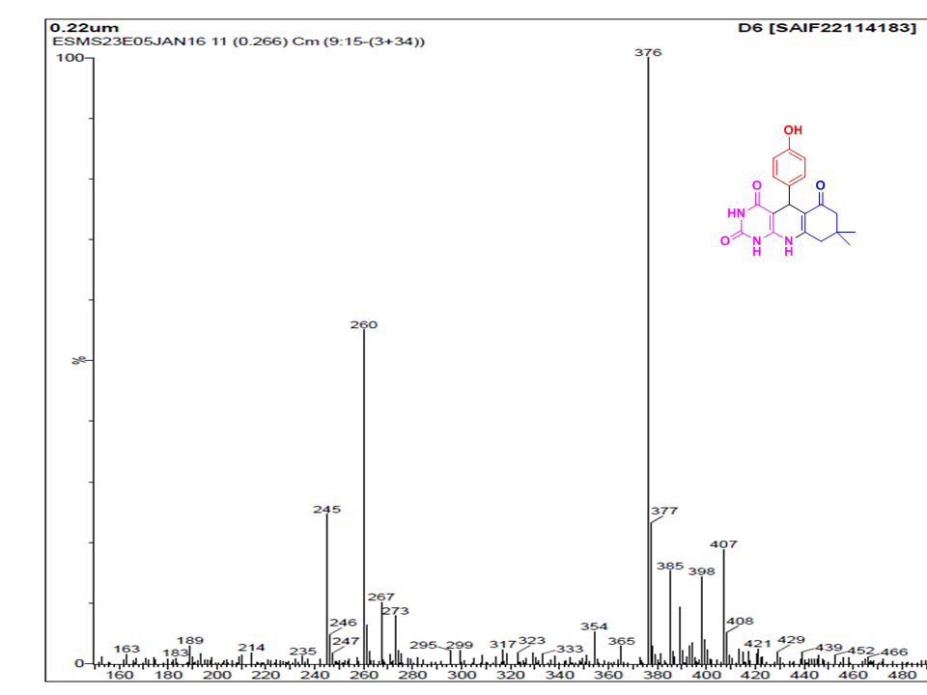

IR spectrum of Compound (6c)
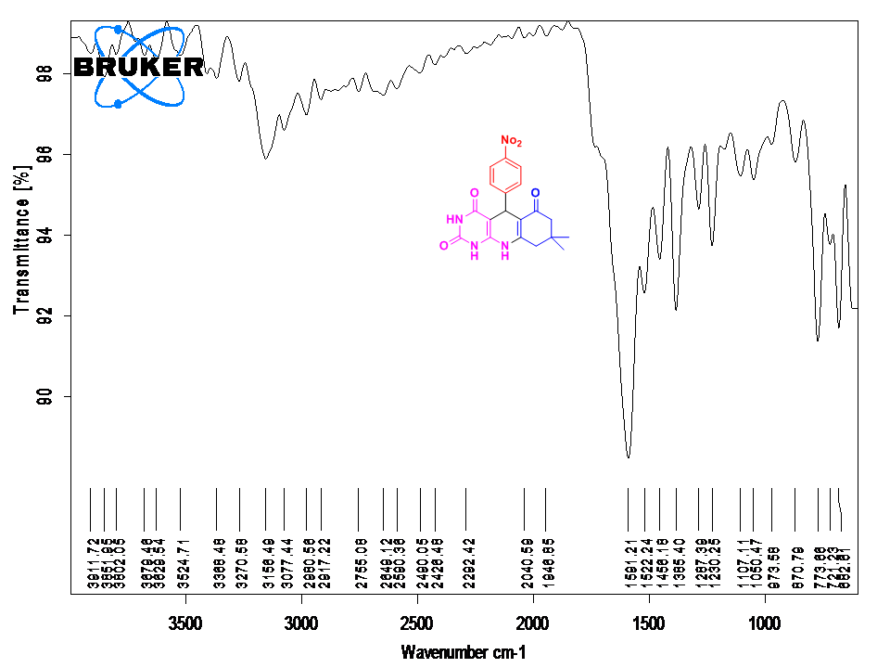
¹H NMR of Compound (6c)
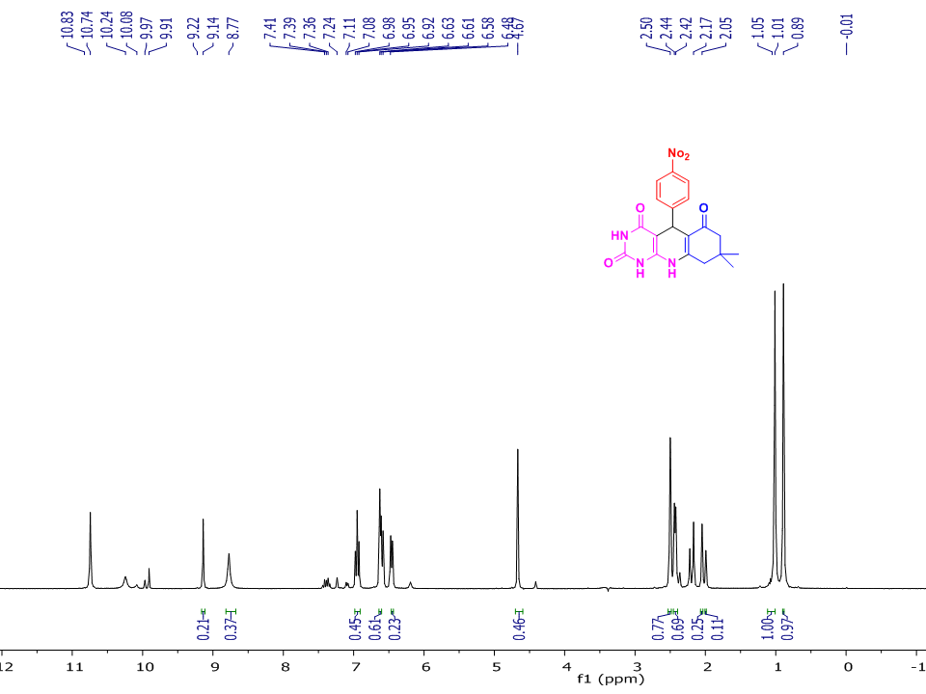
¹³C NMR of Compound (6c)
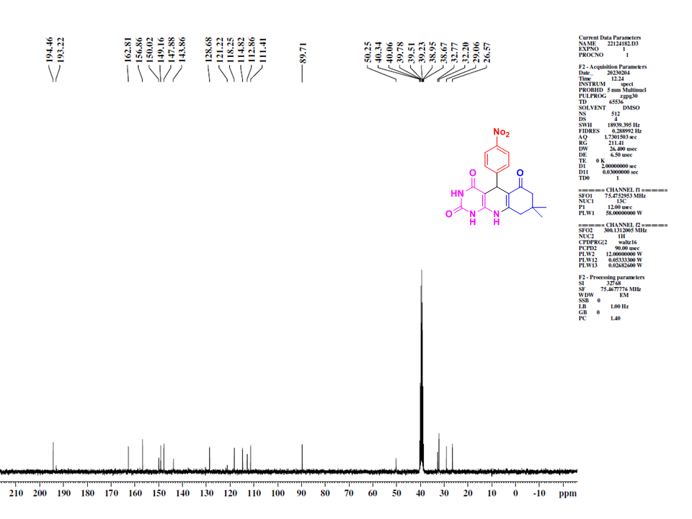

Mass of Compound (6c)
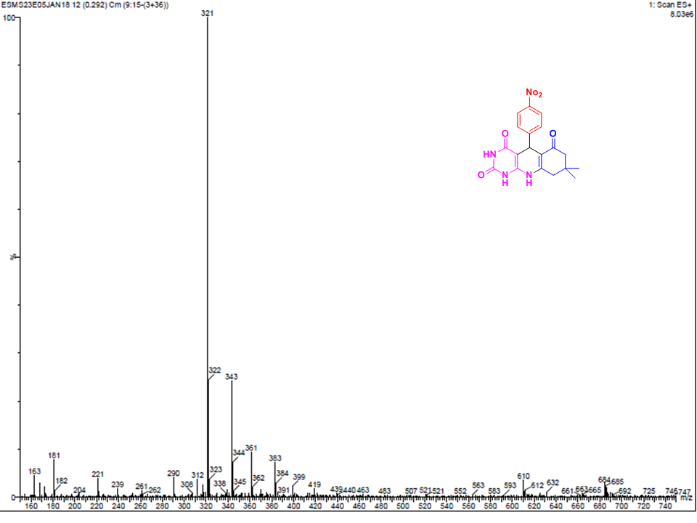
IR spectrum of Compound (6d)
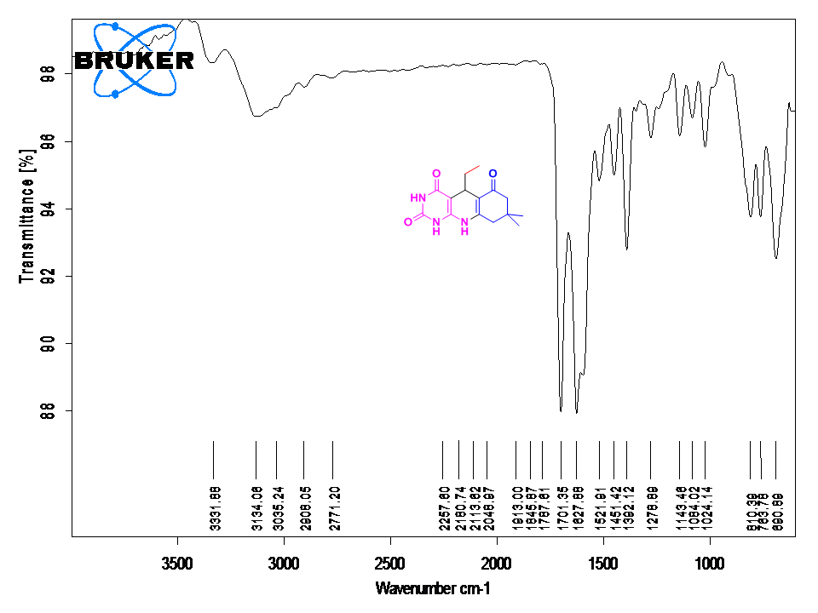
¹H NMR of Compound (6d)
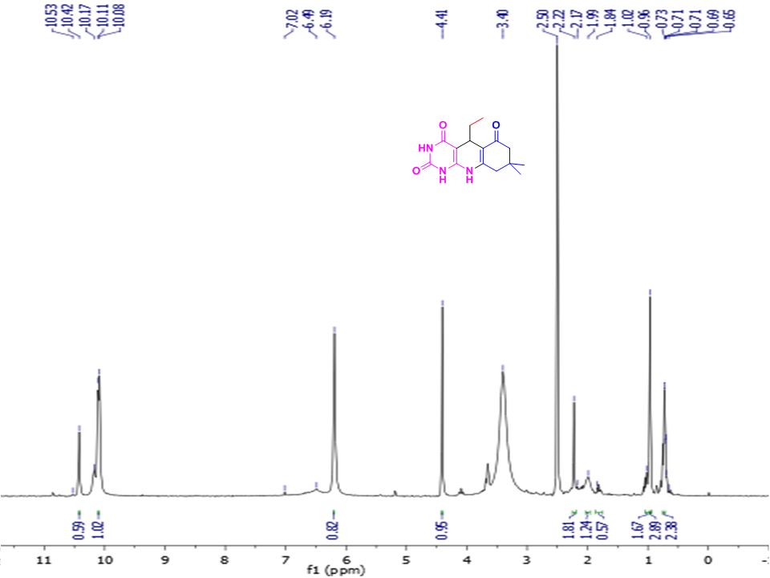
¹³C NMR of Compound (6d)
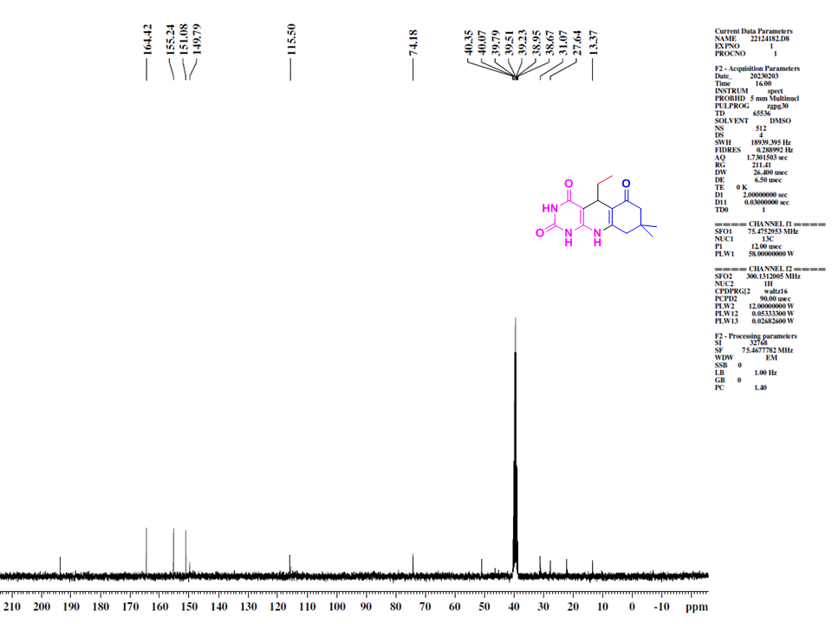
Mass of Compound (6d)
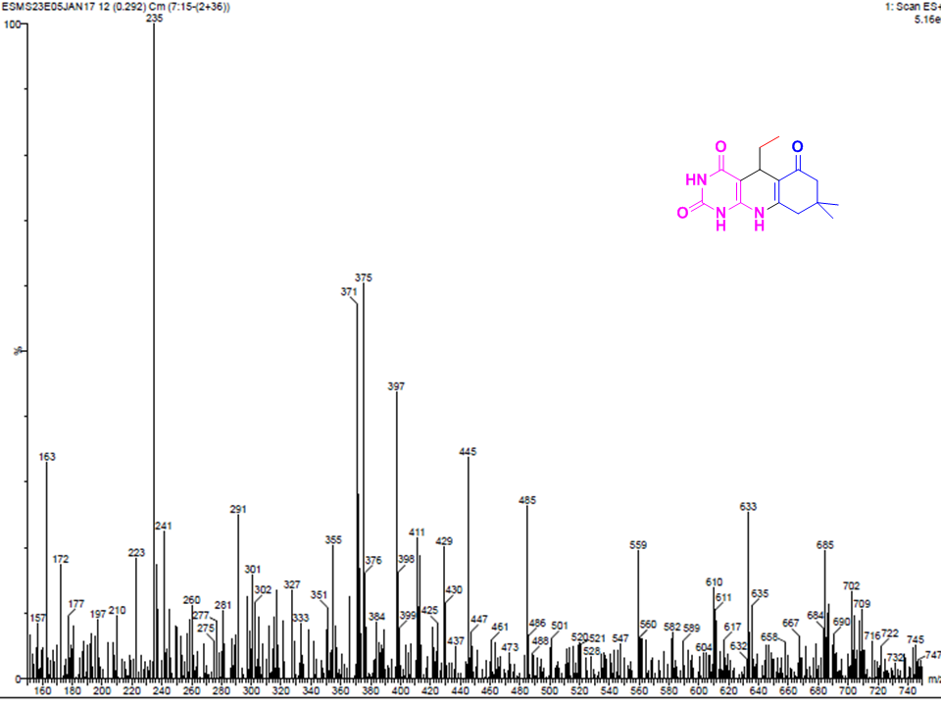
IR spectrum of Compound (6e)
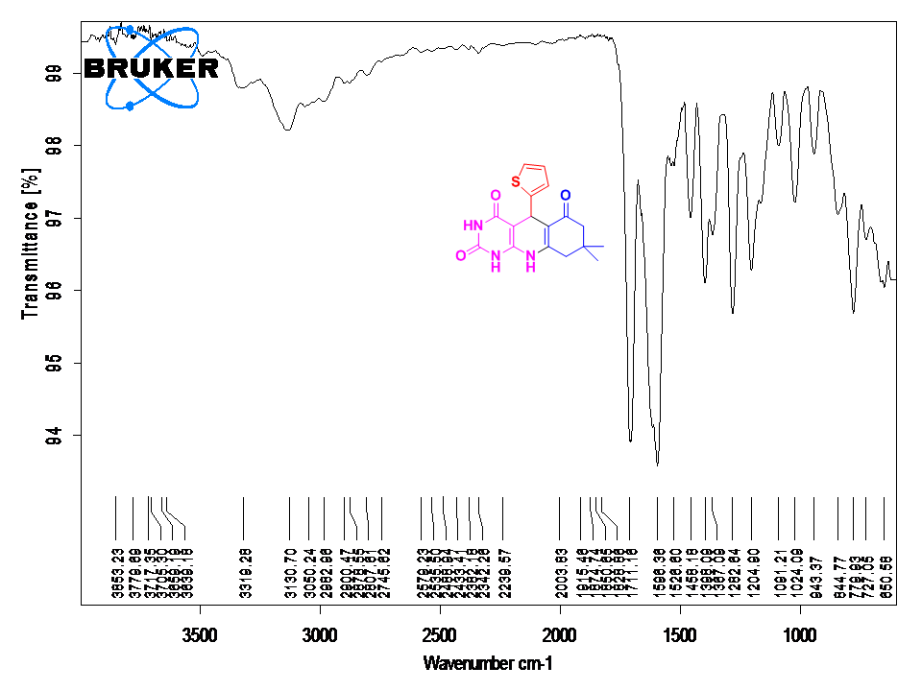
¹H NMR of Compound (6e)
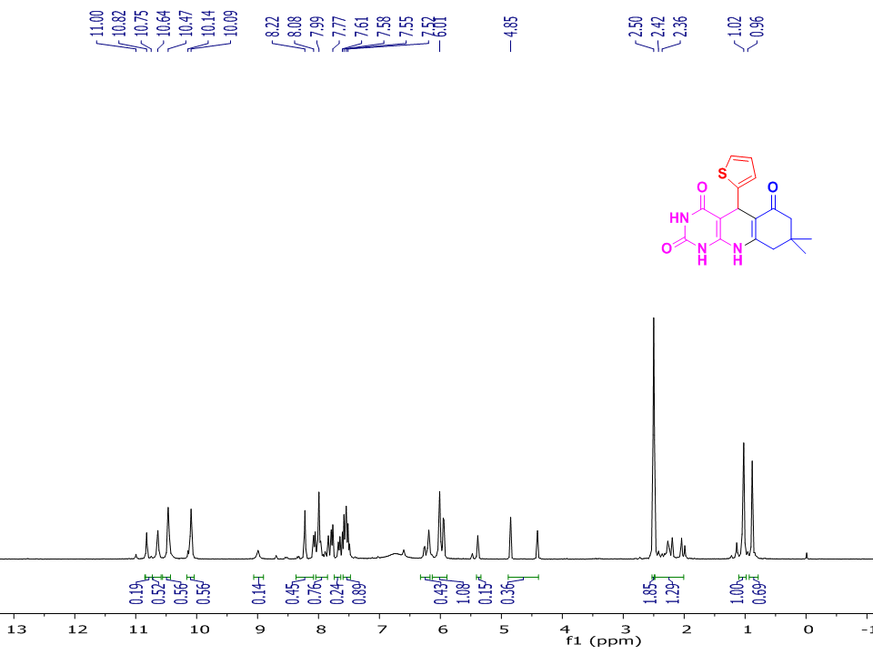
¹³C NMR of Compound (6e)
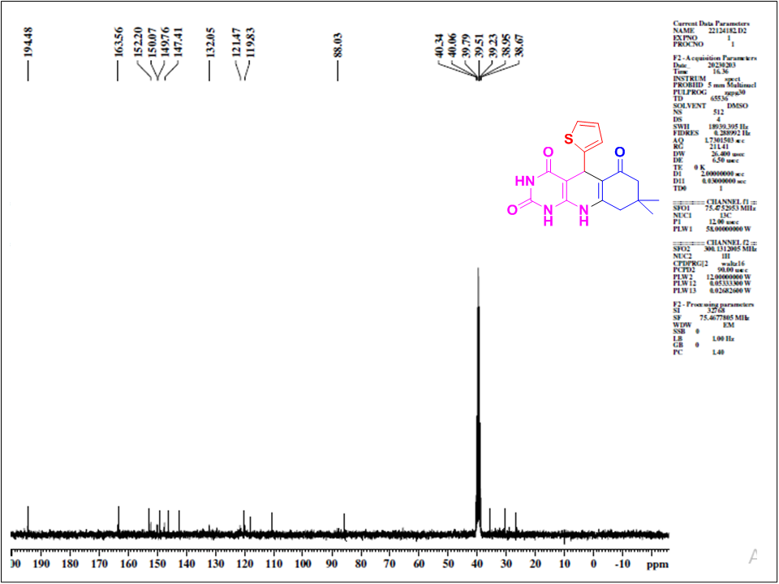

Mass of Compound (6e)
