Table 1. Optimization of solvent, catalyst, temperature for the synthesis of 5-phenyl-5,6-dihydropyrido[2,3-d] pyrimidine 2,4,7 (1H,3H,8H)- trione (4m).
Entry | Catalyst | Solvent | Catalyst loading  (mol%) | Time in minute | Yield (%)
1  2  3  4  5  6  7  8  9  10  11  12  13  14  15 | -  PEG-400  Dicationic ionic liquid  ChCl.ZnCl₂  CTAB  P-TSA  L- Proline  Taurine  Taurine  Taurine  Taurine  Taurine  Taurine  Taurine  Taurine | H₂O  PEG-400  Dicationic ionic liquid  ChCl.ZnCl₂  H₂O  H₂O  H₂O  H₂O/Reflux  H₂O  H₂O/US/rt  EtOH (US)  EtOH : H₂O (US)  CH₃CN (US)  DCM (US)  MeoH (US) | -  -  -  -  25  25  25  25  10,15,20,25  25  25  25  25  25  25 | 120  180  150  180  120  100  90  150  45  45  45  45  45  45  45 | 0  60  72  68  45  50  60  75  60,75,90 and 95  95  65  70  No Reaction  No Reaction  58
ªReaction Conditions: Substituted benzaldehyde 1m (1 mmol), 6-amino uracil 2 (1 mmol), meldrum's acid 3 (1 mmol), Water (15 ml) ^{b}Isolated yield, ^{c}rt-room temperature, ^{d}US-ultrasonication.

Table 2. Physical data of 5-phenyl-5,6dihydropyrido[2,3-d] pyrimidine 2,4,7 (1H,3H,8H)-trione derivatives (4a-p).
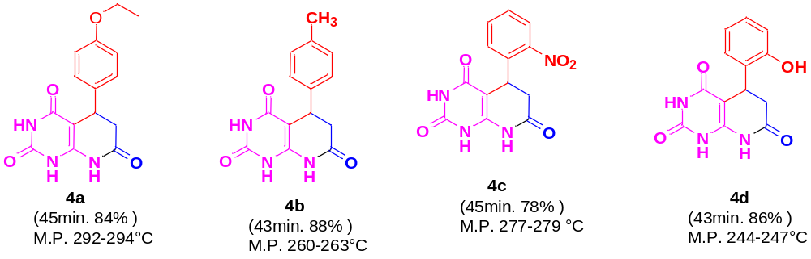
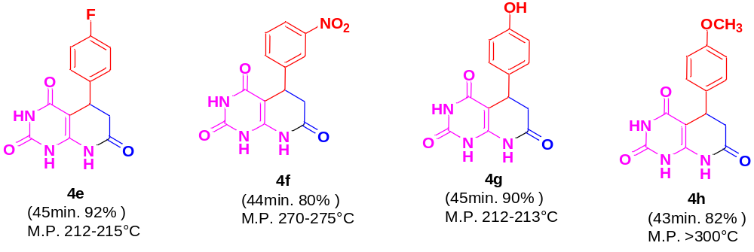
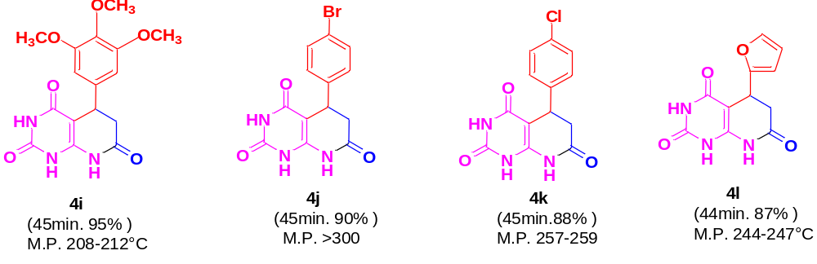
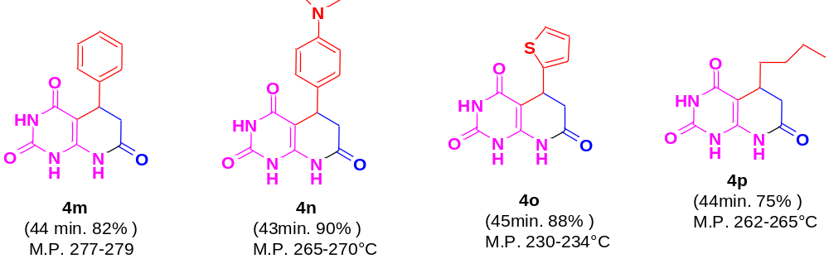
ªReaction Conditions: Substituted benzaldehyde 1m (1 mmol), 6-amino uracil 2 (1 mmol), meldrum's acid 3 (1 mmol), Taurine, Water (15 ml) ^{b}Isolated yield.

Table 3. Synthesis of 5-(phenyl)-8,9-dihydro-8,8-dimethylpyrimido[4,5-b]quinoline-2,4,6-(1H,3H,5H,7H,10H)-trione (6a-j)
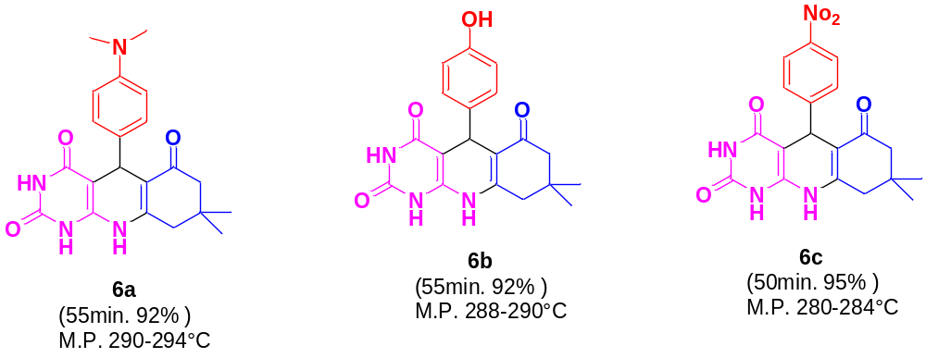
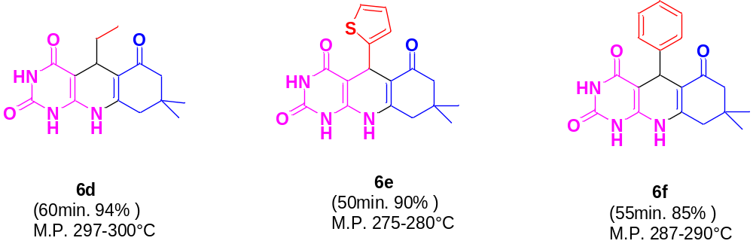
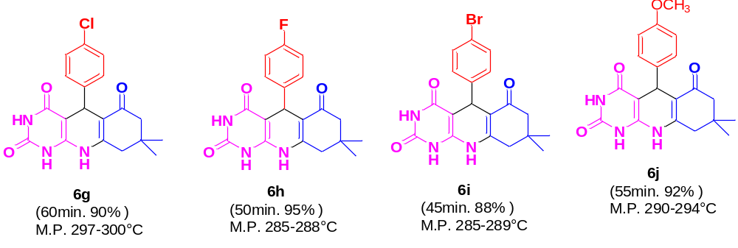

ªReaction Conditions: Substituted benzaldehyde 1a-j (1 mmol), 6-amino uracil 2 (1 mmol), dimedone 5 (1 mmol), Taurine, Water (15 ml) ^{b}Isolated yield.

