Table 1. Investigation on the Impact of Different Oxidants^{[a]}
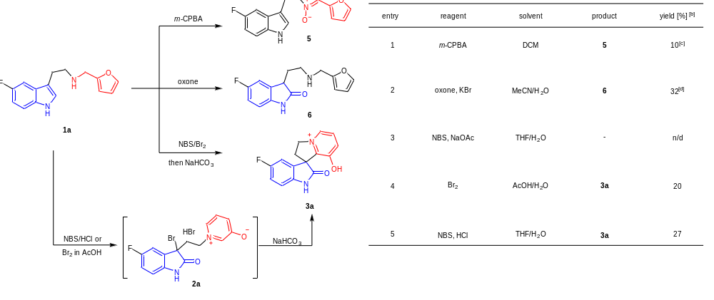
[a] Reactions conducted on 0.2 mmol of 1a. [b] Determined by ¹H NMR using 1,3,5-trimethoxybenzene as an internal standard. [c] Isolated yield of 5. [d] Isolated yield of 6. n/d = not detected. m-CPBA = meta-chloroperoxybenzoic acid, DCM = dichloromethane, THF = tetrahydrofuran, HCl = hydrochloride acid.

Table 2. Optimization of the Reaction Conditions^{[a], [b]}
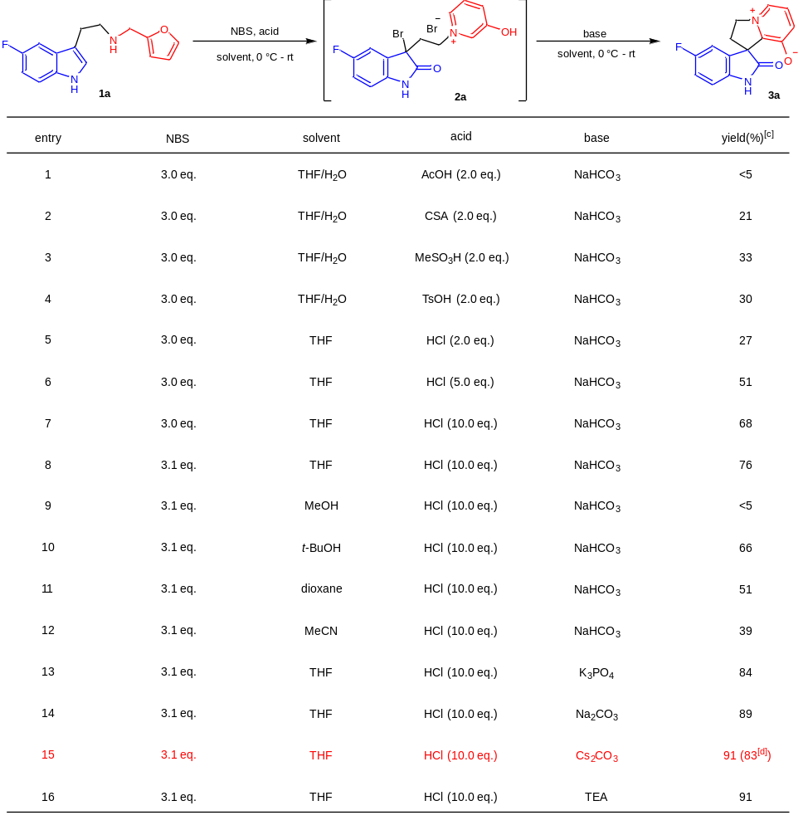
[a] Reaction conditions: substrate 1a (0.2 mmol), solvent (0.1 M) at 0 °C for 30 min; HCl (2.5 M in H₂O). [b] Then the reaction mixture was added dropwise to the base solution (0.05 M in H₂O). [c] Determined by ¹H NMR using 1,3,5-trimethoxybenzene as an internal standard. [d] Isolated yield. CSA = camphorsulfonic acid, TsOH = para-toluenesulfonic acid, TEA = triethylamine

Table 3. Substrate Scope^{[a], [b]}
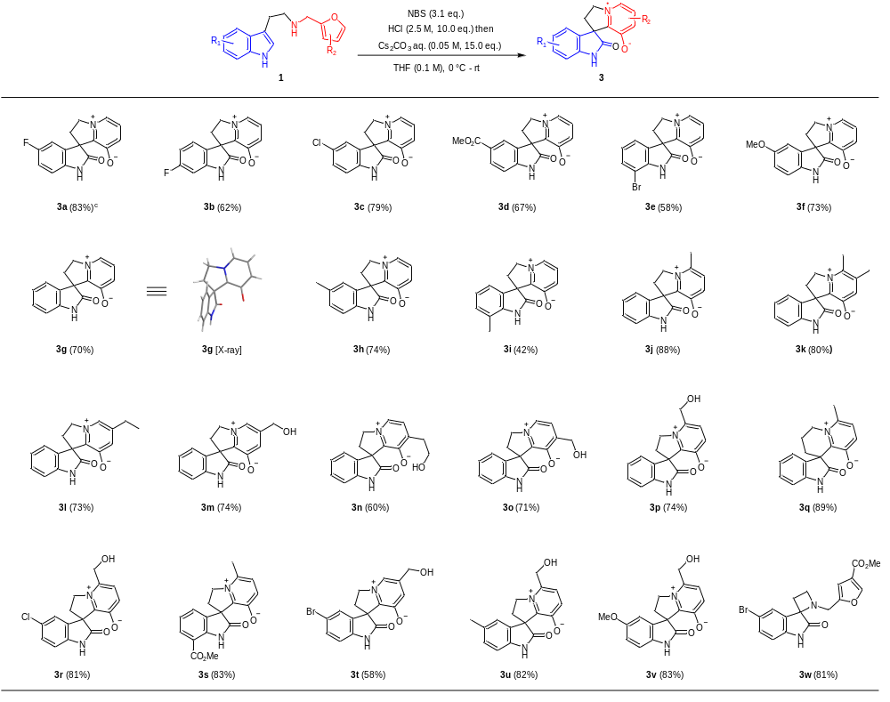
[a] Reaction conditions: substrate (0.2 mmol), NBS (0.63 mmol), HCl (2.0 mmol, 2.5 M in H₂O), THF (0.1 M) at 0 °C or -5 °C for 0.5 h to 2 h (depends on the complete transformation of 1. [b] Then the reaction mixture was dropwise to Cs₂CO₃ aqueous solution (3.0 mmol, 0.05 M in H₂O). [c] Isolated yields.

Table 4. Optimization of the carbene insertion^{[a]}
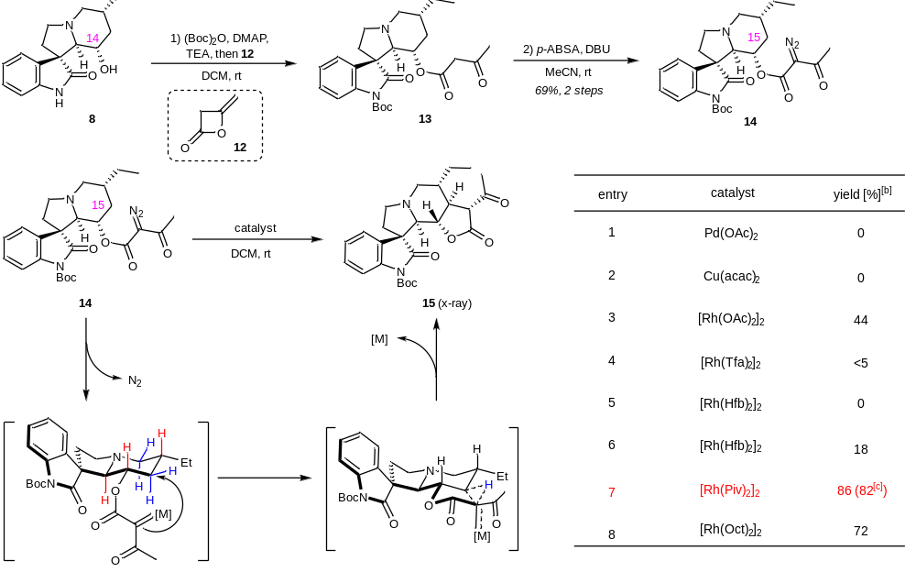
[a] Reaction conditions: substrate (0.04 mmol), catalyst (2 mol %), DCM (0.04 M) at rt for 0.5 h. [b] Determined by ¹H NMR yield using 1,3,5-trimethoxybenzene as an internal standard. [c] Isolated yield. Cu(acac)₂ = cupric acetylacetonate, [Rh(Hfb)₂]₂ = rhodium(II) heptaflurobutyrate dimer, [Rh(Tpa)₂]₂ = rhodium(II) triphenylacetate dimer, [Rh(Piv)₂]₂ = rhodium(II) trimethylacetate dimer, [Rh(Oct)₂]₂ = rhodium(II) octanoate dimer.

