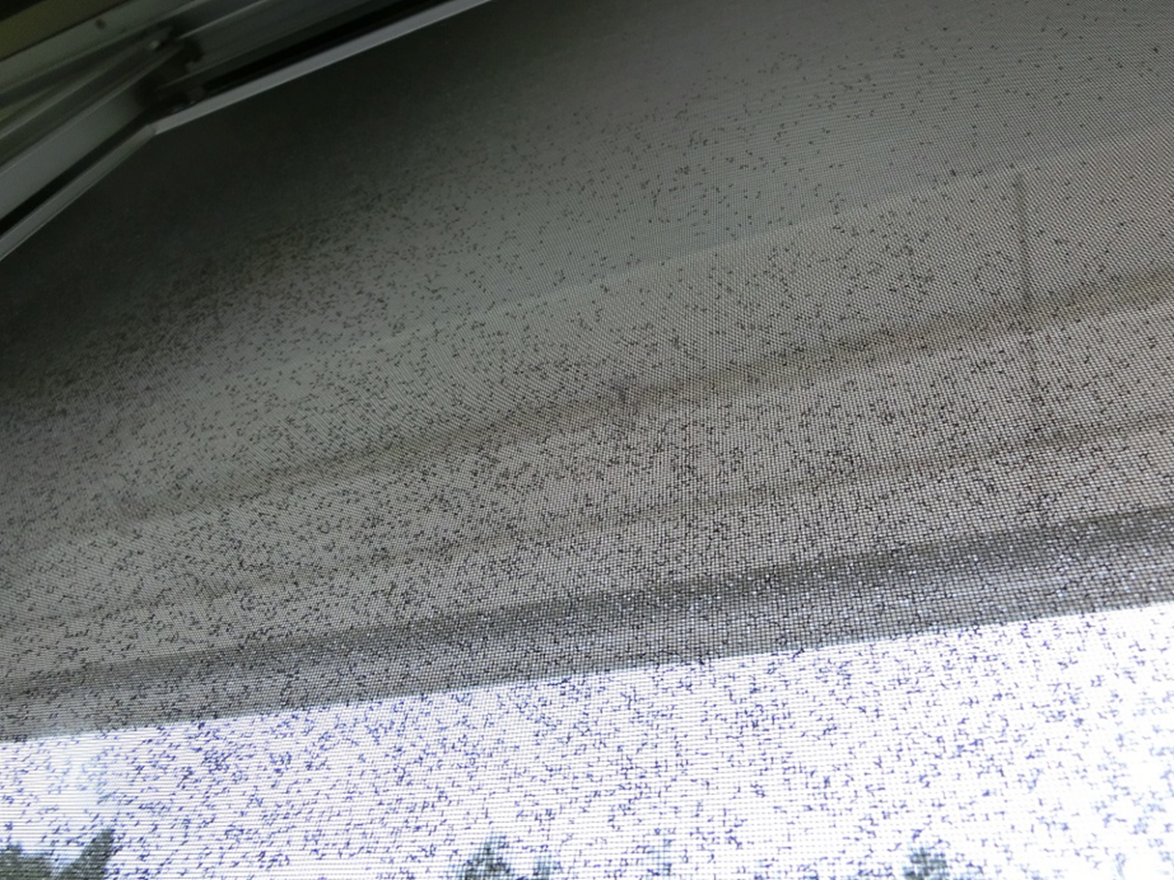
Supplementary Figure S1 Swarmed Hyperlasion breviantenna to a mosquito screen (July 6th 2018, at the building of the Ichinokura Elementary School).
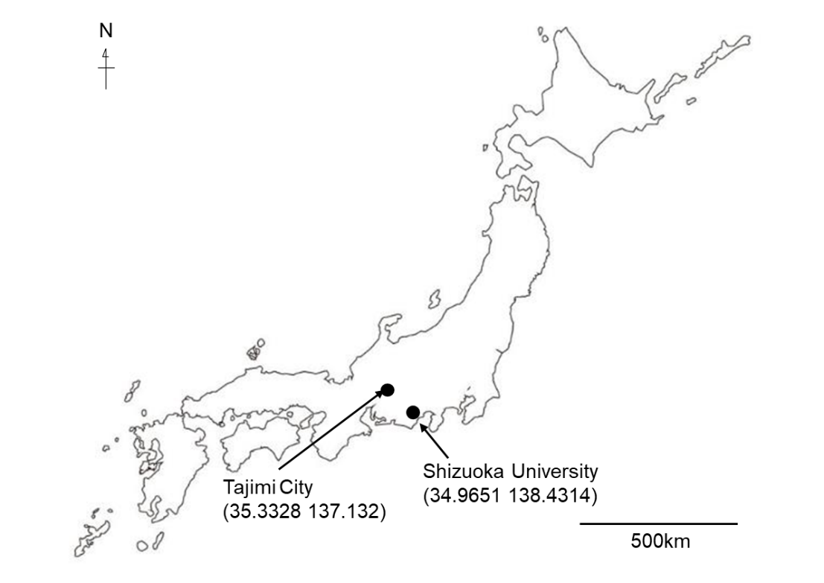
Supplementary Figure S2 Locations of investigated sites, Shizuoka University, Shizuoka (2007-2008) and Tajimi City, Gifu (2020-2022), Japan, in this study.
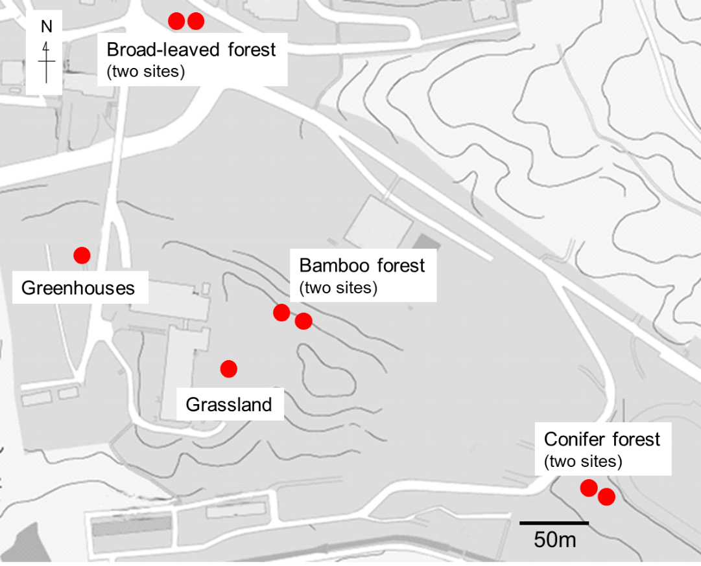
Supplementary Figure S3 Location of the yellow and blue sticky traps used in Shizuoka University, Shizuoka, 2008.
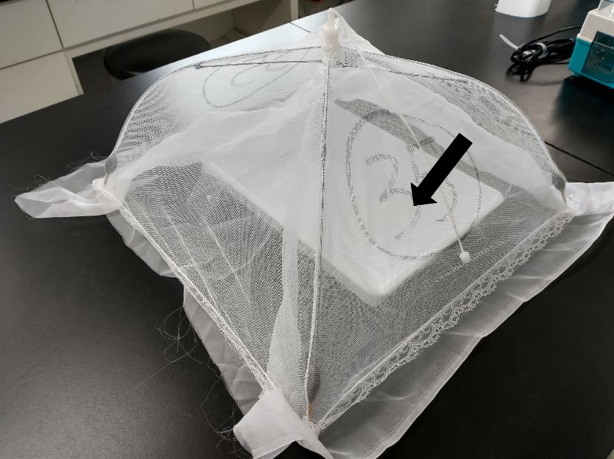
Supplementary Figure S4 Emergence trap used in this study. A white water pan (arrow) is inside of a mesh net.
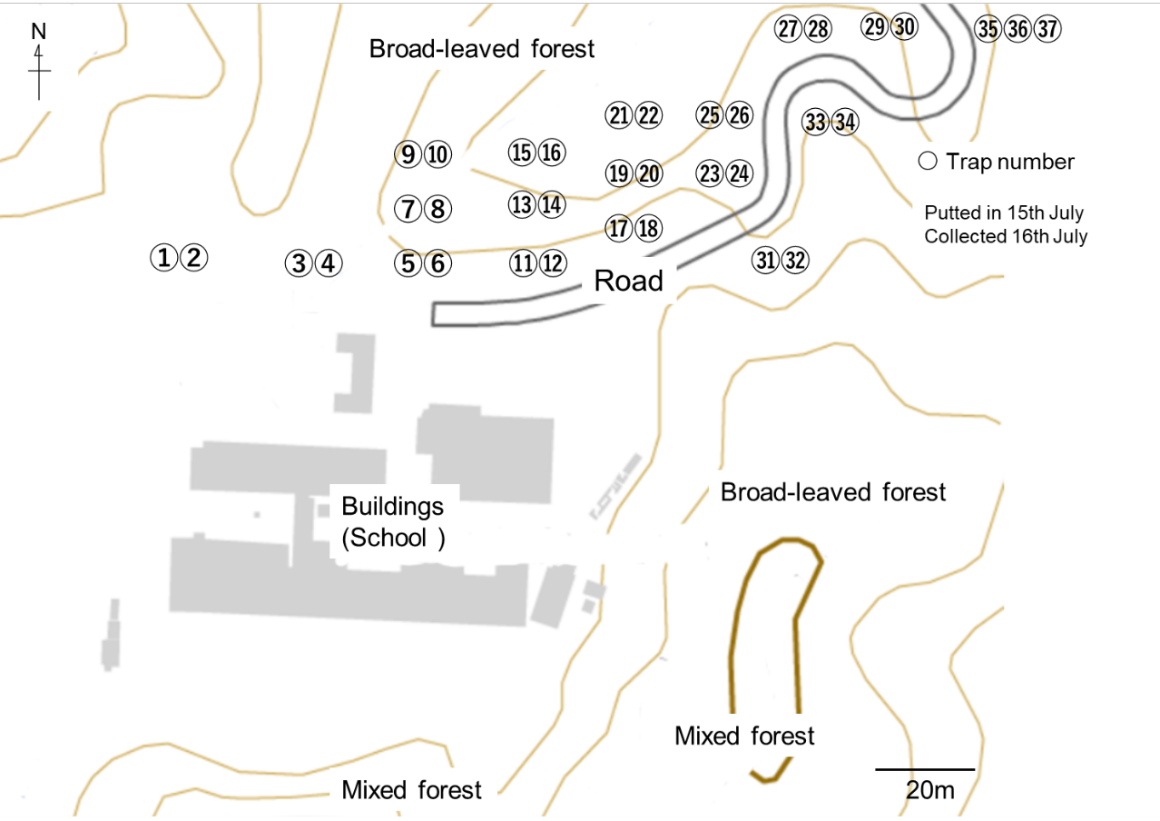
Supplementary Figure S5 Arrangements of 37 emergence traps set in the forests around Ichinokura Elementary School, Tajimi City, Gifu, on the 15th July, 2020.
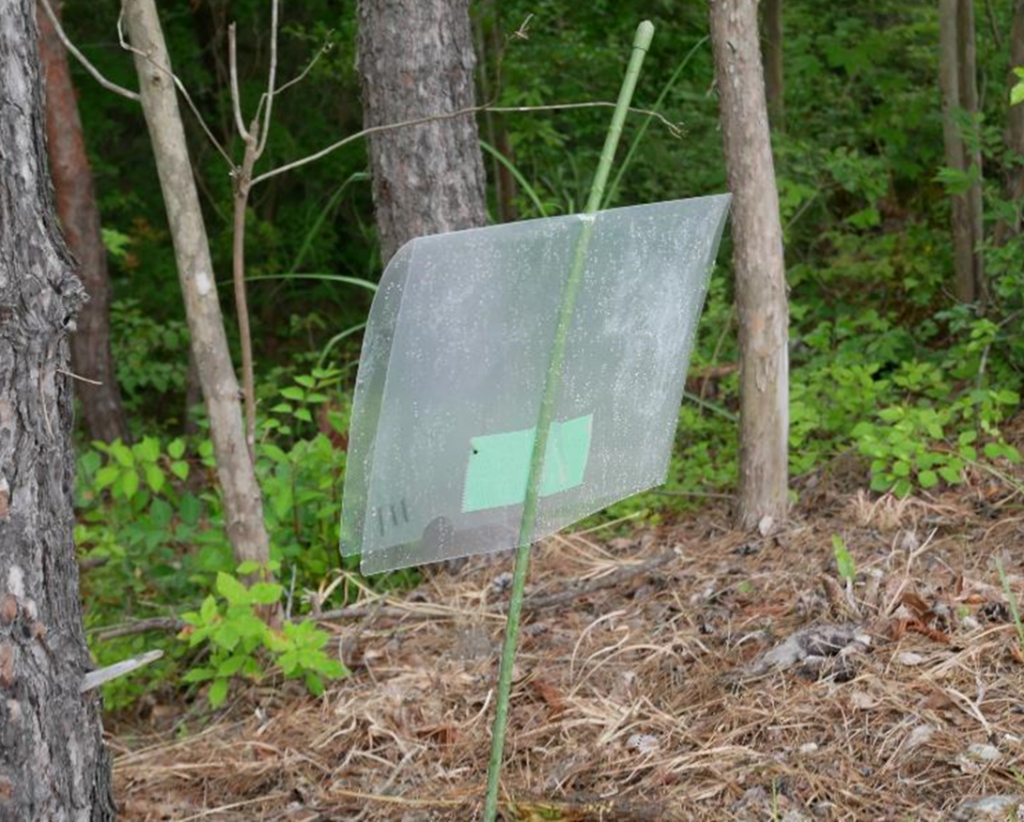
Supplementary Figure S6 Hyaline sticky trap used at the forest edge in Ichinokura Elementary School, Tajimi-City, Gifu, Japan.
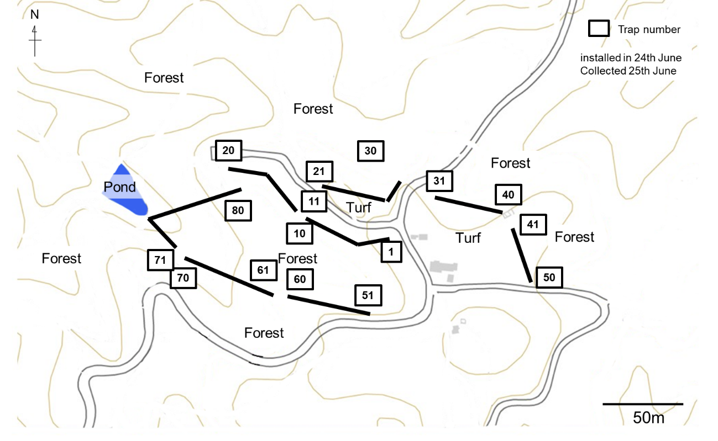
Supplementary Figure S7 Arrangements of 80 hyaline sticky traps installed in forest of Shiominomori Park, Tajimi City, Gifu, on 24th June, 2021.
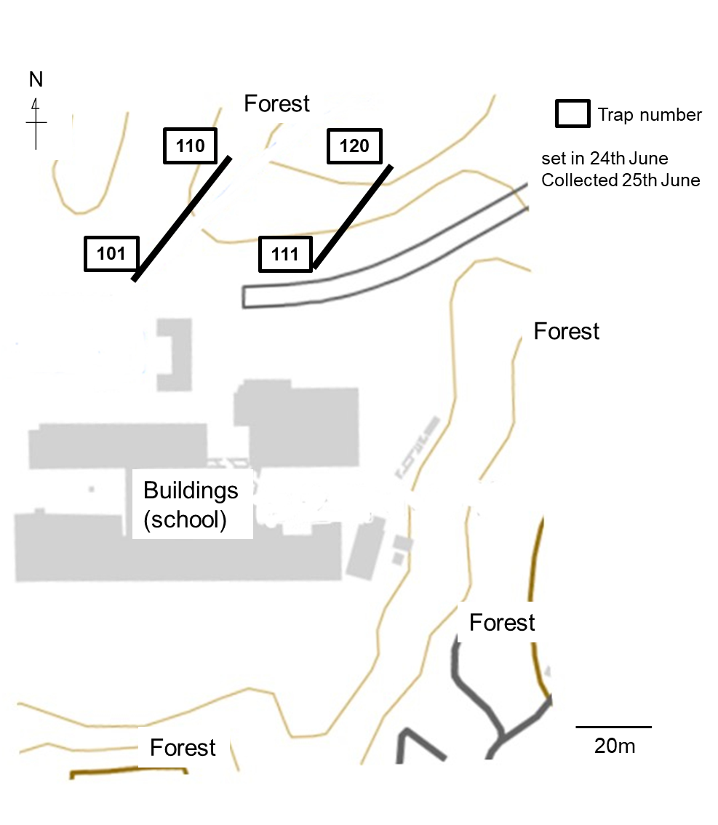
Supplementary Figure S8 Arrangement of 20 hyaline sticky traps set in the forest north of Ichinokura Elementary School, Tajimi City, Gifu, on 24th June, 2021.
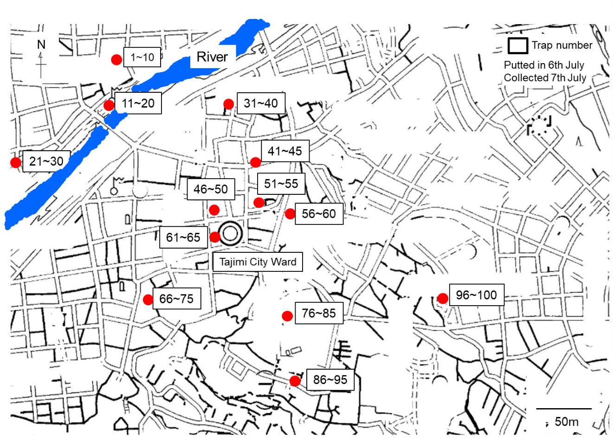
Supplementary Figure S9 Arrangement of 100 hyaline sticky traps used in the urban area of Tajimi City, Gifu on 6th July 2022. Investigated points are marked in red. All collected points are close to small garden, parks, and woodlands.
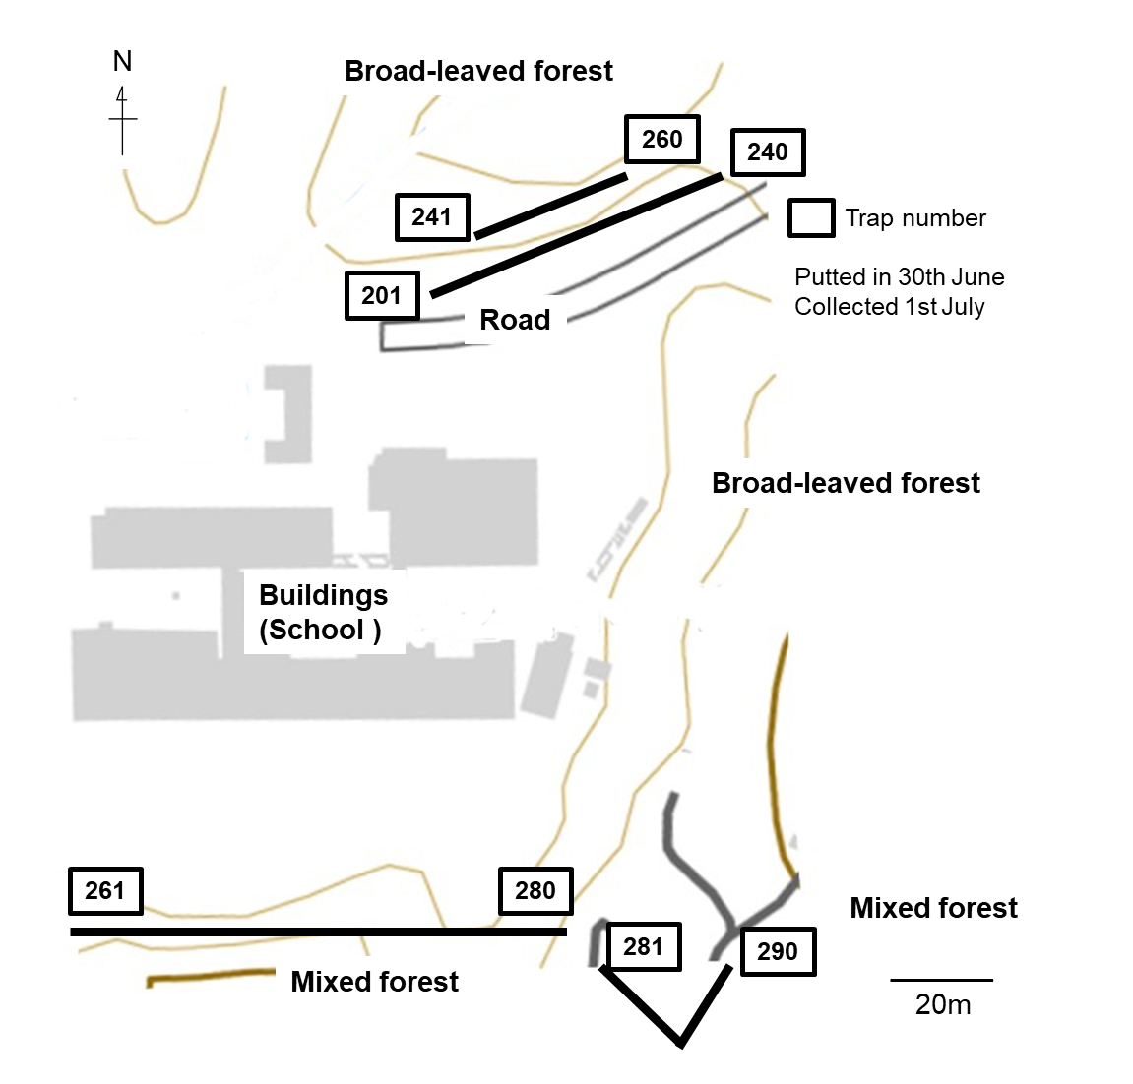
Supplementary Figure S10 Arrangement of 90 hyaline sticky traps set in two different forests around the Ichinokura Elementary School, Tajimi City, Gifu, on June 30th 2021.

