Supplementary Table 1: Consistency analysis of CD39 expression by gp70 tet⁺CD8⁺T cells in 4T1 and 4T1.2 mouse models
 | CD39⁺gp70⁺ (%) | gp70⁺ (%) | Possibility _{(CD39}⁺_{gp70}⁺_{|gp70}⁺₎
4T1
Total (n = 13609) | 4851 (35.7) | 4879 (35.9) | 0.994
PBMCs (n = 6345) | 2418 (37.0) | 2431 (38.3) | 0.995
TILs (n = 7264) | 2433 (33.5) | 2448 (33.7) | 0.994
4T1.2
Total (n = 62889) | 7166 (11.4) | 7176 (11.4) | 0.999
PBMCs (n = 54731) | 5350 (9.8) | 5357 (9.8) | 0.999
TILs (n = 8158) | 1816 (22.3) | 1819 (22.3) | 0.998

n, counts of CD8⁺T cell gated in PBMCs or TILs from either 4T1 mice or 4T1.2 mice.
Supplementary Table 2: Demographic summary of cohorts
Factors | CD39⁺ infiltrates |  |  | CD39⁺CD8⁺ infiltrates
Age at diagnosis (years, mean ± SD) | High | Low | P-value | High | Low | P-value
Age at diagnosis (years, mean ± SD) | 55.4 (12.5) | 53.6 (10.5) | 0.2700 | 55.1 (12.4) | 54.9 (11.5) | 0.8896
Tumor Size (n, %) |  |  | 0.6568 |  |  | 0.9528
≤10 mm | 10 (3.5) | 2 (2.8) |  | 9 (3.5) | 3 (3.0)
>10 mm | 273 (95.5) | 69 (97.2) |  | 246 (95.7) | 96 (96.0)
Tumor Grade (n, %) |  |  | 0.2980 |  |  | 0.5597
1/2 | 46 (16.1) | 10 (14.1) |  | 37 (14.4) | 19 (19.0)
3 | 238 (83.2) | 59 (83.1) |  | 217 (84.4) | 80 (80.0)
Lymph Node Stage  (n, %) |  |  | 0.0171 |  |  | 0.6085
0 | 89 (31.2) | 29 (40.9) |  | 79 (30.7) | 39 (39.0)
1 | 38 (13.3) | 10 (14.1) |  | 36 (14.0) | 12 (12.0)
2 | 18 (6.3) | 10 (14.1) |  | 21 (8.2) | 7 (7.0)
3 | 11 (3.9) | 4 (5.6) |  | 10 (3.9) | 5 (5.0)
Ethnicity (n, %) |  |  | 0.4461 |  |  | 0.7713
Chinese | 222 (77.6) | 55 (77.5) |  | 196 (76.3) | 81 (81.0)
Indian | 17 (5.9) | 5 (7.0) |  | 16 (6.2) | 6 (6.0)
Malay | 21 (7.3) | 2 (2.8) |  | 18 (7.0) | 5 (5.0)
Others | 26 (9.1) | 9 (12.7) |  | 27 (10.5) | 8 (8.0)

Supplementary Table 3: Antibodies used for multiplex immunohistochemistry
Primary antibody | Manufacturer | Clone | Cat#
CD3 | Dako | Polyclonal | A0452
CD8 | Leica Biosystems | 4B11 | NCL-L-CD8-4B11
CD39 | OriGene | OT12B10 | TA804559
CD68 | Dako | PGM1 | M0876
FoxP3 | Abcam | 236A/E7 | ab20034

Supplementary Table 4: Antibodies used for flow cytometric analysis of TNBC samples
Fluorochrome | Marker | Manufacturer | Clone | Cat#
BV480 | TCRgd | BD | B1 | 566076
Pac Orange | CD45 | Invitrogen | HI30 | MHCD4530
BV570 | CD8a | BioLegend | RPA-T8 | 301038
BV750 | CD4 | BD | SK3 | 566355
BB515 | CD11c | BD | B-ly6 | 564490
Alexa 532 | CD3 | Invitrogen | UCHT1 | 58-0038-42
PE | CD25 | BioLegend | M-A251 | 356104
PE-CF594 | CD39 | BD | TU66 | 563678
PerCP-Cy5.5 | CD11b | BioLegend | ICRF44 | 301328
PE-Cy7 | CD68 | Invitrogen | eBioY1/82A | 25-0689-42
Zombie NIR | L/D | BioLegend | - | 423106
APC-Fire 750 | HLA-DR | BioLegend | L243 | 307658

Supplementary Table 5: Reagents used for flow cytometric analysis of mouse samples
Marker | Fluorochrome | Manufacturer | Clone | Cat#
CD39 | PE-Cy7 | Invitrogen | 24DMS1 | 25−0391−82
CD3e | APC | BioLegend | 145-2C11 | 100312
TCRb | PE-Cy5.5 | Invitrogen | H57-597 | A15410
CD8a | BV711 | BioLegend | 53-6.7 | 100748
CD4 | BV605 | BioLegend | RM4-5 | 100548
CD45 | APC-Cy7 | BD | 30-F11 | 557659
CD11c | BV570 | Genomax | N418 | 117331
CD11b | BV750 | BioLegend | M1/70 | 101267
F4/80 | APC-Fire 810 | BioLegend | BM8 | 123166
Live/Dead Fixable Blue | / | Invitrogen | / | L23105
H-2Ld  tetramer to  peptide SPSYVYHQF | PE | NIH | MuLV env gp70 423-  431 | /

Supplementary Figure 1. Classification of CD39 and gp70 tet expression in all CD8⁺ T cells from 4T1.2 tumor-bearing mice.
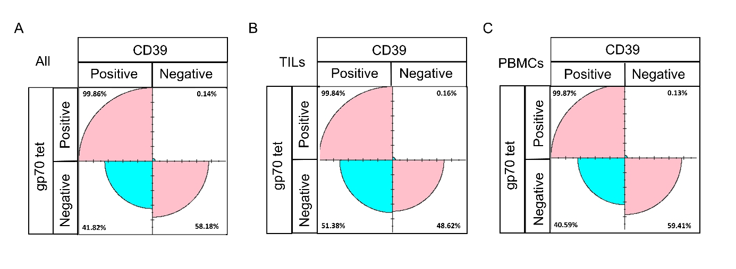
A. All CD8⁺ T cells gated from both TILs and PBMCs, B. CD8⁺ T cells gated from TILs, C. CD8⁺ T cells gated from PBMCs from 4T1.2 tumor-bearing mice. Numbers indicate the actual CD8⁺ T cells classified as DP, SP or NP CD8⁺ T cells.
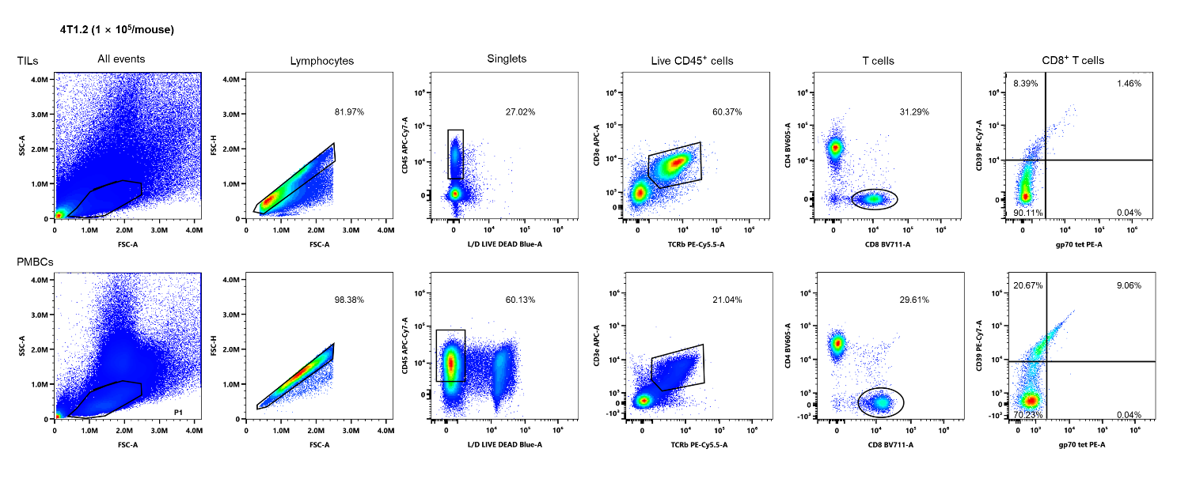
Supplementary Figure 2. Gating strategy and representative gp70 tetramer⁺ CD8⁺ T cells staining gated on live CD45⁺ of lymphocyte morphology in 4T1.2 mice experiment.

CD8⁺T cells were gated as the following strategy: Live CD45⁺ TCRγδ⁻CD3⁺CD8⁺ T cells. gp70 tet⁺CD8⁺T cells, CD39⁺CD8⁺T cells and double positive CD8⁺T cells were further gated by gp70tet positive, CD39 positive and gp70tet, CD39 double positive.

