Supplementary Methods
Restricted cubic spline (RCS)
RCS is a statistical technique used for modeling the dose response relationship between a predictor variable and a response variable. It is a flexible method that allows for non-linear relationships to be captured in the analysis. RCS works by dividing the predictor variable into several intervals or knots, and then fitting separate cubic spline functions within each interval. The cubic spline functions are piecewise-defined polynomials that are joined at the knots to create a smooth curve. The "restricted" part in RCS refers to the imposition of restrictions on the spline function. These restrictions are applied to ensure the linearity of the relationship beyond the extreme values of the predictor variable. This is done by constraining the estimated coefficients to be linear in certain intervals outside the range of the knots. RCS models provide flexibility in capturing both linear and non-linear associations between the predictor and response variables^{[1]}.
Nomogram model
A nomogram is a graphical tool used in statistics and predictive modeling to estimate the probability or risk of an event or outcome based on multiple predictor variables. It provides a visually intuitive way to interpret and communicate complex statistical models. A nomogram typically consists of a set of scales or axes, each representing a predictor variable. The values of the predictor variables are plotted on the corresponding axes, and a straight line is drawn to connect the values. The intersecting point of the lines represents the predicted probability or risk associated with that specific combination of predictor variables^{[2]}. Nomograms are often derived from regression models, in our study, nomogram was derived from logistic regression. The coefficients or regression parameters obtained from logistic regression were used to assign weights or values to the predictor variables on the nomogram scales. These weights reflect the relative contribution of each predictor variable to the outcome. The advantages of using a nomogram include its simplicity, ease of use, and facilitation of quick predictions. It allows users to visually assess the impact of different predictor variables and their interactions on the predicted outcome^{[3]}. Overall, a nomogram serves as a practical and effective tool for translating complex statistical models into readily interpretable and clinically relevant information.
Mediation analysis
Mediation analysis is a statistical technique used to explore the relationship between an independent variable and a dependent variable through one or more intermediate variables, known as mediators. It aims to assess whether the effect of the independent variable on the dependent variable is transmitted through the mediator(s), thereby uncovering the underlying causal mechanism of the relationship^{[4]}. The process of mediation analysis involves several steps. First, the direct effect of the independent variable on the dependent variable is examined, without considering any mediators. This provides a baseline understanding of the relationship. Next, the indirect effect is assessed by examining the relationship between the independent variable and the mediator(s), and the relationship between the mediator(s) and the dependent variable^{[5]}. The indirect effect represents the portion of the total effect of the independent variable on the dependent variable that is mediated through the mediator(s). By identifying and quantifying the indirect effects, mediation analysis offers insights into how interventions or treatments may operate and suggests potential points of intervention for modifying the effects of the independent variable on the dependent variable^{[6]}. It provides a valuable tool for theoretical development, hypothesis testing, and practical decision-making.
A multiple mediation model was used to estimate the direct effect of sleep quality metrics, and the indirect effects of anxiety and depression, on miscarriage. Logistic regression with the product of coefficients method was used which estimates the effect of the exposure on the mediators (𝑎_{𝑖}; 𝑖 = 1, 2), the effect of the mediators on the outcome (𝑏_{𝑖}; 𝑖 = 1, 2) and the direct effect of the exposure on the outcome after adjusting for the mediators (𝑐′). The average causal mediation effect (ACME) for each mediator is then calculated as 𝛾_{𝑖} = 𝑎_{𝑖} × 𝑏_{𝑖}; 𝑖 = 1, 2 and the proportion mediated by the 𝑖 h mediator is 100 × 𝛾𝑖/ (𝑐 ′ + 𝛾1 + 𝛾2) ^{[7]}. Confidence intervals for the ACMEs were computed using a bootstrap approach to loosen the assumption of normally distributed residuals with 1,000 resamples. This was conducted using the R package lavaan version 0·6-12.
Supplementary Results
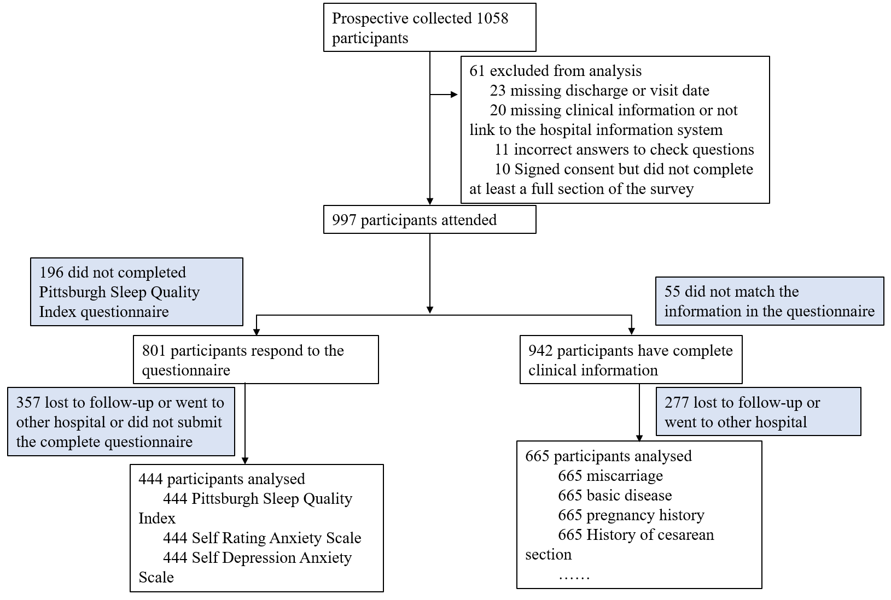
Figure S1 diagram for participants included in the analysis

Supplementary Table 1 Demographics of study participants strata by miscarriage
 | No | Yes | p
n | 556 | 109
Age (mean (SD)) | 30.11 (3.40) | 29.87 (3.44) | 0.498
Education (%) |  |  | 0.292
Bachelor's degree | 422 (75.9) | 80 (73.4)
Master degree or above | 83 (14.9) | 22 (20.2)
Senior high school and below | 51 (9.2) | 7 (6.4)
Occupation = unemployed (%) | 63 (11.3) | 6 (5.5) | 0.098
COVID-19 infection (%) |  |  | 0.162
Yes | 434 (78.1) | 91 (83.5)
No | 107 (19.2) | 18 (16.5)
Unclear | 15 (2.7) | 0 (0.0)
Symptom (%) |  |  | 0.703
Asymptomatic | 192 (42.8) | 40 (44.0)
ordinary | 235 (52.3) | 49 (53.8)
Other | 20 (4.5) | 2 (2.2)
severe | 2 (0.4) | 0 (0.0)
Temperature (%) |  |  | 0.109
Normal ª | 49 (10.9) | 4 (4.4)
37 ~38℃ | 120 (26.7) | 23 (25.3)
38~39℃ | 249 (55.5) | 53 (58.2)
≥39℃ | 31 (6.9) | 11 (12.1)
febrifuge = Yes (%) | 152 (33.9) | 35 (38.5) | 0.47
Previous infection (%) |  |  | 0.378
Yes | 297 (53.4) | 62 (56.9)
No | 241 (43.3) | 46 (42.2)
Unclear | 18 (3.2) | 1 (0.9)
Basic disease = Yes(%) | 47 (8.5) | 12 (11.0) | 0.5
Hospital = No (%) | 534 (96.0) | 103 (94.5) | 0.635
COVID-19 vaccine (%) |  |  | 0.493
No | 59 (10.6) | 14 (12.8)
Thrice or more | 226 (40.6) | 38 (34.9)
Twice or less | 271 (48.7) | 57 (52.3)
Flu vaccine (%) |  |  | 0.105
Yes | 35 (6.3) | 6 (5.5)
No | 490 (88.1) | 102 (93.6)
Unclear | 31 (5.6) | 1 (0.9)
Bad habits = Yes (%) | 5 (0.9) | 1 (0.9) | 1
Abortion = No (%) | 457 (82.2) | 40 (36.7) | <0.001
First pregnancy = Yes (%) | 381 (68.5) | 78 (71.6) | 0.608
History of cesarean section (%) |  |  | 0.791
Reject to answer | 118 (21.2) | 26 (23.9)
Yes | 161 (29.0) | 29 (26.6)
No | 277 (49.8) | 54 (49.5)
BMI1 (%) |  |  | 0.363
Normal weight | 338 (60.9) | 74 (67.9)
Obese | 19 (3.4) | 2 (1.8)
Overweight | 170 (30.6) | 26 (23.9)
Underweight | 28 (5.0) | 7 (6.4)
Threatened abortion = Yes (%) | 0 (0.0) | 109 (100.0) | <0.001
Number of full-term births (%) |  |  | 0.464
0 | 395 (75.4) | 80 (80.0)
1 | 125 (23.9) | 20 (20.0)
2 | 4 (0.8) | 0 (0.0)
Number of premature births (%) |  |  | 0.055
0 | 520 (99.4) | 99 (99.0)
1 | 3 (0.6) | 0 (0.0)
2 | 0 (0.0) | 1 (1.0)
Number of abortions (%) |  |  | 0.365
No | 373 (71.3) | 69 (69.7)
Once | 107 (20.5) | 25 (25.3)
Twice or more | 43 (8.2) | 5 (5.1)
Number of children = One or more (%) | 128 (24.6) | 21 (21.0) | 0.524
Operation = Yes (%) | 112 (20.1) | 20 (18.3) | 0.765
Gestational hypertension = No (%) | 416 (99.8) | 77 (98.7) | 0.719
Gestational diabetes = No (%) | 380 (89.2) | 73 (91.2) | 0.726
Pregnancy with thrombocytopenia = No (%) | 395 (99.2) | 76 (100.0) | 1
embolism = No (%) | 366 (92.0) | 59 (78.7) | 0.001
Antiphospholipid syndrome = No (%) | 385 (98.0) | 71 (93.4) | 0.068
hypoproteinemia = No (%) | 386 (99.2) | 74 (100.0) | 1
Anemia = No (%) | 312 (73.6) | 61 (81.3) | 0.201
Iron deficiency =No (%) | 317 (76.6) | 65 (86.7) | 0.073
factor1 (mean (SD)) | 2.24 (0.72) | 2.48 (0.70) | 0.012
factor2 (mean (SD)) | 2.24 (0.53) | 2.73 (0.45) | <0.001
factor3 (mean (SD)) | 1.24 (1.05) | 1.28 (1.11) | 0.765
factor4 (mean (SD)) | 1.76 (0.79) | 2.69 (0.74) | <0.001
factor5 (mean (SD)) | 2.35 (0.50) | 2.99 (0.12) | <0.001
factor6 (mean (SD)) | 1.52 (0.79) | 2.55 (0.89) | <0.001
factor7 (mean (SD)) | 1.96 (0.75) | 2.76 (0.43) | <0.001
PQSI1 (mean (SD)) | 13.31 (2.41) | 17.48 (2.26) | <0.001
SAS (mean (SD)) | 36.44 (3.80) | 49.64 (3.05) | <0.001
SAS standard score (mean (SD)) | 45.55 (4.75) | 62.05 (3.82) | <0.001
SDS (mean (SD)) | 42.44 (4.63) | 54.18 (4.74) | <0.001
SDS standard score (mean (SD)) | 53.05 (5.79) | 67.72 (5.93) | <0.001

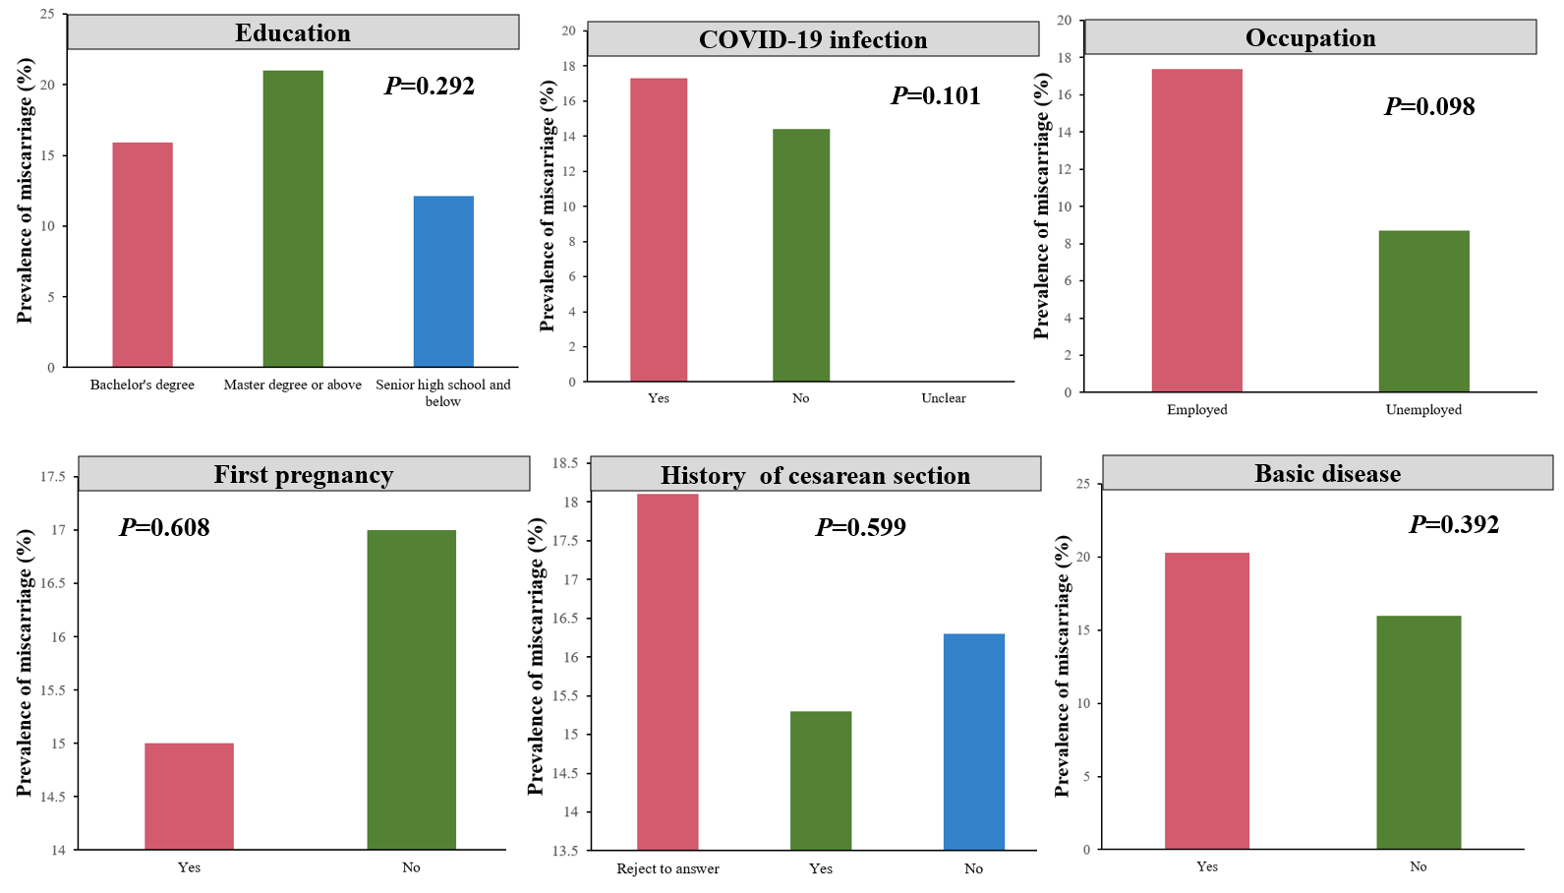
Figure S2 The association between education, COVID-19 infection, occupation, first pregnancy, history of cesarean section, basic disease and miscarriage. (A) The association between education and miscarriage. (B) The association between COVID-19 infection and miscarriage. (C) The association between occupation and miscarriage. (D) The association between first pregnancy and miscarriage. (E) The association between the history of cesarean section and miscarriage. (F) The association between basic disease and miscarriage.

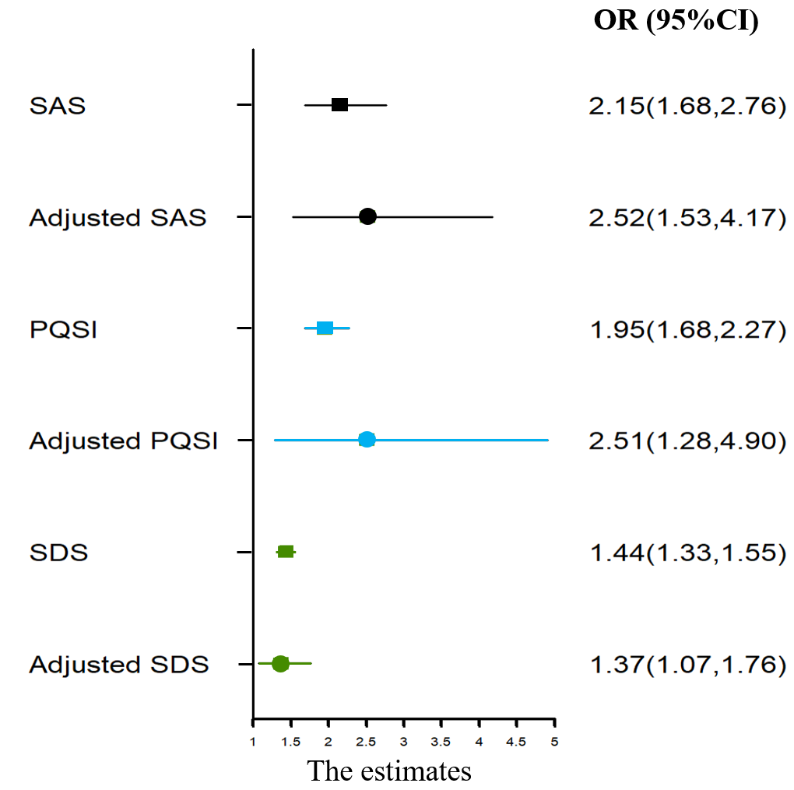
Figure S3 Association between sleep quality, anxiety, depression and miscarriage.
Both unadjusted (squares) or multivariable (circles) multinomial logistic regression relative risks are shown alongside 95% CIs. In multivariable multinomial logistic regression models, the association was adjusted for age, BMI, basic disease, COVID-19 infection, occupation, education, first pregnancy, history of cesarean section and operation.

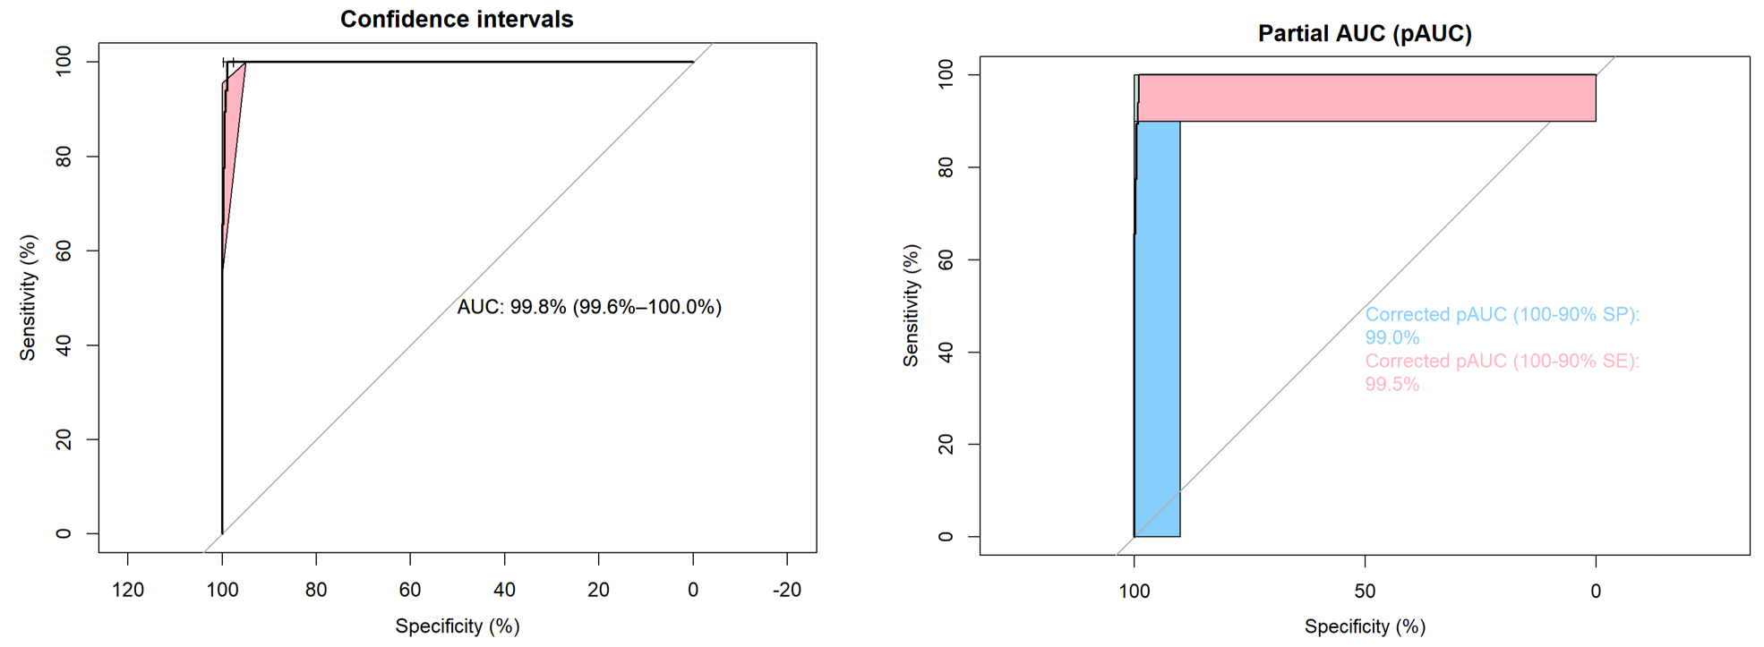
Figure S4 Discriminability of nomogram model to predict pregnant women's miscarriage

Table S2 Results of the multiple mediation model using sleep quality (Pittsburgh Sleep Quality Index) as the exposure and miscarriage as the outcome.
Label | Effect size | Mediated effect | Proportion mediation, %
c' | 0.019(0.010,0.027)
a₁ | 1.446(1.213,1.665)
b₁ | 0.026(0.020,0.031) | 0.038(0.028,0.047) | 55.88(41.18,69.12)
a₂ | 1.078 (0.833,1.301)
b₂ | 0.010 (0.005,0.016) | 0.011 (0.005,0.019) | 16.18(7.35,27.94)
* Results show 95% confidence intervals calculated using a bootstrap with 1,000 resamples

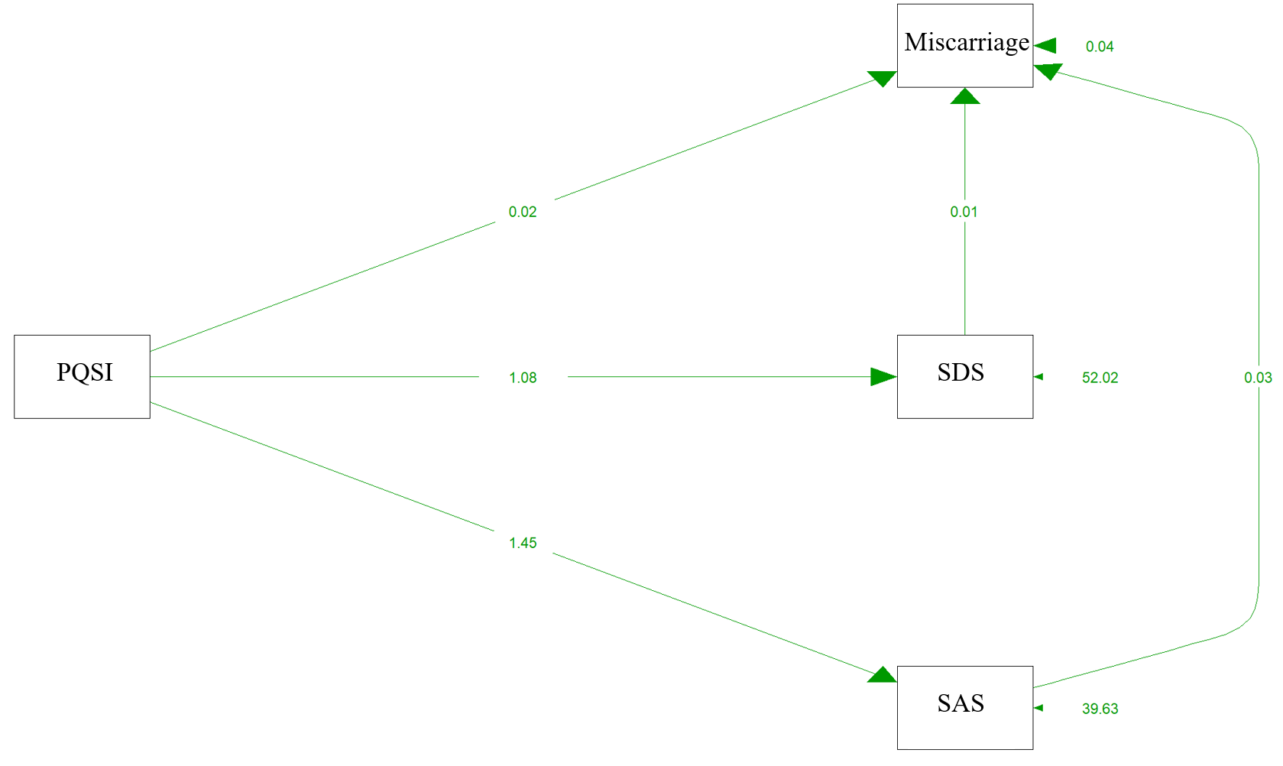
Figure S5 DAG of SDS, SAS, PQSI and Miscarriage

References
[1] Feng X, Wu W, Zhao F, Xu F, Han D, Guo X, Lyu J. Relationship Between Body Mass Index and Kidney Stones Based on Dose-Response Analyses Using Restricted Cubic Splines Applied to NHANES 2011-2016 Data. J Ren Nutr. 2021 May;31(3):263-269. doi: 10.1053/j.jrn.2020.05.003. Epub 2020 Jul 18. PMID: 32693968.
[2] Balachandran VP, Gonen M, Smith JJ, DeMatteo RP. Nomograms in oncology: more than meets the eye. Lancet Oncol. 2015 Apr;16(4):e173-80. doi: 10.1016/S1470-2045(14)71116-7. PMID: 25846097; PMCID: PMC4465353.
[3] Iasonos A, Schrag D, Raj GV, Panageas KS. How to build and interpret a nomogram for cancer prognosis. J Clin Oncol. 2008 Mar 10;26(8):1364-70. doi: 10.1200/JCO.2007.12.9791. PMID: 18323559.
[4] Ananth CV, Brandt JS. A principled approach to mediation analysis in perinatal epidemiology. Am J Obstet Gynecol. 2022 Jan;226(1):24-32.e6. doi: 10.1016/j.ajog.2021.10.028. Erratum in: Am J Obstet Gynecol. 2023 Jan;228(1):121. PMID: 34991898; PMCID: PMC9204564.
[5] Rijnhart JJM, Lamp SJ, Valente MJ, MacKinnon DP, Twisk JWR, Heymans MW. Mediation analysis methods used in observational research: a scoping review and recommendations. BMC Med Res Methodol. 2021 Oct 25;21(1):226. doi: 10.1186/s12874-021-01426-3. PMID: 34689754; PMCID: PMC8543973.
[6] Rijnhart JJM, Twisk JWR, Deeg DJH, Heymans MW. Assessing the Robustness of Mediation Analysis Results Using Multiverse Analysis. Prev Sci. 2022 Jul;23(5):821-831. doi: 10.1007/s11121-021-01280-1. Epub 2021 Jul 16. PMID: 34272641; PMCID: PMC9283158.
[7] Jackson C, Stewart ID, Plekhanova T, Cunningham PS, Hazel AL, Al-Sheklly B, Aul R, Bolton CE, Chalder T, Chalmers JD, Chaudhuri N, Docherty AB, Donaldson G, Edwardson CL, Elneima O, Greening NJ, Hanley NA, Harris VC, Harrison EM, Ho LP, Houchen-Wolloff L, Howard LS, Jolley CJ, Jones MG, Leavy OC, Lewis KE, Lone NI, Marks M, McAuley HJC, McNarry MA, Patel BV, Piper-Hanley K, Poinasamy K, Raman B, Richardson M, Rivera-Ortega P, Rowland-Jones SL, Rowlands AV, Saunders RM, Scott JT, Sereno M, Shah AM, Shikotra A, Singapuri A, Stanel SC, Thorpe M, Wootton DG, Yates T, Gisli Jenkins R, Singh SJ, Man WD, Brightling CE, Wain LV, Porter JC, Thompson AAR, Horsley A, Molyneaux PL, Evans RA, Jones SE, Rutter MK, Blaikley JF; PHOSP-COVID Study Collaborative Group. Effects of sleep disturbance on dyspnoea and impaired lung function following hospital admission due to COVID-19 in the UK: a prospective multicentre cohort study. Lancet Respir Med. 2023 Apr 14:S2213-2600(23)00124-8. doi: 10.1016/S2213-2600(23)00124-8. Epub ahead of print. PMID: 37072018; PMCID: PMC10156429.

