Supplementary Tables

Table 1: QuPath cell detection parameters for interneuron subpopulations.
QuPath Parameter | Interneuron Subpopulation
QuPath Parameter | PV(+)/VVA(All/+/-) | VVA(+)/PV(All)
Requested Pixel Size (μm) | 0.5 | 0.5
Background Radius (μm) | 8.6 | 6.0
Median Radius (μm) | 2.3 | 3.0
Sigma (μm) | 1.5 | 3.0
Minimum Area (μm) | 25.0 | 60.0
Maximum Area (μm) | 400.0 | 600.0
Detection Threshold | 5000.0 | 200.0
Split by Shape | Yes | Yes
Cell Expansion (μm) | 4.0 | 2.0
Include Nuclei | No | No
Smooth Boundaries | Yes | Yes
Make Measurements | Yes | Yes
Positive Detection Threshold 1 | 800.0 | N/A
Positive Detection Threshold 2 | 800.0 | N/A
Positive Detection Threshold 3 | 800.0 | N/A
Single Threshold | Yes | N/A

Table 2: QuPath object classifiers applied for each of four interneuron subpopulations.

Interneuron Subpopulation |  | Object Classification | Threshold
PV | VVA | Object Classification | Threshold
+ | All | PV Area | < 200.0
+ | All | PV Circularity | > 0.8
+ | + | PV Area | < 200.0
+ | + | PV Circularity | > 0.8
+ | + | VVA signal intensity standard deviation | > 200.0
+ | - | PV Area | < 200.0
+ | - | PV Circularity | > 0.8
+ | - | VVA signal intensity standard deviation | < 200.0
All | + | VVA signal intensity standard deviation | > 354.9

Table 3: IP injections of saline and CNO in Rbp4^{Cre}-hM4Di and Rbp4^{Cre}-hM3Dq
Red asterisks indicate mice that died within 90 min of CNO administration, and before perfusion could be initiated. The brains of these mice were collected but were not included in further data analysis. Blue asterisks indicate if fewer brains were used for interneuron analyses. All animals used for this part of experiments were adults and littermates.

Inhibitory DREADD (Rbp4^{Cre}-hM4Di) |  |  |  | Excitatory DREADD (Rbp4^{Cre}-hM3Dq)
No of mice | Compound | Concentration | Animal behaviour | No of mice | Compound | Concentration | Animal behaviour
n = 2 | Saline (control) | 0.25 mg/ml | No changes in behaviour or welfare | n = 6 (3*) | Saline (control) | 0.25 mg/ml | No changes in behaviour
n = 2 | CNO | 1 mg/kg | No changes in behaviour or welfare | n = 2 | CNO | 0.05 mg/kg | Mild behavioural effect of reduced activity and slower locomotor activity with no signs of distress
n = 2 (1*) | CNO | 5 mg/kg | No changes in behaviour or welfare | n = 2 | CNO | 0.1 mg/kg | Seemed less active but were easily arousable
 |  |  |  | n = 1 | CNO | 0.5 mg/kg | Seemed less active but were easily arousable
 |  |  |  | n = 1* | CNO | 1 mg/kg | Seizure-like activity and died after 20 min
 |  |  |  | n = 3 (4*) | CNO | 10 mg/kg | Sedation-like state, 1* mouse died after 55 min
 | All animals were perfused 90 min after CNO administration

Table 4: Animals used for control experiments

Number of animals | Mouse line | Compounds | Concentration | Injection
n = 2 | Rbp4^{Cre} | Saline | 0.25 mg/ml | IP
n = 2 | hM4Di | Saline | 0.25 mg/ml | IP
n = 2 | hM3Dq | Saline | 0.25 mg/ml | IP
All animals were perfused 90 min after CNO administration

Supplementary figures

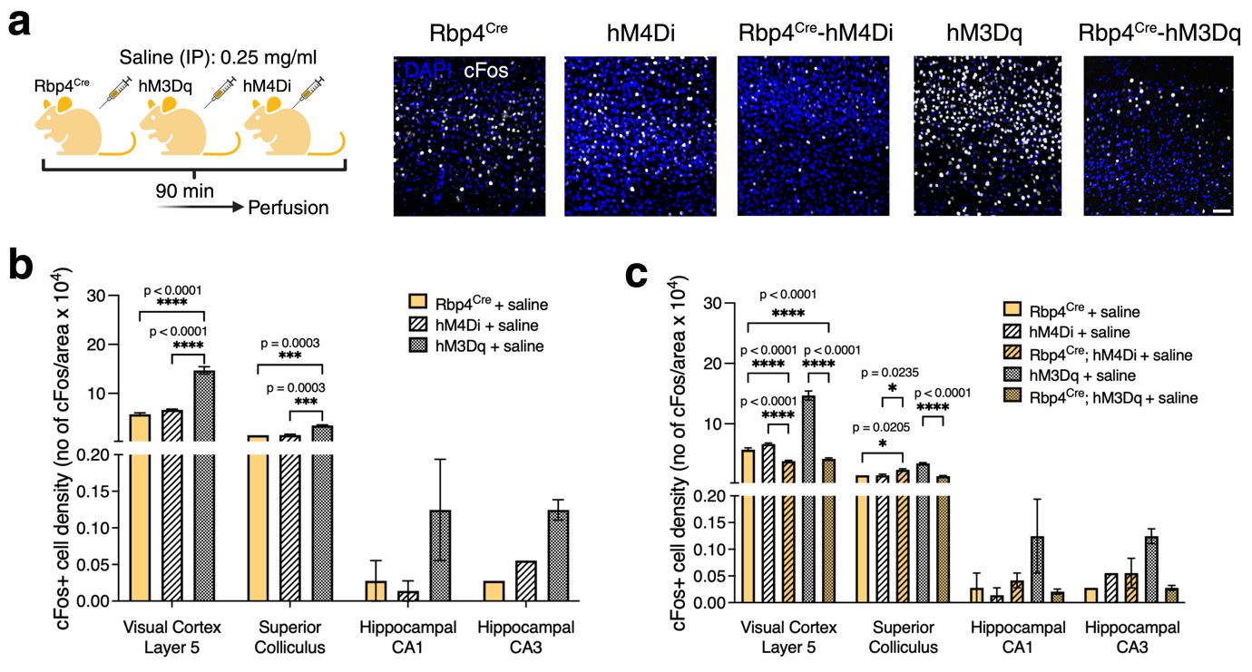
Figure 1: Control experiments
a, Cortical layer 5 driver line (Rbp4^{Cre}), inhibitory DREADD receptor line (hM4Di) and excitatory DREADD receptor (hM3Dq) mice were injected only with saline and for validation using cFos immunolabelling. b, In visual cortex layer 5, cFos+ density was increased in hM4Di and hM4Dq compared with Rbp4^{Cre}. In SC, increased cFos+ density was higher in hM3Dq than in hM4Di and Rbp4^{Cre}. n = 2 mouse, one-way ANOVA via Šidak’s multiple comparison test. c, Furthermore, we compared control experiments results with both Rbp4^{Cre}-hM4Di and Rbp4^{Cre}-hM3Dq saline injected mice. In both Rbp4^{Cre}-hM4Di and Rbp4^{Cre}-hM3Dq, cFos+ cell density was lower than hM4Di, hM3Dq and Rbp4^{Cre}, and no differences between transgenic lines were observed. Although, it is important to notice that the excitatory DREADD receptor line itself has much higher cFos+ density than others suggesting that excitatory DREADD itself has an increased activity without CNO. n = 2 mouse, one-way ANOVA via Šidak’s multiple comparison test. All data presented as mean ± SEM, * p < 0.05, ** p < 0.01, *** p < 0.001, **** p < 0.0001. Scale bar of a - 100 μm. Detailed statistical information was listed in Supplementary Statistical Data. Source data is provided as a Source Data file.

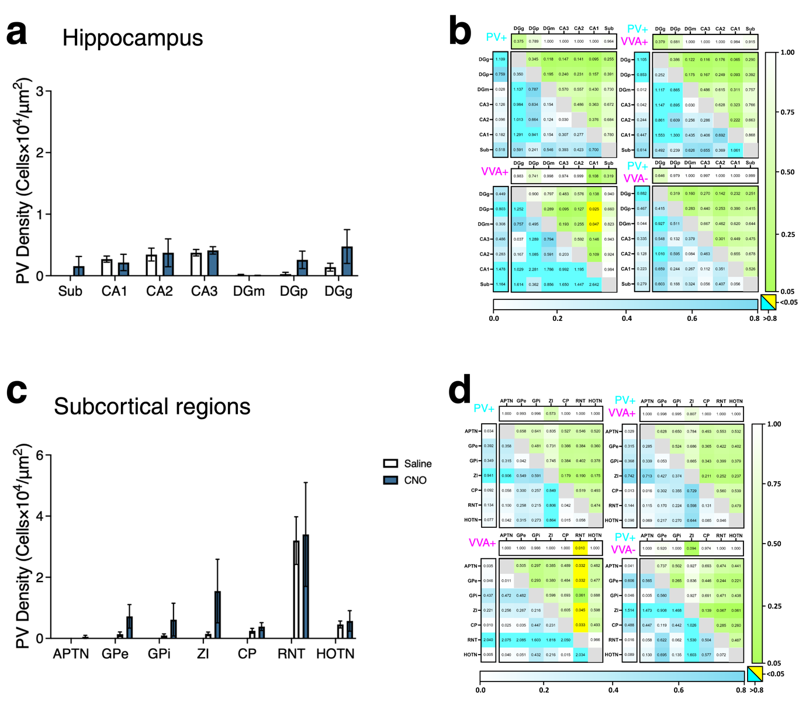
Figure 2: Interneuron density and PV-VVA co-expression in subcortical regions in Rbp4^{Cre}-hM3Dq mice
a, c, Changes in PV+ cell density in hippocampus and other subcortical regions. n = 3 mouse/dose, average of 3 sections per region and per mouse, two-way ANOVA via Šidak’s multiple comparisons test. b, d, Heat maps illustrate the effects of CNO administration within and between brain regions on PV+ (top left), VVA+ (bottom left), PV+/VVA+ (top right) and PV+/VVA- (bottom right) interneuron densities. Shades of blue indicate effect size as Cohen’s d - values (cyan for large effect sizes > 0.8), and shades of green indicate statistical significance as p - values (yellow for p < 0.05). Horizontal bars indicate the overall within-region/layer statistical significance of CNO administration evaluated using two-way ANOVA (Šidak’s multiple comparisons), and vertical bars indicate the overall within-region/layer effect size of CNO administration evaluated using Cohen’s d. Pairwise comparisons between cortical layers/regions are represented in the body of each heat map, with statistical significance calculated by applying the student’s t-test to outcomes of the two-stage step-up method of Benjamini, Krieger and Yekutieli and effect size calculated via Cohen’s d.. Sub - subiculum; CA1, CA2, CA3 - cornu ammonis 1, 2, 3; DGm - dentate gyrus molecular layer; DGp - dentate gyrus polymorph layer; DGg - dentate gyrus granule layer; APTN - anterior pretectal nucleus; GPe - globus pallidus external segment; GPi - globus pallidus internal segment; ZI - zona incerta; CP - caudoputamen; RNT - reticular nucleus thalamus; HOTN - higher order thalamic nuclei. All data presented as mean ± SEM, * p < 0.05, ** p < 0.01, *** p < 0.001, **** p < 0.0001.

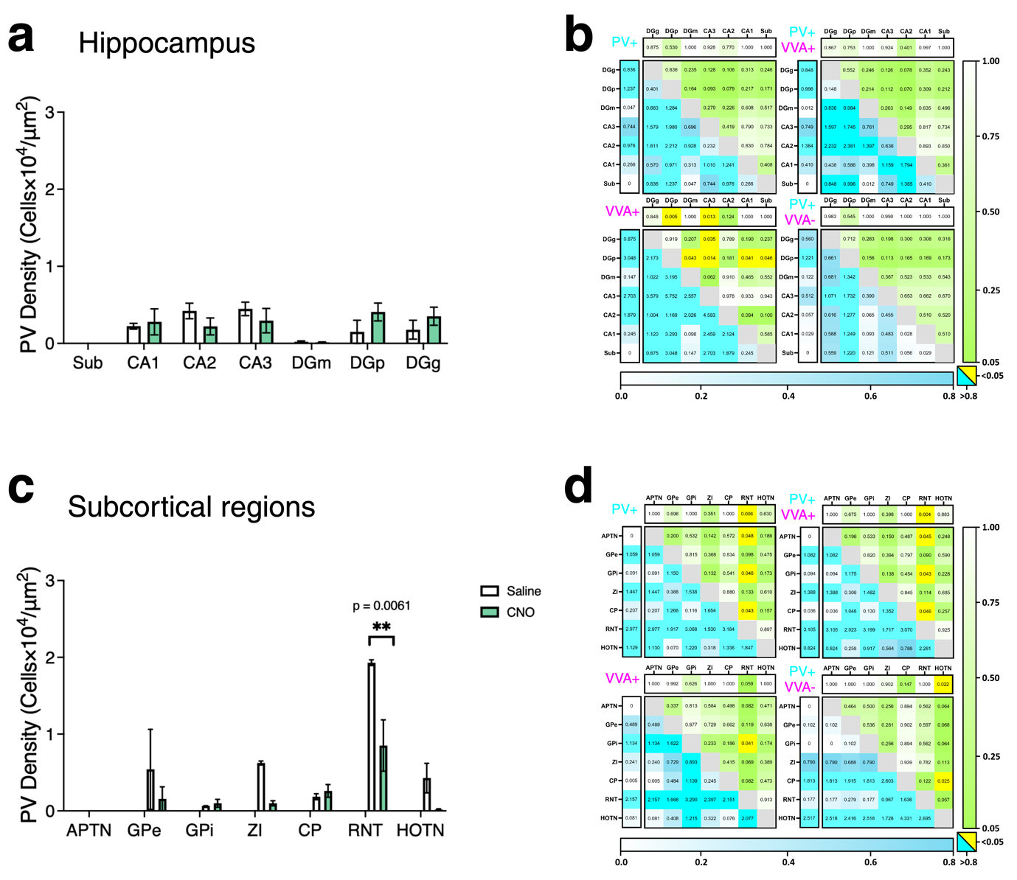
Figure 3: Interneuron density and PV-VVA co-expression in subcortical regions in Rbp4^{Cre}-hM4Di mice
a, c, Changes in PV+ cell density in hippocampus and other subcortical regions. n = 2 mouse/dose, average of 3 sections per region and per mouse, two-way ANOVA via Šidak’s multiple comparisons test. b, d, Heat maps illustrate the effects of CNO administration within and between brain regions on PV+ (top left), VVA+ (bottom left), PV+/VVA+ (top right) and PV+/VVA- (bottom right) interneuron densities. Shades of blue indicate effect size as Cohen’s d - values (cyan for large effect sizes > 0.8), and shades of green indicate statistical significance as p - values (yellow for p < 0.05). Horizontal bars indicate the overall within-region/layer statistical significance of CNO administration evaluated using two-way ANOVA (Šidak’s multiple comparisons), and vertical bars indicate the overall within-region/layer effect size of CNO administration evaluated using Cohen’s d. Pairwise comparisons between cortical layers/regions are represented in the body of each heat map, with statistical significance calculated by applying the student’s t-test to outcomes of the two-stage step-up method of Benjamini, Krieger and Yekutieli and effect size calculated via Cohen’s d. Sub - subiculum; CA1, CA2, CA3 - cornu ammonis 1, 2, 3; DGm - dentate gyrus molecular layer; DGp - dentate gyrus polymorph layer; DGg - dentate gyrus granule layer; APTN - anterior pretectal nucleus; GPe - globus pallidus external segment; GPi - globus pallidus internal segment; ZI - zona incerta; CP - caudoputamen; RNT - reticular nucleus thalamus; HOTN - higher order thalamic nuclei. All data presented as mean ± SEM, * p < 0.05, ** p < 0.01, *** p < 0.001, **** p < 0.0001.

