Supplementary Materials for

Escherichia coli Microcin B17 as a chassis for the development of novel antimicrobial peptides

Shamal Withanage¹, Joleen Masschelein^{2,3}, Vitor B. Pinheiro¹*
Corresponding author: v.pinheiro@kuleuven.be

The PDF file includes:

Materials and Methods
Figs. S1 to S6
Tables S1 to S3
References

Other Supplementary Materials for this manuscript include the following:

Data S1 to S2

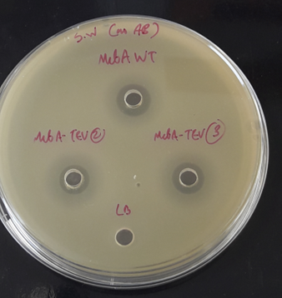

Fig. S1. Evaluating the impact on microcin B17 activity of introducing a TEV-recognition site to the mcbA gene.
The two-plasmid system was used to express wild-type B17 and the TEV-modified B17 (McbA-TEV) of which the peptide-containing supernatants were added to wells created on an LB agar plate consisting of a soft-agar overlay containing B17-sensitive E. coli BL21 (DE3). Comparable zones of inhibition – indicating the prevention of sensitive cell growth – are observed in both the wild-type and TEV-modified versions of the B17, suggesting the modification has no significant impact on microcin activity.

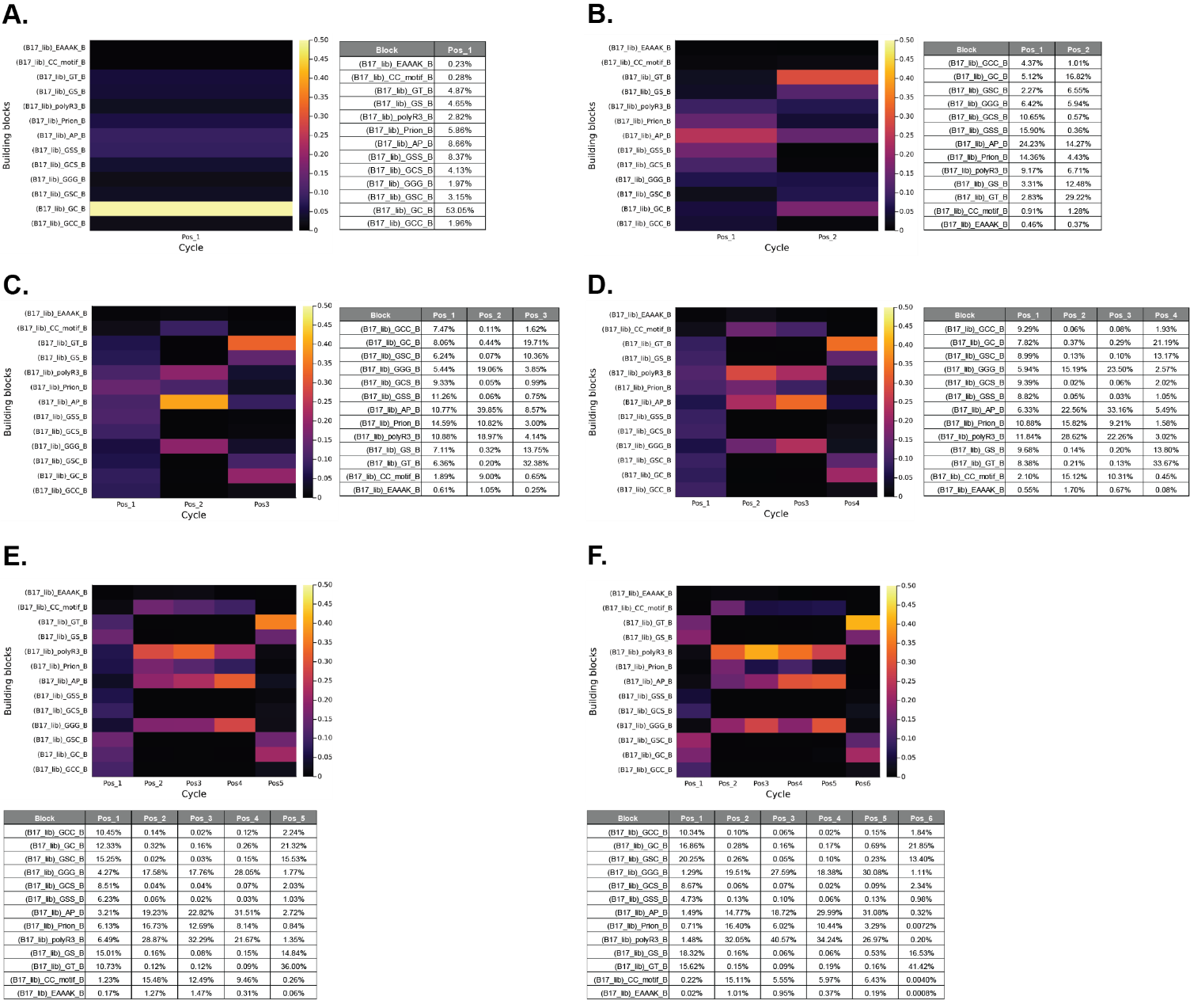

Fig. S2. Summary of mixed linker R0 library composition per length.
Assembled sequences are split by the number of blocks incorporated (including unique sequences) and the frequency of incorporation per position is shown. (A-F) show that for 1- through to 6-block assembly respectively. Graphical and tabular summaries are shown.

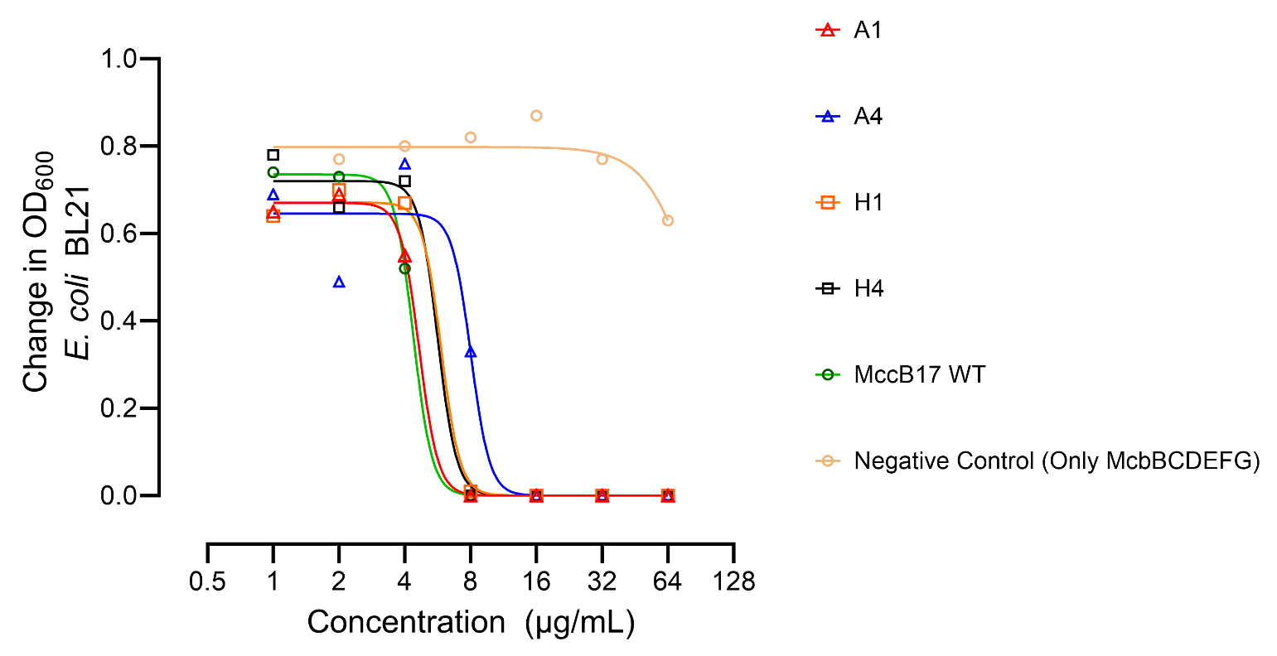

Fig. S3. Concentration response of E. coli BL21 against four peptides selected from the standard libraries.
Wild-type MccB17 expressed from the 2-plasmid system was included as a positive control (green circle) whilst the MccB17 machinery (McbBCDEFG) in the absence of any peptide was included as a negative control (light orange circle). Isolates from the standard library were SA1 (red triangle), SA4 (blue triangle), SH1 (orange square), and SH4 (black square). Non-linear regression determined the IC₅₀ of A1 as 4.7 μg/mL (95% CI: 4.47 - 5.20, R² = 0.999), A4 as 8.0 μg/mL (95% CI: 5.59 - 12.9, R² = 0.941), H1 as 5.9 μg/mL (95% CI: - 6.56, R² = 0.999), H4 as 5.7 μg/mL (95% CI: 4.58 - 6.87, R² = 0.991) and MccB17 WT as 4.4 μg/mL (95% CI: 4.34 - 4.51, R² = 0.999). Antimicrobial activity of the peptides tested is dose-dependent and requires both the MccB17 machinery (McbBCDEFG) and the peptide for activity. Microcin core sequences shown here are: SA1 – GSFELGSHI, SA4 – GCCFPNHVPGSHI, SH1 – GCCGGSGSHI, and SH4 – GTMYIPGSHI).

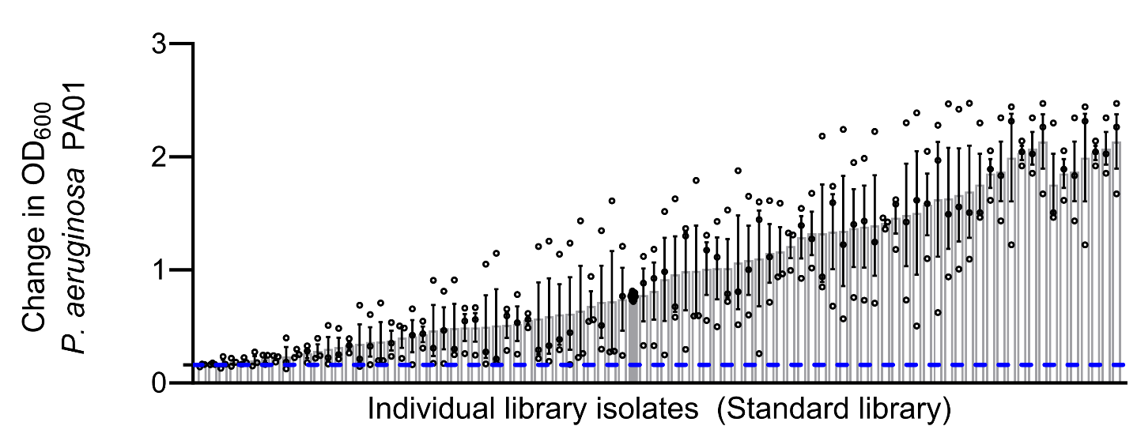

Fig. S4. Screening of engineered microcins from the standard library against a P. aeruginosa PA01 target.
The negative control containing no microcin is highlighted as a grey bar (n = 9). Experiments were carried out in triplicate and individual observations are shown as black dots; error represents the standard deviation between experiments; averages are shown as bars. The cut-off used for defining cell toxicity (25% growth of the wild type) is shown as a blue dotted line. Only 5 isolates from the 80 screened from the standard library demonstrated significant antimicrobial activity against P. aeruginosa PA01.

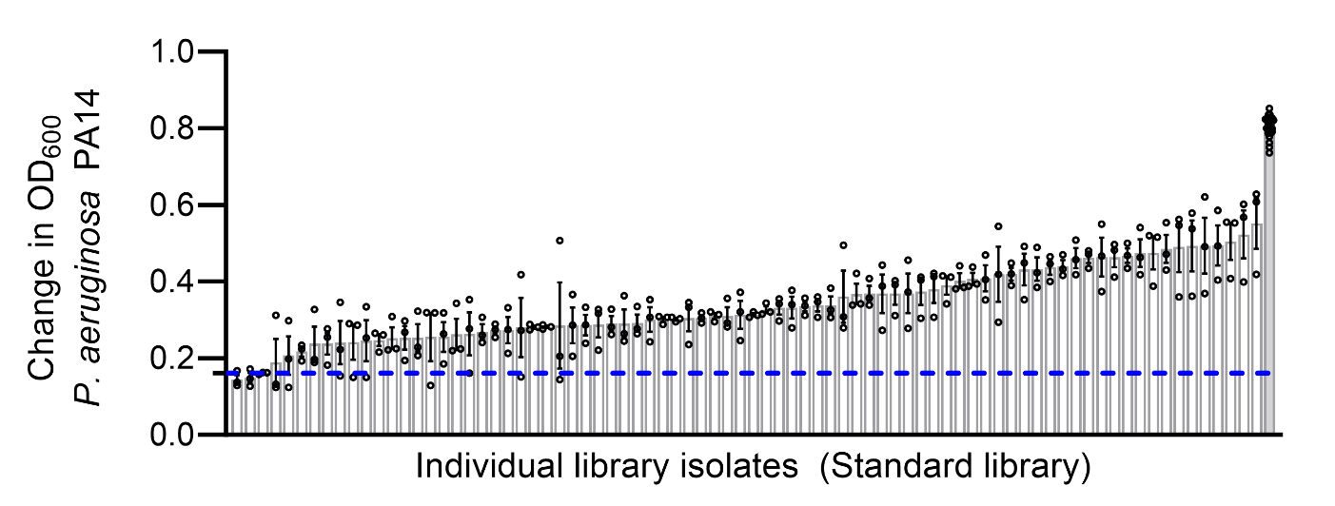

Fig. S5. Screening of engineered microcins from the standard library against a P. aeruginosa PA14 target.
The negative control containing no microcin is highlighted as a grey bar (n = 9). Experiments were carried out in triplicate and individual observations are shown as black dots; error represents the standard deviation between experiments; averages are shown as bars. The cut-off used for defining cell toxicity is shown as a blue dotted line. Only 4 isolates from the 80 screened from the standard library demonstrated significant antimicrobial activity against P. aeruginosa PA14.

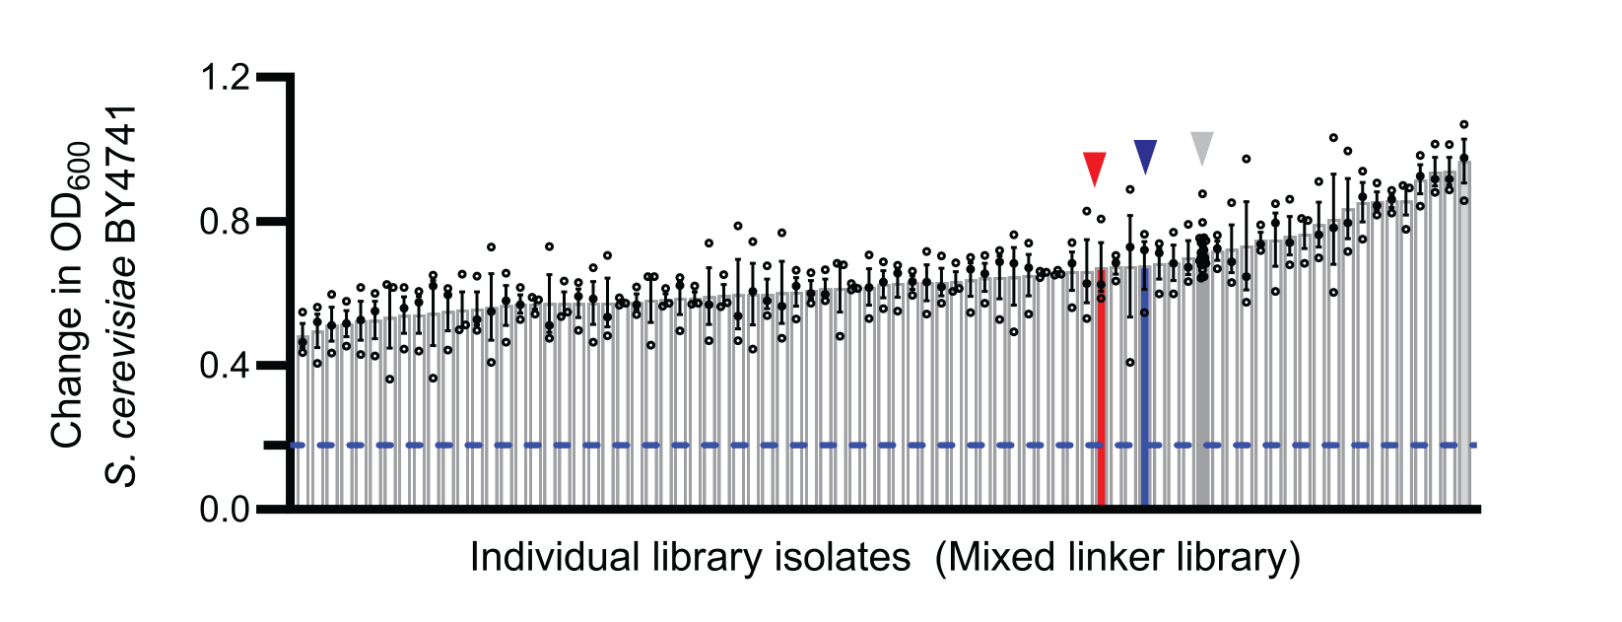

Fig. S6. Screening of engineered microcins from the mixed linker library against a S. cerevisiae BY4741 target.
The negative control containing no microcin is highlighted as a grey bar (n = 9). Experiments were carried out in triplicate and individual observations are shown as black dots; error represents the standard deviation between experiments; averages are shown as bars. The cut-off used for defining cell toxicity is shown as a blue dotted line. A few isolates from the mixed linker library showed some impact on the growth of S. cerevisiae, however none demonstrated antifungal activity. MF1 (red) and MH10 (blue) are highlighted.

Table S1. Analysis of next generation sequencing from microcin mixed linker library R0.
The mixed linker library, initially transformed into E. coli 10β cells without the microcin synthase machinery, was deep sequenced to test assembly methodology and estimate library diversity. The table below shows the impact of each processing step on the number of available sequences for analysis.

Processing step | Output sequences
Total number of reads | 15,212,818 | (100%)
Pear-joined sequences | 13,595,503 | (89.4%)
Filtered sequences (Galaxy) | 9,904,008 | (65.1%)
Strict sequence filter (Jupyter) | 7,701,628 | (50.6%)
Total assembled sequences | 5,526,551 | (36.3%, 71.8%ª)
Non-unique sequences | 5,421,405 | (35.6%, 70.4%ª)
Assembled non-unique sequences | 4,999,193 | (32.9%, 92.2%^{b})
ª Percentages calculated against the strict-filtered sequences. ^{b} Percentage calculated against the total number of non-unique sequences.

Table S2. Assembly order for the first standard library.
Cycles 1, 4, and 12 introduce assembly blocks encoding MAMMs in equal ratios. The remaining cycles introduce assembly blocks encoding a single amino acid mixed in equal ratios.

Cycle1 | Cycle2 | Cycle3 | Cycle4 | Cycle5 | Cycle6 | Cycle7 | Cycle8 | Cycle9 | Cycle10 | Cycle11 | Cycle12
GS | A | A | GS | A | A | A | A | A | A | A | GS
GC | G | G | GC | G | G | G | G | G | G | G | GC
GT | I | I | GT | I | I | I | I | I | I | I | GT
GSC | L | L | GSC | L | L | L | L | L | L | L | GSC
GCS | P | P | GCS | P | P | P | P | P | P | P | GCS
GSS | V | V | GSS | V | V | V | V | V | V | V | GSS
GCC | F | F | GCC | F | F | F | F | F | F | F | GCC
 | W | W |  | W | W | W | W | W | W | W
 | Y | Y |  | Y | Y | Y | Y | Y | Y | Y
 | D | D |  | D | D | D | D | D | D | D
 | E | E |  | E | E | E | E | E | E | E
 | R | R |  | R | R | R | R | R | R | R
 | H | H |  | H | H | H | H | H | H | H
 | K | K |  | K | K | K | K | K | K | K
 | S | S |  | S | S | S | S | S | S | S
 | T | T |  | T | T | T | T | T | T | T
 | C | C |  | C | C | C | C | C | C | C
 | M | M |  | M | M | M | M | M | M | M
 | N | N |  | N | N | N | N | N | N | N
 | Q | Q |  | Q | Q | Q | Q | Q | Q | Q

Table S3. Assembly order of the second standard library.
A second “standard” library was generated consisting of 12 rounds of assembly. Both libraries were mixed before transformation. Cycles alternate between the introduction of MAMMs and single amino acids.

Cycle 1 | Cycle2 | Cycle 3 | Cycle4 | Cycle5 | Cycle6 | Cycle7 | Cycle8 | Cycle9 | Cycle10 | Cycle11 | Cycle12
GS | A | GS | A | GS | A | GS | A | GS | A | GS | A
GC | G | GC | G | GC | G | GC | G | GC | G | GC | G
GT | I | GT | I | GT | I | GT | I | GT | I | GT | I
GSC | L | GSC | L | GSC | L | GSC | L | GSC | L | GSC | L
GCS | P | GCS | P | GCS | P | GCS | P | GCS | P | GCS | P
GSS | V | GSS | V | GSS | V | GSS | V | GSS | V | GSS | V
GCC | F | GCC | F | GCC | F | GCC | F | GCC | F | GCC | F
 | W |  | W |  | W |  | W |  | W |  | W
 | Y |  | Y |  | Y |  | Y |  | Y |  | Y
 | D |  | D |  | D |  | D |  | D |  | D
 | E |  | E |  | E |  | E |  | E |  | E
 | R |  | R |  | R |  | R |  | R |  | R
 | H |  | H |  | H |  | H |  | H |  | H
 | K |  | K |  | K |  | K |  | K |  | K
 | S |  | S |  | S |  | S |  | S |  | S
 | T |  | T |  | T |  | T |  | T |  | T
 | C |  | C |  | C |  | C |  | C |  | C
 | M |  | M |  | M |  | M |  | M |  | M
 | N |  | N |  | N |  | N |  | N |  | N
 | Q |  | Q |  | Q |  | Q |  | Q |  | Q

Table S4. Sequenced novel microcins. Sanger-sequenced microcins isolated in screening. Translated peptide sequences are separated in assembly blocks to highlight their origin. Sequences isolated from the mixed linker library are shown as Mxx (where xx refers to their position on the assay plate). Sequences from either standard library are shown as Sxx.
Microcin reference | Core peptide sequence
MA1 | NNQQNN AP AP GGG GSHI
MB10 | GSS EAAAK AP RRR GC GSHI
MC5 | EAAAK GSHI
MD4 | GS GSHI
MD6 | GC GGG AP GT GSHI
ME4 | GCS GSHI
ME6 | NNQQNN GGG GT GSHI
ME9 | NNQQNN RRR GCS GSHI
MF1 | GSC RRR AP LAAIKWE GT GSHI
MF3 | GCS RRR LAAIKWE GCC GCS GSHI
MF4 | GCS RRR RRR GT GSHI
MF7 | GGG GGG GT GSHI
MF8 | GSS SSC GSHI
MF9 | GS AP AP GT GSHI
MG1 | GGG GSHI
MG2 | GSC AP GT GSHI
MG6 | GSS GS GSHI
MH1 | RRR AP RRR GSHI
MH2 | GSC AP GT GSHI
MH10 | GS LAAIKWE LAAIKWE RRR GT GSHI
SA1 | GS F E L GSHI
SH1 | GCC G GS GSHI
SA4 | GCC F P N H V P GSHI
SH4 | GT M Y I P GSHI
SA9 | GT GSHI
SH9 | GSS S D G R GSC GSHI
SH10 | GCC A GSHI

Data S1. Galaxy workflow for the processing of NGS data.
Starting from raw FASTQ files generated in sequencing, the workflow was used in the Galaxy servers to join pair-ended sequences, convert FASTQ to FASTA format, and select sequences containing conserved sequences from the vector.

Data S2. Jupyter notebook with code in Julia for the processing of NGS data.
Starting from the FASTA sequences in the Galaxy output, this notebook shows how sequences were analyzed and the mixed linker R0 library reconstructed from the known sequence elements used in the library assembly.

