Table 1.
Comparison of Web Wearching for ‘Covid-19’ and ‘psbb’ Terms in Indonesia
during March 2020 – May 2020
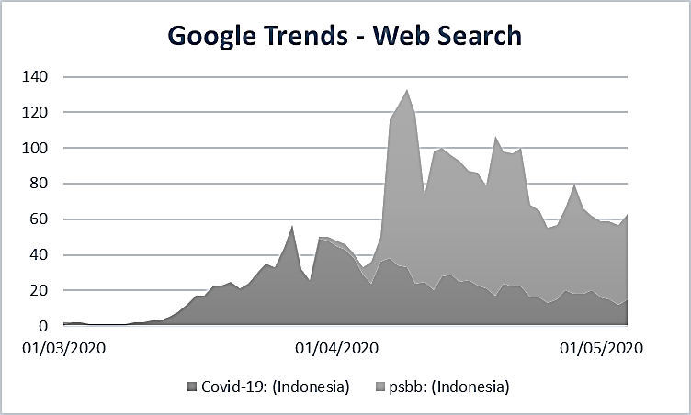
Scource: Google Trends search of ‘Covid-19’ and ‘psbb’, retreived from https://trends.google.co.id/trends/explore?date=2020-03-01%202020-05-08&geo=ID&q=Covid-19,psbb

Table 2.
Topic Mining of ‘psbb’ and ‘#psbb’ Issue in Twitter in Indonesian Language
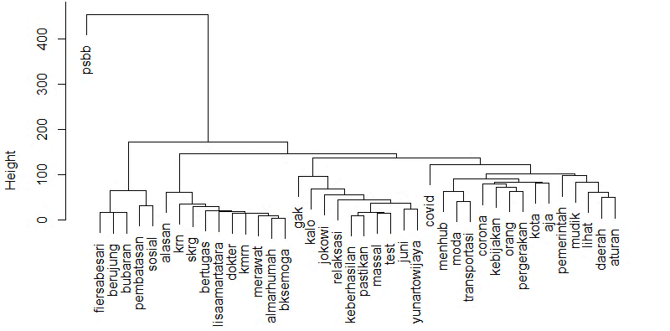
Source: obtained from topic mining of 5,000 tweets on May 6th, 2020 using RStudio

Table 3.
Tweets of Core Users within PSBB Issue
No | Users | Tweets
1 | @yunartowijaya  (56.8 thousand tweets in total) | - Pak @jokowi saya juga mengerti isu kesehatan & ekonomi gak bisa ditrade off, kebijakan hrs sequencing, makanya kalo juni…  (Mr. @jokowi I am also understand of health and economics issue could not be trades off, there is also sequencing of policies, therefore if June...)  - Pak @jokowi kalo anda ingin mulai relaksasi awal juni, pastikan dulu keberhasilan PSBB melalui test yg sudah massal, gak…  (Mr. @jokowi if you want to start the relaxation in early of June, make sure of PSBB success through massive test, not...)
2 | @detikcom  (1.6 million tweets in total) | - Seorang pengendara motor asal Tulungagung terjaring razia di Pos Check Point PSBB Bundaran Waru. Pria tersebut diketahui posi…  (a motorcycle biker from Tulungagung caught up at PSBB Check Point in Bundaran Waru. The man is known positive...)  - Wali Kota Bandung Oded M Danial mengklaim Pembatasan Sosial Berskala Besar (PSBB) dua pekan terakhir berhasil. Risiko penyeba…  (City Major of Bandung Oded M Danial claimed that two weeks PSBB works successfully. The spread risk...)  - Ojol cuma boleh angkut barang saat PSBB. Tapi ongkirnya dipotong 20%. #Ojol via @detikfinance  (Online transportation operator could only load goods during PSBB. But the delivery fee is cut of 20% #Ojol via @detikfinance)  - Anggota DPR Marwan Jafar melihat pemerintah mulai menerapkan PSBB plus. Menurut Marwan, PSBB plus penting, namun harus dilaku…  (Member of House of Representatives Marwan Jafar sees that government started to apply PSBB plus. According to Marwan, PSBB plus is important, but it must be conducted...)
3 | @Demokrat_TV  (157 thousand tweets in total) | - Anggota @FPD_DPR @irwan_fecho mengkritik kebijakan pemerintah pusat yg akan merelaksasi PSBB. Sebab 2 bulan ke depan adala…  (Member of @FPD_DPR @irwan_fecho critize government policies of relaxation during PSBB. Because in two months later is...)  - Tak Setuju Pelonggaran PSBB, Syarief Hasan Tagih Konsistensi Pemerintah Perangi Covid-19  (Being disagree to relaxation during PSBB, Syarief Hasan asks govenrment consistency in fighting CoVID-19)
4 | @CNNIndonesia  (407 thousand tweets in total) | - PKS Kritik Menko Polhukam-Menhub soal Relaksasi PSBB Corona  (PKS Party critize Coordinator Minister of Politics, Law, and Security – Ministter of Transportation for relaxation during PSBB Corona)  - PSBB Jawa Barat Dimulai, Garut Hanya Terapkan Parsial  (PSBB in West Java Province is started, Garut region run in partial places)  - Gojek Tutup Fitur Antar Penumpang Ojol Selama PSBB Jabar  (Gojek closed passanger services during PSBB in West Java Province)  - PSBB, PLN Sebut Konsumsi Listrik Jakarta Jatuh 20 Persen  (PSBB, PLN stated that electricity consumption in Jakarta reduced 20%)  - PSBB, Bandung Bolehkan Motor Boncengan dan Toko Material Buka  (PSBB, Bandung City allowed motorcycle loads passanger and allowed construction shop to open)
5 | @FerryFe40732164  (14 thousand tweets in total) | - Kenapa toko pasar rakyat di tanah Abang di tutup @aniesbaswedan .. toko orang cina atau bengkel orang cina tidak beran…  (Why traditional market in Tanah Abang is closed @aniesbaswedan... while market and reparation service run by Chinese citizen not...)  - Toko yg bukan sembako banyak buka... Bengkel Honda dan Yamaha buka rame sekali... Psbb Jakarta Gagal total.... @aniesb…  (Many shopping galery of non main foods still open... Reparation service like Honda and Yamaha still open and crowded... Psbb in Jakarta is totally failed... @aniesbaswedan...)  - Psbb di Jakarta Gagal total.. jalanan sudah rame sekali sekarang...  (Psbb in Jakarta is totally failed... Roads are being crowded again now...)  - @yunartowijaya @jokowi Semua negara Asean dan Hindia Eropa mulai melonggarkan psbb... Baca koran tak...  (@yunartowijaya @jokowi All Asean and Europe Hindia countries starts to run relaxation of PSBB... Read the newspaper...)
6 | @FPD_DPR  (8,151 tweets in total) | - Wakil Ketua MPR @PDemokrat Syarief Hasan menyoroti secara serius rencana pelonggaran PSBB di sektor moda transportasi umum y…  (Vice of House of Representatives @PDemokrat Syarief Hasan is seriously monitoring the plan of PSBB relaxation in public transportation mode...)  - Saat Raker dgn Menhub, anggota @DPR_RI Fraksi @PDemokrat @irwan_fecho kritik pemerintah pusat yang akan merelaksasi PSBB. 2 Bu…  (During the meeting with Minister of Transportation, member of @DPR_RI Fraksi @PDemokrat @irwan_fecho critize the government’s plan of PSBB relaxation...)
7 | @LisaAmartatara3  (24.2 thousand tweets in total) | - Pak BK..semoga anda ingat almarhumah dokter yg kmrn bertugas merawat anda Lalu skrg Hanya krn alasan Kalian Gak mampu…  (Mr. BK, Minister of Transportation, hope you remembered the doctor who taking care of you, who have already passed away now, and then due to your incapable of...)
Source: obtained from tweets mining on May 6th, 2020 using RStudio, translated by the author

