SUPPLEMENTARY MATERIAL
NMR fingerprinting of conventional and genetically modified soybean plants with AtAREB transcription factors

Isabel Duarte Coutinho^{1*}, William Marcondes Facchinatto^{2*,†}, Liliane Marcia Mertz-Hernning³, Américo José Carvalho Viana⁴, Silvana Regina Rockenbach Marin⁴, Silvia Helena Santagneli³, Alexandre Lima Nepomuceno³, Luiz Aberto Colnago¹

¹ Brazilian Corporation for Agricultural Research, Embrapa Instrumentation, St. XV de Novembro 1452, 13560-970, PO Box 741, São Carlos, São Paulo, Brazil.
² Department of Chemistry, CICECO – Aveiro Institute of Materials, University of
Aveiro, 3810-193 Aveiro, Portugal
³ Brazilian Corporation of Agricultural Research, Embrapa Soja, HWY Carlos João Strass, Warta District, 86085-981, PO Box 4006, Londrina, Paraná, Brazil
⁴ Institute of Chemistry, São Paulo State University “Júio de Mesquita Filho”, Ave. Francisco Degni 55, CEP 14800-060, Araraquara, São Paulo, Brazil.

* These two authors contributed equally to this work.

† Corresponding author: william.facchinatto@ua.pt; williamfacchinatto@alumni.usp.br (William Marcondes Facchinatto).

ORCID: IDC (0000-0002-7795-6129); WMF (0000-0002-1846-2700); LMMH (0000-0001-7622-0649); AJCV (0000-0001-9509-0093); SRRM (0000-0002-6764-1422); SHS (0000-0002-5456-6347); ALN (0000-0003-2012-6201); LAC (0000-0002-9516-9022).

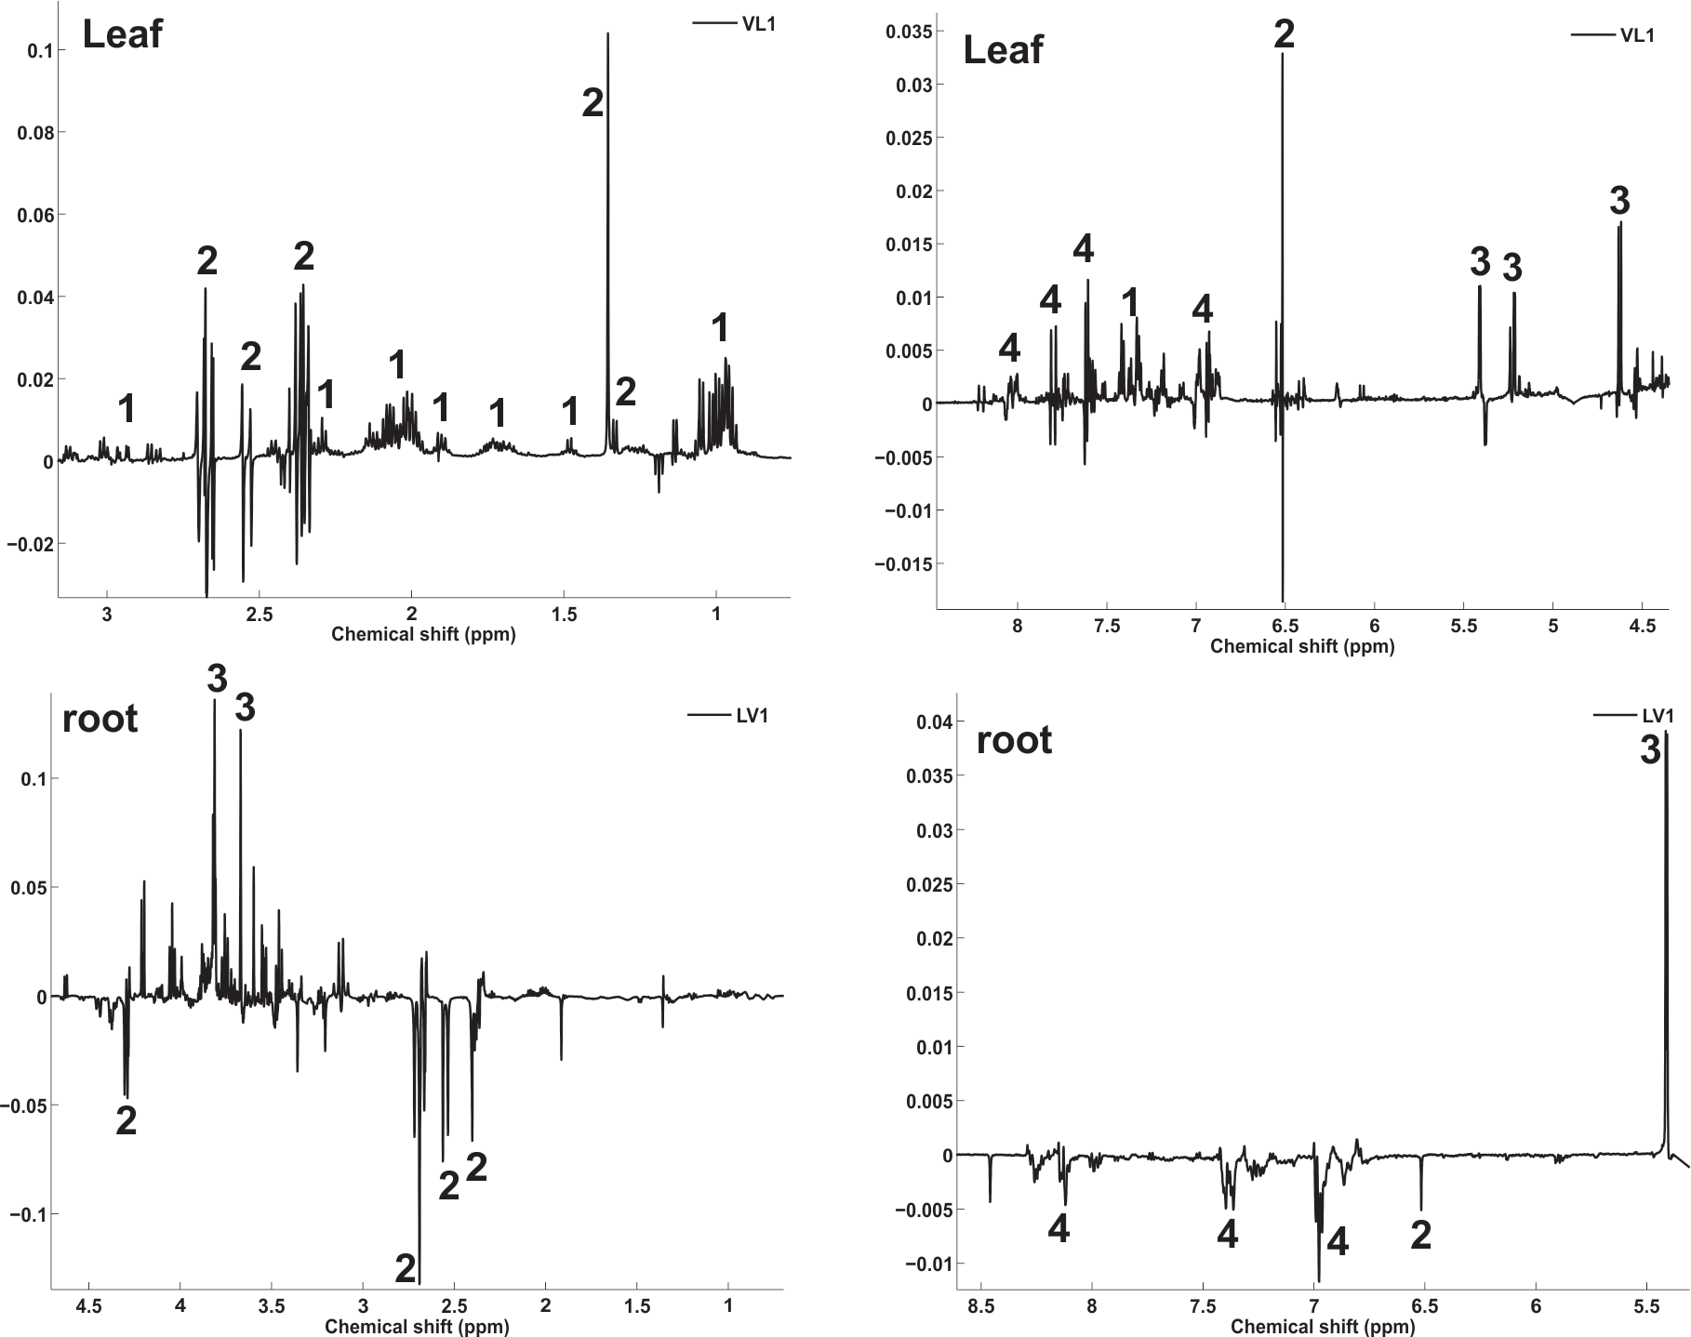
D)
C)
B)
A)
Figure S1. PCA loadings from PLS-DA model from ¹H NMR spectra extracts from soybean leaves and roots of sensitive genotype and tolerant genetically modified plants. Numbers indicated at loadings LV1 correspond to metabolites identified at extracts of soybean leaves (A, B) and roots (C, D). The metabolites assigned correspond to groups of amino acids (1), organic acids (2), sugars (3) and phenolic compounds (4).

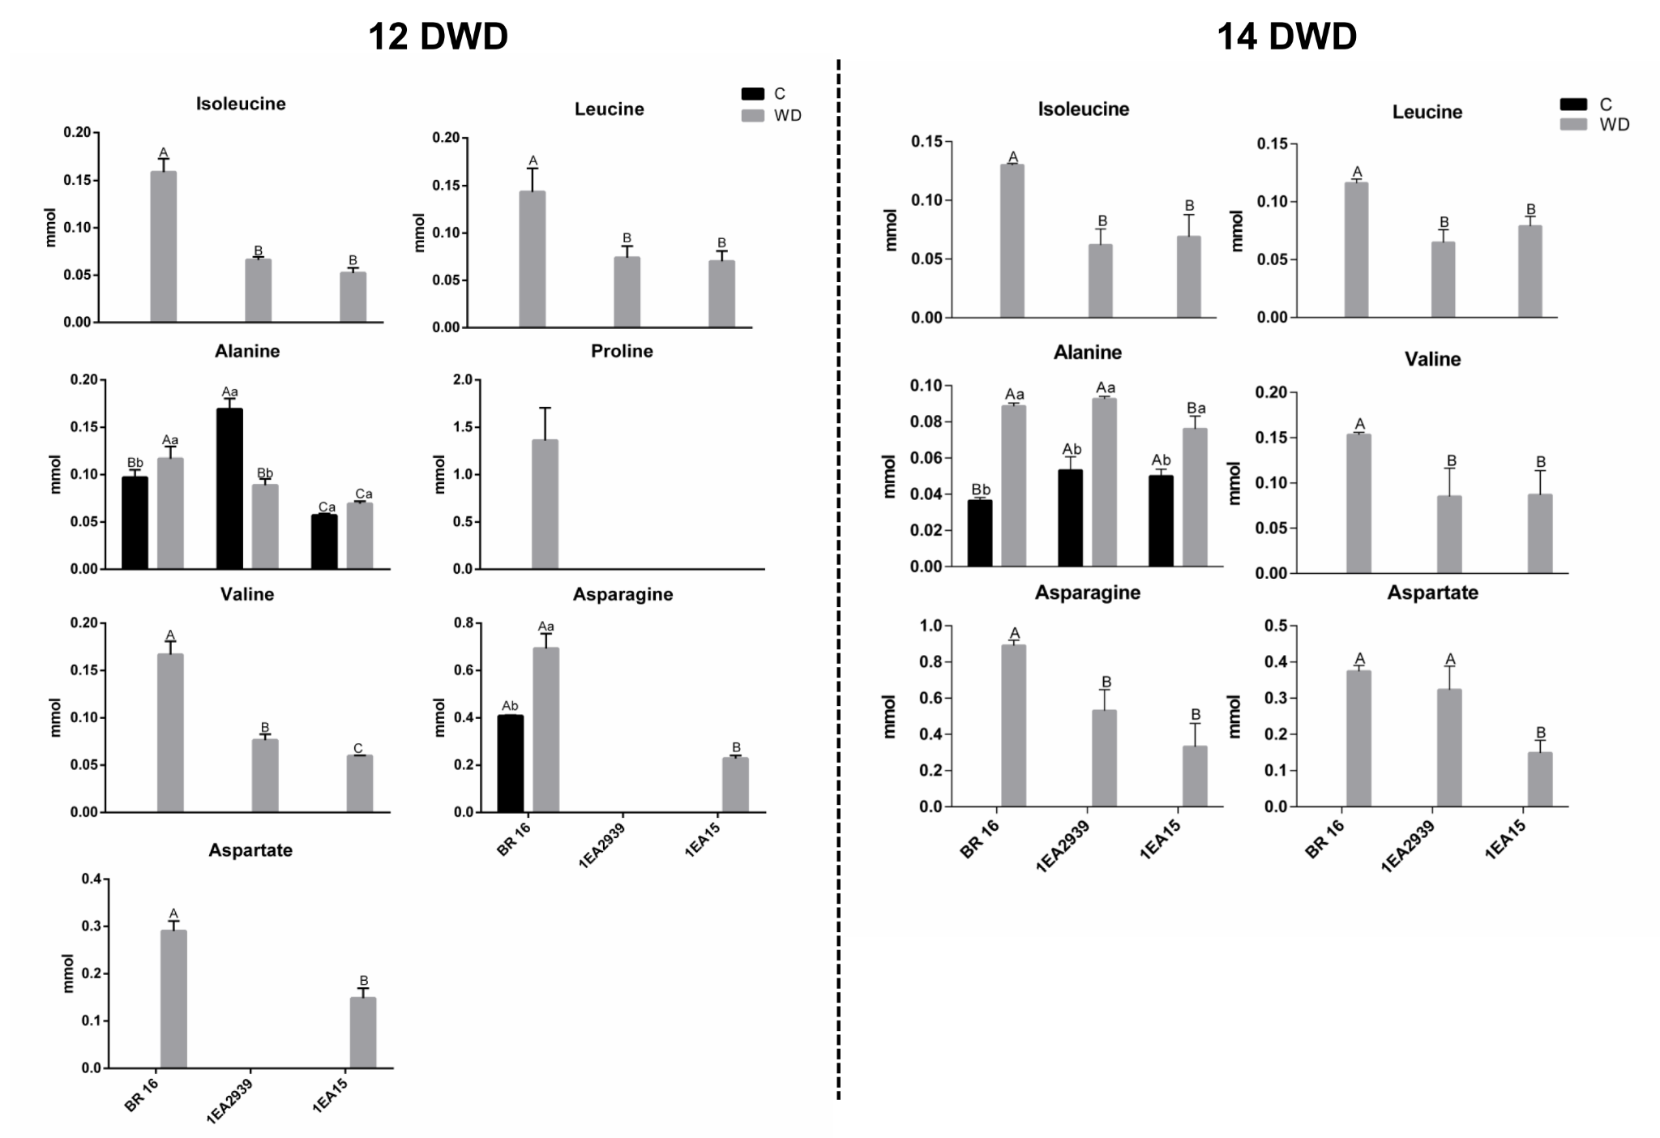
Figure S2. Amino acids content in roots of 1Ea2939, 1Ea15 and BR 16 under control (C) and water deficit (WD) conditions. The means (n = 6) and standard deviation, represented by columns and bars, respectively, followed by same capital letters (between the same water status) and lowercase letters (between the same genotype) do not differ by Tukey’s test (p ≤ 0.05).

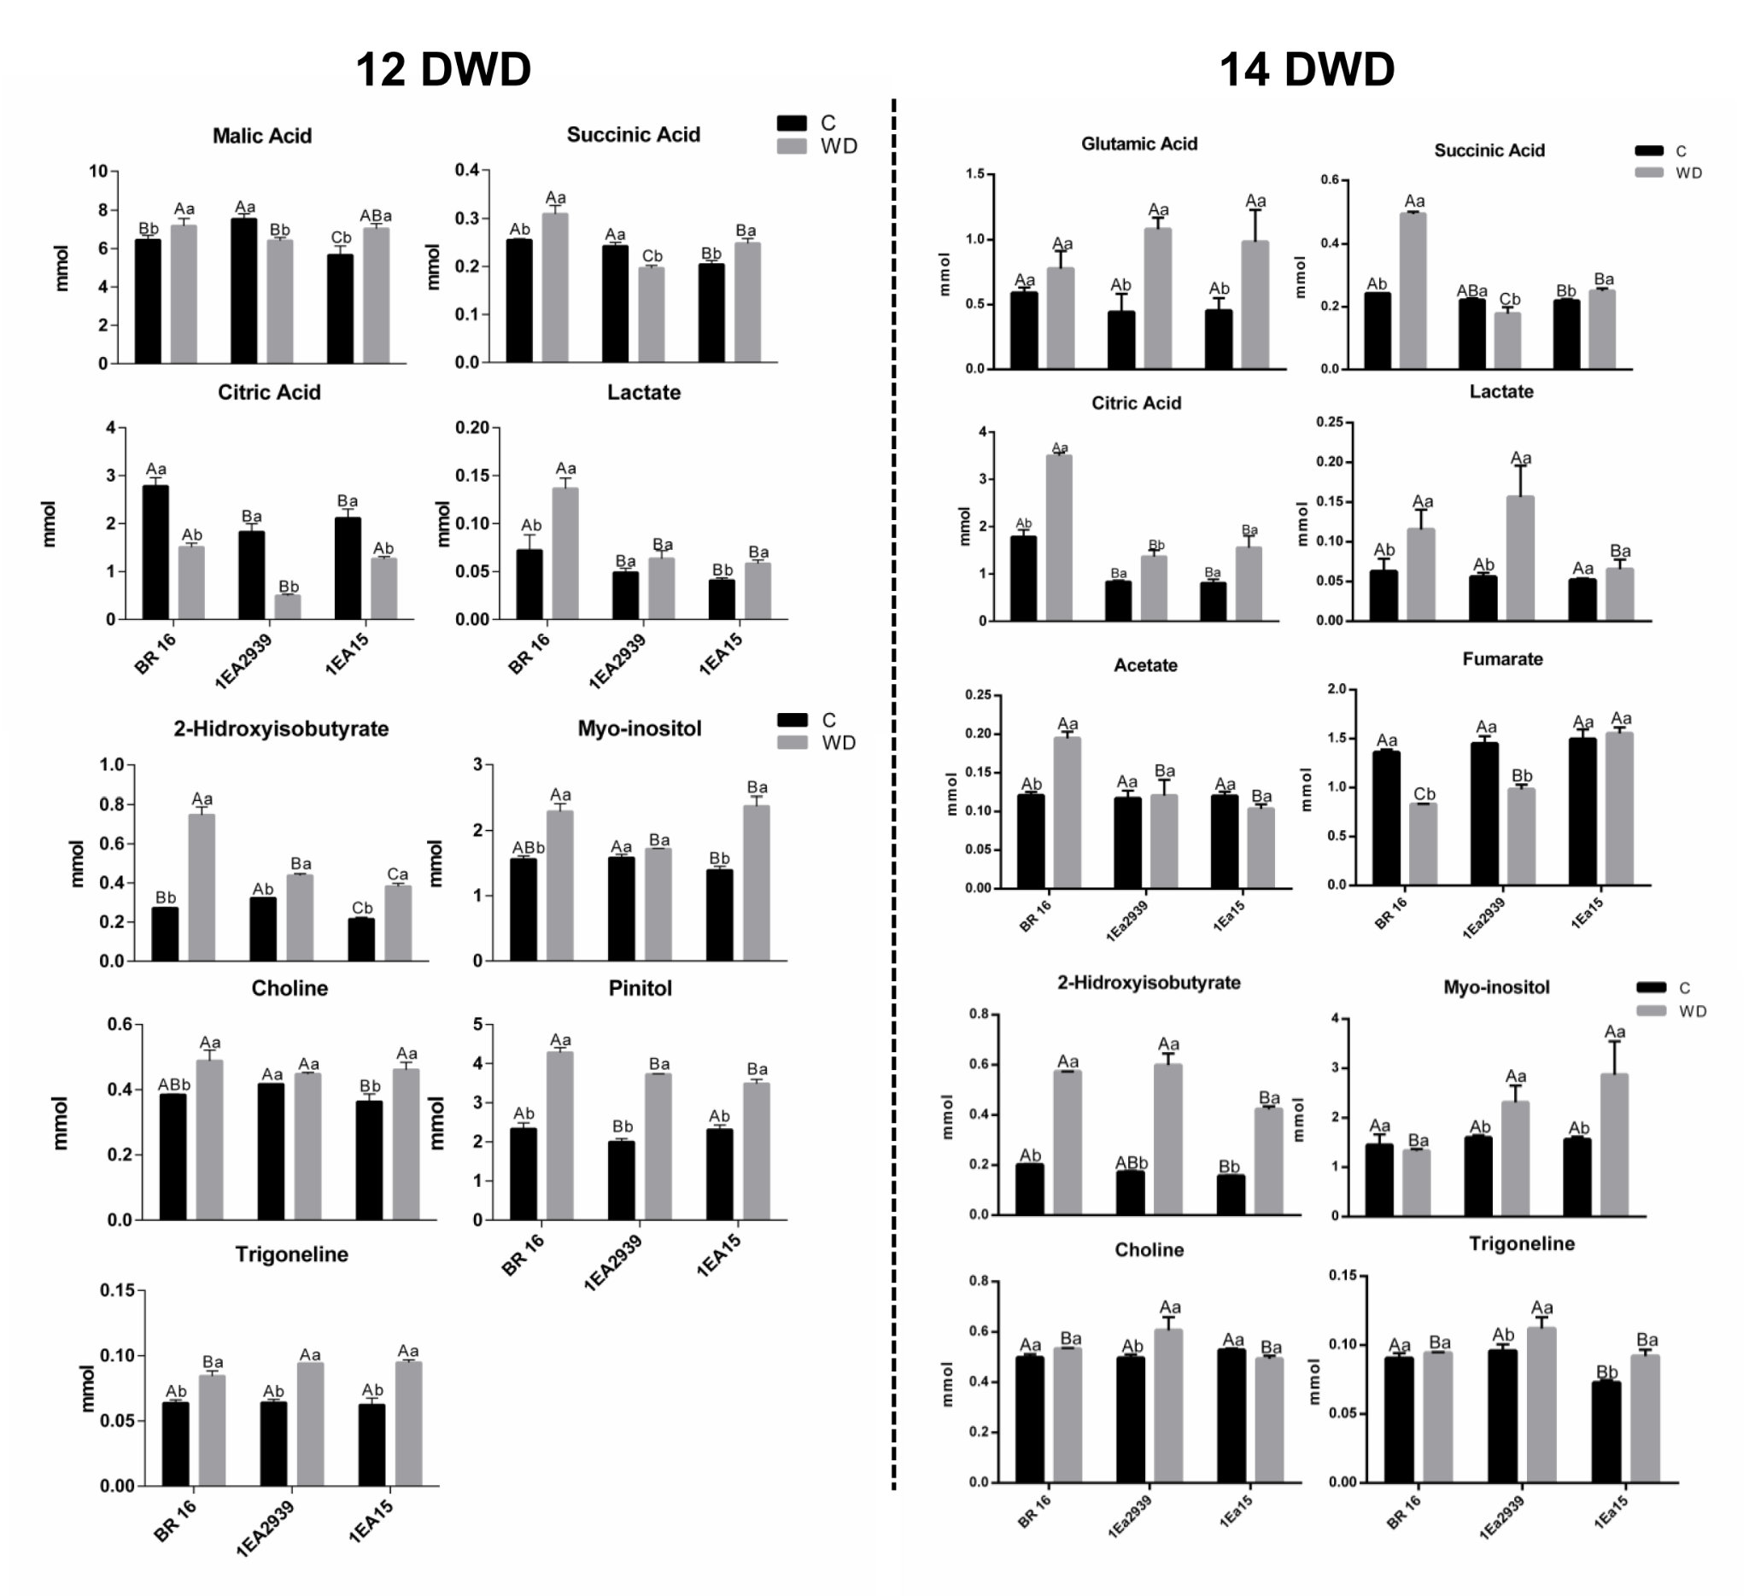
Figure S3. Organic acids in leaves, 2-hydroxyisobutyrate, myo-inositol, choline, pinitol and trigonelline content in 1Ea2939, 1Ea15 and BR 16 under control (C) and water deficit (WD) conditions. The means (n = 6) and standard deviation, represented by columns and bars, respectively, followed by same capital letters (between the same water status) and lowercase letters (between the same genotype) do not differ by Tukey’s test (p ≤ 0.05).

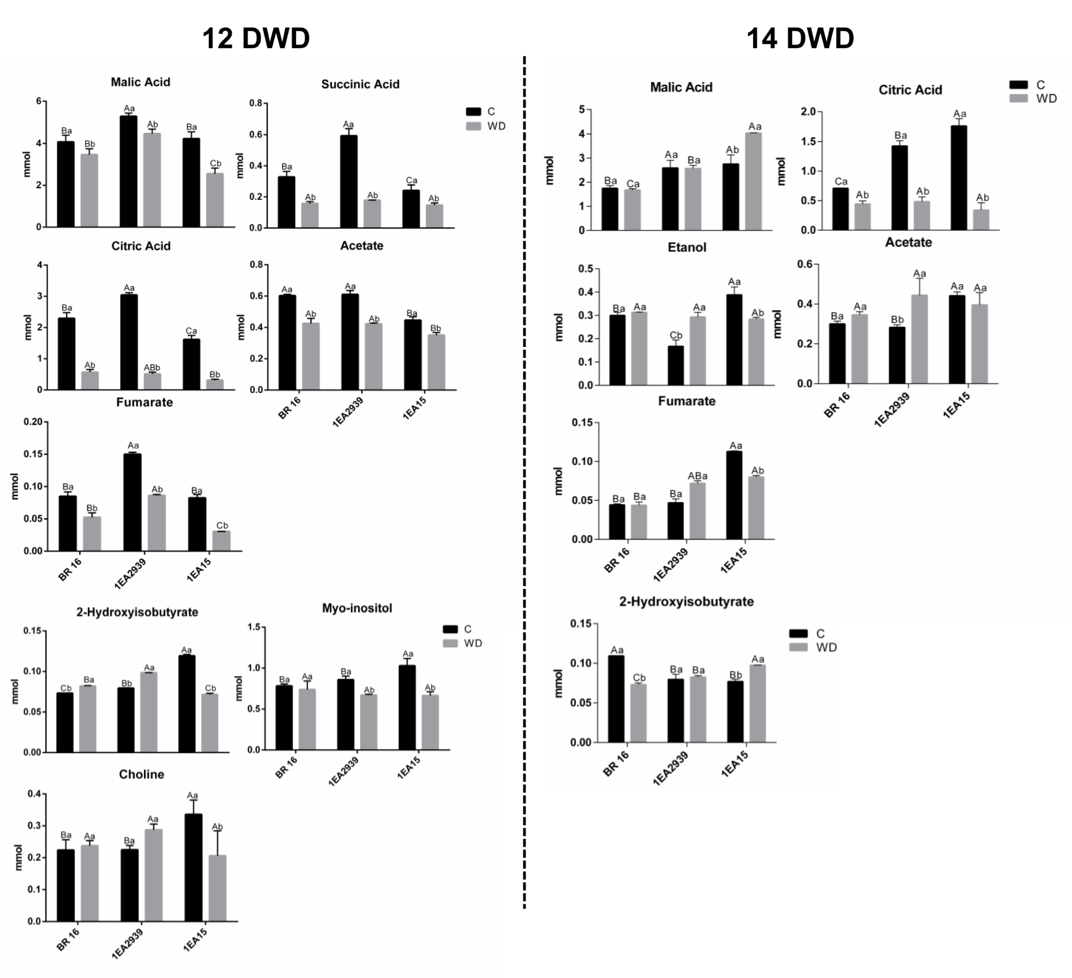
Figure S4. Organic acids in roots, 2-hydroxyisobutyrate, myo-inositol, choline, pinitol and trigonelline content in 1Ea2939, 1Ea15 and BR 16 under control (C) and water deficit (WD) conditions. The means (n = 6) and standard deviation, represented by columns and bars, respectively, followed by same capital letters (between the same water status) and lowercase letters (between the same genotype) do not differ by Tukey’s test (p ≤ 0.05).

Figure S5. Isoflavones content in 1Ea2939, 1Ea15 and BR 16 under control (C) and water deficit (WD) conditions. The means (n = 6) and standard deviation, represented by columns and bars, respectively, followed by same capital letters (between the same water status) and lowercase letters (between the same genotype) do not differ by Tukey’s test (p ≤ 0.05).

Figure S6. Phenolic compounds content in 1Ea2939, 1Ea15 and BR 16 under control (C) and water deficit (WD) conditions. The means (n = 6) and standard deviation, represented by columns and bars, respectively, followed by same capital letters (between the same water status) and lowercase letters (between the same genotype) do not differ by Tukey’s test (p ≤ 0.05).

Table S1. Water condition effect for metabolites identified in leaves and roots 12 DWD and 14 DWD.

12 DWD
 | METABOLITES | MEANS |  | CV (%)
 | METABOLITES | C | WD | CV (%)
 | Malonic Acid | 0.122778 B | 0.186333 A | 15.57
Leaves | Fumarate | 1.150000 B | 1.739667 A | 5.49
 | Trans-p-coumaroylquinic acid | 0.561000 B | 0.85033 A | 10.79
 | Gaba | 0.121867 B | 0.190011 A | 6.51
Roots | Formic Acid | 0.276833 A | 0.145611 B | 5.95
 | Malonyldaidzin | 0.047422 A | 0.024078 B | 7.72
 | Ethanol | 0.228189 B | 0.293811 A | 8.24
14 DWD
 | METABOLITES | MEANS |  | CV (%)
 |  | C | WD
Leaves | Malonic acid | 0.183111 B | 0.236222 A | 19.04
 | Glycine | 2.833000 B | 4.511556 A | 9.62
 | Pinitol | 2.333556 B | 3.655778 A | 6.62
 | Formic Acid | 0.195667 A | 0.157556 B | 15.06
 | Gaba | 0.0809111 B | 0.1508500 A | 15.43
Roots | Lactate | 0.0803055 B | 0.1108889 A | 15.02
 | Myo-inositol | 0.9030111 A | 0.5214889 B | 11.62

Table S2. Genotype effect for metabolites identified in leaves and roots after 12 DWD and 14 DWD.
12 DWD
 | METABOLITES | MEANS |  |  | CV (%)
 | METABOLITES | BR 16 | 1Ea2939 | 1Ea15 | CV (%)
 | Fumarate | 1.325167 B | 1.552833 A | 1.4565 A | 5.49
Leaves | Trans-p- coumaroylquinic acid | 0.616167 B | 0.696833 AB | 0.804 A | 10.79
Roots | Lactate | 0.1378167 A | 0.1174917 B | 0.08905 C | 8.24
Roots | Gaba | 0.2107170 A | 0.154500 B | 0.1026 C | 6.51
Roots | Formic Acid | 0.2356670 A | 0.249067 A | 0.148933 B | 5.95
Roots | Treahalose | 0.167317 AB | 0.151583 B | 0.18955 A | 10.92
Roots | Malonyldaidzin | 0.0395330 A | 0.043567 A | 0.02415 B | 7.72
14 DWD
 | METABOLITES | MEANS |  |  | CV (%)
 | METABOLITES | BR 16 | 1Ea2939 | 1Ea15 | CV (%)
Leaves | Malic Acid | 5.300333 A | 4.563333 B | 4.599 AB | 9.8
Leaves | Glycine | 3.6865 AB | 4.033167 A | 3.297167 B | 9.62
Leaves | Pinitol | 3.092167 A | 3.310333 A | 2.5815 B | 6.62
Leaves | Fructose | 2.063167 B | 2.5085 AB | 2.907333 A | 20.88
Leaves | Lysine | 0.1278833 A | 0.1191917 AB | 0.08261667 B | 26.55

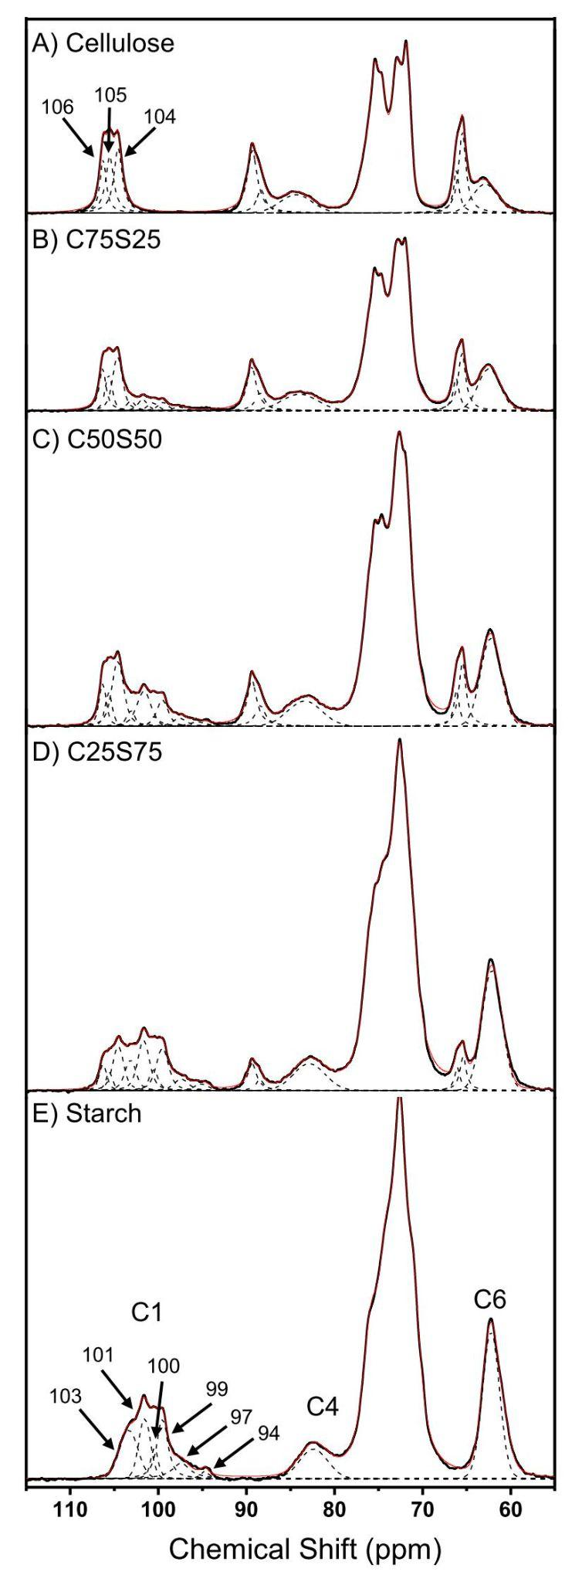
Figure S7. ¹³C SSNMR spectra shape profile recorded for cellulose (a) mixtures of cellulose and starch (b-d) and starch (e). The procedure brings a clear overview of the C1 carbon signal, used to evaluate the average content of both polysaccharides remaining in the leaves and roots from GMP and BR16 samples.

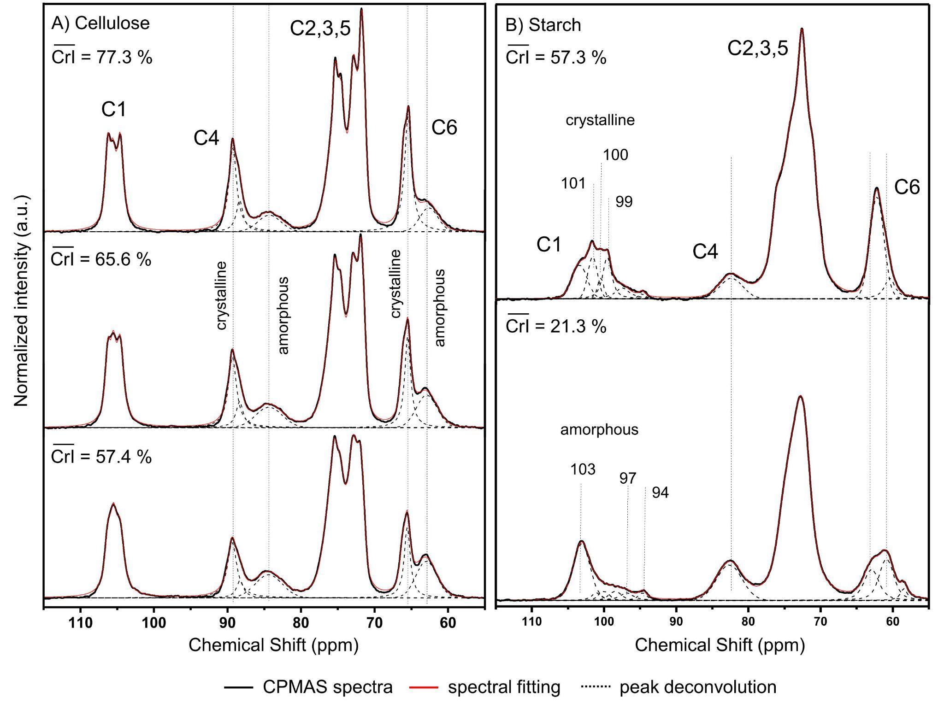
Figure S8. ¹³C NMR spectra from cellulose (a) and starch (b) samples.

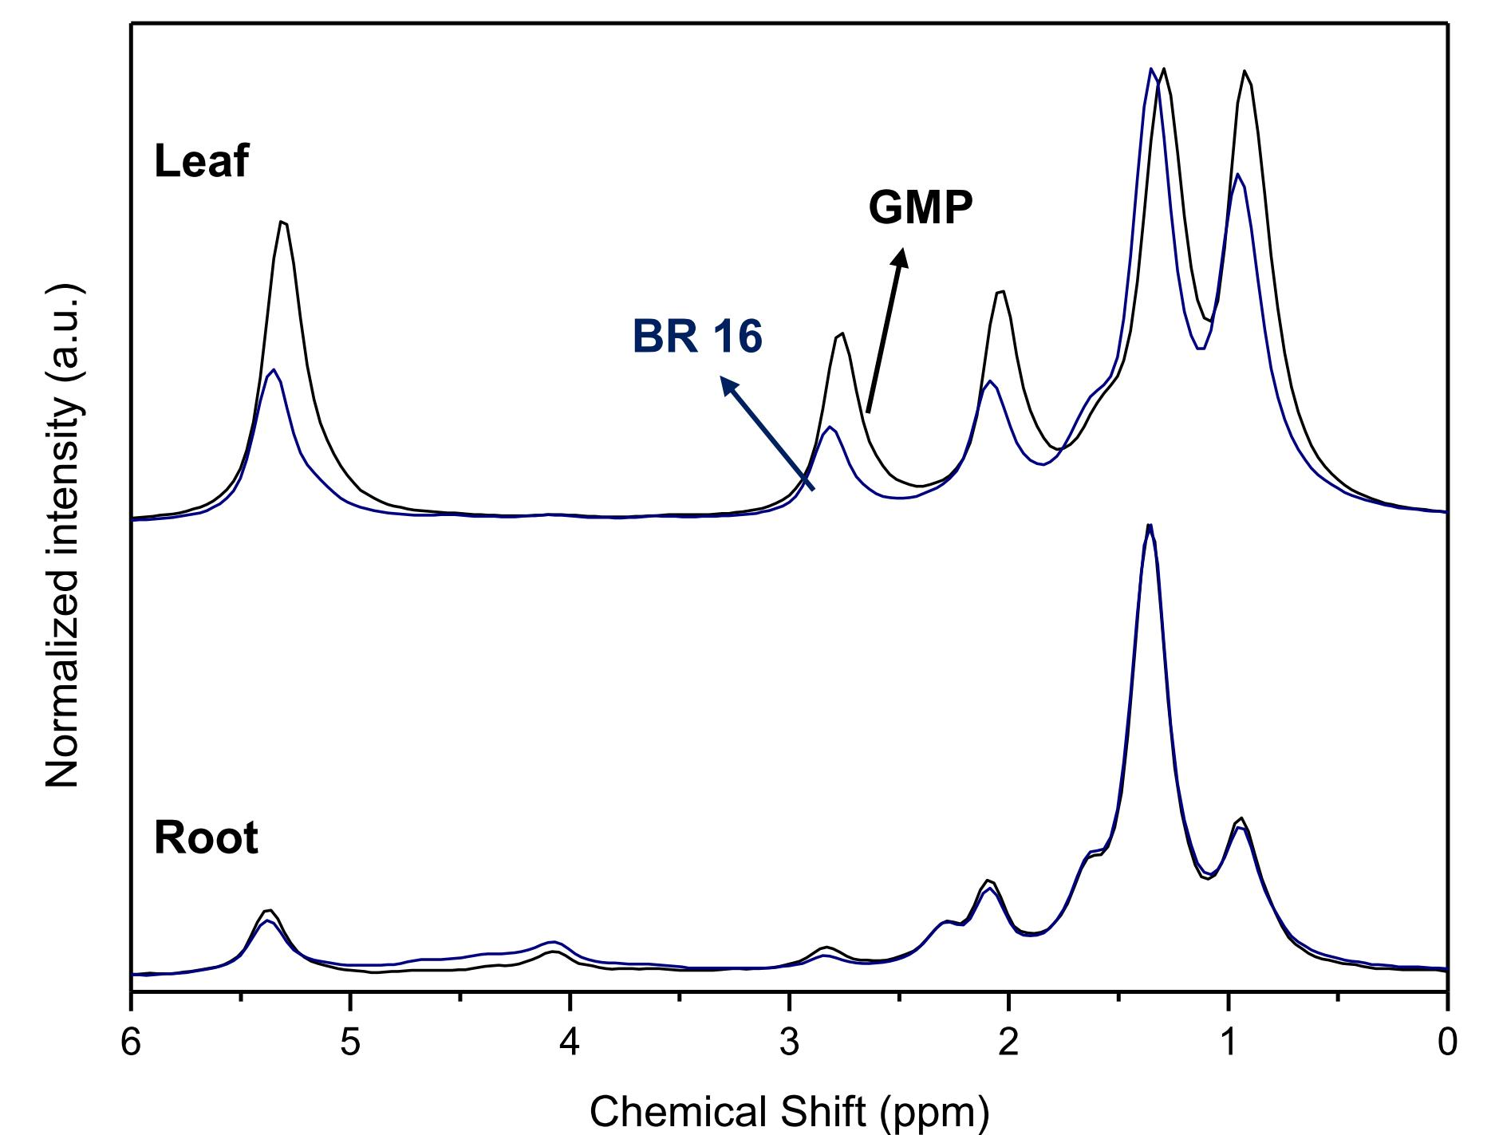
Figure S9. ¹H-ECHO-MAS spectra of lyophilized soybean leaves and roots under 14DWD from BR16 and GMP (1Ea2939).

Table S3. Chemical shifts relative to the ¹H NMR spectral signals employing the ECHO-MAS pulse sequence, and reported according to Guillén et al, 2001.
Chemical shift (δ, ppm) | Group assigned
0,97 | -CH₃ grupos acil
1,37 | -(CH₂) grupos acil
1,63 | -OCO-CH₂-CH₂
2,10 | -CH₂-CH=CH
2,83 | -HC-CH₂-CH
5,15 | CHOCOR
5,37 | CH=CH

