Patient reported outcomes following whole brain radiotherapy in patients with brain metastases

Bolanle Adegboyega^{1*}, Adedayo Joseph¹, Adewumi Alabi¹, John Omomila¹, Lindokuhle M. Ngema^{2*}, Victoria Ainsworth^{2,3}, Jennifer Chin², Moses Evbuomwam⁴, Wilfred Ngwa²

¹NSIA-LUTH Cancer Centre, Lagos University Teaching Hospital, Lagos, Nigeria
²Johns Hopkins Medicine, Sydney Kimmel Comprehensive Cancer Centre, Baltimore, MD 21218, USA
³Department of Physics, University of Massachusetts Lowell, Lowell, MA 01854, USA
⁴Department of Radiation Oncology, University of Iowa Hospitals and Clinics, Iowa City, IA 52242, USA

*Corresponding Author(s):
Dr. Bolanle Adegboyega; E: abecee2001@yahoo.com
Lindokuhle M. Ngema; E: 845407@students.wits.ac.za

SCORE TRANSFORMATION PROCEDURE
(A) EORTC QLQ-C15-PAL

- 2-multi-item scales (physical and emotional functioning)
- 2-multi-item scales (fatigue and pain)
- 5-single-item scales (dyspnea, insomnia, appetite loss, nausea/vomiting, and constipation)
- 1-overall QOL (global health status)

- Function Scales
  - Physical functioning (PF) = (Q 1 + Q2 + Q3)
  - Emotional functioning (EF) = (Q13 + Q14)

- Symptom Scales
  - Fatigue (FA) = (Q7 + Q11)
  - Pain (PA) = (Q 5 + Q12)
  - Dyspnea (DY) = (Q4)
  - Insomnia (SL) = (Q6)
  - Appetite loss (AP) = (Q 8)
  - Nausea/vomiting (NV)= (Q9)
  - Constipation (CO) = (Q10)

- Global health status (quality of life, QoL) = (Q 15)

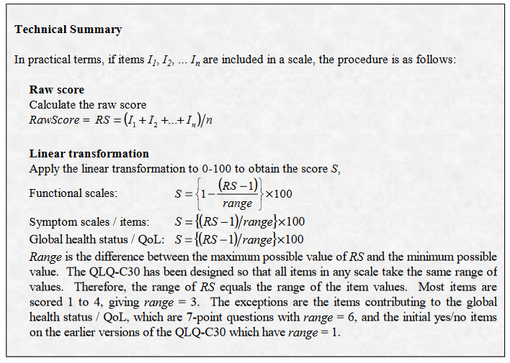
All QLQ-C15-PAL scale scores were linearly transformed, and the resultant scores ranged from 0 to 100

(B) EORTC QLQ-BN20

- 4-multi-item scales (future uncertainty)
- 3-multi-item scales (visual disorder, motor dysfunction, and communication deficit)
- 7-single-item scales (headache, seizure, drowsiness, hair loss, itchy skin, weakness of leg, and bladder control)

- Symptom Scales

Multi-item scales
  - Future uncertainty = (Q31 + Q32 + Q33 + Q35)
  - Visual disorders = (Q36 + Q37 + Q38)
  - Motor dysfunction = (Q40 + Q45 + Q49)
  - Communication deficit = (Q41 + Q42 + Q43)

Single-item scales
  - Headache = (Q34)
  - Seizures = (Q39)
  - Drowsiness = (Q44)
  - Hair loss = (Q46)
  - Pruritus or Itchy skin = (Q47)
  - Weakness of both leg = (Q48)
  - Difficulties with bladder control = (Q50)

The self-assessed scale scores ranging from 1–4 is then linearly converted to a 0–100 scale, with higher scores indicating more severe symptoms. In the case of functions, higher scores indicate better function.

