Supplementary Materials for

Projecting Future Heat Stress Disparities to 2100 in the Contiguous United States

Kaihui Song,¹* Angel Hsu,¹ Wei Peng,^{2,3} Ying Yu,⁴ Noah Kittner^{4,5}

1 Data-Driven EnviroLab, School of Public Policy, University of North Carolina at Chapel Hill, Chapel Hill, NC 27599, USA.
2 School of Public and International Affairs, Princeton University, Princeton, NJ 08540, USA.
3 Andlinger Center For Energy and the Environment, Princeton University, Princeton, NJ 08540, USA.
4 Department of Environmental Sciences and Engineering, Gillings School of Global Public Health, University of North Carolina at Chapel Hill, Chapel Hill, NC 27599, USA.
5 Department of City and Regional Planning, University of North Carolina at Chapel Hill, Chapel Hill, NC 27599, USA.

*Corresponding author: Kaihui Song (email: kaihuis@unc.edu)

Supplementary Text
Supplementary data description

1 CMIP6 models

CMIP6 (Coupled Model Intercomparison Project 6): We obtain near-surface air temperature (2m above the ground) (tas) and corresponding relative humidity (hurs) from ScenarioMIP in CMIP6. This database provides a range of outcomes based on concentration-driven simulations from participating global coupled Earth System Models¹. ScenarioMIP specifically provides multi-model climate projections based on different scenarios with future emissions and land use changes produced with Integrated Assessment Models, using 1995-2014 as historical baseline for simulations ². Figure S1 illustrated the coupled SSP-RCP simulations in CMIP6.

Our analysis focuses on Tier 1 experiments (SSP1-RCP2.6, SSP2-RCP4.5, SSP3-RCP7.0 and SSP5-RCP8.5) and the additional scenario designed to limit global warming to 1.5 degree above 1850-1900 (a period often used as a proxy for pre-industrial conditions), SSP1-RCP1.9. A detailed description of these scenarios under focus is provided in Table S1.

We filtered 25 models that performed the projection of near-surface air temperature (tas) and near-surface relative humidity (hurs) to 2100. We ended up having 4 models for SSP1-RCP1.9, 16 models for SSP1-RCP2.6, 17 models for SSP2-RCP4.5, 16 models for SSP3-RCP7.0, and 17 models for SSP5-RCP8.5 to calculate Heat Index (Table S2).

2 Socioeconomic data

Total population, population by race, age and gender are county-level projections under five SSPs at a five-year interval from 2020 to 2100 ³ . Sociodemographic data collected from multiple sources are details in Table S3. In our analysis, populations by race are categorized into non-Hispanic White, non-Hispanic Black, Hispanic (all races), and Other Races. The age groups under study are classified into Young (age below 20), Adult (age 20-64) and Elderly (age 65+). To get the downscaled data, Hauer ⁴ calculates cohort-change ratios (CCRs) and cohort-change differences and projects into Leslie matrix population projection models using inputs from ARIMA models and control the projections to the SSPs.

3 Details of county-level Heat Index

The increases in Heat Index are more pronounced than the increases in surface temperature on average in the contiguous US. However, the increase in Heat Index is largely heterogeneous across the US, ranging from 0.83°F (San Benito, California) to 4.37°F (Screven, Georgia) by the middle of this century, from 2.85°F (Santa Cruz, California) to 8.53°F (Hampton, South Carolina) by the end of this century under SSP2-RCP4.5 (Fig. S3). The top 20 counties that will experience the highest increase in Heat Index are mainly located in the Southeast and their heat Indices are already as high as 80–85 °F during summer months for the baseline period. In contrast, the counties that would experience the least temperature increase are more widely distributed spatially, and most of them are located in the West region.

Fig. S1. SSP-RCP scenario matrix illustrating ScenarioMIP simulations in CMIP6 (2)

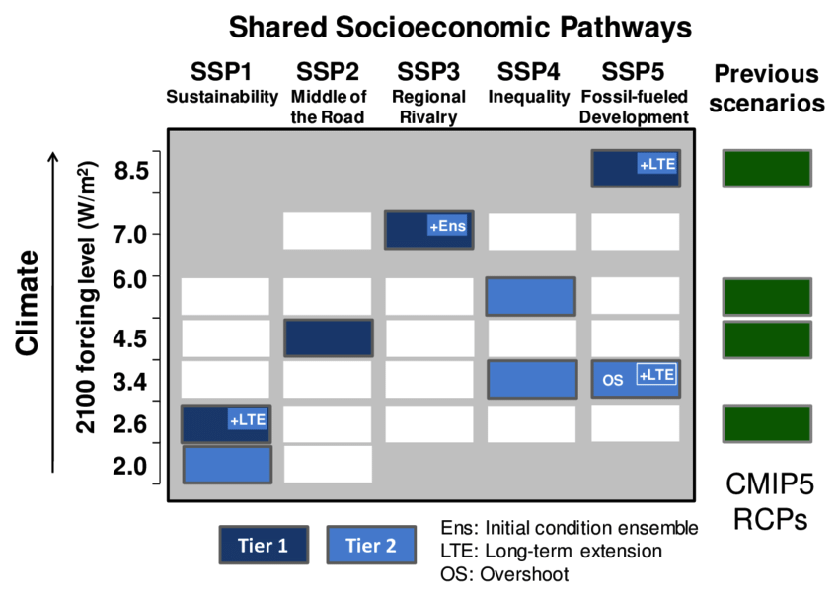

Fig. S2. Top 10 counties that would experience the highest Heat Index (A) in baseline period (2015-2020), (B) middle of the century period (2045-2050), and (C) end of the century period (2095-2100) under five coupled SSP-RCP scenarios

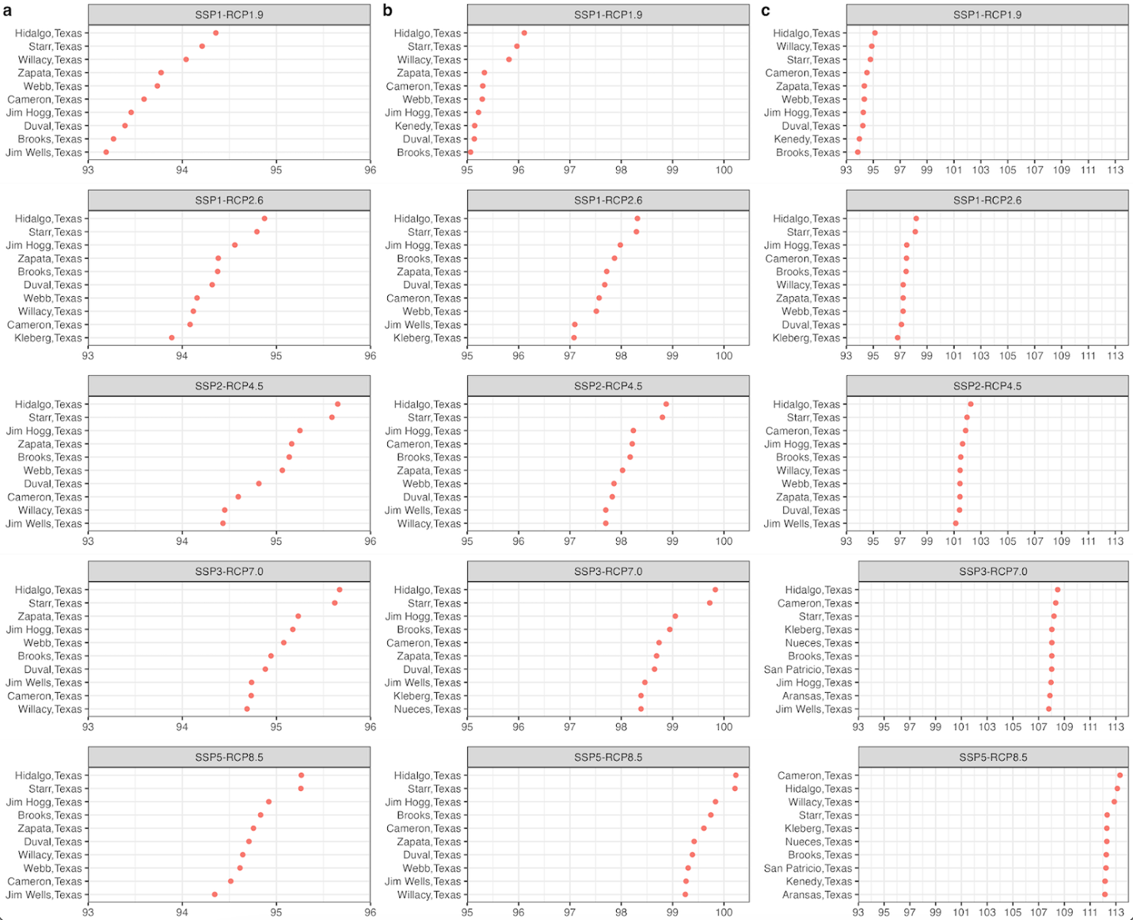

Fig. S3. Top 10 counties that would experience highest increases in Heat Index (A) by middle of the century period (2045-2050) and (B) by the end of the century period (2095-2100)

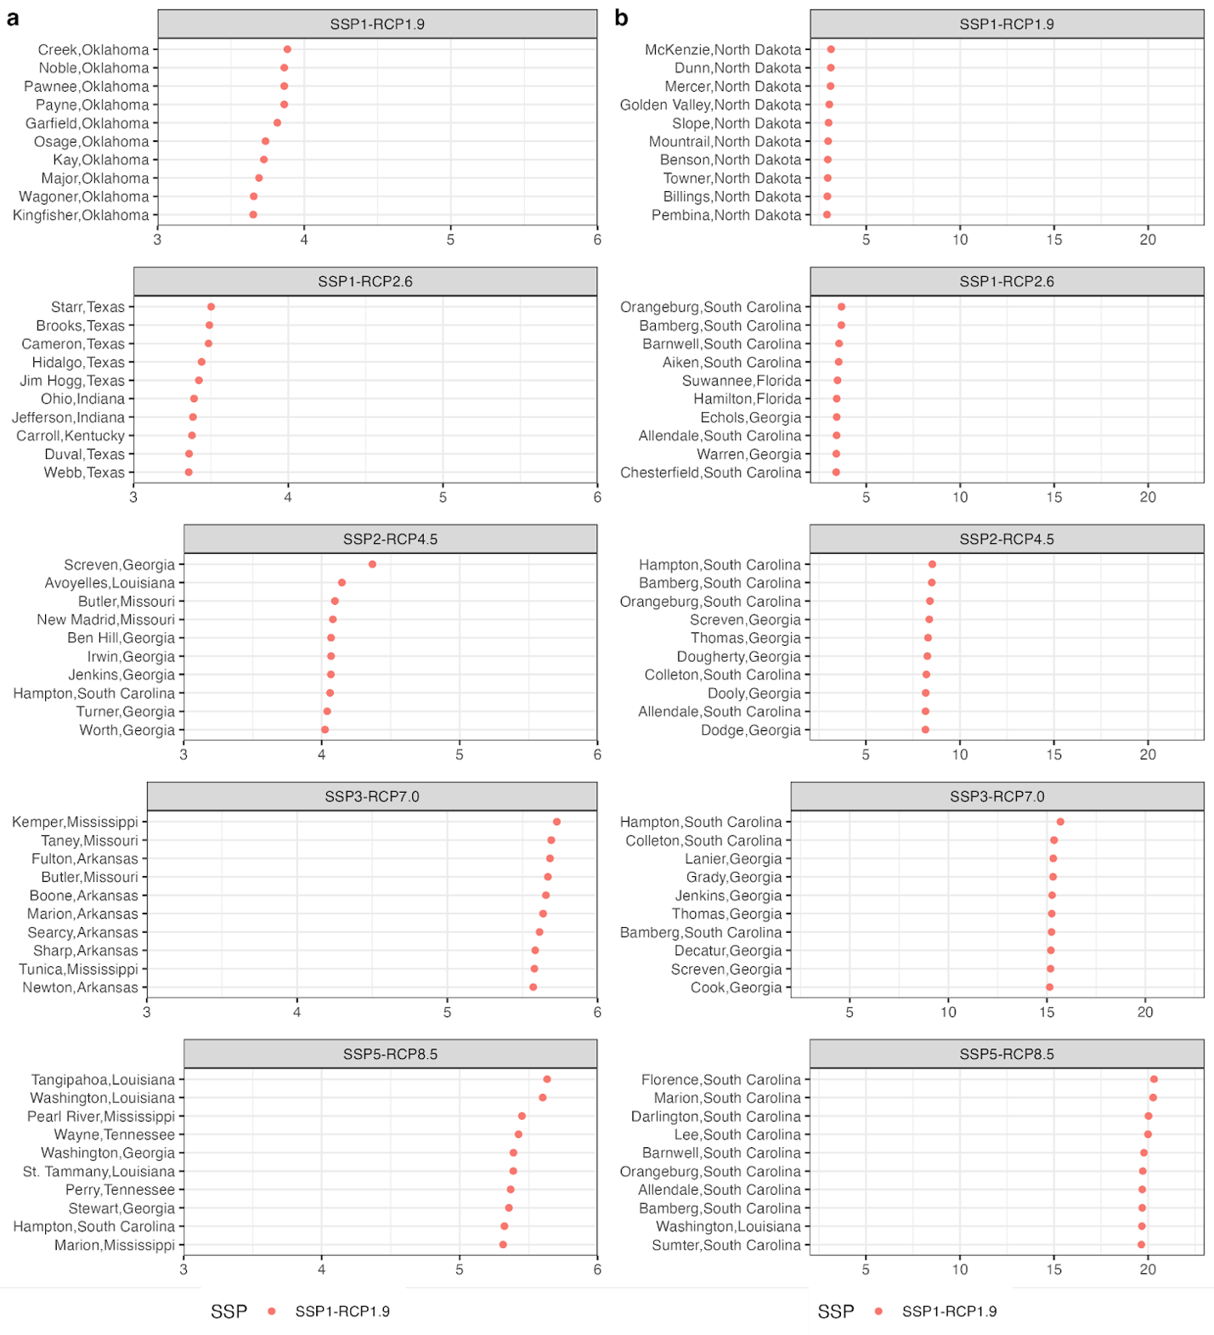

Fig. S4. Race composition for each Heat Index zone

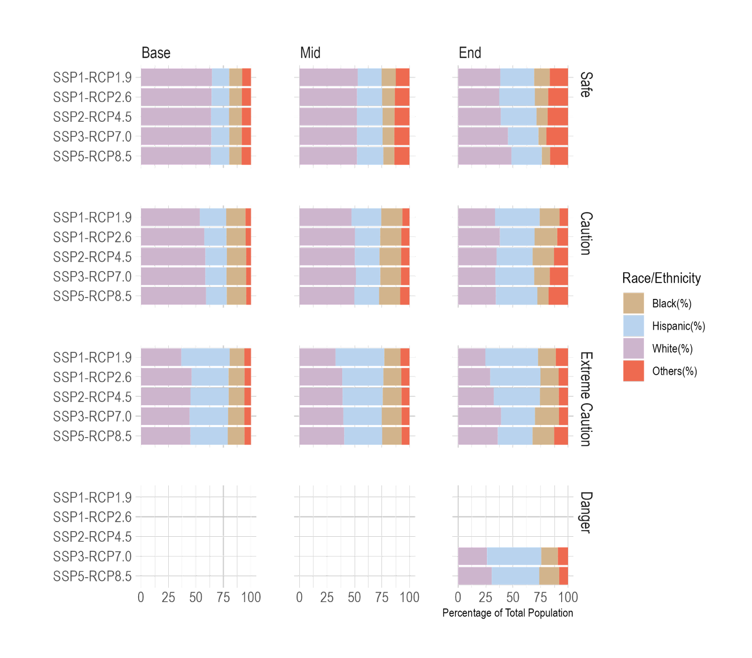

Fig. S5. Age composition for each Heat Index zone

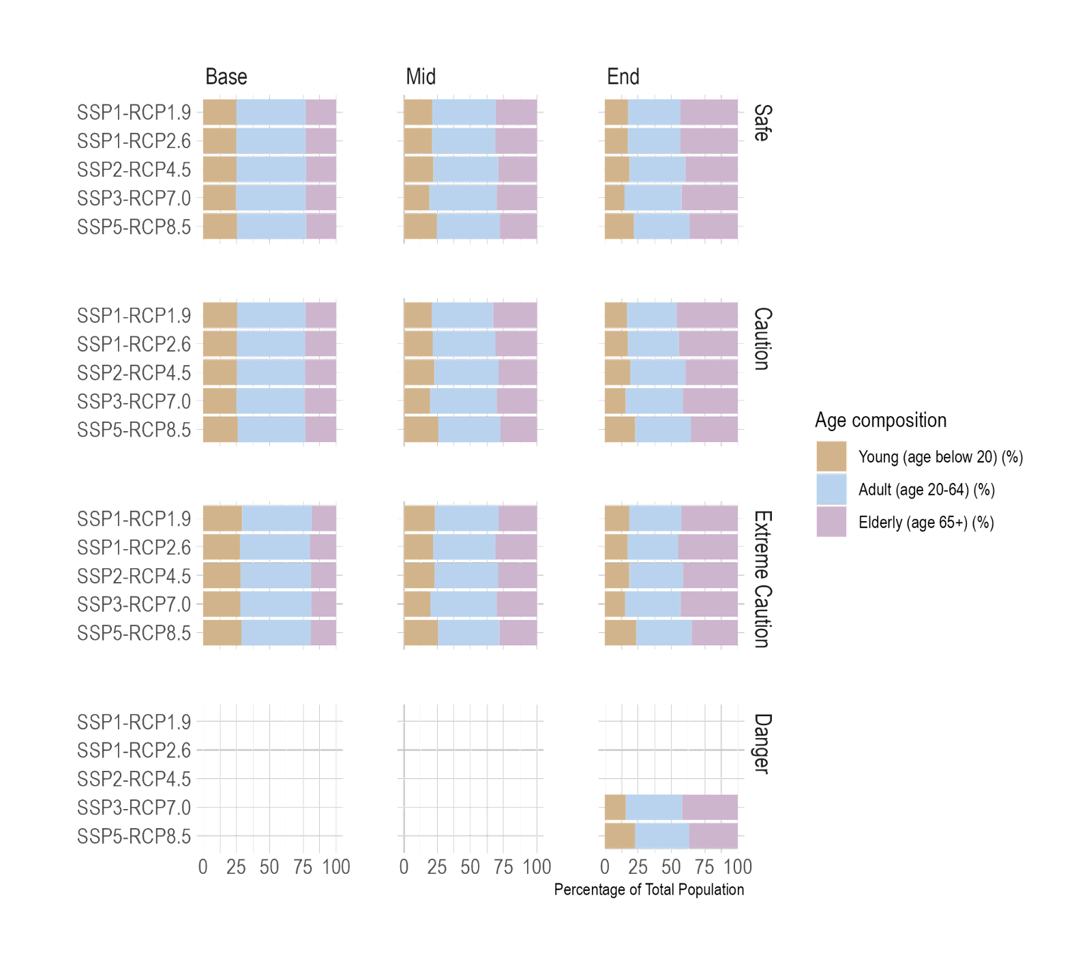

Fig. S6. Project share of non-Hispanic Black population throughout the contiguous US in five SSP scenarios for present day to 2100
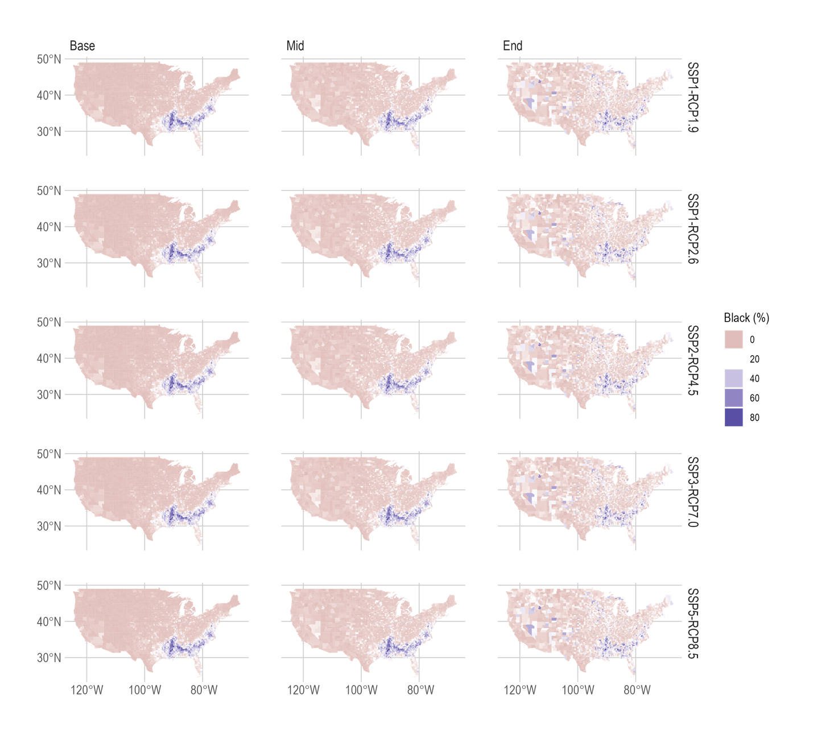

Fig. S7. Project share of Hispanic (all races) population throughout the contiguous US in five SSP scenarios for present day to 2100

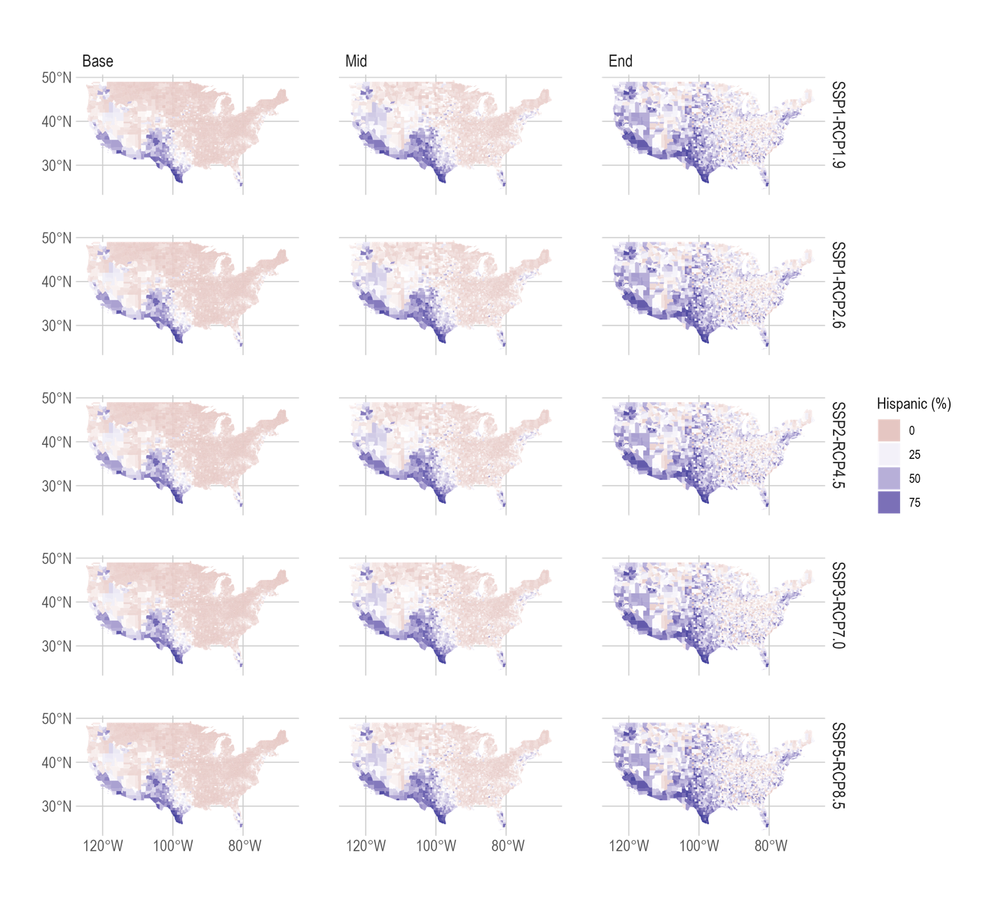

Fig. S8. Project share of Elderly (age 65+) population throughout the contiguous US in five SSP scenarios for present day to 2100

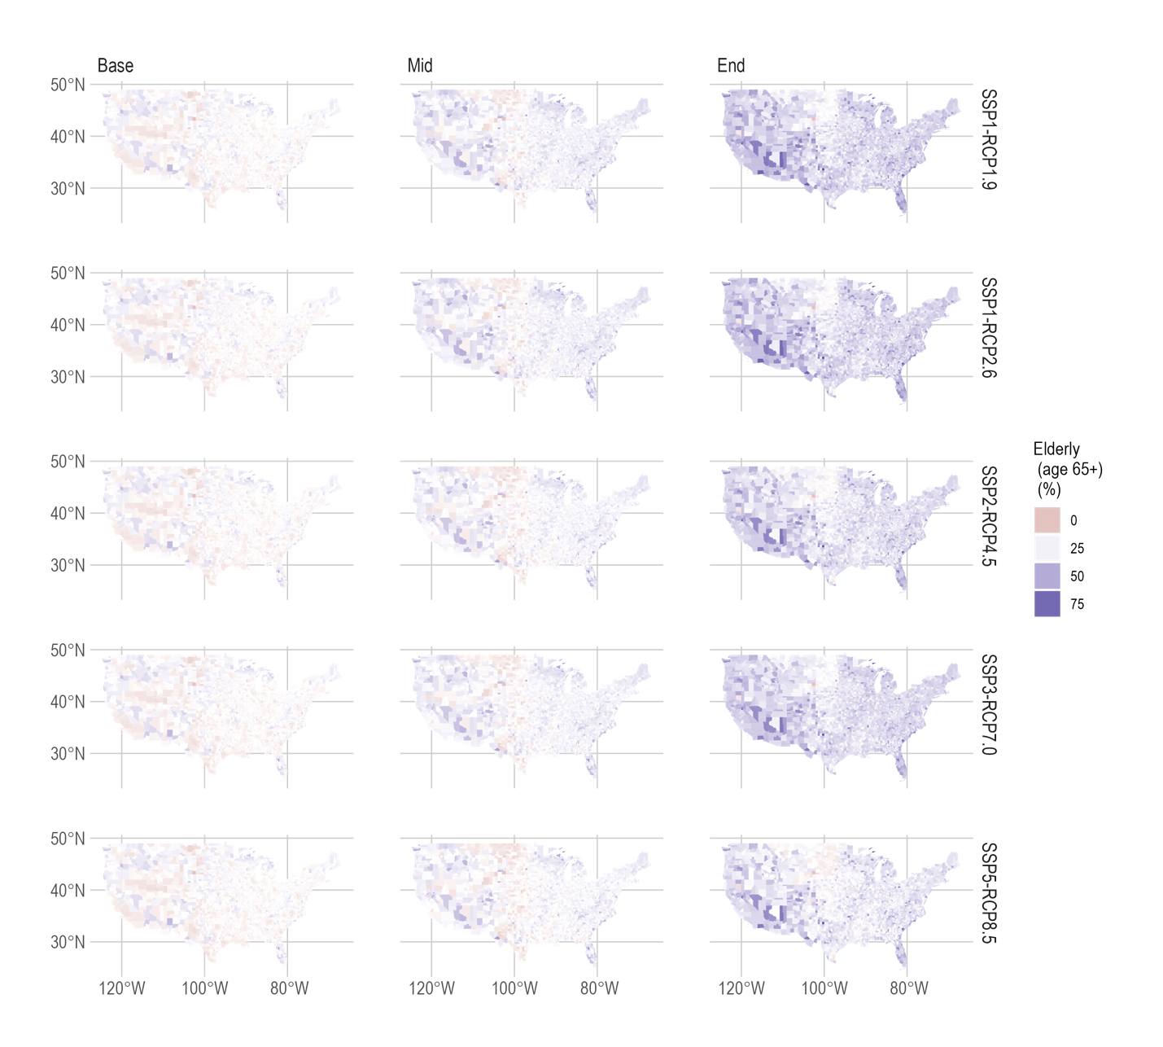

Table S1. Coupled Shared Socioeconomic Pathways (SSP) and Representative Concentration Pathways (RCP) scenarios considered in this study

SSP-RCP Pathways | Description
SSP1-RCP1.9 | Very low GHG emissions: CO₂ emissions cut to net zero around 2050
SSP1-RCP2.6 | Low GHG emissions: CO₂ emissions cut to net zero around 2075
SSP2-RCP4.5 | Intermediate GHG emissions: CO₂ emissions around current levels until 2050, then falling but not reaching net zero by 2100
SSP3-RCP7.0 | High GHG emissions: CO₂ emissions double by 2100
SSP5-RCP8.5 | Very high GHG emissions: CO₂ emissions triple by 2075

Table S2. Model details from CMIP6

ID | Models | Model county | Model Institute | Resolution | Experiments | Variable |  | Ensemble variant
 |  |  |  |  |  | tas | hurs
1 | AWI-CM-1-1-MR | Germany | Alfred Wegener Institute (AWI) | 100km | SSP1-RCP1.9 | 0 | 0 | r1i1p1
 |  |  |  |  | SSP1-RCP2.6 | 1 | 1 | r1i1p1
 |  |  |  |  | SSP2-RCP4.5 | 1 | 1 | r1i1p1
 |  |  |  |  | SSP3-RCP7.0 | 1 | 1 | r1i1p1
 |  |  |  |  | SSP5-RCP8.5 | 1 | 1 | r1i1p1
2 | BCC-CSM2-MR | China | Beijing Climate Center (BCC) | 100km (320 x 160 longitude/latitude) | SSP1-RCP1.9 | 0 | 0 | r1i1p1
 |  |  |  |  | SSP1-RCP2.6 | 1 | 0 | r1i1p1
 |  |  |  |  | SSP2-RCP4.5 | 1 | 0 | r1i1p1
 |  |  |  |  | SSP3-RCP7.0 | 1 | 0 | r1i1p1
 |  |  |  |  | SSP5-RCP8.5 | 1 | 0 | r1i1p1
3 | CAMS-CSM1-0 | China | Chinese Academy of Meteorological Sciences (CAMS) | 100km (320 x 160 longitude/latitude) | SSP1-RCP1.9 | 1 | 0 | r1i1p1
 |  |  |  |  | SSP1-RCP2.6 | 1 | 0 | r1i1p1
 |  |  |  |  | SSP2-RCP4.5 | 1 | 0 | r1i1p1
 |  |  |  |  | SSP3-RCP7.0 | 1 | 0 | r1i1p1
 |  |  |  |  | SSP5-RCP8.5 | 1 | 0 | r1i1p1
4 | CAS-ESM2-0 | China | Chinese Academy of Sciences (CAS) | 100km (256 x 128 longitude/latitude) | SSP1-RCP1.9 | 0 | 0 | r1i1p1
 |  |  |  |  | SSP1-RCP2.6 | 1 | 1 | r1i1p1
 |  |  |  |  | SSP2-RCP4.5 | 1 | 1 | r1i1p1
 |  |  |  |  | SSP3-RCP7.0 | 1 | 1 | r1i1p1
 |  |  |  |  | SSP5-RCP8.5 | 1 | 1 | r1i1p1
5 | CESM2-WACCM | USA | National Center for Atmospheric Research (NCAR) | 100km (0.9x1.25 finite volume grid; 288 x 192 longitude/latitude) | SSP1-RCP1.9 | 0 | 0 | r1i1p1
 |  |  |  |  | SSP1-RCP2.6 | 1 | 1 | r1i1p1
 |  |  |  |  | SSP2-RCP4.5 | 1 | 1 | r1i1p1
 |  |  |  |  | SSP3-RCP7.0 | 1 | 1 | r1i1p1
 |  |  |  |  | SSP5-RCP8.5 | 1 | 1 | r1i1p1
6 | CIESM | China | Tsinghua University | 100km (288 x 192 longitude/latitude) | SSP1-RCP1.9 | 0 | 0 | r1i1p1
 |  |  |  |  | SSP1-RCP2.6 | 1 | 0 | r1i1p1
 |  |  |  |  | SSP2-RCP4.5 | 1 | 0 | r1i1p1
 |  |  |  |  | SSP3-RCP7.0 | 0 | 0 | r1i1p1
 |  |  |  |  | SSP5-RCP8.5 | 1 | 0 | r1i1p1
7 | CMCC-CM2-SR5 | Italy | Fondazione Centro Euro-Mediterraneo sui Cambiamenti Climatici (CMCC) | 100km (1deg; 288 x 192 longitude/latitude) | SSP1-RCP1.9 | 0 | 0 | r1i1p1
 |  |  |  |  | SSP1-RCP2.6 | 1 | 1 | r1i1p1
 |  |  |  |  | SSP2-RCP4.5 | 1 | 1 | r1i1p1
 |  |  |  |  | SSP3-RCP7.0 | 1 | 1 | r1i1p1
 |  |  |  |  | SSP5-RCP8.5 | 1 | 1 | r1i1p1
8 | CMCC-ESM2 | Italy | Fondazione Centro Euro-Mediterraneo sui Cambiamenti Climatici (CMCC) | 100km (1deg; 288 x 192 longitude/latitude) | SSP1-RCP1.9 | 0 | 0 | r1i1p1
 |  |  |  |  | SSP1-RCP2.6 | 1 | 1 | r1i1p1
 |  |  |  |  | SSP2-RCP4.5 | 1 | 1 | r1i1p1
 |  |  |  |  | SSP3-RCP7.0 | 1 | 1 | r1i1p1
 |  |  |  |  | SSP5-RCP8.5 | 1 | 1 | r1i1p1
9 | E3SM-1-0 | United States | E3SM-Project LLNL UCI UCSB | 100km (deg average grid spacing; 90 x 90 x 6 longitude/latitude/cubeface) | SSP1-RCP1.9 | 0 | 0 | r1i1p1
 |  |  |  |  | SSP1-RCP2.6 | 0 | 0 | r1i1p1
 |  |  |  |  | SSP2-RCP4.5 | 0 | 0 | r1i1p1
 |  |  |  |  | SSP3-RCP7.0 | 0 | 0 | r1i1p1
 |  |  |  |  | SSP5-RCP8.5 | 1 | 0 | r1i1p1
10 | E3SM-1-1 | USA | E3SM-Project; RUBISCO | 100km (1 deg average grid spacing; 90 x 90 x 6 longitude/latitude/cubeface) | SSP1-RCP1.9 | 0 | 0 | r1i1p1
 |  |  |  |  | SSP1-RCP2.6 | 0 | 0 | r1i1p1
 |  |  |  |  | SSP2-RCP4.5 | 1 | 0 | r1i1p1
 |  |  |  |  | SSP3-RCP7.0 | 0 | 0 | r1i1p1
 |  |  |  |  | SSP5-RCP8.5 | 1 | 0 | r1i1p1
11 | E3SM-1-1-ECA | United States | E3SM-Project | 100km (90 x 90 x 6 longitude/latitude/cubeface) | SSP1-RCP1.9 | 0 | 0 | r1i1p1
 |  |  |  |  | SSP1-RCP2.6 | 0 | 0 | r1i1p1
 |  |  |  |  | SSP2-RCP4.5 | 0 | 0 | r1i1p1
 |  |  |  |  | SSP3-RCP7.0 | 0 | 0 | r1i1p1
 |  |  |  |  | SSP5-RCP8.5 | 1 | 0 | r1i1p1
12 | EC-Earth3 | Spain, Italy, Germany, UK, Finland, Switzerland | EC-Earth-Consortium | 100km (linearly reduced Gaussian grid equivalent to 512 x 256 longitude/latitude) | SSP1-RCP1.9 | 0 | 0 | r1i1p1
 |  |  |  |  | SSP1-RCP2.6 | 1 | 1 | r1i1p1
 |  |  |  |  | SSP2-RCP4.5 | 1 | 1 | r1i1p1
 |  |  |  |  | SSP3-RCP7.0 | 1 | 1 | r1i1p1
 |  |  |  |  | SSP5-RCP8.5 | 1 | 1 | r1i1p1
13 | EC-Earth3-CC | Spain, Italy, Germany, UK, Finland, Switzerland | EC-Earth-Consortium | 100km (linearly reduced Gaussian grid equivalent to 512 x 256 longitude/latitude) | SSP1-RCP1.9 | 0 | 0 | r1i1p1
 |  |  |  |  | SSP1-RCP2.6 | 0 | 0 | r1i1p1
 |  |  |  |  | SSP2-RCP4.5 | 1 | 1 | r1i1p1
 |  |  |  |  | SSP3-RCP7.0 | 0 | 0 | r1i1p1
 |  |  |  |  | SSP5-RCP8.5 | 1 | 1 | r1i1p1
14 | EC-Earth3-AerChem | Spain, Italy, Germany, UK, Finland, Switzerland | EC-Earth-Consortium | 100km (linearly reduced Gaussian grid equivalent to 512 x 256 longitude/latitude) | SSP1-RCP1.9 | 0 | 0 | r1i1p1
 |  |  |  |  | SSP1-RCP2.6 | 0 | 0 | r1i1p1
 |  |  |  |  | SSP2-RCP4.5 | 0 | 0 | r1i1p1
 |  |  |  |  | SSP3-RCP7.0 | 1 | 1 | r1i1p1
 |  |  |  |  | SSP5-RCP8.5 | 0 | 0 | r1i1p1
15 | EC-Earth3-Veg | Spain, Italy, Germany, UK, Finland, Switzerland | EC-Earth-Consortium | 100km (linearly reduced Gaussian grid equivalent to 512 x 256 longitude/latitude) | SSP1-RCP1.9 | 1 | 1 | r1i1p1
 |  |  |  |  | SSP1-RCP2.6 | 1 | 1 | r1i1p1
 |  |  |  |  | SSP2-RCP4.5 | 1 | 1 | r1i1p1
 |  |  |  |  | SSP3-RCP7.0 | 1 | 1 | r1i1p1
 |  |  |  |  | SSP5-RCP8.5 | 1 | 1 | r1i1p1
16 | EC-Earth3-Veg-LR | Spain, Italy, Germany, UK, Finland, Switzerland | EC-Earth-Consortium | 100km (linearly reduced Gaussian grid equivalent to 512 x 256 longitude/latitude) | SSP1-RCP1.9 | 1 | 1 | r1i1p1
 |  |  |  |  | SSP1-RCP2.6 | 1 | 1 | r1i1p1
 |  |  |  |  | SSP2-RCP4.5 | 1 | 1 | r1i1p1
 |  |  |  |  | SSP3-RCP7.0 | 1 | 1 | r1i1p1
 |  |  |  |  | SSP5-RCP8.5 | 1 | 1 | r1i1p1
17 | FGOALS-f3-L | China | Chinese Academy of Sciences (CAS) | 100km (360 x 180 longitude/latitude) | SSP1-RCP1.9 | 0 | 0 | r1i1p1
 |  |  |  |  | SSP1-RCP2.6 | 1 | 1 | r1i1p1
 |  |  |  |  | SSP2-RCP4.5 | 1 | 1 | r1i1p1
 |  |  |  |  | SSP3-RCP7.0 | 1 | 1 | r1i1p1
 |  |  |  |  | SSP5-RCP8.5 | 1 | 1 | r1i1p1
18 | FIO-ESM-2-0 | China | First Institute of Oceanography, Qingdao National Laboratory for Marine Science and Technology (FIO-QLNM) | 100 km (0.9x1.25 finite volume grid; 192 x 288 longitude/latitude) | SSP1-RCP1.9 | 0 | 0 | r1i1p1
 |  |  |  |  | SSP1-RCP2.6 | 1 | 1 | r1i1p1
 |  |  |  |  | SSP2-RCP4.5 | 1 | 1 | r1i1p1
 |  |  |  |  | SSP3-RCP7.0 | 0 | 0 | r1i1p1
 |  |  |  |  | SSP5-RCP8.5 | 1 | 1 | r1i1p1
19 | GFDL-ESM4 | USA | National Oceanic and Atmospheric Administration, Geophysical Fluid Dynamics Laboratory (NOAA-GFDL) | 100km (1 degree nominal horizontal resolution; 360 x 180 longitude/latitude) | SSP1-RCP1.9 | 1 | 1 | r1i1p1
 |  |  |  |  | SSP1-RCP2.6 | 1 | 1 | r1i1p1
 |  |  |  |  | SSP2-RCP4.5 | 1 | 1 | r1i1p1
 |  |  |  |  | SSP3-RCP7.0 | 1 | 1 | r1i1p1
 |  |  |  |  | SSP5-RCP8.5 | 1 | 1 | r1i1p1
20 | INM-CM4-8 | Russia | Institute for Numerical Mathematics (INM) | 100km (2x1.5; 180 x 120 longitude/latitude; 21 levels; top level sigma = 0.01)) | SSP1-RCP1.9 | 0 | 0 | r1i1p1
 |  |  |  |  | SSP1-RCP2.6 | 1 | 1 | r1i1p1
 |  |  |  |  | SSP2-RCP4.5 | 1 | 1 | r1i1p1
 |  |  |  |  | SSP3-RCP7.0 | 1 | 1 | r1i1p1
 |  |  |  |  | SSP5-RCP8.5 | 1 | 1 | r1i1p1
21 | INM-CM5-0 | Russia | Institute for Numerical Mathematics (INM) | 100km (2x1.5; 180 x 120 longitude/latitude; 73 levels; top level sigma = 0.0002) | SSP1-RCP1.9 | 0 | 0 | r1i1p1
 |  |  |  |  | SSP1-RCP2.6 | 1 | 1 | r1i1p1
 |  |  |  |  | SSP2-RCP4.5 | 1 | 1 | r1i1p1
 |  |  |  |  | SSP3-RCP7.0 | 1 | 1 | r1i1p1
 |  |  |  |  | SSP5-RCP8.5 | 1 | 1 | r1i1p1
22 | MPI-ESM1-2-HR | Germany | Max Planck Institute for Meteorology (MPI-M); Deutscher Wetterdienst (DWD); Deutsches Klimarechenzentrum (DKRZ) | 100km (spectral T127; 384 x 192 longitude/latitude; 95 levels; top level 0.01 hPa) | SSP1-RCP1.9 | 0 | 0 | r1i1p1
 |  |  |  |  | SSP1-RCP2.6 | 1 | 1 | r1i1p1
 |  |  |  |  | SSP2-RCP4.5 | 1 | 1 | r1i1p1
 |  |  |  |  | SSP3-RCP7.0 | 1 | 1 | r1i1p1
 |  |  |  |  | SSP5-RCP8.5 | 1 | 1 | r1i1p1
23 | MRI-ESM2-0 | Japan | Meteorological Research Institute (MRI) | 100km (320 x 160 longitude/latitude; 80 levels; top level 0.01 hPa) | SSP1-RCP1.9 | 1 | 1 | r1i1p1
 |  |  |  |  | SSP1-RCP2.6 | 1 | 1 | r1i1p1
 |  |  |  |  | SSP2-RCP4.5 | 1 | 1 | r1i1p1
 |  |  |  |  | SSP3-RCP7.0 | 1 | 1 | r1i1p1
 |  |  |  |  | SSP5-RCP8.5 | 1 | 1 | r1i1p1
24 | TaiESM1 | Taiwan | Research Center for Environmental Changes, Academia Sinica (AS-RCEC) | 100km (0.9x1.25 degree; 288 x 192 longitude/latitude; 30 levels; top level ~2 hPa) | SSP1-RCP1.9 | 0 | 0 | r1i1p1
 |  |  |  |  | SSP1-RCP2.6 | 1 | 0 | r1i1p1
 |  |  |  |  | SSP2-RCP4.5 | 1 | 0 | r1i1p1
 |  |  |  |  | SSP3-RCP7.0 | 1 | 0 | r1i1p1
 |  |  |  |  | SSP5-RCP8.5 | 1 | 0 | r1i1p1
25 | NorESM2-MM | Norway | Norwegian Climate Centre (NCC) | 100km (1 degree resolution; 288 x 192; 32 levels; top level 3 mb) | SSP1-RCP1.9 | 0 | 0 | r1i1p1
 |  |  |  |  | SSP1-RCP2.6 | 1 | 1 | r1i1p1
 |  |  |  |  | SSP2-RCP4.5 | 1 | 1 | r1i1p1
 |  |  |  |  | SSP3-RCP7.0 | 1 | 1 | r1i1p1
 |  |  |  |  | SSP5-RCP8.5 | 1 | 1 | r1i1p1
Note: "tas" denotes near-surface air temperature (2m above the ground), "hurs" denotes relative humidity, data sources: https://github.com/WCRP-CMIP/CMIP6_CVs/blob/master/README.md

Table S3. Downscaled Sociodemographic data and their sources

Socioeconomic factors |  | Data source |  | Original spatial resolution |  | Reference
 | Urban fraction |  | Gao et al. (2021) |  | 1/8 degree |  | ³
 | Population |  | Socioeconomic Data and Applications Center (SEDAC) |  | US county |  | ⁴
 | Gender |  | Socioeconomic Data and Applications Center (SEDAC) |  | US county |  | ⁴
 | Race |  | Socioeconomic Data and Applications Center (SEDAC) |  | US county |  | ⁴
 | Age |  | Socioeconomic Data and Applications Center (SEDAC) |  | US county |  | ⁴
 | Income |  | Murakami |  | 1/12 degree |  | ⁵

Table S4. Probability of having heat disorders with prolonged exposure (summer average HI>80F)

Month | 2020 | 2050 | 2100 | Increase in likelihood of heat disorders (2020-2050) | Increase in likelihood of heat disorders (2020-2100)
Jan | 0.00 | 0.00 | 0.04 | 0.00 | 0.04
Feb | 0.00 | 0.00 | 0.04 | 0.00 | 0.04
Mar | 0.00 | 0.01 | 0.12 | 0.01 | 0.12
Apr | 0.04 | 0.10 | 0.22 | 0.05 | 0.18
May | 0.19 | 0.27 | 0.44 | 0.08 | 0.26
Jun | 0.35 | 0.45 | 0.63 | 0.10 | 0.28
Jul | 0.47 | 0.56 | 0.75 | 0.09 | 0.28
Aug | 0.47 | 0.57 | 0.75 | 0.10 | 0.28
Sep | 0.32 | 0.41 | 0.63 | 0.09 | 0.31
Oct | 0.17 | 0.24 | 0.42 | 0.07 | 0.25
Nov | 0.04 | 0.10 | 0.24 | 0.06 | 0.20
Dec | 0.00 | 0.00 | 0.12 | 0.00 | 0.12

Table S5. Population movement between Heat Index zones in 2050 and 2100

Coupled SSP-RCP scenarios | 2050 |  |  | 2100
Coupled SSP-RCP scenarios | No movement (%) | Safe to Caution (%) | Caution to Extreme Caution (%) | No movement (%) | Safe to Caution (%) | Caution to Extreme Caution (%) | Extreme Caution to Danger (%) | Caution to Danger (%) | Safe to Extreme Caution (%)
SSP1-1.9 | 91.4 (90.7) | 2.3 (4.9) | 6.2 (4.4) | 94.9 (94.0) | 2.1 (4.6) | 2.9 (1.4) | NA | NA | NA
SSP1-2.6 | 87.4 (84.8) | 6.1 (9.7) | 6.5 (5.5) | 86.0 (84.4) | 6.8 (10.3) | 7.2 (5.3) | NA | NA | NA
SSP2-4.5 | 81.2 (78.9) | 10.3 (13.4) | 8.5 (7.7) | 59.0 (55.3) | 26.2 (25.6) | 14.9 (19.0) | NA | NA | NA
SSP3-7.0 | 78.8 (73.6) | 11 (15.6) | 10.2 (10.7) | 17.4 (17.0) | 45.7 (37.6) | 22 (32.2) | 8.9 (5.8) | 1.8 (0.8) | 4.3 (6.6)
SSP5-8.5 | 72.7 (72.0) | 14.9 (15.4) | 12.4 (12.5) | 7.2 (8.0) | 35.5 (27.8) | 15.1 (24.4) | 9.6 (7.1) | 11.2 (12.6) | 21.4 (20.0)

Note: the numbers show the percentage of population and number of counties using 2020 as reference, the percentage does not add up to 100%

Table S6. Population-weighted Heat Index by race under four coupled SSP-RCP scenarios

Race | SSP-RCP | 2020 | 2050 | 2100
White NH | SSP1-RCP2.6 | 77.0 | 79.6 | 80.3
Black NH | SSP1-RCP2.6 | 80.0 | 82.5 | 82.7
Hispanic | SSP1-RCP2.6 | 80.2 | 82.6 | 82.7
Others | SSP1-RCP2.6 | 76.5 | 78.7 | 79.0
White NH | SSP2-RCP4.5 | 77.1 | 80.1 | 83.7
Black NH | SSP2-RCP4.5 | 79.9 | 83.1 | 86.4
Hispanic | SSP2-RCP4.5 | 80.2 | 83.0 | 86.0
Others | SSP2-RCP4.5 | 76.5 | 79.1 | 82.0
White NH | SSP5-RCP8.5 | 77.4 | 81.4 | 93.3
Black NH | SSP5-RCP8.5 | 80.4 | 84.5 | 96.8
Hispanic | SSP5-RCP8.5 | 80.4 | 84.1 | 95.3
Others | SSP5-RCP8.5 | 76.7 | 80.2 | 91.0
White NH | SSP3-RCP7.0 | 76.8 | 80.6 | 88.7
Black NH | SSP3-RCP7.0 | 79.8 | 83.7 | 91.8
Hispanic | SSP3-RCP7.0 | 80.1 | 83.5 | 91.0
Others | SSP3-RCP7.0 | 76.3 | 79.4 | 86.6
Note: NH denotes non-Hispanic

Table S7. US Census Regions in the contiguous United States

State | State Code | Region
Alabama | AL | South
Arkansas | AR | South
Arizona | AZ | West
California | CA | West
Colorado | CO | West
Connecticut | CT | Northeast
District of Columbia | DC | South
Delaware | DE | South
Florida | FL | South
Georgia | GA | South
Iowa | IA | Midwest
Idaho | ID | West
Illinois | IL | Midwest
Indiana | IN | Midwest
Kansas | KS | Midwest
Kentucky | KY | South
Louisiana | LA | South
Massachusetts | MA | Northeast
Maryland | MD | South
Maine | ME | Northeast
Michigan | MI | Midwest
Minnesota | MN | Midwest
Missouri | MO | Midwest
Mississippi | MS | South
Montana | MT | West
North Carolina | NC | South
North Dakota | ND | Midwest
Nebraska | NE | Midwest
New Hampshire | NH | Northeast
New Jersey | NJ | Northeast
New Mexico | NM | West
Nevada | NV | West
New York | NY | Northeast
Ohio | OH | Midwest
Oklahoma | OK | South
Oregon | OR | West
Pennsylvania | PA | Northeast
Rhode Island | RI | Northeast
South Carolina | SC | South
South Dakota | SD | Midwest
Tennessee | TN | South
Texas | TX | South
Utah | UT | West
Virginia | VA | South
Vermont | VT | Northeast
Washington | WA | West
Wisconsin | WI | Midwest
West Virginia | WV | South
Wyoming | WY | West

References
1. Tebaldi, C. et al. Climate model projections from the Scenario Model Intercomparison Project (ScenarioMIP) of CMIP6. Earth Syst. Dyn. 12, 253–293 (2021).
2. O’Neill, B. C. et al. The Scenario Model Intercomparison Project (ScenarioMIP) for CMIP6. Geosci. Model Dev. 9, 3461–3482 (2016).
3. Gao, J. & Pesaresi, M. Downscaling SSP-consistent global spatial urban land projections from 1/8-degree to 1-km resolution 2000–2100. Sci. Data 8, 281 (2021).
4. Hauer, M. E. Population projections for U.S. counties by age, sex, and race controlled to shared socioeconomic pathway. Sci. Data 6, 190005 (2019).
5. Murakami, D., Yoshida, T. & Yamagata, Y. Gridded GDP Projections Compatible With the Five SSPs (Shared Socioeconomic Pathways). Front. Built Environ. 7, (2021).

