Strain Rate Sensitive Polyampholyte Hydrogels Via Well Dispersed XLG Sheets

Su Esra^{a*}, Yelemessova Gaukhargul ^{b}, Toleutay Gaukhar^{b,c*}

ªIstanbul University, Faculty of Aquatic Sciences, Department of Aquatic Biotechnology ang Genomics, 34134 Istanbul, Turkey
^{b}Satbayev University, Laboratory of Engineering Profile, 050013 Almaty, Kazakhstan,
^{c}University of Tennessee, Department of Chemistry, 37996 Tennessee, Knoxville, USA

*Corresponding authors: esra.su@istanbul.edu.tr
https://orcid.org/0000-0001-6643-6788
gtoleuta@utk.edu
https://orcid.org/0000-0003-0381-6665

Supplementary Material

Table S1 Content and viscosity (η) of XLG dispersions in distilled water and monomer (AMPS and AMPS+MAPTAC) solutions
System | XLG / g | AMPS / g | MAPTAC / g | water / mL | η / Pa.s
Control group:  XLG in H₂O | 0.1 | -- | -- | 10 | 1.67×10⁻³
Control group:  XLG in H₂O | 0.2 | -- | -- | 10 | 9.25×10⁻³
Control group:  XLG in H₂O | 0.5 | -- | -- | 10 | 34.13
Control group:  XLG in H₂O | 1.0 | -- | -- | 10 | 520.71
Binary Systems:  XLG in AMPS solution | 0.1 | 5 | -- | 10 | 1.09×10⁻²
Binary Systems:  XLG in AMPS solution | 0.2 | 5 | -- | 10 | 7.83×10⁻³
Binary Systems:  XLG in AMPS solution | 0.5 | 5 | -- | 10 | 1.51×10⁻²
Binary Systems:  XLG in AMPS solution | 1.0 | 5 | -- | 10 | 4.26×10⁻²
Binary Systems:  XLG in AMPS solution | 2.0 | 5 | -- | 10 | 1.67×10⁻²
Ternary Systems:  XLG in AMPS/MAPTAC solution | 0.1 | 2.5 | 5 | 7.5 | 8.07×10⁻³
Ternary Systems:  XLG in AMPS/MAPTAC solution | 0.2 | 2.5 | 5 | 7.5 | 1.23×10⁻²
Ternary Systems:  XLG in AMPS/MAPTAC solution | 0.5 | 2.5 | 5 | 7.5 | 1.92×10⁻²
Ternary Systems:  XLG in AMPS/MAPTAC solution | 1.0 | 2.5 | 5 | 7.5 | 5.01×10⁻²
Ternary Systems:  XLG in AMPS/MAPTAC solution | 2.0 | 2.5 | 5 | 7.5 | 6.69×10⁻²

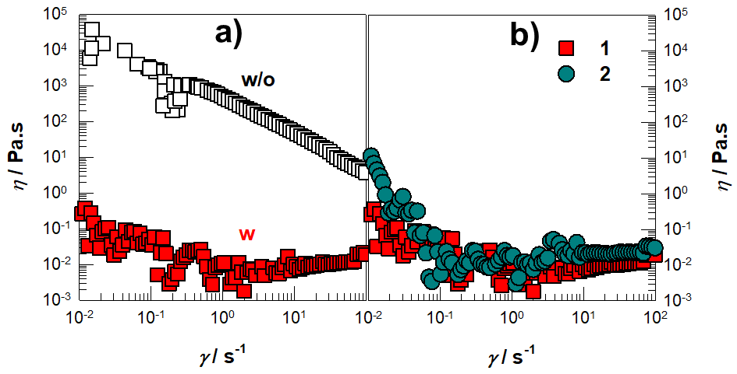
Figure S1 a, b: Viscosity (η) of XLG dispersions with (w), without (w/o) AMPS solutions (a) and higher amount of XLG dispersions (b). The mass of XLG dissolved in 10 mL of solution is shown on the graph in g. The amount of XLG dissolved in 10 mL of water is shown on the graph.

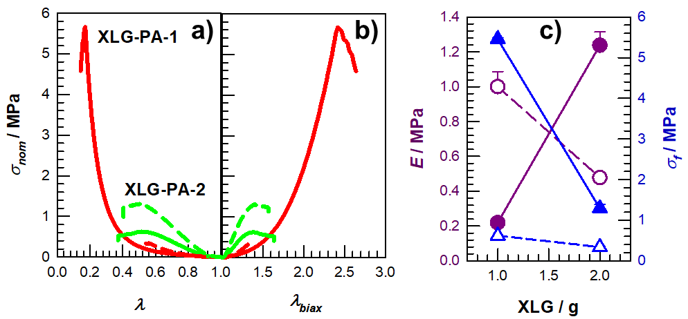
Fig. S2 a, b: Stress-strain curves for XLG-PA hydrogel samples plotted against λ (a) and λ_{biax} (b). Solid lines refer to the after preparation state of the samples, while dashed lines refer to samples that have reached swelling equilibrium. c) Mechanical parameters obtained from compression tests of samples for after preparation (filled) and swollen states (open symbols). Young modulus, E and fracture stresses σ_{f} are indicated by circles and triangles, respectively.

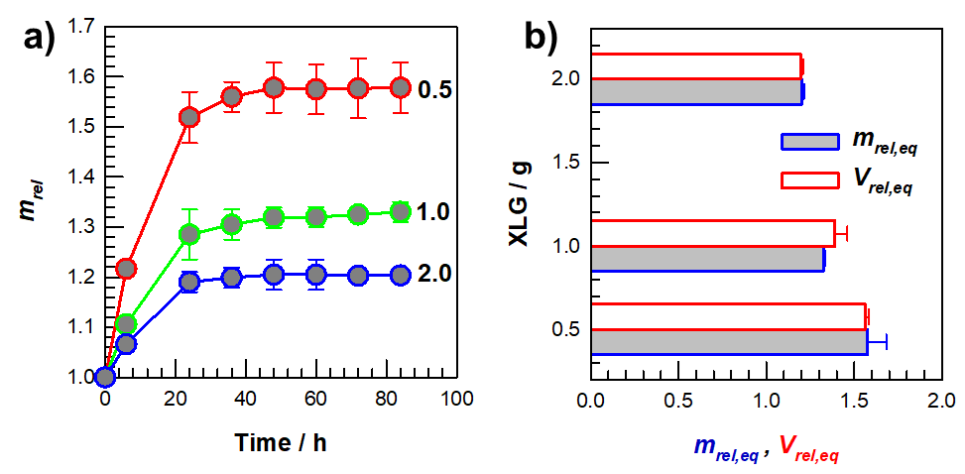
Fig. S3 a) Mass swelling profiles against the time in distilled water of XLG-PAM hydrogels prepared with different XLG contents. The amount of XLG dissolved in 10 mL of water is shown on the graph. b) The degree of swelling in equilibrium m_{rel} and gel fraction W_{g} values of depending on the XLG contents of the hydrogels.

