Supplementary Material

METHOD
Acquisition and Preparation of Plant Specimens
Citrus sinensis (L.) fruit specimens were acquired in Rio Preto da Eva, located in the State of Amazonas, Brazil, in 2019. These samples were then carefully packed into plastic bags for transportation to the ICET (Institute of Exact Sciences and Technology) chemistry laboratory at UFAM-Itacoatiara (Federal University of Amazonas-Itacoatiara). Subsequently, the fruit specimens underwent a series of steps: they were thoroughly washed with running water, peeled, and the peel (epicarp) was separated from the fruit. The peel was cut into smaller pieces, weighed, and subjected to hydrodistillation for essential oil extraction. This entire process took place at the ICET chemistry laboratory.
Extraction of Essential Oil from Citrus sinensis (L.) Peel
To extract the essential oil from Citrus sinensis (L.) fruit peel, hydrodistillation was performed using a Clevenger instrument attached to a round-bottom flask containing 1 L of distilled water and 400 g of peel mass. This distillation lasted around 3 hours. Following this, the collected samples underwent centrifugation at 3500 rpm for 10 minutes to facilitate the separation of oil and water phases. A graduated micropipette was then employed to isolate the liquids. The essential oil was obtained in a single extraction step, subsequently preserved within a sealed Eppendorf tube at -4 °C for analysis and testing. To calculate the essential oil yield, the peel weight (v/m) was utilized in accordance with the provided formula. The obtained essential oil was designated as CsPO (essential oil from Citrus sinensis L. fruit peel), and all tests were conducted at ICET-UFAM.
Gas Chromatography-Mass Spectrometry (GC-MS)
The gas chromatography analysis took place at the UFAM-Manaus Analysis Center (Federal University of Amazonas-Manaus). Essential oil samples were subjected to analysis using a TRACE GC ULTRA chromatograph coupled with a Thermo Scientific mass spectrometer (ISQ Single Quadrupole). For this purpose, a 30 m × 0.25 mm DB-5MS column with 0.25 μm internal film thickness was utilized.
To prepare the injection solution, around 1.0 mg of essential oil was dissolved in 1.0 ml of methanol. Subsequently, a volume of one μL from this solution was injected at a 1:50 split ratio. The column temperature underwent a gradient change, ranging from 40 to 280 °C at a consistent rate of 4.0 °C/min. It was then held steady at 240 °C for 4 minutes. Subsequently, the temperature incrementally escalated at 10 °C/min until it reached a final temperature of 280 °C, maintaining this level for an additional two minutes.
During the process, the injector and source temperatures were set to 220 and 250 °C, respectively, while mass variation spanned from 40 to 600 m/z. Identification of components was achieved through interpretation of their respective mass spectra and linear retention index (Kovat’s index), calculated in accordance with the Van der Dool and Kratz equation [23]. For validation, a homologous series of hydrocarbons (ranging from C12 to C40) was introduced and compared to existing literature data. Furthermore, their calculated arithmetic indexes (AI) were juxtaposed with those of isolated compounds as outlined in Adams [24].
Biological Assays
Evaluation of Microbial Activity
The antimicrobial analysis was conducted using the agar diffusion technique [25]. For assessing the susceptibility of various microbial species to CsPO, four strains were chosen: Escherichia coli (ATC25922), Enterococcus faecalis (ATCC 29212), Candida albicans (ATCC 10231), and Mycobacterium smegmatis (ATCC 14468). These microbial strains were sourced from the CBA-AM (Amazon Biotechnology Center), which also facilitated the experimental procedures.
To initiate the process, standardized indicator bacteria were evenly spread on a Petri dish containing Mueller Hinton agar medium, using a sterile swab. Subsequently, 6-millimeter paper disks were immersed in 30 µL of oil solubilized in methanol, achieving a concentration of 2 mg/mL. After allowing these disks to evaporate for 24 hours, they were positioned on the plates previously inoculated with the standardized microorganisms. These plates were then refrigerated overnight and subsequently incubated at a temperature ranging from 35 to 37 °C for 24 h for bacteria and 48 h for yeasts.
Following the incubation period, the formation of inhibition halos was evaluated to gauge the extent of antimicrobial effect.
Allelopathic Effect
Phytotoxic Effect Bioassays
To conduct the allelopathy evaluations, butter bean seeds were sourced from a nearby farmers’ market in Itacoatiara, AM, Brazil. Before initiating the experiments, these seeds underwent a sanitation process with NaClO (2%) for two minutes. Subsequently, the sanitized seeds were air-dried on sterilized filter paper and subsequently placed into separate plastic bags corresponding to various treatment conditions. All of these procedural stages were carried out at the UFAM-ICET Agronomy Laboratory.
The experimental treatments involved formulations in which essential oil was dissolved in soybean oil at concentrations of 10 (T2), 100 (T3), 500 (T4), and 1000 μg/mL (T5). For the control water T0 and soybean oil T1 were used. These formulations were administered at a rate of 50 mL/kg of seeds. As a comparison, water was utilized as a control. Each treatment was applied for about 60 seconds [26].
Germination experiments were executed in a BOD-type germination chamber set at 25 °C. The Germitest paper approach was employed, wherein the substrates were subjected to prior sterilization at 105 °C for 2 h. Each roll was seeded with 50 seeds, and the arrangement was randomized, comprising four replications. Before sowing, the Germitest paper was suitably moistened with distilled water, maintaining a ratio of 2.5 times the dry mass of the paper.
Throughout a continuous span of seven days, germination rates were assessed daily at the same consistent time. This was accomplished by tallying the number of seedlings displaying radicle protrusion on a daily basis. Upon the conclusion of this seven-day timeframe, the germination rate was computed utilizing the formula outlined by Maguire (1962): GRI = G1/N1 + G2/N2 + ... + Gn/Nn. In this equation, GRI signifies the germination rate index, G1, G2, ... Gn represent the quantities of seedlings observed on Day 1, 2, ... n, while N1, N2, ... Nn denote the number of days elapsed since the day of sowing. By Day 7, the tally included the count of normal and abnormal seedlings as well as non-germinated seeds. The outcomes were subsequently presented as percentages [27].
Using a digital caliper, the dimensions of the aerial portions and roots of butter bean seedlings were gauged. The acquired data was subjected to a variance analysis (F-test), and the means were subsequently evaluated using Tukey’s test at a significance level of 0.05. These analyses were facilitated through the utilization of Sisvar software [28]. The testing process was carried out in quadruplicate.
In Vitro Assessment of Acetylcholinesterase Inhibition
The enzymatic activity of acetylcholinesterase was assessed on microplates using the Ellman’s spectrophotometric method [62], with modifications introduced by Azevedo and colleagues [29]. The study employed the following components: acetylcholinesterase (AChE) from Electrophorus electricus (type VI), 5,5’-dithiobis(2-nitrobenzoic acid) (DTNB), iodinated acetylcholine substrate, and eserine, all sourced from Sigma.
For each well of the microplate, the following was added: 25 µL of iodinated acetylcholine (15 mM), 125 µL of DTNB, 50 µL of tris-HCl buffer (50 mM, pH 8.0) supplemented with 0.1% BSA (bovine serum albumin), and 25 µL of plant extract at a concentration of 1 mg/mL (resulting in a final test concentration of 0.1 mg/mL). Controls encompassed methanol and tris-HCl, while eserine (10 µM) served as the standard inhibitor.
Absorbance measurements were conducted five times at 405 nm, with 15-second intervals, using a TP-reader (Thermoplate microplate reader). Following this initial reading, 25 µL of acetylcholinesterase (0.22 U mL-1) were introduced into the wells. Subsequently, absorbance readings were taken an additional nine times at 405 nm, with 15-second intervals.
To mitigate the impact of spontaneous substrate hydrolysis, the increase in absorbance was adjusted by subtracting the reaction rate observed before enzyme addition. The calculation of percentage inhibition involved comparing the rates observed in the samples to those of the control group. This entire process was conducted in triplicate. The enzymatic activity and the percentage of AChE inhibition were computed utilizing Microsoft Excel. This assessment was carried out at the IFAM-CMC Analytical Center.
In Silico Assessment of Acetylcholinesterase Inhibition
The molecular docking analysis followed a previously established methodology [61]. Initially, the three-dimensional (3D) structures of β-citronelene, β-pinene, limonene, α-humulene, and β-acoradiene were obtained from PubChem in spatial data file format (SDF). Subsequently, the structures with lower energy were optimized using the PM7 semi-empirical method [30], facilitated by the MOPAC2016 software [31].
The 3D crystal structure of Torpedo californica (TcAChE) complexed with galantamine was acquired from the RCSB (Research Collaboratory for Structural Bioinformatics) protein database, identified by PDB ID 1QTI [32]. For all docking experiments, AutoDock Vina 1.1.2 [33] was utilized. The grid box was centered on the ligand (coordinates x, y, z = 4.34, 64.37, 60.09), and its dimensions were set at 18 × 28 × 26 Å.
To convert ligand and receptor molecules into the desired pdbqt file format suitable for AutoDock Vina [34], Autodock Tools (version 1.5.6) was employed. Analysis of the binding conformations was carried out using the Discovery Studio software [35].

Figures
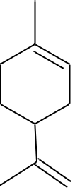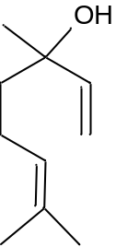
- (B)
Figure S1: Chemical structure of limonene (A) and linalool (B). Source: Authors (2023). ChemSketch 2020

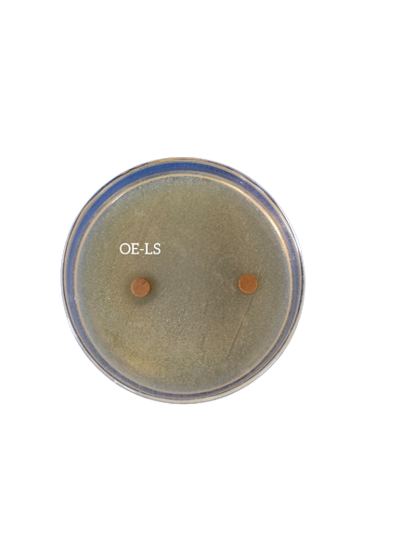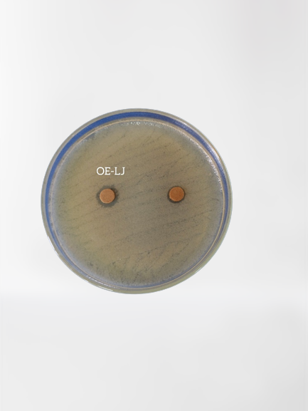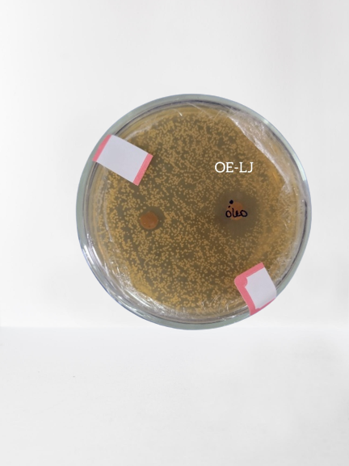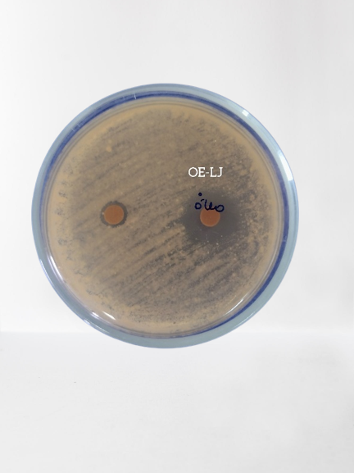
OECCs
OECCs
OECCs
OECCs
A
B
C
D
Figure S2: Agar diffusion antibiosis method: (A) C. albicnas ATCC 10231; (B) M. smegmatis ATCC 14468, Sample antimicrobial assay: (C) E. faecalis ATCC 29212; (D) E. coli ATCC 25922

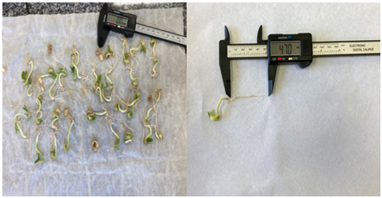Figure S3: Root growth of bean seeds. Source: Authors (2023)

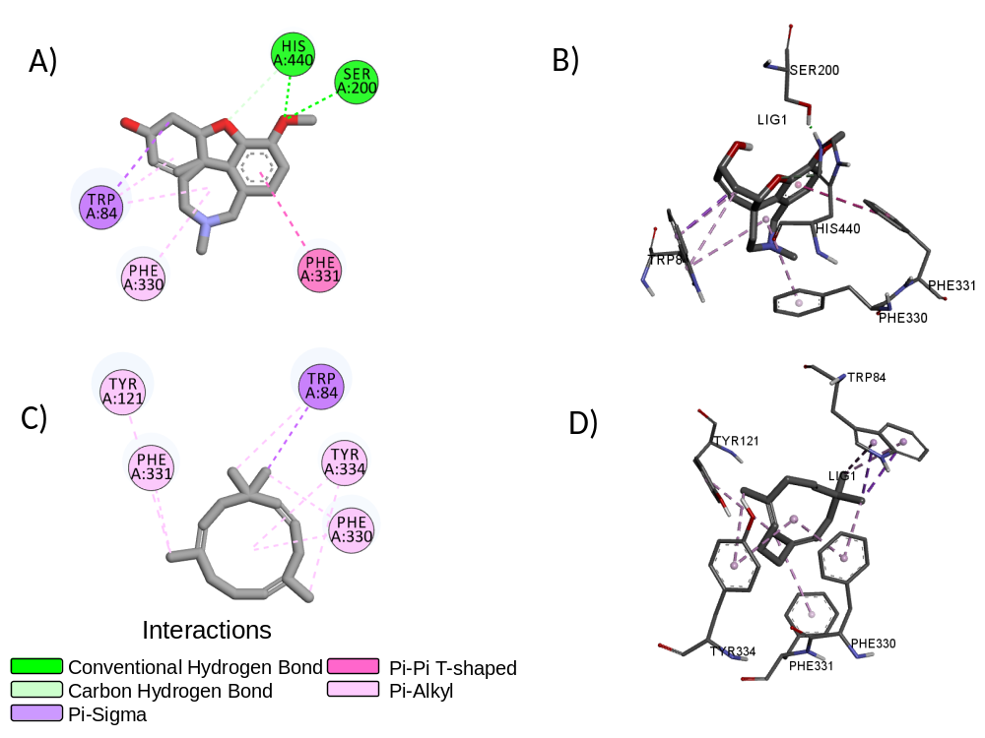
Figure S4. Main interactions observed for the galantamine-AChE complex in 2D (A) and 3D (B) and α-humulene-AChE in 2D (C) and 3D (D).
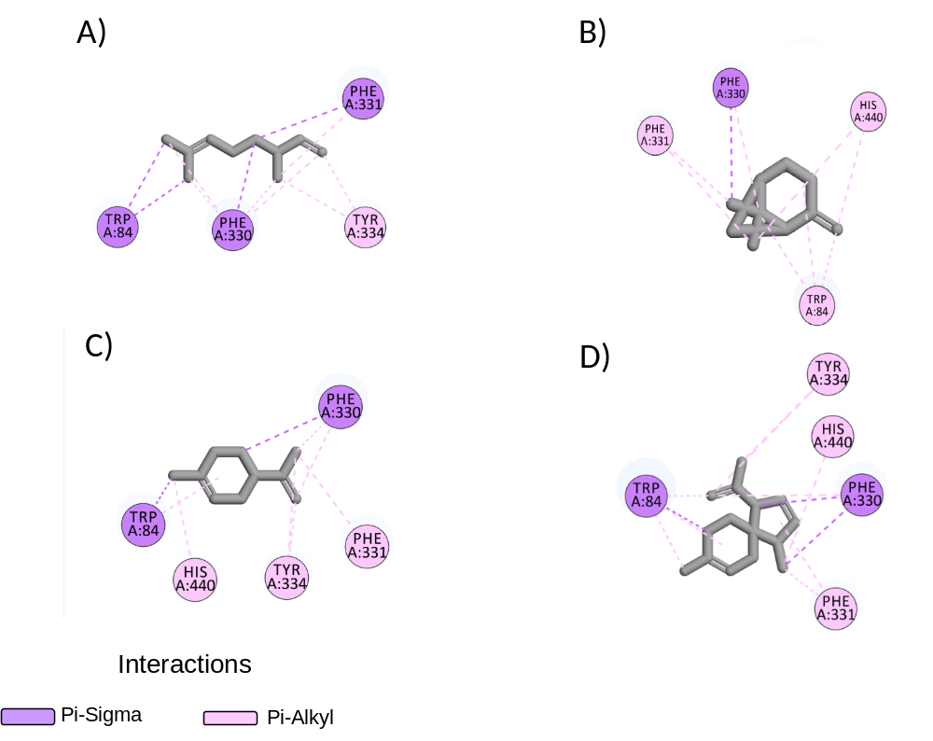
Figure S5: Simulated binding modes of the compounds β-Citronelene (A), β-Pinene (B), Limonene (C) and β-Acoradiene (D) with TcAChE by 2D diagram

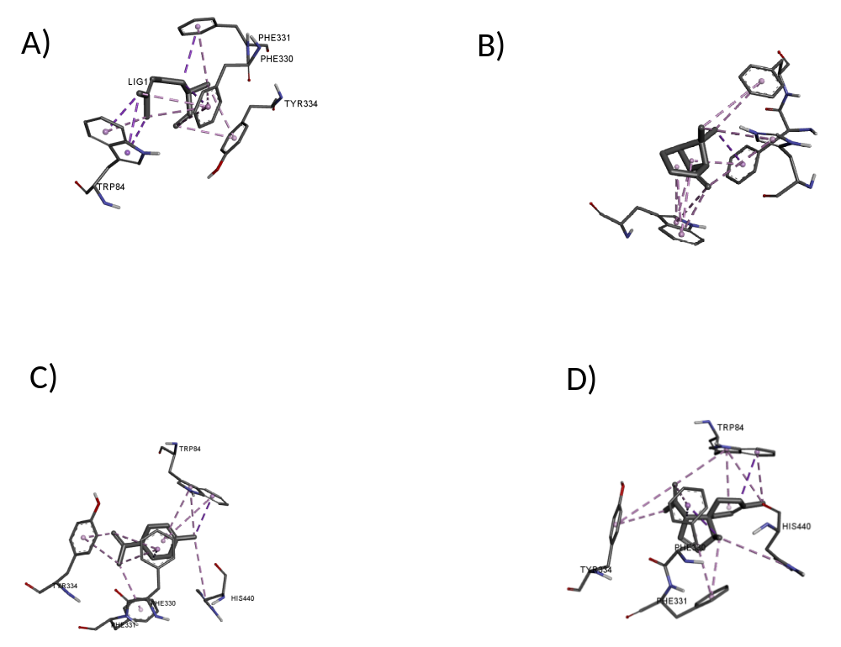

Figure S6: Simulated binding modes of β-Citronelene (A), β-Pinene (B), Limonene (C) and β-Acoradiene (D) compounds with TcAChE by 3D diagram

Tables

Table S1. Chemical composition of 33 CsPO components.
Compounds | Class | Area (%) | RTª | KI_{cal}^{b} | KI_{tab}^{c}
β-Citronelene | MH^{d} | 7.33 | 9.18 | 930 | 932
Santene | MH | 4.09 | 10.8 | 885 | 884
α-Fenchene | MH | 0.32 | 11.54 | 945 | 945
β-Pinene | MH | 9.63 | 12.16 | 959 | 969
Verbenene | MH | 0.26 | 12.72 | 961 | 961
Sabinene | MH | 1.87 | 12.92 | 963 | 969
β-Ocimene | MH | 1.35 | 13.37 | 1038 | 1032
Trans-Isolimonene | MH | 2.56 | 13.75 | 974 | 980
Cis-Pinene | MH | 0.35 | 14.07 | 978 | 982
<(E)-β->Ocimene | MH | 0.15 | 15.19 | 1044 | 1044
γ-Terpinene | MH | 2.3 | 15.69 | 1050 | 1054
ρ-Cimenene | MH | 0.29 | 18.45 | 1087 | 1089
Linalol | MO | 0.16 | 18.95 | 1094 | 1095
Car-3-en-2-one | MO | 8.43 | 22.37 | 1244 | 1244
Neo-Ethyl Acetate | SO^{e} | 1.3 | 24.05 | 1269 | 1271
Iso-Ethyl Acetate | SO | 0.17 | 24.9 | 1301 | 1304
Fenchol-2-ethyl-ende | MO^{f} | 3.56 | 25.28 | 1287 | 1287
2-Ethyl-isomentone | SO | 1.22 | 25.81 | 1295 | 1293
Eugenol | MO | 4.24 | 26.23 | 1353 | 1356
Limonene-10-ol | MO | 8.26 | 26.64 | 1283 | 1288
Daucene | SH^{g} | 0.61 | 27.7 | 1376 | 1380
β-Elemene | SH | 2.88 | 28.55 | 1389 | 1389
α-Humulene | SH | 10.52 | 29.04 | 1448 | 1452
α-Neoclovene | SH | 4.83 | 29.45 | 1455 | 1452
β-Acoradiene | SH | 12.47 | 30.07 | 1466 | 1470
γ–Murolene | SH | 3.78 | 30.83 | 1478 | 1478
β-Elemene | SH | 2.88 | 28.55 | 1389 | 1389
α-Humulene | SH | 10.52 | 29.04 | 1448 | 1452
α-Neoblovene | SH | 4.83 | 29.45 | 1455 | 1452
β-Acoradiene | SH | 12.47 | 30.07 | 1466 | 1470
γ–Murolene | SH | 3.78 | 30.83 | 1478 | 1478
β-Elemene | SH | 2.88 | 28.55 | 1389 | 1389
α-Humulene | SH | 10.52 | 29.04 | 1448 | 1452
ªRT: Retention Time; ^{b}KI_{cal}: calculated Kovats index; ^{c}KI_{tab}: tabulated Kovats index; ^{d}MH: hydrogen monoterpene; ^{e}OS: oxygenated sesquiterpene; ^{f}OM: oxygenated monoterpene; ^{g}HS: Hydrocarbon sesquiterpene.

Table S2. Docking outcomes for main active components of CsPO against AChE.
Compounds | Biding Energy (Kcal/mol) | Main interactions
Galantamineª | -9.8 | HB^{b} (Ser200, His440), PAI^{c} (Phe330), PSI^{d} (Trp84), PP^{e} (Phe331).
β-Citronelene | -6.2 | PAI (Tyr334), PSI (Trp84, Phe330, Phe331)
β -Pinene | -6.7 | PAI (Typ84, Phe331, His440), PSI (Phe330).
Limonene | -7.2 | PAI (Phe331, Tyr334, and His440), PSI (Trp84, Phe330).
β-Acoradiene | -8.5 | PAI (Phe331, Tyr334, His440), PSI (Trp84, Phe330).
α-Humulene | -9.6 | PAI (Tyr121, Phe330, Phe331, Tyr334), PSI (Trp84).
ªPositive control; ^{b}HB- hydrogen bond; ^{c}PAl-π-alkyl; ^{d}PSi-π-sigma; ^{e}PP-π-π.

