Understanding the impact of covariates on the classification of implementation units for soil-transmitted helminths control: A case study from Kenya

Study site
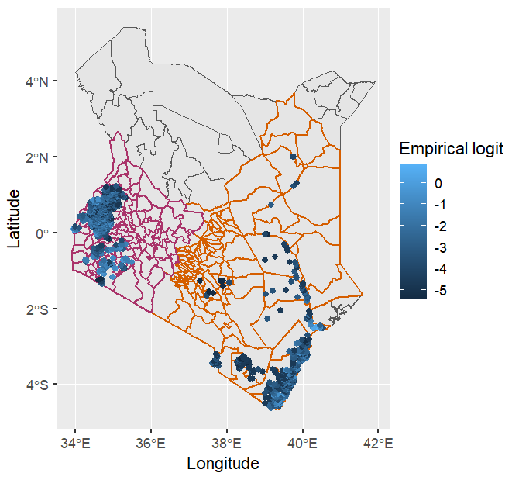
Figure S1: Quintile map of empirical logit - STH in Kenya
To visualize the spatial coverage of the study region and to get an initial insight into the spatial pattern of prevalence, the empirical logit is used which is computed as
$$Empirical logit=log\left(\frac{num+0.5}{den-num+0.5}\right)$$
where, num=data on number of children tested and den= number positive of any STH.

Variables and sources
Table S1: Variables and the source
Variable | Source
Aridity index | http://www.cgiar-csi.org/wp-content/uploads/2012/11/Global-Aridity-and-Global-PET-Methodology.pdf
Irrigated areas | https://www.fao.org/aquastat/en/geospatial-information/global-maps-irrigated-areas
Potential evapotranspiration | http://worldclim.org/
Slope | http://srtm.csi.cgiar.org/
WASH-availability of improved drinking water source | https://www.thiswormyworld.org/maps/water-supply-and-sanitation-wss-coverage
WASH- availability of improved sanitation facility | https://www.thiswormyworld.org/maps/water-supply-and-sanitation-wss-coverage
Wetlands | http://due.esrin.esa.int/page_globcover.php#:~:text=GlobCover%20is%20an%20ESA%20initiative,board%20the%20ENVISAT%20satellite%20mission
Urban areas-Grump | https://sedac.ciesin.columbia.edu/data/set/grump-v1-urban-extents
Elevation | http://viewfinderpanoramas.org/dem3.html
Improved housing prevalence | https://www.nature.com/articles/s41586-019-1050-5
Soil moisture | https://cds.climate.copernicus.eu/cdsapp#!/dataset/satellite-soil-moisture?tab=overview
Poverty | https://www.worldpop.org/geodata/summary?id=1262
Night lights | https://eogdata.mines.edu/download_dnb_composites.html
Rainfall - monthly average | https://www.chc.ucsb.edu/data/chirps
Enhanced vegetation index - monthly average | http://modis.gsfc.nasa.gov/data/dataprod/dataproducts.php?MOD_NUMBER=13
Land surface temperature - Day - monthly average | https://lpdaac.usgs.gov/products/mod11a1v006/
Land surface temperature - Night - monthly average | https://lpdaac.usgs.gov/products/mod11a1v006/
Land surface temperature - Difference - monthly average | https://lpdaac.usgs.gov/products/mod11a1v006/
Tasseled cap brightness - monthly average | https://lpdaac.usgs.gov/dataset_discovery/modis/modis_products_table/mcd43b4
Tasseled cap wetness - monthly average | https://lpdaac.usgs.gov/dataset_discovery/modis/modis_products_table/mcd43b4
Population - interpolated | https://www.worldpop.org/geodata/listing?id=64,https://sedac.ciesin.columbia.edu/data/collection/gpw-v4
Urban area-Building Density | https://sites.research.google/open-buildings
Grasslands | https://lpdaac.usgs.gov/products/mcd12q1v006/
Croplands | https://lpdaac.usgs.gov/products/mcd12q1v006/
Croplands / Natural vegetation | https://lpdaac.usgs.gov/products/mcd12q1v006/

Results of Binomial mixed model with unstructured random effects
Table S2: Estimates and corresponding standard errors of the Binomial mixed model with unstructured random effects fitted with covariates to the STH prevalence data
Region | Parameters | Estimate | Standard error | p value
Western region | Intercept | -1.223 | 0.174 | 2.06e-12
Western region | Aridity index | 0.985 | 0.127 | 9.10e-15
Western region | Enhanced vegetation index | 4.381 | 0.383 | <2e-16
Western region | Tassled cap wetness | 12.734 | 0.665 | <2e-16
Western region | Availability of drinking water | -1.883 | 0.096 | <2e-16
Eastern region | Intercept | -5.997 | 0.185 | <2e-16
Eastern region | Aridity index | 3.282 | 0.304 | <2e-16
Eastern region | Enhanced vegetation index | 6.682 | 0.365 | <2e-16
Eastern region | Rainfall | -0.014 | 0.002 | <2e-16
Eastern region | Elevation | -0.002 | 0.00014 | <2e-16

Testing for residual spatial variation
To establish whether prediction of prevalence throughout the study-region would benefit from geostatistical methods, empirical variogram is calculated. The empirical variogram is useful for establishing that the data show evidence of spatial correlation and for suggesting a suitable form of parametric model. The plot (Figure S2) suggested that the empirical variogram levels out, indicating that the spatial correlation becomes negligible, at a distance somewhere in the range 100 to 120 kms and at 200 to 400 kms in the western region and eastern region, respectively.
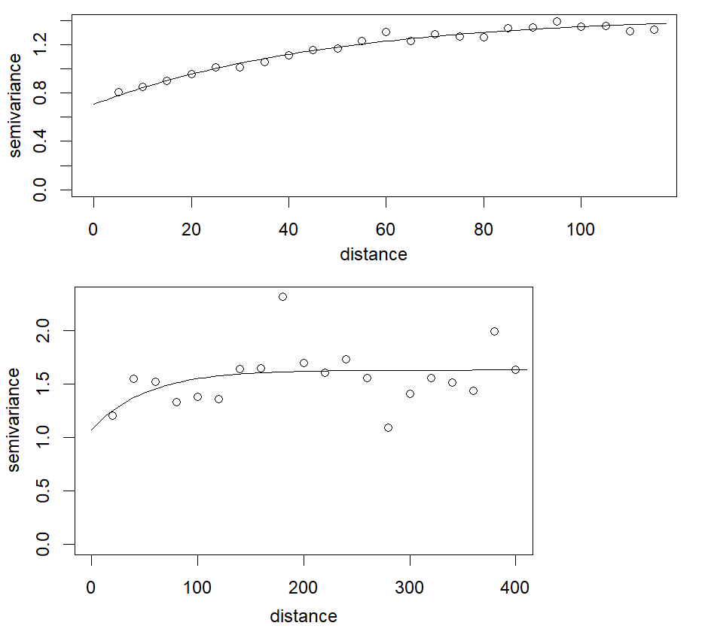
Figure S2: Empirical variogram of the empirical logit of infection with any STH (open circles) and a theoretical variogram of the form $V(u) = τ^{2} +σ^{2}(1-exp(-u/φ)$, where u is distance (km) – Western region of Kenya (top) and Eastern region of Kenya (bottom)

Scatter plots for exploratory analysis
In Figure S3a and Figure S3b the simple linear fit is depicted by the dashed green line and the solid blue line represents the natural spline.

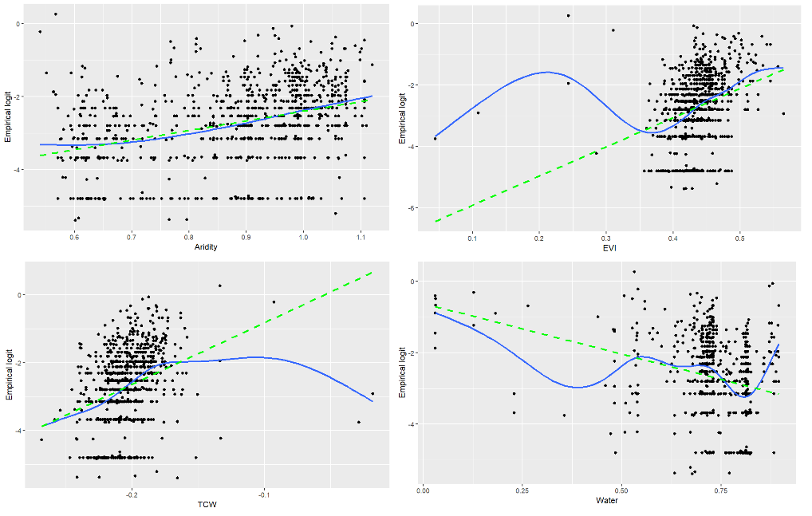
Figure S3a: Scatter plots for empirical logit transformation against each of the selected covariates – Western region of Kenya
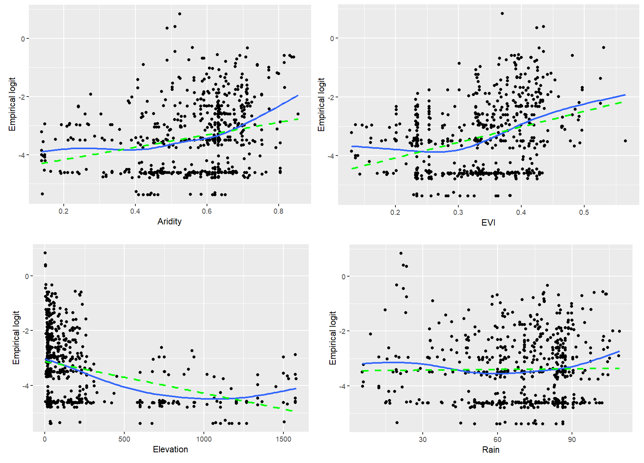
Figure S3b: Scatter plots for empirical logit transformation against each of the selected covariates – Eastern region of Kenya

Mapping of standard error of predicted prevalence
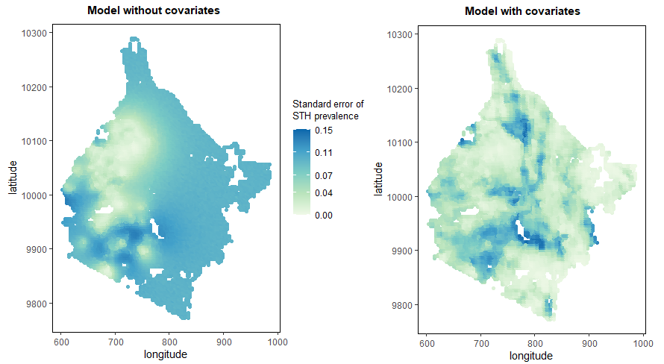
Figure S4: Standard error of predicted prevalence obtained from the geostatistical models without and with covariates in Western region of Kenya

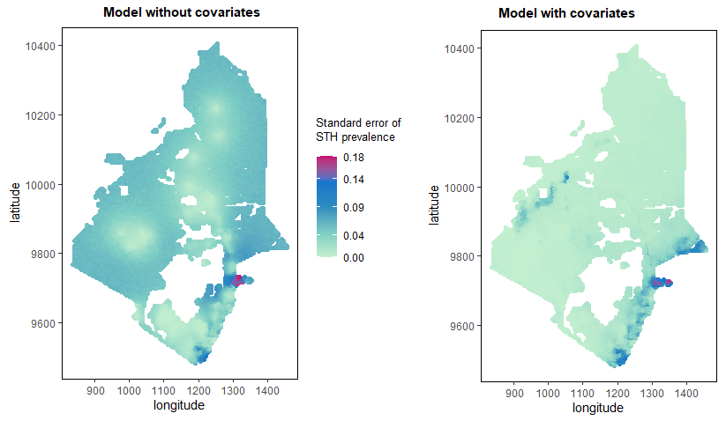
Figure S5: Standard error of predicted prevalence obtained from the geostatistical models without and with covariates in Eastern region of Kenya

The predictive precision from the two models were compared using the mean of log of standard errors of predicted prevalence given in Table S3. It was observed that the model with covariates in both regions provided increased precision.
Table S3: Mean of log of standard errors of predicted prevalence of STH
Model | Mean log of standard errors
Model | Western region | Eastern region
Without covariates | -2.655 | -3.253
With covariates | -3.450 | -4.876

Predictive probability maps
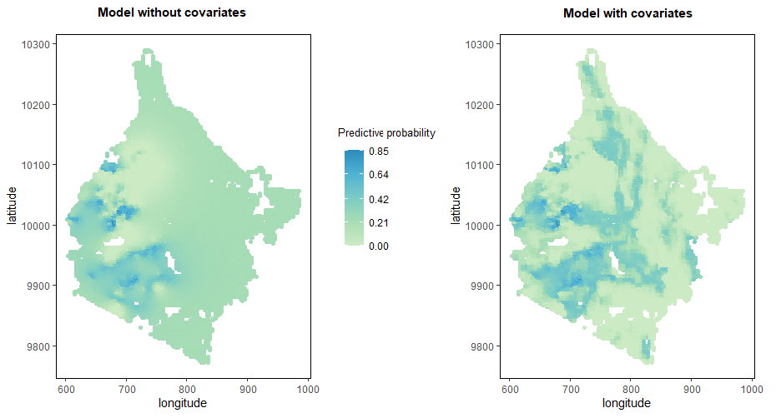
Figure S6: Predictive probability maps for endemicity level between 10% and 20% for STH obtained from geostatistical models without and with covariates in Western region of Kenya

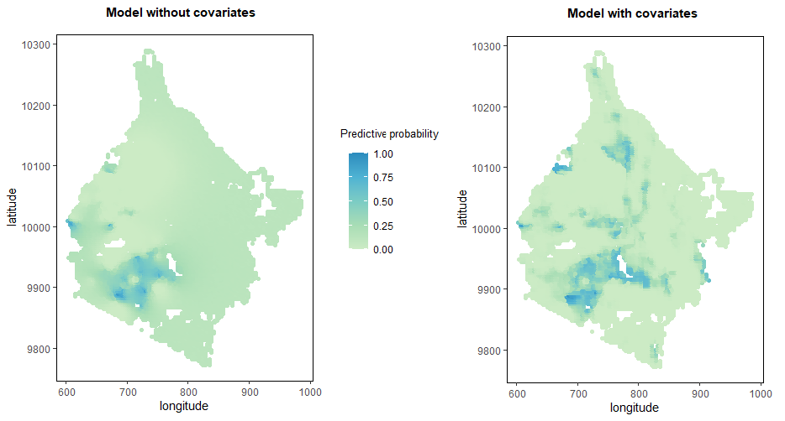

Figure S7: Predictive probability maps for endemicity level between 20% and 50% for STH obtained from geostatistical models without and with covariates in Western region of Kenya

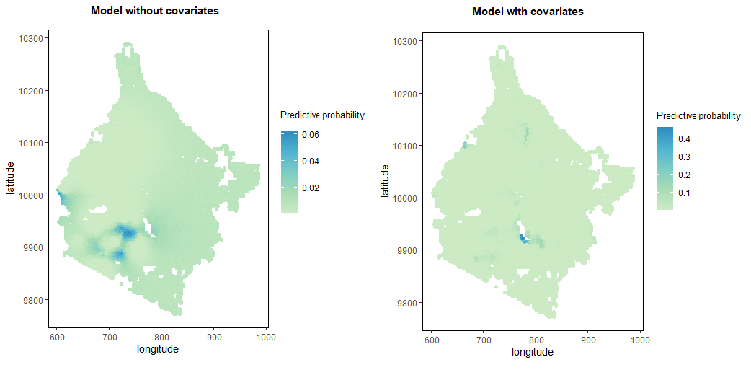

Figure S8: Predictive probability maps for endemicity level greater than 50% for STH obtained from geostatistical models without and with covariates in Western region of Kenya

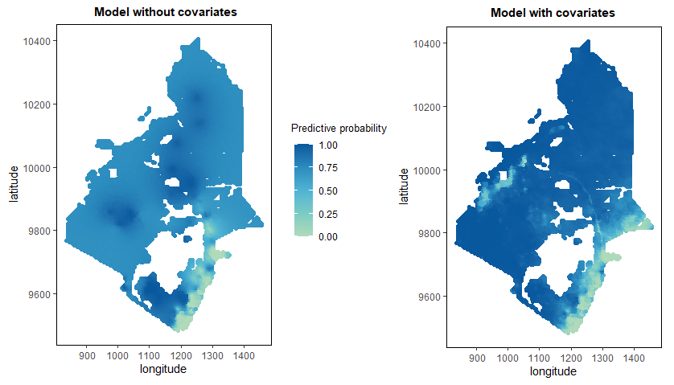

Figure S9: Predictive probability maps for endemicity level less than 2% for STH obtained from geostatistical models without and with covariates in Eastern region of Kenya

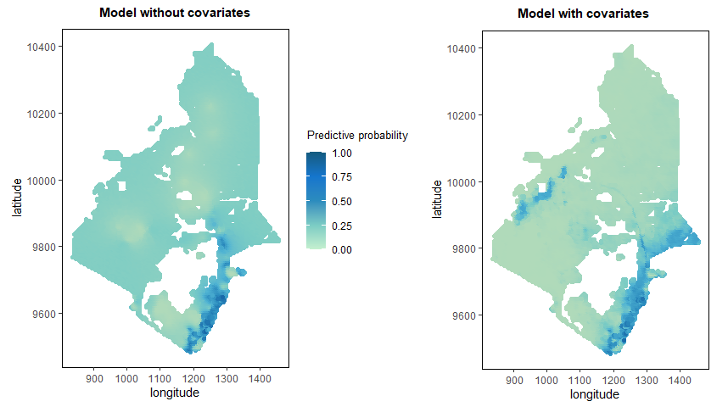
Figure S10: Predictive probability maps for endemicity level between 2% and 10% for STH obtained from geostatistical models without and with covariates in Eastern region of Kenya
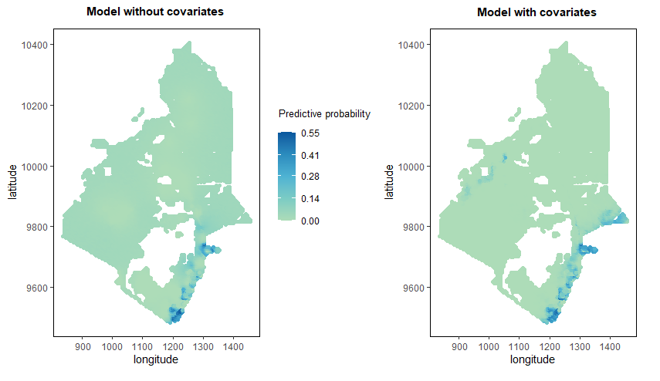
Figure S11: Predictive probability maps for endemicity level between 10% and 20% for STH obtained from geostatistical models without and with covariates in Eastern region of Kenya

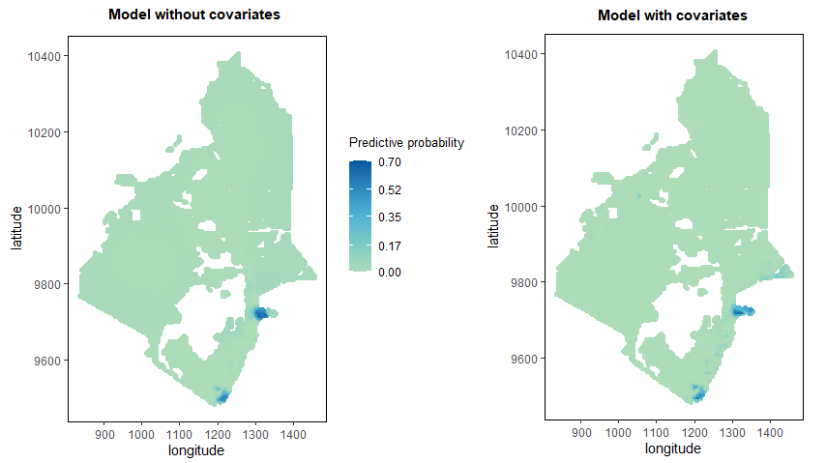

Figure S12: Predictive probability maps for endemicity level between 20% and 50% for STH obtained from geostatistical models without and with covariates in Eastern region of Kenya

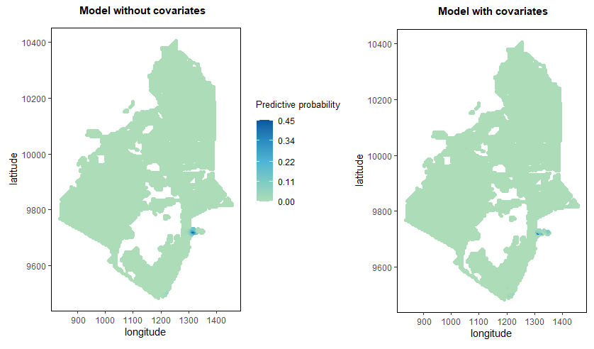

Figure S13: Predictive probability maps for endemicity level greater than 50% for STH obtained from geostatistical models without and with covariates in Eastern region of Kenya

Simulation study
- Simulation study results in the Western region

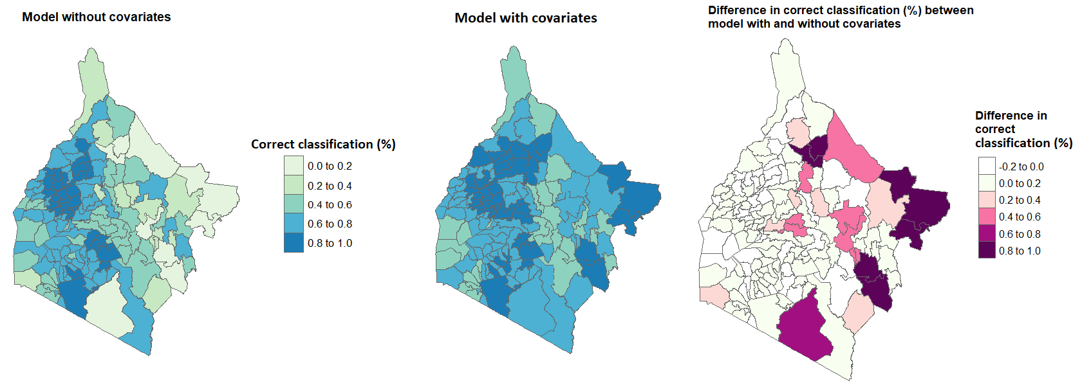
Figure S14: Proportion of correct classification and their differences at each sub-county for simulated dataset - sample size: 875; average prevalence: 12%

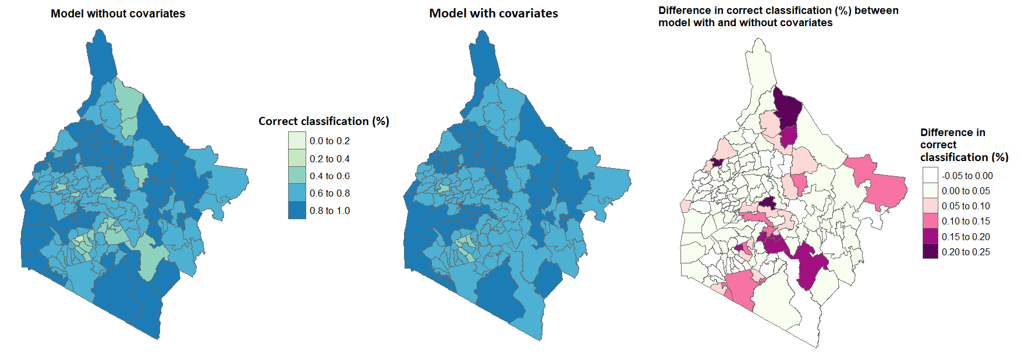

Figure S15: Proportion of correct classification and their differences at each sub-county for simulated dataset - sample size: 438; average prevalence: 6%
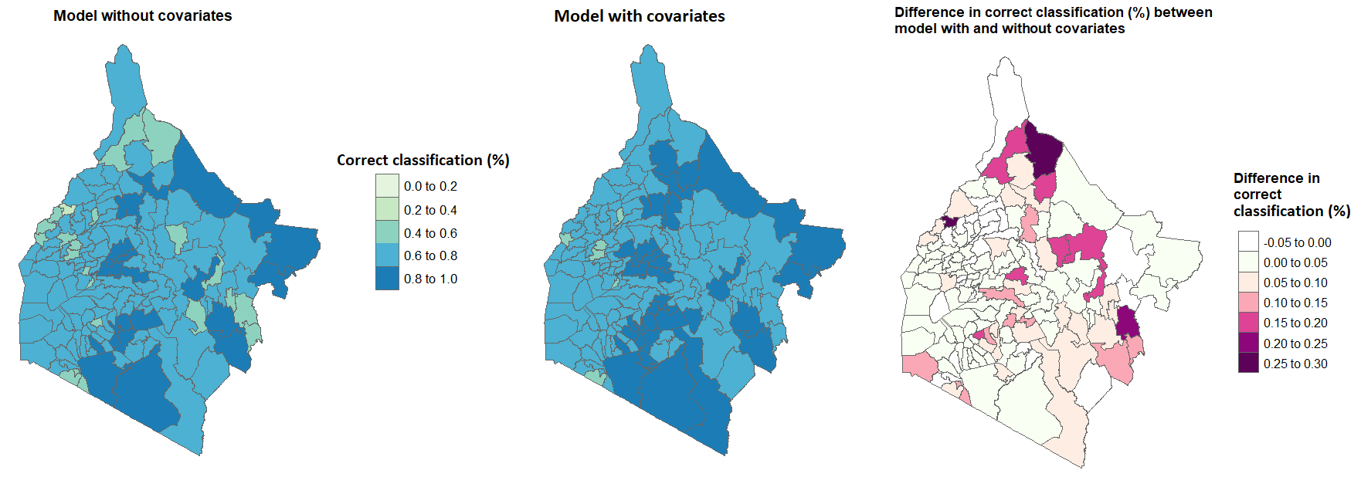
Figure S16: Proportion of correct classification and their differences at each sub-county for simulated dataset - sample size: 438; average prevalence: 12%

- Simulation study results in the Eastern region
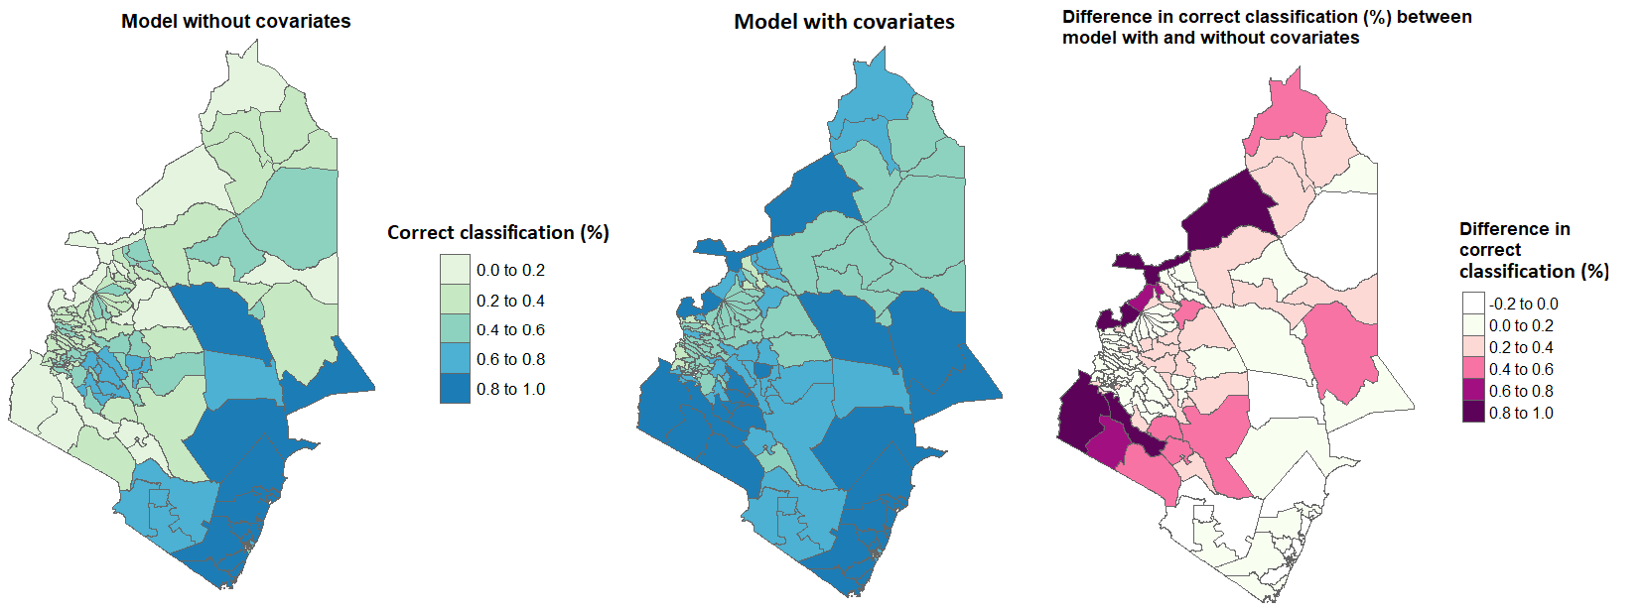
Figure S17: Proportion of correct classification and their differences at each sub-county for simulated dataset - sample size: 618; average prevalence: 10%
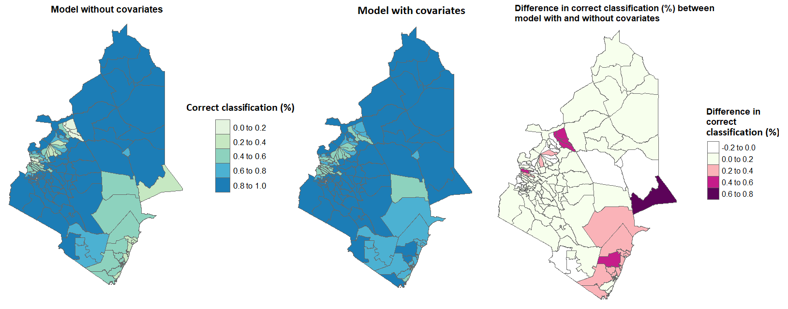Figure S18: Proportion of correct classification and their differences at each sub-county for simulated dataset - sample size: 309; average prevalence: 1%

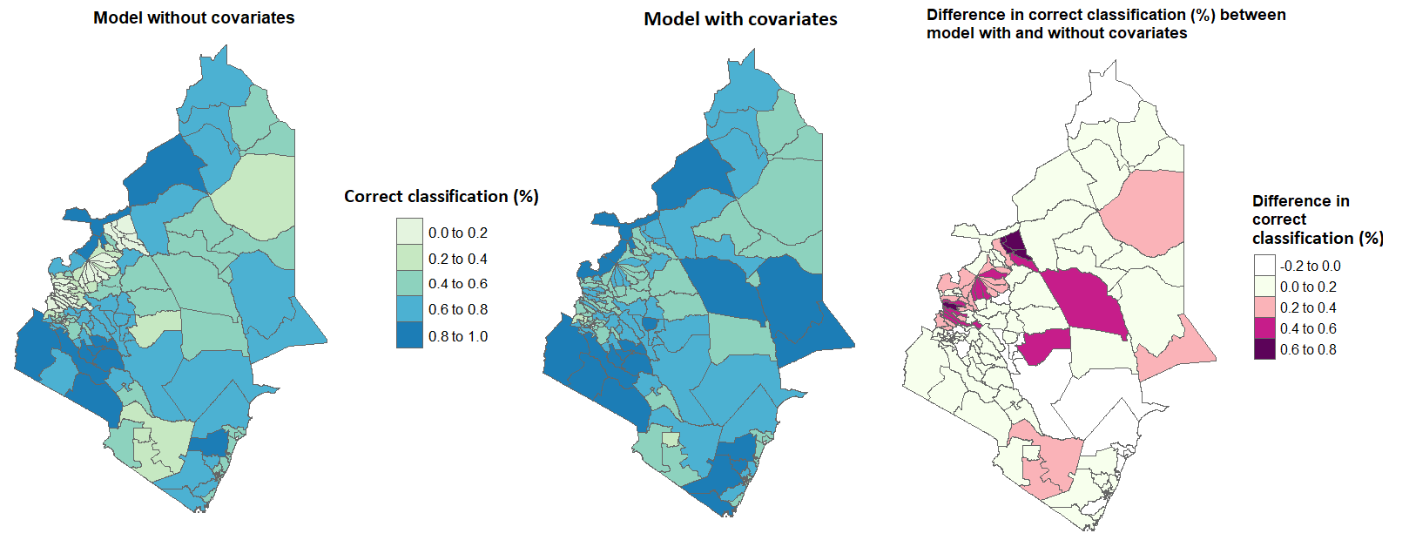Figure S19: Proportion of correct classification and their differences at each sub-county for simulated dataset - sample size: 309; average prevalence: 10%

