In vivo pharmacodynamics of lactoferrin-coupled lipid nanocarriers for lung carcinoma: intravenous versus powder for inhalation

Dina M. Gaber ª, Noha Nafee ^{b,c,*}, Ahmed O. Elzoghby ^{d,e,f} , Maged W. Helmy ^{g}, and Osama Y. Abdallah^{b}
ª Department of Pharmaceutics, Division of Pharmaceutical Sciences, College of Pharmacy, Arab Academy for science, Technology and Maritime Transport, Alexandria 1029, Egypt
^{b} Department of Pharmaceutics, Faculty of Pharmacy, Alexandria University, Alexandria 21521, Egypt
^{c} Department of Pharmaceutics, College of Pharmacy, Kuwait University, 13110 Kuwait
^{d} Cancer Nanotechnology Research Laboratory (CNRL), Faculty of Pharmacy, Alexandria University, Alexandria 21521, Egypt
^{e} Department of Industrial Pharmacy, Faculty of Pharmacy, Alexandria University, Alexandria 21521, Egypt
^{f} Division of Engineering in Medicine, Department of Medicine, Brigham and Women's Hospital, Harvard Medical School, Boston, MA 02115, USA
^{g} Department of Pharmacology, Faculty of Pharmacy, Damanhour University, Damanhour, Beheira 22516, Egypt

Supplementary material
- Percentage of yield recovered and drug content
The powder yield was simply calculated by dividing the weight of spray-dried powder (SD) by the total mass of solid introduced in the preparation submitted to spray drying as follows:
% Yield= $\frac{Mass of SD powder recovered}{Total mass of solid used in formulation}*100$ ……Equation S.1
Table S.1: Spray dried MYR-microparticles characteristics (mean ± S.D., n=3).
Formula code | Yield (%w/w) | % Drug recovery to theoretical content
SD-MYR-CPX-SLNs | 28.75±1.77 | 73.3±1.70
SD-MP1 | 68.8±1.06 | 90.50±0.71
SD-MP2 | 80.5±0.71 | 92.65±1.91
SD-MP3 | 89.05±0.64 | 95.15±1.20
SD-MP4 | 86.15±0.92 | 93.7±0.99

- Particle size measurements
The particle size of a powder formulation intended for inhalation is, together with the particle density, a prominent factor in the success of the formulation because it strongly influences the dispersion and sedimentation properties of the powder ^{[1]}. Particle size of spray-dried powders (SD-MP1-SD-MP4) was determined using a laser light-scattering technique. In this study, isopropyl alcohol was chosen as a suspending medium among the other solvents. For all formulae, the particle size distribution curves showed a normal unimodal distribution with no evidence of existence of various size populations. SD-MYR-CPX-SLNs powder alone without any matrix formers exhibited a large particle size (Dv₅₀= 22.03 ± 2.50 μm), revealing the presence of large agglomerates and aggregates. In contrast, the size of (SD-MP1-SD-MP4), (Dv₅₀) was remarkably smaller ranging from 4.5 to 6.90 μm indicating suitability for lung deposition. The suitable span values (1.24 – 1.84) might be a proof for a narrow particle size distribution as depicted in Table S.2.

Table S.2: Particle size distribution data of spray dried MYR-microparticles
Formula code | Dv ₁₀  (µm) | Dv ₅₀  (µm) | Dv ₉₀  (µm) | Theoretical calculated aerodynamic diameter (µm) | Span index
SD-MYR-CPX-SLNs | 7.37 | 22.03 | 42.51 | 8.67 | 1.60
SD-MP1 | 1.84 | 6.9 | 10.37 | 4.40 | 1.24
SD-MP2 | 1.46 | 5.19 | 9.98 | 2.57 | 1.64
SD-MP3 | 1.72 | 4.5 | 10 | 2.39 | 1.84
SD-MP4 | 1.67 | 5.94 | 12.3 | 3.24 | 1.79

Spray-dried Powder Flowability
Dry powder for inhalation should possess good flowability which has already been related to generating adequate metering, dispersion, and fluidization of a dry powder from an inhaler device. Angle of Repose (θ), Carr’s index (CI) and Hausner ratio (HR) are considered indirect methods for quantifying powder flowability according to identified scale reported in the Pharmacopeia ^{[2]}.
As depicted in Table S.3, examination of SD-MYR-CPX-SLNs without any matrix former showed an extremely poor flowability with values of 67.2°, 41.3% and 1.7 in terms of angle of repose, CI and HR, respectively. Unfortunately, powders obtained from pure SD-MYR-CPX-SLNs were sticky and exhibited strong interparticulate cohesion, leading to poor flow properties. In contrast, the usage of different carriers (SD-MP1-SD-MP4) was obviously accompanied by improvement in the flow properties as evidenced by the low θ, CI and HR values.
Table S.3: Flow Characteristics of spray dried MYR microspheres (mean ± S.D., n=3).
Formula code | Angle of repose  (θ) | Bulk  density  (g/cm³) | Tapped density  (g/cm³) | CI  % | HR
SD-MYR-CPX-SLNs | 67.2±0.71 | 0.091±0.03 | 0.155±0.09 | 41.3±0.3112 | 1.7±0.16
SD-MP1 | 46.7±2.12 | 0.265±0.014 | 0.407±0.12 | 34.9±0.0246 | 1.53±0.07
SD-MP2 | 32.6±0.42 | 0.2079±0.022 | 0.2445±0.005 | 14.96±0.317 | 1.17±0.092
SD-MP3 | 29.3±0.14 | 0.247±0.053 | 0.2823±0.42 | 12.5±0.09 | 1.143±0.12
SD-MP4 | 38.65±0.85 | 0.2483±0.007 | 0.2979±0.26 | 16.64±0.075 | 1.19±0.088

The use of mannitol (SD-MP1) as a matrix former significantly decreased the values of flow indices as illustrated in Table S.3 (One-way ANOVA, p < 0.05) as mannitol is characterized by low compressibility value. Nevertheless, SD-MP1 exhibited poor to very poor flowability where the values of θ, CI and HR were 46.7°, 34.9 % and 1.53, respectively. This difference in flow properties may be attributed to the presence of the matrix former used.
On the other hand, an improvement in flow properties was observed with the introduction of L-leucine (SD-MP2) which potentially reduced particle surface energy and water sorption and therefore cohesion and resulted in powder with good flow properties. Additionally, leucine induced surface irregularities that could increase the inter-particle distance and decrease the total surface area, thereby reducing the inter-particular interactions as reported in earlier findings ^{[3]}.
With regards to Table S.3, the combination of maltodextrin with mannitol in SD-MP3 in ratio 0.75:1.5 w/w showed a good flow characteristic as evidenced by low θ, CI and HR values of 29.3°, 12.5 % and 1.14, respectively. Unlikely, atorvastatin microemulsion co-sprayed with a mixture of dextran and mannitol showed a slight, non-significant decrease in the flowability indices compared to the usage of either dextran or mannitol alone ^{[4]}. In addition, the change in maltodextrin/ mannitol ratio to 1.5:0.75 w/w as in SD-MP4 resulted in significantly poorer flow properties (One-way ANOVA, P< 0.05), where the values of θ, CI and HR were 38.65°, 16.6 % and 1.19 and powder exhibited fair flow properties.
- Drug-Excipient Compatibility Study
  - Differential Scanning Calorimetry (DSC)
MYR thermograms showed a single endothermic peak at 314.161 °C as previously mentioned (Figure S.1A). Maltodextrin thermograms revealed no endothermic peaks indicating its amorphous structure (Figure S.1B). It is worthy to note that melting point is varying among different grades of maltodextrin. To the best of our knowledge, no reports for maltodextrin melting point are available. Similar thermograms were obtained by El-naggar et al. ^{[5]} where, no endothermic peaks for maltodextrin were observed. They also inspected visually the heating process of fresh maltodextrin powder in a Petri dish in an oven in the heating range from 35-220 °C. The results showed that, maltodextrin powder did not melt till a temperature of 220 °C, at which charring began without melting. Therefore, endothermic peaks appearing in the thermogram (Figure S.1B) till 250°C were expected to be corresponding to elution of water content. Otherwise, mannitol and leucine thermograms exhibited a single endothermic peak with single melting point at 168.9 and 263.82 °C (Figures S.1C-D). In case of SD-MPs (SD-MP2/ SD-MP3), no characteristic peak of drug was observed as drug is dissolved in SLNs as previously discussed in our previous work ^{[6]}. While, peaks of mannitol and leucine were detected after spray drying (Figure S.1E-F).
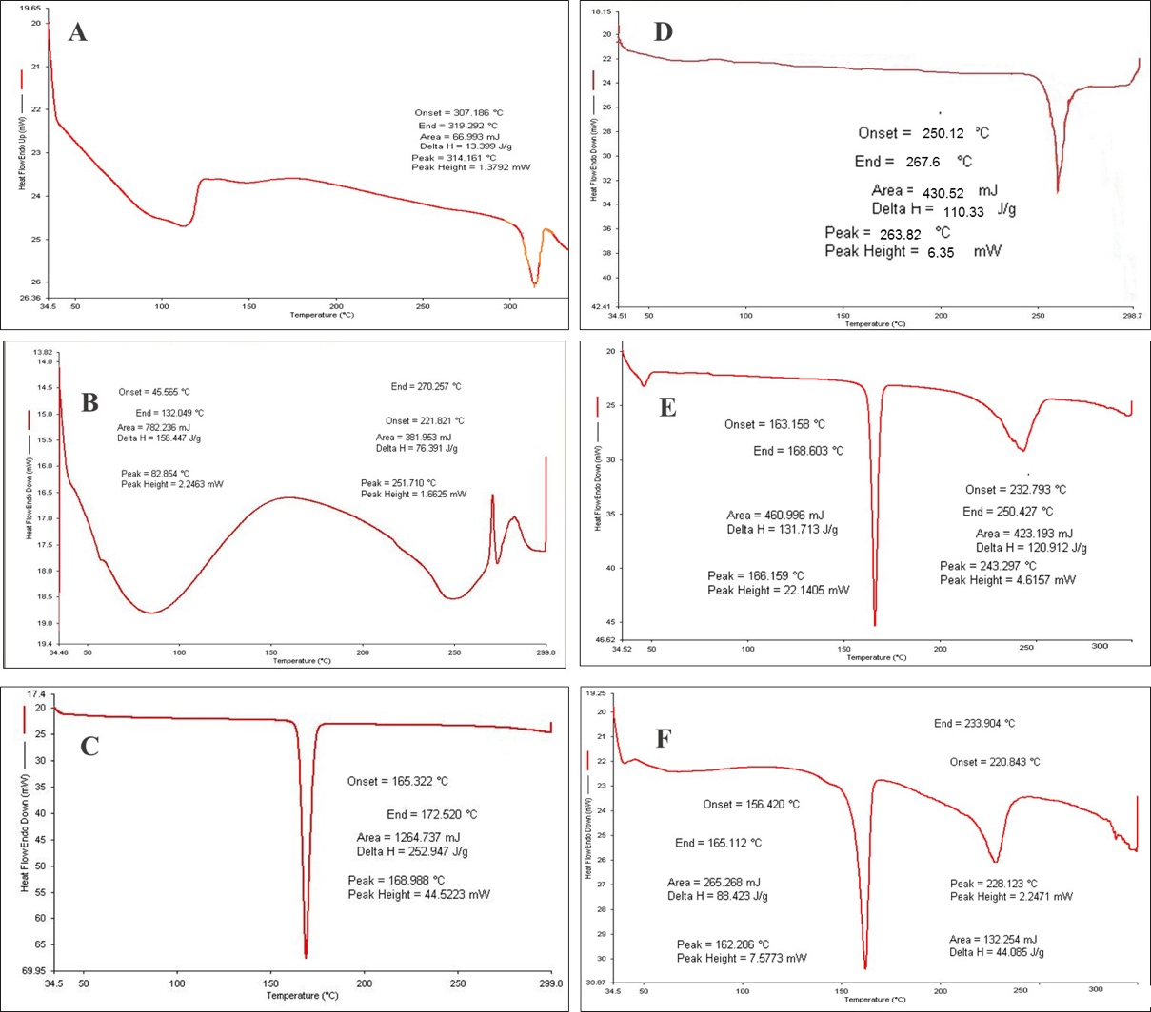

Figure S.1: DSC thermograms of spray dried MYR microspheres powder with its individual components; (A) Myricetin, (B) Maltodextrin, (C)Mannitol, (D) Leucine, (E) SD-MP2, and (F) SD-MP3.

Fourier transform infrared (FTIR) spectroscopy
MYR showed IR absorption at wave number (cm⁻¹) 3586.65-3282.31 (O-H stretching), 2942.33, 2855.4 (C-H stretching), 1660.5 (-C=O group), 1611.71-1517 (-C=C), 1462 (aromatic ring), 1377.06, 1325.97 (C-O-C). The IR spectrum of pure maltodextrin revealed the band at 3317.05 cm⁻¹ due to O–H stretching, at 2925.027 cm⁻¹ attributed to the sp3 C–H stretching, at 1647 cm⁻¹ assigned to C-O stretching and 1419 cm⁻¹ due to-CH₂ bending. Further, pure maltodextrin spectrum presented peaks of 1147.38, 1076.89, and 928 cm⁻¹. The peaks of 1147.38 and 1076.89 cm⁻¹ are caused by stretching of the C-O bond and the 928 cm⁻¹ peak due to the angular deformation of the CH and CH₂ bonds, all from groups found in the carbohydrates ^{[7]}. Mannitol showed a broad band at 3384-3277 cm⁻¹ relating to O-H stretching vibration as well as a band at 2983.67 due to C-H stretching. The OH plane deformation of 1^{ry} and 2^{ry} alcohol was attributed to peaks 1280 and 1259 cm⁻¹. The peaks at 1075 and 1017 are caused by 1^{ry} and 2^{ry} alcohol CO stretching. Furthermore, bands at 951, 926, 880 and 659 represented the fingerprint of mannitol ^{[8]}. The aerosolization enhancer L-leucine molecules exhibited a characteristic peak at 2925 cm⁻¹ due to its methyl group characterized by aliphatic CH₃. At 1508 cm⁻¹ assigned to the bending vibration of N-H band and at 1571.4 cm⁻¹ attributed to the stretching mode of carbonyl group which is confirmed by the appearance of medium intensity band at 1405 cm⁻¹ assigned to COO⁻ asymmetric vibration as previously reported by Ishak and Osman ^{[4]}.
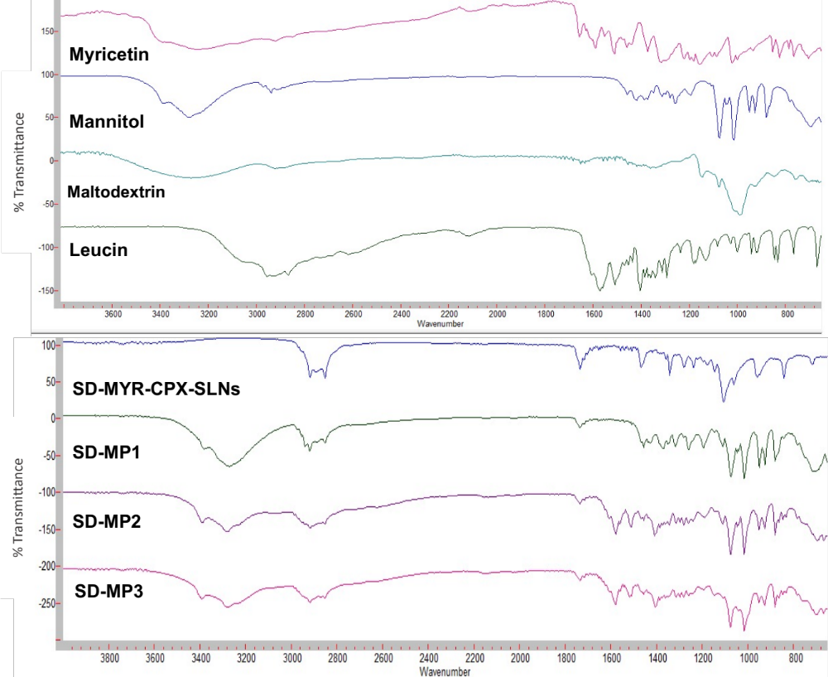

Figure S.2: FTIR spectra of SD-MPS powder (SD-MP1-SD-MP3) with its individual components and SD-MYR-CPX-SLNs.
- In vitro deposition
The SD-MPs powder generated from the inhaler device is required to penetrate deeply to reach the tumor site. The aerosol performance is guided by different parameters like; mass median aerodynamic diameter (MMAD), fine particle fraction (FPF) and emitted fraction (EF). Therefore, the DPI formulation strategy requires the preparation of aerosols that can be readily emitted off the inhaler, while at the same time possesses aerodynamic diameters (d_{ae}) between 1 and 5 μm for effective deposition in the lower respiratory tract ^{[9,10]}.
The deposition pattern of different spray dried microparticles is illustrated in terms of amount deposited in µg per stage and percentage in Figures S.3A-B, respectively. Generally, a minimum % deposited in the upper part of the respiratory tract would be favored. Indeed, SD-MP3 ensured as low as 16 % MYR deposition in the early stages of the impinger S0-S2, Figure S.3B.

In contrast, more than 60 % of SD-MP1 were lost at this initial stages. The use of mannitol alone as a matrix former (SD-MP1) might lead to elimination of the vast majority of the particles from the airways by mucocilary clearance. Comparatively, leucine as a surface active molecule was found to reduce early particle deposition to ~ 40 % (SD-MP2) by enhancing the dispersibility of particles through the formation of a coat (shell) on the particle surface limiting their cohesiveness ^{[11,12]}, together with lowering the surface free energy therefore reducing the particle tendency to agglomerate ^{[13]}. The same observation was noticed by Osman et al. ^{[14]}, where the spray drying of DNase microparticles in the presence of leucine raised the emitted fraction from 75 to more than 96% with a high stage 2 deposition corresponding to respirable fraction (RF) of 68%. Meanwhile, SD-MP3 formula ensured selective deposition in the bronchial region (estimated by ~ 78 % and represented by stages 3-5), which could be considered a promising achievement. However, SD-MP4 exhibited noticeable difference in the in vitro lung deposition data relative to the corresponding formulation (SD-MP3) by changing mannitol: maltodextrin ratio as shown in Figure S.3A.
Figure S.3A: Drug distribution per discharge showing drug deposition at each stage for SD-MPs (SD-MP1-SD-MP4)

Figure S.3B: In vitro deposition data of SD-MPs powders (SD-MP1-SD-MP

References
1. Al-Qadi S, Grenha A, Carrión-Recio D, Seijo B, Remuñán-López C. Microencapsulated chitosan nanoparticles for pulmonary protein delivery: In vivo evaluation of insulin-loaded formulations. Journal of Controlled Release 2012;157(3):383–90.
2. Rockville M. The United States Pharmacopoeia 30, the National Formulary 25 US Pharmacopeial Convention. Electronic version 2007.
3. El-Gendy N, Berkland C. Combination chemotherapeutic dry powder aerosols via controlled nanoparticle agglomeration. Pharmaceutical Research 2009;26(7):1752–63.
4. Ishak RAH, Osman R. Lecithin/TPGS-based spray-dried self-microemulsifying drug delivery systems: In vitro pulmonary deposition and cytotoxicity. Int J Pharm 2015;485(1–2):249–60.
5. Elnaggar YSR, El-Massik MA, Abdallah OY, Ebian AER. Maltodextrin: a novel excipient used in sugar-based orally disintegrating tablets and phase transition process. AAPS PharmSciTech 2010;11(2):645–51.
6. Nafee N, Gaber DM, Elzoghby AO, Helmy MW, Abdallah OY. Promoted Antitumor Activity of Myricetin against Lung Carcinoma Via Nanoencapsulated Phospholipid Complex in Respirable Microparticles. Pharm Res 2020;37(82):1–24.
7. Krishnaiah D, Sarbatly R, Nithyanandam R. Microencapsulation of Morinda citrifolia L. extract by spray-drying. Chemical Engineering Research and Design 2012;90(5):622–32.
8. Bruni G, Berbenni V, Milanese C, Girella A, Cofrancesco P, Bellazzi G, et al. Physico-chemical characterization of anhydrous D-mannitol. Journal of Thermal Analysis and Calorimetry 2009;95(3):871–6.
9. Yu H, Teo J, Chew JW, Hadinoto K. Dry powder inhaler formulation of high-payload antibiotic nanoparticle complex intended for bronchiectasis therapy: Spray drying versus spray freeze drying preparation. International Journal of Pharmaceutics 2016;499(1):38–46.
10. Jacobs C, Müller RH. Production and characterization of a budesonide nanosuspension for pulmonary administration. Pharmaceutical Research 2002;19(2):189–94.
11. Malamatari M, Somavarapu S, Bloxham M, Buckton G. Nanoparticle agglomerates of indomethacin: The role of poloxamers and matrix former on their dissolution and aerosolisation efficiency. Int J Pharm 2015;495(1):516–26.
12. Sou T, Orlando L, McIntosh MP, Kaminskas LM, Morton DA V. Investigating the interactions of amino acid components on a mannitol-based spray-dried powder formulation for pulmonary delivery: a design of experiment approach. International Journal of Pharmaceutics 2011;421(2):220–9.
13. Kho K, Hadinoto K. Optimizing aerosolization efficiency of dry-powder aggregates of thermally-sensitive polymeric nanoparticles produced by spray-freeze-drying. Powder Technology 2011;214(1):169–76.
14. Osman R, Al Jamal KT, Kan PL, Awad G, Mortada N, Abd-Elhameed ES, et al. Inhalable DNase I microparticles engineered with biologically active excipients. Pulmonary Pharmacology & Therapeutics 2013;26(6):700–9.

