Supplementary materials
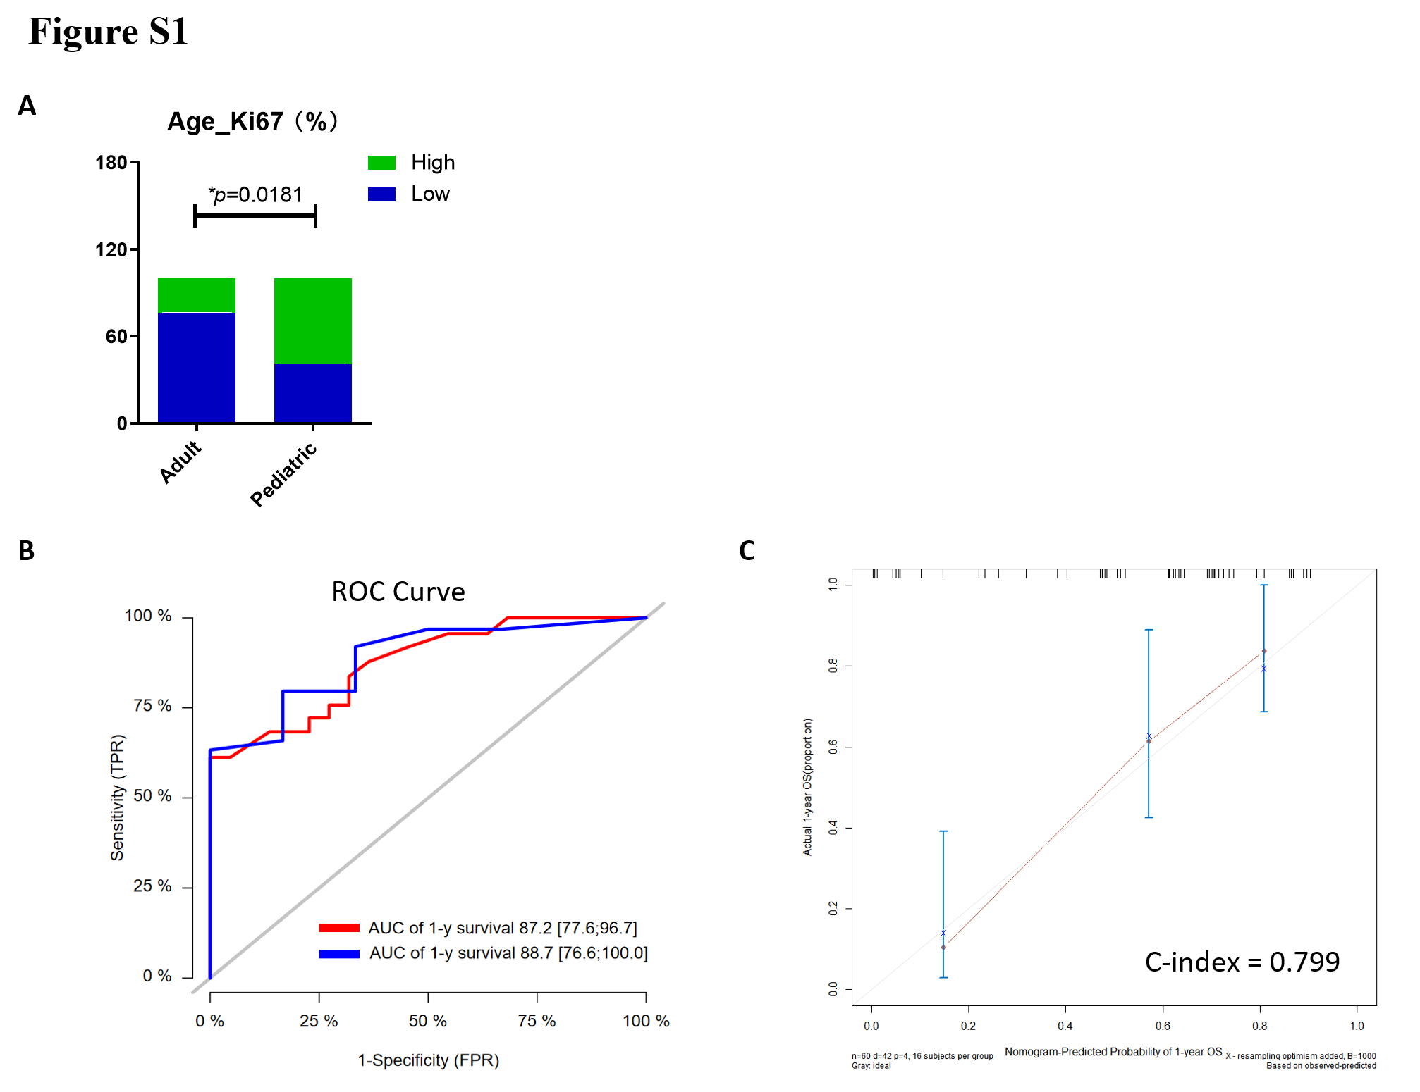
Fig. S1 (a) Comparison of the expression of Ki67 between adults and pediatrics. (b) ROC curves showing the predictive efficiency of the clinical factors on 1- and 2-years survival rate; (c) Calibration curve was used to evaluate the consistency between predicted and observed survival outcomes.

Table S1 Overall clinical features and comparisons of clinical characteristics between adults and pediatrics. P values less than 0.05 were considered statistically significant (*P < 0.05).
Table S1 Overall clinical features and comparisons of clinical characteristics between adults and pediatrics
Variable | Overall | Age
Variable | Overall | Adult | Pediatric | p value
N | 64 | 43 | 21
- Clinical characteristics
Age (mean (SD)) | 27.719 (14.128) | 34.191 (10.373) | 9.824 (3.644) | <0.0001
OS (median [IQR]) | 9.000 [6.000, 16.000] | 9.000 [5.500, 17.500] | 11.000 [6.000, 13.000] | 0.9031
Size diameter (mean (SD)) | 3.769 (1.514) | 3.674 (1.549) | 4.029 (1.424) | 0.4119
Size volume (median [IQR]) | 16.270 [4.352, 33.158] | 11.680 [3.255, 27.365] | 27.380 [12.350, 41.700] | 0.0717
CD25 (mean (SD)) | 16.420 (6.349) | 17.683 (6.856) | 13.388 (3.960) | 0.2139
Age (%)
≥18 | 47 (73.44) | 47 (100.00) | 0 (0.00)
<18 | 17 (26.56) | 0 (0.00) | 17 (100.00)
Sex (%)
Male | 39 (60.94) | 29 (61.70) | 10 (58.82) | 1
Female | 25 (39.06) | 18 (38.30) | 7 (41.18)
Location (%)
Thalamus | 34 (53.12) | 25 (53.19) | 9 (52.94) | 0.7257
Brainstem | 19 (29.69) | 13 (27.66) | 6 (35.29)
Spinal cord | 11 (17.19) | 9 (19.15) | 2 (11.76)
- Clinical Signs and Symptoms
Intracranial
Hypertension (%)
None | 46 (71.88) | 35 (74.47) | 11 (64.71) | 0.651
Present | 18 (28.12) | 12 (25.53) | 6 (35.29)
Cranial nerve palsy (%)
None | 51 (79.69) | 37 (78.72) | 14 (82.35) | 1
Present | 13 (20.31) | 10 (21.28) | 3 (17.65)
Psychonosema (%)
None | 54 (84.38) | 41 (87.23) | 13 (76.47) | 0.5107
Present | 10 (15.62) | 6 (12.77) | 4 (23.53)
Dizziness (%)
None | 39 (60.94) | 31 (65.96) | 8 (47.06) | 0.2808
Present | 25 (39.06) | 16 (34.04) | 9 (52.94)
Focal Neurological Deficit (%)
None | 25 (39.06) | 17 (36.17) | 8 (47.06) | 0.6181
Present | 39 (60.94) | 30 (63.83) | 9 (52.94)
Motor Deficit (%)
None | 37 (57.81) | 25 (53.19) | 12 (70.59) | 0.338
Present | 27 (42.19) | 22 (46.81) | 5 (29.41)
Superficial reflex (%)
Obtusion | 51 (83.61) | 36 (81.82) | 15 (88.24) | 0.798
Normal | 4 (6.56) | 3 (6.82) | 1 (5.88)
Oxypathia | 6 (9.84) | 5 (11.36) | 1 (5.88)
Deep reflection (%)
Obtusion | 43 (70.49) | 32 (72.73) | 11 (64.71) | 0.4442
Normal | 16 (26.23) | 10 (22.73) | 6 (35.29)
Oxypathia | 2 (3.28) | 2 (4.55) | 0 (0.00)
Pyramidal sign (%)
Negative | 56 (91.80) | 40 (90.91) | 16 (94.12) | 1
Positive | 5 (8.20) | 4 (9.09) | 1 (5.88)
- Molecular Features
P53Mut (%)
Mutation | 16 (50.00) | 11 (44.00) | 5 (71.43) | 0.3924
None | 16 (50.00) | 14 (56.00) | 2 (28.57)
Co1p19q (%)
None | 49 (92.45) | 35 (89.74) | 14 (100.00) | 0.5115
Present | 4 (7.55) | 4 (10.26) | 0 (0.00)
- MRI
Contrast Enhancement (%)
None | 17 (30.36) | 11 (26.83) | 6 (40.00) | 0.5345
Present | 39 (69.64) | 30 (73.17) | 9 (60.00)
Hydrocephalus (%)
None | 34 (53.12) | 27 (57.45) | 7 (41.18) | 0.3852
Present | 30 (46.88) | 20 (42.55) | 10 (58.82)
- Immunohistochemistry Characteristics
Ki67 (%)
Low | 43 (67.19) | 36 (76.60) | 7 (41.18) | 0.0181*
High | 21 (32.81) | 11 (23.40) | 10 (58.82)
NeuN (%)
Negative | 35 (54.69) | 22 (46.81) | 13 (76.47) | 0.0686
Positive | 29 (45.31) | 25 (53.19) | 4 (23.53)
P53 (%)
(-) | 10 (15.62) | 6 (12.77) | 4 (23.53) | 0.3106
(+) | 22 (34.38) | 18 (38.30) | 4 (23.53)
(++) | 13 (20.31) | 11 (23.40) | 2 (11.76)
(+++) | 19 (29.69) | 12 (25.53) | 7 (41.18)
MGMT (%)
(-) | 2 (3.23) | 2 (4.44) | 0 (0.00) | 0.6984
(+) | 14 (22.58) | 9 (20.00) | 5 (29.41)
(++) | 17 (27.42) | 12 (26.67) | 5 (29.41)
(+++) | 29 (46.77) | 22 (48.89) | 7 (41.18)
VEGF (%)
(-) | 1 (1.61) | 0 (0.00) | 1 (5.88) | 0.2925
(+) | 15 (24.19) | 10 (22.22) | 5 (29.41)
(++) | 17 (27.42) | 14 (31.11) | 3 (17.65)
(+++) | 29 (46.77) | 21 (46.67) | 8 (47.06)
EGFR (%)
(-) | 4 (6.45) | 4 (8.89) | 0 (0.00) | 0.3852
(+) | 21 (33.87) | 14 (31.11) | 7 (41.18)
(++) | 27 (43.55) | 21 (46.67) | 6 (35.29)
(+++) | 10 (16.13) | 6 (13.33) | 4 (23.53)
- Treatment condition
KPS (%)
≥70 | 36 (56.25) | 27 (57.45) | 9 (52.94) | 0.9716
<70 | 28 (43.75) | 20 (42.55) | 8 (47.06)
Treatment protocol (%)
Complete  standard therapy | 16 (26.67) | 12 (26.67) | 4 (26.67) | 0.9842
Advanced  standard therapy | 27 (45.00) | 20 (44.44) | 7 (46.67)
Incomplete  standard therapy | 17 (28.33) | 13 (28.89) | 4 (26.67)
- Follow-up
Short-term recurrence (%)
None | 31 (58.49) | 21 (53.85) | 10 (71.43) | 0.407
Present | 22 (41.51) | 18 (46.15) | 4 (28.57)
Status (%)
Survive | 22 (34.38) | 14 (29.79) | 8 (47.06) | 0.3237
Dead | 42 (65.62) | 33 (70.21) | 9 (52.94)

