Supplementary material
Microplastic accumulation in sewer sediments and its potential entering the environment via combined sewer overflows: a study case in Paris
Minh Trang NGUYEN¹, Ngoc Nam PHUONG², Mohamed SAAD¹, Bruno TASSIN¹, Thomas GILLET³, Sabrina GUÉRIN-RECHDAOUI⁴, Sam AZIMI⁴, Vincent ROCHER⁴, Johnny GASPERI², Rachid DRIS¹
1 LEESU, Ecole des Ponts ParisTech, Université Paris Est Creteil, Marne-la-Vallée, France
2 Université Gustave Eiffel – Laboratoire eau environnement (LEE)-Allée des Ponts et Chaussées, 44344 Bouguenais, France
3 Section de l’Assainissement de Paris, Subdivision Contrôle des Eaux, 17 Rue Delesseux, 75019 Paris
4 Syndicat Interdépartemental pour l’Assainissement de l’Agglomération Parisienne (SIAAP), Direction de l'innovation, 82 Avenue Kléber, F-92700 Colombes, France

*Corresponding authors
Minh Trang Nguyen
minh-trang.nguyen@enpc.fr
Rachid Dris
rachid.dris@u-pec.fr

Table S1: Information on sample collection
Sample ID | Sampling date | Location | Latitude | Longtitude
SC1 | 15/03/2021 | 5, Boulevard Lefebvre 75015 | 48.832748 | 2.289059
SC2 | 15/03/2021 | 51, Rue Censier 75005 | 48.839362 | 2.350496
SC3 | 16/03/2021 | 44, Rue de Turbigo 75003 | 48.865107 | 2.354860
SC4 | 25/03/2021 | 79, Rue des Entrepreneurs 750015 | 48.844426 | 2.292023
SC5 | 29/03/2021 | The corner of Rue Cordinet and Rue Truffaut 75017 | 48.889071 | 2.316190
SC6 | 07/04/2021 | Interior courtyard of Austerlitz train station 75013 | 48.842614 | 2.363928
SC7 | 13/04/2021 | The corner of Rue de l'Universite and Rue de Solferino | 48.859663 | 2.322772
SC8 | 01/06/2021 | 5, Rue de Solferino 75005 | 48.860108 | 2.323630
SC9 | 11/06/2021 | 24, Rue Saint Bernard 75011 | 48.851902 | 2.381891
SC10 | 19/05/2021 | 22, Bouvelard Jules Ferry) | 48.868451 | 2.367996
SC11 | 22/06/2021 | 10, Rue Affre 75018 | 48.885700 | 2.355915
SC12 | 16/08/2021 | 234, Rue de Crimee 75019 | 48.894557 | 2.373119

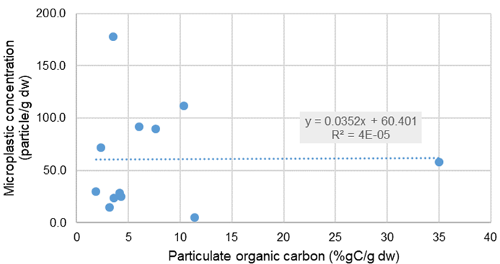
Figure S1: Relationship between microplastics concentration and particulate organic carbon in sewer sediments

