TOC:
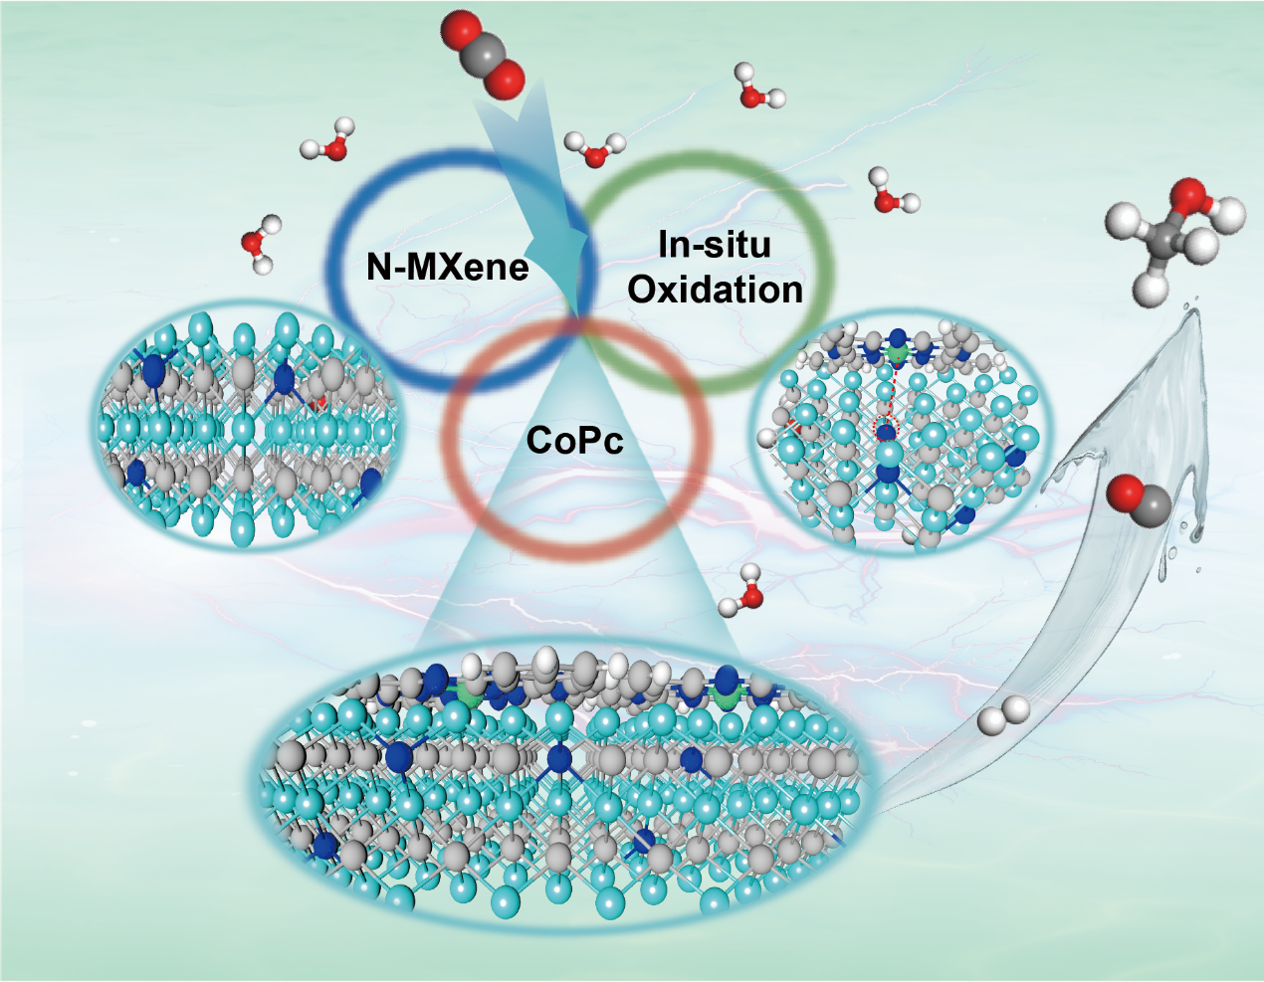
(The white, gray, royal blue, green, sky blue, and red spheres represent H, C, N, Co, Ti, and O respectively.)
Molecular catalyst (CoPc) with well-designed structure and rich metal-Nitrogen active sites supported by N-doped MXene and in-situ oxidation has been synthesized by a simple method. Through both experimental results and DFT calculations, it can be found that CoPc/o-N-MXene exhibits the superior activity and selectivity for ERCD to methanol with long-term stability.

