Figure 2A line 1 Wnt1

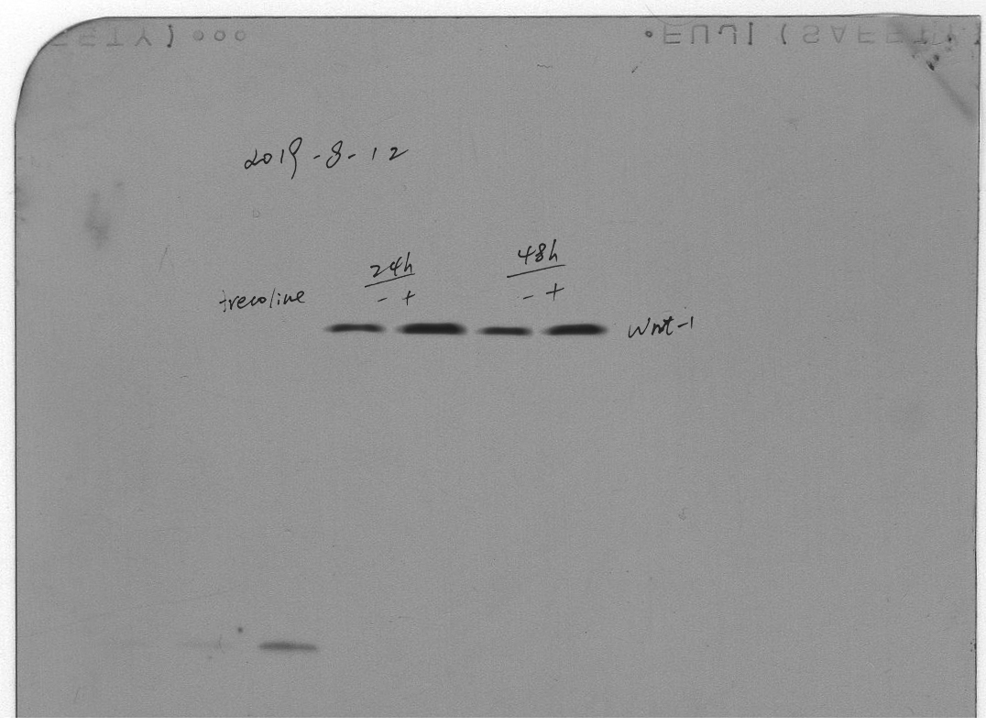

Figure 2A line 2 Wnt2

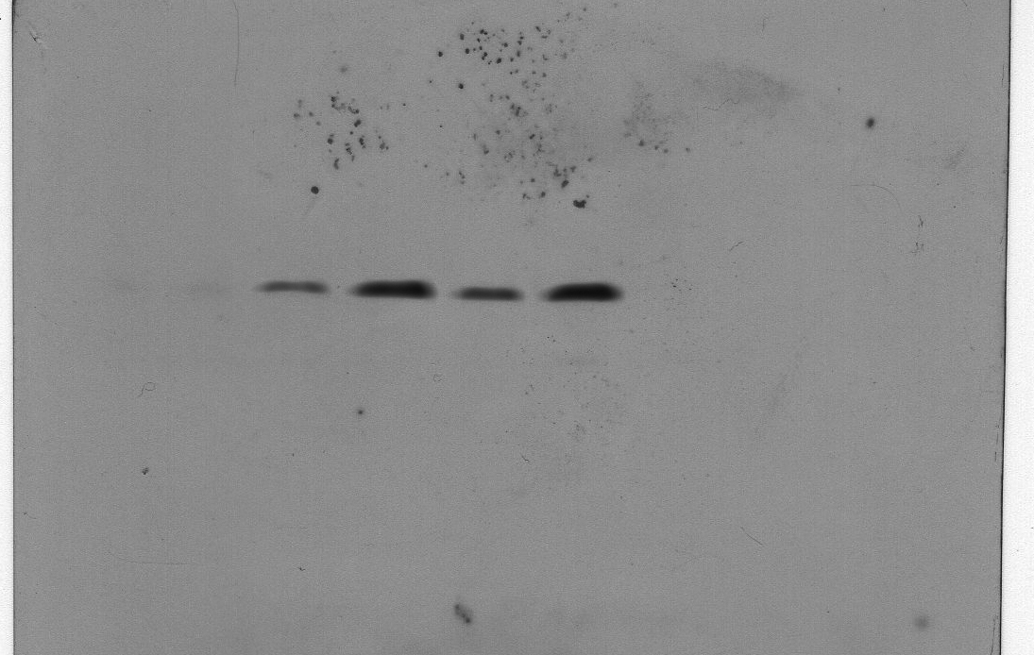

Figure 2A line 3 Wnt5a

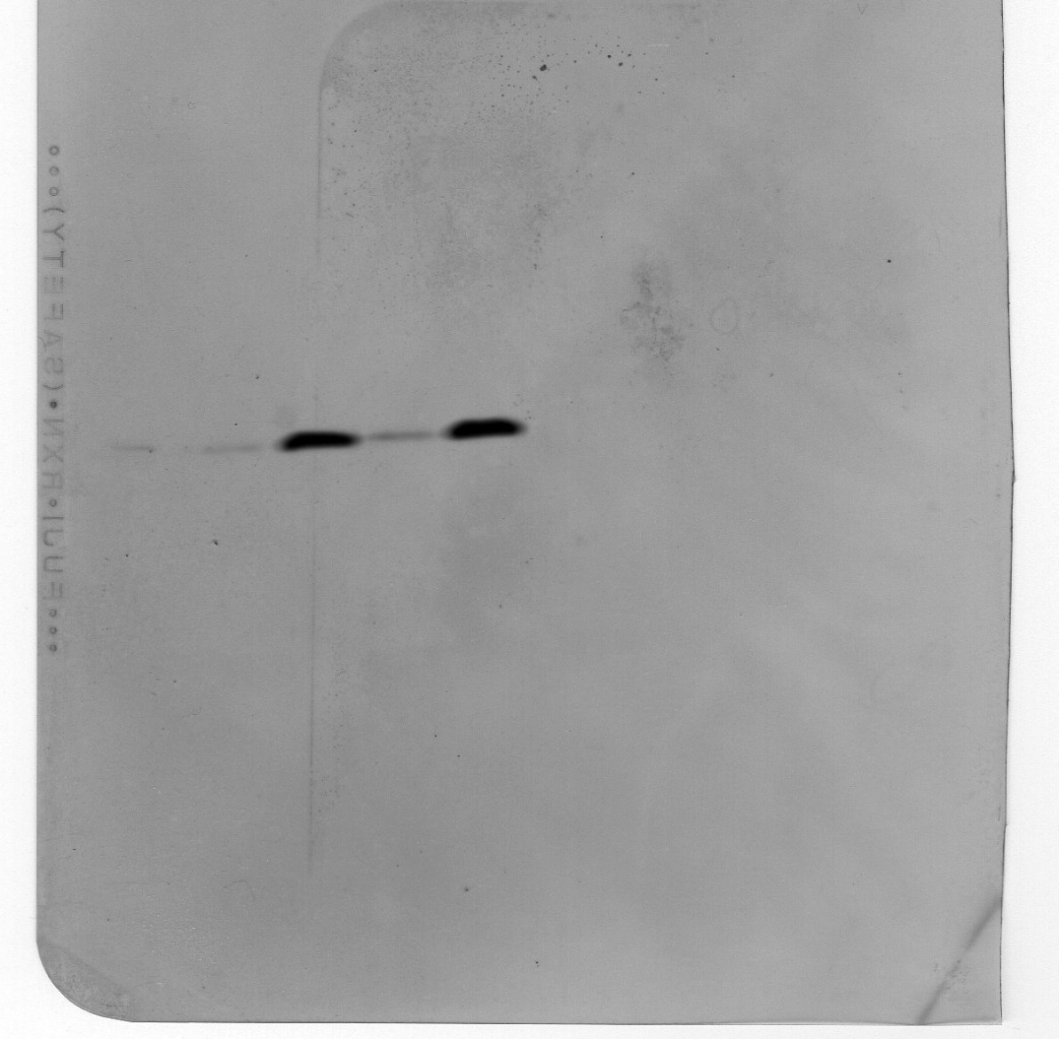

Figure 2A line 4 GAPDH

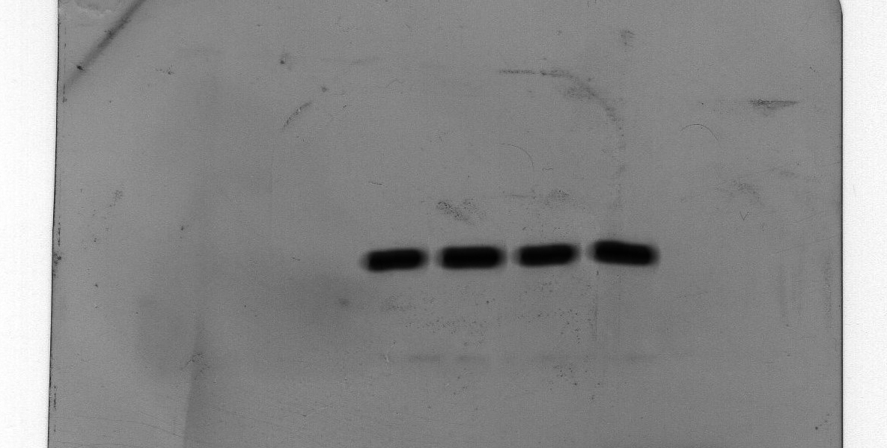

Figure 3C line 1 Wnt5a

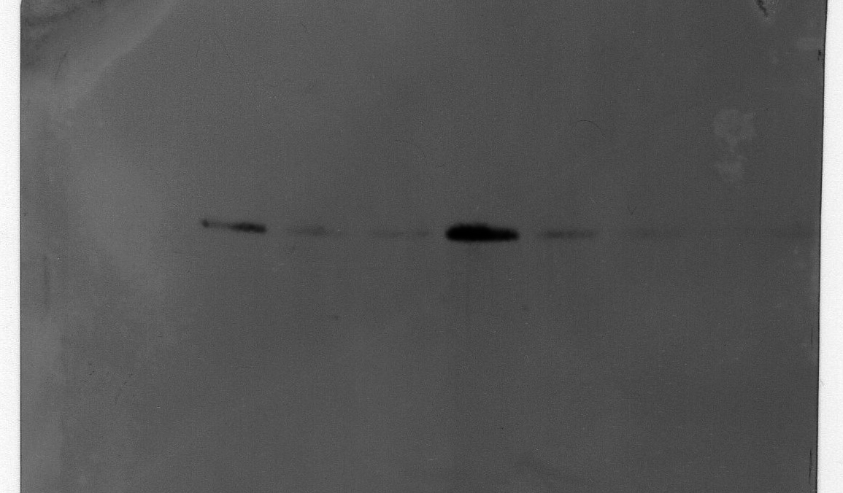

Figure 3C line 2 GAPDH

