Cerebral microvascular endothelial cell-derived extracellular vesicles contribute to blood−brain barrier disruption
Hosseinkhani Baharak ^{1,2,3}*#, Duran Gayel^{1,2#}, Hoeks Cindy^{1,2}, Hermans Doryssa^{1,2}, Schepers Melissa^{1,2,4,5} Baeten Paulien^{1,2}, Poelmans Joren^{1,2}, Coenen Britt^{1,2}, Bekar Kübra^{1,2}, Pintelon Isabel⁶, Timmermans Jean-Pierre⁶, Vanmierlo Tim^{1,2,4,5}, Michiels Luc⁷, Hellings Niels^{1,2}, Broux Bieke^{1,2}*

¹University MS Center, Campus Diepenbeek, Diepenbeek, Belgium
²Neuro-Immune Connections and Repair Lab, Department of Immunology and Infection, Biomedical Research Institute, UHasselt, Diepenbeek, Belgium
³Laboratory of Angiogenesis and Vascular Metabolism, Center for Cancer Biology (CCB), VIB and Department of Oncology, Leuven Cancer Institute (LKI), KU Leuven, Leuven, Belgium
⁴ Department Psychiatry and Neuropsychology, School for Mental Health and Neuroscience, Maastricht University, Maastricht, The Netherlands.
⁵ Department of Neuroscience, Biomedical Research Institute, Faculty of Medicine and Life Sciences, Hasselt University, Hasselt, Belgium.
⁶Laboratory of Cell Biology & Histology / Antwerp Centre for Advanced Microscopy (ACAM), University of Antwerp, Universiteitsplein 1, Antwerp 2610, Belgium
⁷Bionanotechnology group, Biomedical Research Institute, UHasselt, Diepenbeek, Belgium

* These authors share senior authorship
#These authors share first- authorship
* To whom correspondence may be addressed: prof. Dr. Bieke Broux, Universiteit Hasselt- Campus Hasselt, Martelarenlaan 42- B-3500 Hasselt, T +32(0)11 26 93 13, bieke.broux@uhasselt.be

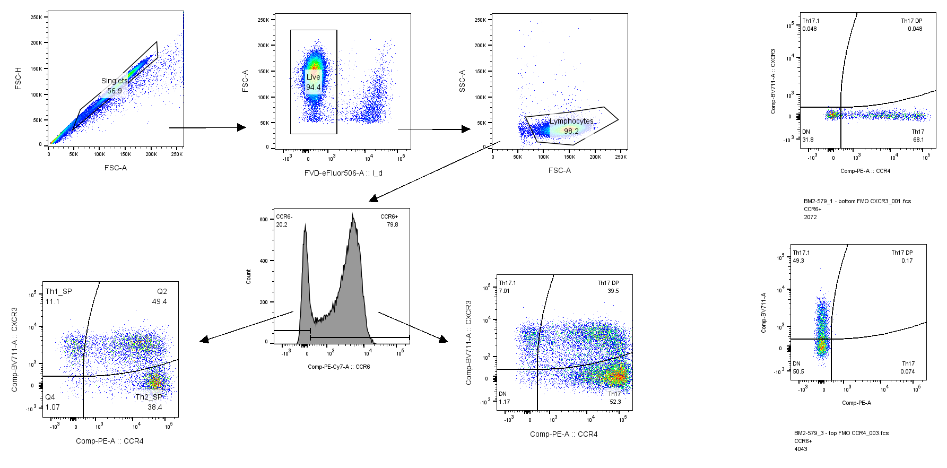
Figure S1: Gating strategy for flowcytometric analysis on migrated and non-migrated CD4 memory T cells over an inflamed or EV treated hCMEC/d3 coated insert. Gating is based on fluorescence minus one principle gates.

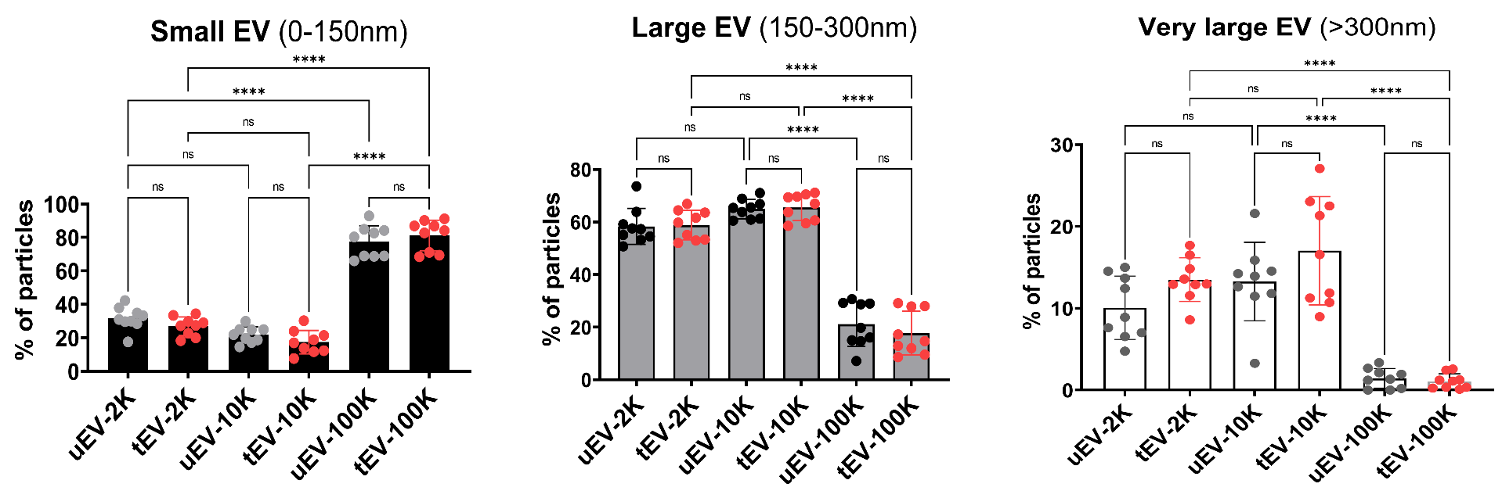
Figure S2A: The percentage of small EV (0- 150 nm), large EV (150- 300 nm) and very large EV (>300 nm) in different size-based subpopulations of EV derived either from untreated cells (uEV; gray dots) or TNFα/IFNγ inflammatory triggered (tEV; red dots) cells. Inflammation does not impact on size profile of EV released by BBB-EC (uEV vs tEV). The EV-10 K subsets predominantly contained of small-sized ((81.1±9.1%), while the two fractions of 2K and 10K were dominated by large- (50–100 nm) and very large-sized EV (with a distribution of 65.5±5.1% and 58.8±5.6% respectively). There was no significant difference in the percentage of small EV, large EV and very large EV (>300 nm) of EV2K and 10K subpopulations. Data are presented as means ± SD (n ≥ 6 independent biological experiments, 1 symbol per batch) and one-way ANOVA Tukey's multiple comparison was used to determine significance between multiple groups: ns, no significance, *p < 0.05 **P < 0.01, ****P < 0.0001.
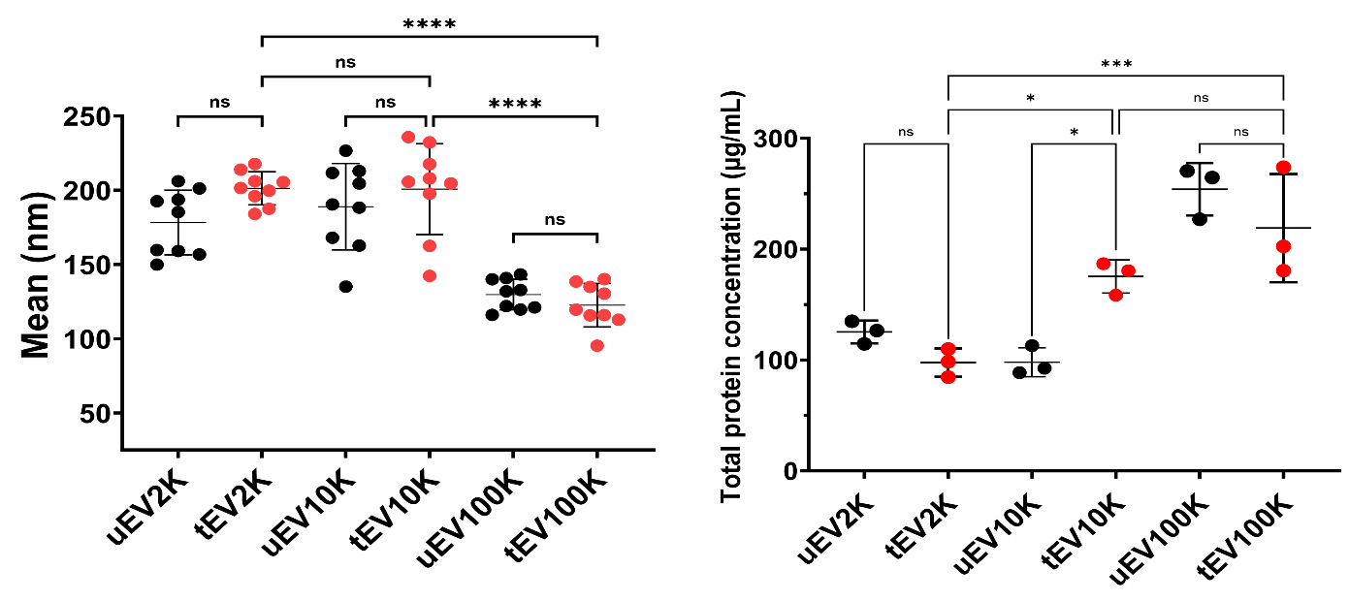

Figure S2B: Mean size (nm) and total protein concentration (µg/ml) in different size-based subpopulations of EV derived either from untreated cells (uEV; black dots) or TNFα/IFNγ inflammatory triggered (tEV; red dots) cells.

Table S1: Grouped inflammatory proteins between EV size- based populations (EV-2K, EV-10K and EV-100K )and TNFα/IFNγ treated hCMEC/D3in Venn diagram produced using open source software(http://bioinformatics.psb.ugent.be).
Conditions | Total | Elements
EV-2K, EV-10K, EV100K and TNFα/IFNγ treated hCMEC/D3 | 6 | CCL2, CCL5, IL6, IL-8, ICAM-1, CXCL10
EV-2K, EV-10K, EV100K | 2 | CCL8, CXCL9
TNFα/IFNγ treated hCMEC/D3 | 2 | IL15 and IL16
EV-2K, , | 1 | IL1-β
EV100K | 3 | CCL1, IL10 and IL17

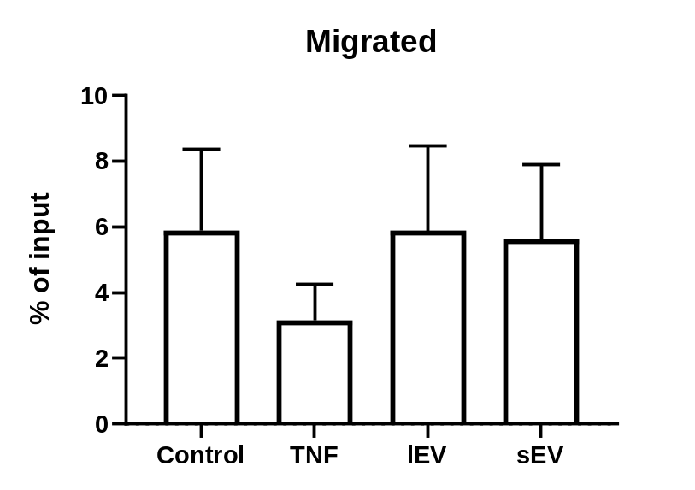
Figure S3: Fraction of migrated cells after 24 h as a percentage of total plated CD4⁺ memory T cells in different conditions of BBB-EC treatment. Data is from five different HDs and statistical analysis is done using a one-way ANOVA and Tukey’s multiple comparisons test. No statistical differences were found.

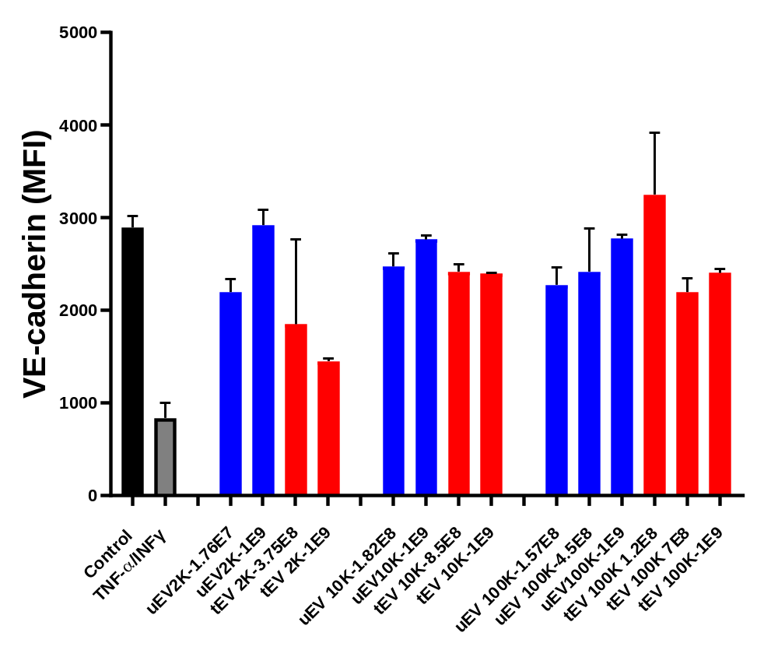
Figure S4: VE-cadherin level hCMEC/D3 in the response to increasing doses of size- based EV subpopulations (2K,10K and 100K) and in comparison, to TNFα/IFNγ (10 ng/mL) and untreated hCMEC/D3 as positive and negative controls, respectively. One-way analysis of variance with a multiple comparisons test (Dunnet test, p-value < 0.05 considered significant) was used to evaluate the statistical significance between treatment versus negative control (<0.0001), and Tukey’s test at the value of *p < 0.05 () was applied to evaluate the statistical significance between different treatments; *, **, ***, ****: significantly different from controls (p < 0.05, p < 0.01, p < 0.001 and p < 0.0001, respectively).

Table 3: Grouped inflammatory proteins between cells-treated with different EV size- based populations (EV-2K, EV-10K and EV-100K )and TNFα/IFNγ treated hCMEC/D3in Venn diagram produced using open source software(http://bioinformatics.psb.ugent.be).
Conditions | Total | Elements
EV-2K, EV-10K, EV100K and TNFα/IFNγ treated hCMEC/D3 | 5 | CCL2, IL8, IL6, ICAM-1, CXCL10
EV-10K, EV100K and TNFα/IFNγ treated hCMEC/D3 | 3 | IL13, TNF-α and TNF-β
EV-2K, EV-10K, EV100K | 1 | IL15
EV-2K, EV-10K, and TNFα/IFNγ treated hCMEC/D3 | 1 | IL1- β
EV-2K, EV-100K, and TNFα/IFNγ treated hCMEC/D3 | 1 | CSF 3
EV-2K, EV-10K, | 3 | IFN-γ, IL3, CCL11
EV-2K, EV100K | 3 | IL16, IL17 and CSF2
TNFα/IFNγ treated hCMEC/D3 and EV100K | 2 | CCL-5, CD120B
TNFα/IFNγ treated hCMEC/D3 and EV-2K, | 2 | CCL1, TGF- β, CXCL9
EV-100K | 5 | MCSF, IL2, IL7, IL10 and CD120A
EV-2K | 1 | INF-γ
TNFα/IFNγ treated hCMEC/D3 | 3 | IL12, CCL8, IL1-α

