Tree trait-mediated differences in soil moisture regimes: A comparative study of Beech, Spruce, and Larch in a drought-prone area of Central Europe

Marta Kuželková, Lukáš Jačka*, Martin Kovář, Václav Hradilek, Petr Máca
Department of Water Resources and Environmental Modeling, Faculty of Environmental Sciences, Czech University of Life Sciences Prague, Kamýcká 129, Praha – Suchdol, 165 00, Czech Republic
*Corresponding author: jacka@fzp.czu.cz
Number of pages: 9 (including cover page)
Number of tables: 4
Number of figures: 10
Table S1. Selected soil characteristics of the study area (mean ± SD, n= 5).

Location | Tree stand | Sampling depth [cm] | Bulk density  [g cm⁻³] | FS*  (vol %) | FC**  (vol %) | BEAW***  (vol %)
1 | Beech | 5 | 0.90 ± 0.20 | 0.54 ± 0.05 | 0.44 ± 0.06 | 0.237 ± 0.055
 |  | 10 | 1.37 ± 0.05 | 0.45 ± 0.05 | 0.33 ± 0.02 | NA
 |  | 20 | 1.41 ± 0.05 | 0.43 ±0.03 | 0.30 ± 0.04 | 0.148 ±0.020
1 | Spruce | 5 | 0.34 ± 0.06 | 0.73 ± 0.12 | 0.40 ± 0.07 | 0.211 ± 0.042
 |  | 10 | 1.05 ± 0.14 | 0.47 ± 0.01 | 0.30 ± 0.02 | NA
 |  | 20 | 1.23 ± 0.14 | 0.44 ± 0.04 | 0.31 ± 0.02 | 0.135 ± 0.009
1 | Larch | 5 | 0.62 ± 0.23 | 0.61 ± 0.12 | 0.37 ± 0.05 | 0.208 ± 0.060
 |  | 10 | 1.12 ± 0.20 | 0.46 ± 0.02 | 0.31 ± 0.02 | NA
 |  | 20 | 1.39 ± 0.12 | 0.44 ± 0.04 | 0.28 ± 0.03 | 0.158 ± 0.019
3 | Beech | 5 | 0.54 ± 0.12 | 0.66 ± 0.10 | 0.49 ± 0.04 | 0.315 ± 0.50
 |  | 10 | 1.34 ± 0.03 | 0.44 ± 0.00 | 0.34 ± 0.02 | NA
 |  | 20 | 1.46 ± 0.12 | 0.41 ± 0.04 | 0.30 ± 0.01 | 0.162 ± 0.026
3 | Spruce | 5 | 0.41 ± 0.22 | 0.73 ± 0.08 | 0.40 ± 0.08 | 0.196 ± 0.064
 |  | 10 | 1.27 ± 0.13 | 0.46 ± 0.02 | 0.31 ± 0.02 | NA
 |  | 20 | 1.45 ± 0.14 | 0.41 ± 0.04 | 0.31 ± 0.02 | 0.150 ± 0.006
3 | Larch | 5 | 0.44 ± 0.16 | 0.72 ± 0.05 | 0.45 ± 0.06 | 0.234 ± 0.079
 |  | 10 | 1.31 ± 0.12 | 0.46 ± 0.05 | 0.37 ± 0.03 | NA
 |  | 20 | 1.50 ± 0.12 | 0.40 ± 0.03 | 0.31 ± 0.03 | 0.166 ± 0.006
*FS – full saturation, **FC – field capacity, ***BEAW – boundary of easily available water (pF3.7)

Fig.S1 Mean daily values of 3 TMS sensors for topsoil moisture in period 5/2021–1/2023 for the tested tree species. Mean values are shown for each of the three locations separately. Green lines are for beech, blue for larch, and orange for spruce. Solid lines denote location 1, dotted line location 2, and dashed line location 3.
Fig.S2 Mean daily values of 3 TMS sensors for subsoil moisture in period 5/2021–1/2023 for the tested tree species. Mean values are shown for each of the three locations separately. Green lines are for beech, blue for larch, and orange for spruce. Solid lines denote location 1, dotted line location 2, and dashed line location 3.

Fig.S3 Topsoil water content (mean ± SD, n= 9 TMS sensors) for selected time periods and the tested tree species. Values averaged from 15-min time step. Different letters following values in the measured period indicate significant differences in means (for topsoil and subsoil separately) according to Tukey’s HSD test.
Fig.S4 Subsoil water content (mean ± SD, n= 9 TMS sensors) for selected time periods and the tested tree species. Values averaged from 15-min time step. Different letters following values in the measured period indicate significant differences in means (for topsoil and subsoil separately) according to Tukey’s HSD test.

Fig. S5 Monthly precipitation from reference meteorological station situated in the open landscape (blue) and redline shows corresponding long-term precipitation normal (1991-2020) for Central Bohemia provided by CHMI (2023).

Table S2 Rainfall totals for the quarters of years 2021, 2022, and corresponding long-term precipitation normal (1991-2020) for Central Bohemia
 | First quarter | Second quarter | Third quarter | Fourth quarter | Annual sum
2021 [mm] | 78 | 231 | 220 | 75 | 603
2022 [mm] | 45 | 168 | 159 | 104 | 476
Difference (2021-2022) [mm] | 33 | 63 | 61 | -29 | 127
Ratio 2022 to 2021 [%] | 58 | 73 | 72 | 139 | 79
Precipitation normal [mm]* | 99 | 172 | 199 | 113 | 583
*Modified from CHMI (2023)

Fig. S6 Monthly temperature from reference meteorological station situated in the open landscape and redline shows corresponding long-term normal (1991-2020) for Central Bohemia provided by CHMI (2023).

Table S3 Sums of monthly average air temperatures for the quarters of years 2021, 2022, and the corresponding long-term normal (1991-2020) for Central Bohemia provided by CHMI (2023).
 | First quarter | Second quarter | Third quarter | Fourth quarter | Annual sum
2021 [°C] | 1,0 | 34,0 | 48,1 | 11,1 | 94,2
2022 [°C] | 7,9 | 38,3 | 49,3 | 14,7 | 110,3
Difference (2021-2022) [°C] | -6,9 | -4,3 | -1,2 | -3,7 | -16,1
Ratio 2022 to 2021 [%] | 777 | 113 | 102 | 133 | 117
Temperature normal [°C]* | 3,8 | 40,2 | 51,3 | 13,1 | 108,4
*Modified from CHMI (2023)
Fig. S7 Monthly potential evapotranspiration calculated based on Oudin (2005) model from air temperature measured at reference meteorological station.
Table S4 Potential evapotranspiration for the quarters of years 2021 and 2022. The PET was calculated based on Oudin (2005) model from temperatures measured at reference meteorological station.
 | First quarter | Second quarter | Third quarter | Fourth quarter | Annual amount
2021 [mm] | 37,7 | 233,5 | 265,7 | 42,4 | 579,4
2022 [mm] | 46,1 | 253,7 | 274,1 | 49,5 | 623,5
Difference (2021-2022) [mm] | -8,4 | -20,2 | -8,4 | -7,1 | -44,1
Ratio 2022 to 2021 [%] | 122 | 109 | 103 | 117 | 108

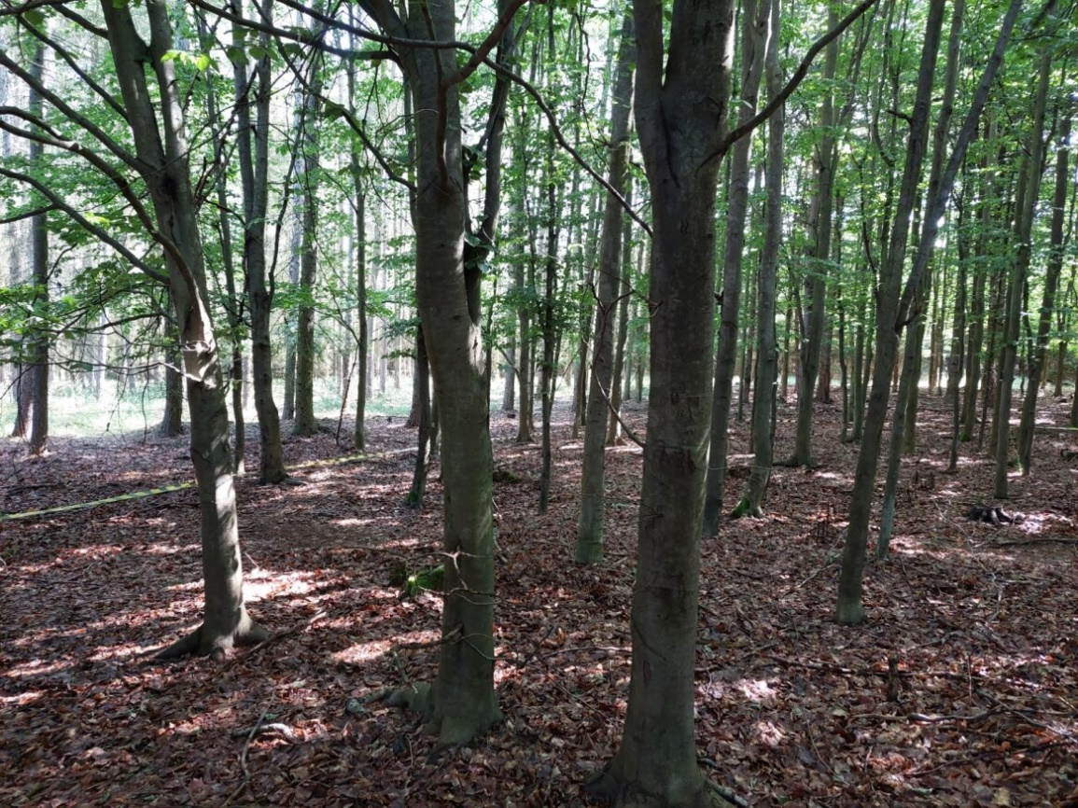
Fig. S8 The beech stand at location 1 in the middle of June 2022. The new foliage is already fully developed.
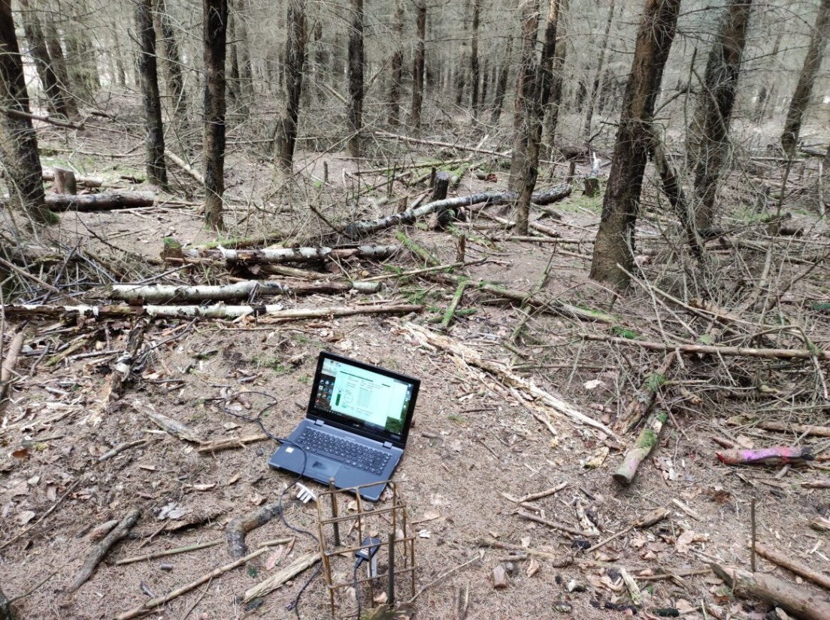
Fig. S9 The spruce stand at location 1 in the middle of June 2022. In the figure, the field download of TMS data is performed. The individual sensors are protected against the wildlife damage.

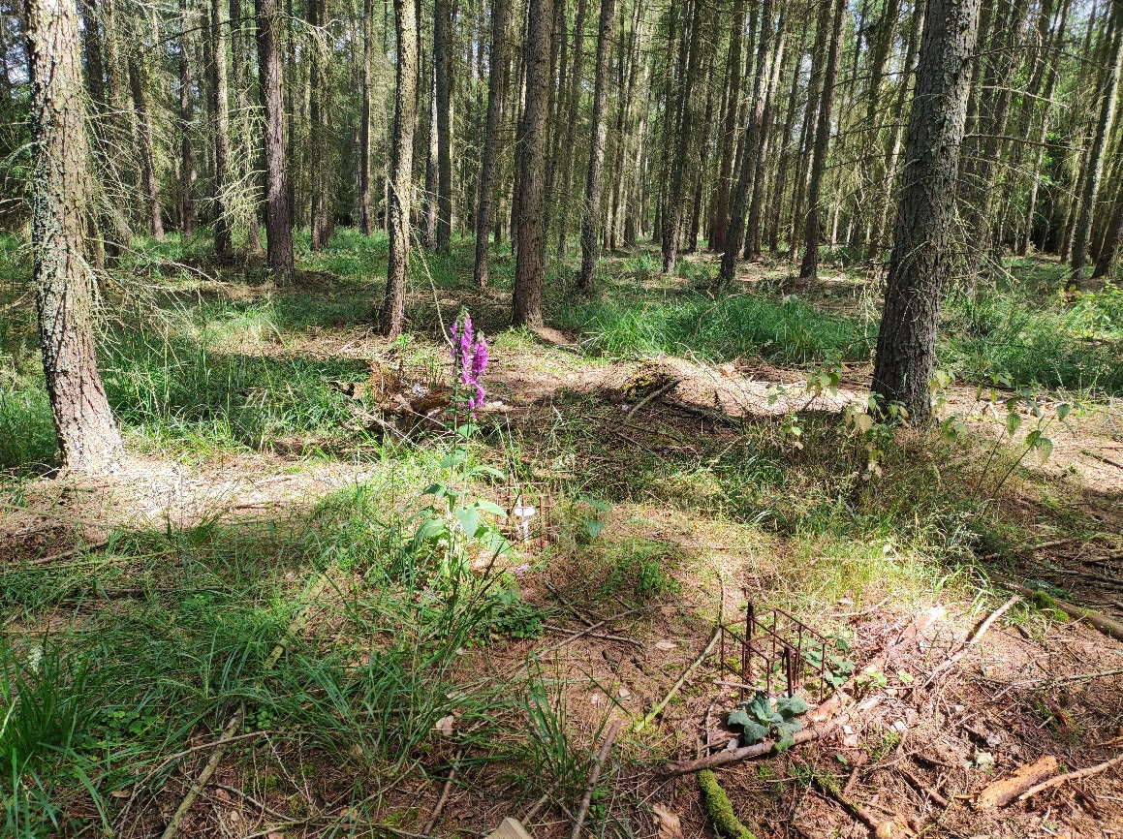
Fig. S10 A larch understory layer is dominated by herbaceous plants and moss species in the middle of June 2022. The heterogenity of larch forest floor when compared to beech and spruce stands is evident.

