Appendix

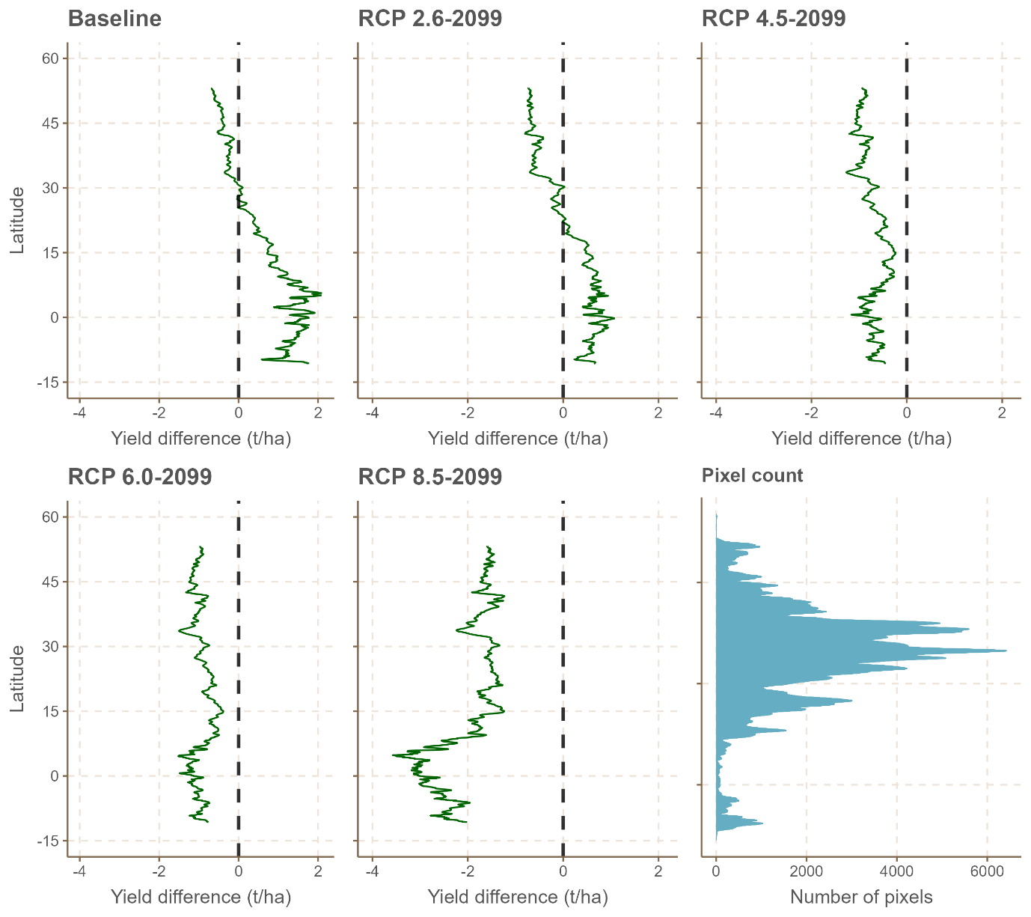
Figure A1. Mean latitudinal yield difference (C₄-C₃) in crop yield by 2100.

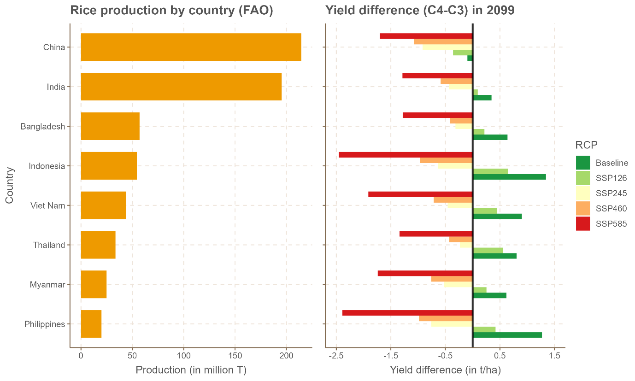
Figure A2. Yield difference (C₄-C₃) in 2050 for major rice-producing countries.

