Supplementary Materials for

Covalent-coordination driven hierarchical assembly of tubular frameworks

Hai-Sen Xu,^{1,2}† Yi Luo,³† Lin Liang,⁴ Runlai Li,⁵ Hongfei Wang,¹ Ting Chen,¹ Wen-Na Jiao,¹ Si Huang,¹ Wei-De Zhu,¹ Mathias Nero,³ Fangzheng Chen,² Qiang Gao,⁶ Xing Li,² Mei Pan,¹ Willhammar Tom,³* Kian Ping Loh,²* Cheng-Yong Su¹*

†These authors contributed equally to this work.
*Correspondence to: cesscy@mail.sysu.edu.cn (C.-Y.S.); chmlohkp@nus.edu.sg (K.P.L.); tom.willhammar@mmk.su.se (W.T.).

The PDF file includes:

Materials and Methods
Supplementary Text
Supplementary Figures 1-72
Supplementary Tables 1-4
Supplementary References

Other Supplementary Materials for this manuscript include the following:

Structural Models (CIF Files)

Materials and Methods
Reagent
All commercially available starting compounds and solvents were purchased from commercial sources and used without further purification. Compounds 4-bromopyridine-2,6-dicarbaldehyde (S1)¹ and 1,4-dibromo-2,5-bis(hexyloxy)benzene (S3)² were synthesized according to reported procedures.

Instrumentation and characterization
Liquid ¹H and ¹³C NMR spectra were recorded on Bruker AVANCE I 300 MHz, Bruker AVANCE III 400 MHz, and Bruker AVANCE I 500 MHz spectrometers.
Solid-state NMR experiments were performed on a Bruker Avance II 400 MHz wide-bore spectrometer at a ¹³C resonance frequency of 100.6 MHz with a 4-mm double-resonance MAS probe.
High-resolution mass spectrometry (HRMS) data were obtained on a Bruker maXis 4G ESI-Q-TOF with Tunningmix as calibrating agent.
Fourier-transform infrared spectroscopy (FT-IR) was carried out on a Frontier FT-IR spectrometer in transmission mode.
Thermogravimetric analysis (TGA) was carried out on a Netzsch TG 209F3 equipment within the temperature range of 30 °C to 700 °C under nitrogen (N₂) atmosphere with a heating rate of 10 °C/min.
The metal contents were determined via inductively coupled plasma mass spectrometry (ICP-MS) on an iCAP RQ (Thermo Fisher Scientific) analyzer.
Powder X-ray diffraction (PXRD) data were collected on a Rigaku SmartLab X-ray diffractometer using Cu K_{α} radiation (40 kV, 40 mA) at room temperature.
Nitrogen (N₂) adsorption-desorption isotherms at 77 K were obtained using a Quantachrome Autosorb-iQ2-MP gas adsorption analyzer. Surface areas were calculated using the Brunauer−Emmett−Teller (BET) method. Pore size distributions were calculated from adsorption isotherms using quenched solid density functional theory (QSDFT). The carbon dioxide (CO₂) adsorption-desorption isotherm was performed at 195 K with a Micromeritics ASAP 2020 system.
Scanning electron microscopy (SEM) images were obtained with JEOL JSM-6701F and JSM-6330F microscopes.
Structural modeling and theoretical simulations were conducted using BIOVIA Materials Studio modeling version 2016 (Dassault Systèmes).
Scanning transmission electron microscopy (STEM) images were obtained using a ThermoFisher Themis Z double aberration-corrected TEM. Sample preparation for STEM imaging of SNF-LIFM1 was performed by embedding a small amount of the sample in a resin (LR White) inside a gelatin capsule (size 00). The resin was then hardened at 60 °C for 24 h. Ultra-thin sectioning, with an estimated section thickness of 50 nm, was later carried out using a Leica Ultracut UCT with a 45° diamond knife from Diatome. The sections were then transferred to carbon-coated copper grids (EMS-CF150-Cu-UL). The CNF-LIFMs were directly dispersed on a carbon-coated copper grid for imaging. The microscope was operated at an accelerating voltage of 300 kV. The images were acquired using a beam current of ~10 pA, a convergence angle of 16 mrad and a dwell time of 5 µs. Integrated differential phase contrast (iDPC) and annular dark field (ADF) images were obtained simultaneously. The ADF detector was set at a collection angle of 25-153 mrad. The iDPC images were formed using a segmented ADF detector. A high-pass filter was applied to the iDPC images to reduce low-frequency contrast. The lattice-averaged projected potential maps were obtained by crystallographic image processing using the software CRISP³.
3D electron diffraction (3D ED) data were collected using the cRED method implemented in the software Instamatic⁴, on a JEOL JEM-2100 transmission electron microscope (TEM) operating at 200 kV, equipped with a Timepix hybrid pixel detector (Amsterdam Scientific Instruments). The reciprocal space reconstruction and unit cell determination was carried out using the RED software^{5,6}.

Supplementary Text
Synthesis of building unit A1
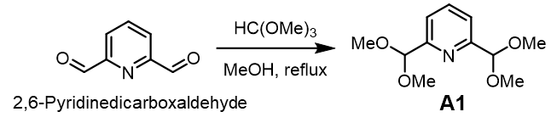
Building unit A1. 2,6-Pyridinedicarboxaldehyde (676 mg, 5.0 mmol), trimethyl orthoformate (5.306 g, 50.0 mmol), p-toluenesulfonic acid monohydrate (380 mg, 2.0 mmol) were dissolved in 70 mL MeOH in a round bottom flask. The resulting mixture was heated at 70 °C for 18 h and then concentrated to remove the solvent. The crude product was purified by column chromatography using petroleum ether/ethyl acetate = 5/1 as the eluent to give the building unit A1 (818 mg, 72% yield). ¹H NMR (400 MHz, CDCl₃): δ = 7.75 (dd, J = 8.0, 7.5 Hz, 1H), 7.50 (d, J = 7.7 Hz, 2H), 5.36 (s, 2H), 3.37 (s, 12H). ¹³C NMR (100 MHz, CDCl₃): δ = 156.66, 137.13, 120.88, 104.25, 53.75. HRMS: m/z calcd for C₁₁H₁₇NNaO₄ [M + Na]⁺: 250.1050, found: 250.1051.
Synthesis of building unit E1
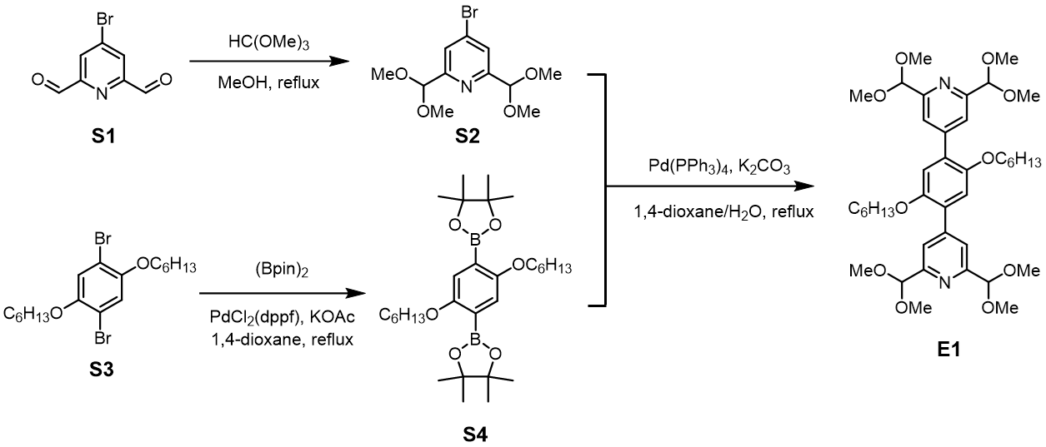
Compound S2. Compound S1 (1.498 g, 7.0 mmol), trimethyl orthoformate (7.428 g, 70.0 mmol), p-toluenesulfonic acid monohydrate (533 mg, 2.8 mmol) were dissolved in 100 mL MeOH in a round bottom flask. The resulting mixture was heated at 70 °C for 18 h and then concentrated to remove the solvent. The crude product was purified by column chromatography using petroleum ether/ethyl acetate = 5/1 as the eluent to give the product S2 (1.464 g, 68% yield). ¹H NMR (400 MHz, CDCl₃): δ = 7.71 (s, 2H), 5.34 (s, 2H), 3.39 (s, 12H). ¹³C NMR (100 MHz, CDCl₃): δ = 158.19, 134.20, 124.52, 103.51, 53.87.
Compound S4. Compound S3 (872 mg, 2.0 mmol), bis(pinacolato)diboron (1.117 g, 4.4 mmol), potassium acetate (1.18 g, 12.0 mmol), PdCl₂(dppf) (146 mg, 0.2 mmol), and dry 1,4-dioxane (20 mL) were added to a round bottom flask. The mixture was degassed by the freeze-pump-thaw method, and then heated to reflux at 100 °C for 24 h under N₂. After cooling to room temperature, the solvent was removed under reduced pressure. The residue was treated with H₂O and extracted with petroleum ether. The organic phase was washed with brine, dried over Na₂SO₄, and concentrated under reduced pressure. The residue was thoroughly washed with n-hexane, and then filtered through Celite. After concentrating under vacuum, the solid was washed with a small amount of methanol to remove impurities, filtered, and dried to afford S4 as a white solid (796 mg, 75% yield). ¹H NMR (500 MHz, CDCl₃): δ = 7.08 (s, 2H), 3.94 (t, J = 6.3 Hz, 4H), 1.75 (ddt, J = 9.3, 7.9, 6.3 Hz, 4H), 1.57–1.45 (m, 6H), 1.34 (s, 24H), 1.33–1.31 (m, 6H), 0.95–0.85 (m, 6H).
Building unit E1. Compound S4 (530 mg, 1.0 mmol), compound S2 (674 mg, 2.2 mmol), K₂CO₃ (828 mg, 6.0 mmol), Pd(PPh₃)₄ (116 mg, 0.1 mmol), 1,4-dioxane (40 mL), and H₂O (10 mL) were added to a round-bottomed flask. The mixture was degassed by the freeze-pump-thaw method, and then heated to reflux for 24 h under N₂. After cooling to room temperature, the solvent was removed under reduced pressure. The residue was treated with water and extracted with ethyl acetate. The organic phase was washed with brine, dried over Na₂SO₄, and concentrated under reduced pressure. The crude product was purified by silica gel column chromatography using petroleum ether/ethyl acetate = 4/1~3/1 as the eluent to give the building unit E1 (678 mg, 93% yield). ¹H NMR (400 MHz, CD₂Cl₂): δ = 7.75 (s, 4H), 7.04 (s, 2H), 5.39 (s, 4H), 3.97 (t, J = 6.4 Hz, 4H), 3.41 (s, 24H), 1.70 (p, J = 6.6 Hz, 4H), 1.45–1.34 (m, 4H), 1.28 (q, J = 3.6 Hz, 8H), 0.95–0.80 (m, 6H). ¹³C NMR (100 MHz, CD₂Cl₂): δ = 156.96, 150.92, 147.42, 129.57, 121.85, 115.70, 104.73, 70.09, 31.97, 29.67, 26.12, 22.93, 14.20. HRMS: m/z calcd for C₄₀H₆₀N₂NaO₁₀ [M + Na]⁺: 751.4140, found: 751.4142.

Synthesis of building unit E2
Compound S5. Compound S2 (1.464 g, 4.8 mmol), bis(pinacolato)diboron (1.341 g, 5.3 mmol), potassium acetate (1.413 g, 14.4 mmol), PdCl₂(dppf) (70 mg, 0.096 mmol), and 25 mL dry dioxane were added to a round bottom flask. The mixture was degassed by the freeze-pump-thaw method, and then heated at 80 °C for 16 h under N₂. After cooling to room temperature, the solvent was removed under reduced pressure. The residue was treated with H₂O and extracted with petroleum ether. The organic phase was washed with brine, dried over Na₂SO₄, and concentrated. The resulting solid was thoroughly washed with n-pentane, and then filtered through Celite. The crude product was obtained by concentrating the filtrate under vacuum. After recrystallization from a small amount of n-pentane at -20 ℃, S5 was obtained as white crystals (1.390 g, 82% yield). ¹H NMR (400 MHz, CDCl₃): δ = 7.88 (s, 2H), 5.40 (s, 2H), 3.39 (s, 12H), 1.33 (s, 12H). ¹³C NMR (150 MHz, CDCl₃): δ = 155.97, 126.11, 104.32, 84.48, 53.71, 24.83.
Compound S6. Compound S5 (1.060 g, 3.0 mmol), compound S3 (3.926 g, 9.0 mmol), 2 M aqueous K₂CO₃ (24 mL), PdCl₂(dppf) (110 mg, 0.15 mmol), and 60 mL toluene were added to a round bottom flask. The mixture was degassed by the freeze-pump-thaw method, and then heated at 90 °C for 20 h under N₂. After cooling to room temperature, the solvent was removed under reduced pressure. The crude product was purified by column chromatography using petroleum ether/ethyl acetate = 5/1 as the eluent to give the product S6 (1.223 g, 70% yield). ¹H NMR (400 MHz, CDCl₃): δ = 7.71 (s, 2H), 7.16 (s, 1H), 6.93 (s, 1H), 5.43 (s, 2H), 3.99 (t, J = 6.5 Hz, 2H), 3.89 (t, J = 6.4 Hz, 2H), 3.42 (s, 12H), 1.87–1.77 (m, 2H), 1.72–1.62 (m, 2H), 1.56–1.44 (m, 2H), 1.35 (q, J = 3.9 Hz, 6H), 1.30–1.18 (m, 4H), 0.88 (dt, J = 18.4, 6.9 Hz, 6H). ¹³C NMR (150 MHz, CDCl₃): δ = 156.50, 150.53, 149.92, 146.95, 127.54, 121.40, 117.87, 115.94, 113.36, 104.42, 70.51, 69.40, 53.85, 31.50, 31.48, 29.22, 29.06, 25.63, 22.56, 22.46, 13.99.
Building unit E2. 1,4-Benzenediboronate bis(pineol)ester (165 mg, 0.5 mmol), S6 (583 mg, 1.0 mmol), K₂CO₃ (415 mg, 3.0 mmol), Pd(PPh₃)₄ (58 mg, 0.05 mmol), 1,4-dioxane (20 mL), and H₂O (5 mL) were added to a round-bottomed flask. The mixture was degassed by the freeze-pump-thaw method, and then heated to reflux for 24 h under N₂. After cooling to room temperature, the solvent was removed under reduced pressure. The residue was treated with water and extracted with ethyl acetate. The organic phase was washed with brine, dried over Na₂SO₄, and concentrated under reduced pressure. The crude product was purified by silica gel column chromatography using petroleum ether/ethyl acetate = 4/1~3/1 as the eluent to give the building unit E2 (384 mg, 71% yield). ¹H NMR (400 MHz, CDCl₃): δ = 7.83 (s, 4H), 7.67 (s, 4H), 7.05 (d, J = 3.3 Hz, 4H), 5.47 (s, 4H), 3.96 (q, J = 6.5 Hz, 8H), 3.45 (s, 24H), 1.72 (p, J = 6.8 Hz, 8H), 1.48–1.35 (m, 8H), 1.28 (dq, J = 9.0, 5.0, 4.3 Hz, 16H), 0.95–0.79 (m, 12H). ¹³C NMR (150 MHz, CDCl₃): δ = 156.39, 150.52, 150.37, 147.44, 136.95, 132.20, 129.06, 127.31, 121.58, 115.83, 115.56, 104.49, 69.83, 69.31, 53.83, 31.55, 31.45, 29.26, 25.72, 22.56, 22.50, 14.02, 13.99. HRMS: m/z calcd for C₆₄H₉₃N₂O₁₂ [M + H]⁺: 1081.6723, found: 1081.6676.

Synthesis of building unit E3
Compound S7. Compound S4 (530 mg, 1.0 mmol), 1,4-dibromobenzene (1.180 g, 5.0 mmol), CsF (911 mg, 6.0 mmol), PdCl₂(dppf) (73 mg, 0.10 mmol), 1,4-dioxane (10 mL), and H₂O (5 mL) were added to a round-bottomed flask. The mixture was degassed by the freeze-pump-thaw method, and then heated to reflux for 24 h under N₂. After cooling to room temperature, the solvent was removed under reduced pressure. The residue was thoroughly washed with petroleum ether. The filtrate was concentrated under vacuum to obtain the crude product. It was purified by silica gel column chromatography using petroleum ether/ethyl acetate = 100/1 as the eluent to give the product S7 (212 mg, 36% yield). ¹H NMR (600 MHz, CDCl₃): δ = 7.53 (d, J = 8.5 Hz, 4H), 7.46 (d, J = 8.5 Hz, 4H), 6.92 (s, 2H), 3.90 (t, J = 6.5 Hz, 4H), 1.67 (p, J = 6.8 Hz, 4H), 1.40–1.31 (m, 4H), 1.27 (dtt, J = 13.0, 6.7, 3.4 Hz, 8H), 0.92–0.83 (m, 6H). ¹³C NMR (150 MHz, CDCl₃): δ = 150.17, 137.17, 131.15, 131.07, 129.90, 121.16, 115.89, 69.65, 31.43, 29.26, 25.74, 22.58, 13.98.
Compound S8. Compound S7 (588 mg, 1.0 mmol), bis(pinacolato)diboron (533 mg, 2.1 mmol), potassium acetate (589 mg, 6.0 mmol), PdCl₂(dppf) (73 mg, 0.10 mmol), and dry 1,4-dioxane (20 mL) were added to a round-bottomed flask. The mixture was degassed by the freeze-pump-thaw method, and then heated at 90 °C for 24 h under N₂. After cooling to room temperature, the solvent was removed under reduced pressure. The residue was treated with water and extracted with diethyl ether. The organic phase was washed with brine, dried over Na₂SO₄, and concentrated under reduced pressure. The crude product was washed with a small amount of diethyl ether to remove impurities, filtered, and dried to afford the product S8 (375 mg, 55% yield). ¹H NMR (400 MHz, CDCl₃): δ = 7.86 (d, J = 8.1 Hz, 4H), 7.61 (d, J = 8.1 Hz, 4H), 6.98 (s, 2H), 3.89 (t, J = 6.5 Hz, 4H), 1.73–1.60 (m, 4H), 1.37 (s, 24H), 1.25 (td, J = 8.4, 7.1, 5.0 Hz, 12H), 0.86 (t, J = 6.8 Hz, 6H). ¹³C NMR (100 MHz, CDCl₃): δ = 150.38, 141.34, 134.40, 130.97, 128.86, 116.38, 83.75, 69.71, 31.45, 29.30, 25.73, 24.90, 22.59, 14.01.
Building unit E3. Compound S8 (273 mg, 0.4 mmol), S6 (489 mg, 0.84 mmol), K₂CO₃ (331 mg, 2.4 mmol), Pd(PPh₃)₄ (46 mg, 0.04 mmol), 1,4-dioxane (24 mL), and H₂O (6 mL) were added to a round-bottomed flask. The mixture was degassed by the freeze-pump-thaw method, and then heated to reflux for 24 h under N₂. After cooling to room temperature, the solvent was removed under reduced pressure. The residue was treated with water and extracted with ethyl acetate. The organic phase was washed with brine, dried over Na₂SO₄, and concentrated under reduced pressure. The crude product was purified by silica gel column chromatography using petroleum ether/ethyl acetate = 3/1 as the eluent to give the building unit E3 (344 mg, 60% yield). ¹H NMR (400 MHz, CDCl₃): δ = 7.83 (s, 4H), 7.74–7.65 (m, 8H), 7.07 (d, J = 9.3 Hz, 6H), 5.47 (s, 4H), 4.03–3.92 (m, 12H), 3.45 (s, 24H), 1.73 (qd, J = 8.7, 7.9, 5.9 Hz, 12H), 1.42 (dt, J = 13.6, 7.1 Hz, 12H), 1.35–1.25 (m, 24H), 0.88 (td, J = 5.2, 2.9 Hz, 18H).¹³C NMR (150 MHz, CDCl₃): δ = 156.38, 150.53, 150.39, 147.46, 137.26, 136.66, 132.31, 130.44, 129.09, 129.02, 127.22, 121.58, 116.21, 115.84, 115.57, 104.49, 69.83, 69.58, 69.31, 53.82, 31.55, 31.46, 29.31, 29.27, 25.76, 25.73, 22.57, 22.51, 14.02, 14.00. HRMS: m/z calcd for C₈₈H₁₂₆N₂O₁₄ [M + 2H]²⁺: 717.4599, found: 717.4588.

Synthesis of model compound M1

Model compound M1. 2,6-Pyridinedicarboxaldehyde (135 mg, 1.0 mmol), p-anisidine (271 mg, 2.2 mmol), p-toluenesulfonic acid monohydrate (19 mg, 0.1 mmol), and 25 mL toluene were added into a round bottom flask. The resulting mixture was heated at reflux for 2 h and then concentrated to remove the solvent. The crude product was recrystallized in CH₃CN to give the model compound M1 (241 mg, 70% yield). ¹H NMR (500 MHz, CDCl₃): δ = 8.71 (s, 2H), 8.24 (d, J = 7.8 Hz, 2H), 7.92 (s, 1H), 7.37 (d, J = 8.9 Hz, 4H), 6.96 (d, J = 8.9 Hz, 4H), 3.85 (s, 6H). ¹³C NMR (125 MHz, CDCl₃): δ = 159.07, 157.66, 154.79, 143.48, 137.22, 122.80, 122.78, 114.47, 55.48.

Synthesis of model compound M2
Model compound M2. M1 (69 mg, 0.2 mmol) and Zn(NO₃)₂•6H₂O (59 mg, 0.2 mmol) were dissolved in 10 mL CH₃CN. The resulting solution was stirred at room temperature for 3 h and model compound M2 was precipitated as a pale-yellow solid by addition of Et₂O. ¹H NMR (500 MHz, CD₃CN): δ = 9.01 (s, 2H), 8.49 (t, J = 7.8 Hz, 1H), 8.17 (d, J = 7.8 Hz, 2H), 7.74 (d, J = 9.0 Hz, 4H), 7.11 (d, J = 9.1 Hz, 4H), 3.88 (s, 6H). ¹³C NMR (125 MHz, CD₃CN): δ = 154.08, 145.27, 130.39, 125.48, 118.31, 116.07, 56.44.

Synthesis of SNF-LIFM1
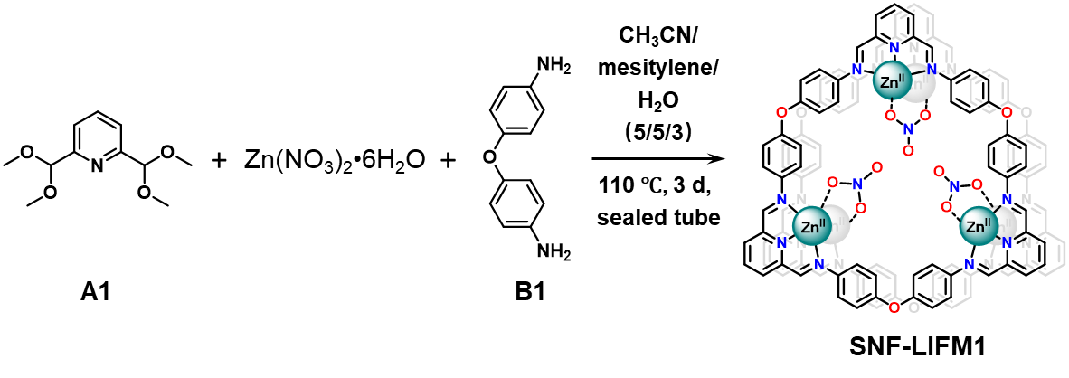
A solution of building unit A1 (9.1 mg, 0.04 mmol) and Zn(NO₃)₂•6H₂O (19.0 mg, 0.064 mmol) in CH₃CN (0.5 mL) was added into a 10 mL ampoule. To the mixture, building unit B1 (8.0 mg, 0.04 mmol), mesitylene (0.5 mL), and deionized water (0.3 mL) were added. The ampoule was then flash frozen in a liquid N₂ bath, vacuumed, and flame sealed. After warming to room temperature, the ampoule was placed into an oven and heated at 110 °C for 2 days, resulting in the formation of an orange solid. While the mixture was still warm, the ampoule was opened and the solid was transferred into a centrifugal tube. The solid was then separated by centrifugation and thoroughly washed with DMSO, THF, CH₃CN, and Et₂O. Further purification of SNF-LIFM1 was carried out by Soxhlet extraction in THF for 24 h. After drying at room temperature, the solid was further dried under vacuum at 100 °C for 12 h, yielding SNF-LIFM1 as an orange solid (14.8 mg, 76% yield).

Synthesis of CNF-LIFM1
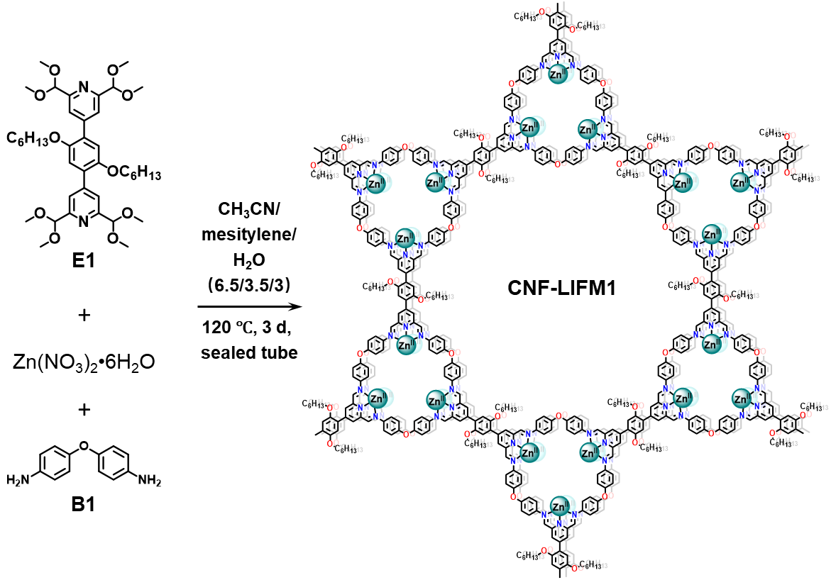
Building unit E1 (11.7 mg, 0.016 mmol) was weighed into a 10 mL ampoule. Zn(NO₃)₂•6H₂O (17.1 mg, 0.0576 mmol) in CH₃CN (0.65 mL) was added affording a clear solution. To the mixture, building unit B1 (6.4 mg, 0.032 mmol), mesitylene (0.35 mL), and deionized water (0.3 mL) were added. The ampoule was then flash frozen in a liquid N₂ bath, vacuumed, and flame sealed. After warming to room temperature, the ampoule was placed into an oven and heated at 120 °C for 3 days, resulting in the formation of an orange solid. While the mixture was still warm, the ampoule was opened and the solid was transferred into a centrifugal tube. The solid was then separated by centrifugation and thoroughly washed with DMSO, THF, CH₃CN, and Et₂O. Further purification of CNF-LIFM1 was carried out by Soxhlet extraction in THF for 24 h. After drying at room temperature, the solid was further dried under vacuum at 100 °C for 12 h, yielding CNF-LIFM1 as an orange solid (17.5 mg, 88% yield).

Synthesis of CNF-LIFM2
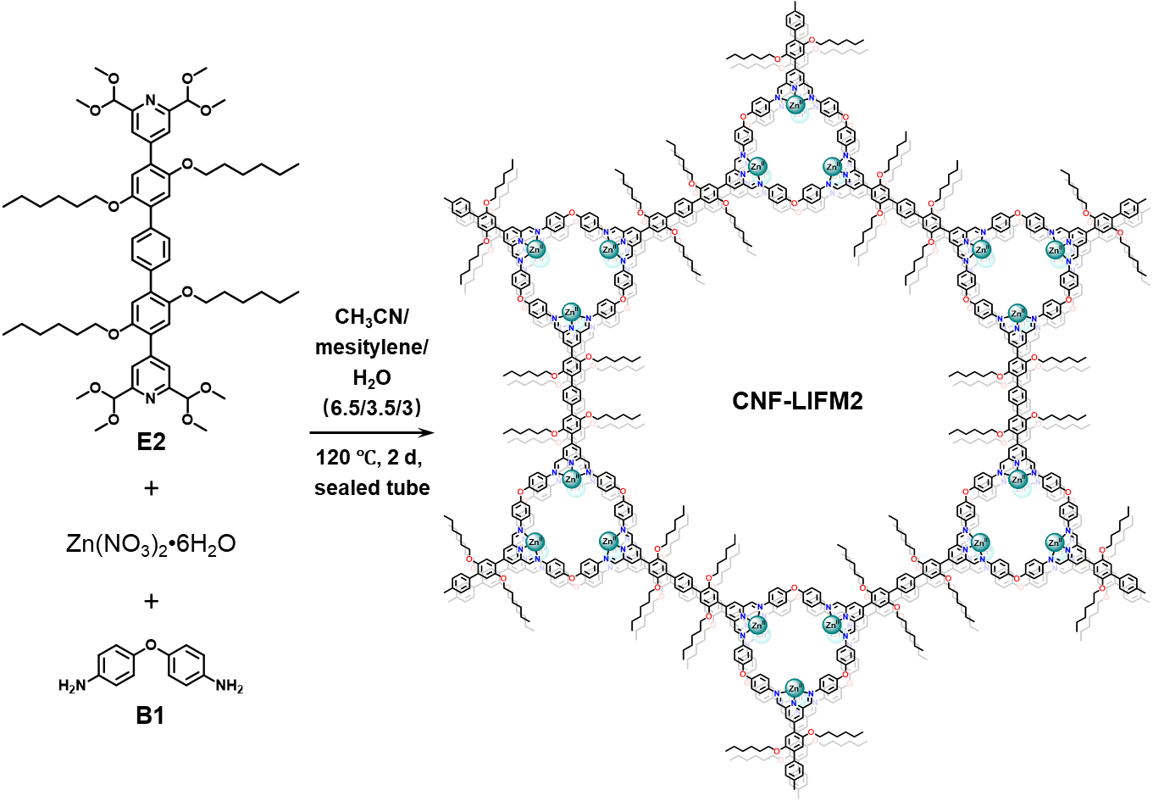
Building unit E2 (17.3 mg, 0.016 mmol) was weighed into a 10 mL ampoule. Zn(NO₃)₂•6H₂O (17.1 mg, 0.0576 mmol) in CH₃CN (0.65 mL) was added. To the mixture, building unit B1 (6.4 mg, 0.032 mmol), mesitylene (0.35 mL), and deionized water (0.3 mL) were added. The ampoule was then flash frozen in a liquid N₂ bath, vacuumed, and flame sealed. After warming to room temperature, the ampoule was placed into an oven and heated at 120 °C for 2 days, resulting in the formation of a brick red solid. While the mixture was still warm, the ampoule was opened and the solid was transferred into a centrifugal tube. The solid was then separated by centrifugation and thoroughly washed with DMSO, THF, CH₃CN, and Et₂O. Further purification of CNF-LIFM2 was carried out by Soxhlet extraction in THF for 24 h. After drying at room temperature, the solid was further dried under vacuum at 100 °C for 12 h, yielding CNF-LIFM2 as a brick red solid (21.6 mg, 84% yield).

Synthesis of CNF-LIFM3
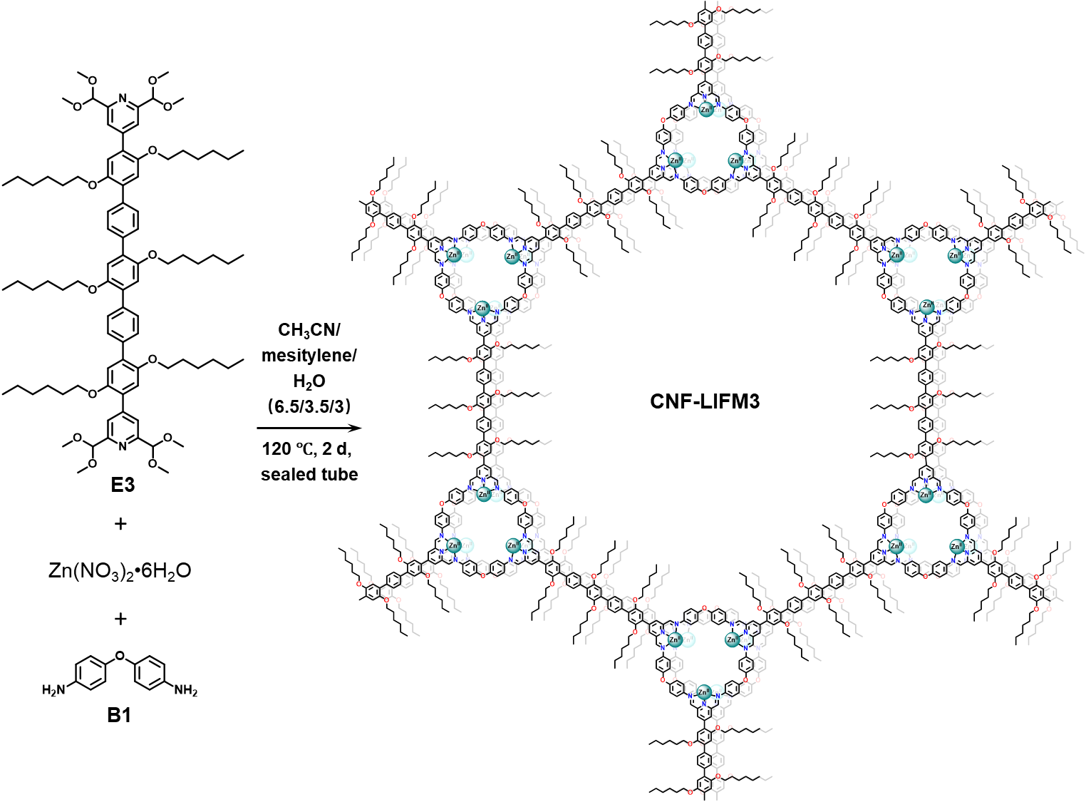
Building unit E3 (22.9 mg, 0.016 mmol) was weighed into a 10 mL ampoule. Zn(NO₃)₂•6H₂O (17.1 mg, 0.0576 mmol) in CH₃CN (0.65 mL) was added. To the mixture, building unit B1 (6.4 mg, 0.032 mmol), mesitylene (0.35 mL), and deionized water (0.3 mL) were added. The ampoule was then flash frozen in a liquid N₂ bath, vacuumed, and flame sealed. After warming to room temperature, the ampoule was placed into an oven and heated at 120 °C for 2 days, resulting in the formation of a brick red solid. While the mixture was still warm, the ampoule was opened and the solid was transferred into a centrifugal tube. The solid was then separated by centrifugation and thoroughly washed with DMSO, THF, CH₃CN, and Et₂O. Further purification of CNF-LIFM3 was carried out by Soxhlet extraction in THF for 24 h. After drying at room temperature, the solid was further dried under vacuum at 100 °C for 12 h, yielding CNF-LIFM3 as a brick red solid (24.7 mg, 79% yield).

Synthetic procedures for demetalation and remetalation
Demetalation: The sample powder (20 mg) and 2.0 mL EtOH were placed into a 10 mL vial. After a brief sonication, 2.0 mL ammonia was added into the mixture. A remarkable change in color was observed immediately, indicating the removal of Zn²⁺. Allow the reaction to stand for a duration of 0.5-2 h to ensure that Zn²⁺ ions were fully removed. Subsequently, the material was thoroughly washed with DI H₂O. After drying at 100 °C for 6 h, the demetalated material was obtained as a pale-yellow solid.
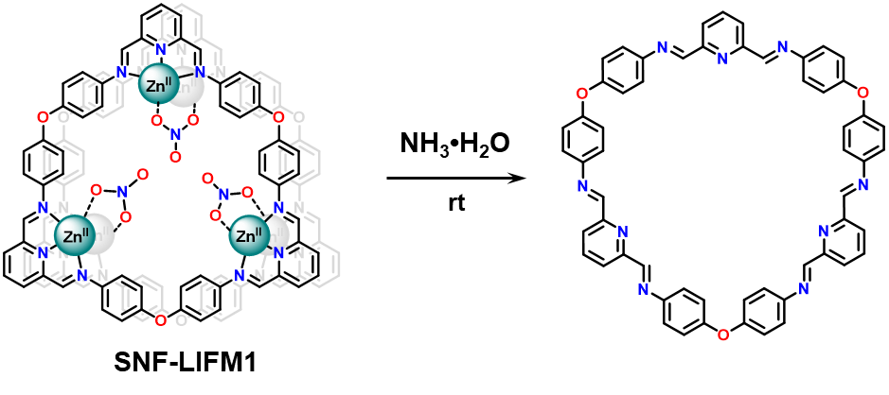
In the case of SNF-LIFM1, the demetalated material lost its crystallinity. However, the demetalated materials of CNF-LIFMs exhibited good crystallinities, and these materials were named COF-LIFMs.
Remetalation: The demetalated materials (COF-LIFMs) could be remetalated by adding a CH₃CN solution of Zn(NO₃)₂•6H₂O. Almost simultaneously, the color changed from pale-yellow to the original material’s color. After 30 minutes, the solid was separated by centrifugation and thoroughly washed with CH₃CN and Et₂O. Upon drying at room temperature, the remetalated material was obtained.
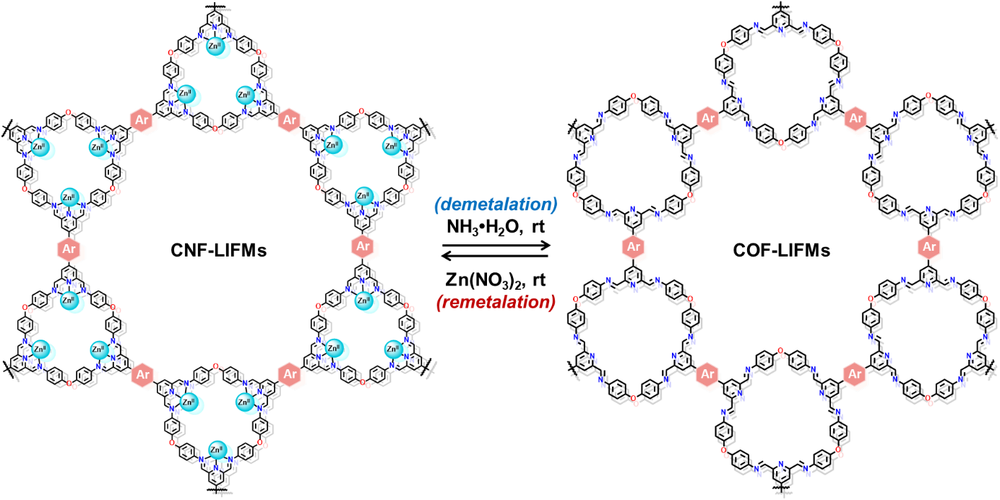
Supplementary Figures and Tables
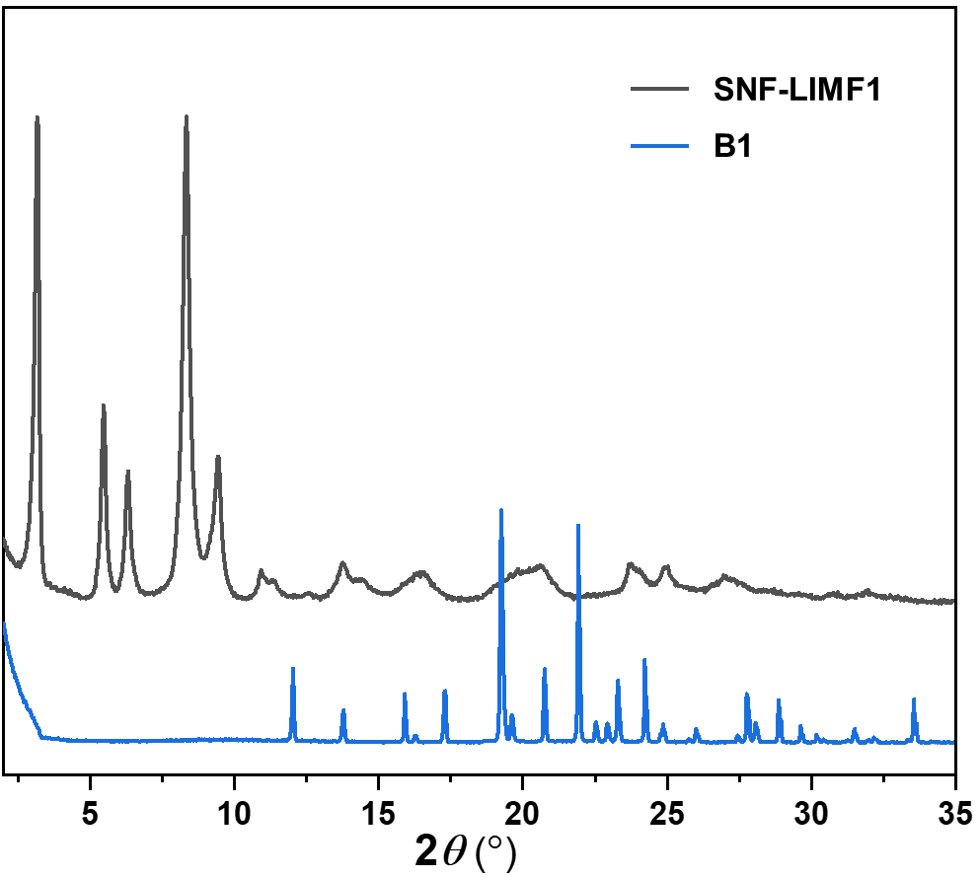
Supplementary Figure 1 | PXRD patterns of SNF-LIFM1 and building unit B1. As building unit A1 is an oily substance, we did not perform PXRD testing on it.
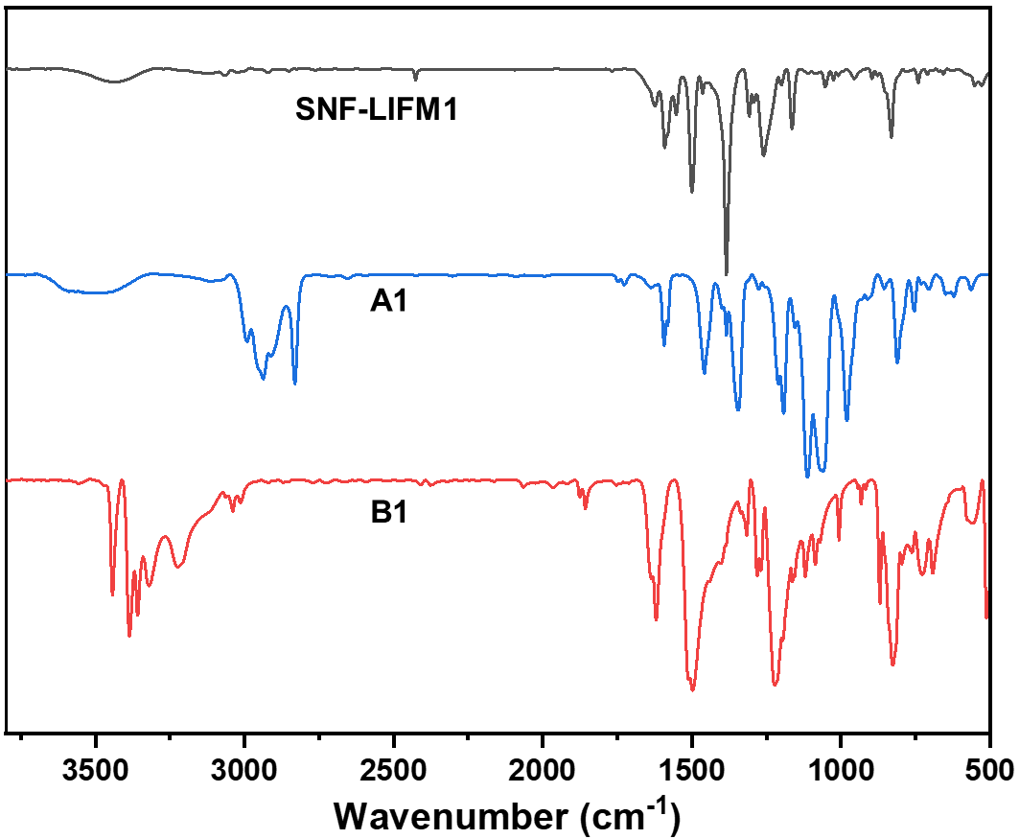
Supplementary Figure 2 | FT-IR spectra of SNF-LIFM1, building unit A1, and building unit B1.
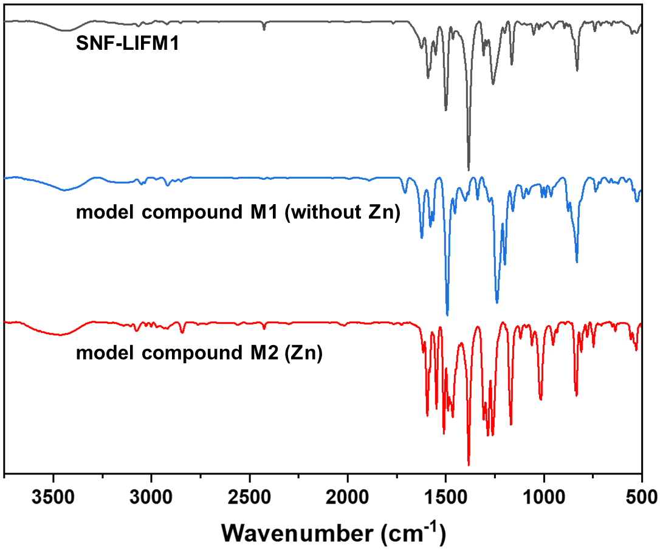
Supplementary Figure 3 | FT-IR spectra of SNF-LIFM1, model compound M1, and model compound M2.
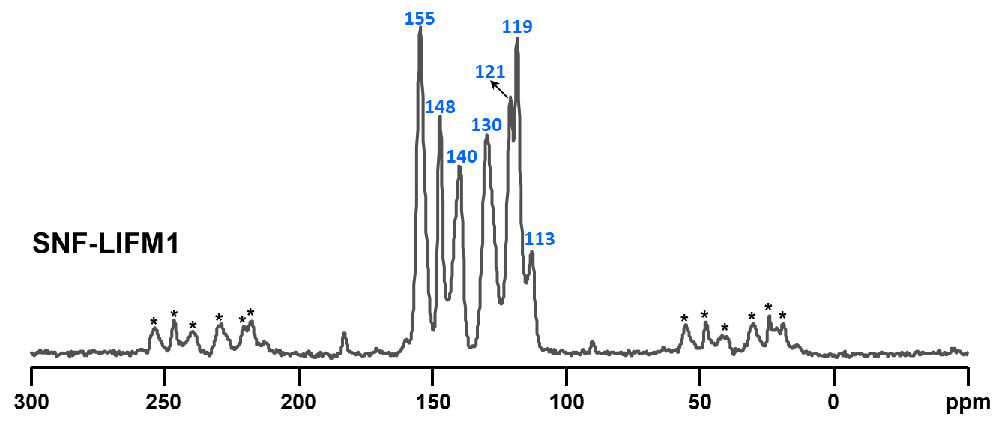
Supplementary Figure 4 | The solid state ¹³C cross polarization/magic-angle spinning (¹³C CP/MAS) NMR spectrum of SNF-LIFM1. The asterisks denote the spinning sidebands.
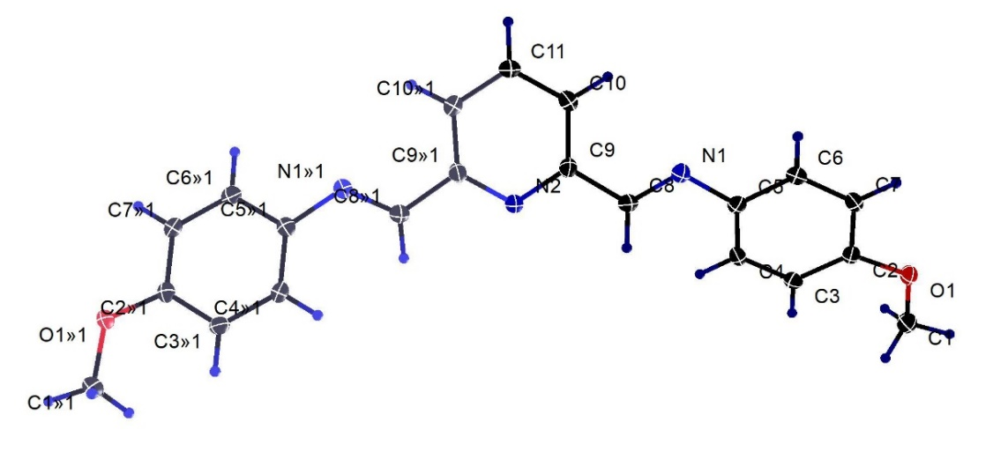
Supplementary Figure 5 | The single crystal structure of model compound M1. Metrical parameters can be obtained from the Cambridge Crystallographic Database Centre (CCDC 2282802).
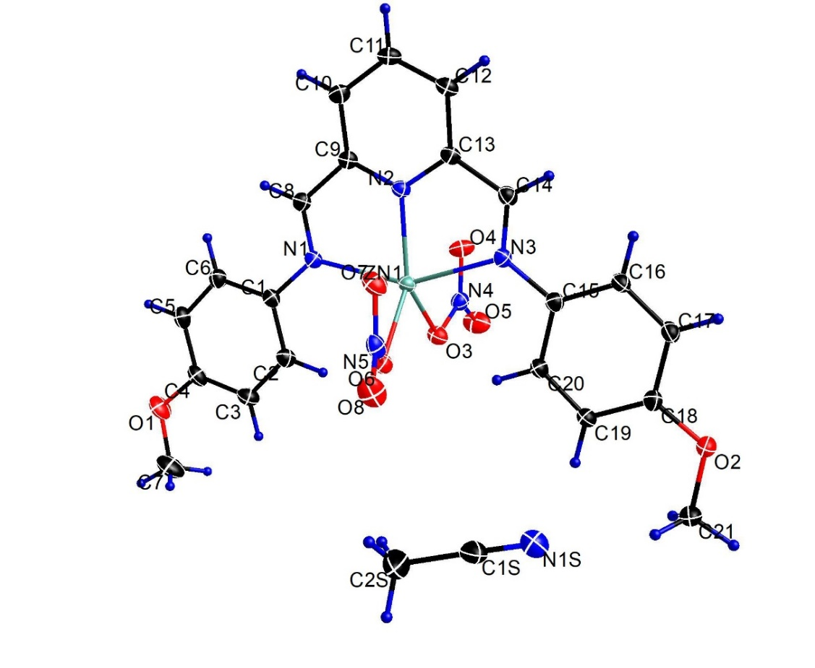
Supplementary Figure 6 | The single crystal structure of model compound M2. Metrical parameters can be obtained from the Cambridge Crystallographic Database Centre (CCDC 2282805).

Supplementary Table 1. Crystal data and structure refinement for model compound M1.
Empirical formula | C₂₁H₁₉N₃O₂
Formula weight | 345.39
Temperature | 100(2) K
Wavelength | 1.54178 Å
Crystal system | Orthorhombic
Space group | Aba2
Unit cell dimensions | a = 6.9993(5) Å α = 90°  b = 40.218(3) Å β = 90°  c = 6.3043(5) Å γ = 90°
Volume | 1774.7(2) Å³
Z | 4
Density (calculated) | 1.293 g/cm³
Crystal size | 0.374 × 0.069 × 0.017 mm³
Reflections collected | 6678
Independent reflections | 1548 [R_{int} = 0.0270]
Data/restraints/parameters | 1548/1/120
Goodness-of-fit on F² | 1.064
Final R indices [I>2sigma(I)] | R₁ = 0.0256, wR₂ = 0.0693
R indices (all data) | R₁ = 0.0259, wR₂ = 0.0695

Supplementary Table 2. Crystal data and structure refinement for model compound M2.
Empirical formula | C₂₃H₂₂N₆O₈Zn
Formula weight | 575.83
Temperature | 100(2) K
Wavelength | 0.71073 Å
Crystal system | Triclinic
Space group | P-1
Unit cell dimensions | a = 9.5424(3) Å α = 78.5180(10)°  b = 10.2725(3) Å β = 89.0870(10)°  c = 13.0732(4) Å γ = 76.5930(10)°
Volume | 1221.01(6) Å³
Z | 2
Density (calculated) | 1.566 g/cm³
Crystal size | 0.443 × 0.291 × 0.088 mm³
Reflections collected | 26746
Independent reflections | 6814 [R_{int} = 0.0277]
Data/restraints/parameters | 6814/0/346
Goodness-of-fit on F² | 1.043
Final R indices [I>2sigma(I)] | R₁ = 0.0255, wR₂ = 0.0629
R indices (all data) | R₁ = 0.0286, wR₂ = 0.0649

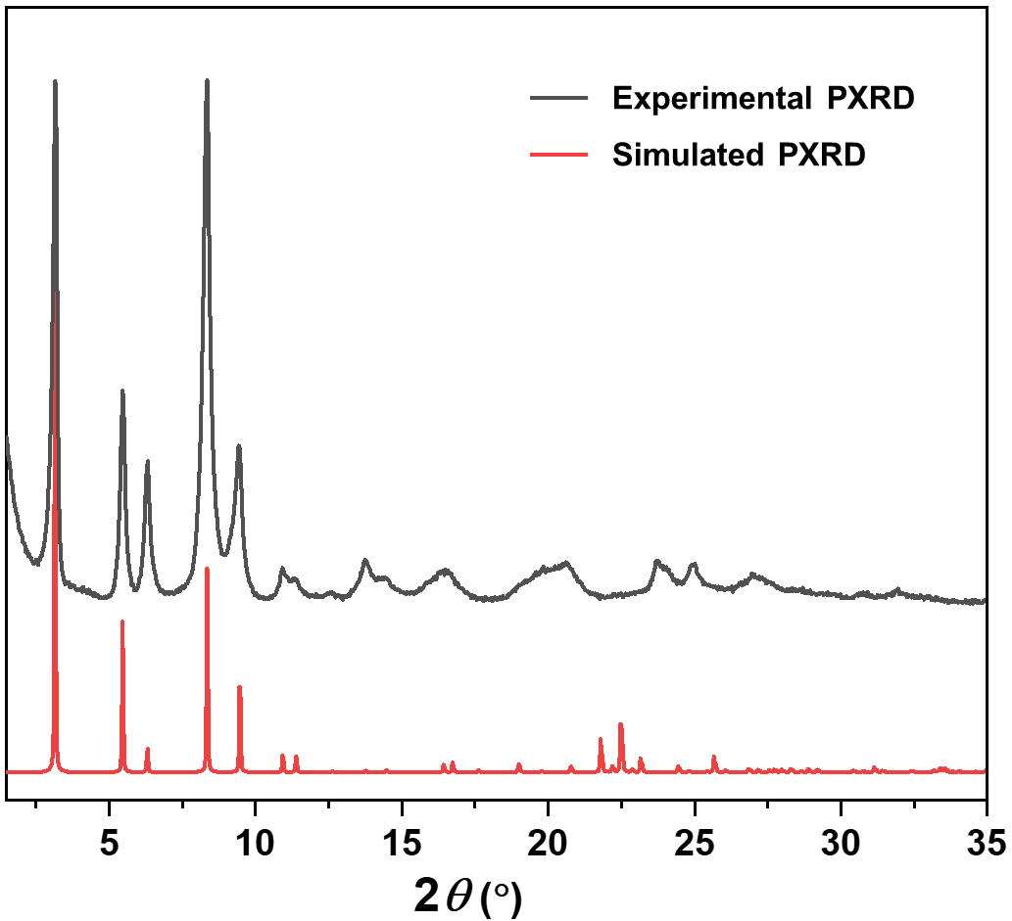
Supplementary Figure 7 | The simulated and experimental PXRD patterns of SNF-LIFM1. The differences in relative intensities of experimental and simulated PXRD patterns are attributed to the preferential orientation growth of the crystals.
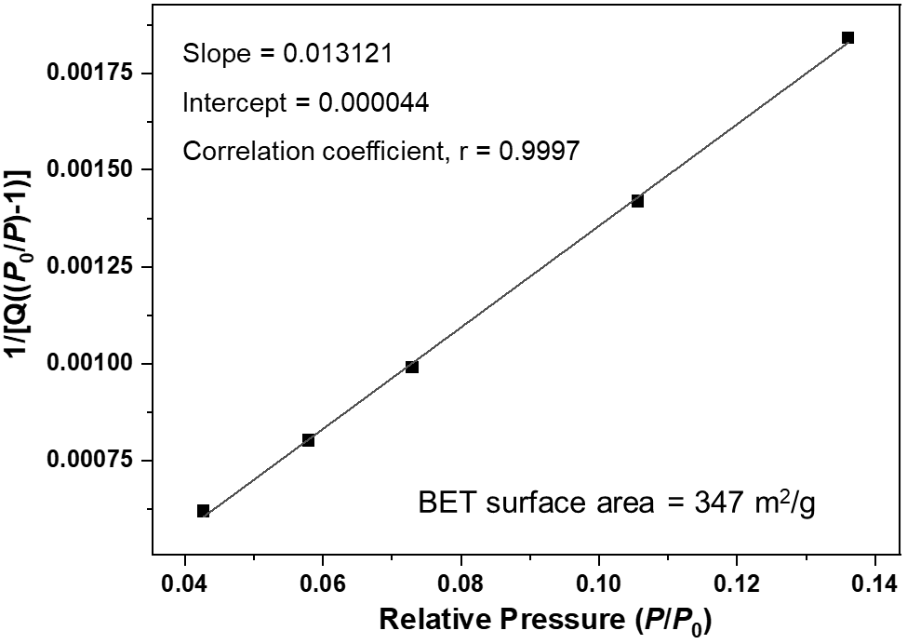
Supplementary Figure 8 | The BET surface area plot for SNF-LIFM1 calculated from CO₂ adsorption data at 195 K.
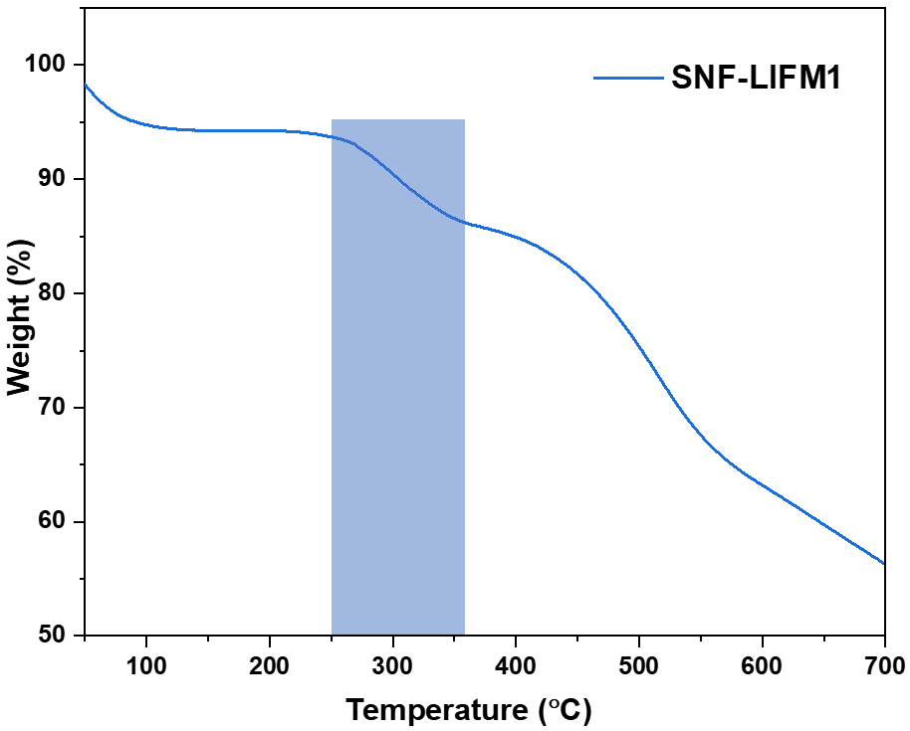
Supplementary Figure 9 | The TGA curve of SNF-LIFM1 under N₂ atmosphere. The weight loss between 250 °C and 360 °C is attributed to the decomposition of nitrate.
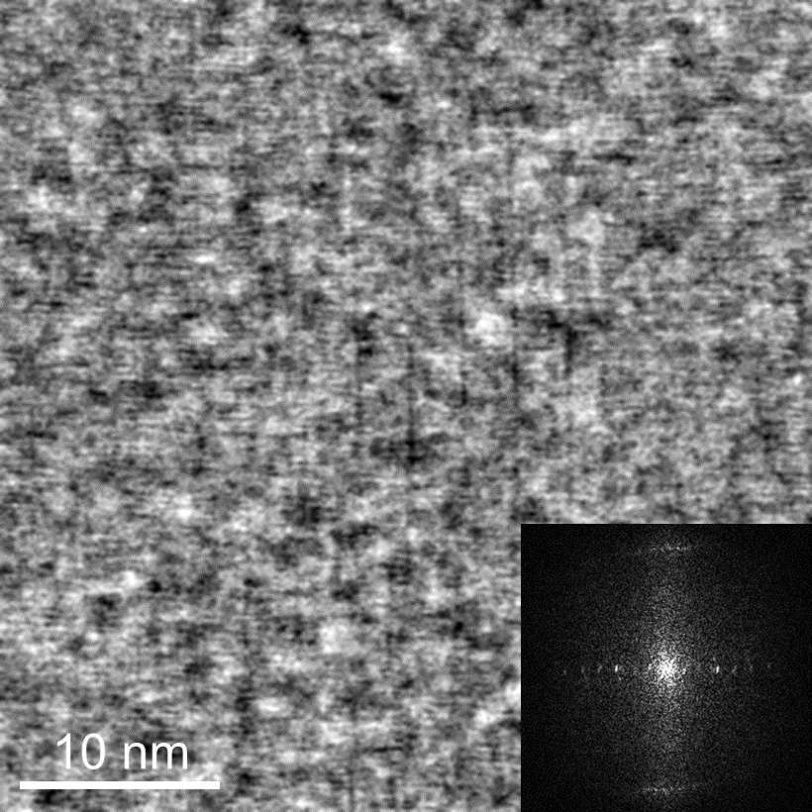
Supplementary Figure 10 | The iDPC-STEM image of SNF-LIFM1 along the [100] direction shows the packing of the pillars as well as the ~4 Å periodicity within the pillars stemming from the stacking of the metallacycles. Fourier transform shows as inset.
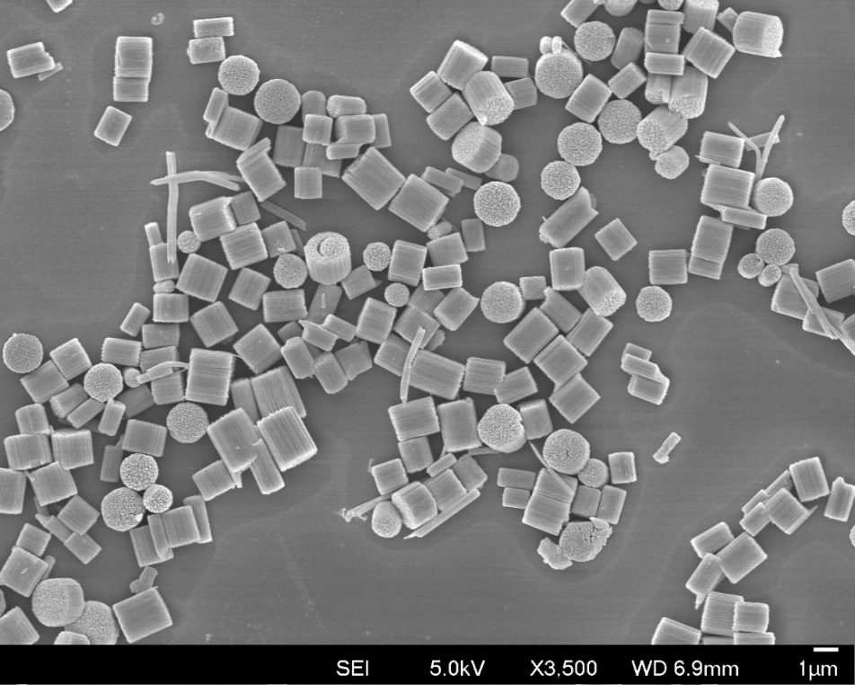
Supplementary Figure 11 | The SEM image of SNF-LIFM1.
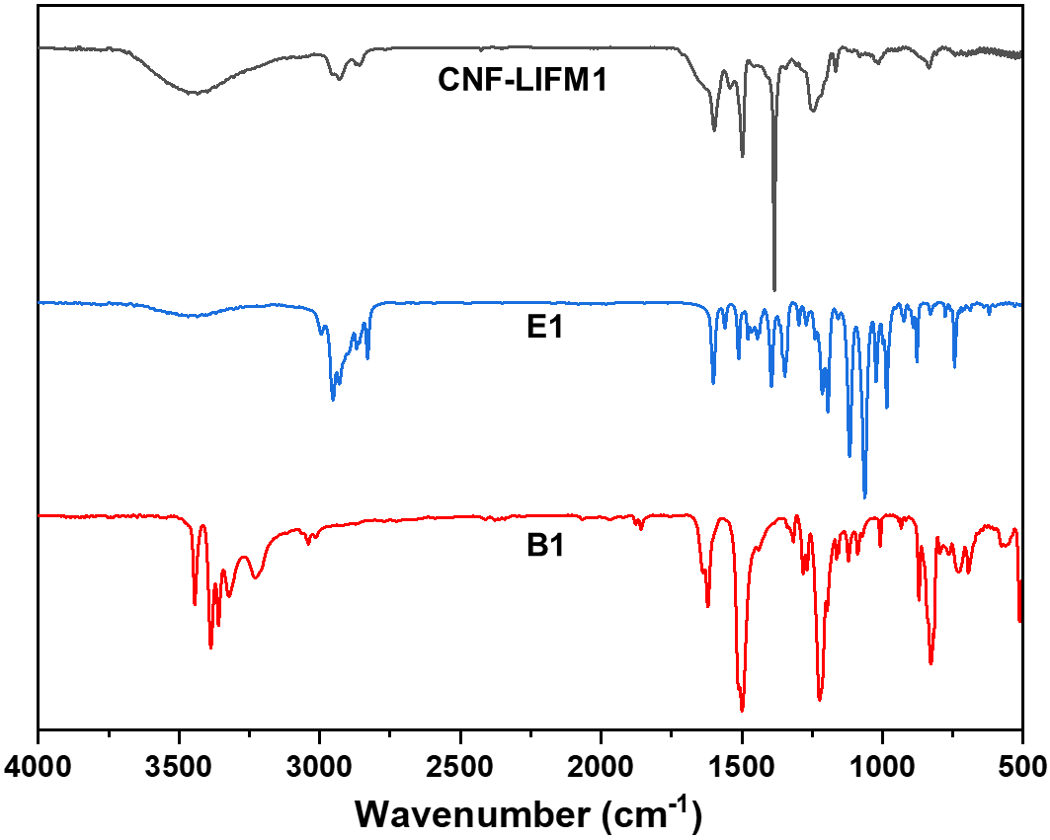
Supplementary Figure 12 | FT-IR spectra of CNF-LIFM1, building unit E1, and building unit B1.
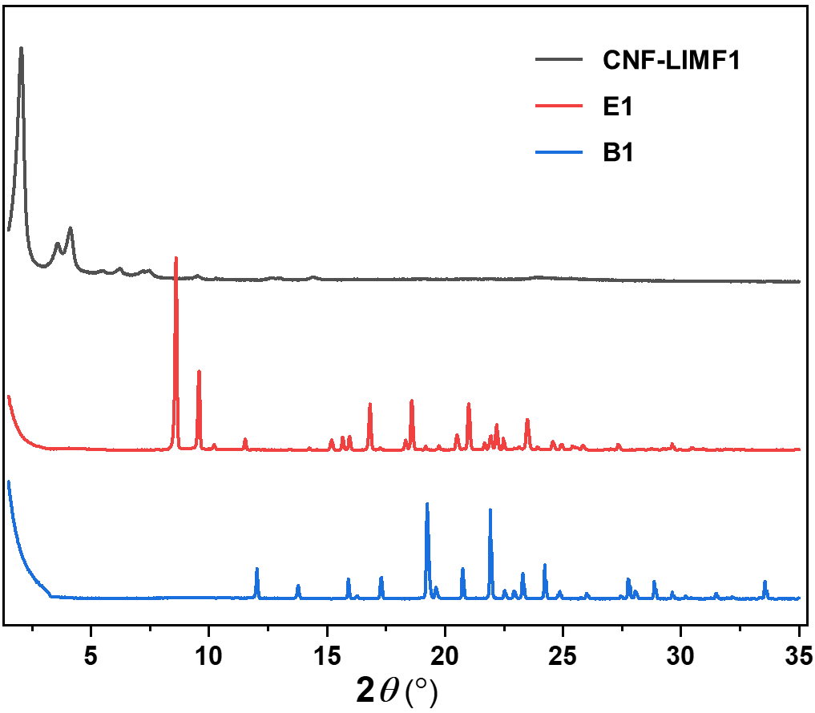
Supplementary Figure 13 | PXRD patterns of CNF-LIFM1, building unit E1, and building unit B1.
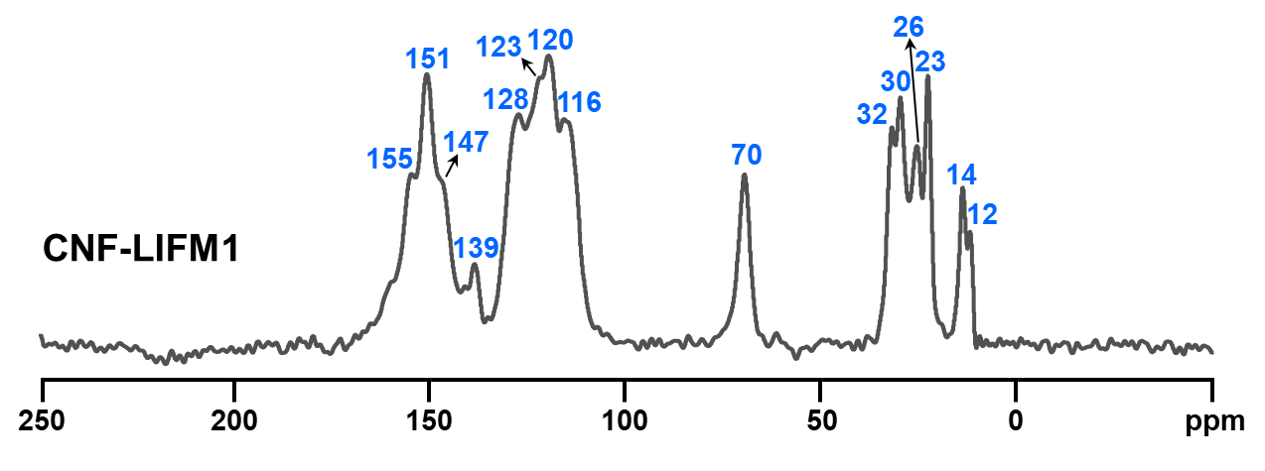
Supplementary Figure 14 | The solid state ¹³C cross polarization/total sideband suppression (¹³C CP/TOSS) NMR spectrum of CNF-LIFM1.
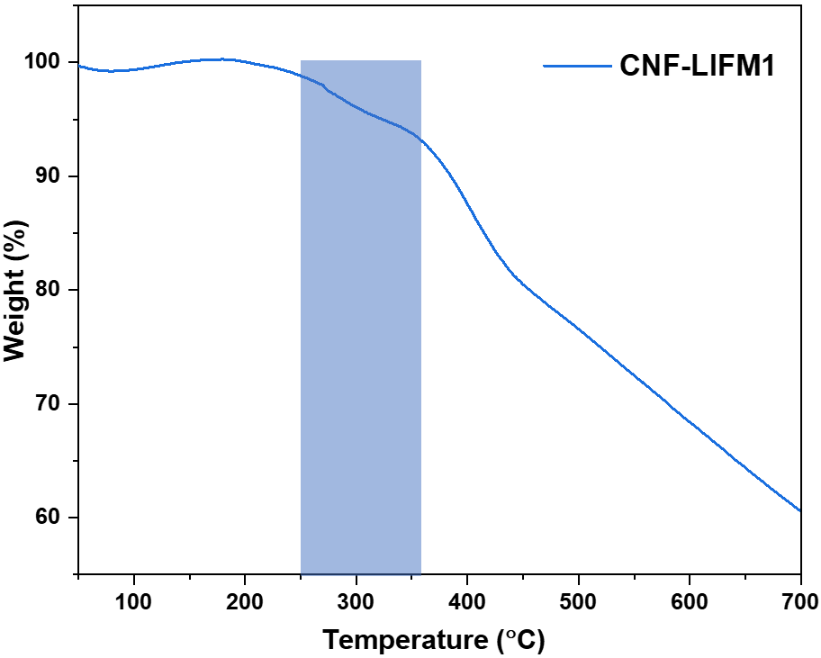
Supplementary Figure 15 | The TGA curve of CNF-LIFM1 under N₂ atmosphere. The weight loss between 250 °C and 360 °C is attributed to the decomposition of nitrate.
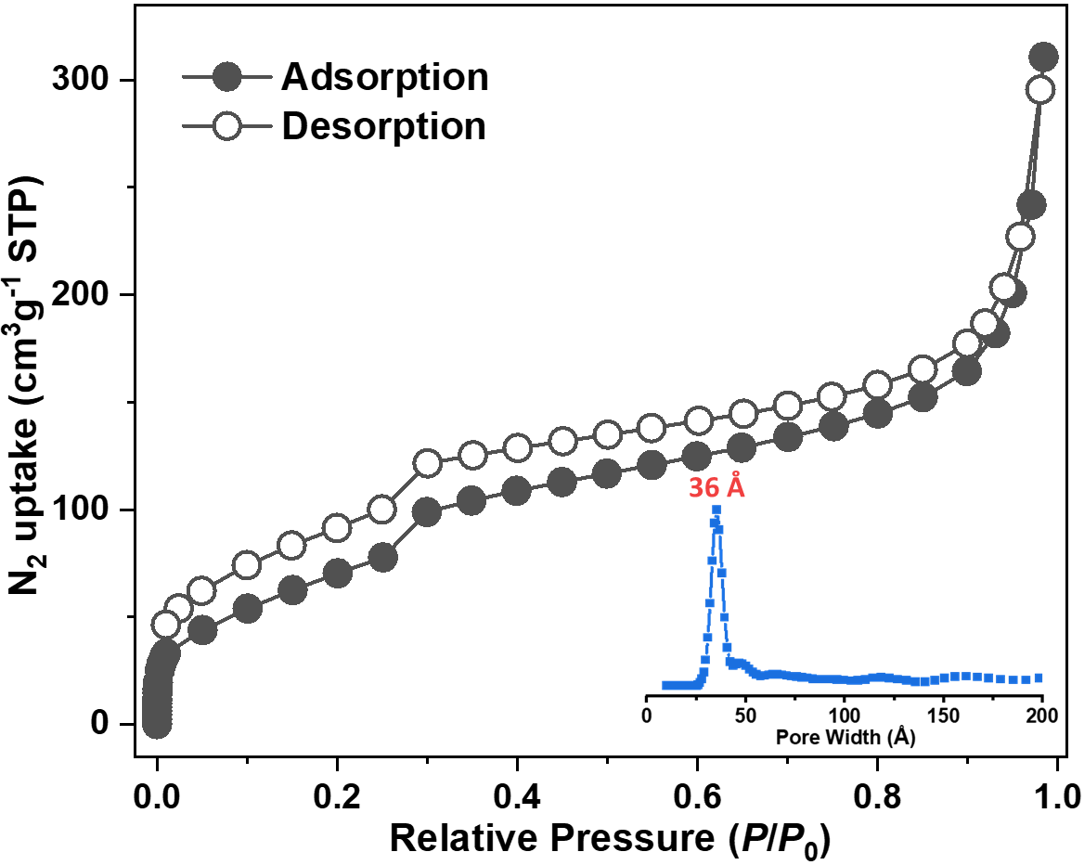
Supplementary Figure 16 | The N₂ adsorption‒desorption isotherm line of CNF-LIFM1. Inset shows the pore size distribution of CNF-LIFM1 calculated by QSDFT.
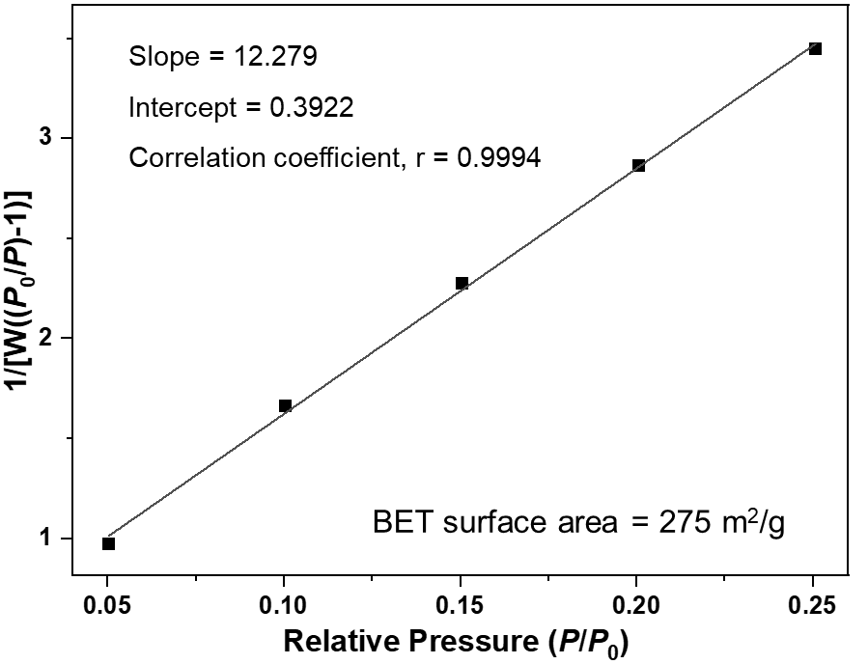
Supplementary Figure 17 | The BET surface area plot for CNF-LIFM1 calculated from N₂ adsorption data.
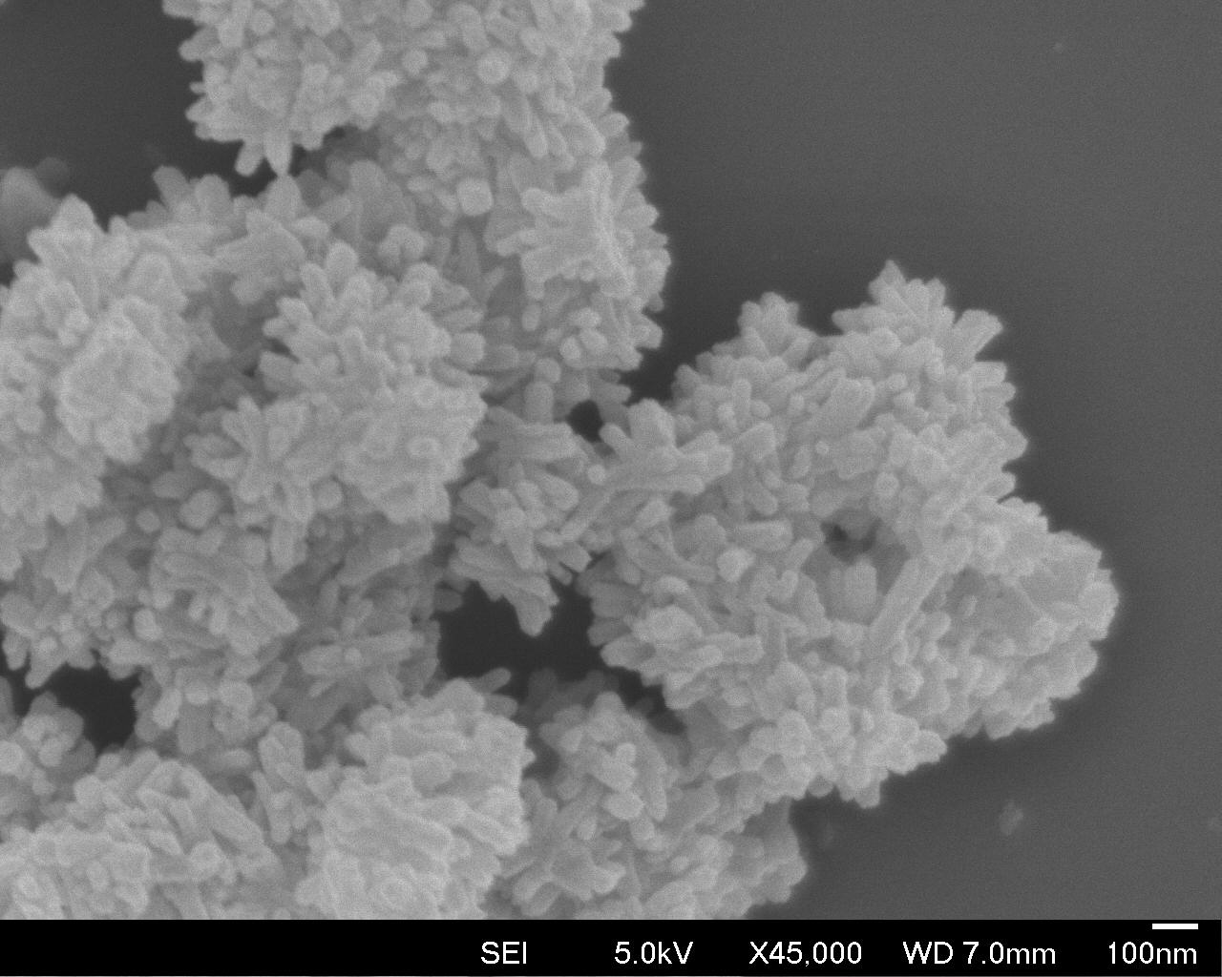
Supplementary Figure 18 | The SEM image of CNF-LIFM1.
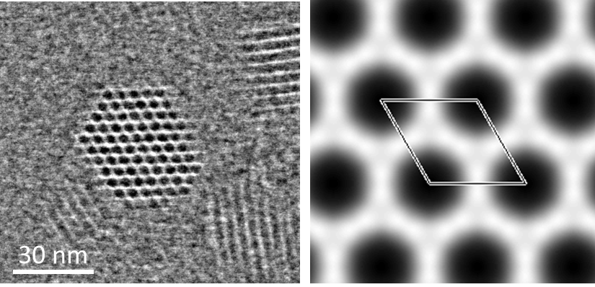
Supplementary Figure 19 | The iDPC-STEM image of CNF-LIFM1 along the [001] direction (left). The lattice averaged projected potential map with p3 plane group symmetry imposed (right).

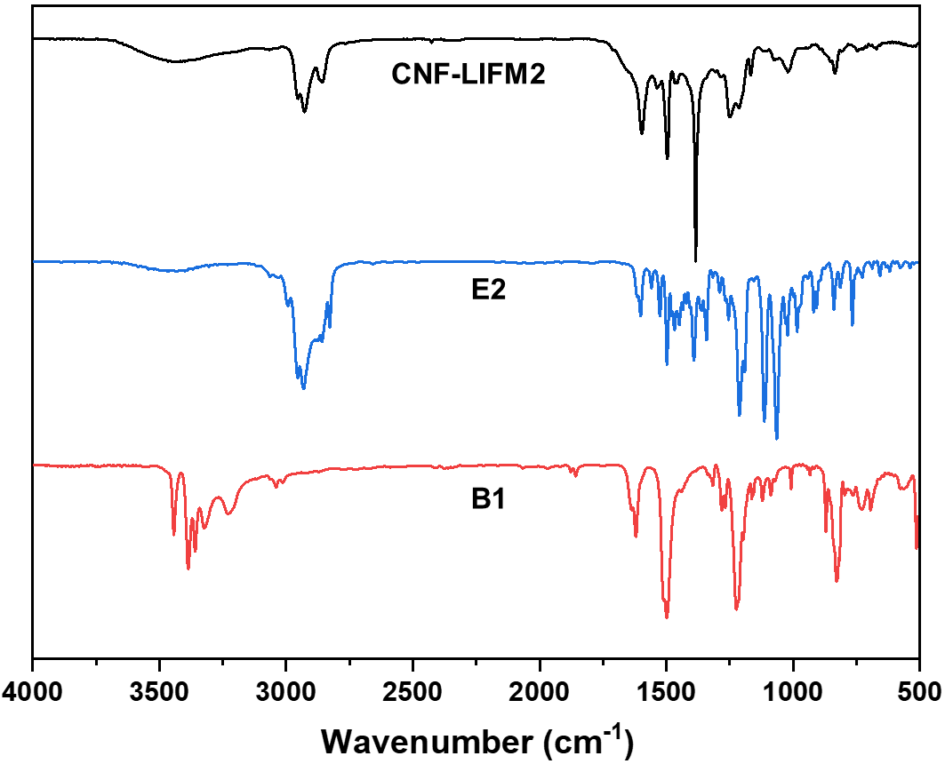
Supplementary Figure 20 | FT-IR spectra of CNF-LIFM2, building unit E2, and building unit B1.
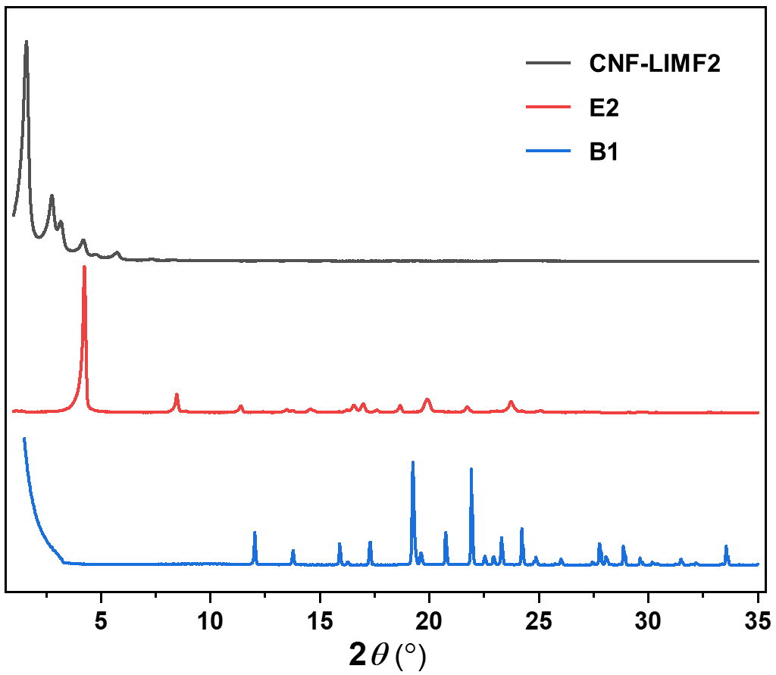
Supplementary Figure 21 | PXRD patterns of CNF-LIFM2, building unit E2, and building unit B1.
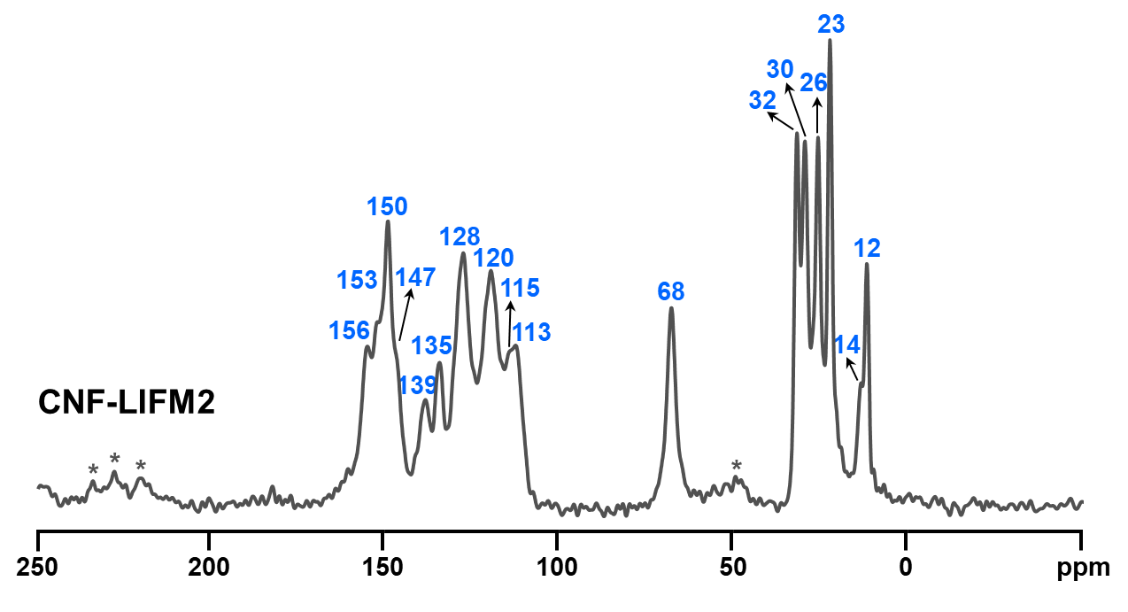
Supplementary Figure 22 | The ¹³C CP/MAS NMR spectrum of CNF-LIFM2.
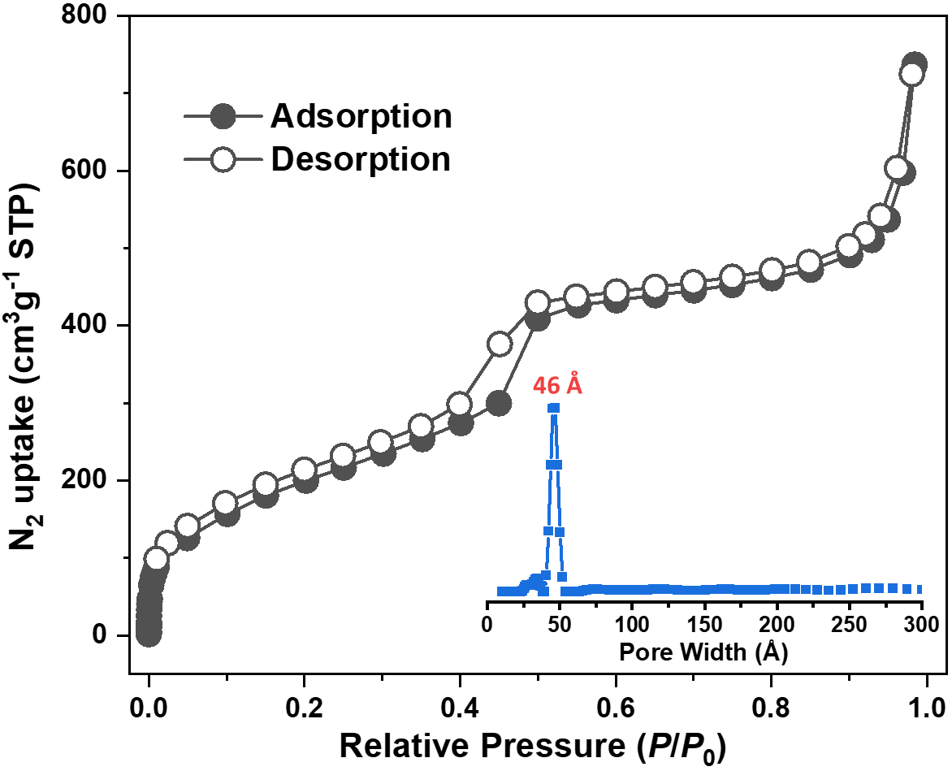
Supplementary Figure 23 | The N₂ adsorption‒desorption isotherm line of CNF-LIFM2. Inset shows the pore size distribution of CNF-LIFM2 calculated by QSDFT.
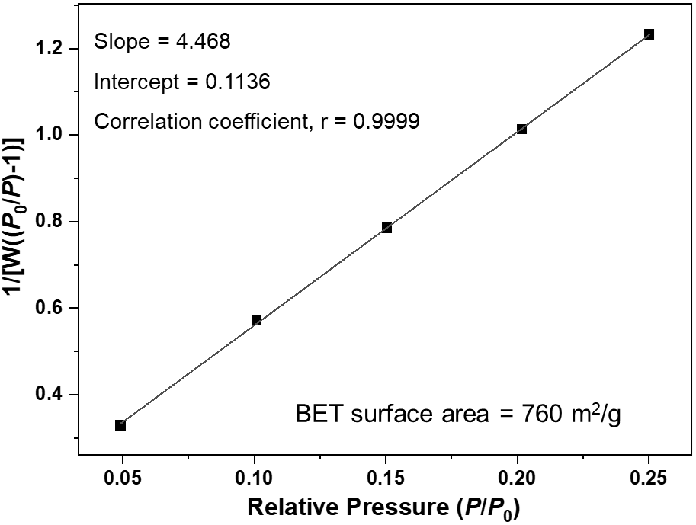
Supplementary Figure 24 | The BET surface area plot for CNF-LIFM2 calculated from N₂ adsorption data.
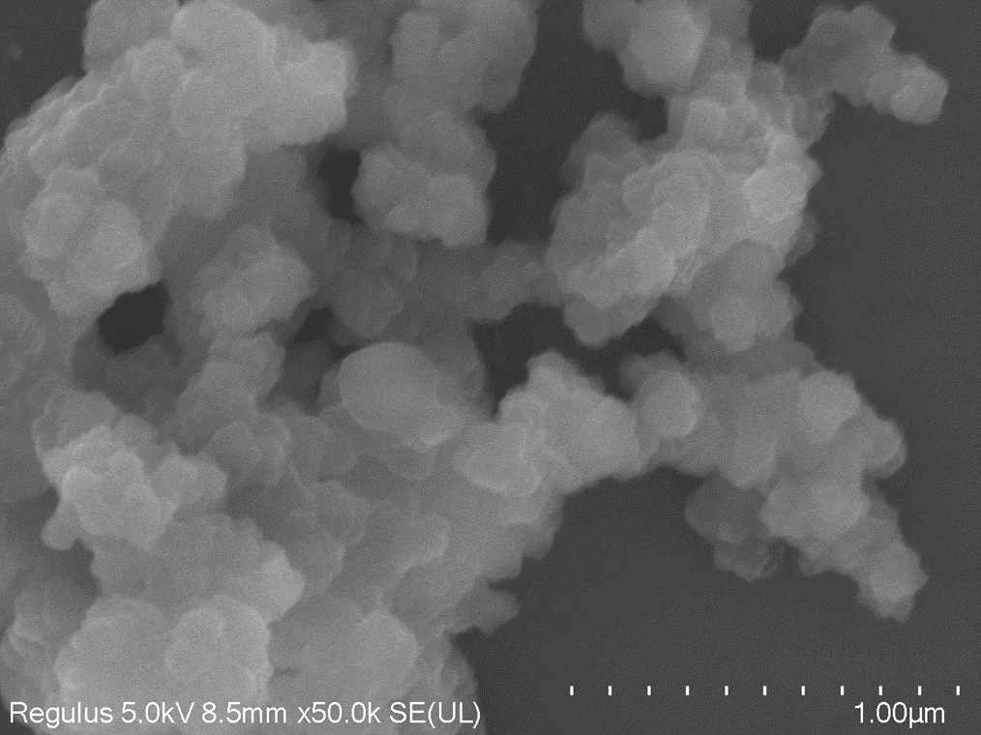
Supplementary Figure 25 | The SEM image of CNF-LIFM2.
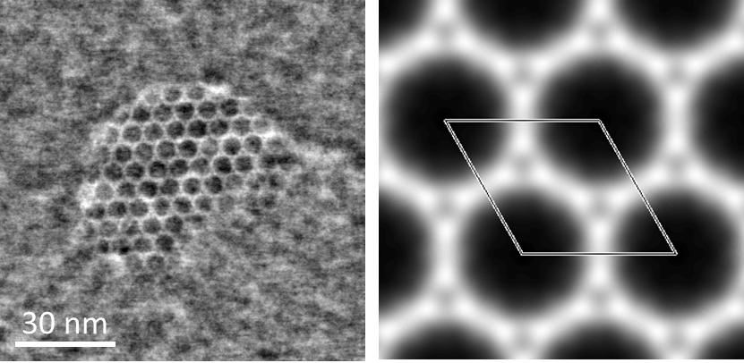
Supplementary Figure 26 | The iDPC-STEM image of CNF-LIFM2 along the [001] direction (left). The lattice averaged projected potential map with p3 plane group symmetry imposed (right).
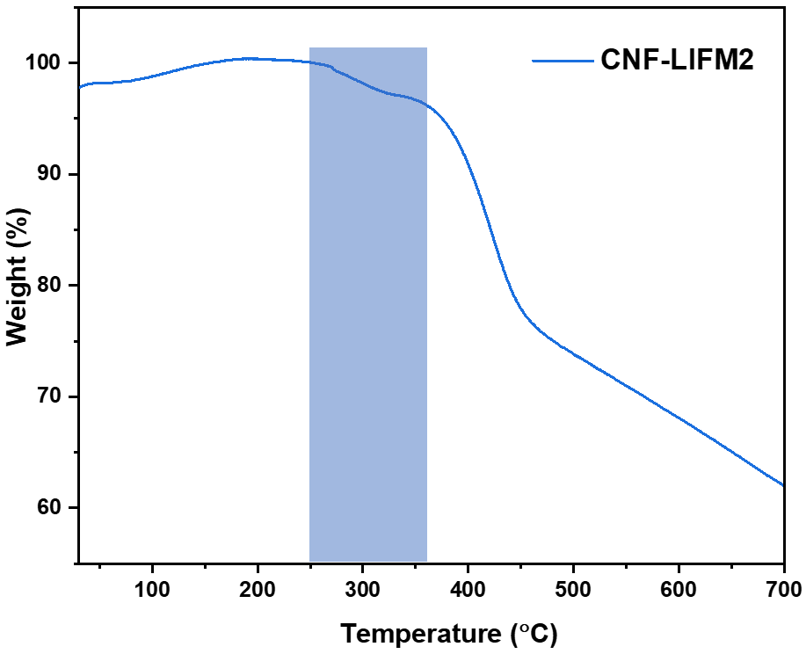
Supplementary Figure 27 | The TGA curve of CNF-LIFM2 under N₂ atmosphere. The weight loss between 250 °C and 360 °C is attributed to the decomposition of nitrate.
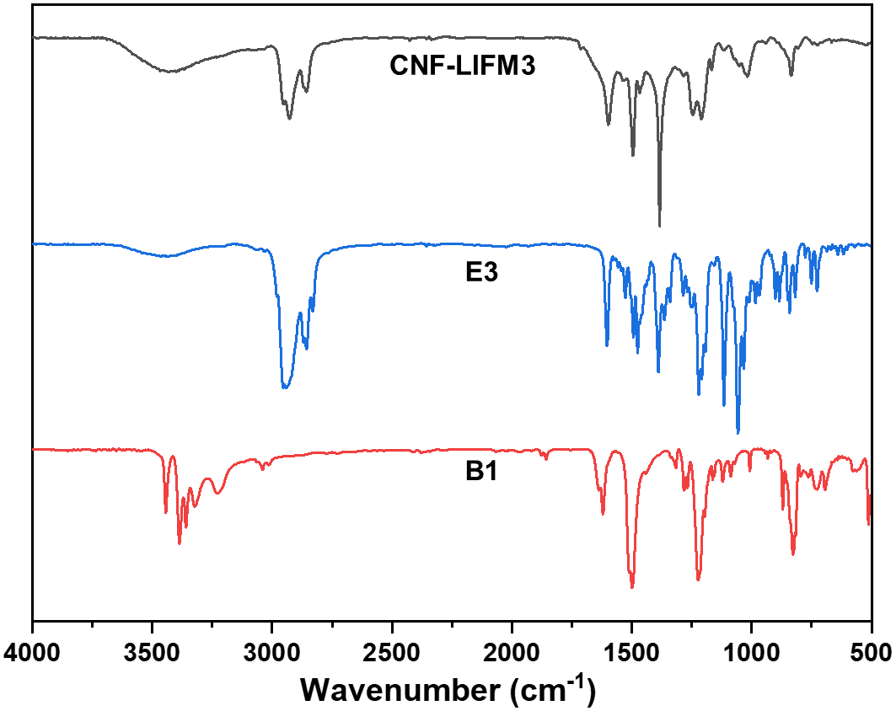
Supplementary Figure 28 | FT-IR spectra of CNF-LIFM3, building unit E3, and building unit B1.
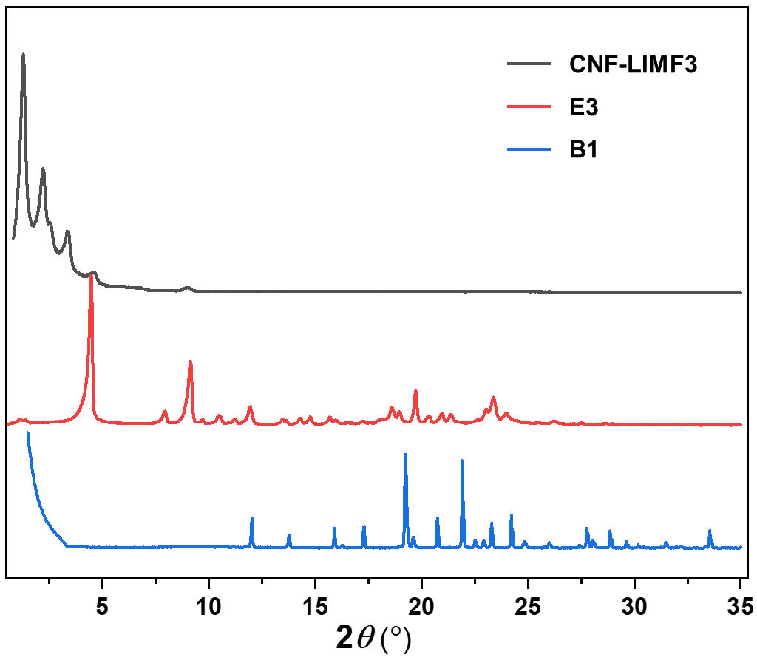
Supplementary Figure 29 | PXRD patterns of CNF-LIFM3, building unit E3, and building unit B1.
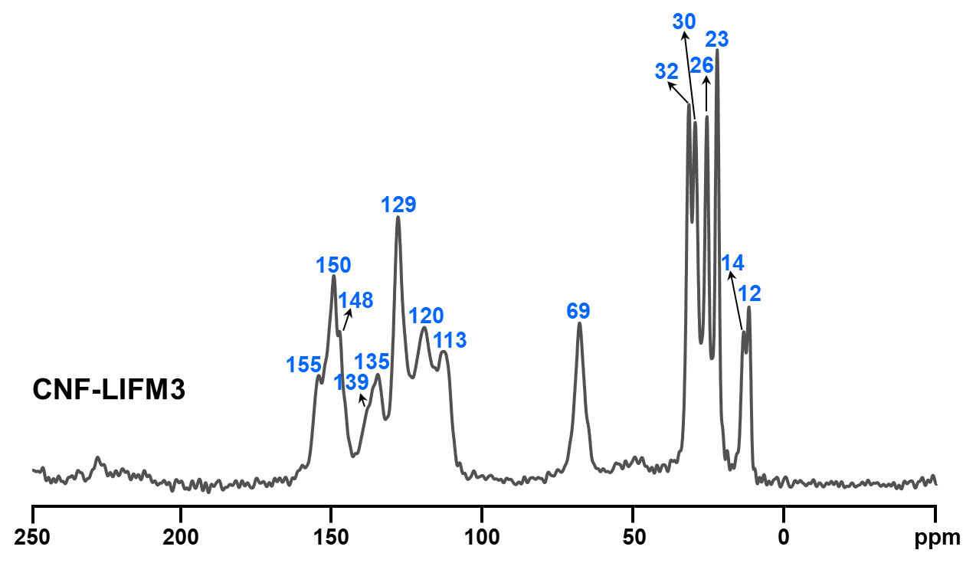
Supplementary Figure 30 | The ¹³C CP/MAS NMR spectrum of CNF-LIFM3.

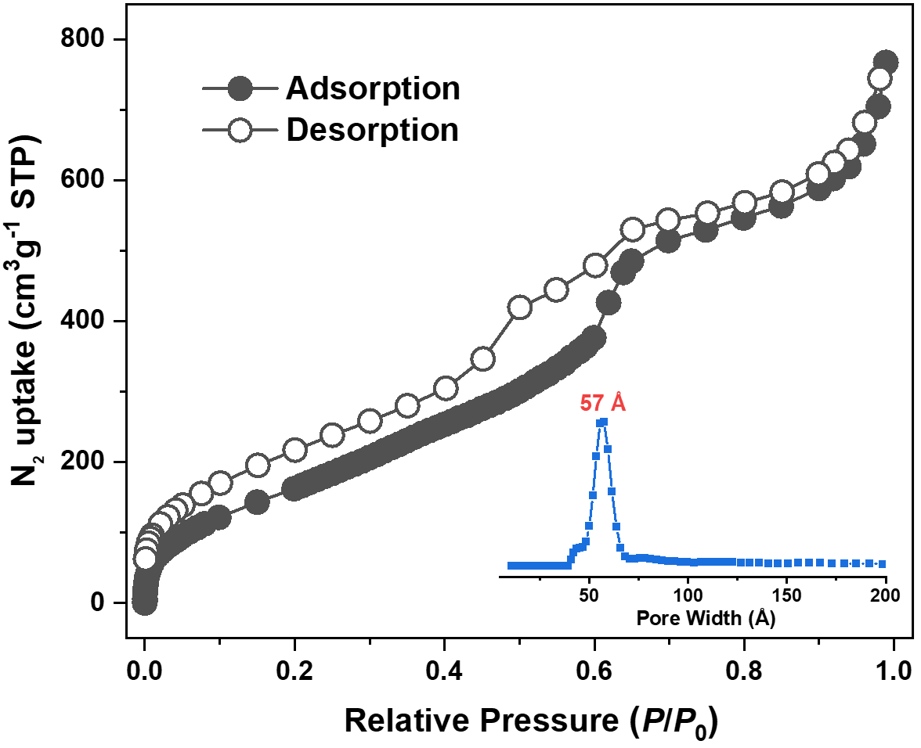
Supplementary Figure 31 | The N₂ adsorption‒desorption isotherm line of CNF-LIFM3. Inset shows the pore size distribution of CNF-LIFM3 calculated by QSDFT.
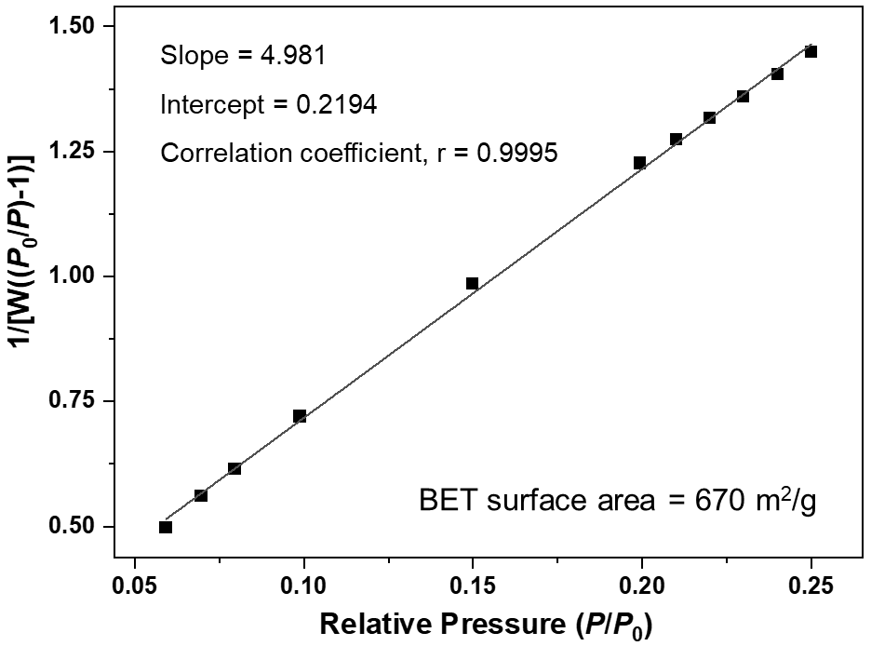
Supplementary Figure 32 | The BET surface area plot for CNF-LIFM3 calculated from N₂ adsorption data.
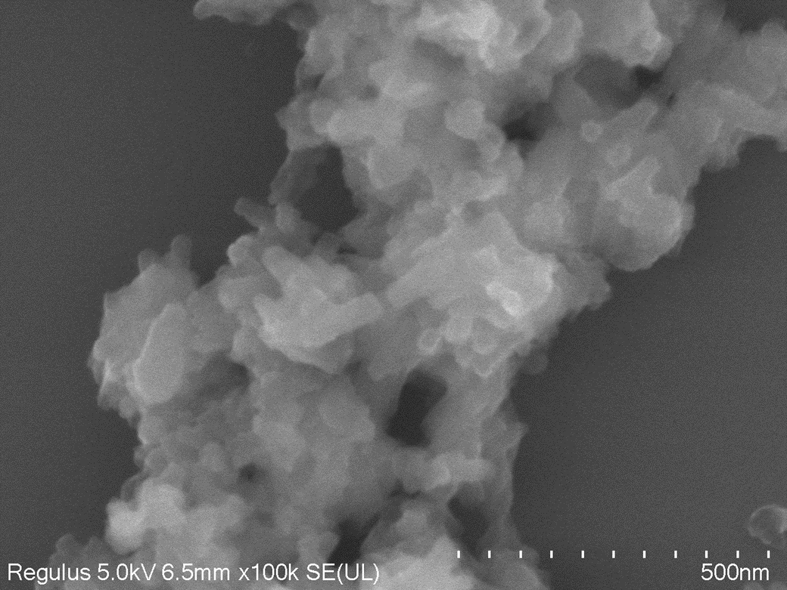
Supplementary Figure 33 | The SEM image of CNF-LIFM3.
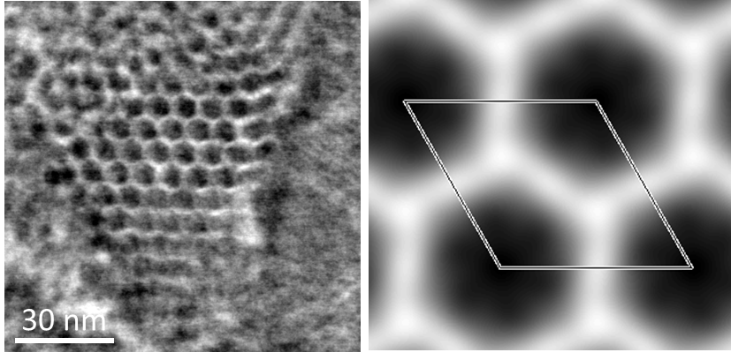
Supplementary Figure 34 | The iDPC-STEM image of CNF-LIFM3 along the [001] direction (left). The lattice averaged projected potential map with p3 plane group symmetry imposed (right).
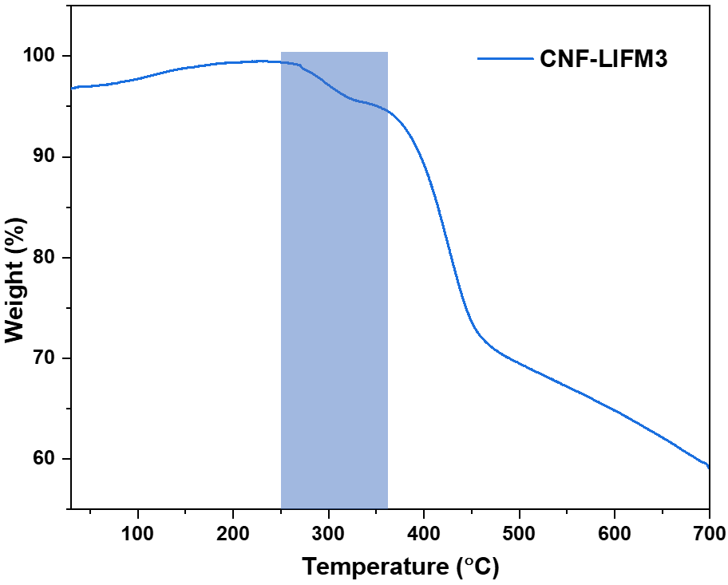
Supplementary Figure 35 | The TGA curve of CNF-LIFM3 under N₂ atmosphere. The weight loss between 250 °C and 360 °C is attributed to the decomposition of nitrate.

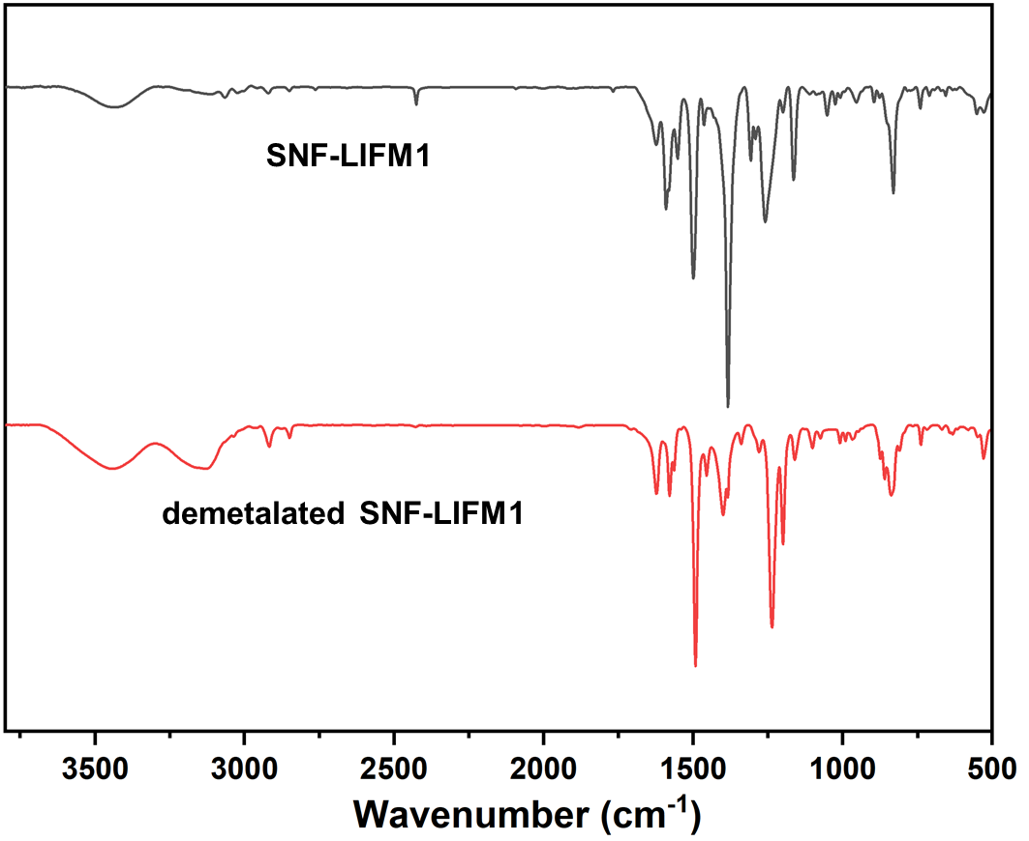
Supplementary Figure 36 | FT-IR spectra of original and demetalated SNF-LIFM1.
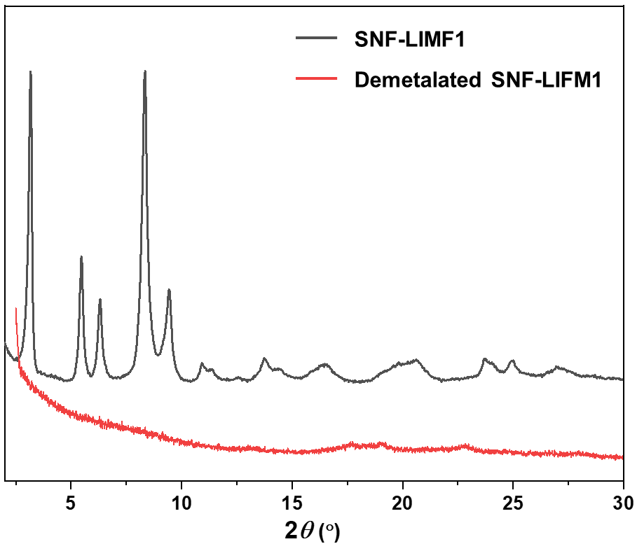
Supplementary Figure 37 | The comparison of experimental PXRD patterns of the original and demetalated SNF-LIFM1.
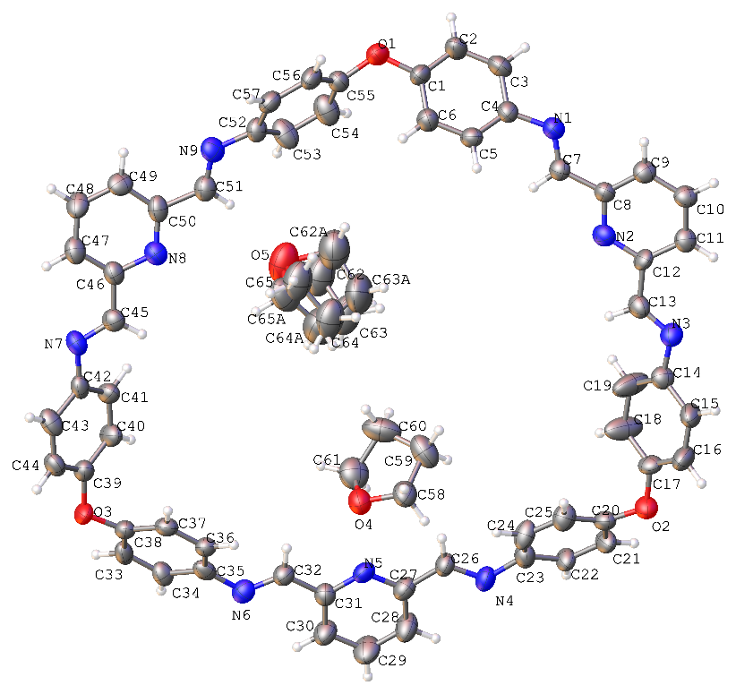
Supplementary Figure 38 | The single crystal structure of the macrocycle (demetalated SNF-LIFM1). Thermal ellipsoids are drawn at the 30% probability level. Metrical parameters can be obtained from the Cambridge Crystallographic Database Centre (CCDC 2282825).
Supplementary Table 3. Crystal data and structure refinement for the macrocycle (demetalated SNF-LIFM1).
Empirical formula | C₆₅H₅₅N₉O₅
Formula weight | 1042.18
Temperature | 100 K
Wavelength | 1.54184 Å
Crystal system | monoclinic
Space group | P2₁/c
Unit cell dimensions | a = 13.0338(7) Å α = 90°  b = 40.125(2) Å β = 95.650(5)°  c = 10.3901(6) Å γ = 90°
Volume | 5407.4(5) Å³
Z | 4
Density (calculated) | 1.280 g/cm³
Reflections collected | 26005
Independent reflections | 8091 [R_{int} = 0.0961]
Data/restraints/parameters | 8091/265/757
Goodness-of-fit on F² | 1.167
Final R indices [I>2sigma(I)] | R₁ = 0.1126, wR₂ = 0.3181
R indices (all data) | R₁ = 0.2060, wR₂ = 0.3772

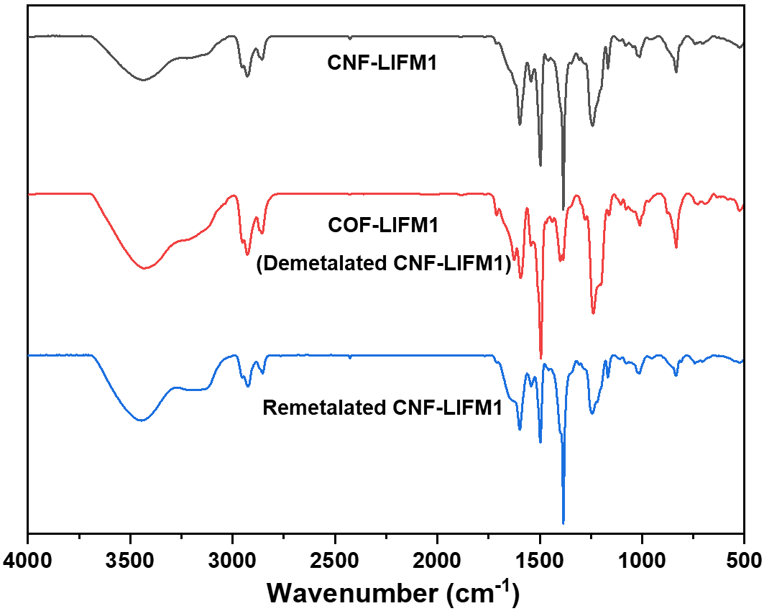
Supplementary Figure 39 | FT-IR spectra of the original CNF-LIFM1, COF-LIFM1 (demetalated CNF-LIFM1), and remetalated CNF-LIFM1.
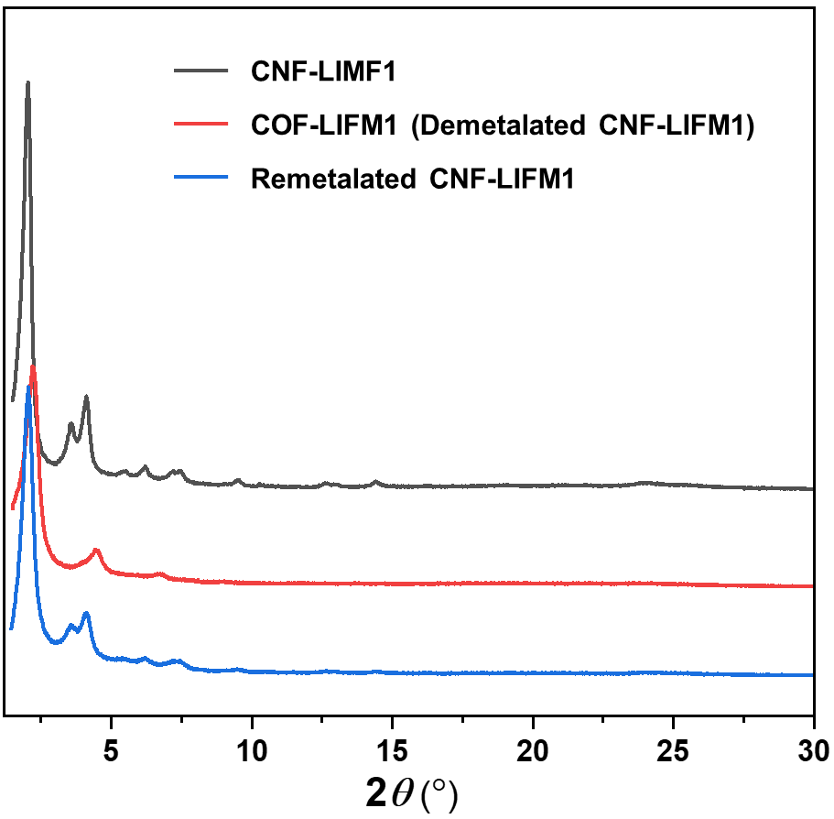
Supplementary Figure 40 | The comparison of experimental PXRD patterns of the original CNF-LIFM1, COF-LIFM1 (demetalated CNF-LIFM1), and remetalated CNF-LIFM1.
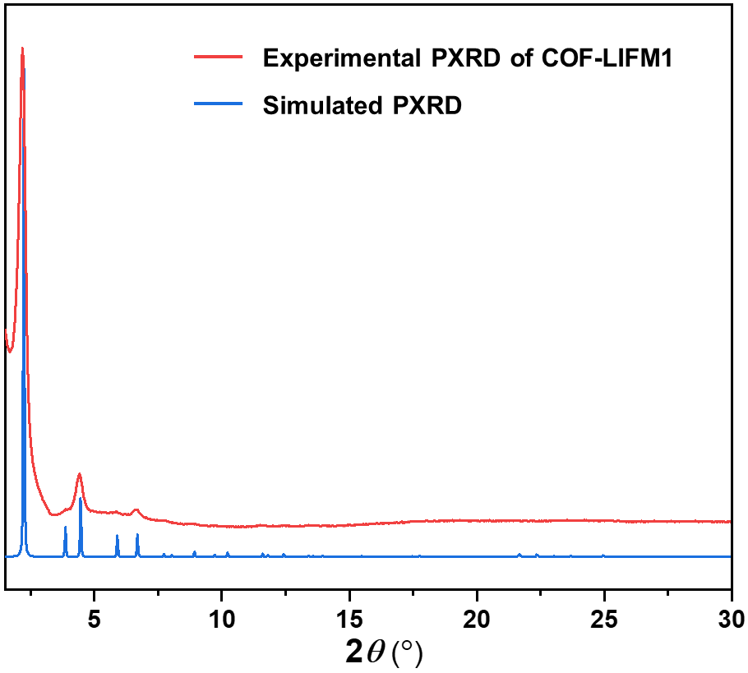
Supplementary Figure 41 | The experimental and simulated PXRD patterns of the COF-LIFM1.
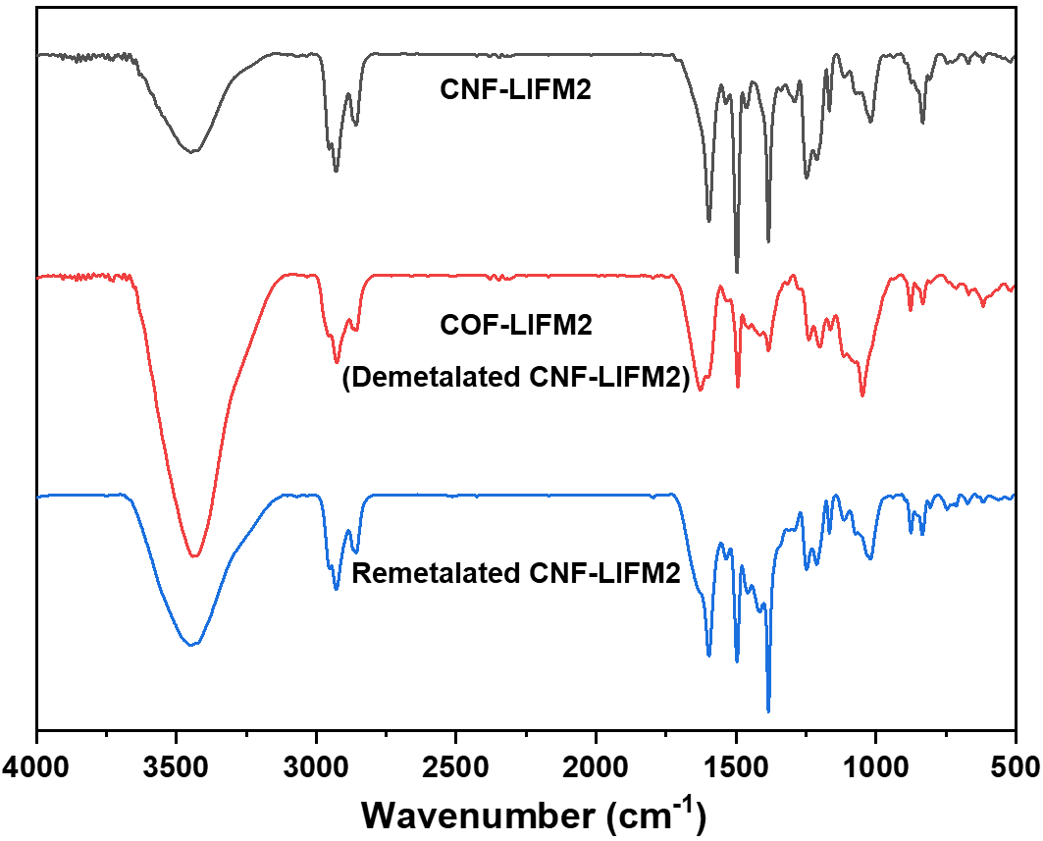
Supplementary Figure 42 | FT-IR spectra of the original CNF-LIFM2, COF-LIFM2 (demetalated CNF-LIFM2), and remetalated CNF-LIFM2.
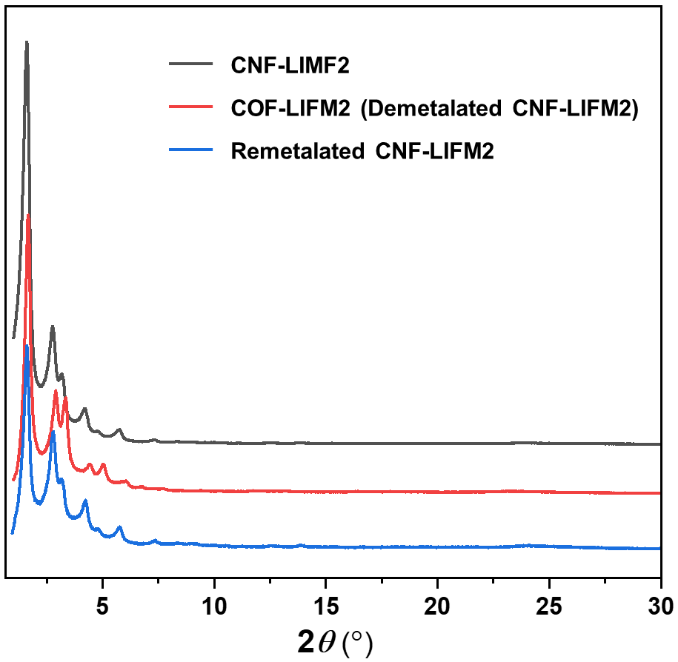
Supplementary Figure 43 | The comparison of experimental PXRD patterns of the original CNF-LIFM2, COF-LIFM2 (demetalated CNF-LIFM2), and remetalated CNF-LIFM2.
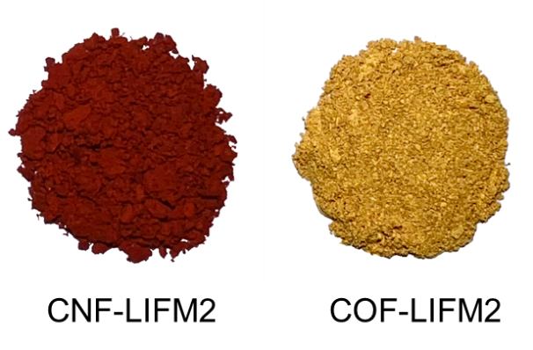
Supplementary Figure 44 | The comparison of colors of CNF-LIFM2 and COF-LIFM2 (demetalated CNF-LIFM2).
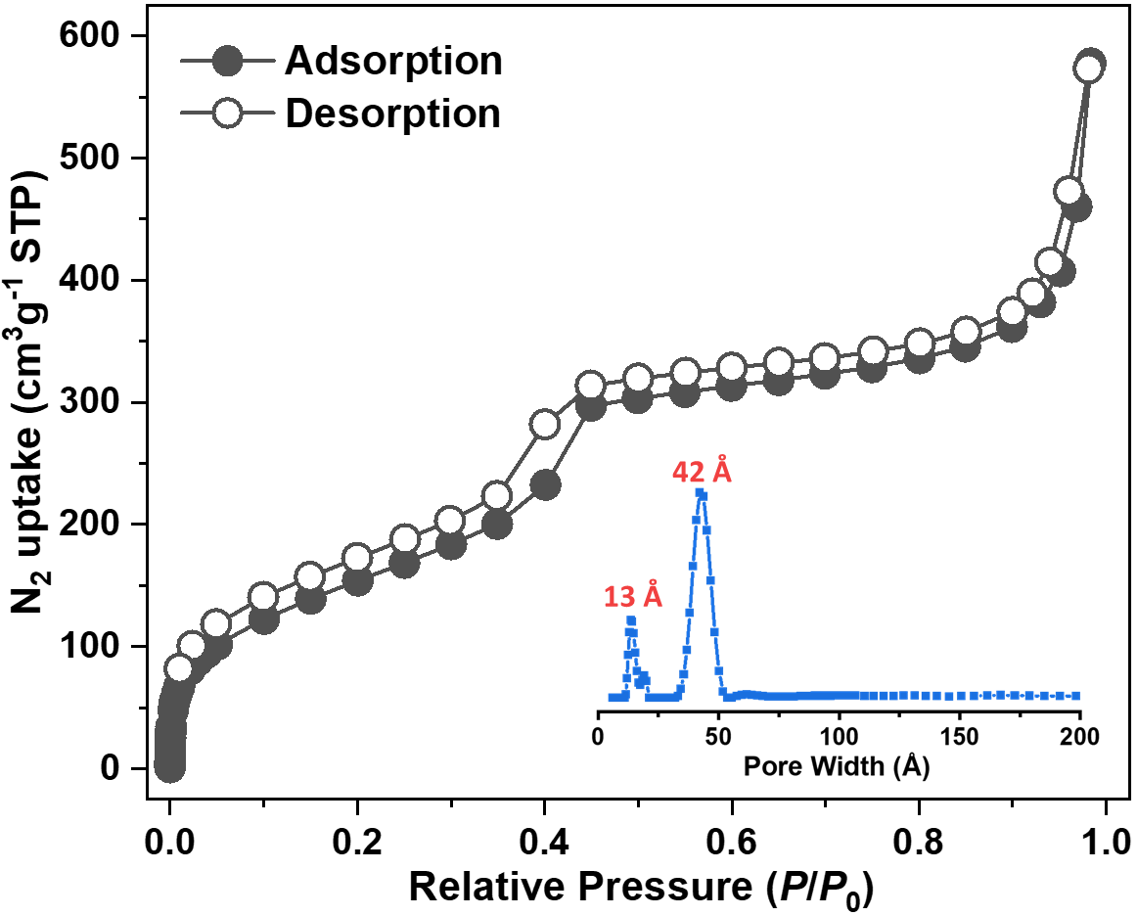
Supplementary Figure 45 | The N₂ adsorption‒desorption isotherm line of COF-LIFM2 (demetalated CNF-LIFM2). Inset shows the pore size distribution of COF-LIFM2 calculated by QSDFT.
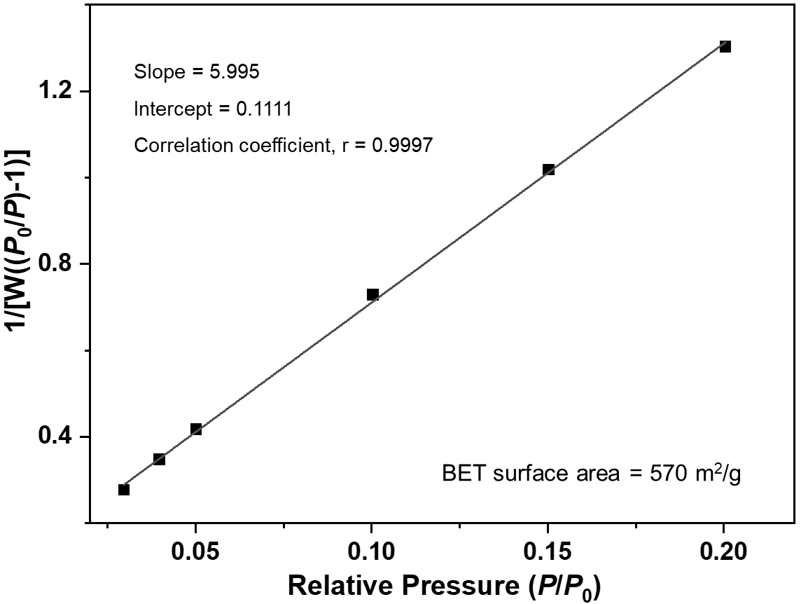
Supplementary Figure 46 | The BET surface area plot for COF-LIFM2 calculated from N₂ adsorption data.
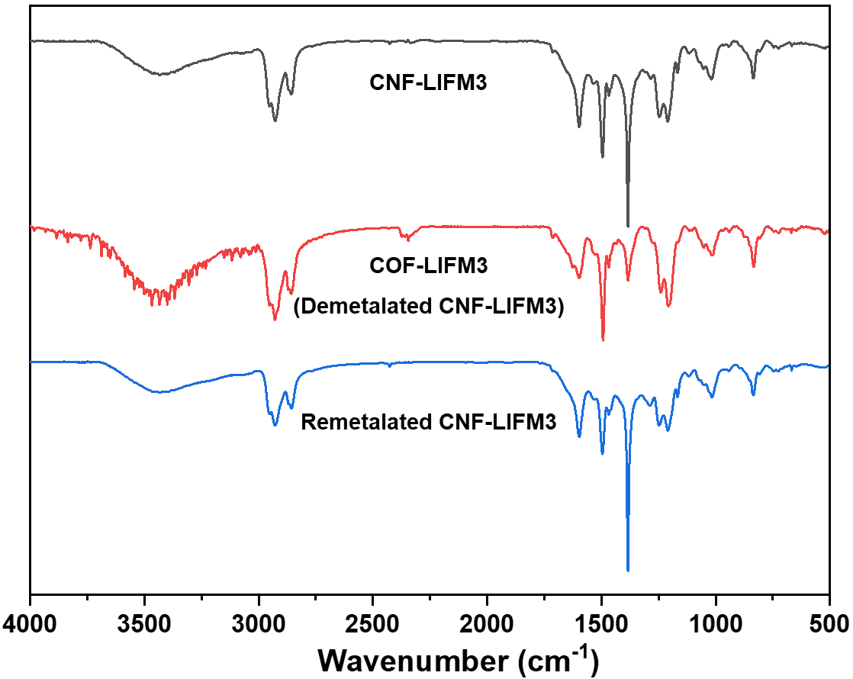
Supplementary Figure 47 | FT-IR spectra of the original CNF-LIFM3, COF-LIFM3 (demetalated CNF-LIFM3), and remetalated CNF-LIFM3.
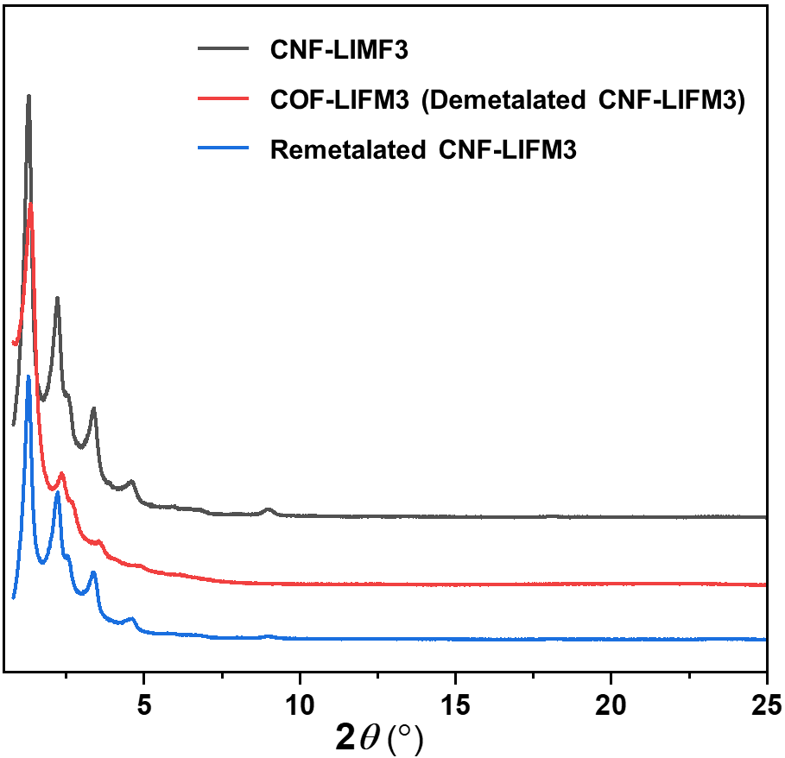
Supplementary Figure 48 | The comparison of experimental PXRD patterns of the original CNF-LIFM3, COF-LIFM3 (demetalated CNF-LIFM3), and remetalated CNF-LIFM3.
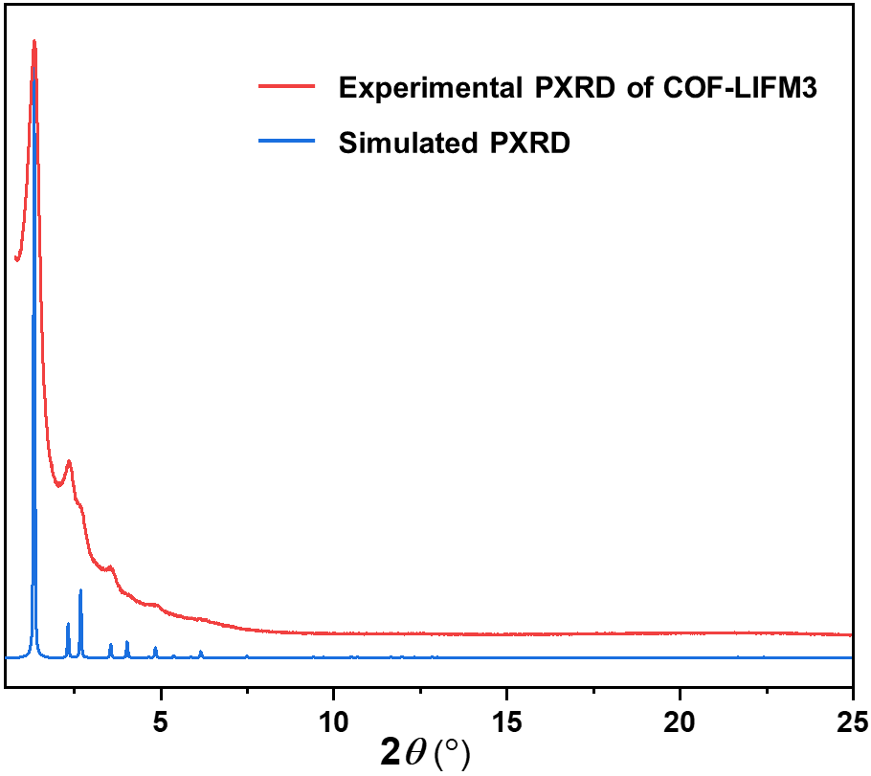
Supplementary Figure 49 | The experimental and simulated PXRD patterns of COF-LIFM3.

Supplementary Table 4. ICP-MS results of the fresh and demetalated materials.
 | Zn content
 | Calculated | Fresh material | Demetalated material
SNF-LIFM1  (C₁₉H₁₃N₅O₇Zn)_{n} | 13.38% | 12.46% | 0.53%
CNF-LIFM1  (C₂₈H₂₆N₅O₈Zn)_{n} | 10.45% | 10.06% | 0.44%
CNF-LIFM2  (C₄₀H₄₂N₅O₉Zn)_{n} | 8.15% | 7.92% | 0.25%
CNF-LIFM1  (C₅₂H₅₈N₅O₁₀Zn)_{n} | 6.68% | 6.21% | 0.29%

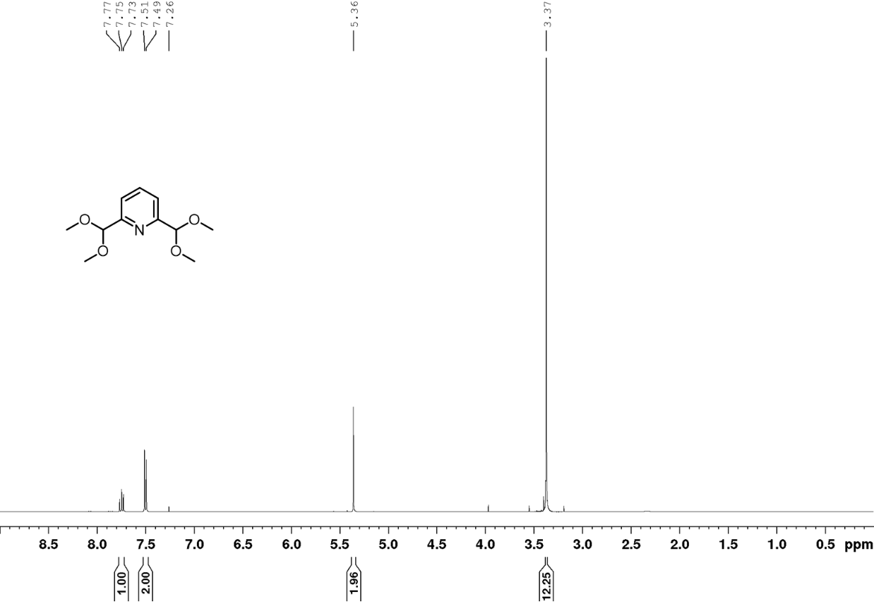
Supplementary Figure 50 | ¹H NMR spectrum of building unit A1 (400 MHz, CDCl₃).

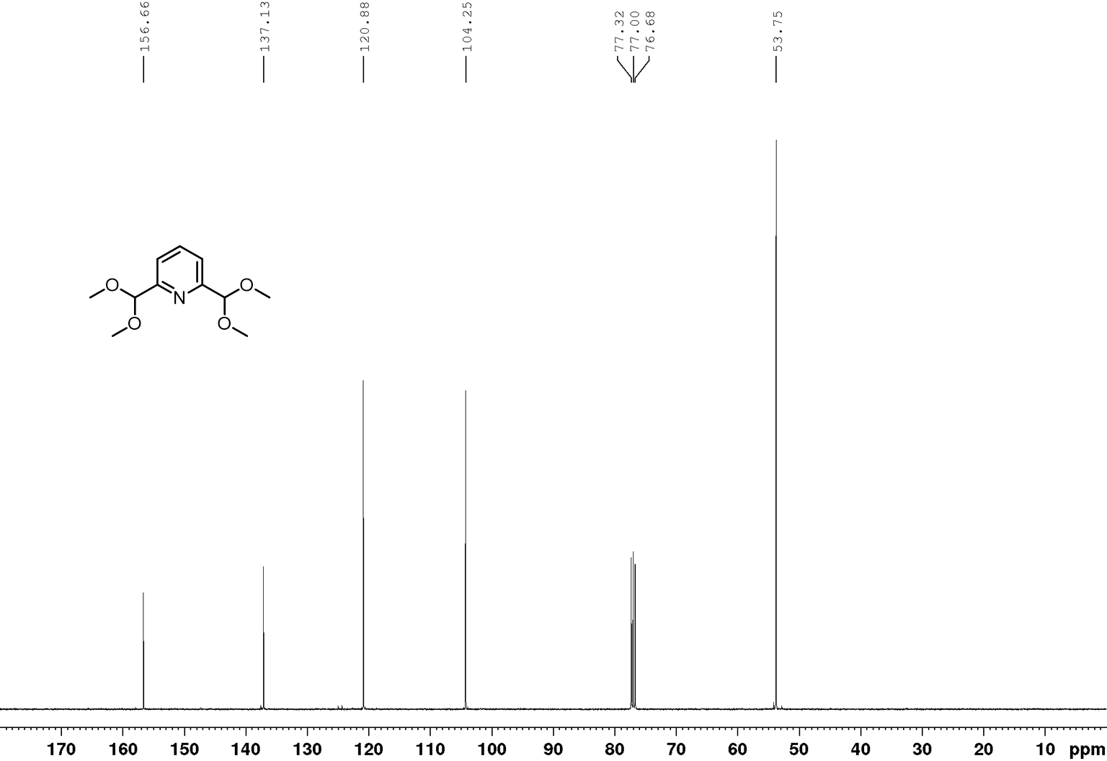
Supplementary Figure 51 | ¹³C NMR spectrum of building unit A1 (100 MHz, CDCl₃).
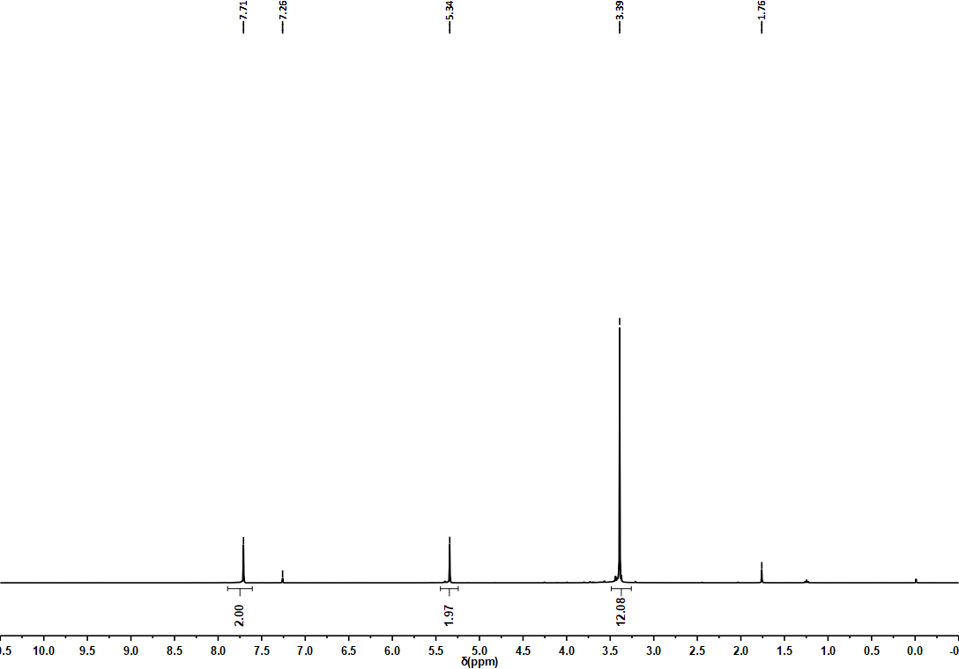
Supplementary Figure 52 | ¹H NMR spectrum of compound S2 (400 MHz, CDCl₃).
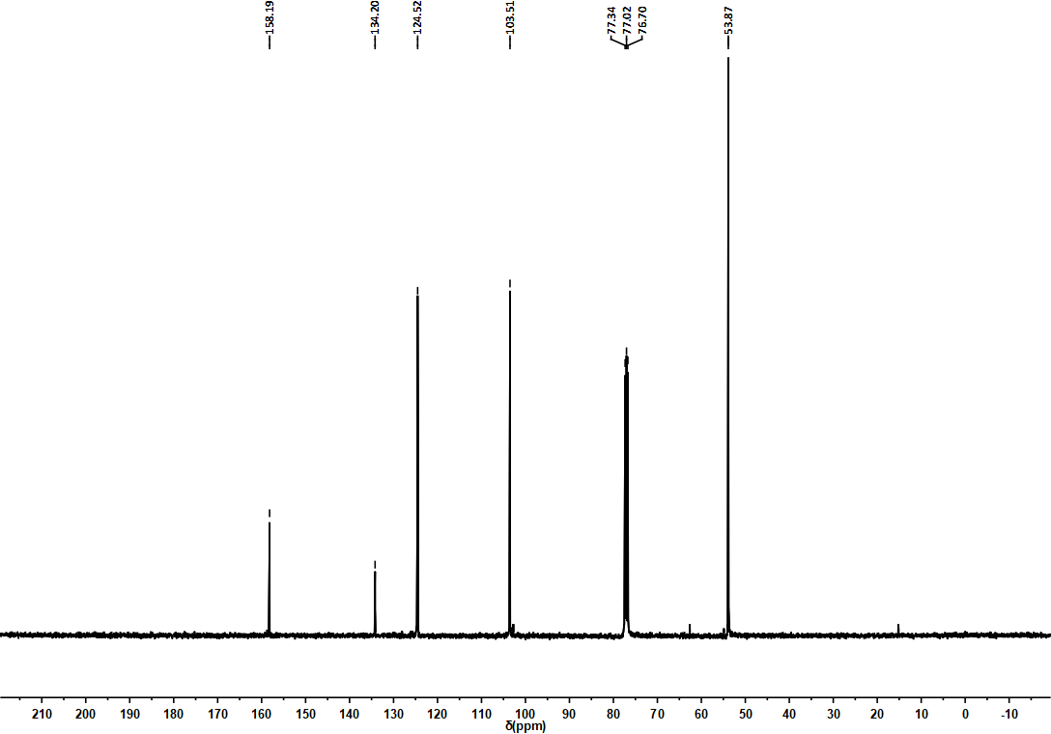
Supplementary Figure 53 | ¹³C NMR spectrum of S2 (100 MHz, CDCl₃).
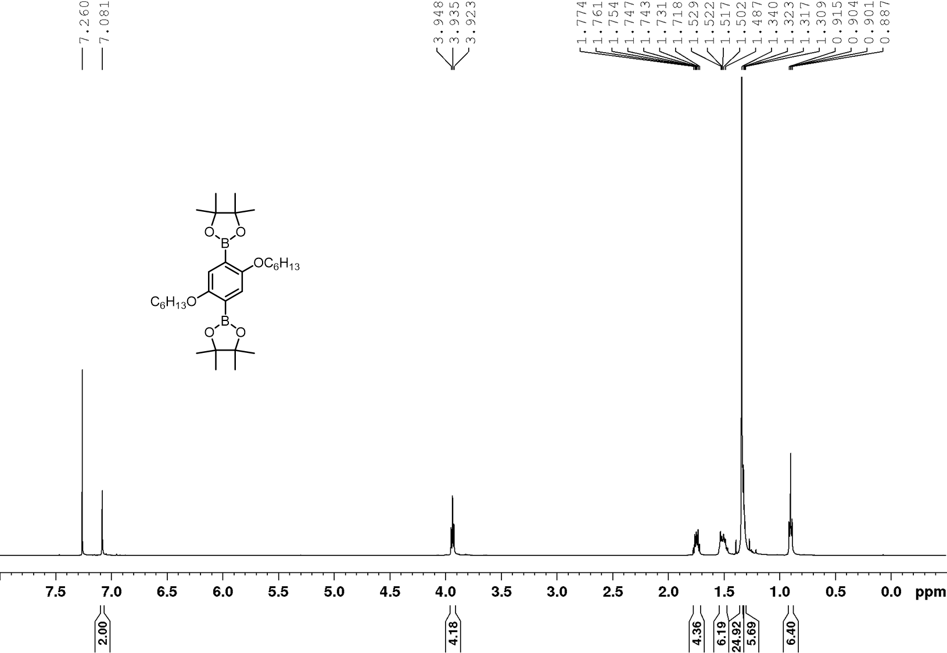
Supplementary Figure 54 | ¹H NMR spectrum of compound S4 (500 MHz, CDCl₃).
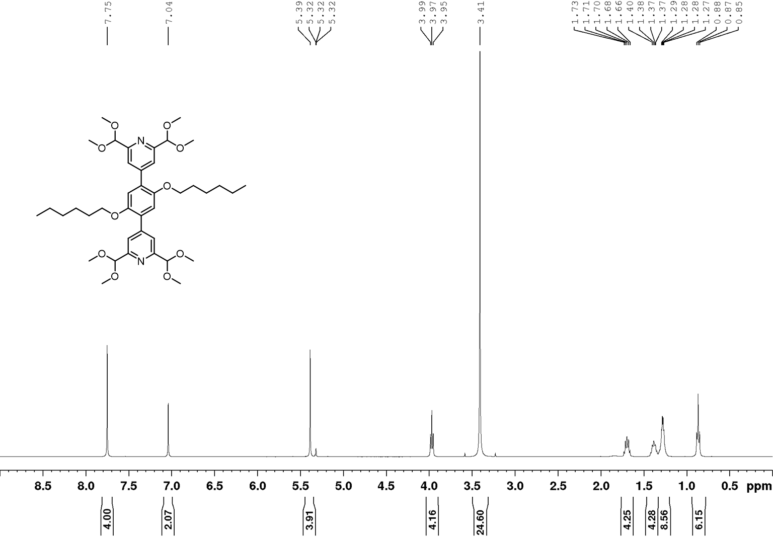
Supplementary Figure 55 | ¹H NMR spectrum of building unit E1 (400 MHz, CD₂Cl₂).
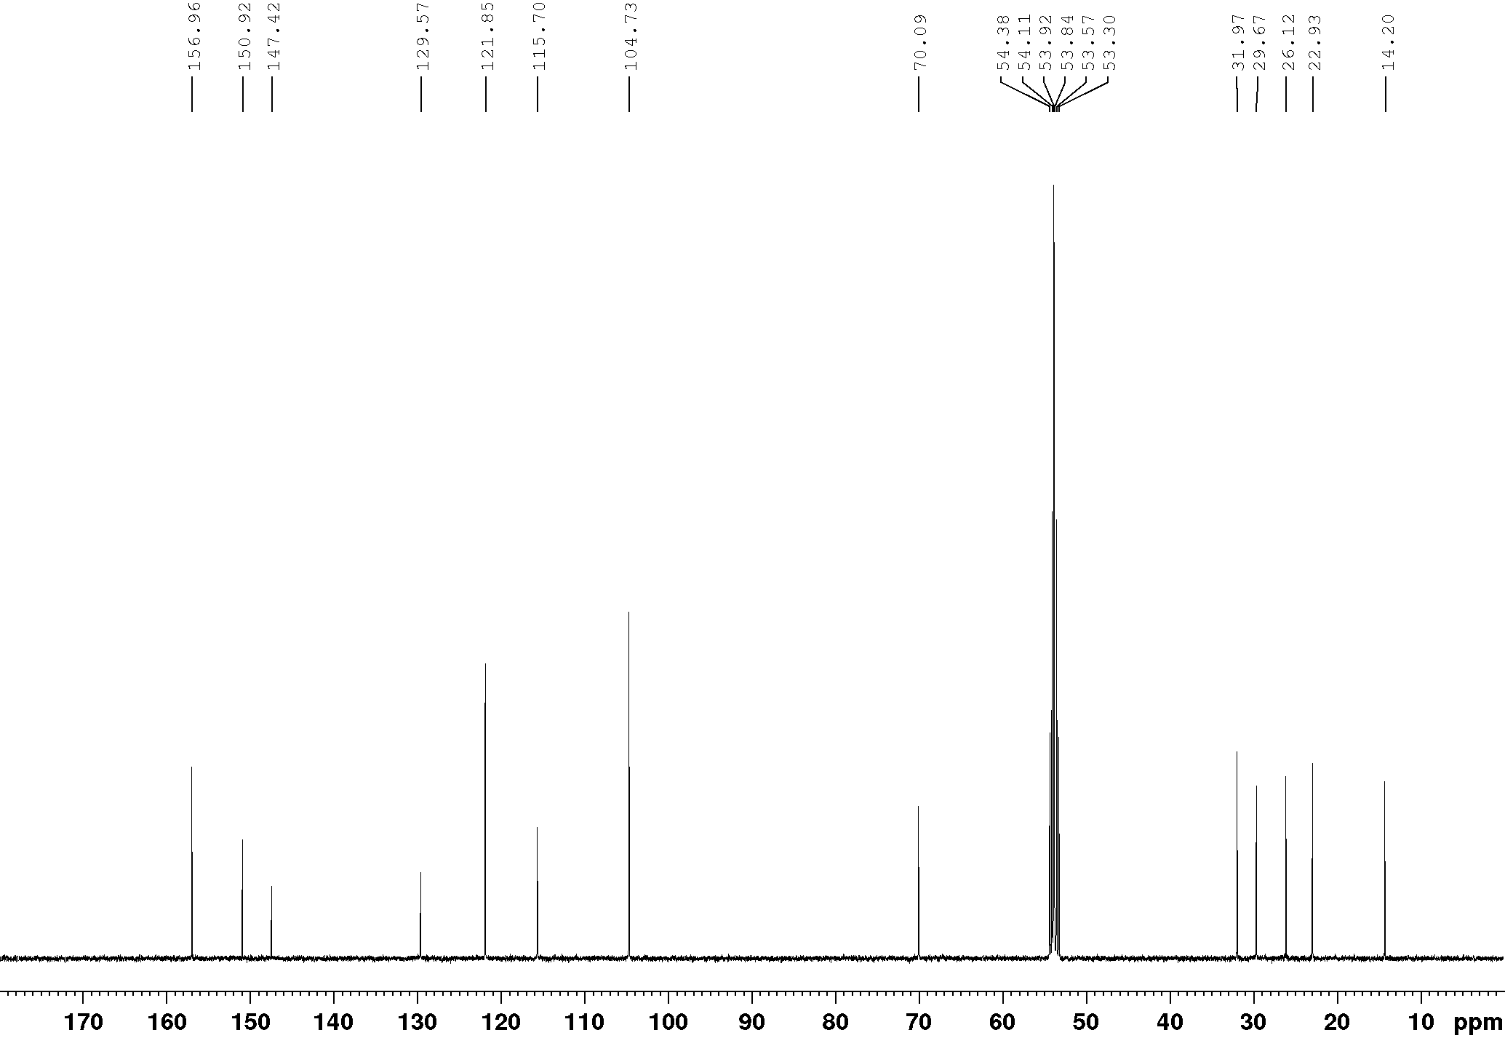
Supplementary Figure 56 | ¹³C NMR spectrum of building unit E1 (100 MHz, CD₂Cl₂).
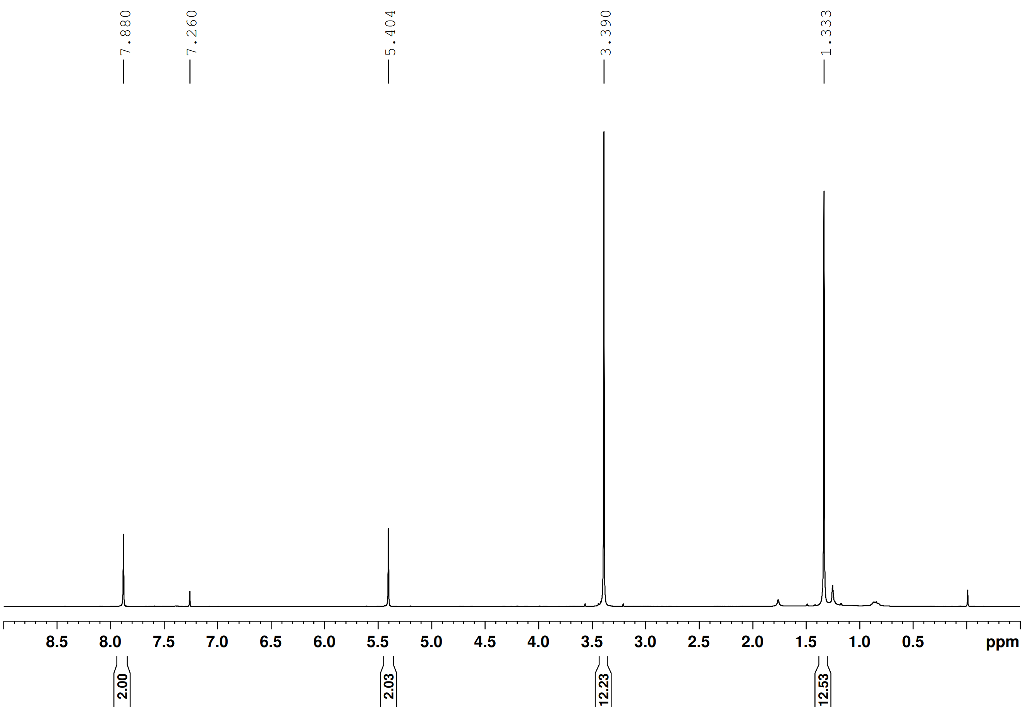
Supplementary Figure 57 | ¹H NMR spectrum of compound S5 (400 MHz, CDCl₃).
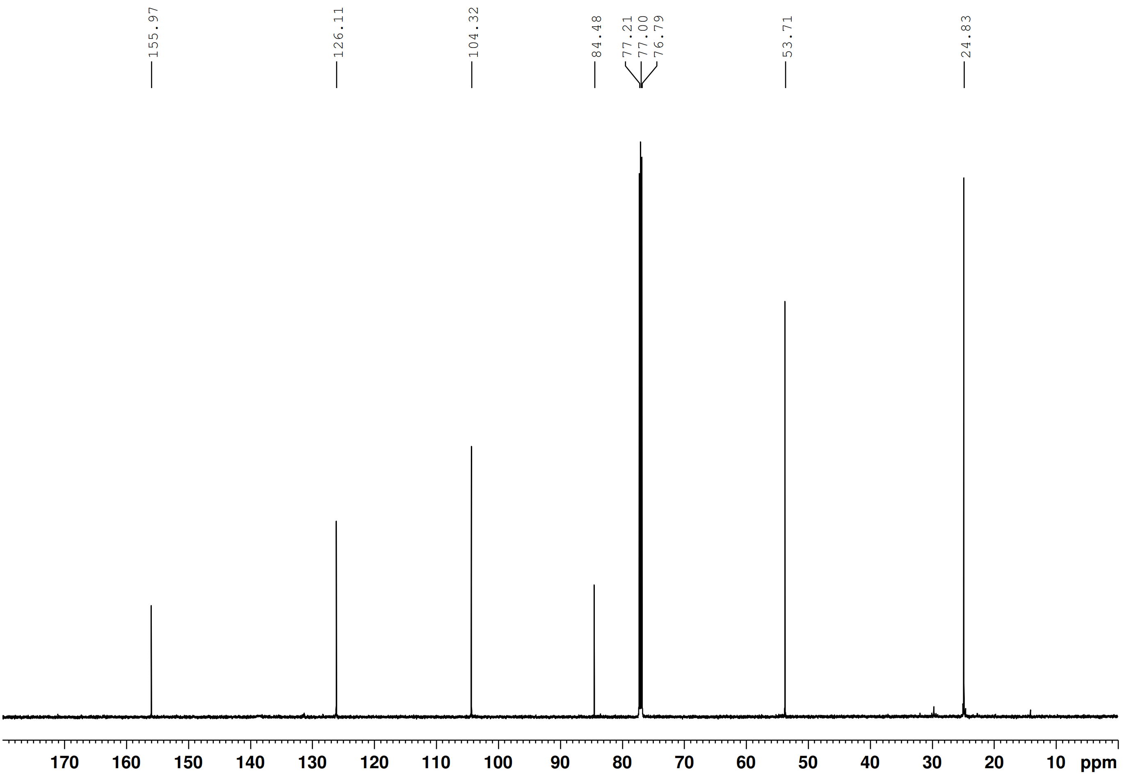
Supplementary Figure 58 | ¹³C NMR spectrum of S5 (150 MHz, CDCl₃).
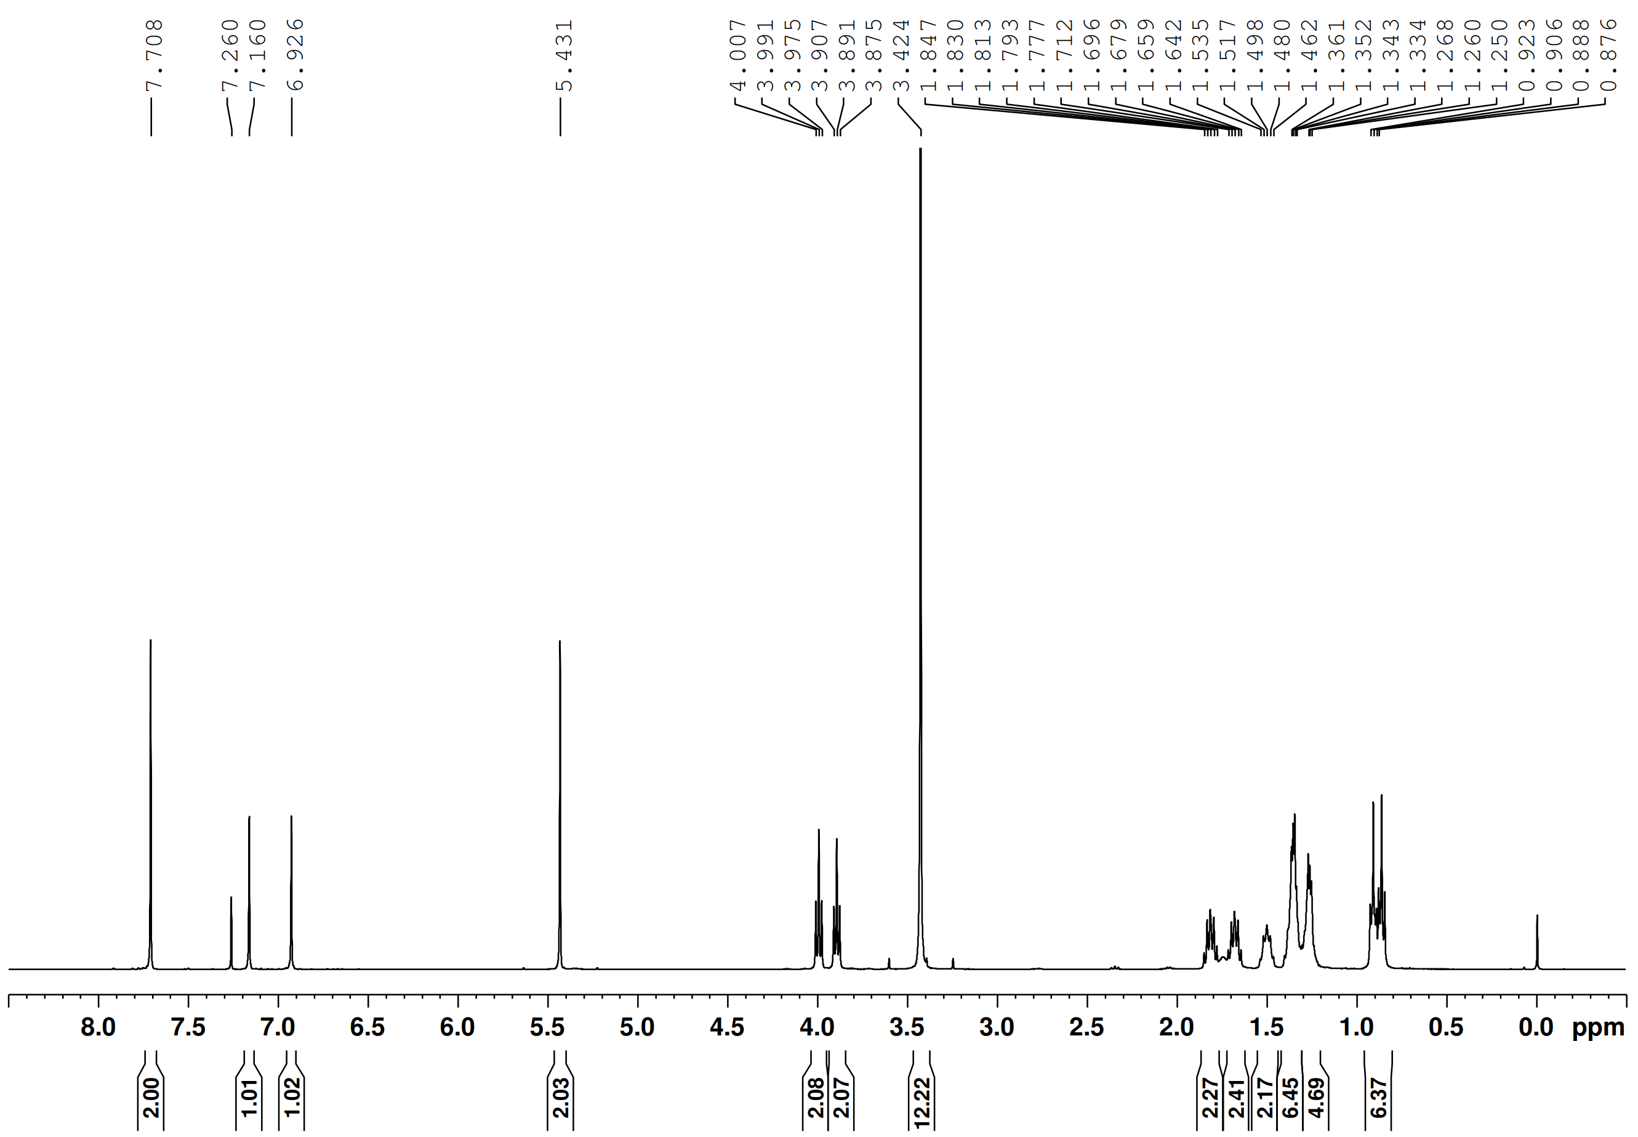
Supplementary Figure 59 | ¹H NMR spectrum of compound S6 (400 MHz, CDCl₃).
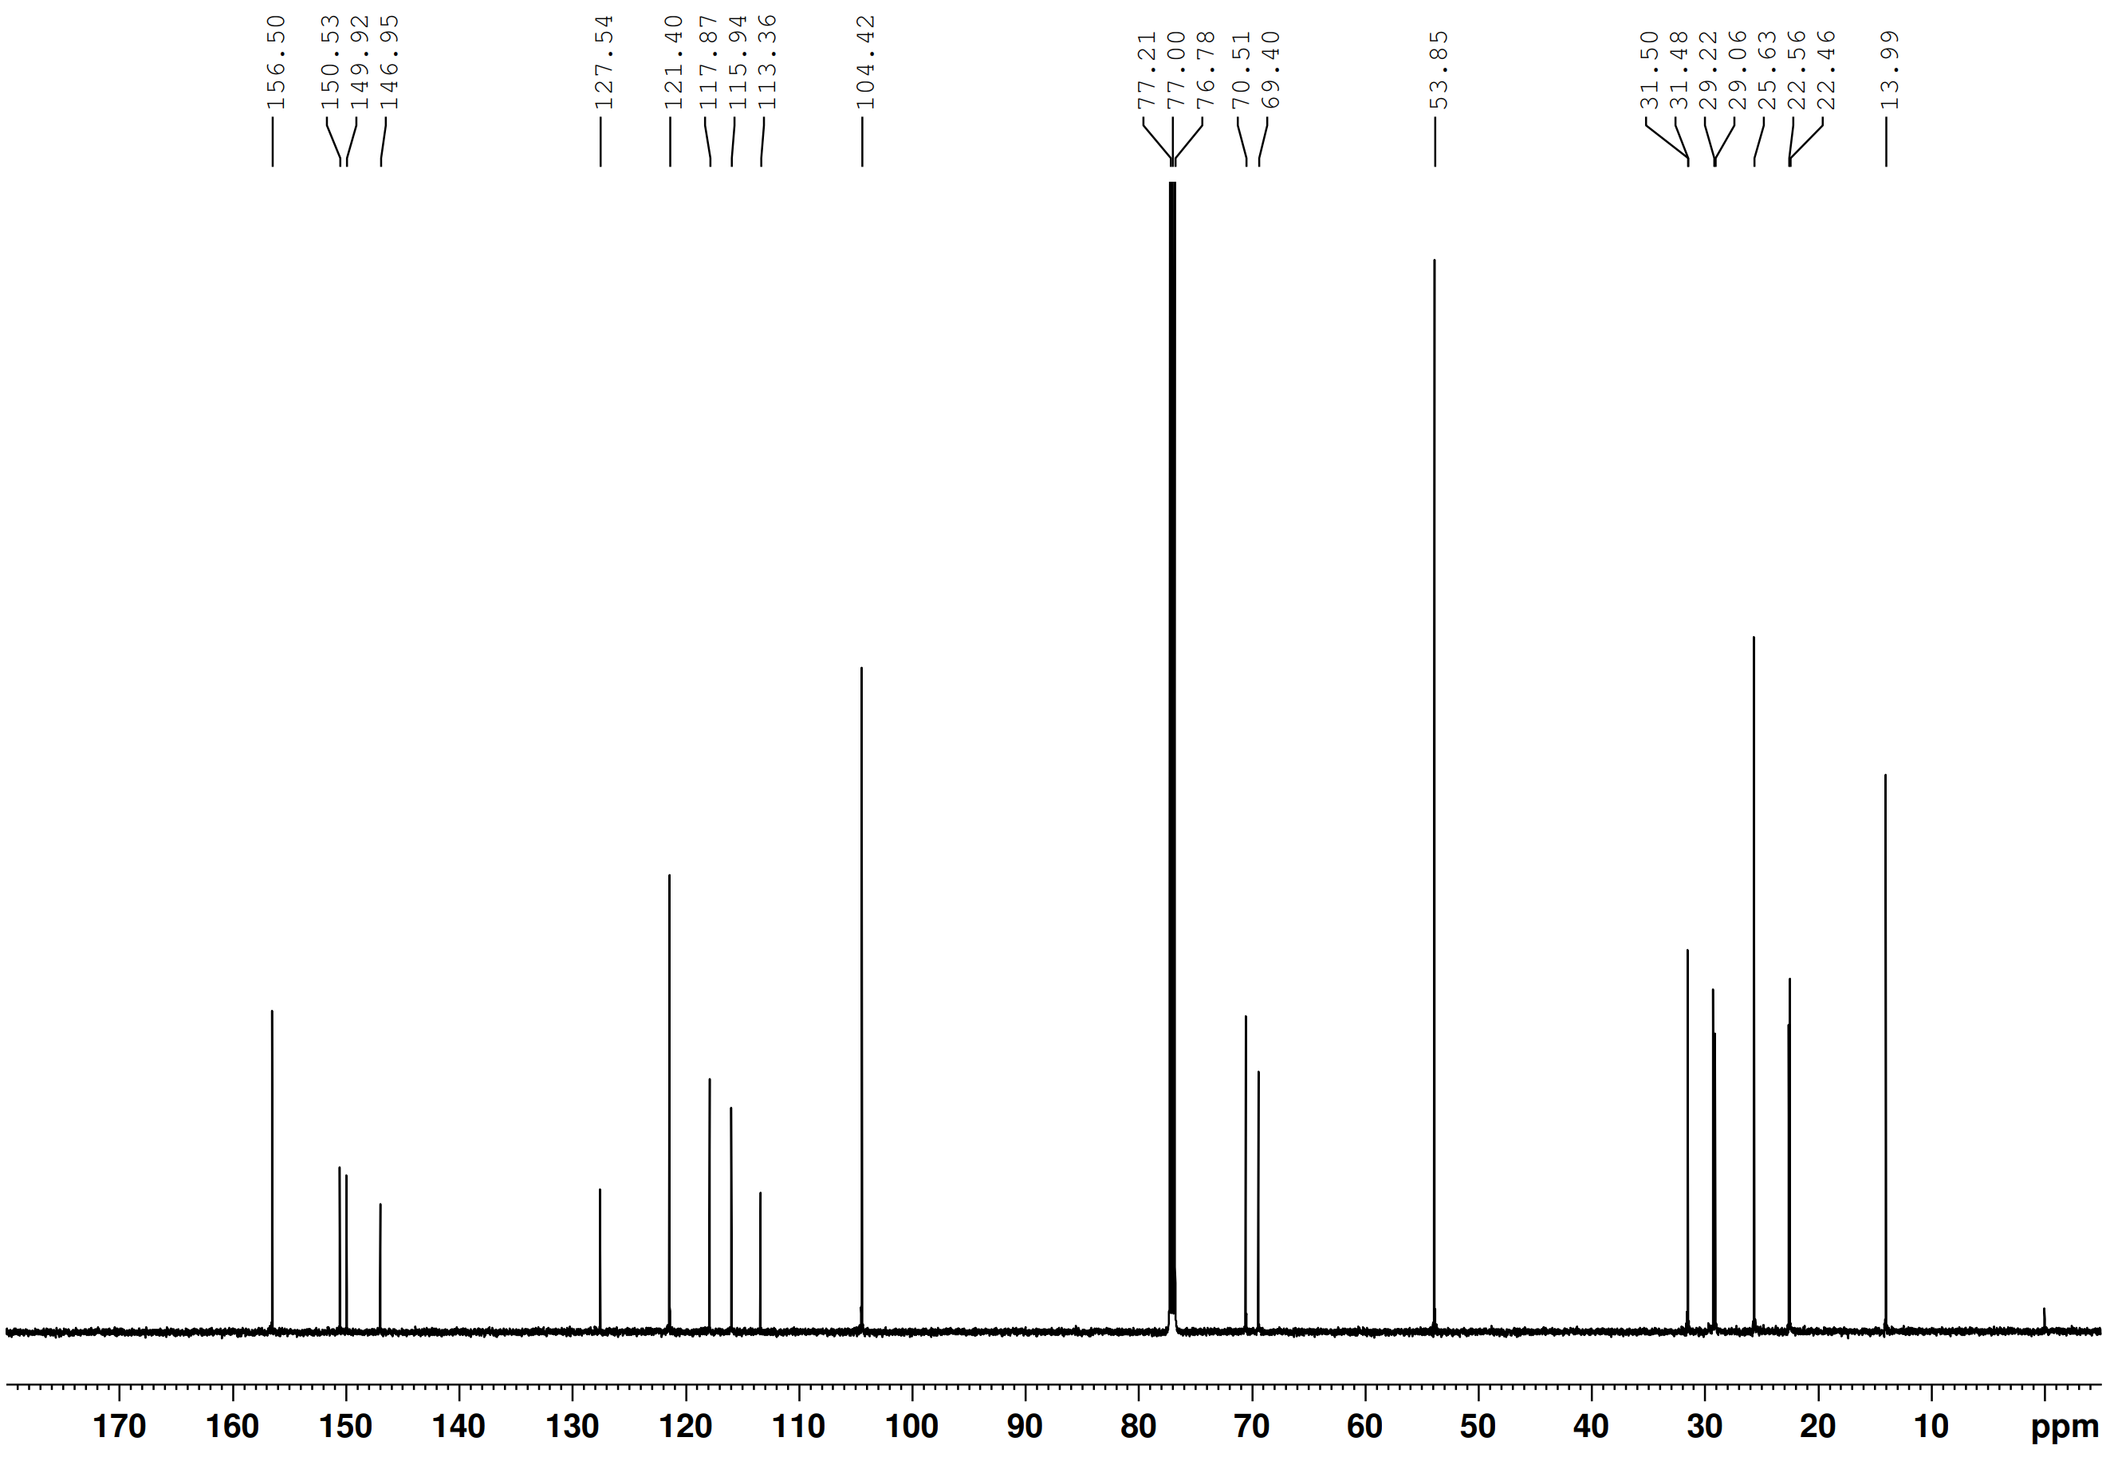
Supplementary Figure 60 | ¹³C NMR spectrum of S6 (150 MHz, CDCl₃).
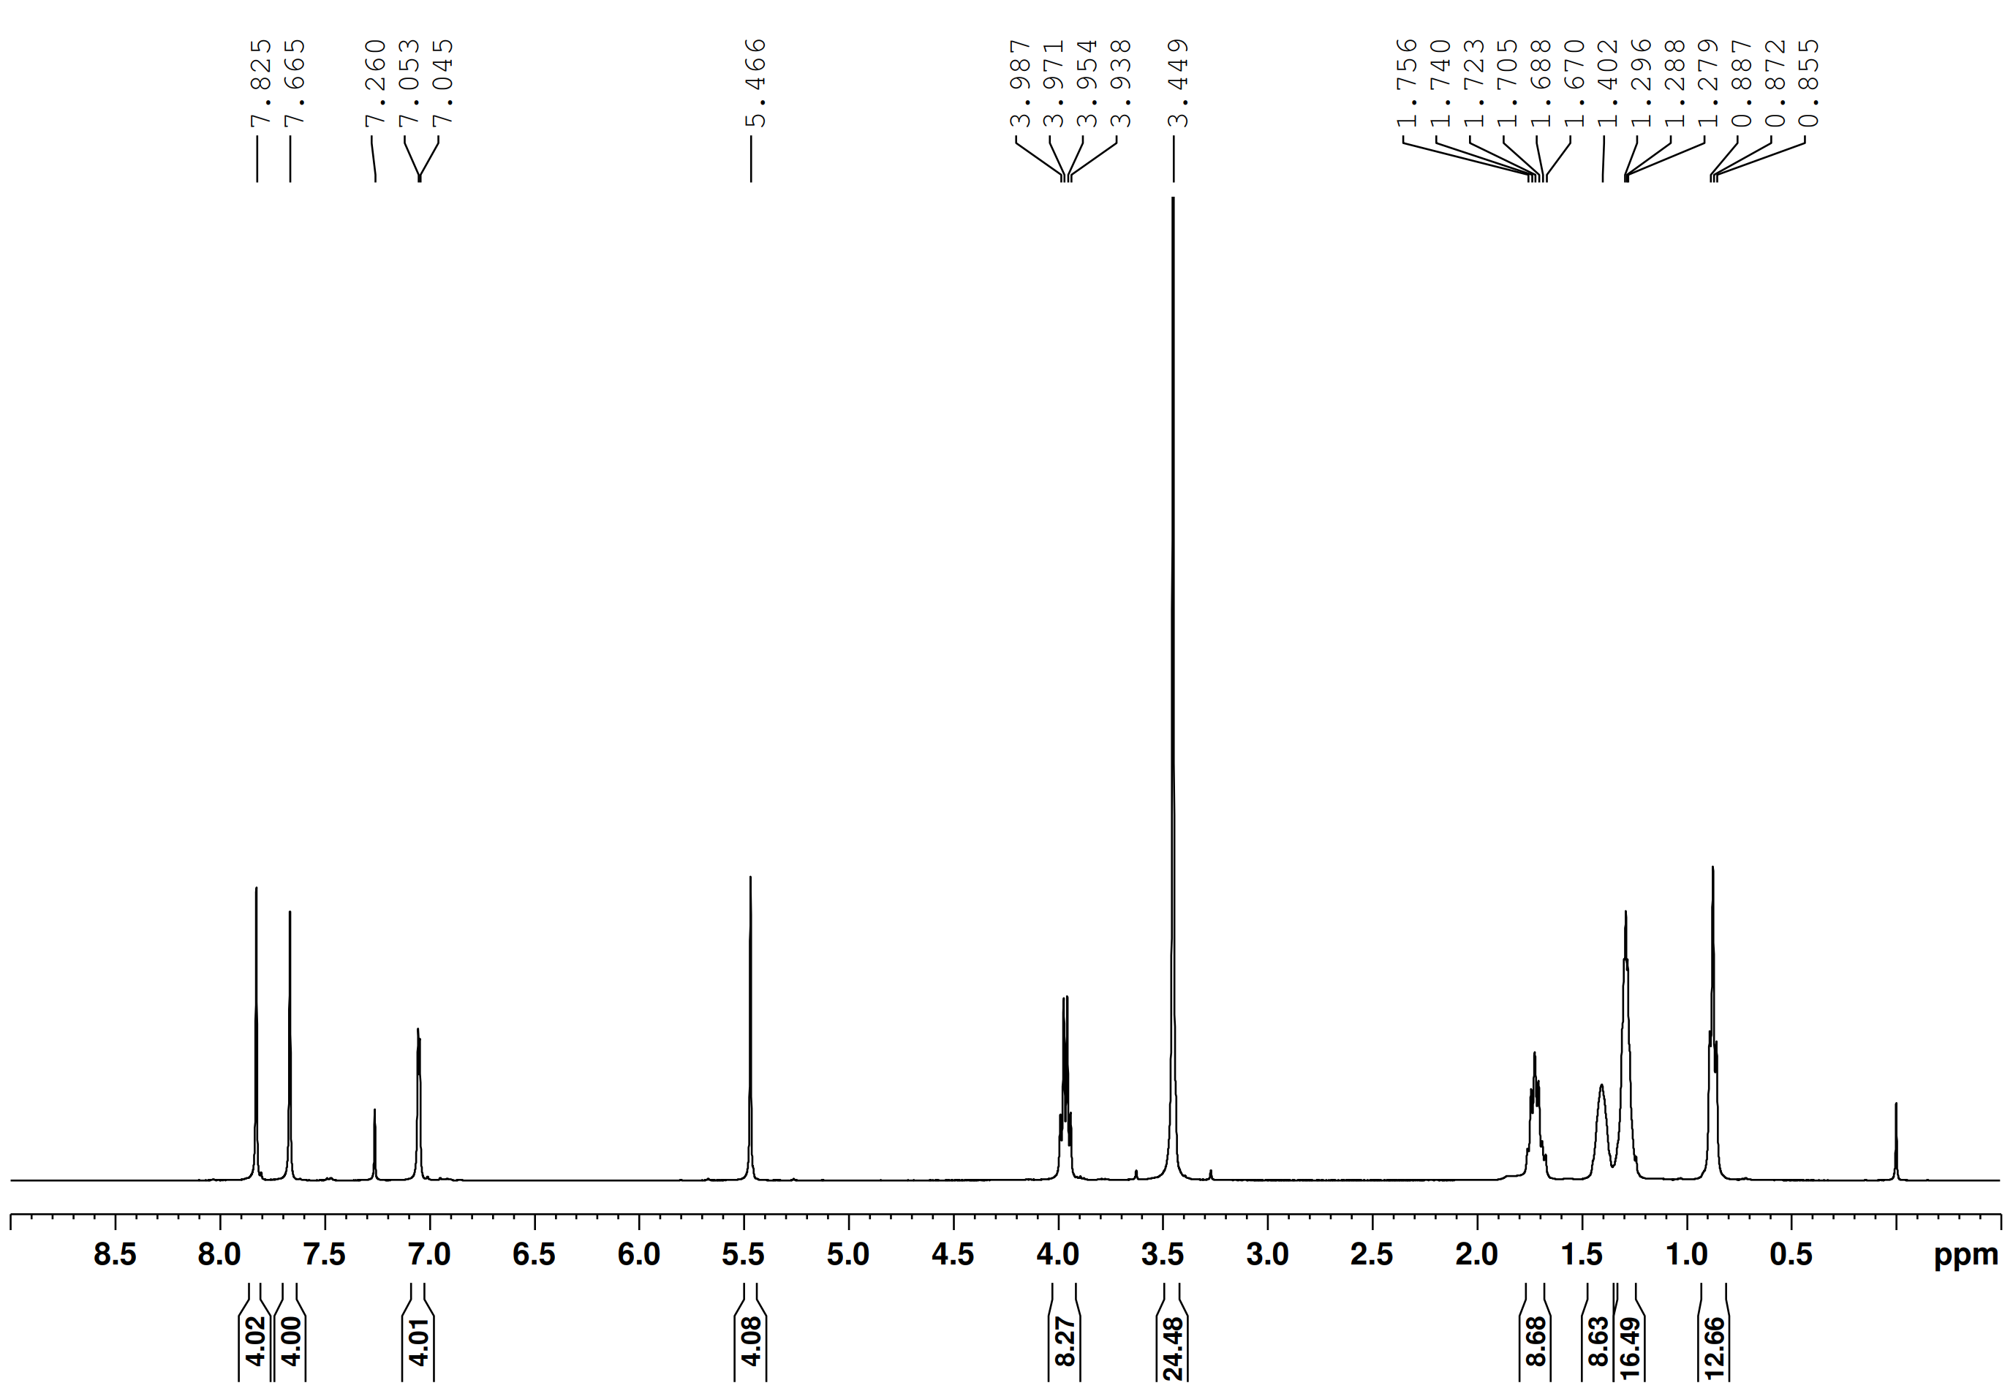
Supplementary Figure 61 | ¹H NMR spectrum of building unit E2 (400 MHz, CDCl₃).
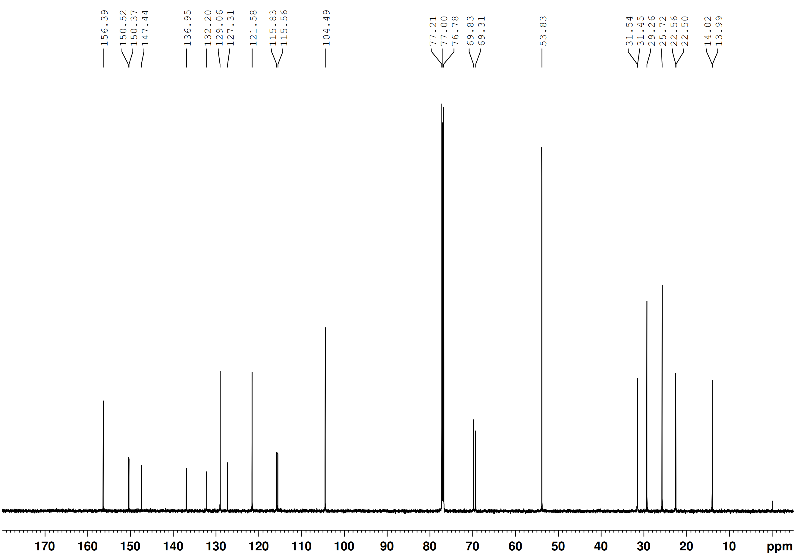
Supplementary Figure 62 | ¹³C NMR spectrum of building unit E2 (150 MHz, CDCl₃).
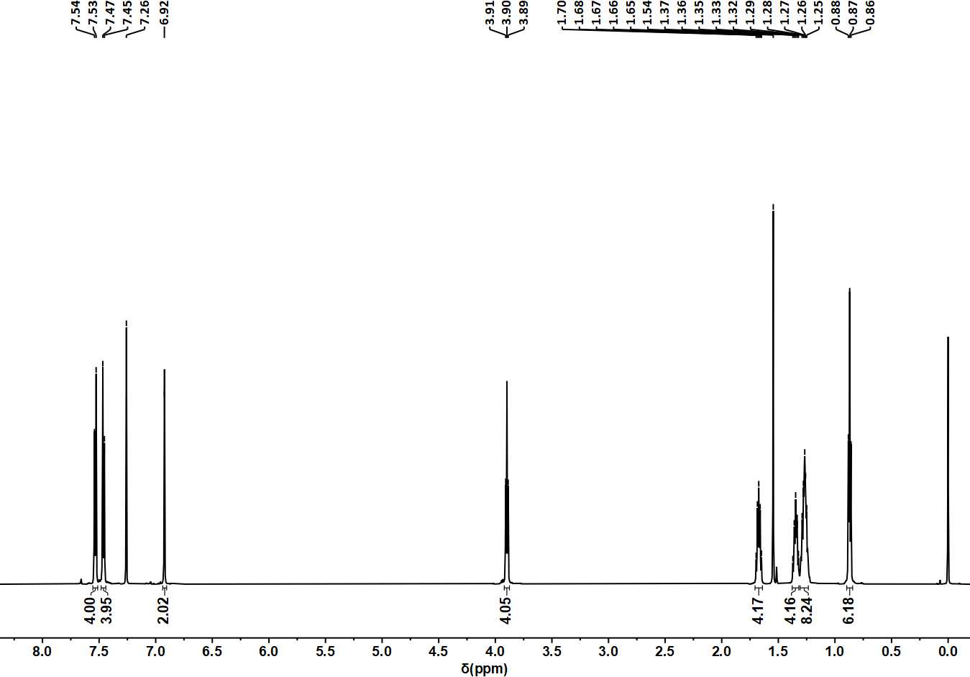
Supplementary Figure 63 | ¹H NMR spectrum of compound S7 (600 MHz, CDCl₃).
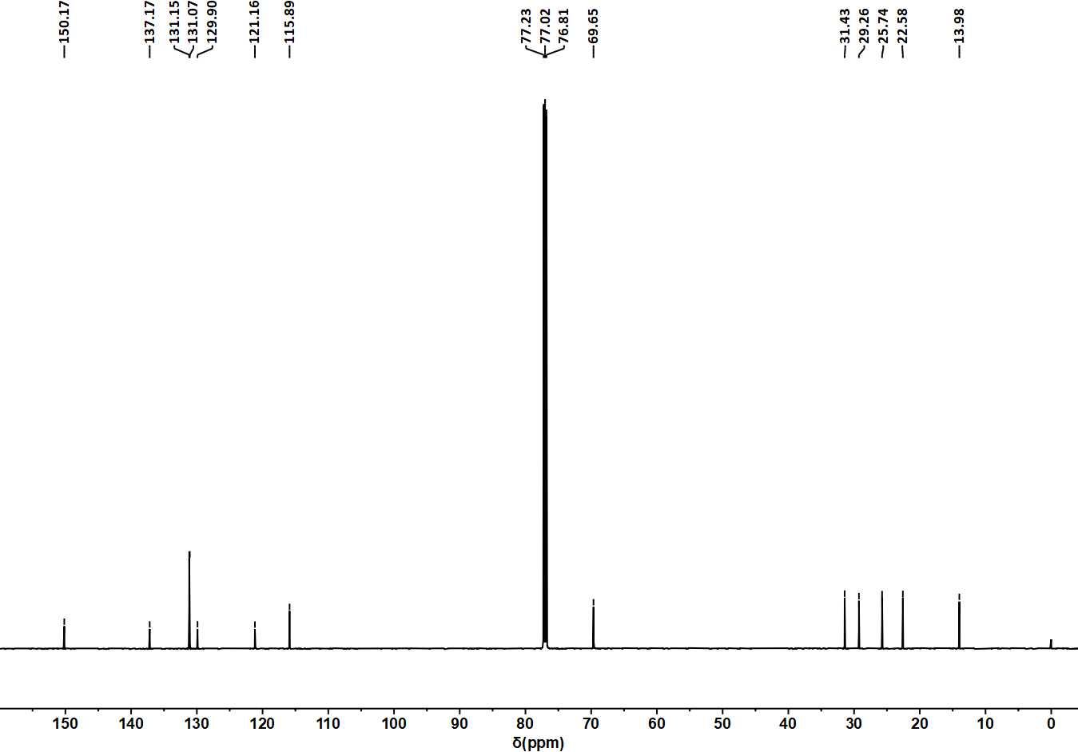
Supplementary Figure 64 | ¹³C NMR spectrum of S7 (150 MHz, CDCl₃).
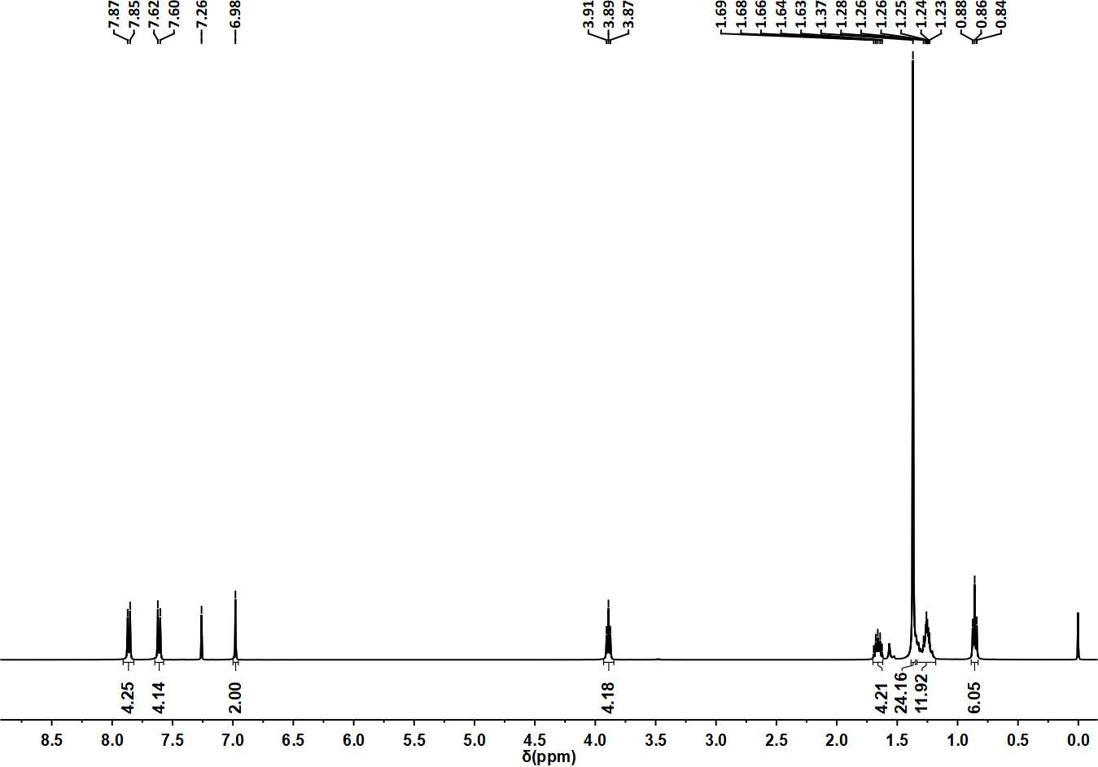
Supplementary Figure 65 | ¹H NMR spectrum of compound S8 (400 MHz, CDCl₃).
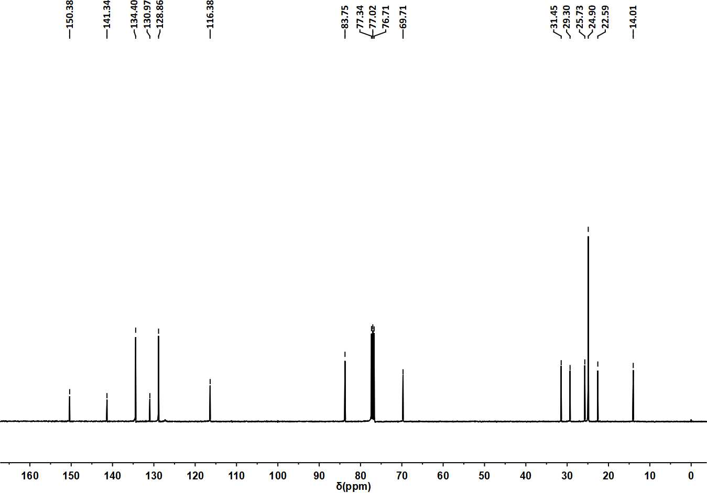
Supplementary Figure 66 | ¹³C NMR spectrum of S8 (100 MHz, CDCl₃).
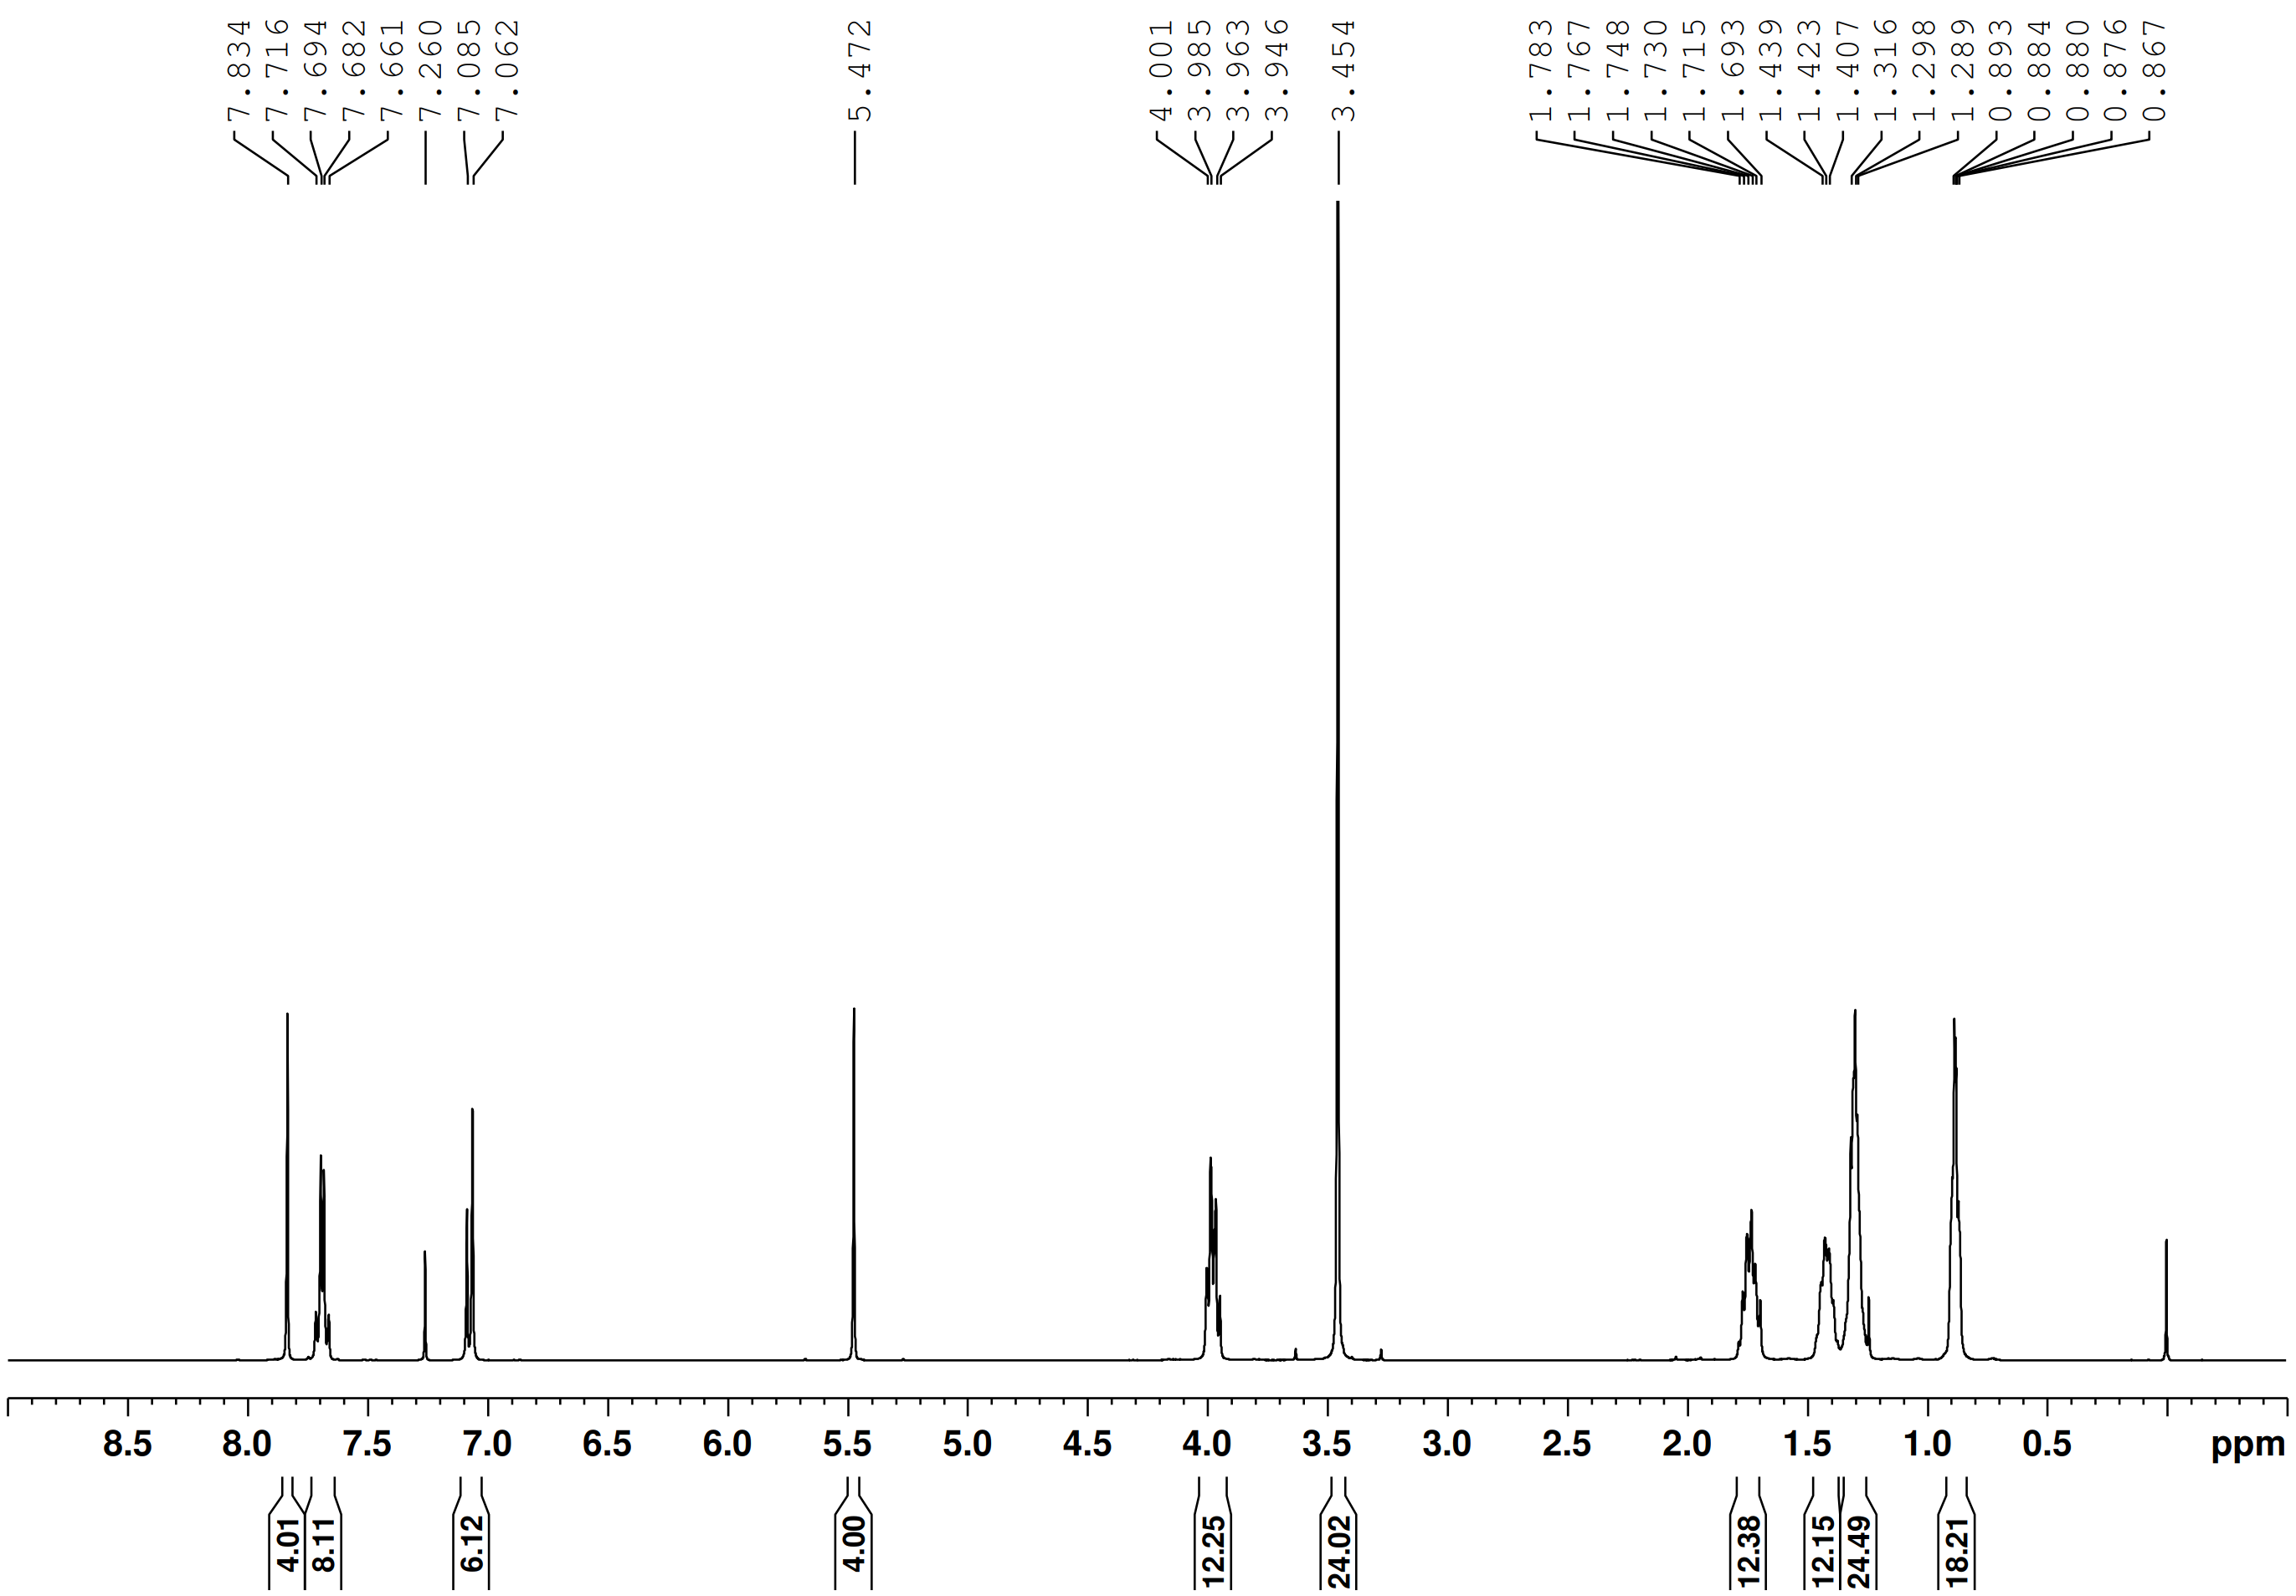
Supplementary Figure 67 | ¹H NMR spectrum of building unit E3 (400 MHz, CDCl₃).
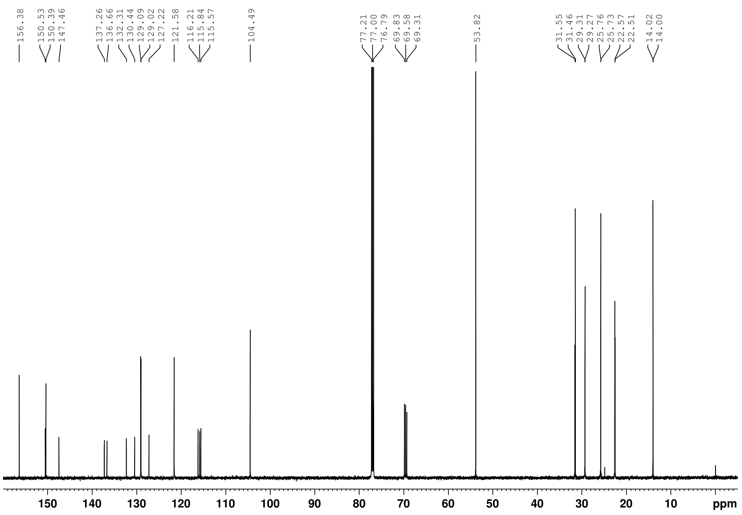
Supplementary Figure 68 | ¹³C NMR spectrum of building unit E3 (150 MHz, CDCl₃).

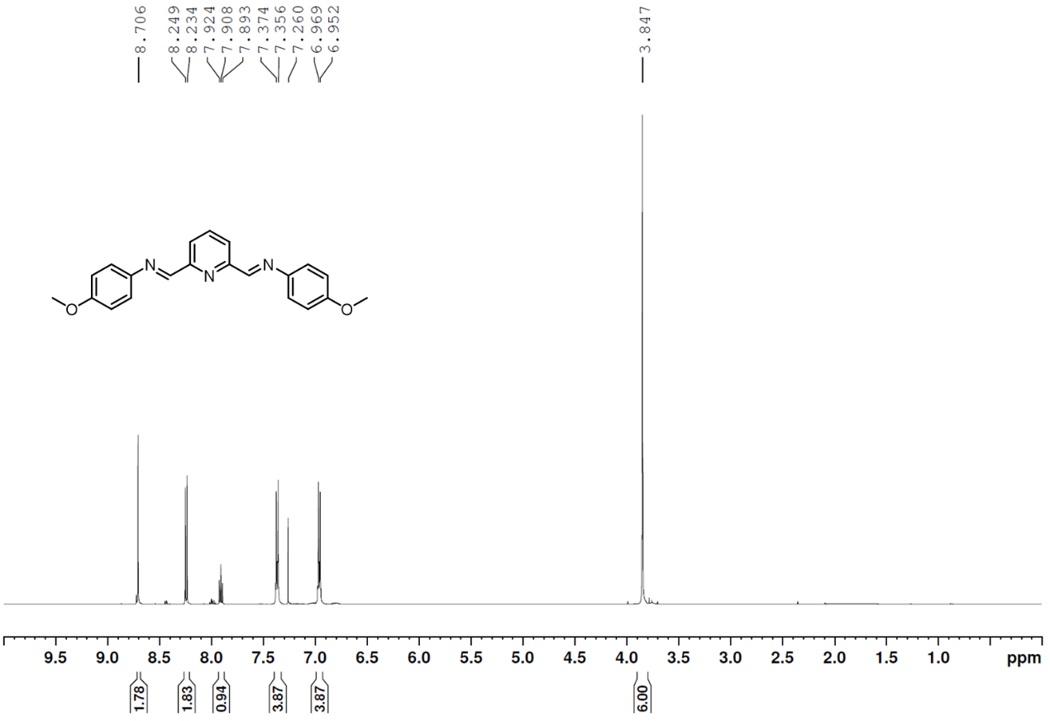
Supplementary Figure 69 | ¹H NMR spectrum of model compound M1 (500 MHz, CDCl₃).
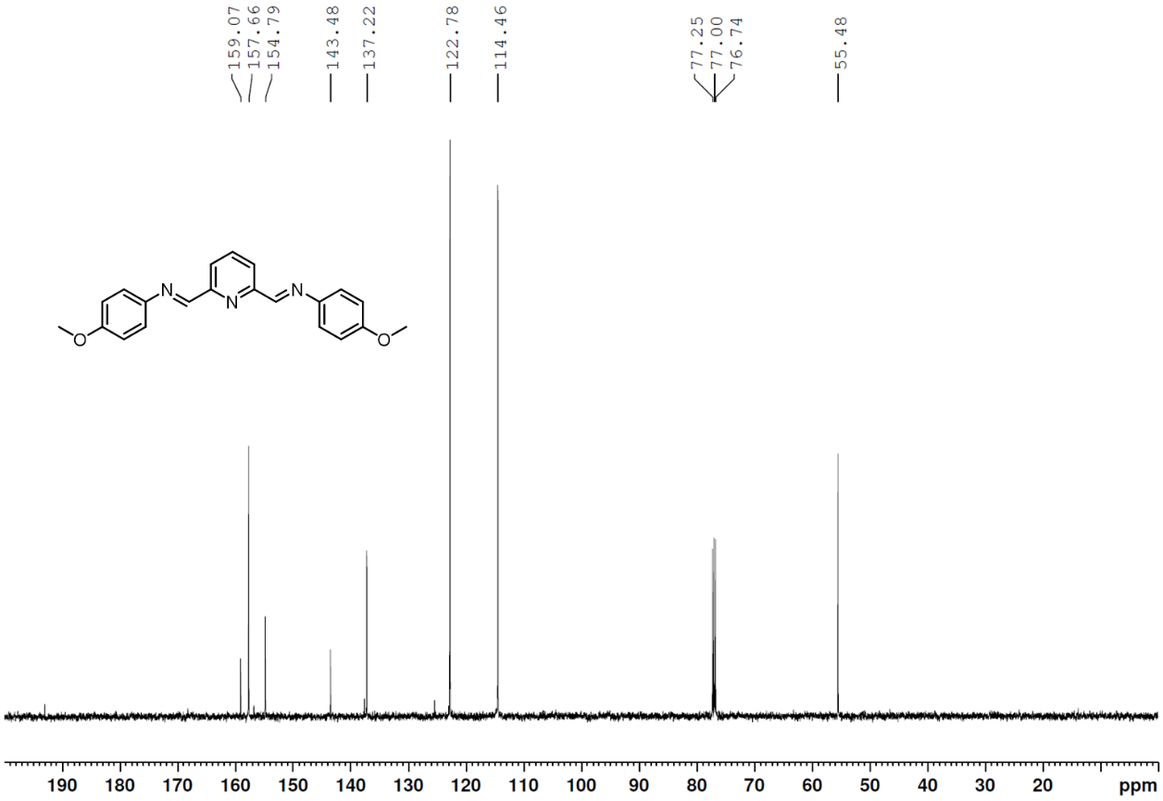
Supplementary Figure 70 | ¹³C NMR spectrum of model compound M1 (125 MHz, CDCl₃).
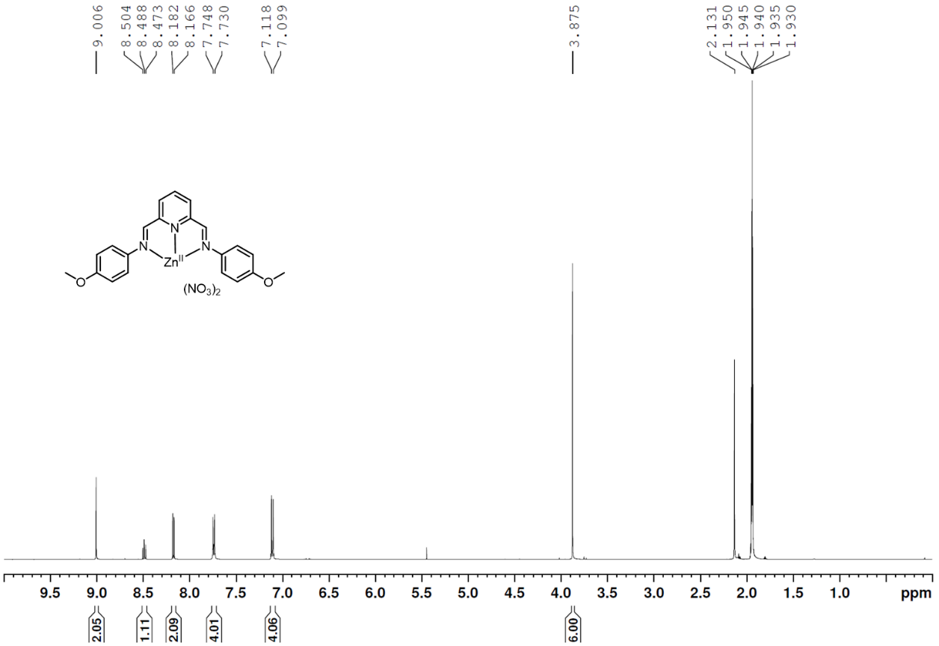
Supplementary Figure 71 | ¹H NMR spectrum of model compound M2 (500 MHz, CD₃CN).
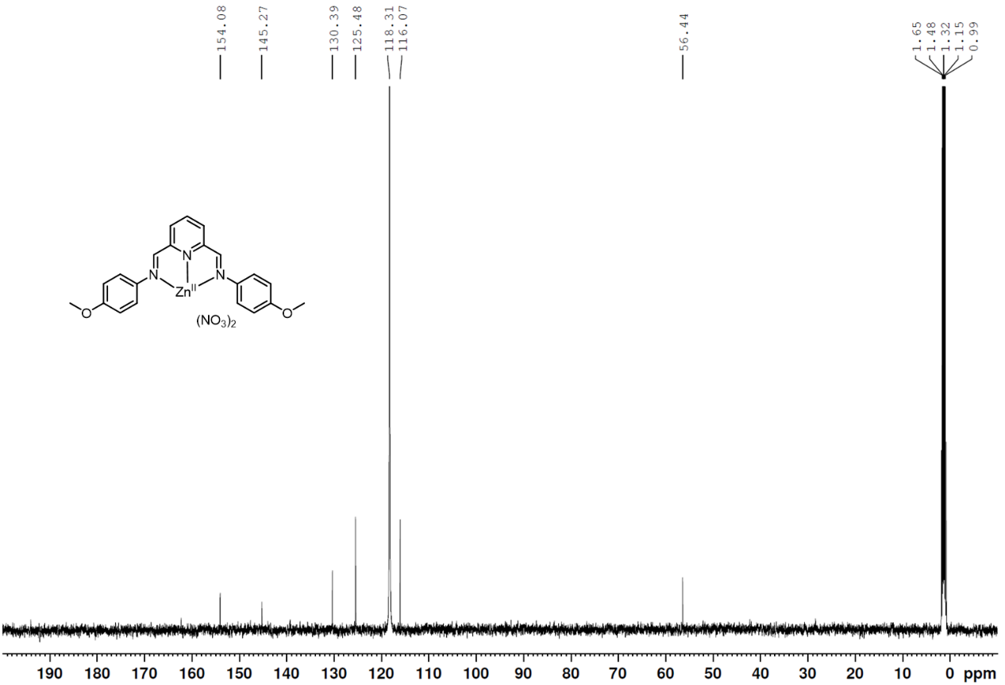
Supplementary Figure 72 | ¹³C NMR spectrum of model compound M2 (125 MHz, CD₃CN).

Supplementary References:
1 Wilson, E. A. et al. Formation of a hetero[3]rotaxane by a dynamic component-swapping strategy. Chem. Commun. 50, 9665-9668 (2014).
2 Prasad, T. K. & Suh, M. P. Metal–Organic Frameworks Incorporating Various Alkoxy Pendant Groups: Hollow Tubular Morphologies, X-ray Single-Crystal Structures, and Selective Carbon Dioxide Adsorption Properties. Chem. Asian J. 10, 2257-2263 (2015).
3 Hovmöller, S. CRISP: crystallographic image processing on a personal computer. Ultramicroscopy 41, 121-135 (1992).
4 Cichocka, M. O., Angstrom, J., Wang, B., Zou, X. & Smeets, S. High-throughput continuous rotation electron diffraction data acquisition via software automation. J. Appl. Crystallogr. 51, 1652-1661 (2018).
5 Kabsch, W. XDS. Acta Crystallogr. Sect. D. 66, 125-132 (2010).
6 Wan, W., Sun, J., Su, J., Hovmoller, S. & Zou, X. Three-dimensional rotation electron diffraction: software RED for automated data collection and data processing. J. Appl. Crystallogr. 46, 1863-1873 (2013).

