Figure S1: Medical certificates of cause of death: World Health Organization International Form (A) and Tongan Form (B)

A) International form of medical certificate of cause of death (2016 version)[1]

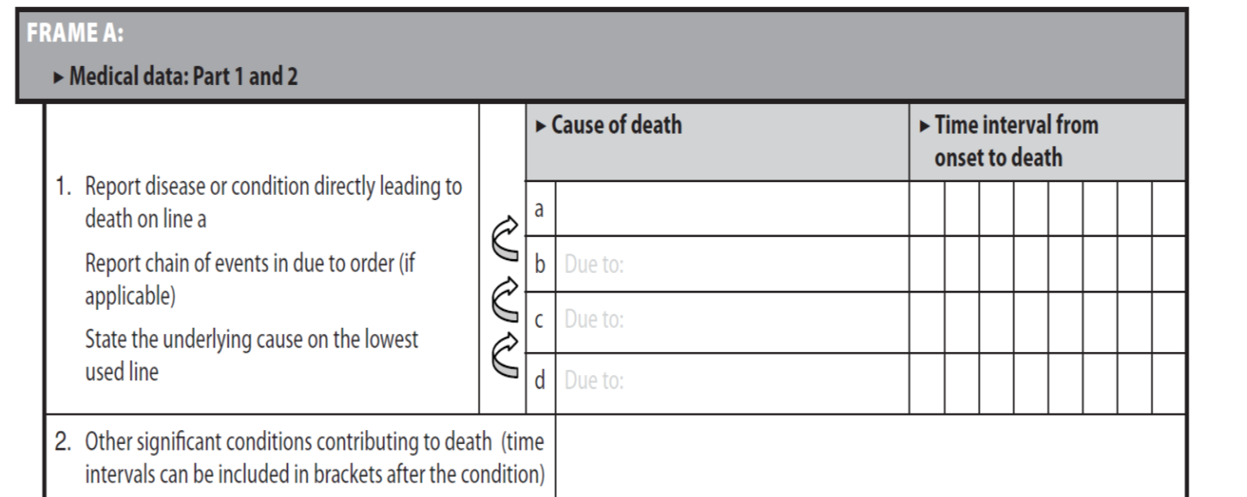
[1] Source: World Health Organization. Annex 7.1 International form of medical certificate cause of death. In: International statistical classification of diseases and related health problems, 10th revision, Volume 2 Instruction Manual. 5th ed. Geneva: World Health Organization, 2016.

B) Tongan medical certificate of cause of death

