Original pictures in figure 1
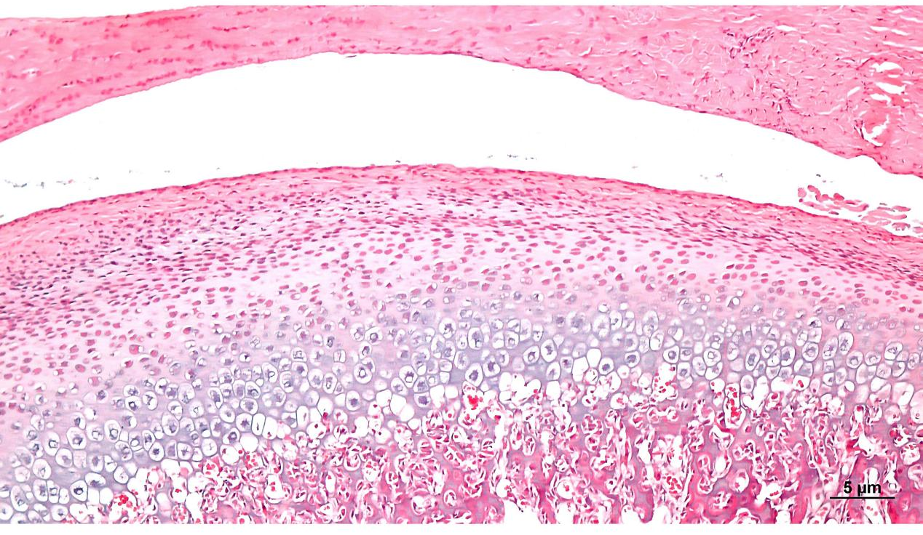
Fig1 A1:HE staining in normal group (x40)

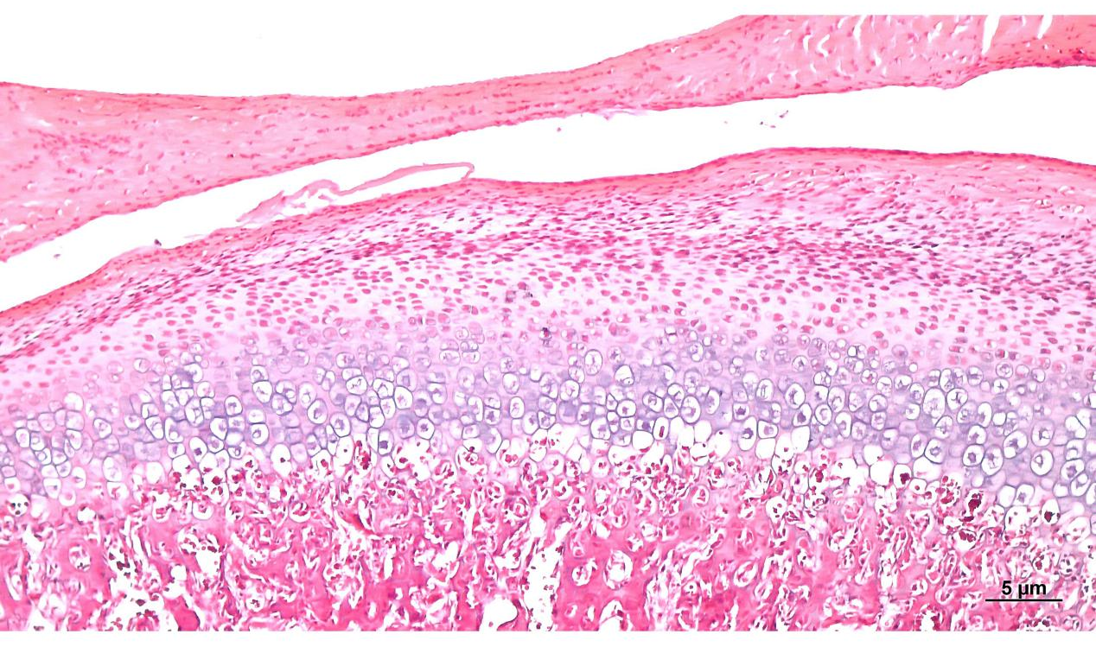
Fig1 A2:HE staining in normal group (x40)

Fig1 A1 and A2: HE staining in normal group, The HE staining results of the condylar cartilage of normal rats have a clear hierarchical structure (from top to bottom, it is joint disc, synovial cavity, proliferative layer, hypertrophic layer, and subchondral bone). The surface of the condylar cartilage is smooth and intact, with mast cells arranged in an alkaline order, and the thickness of the cartilage is normal.
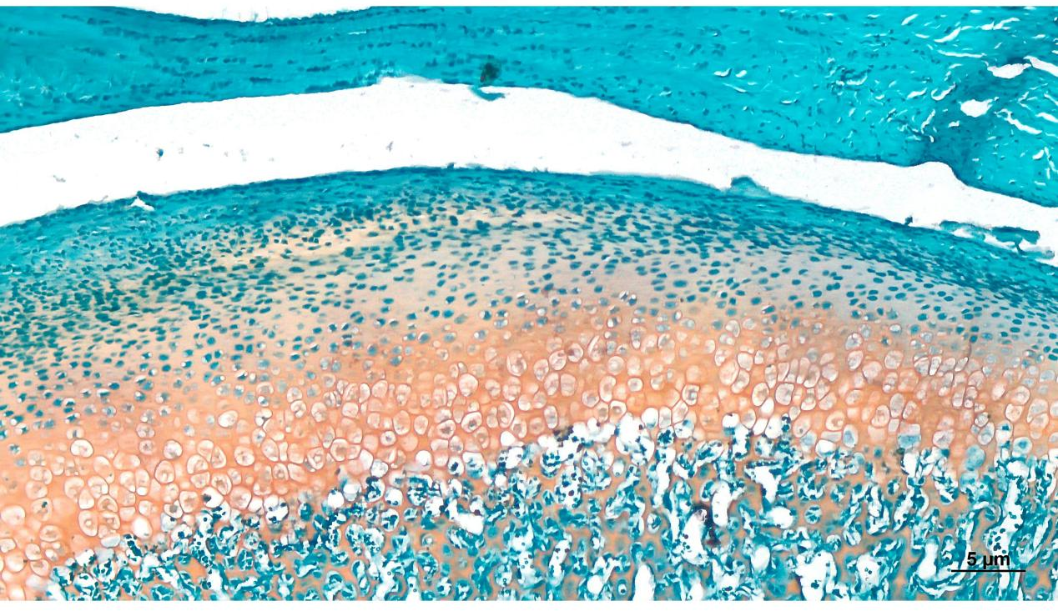
Fig1 A3:Saffron O-fast green staining in normal group (x40)

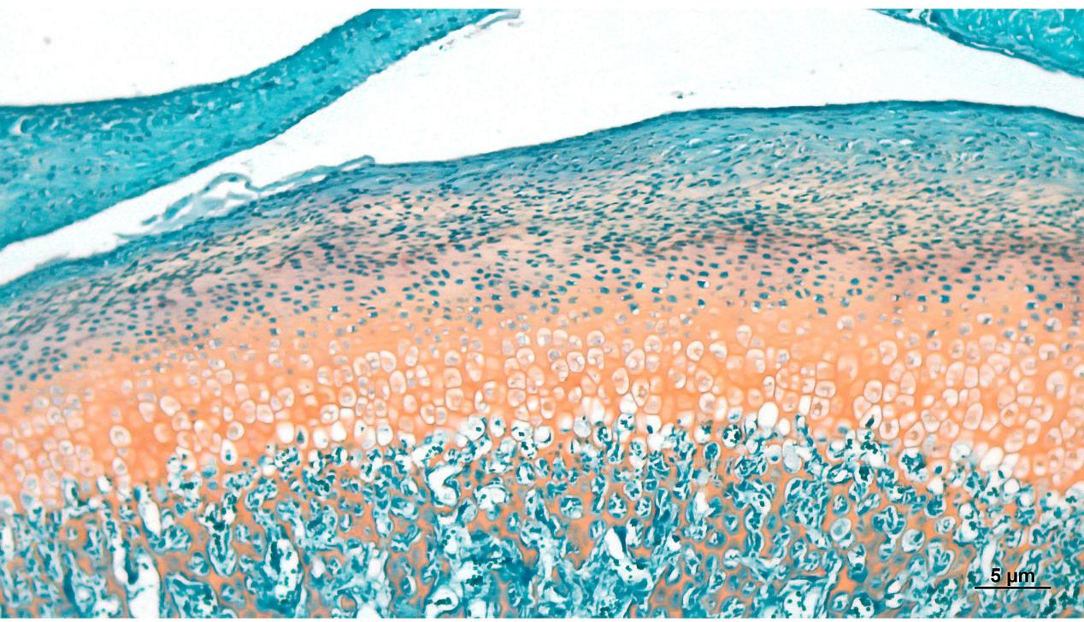
Fig1 A4:Saffron O-fast green staining in normal group (x40)

Fig1 A3 and A4: Saffron O-fast green staining in normal group: chondrocytes were orange red in safranine O-solid green staining, subchondral bone was green, and the interface (tidal line) between cartilage and subchondral bone was intact and smooth.
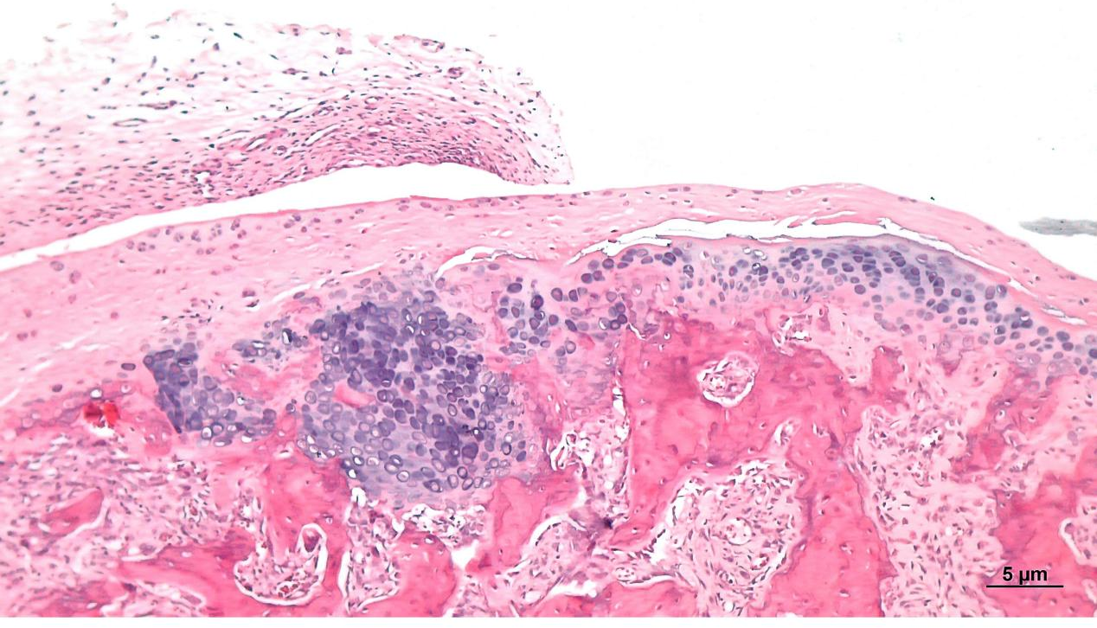
Fig1 B1:HE staining in model group (x40)

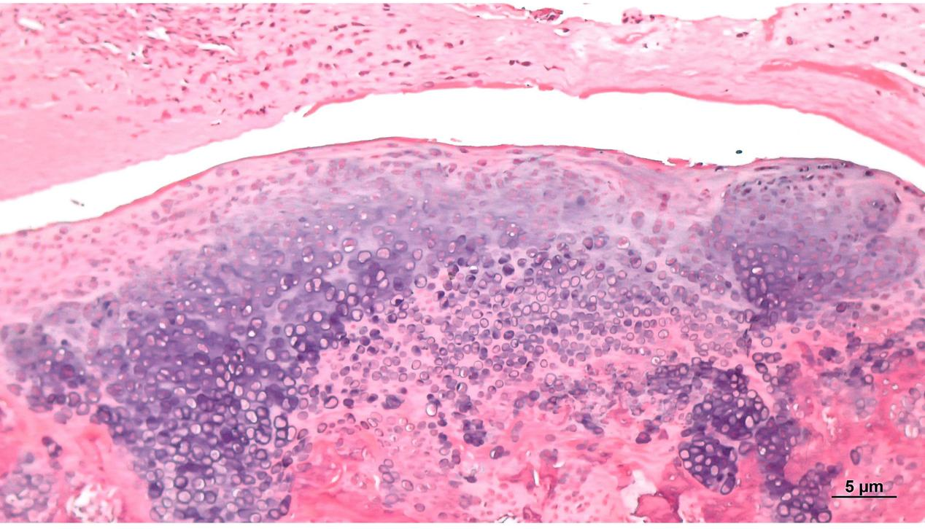
Fig1 B2:HE staining in model group (x40)

Fig1 B1 and B2:HE staining results showed that after injection of IL-1β and TNF-α, the condylar cartilage layer showed disorder, the proliferative layer disappeared, mast cells proliferated abnormally and arranged in disorder, and strong alkaline "chondromatous" like changes appeared.
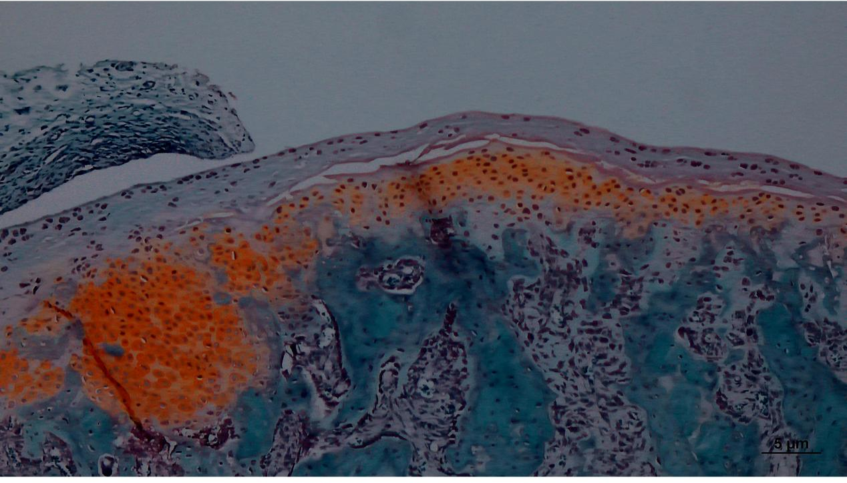
Fig1 B3:Saffron O-fast green staining in model group (x40)

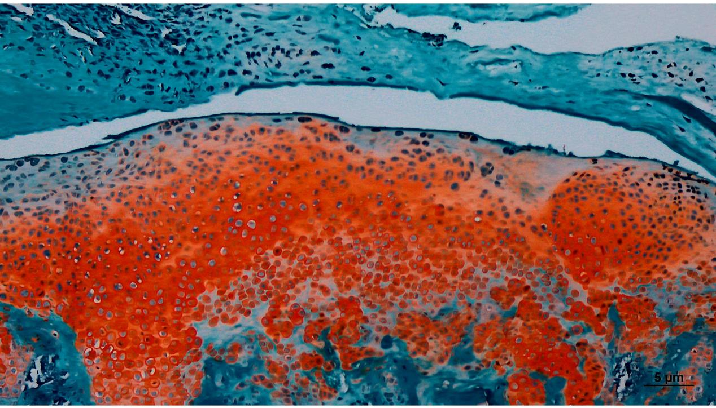
Fig1 B4:Saffron O-fast green staining in model group (x40)

Fig1 B3 and B4: Abnormal proliferation and disordered arrangement of chondrocytes with a bright red color were observed in safranine O-solid green staining, while invading subchondral bone and interrupting the continuity of the tidal line.
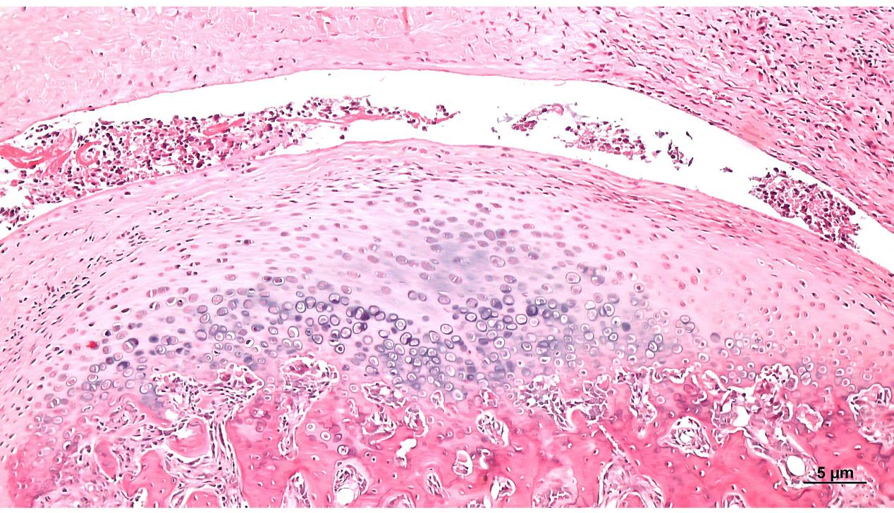
Fig1 C1: HE staining in control group (x40)

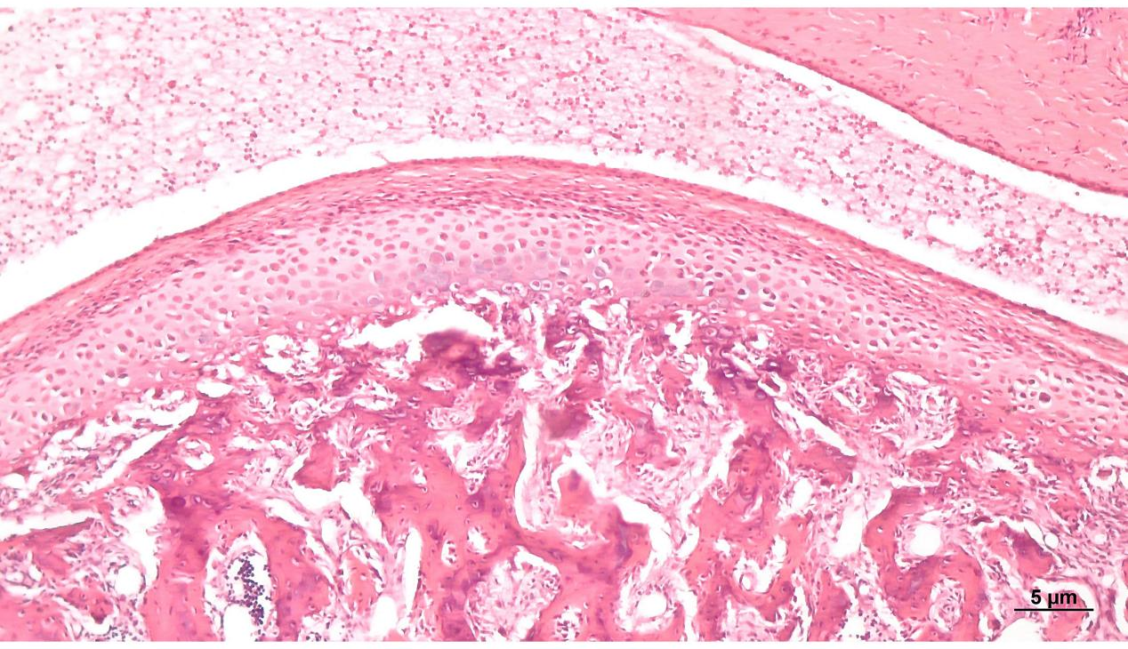
Fig1 C2: HE staining in control group (x40)

Fig1 C1 and C2: HE staining results showed that Inflammatory secretions appeared in the synovial cavity of the condylar cartilage, and the mast layer cells were disordered (abnormal proliferation or reduction of mast cells) after injected with IL-1β , TNF-α and agomir NC.
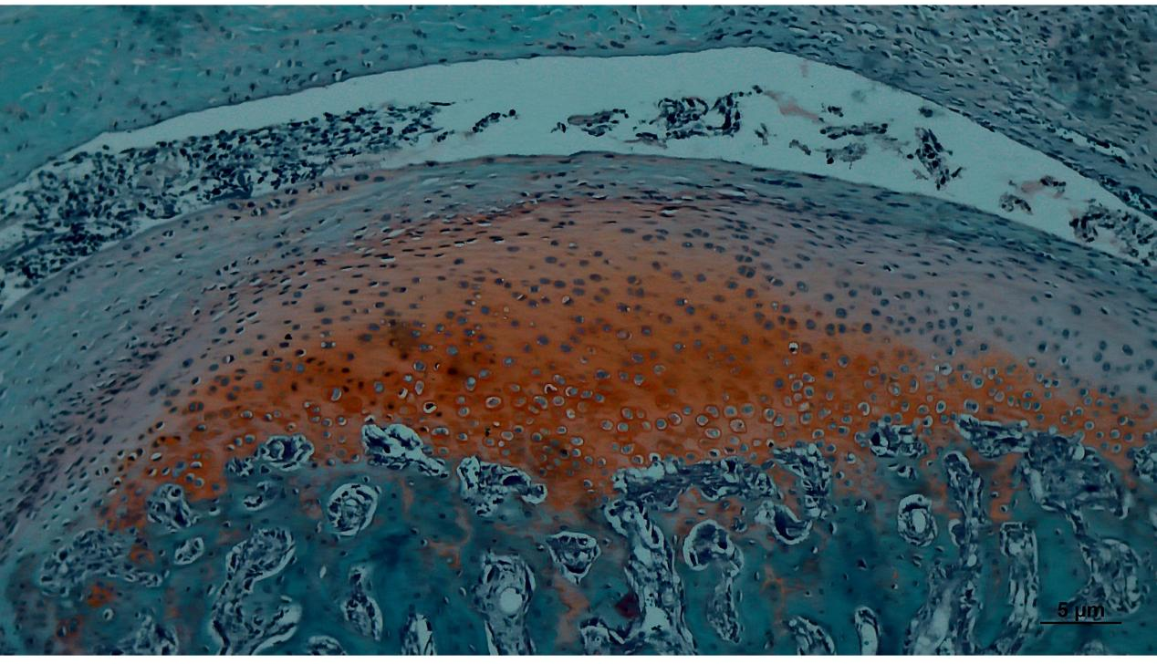
Fig1 C3: Saffron O-fast green staining in control group (x40)

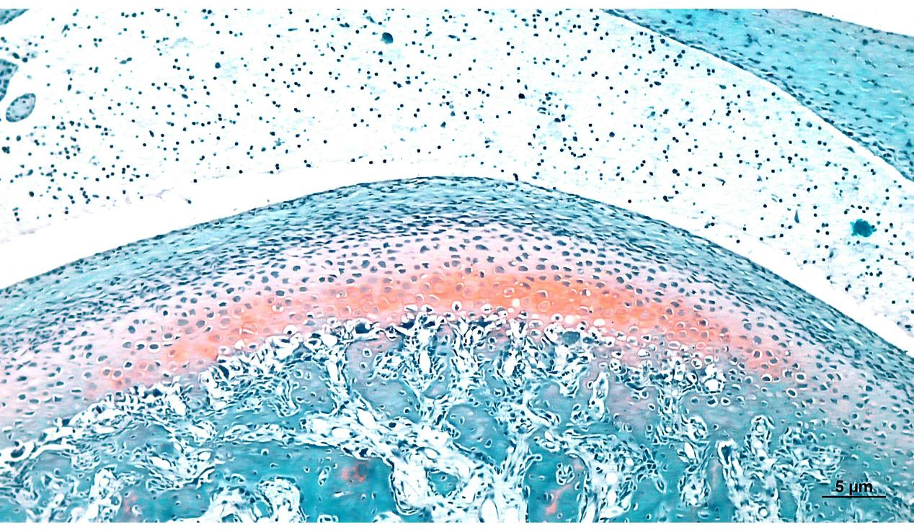
Fig1 C4: Saffron O-fast green staining in control group (x40)

Fig1 C3 and C4: The results of safranine O-solid green staining showed that the matrix of the condylar cartilage layer is loosened, and the arrangement of mast cells is disordered (abnormal proliferation or decrease in number of mast cells). after injected with IL-1β , TNF-α and agomir NC.

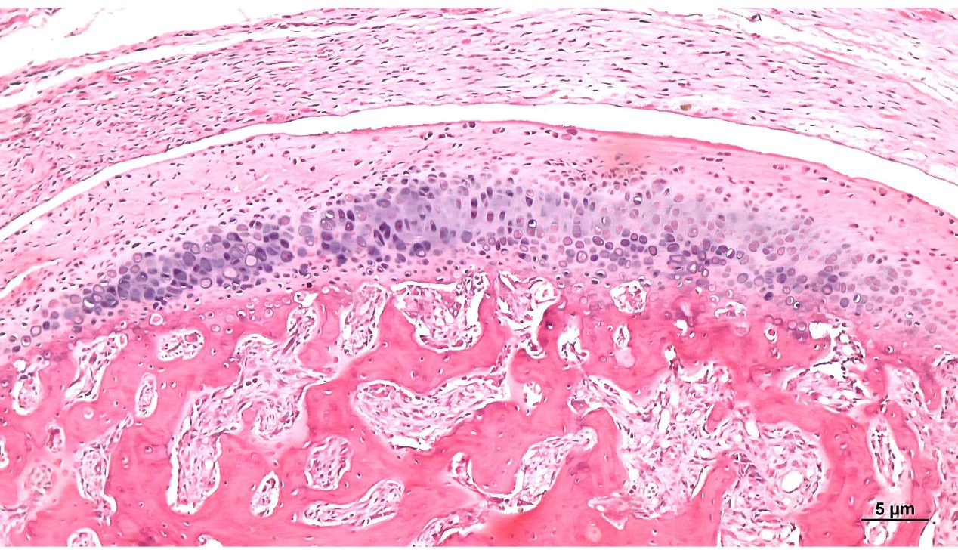
Fig1 D1:HE staining in experimental group (x40)

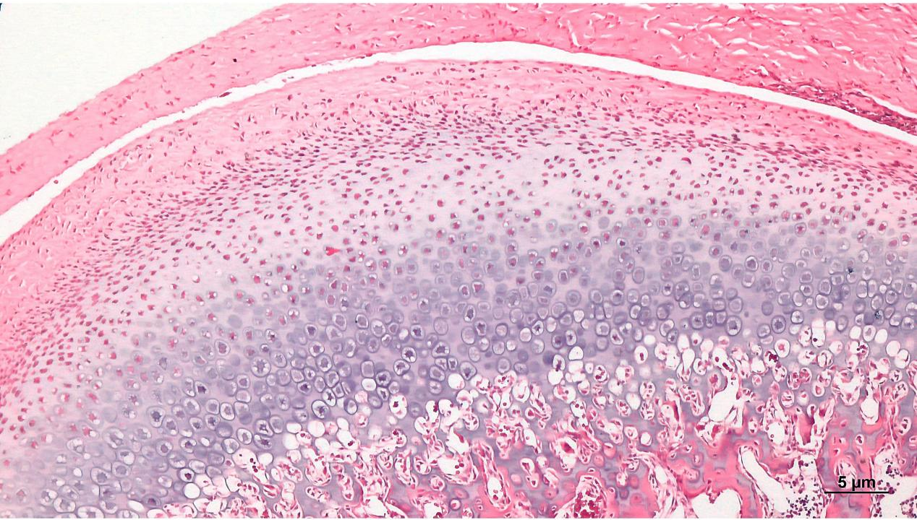
Fig1 D2: HE staining in experimental group (x40)

Fig1 D1 and D2: HE staining results showed that inflammatory secretions were significantly reduced in the experimental group (injection of miR-146a-5p agomir), and the structure of cartilage layers was clearer than that of the control group, and the cartilage structure was improved to some extent.
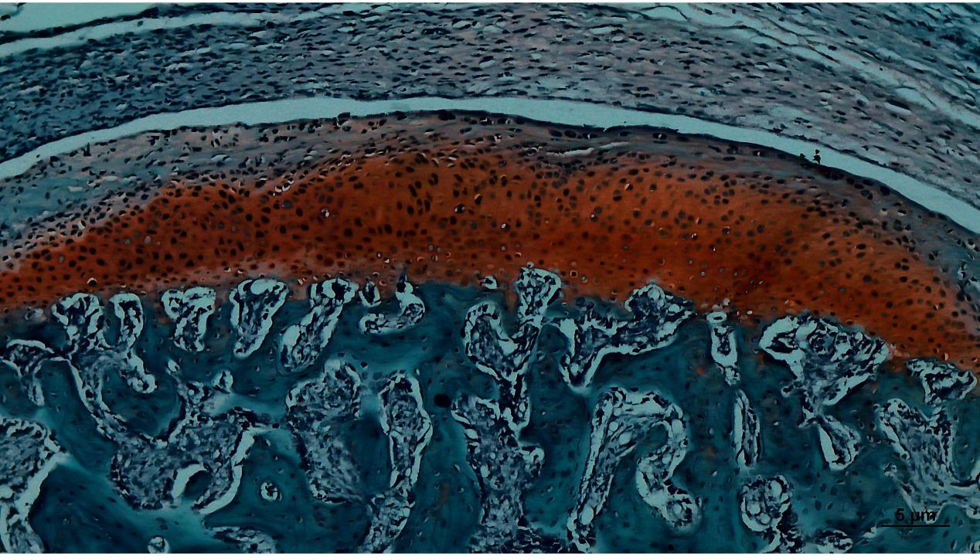
Fig1 D3: Saffron O-fast green staining in experimental group (x40)

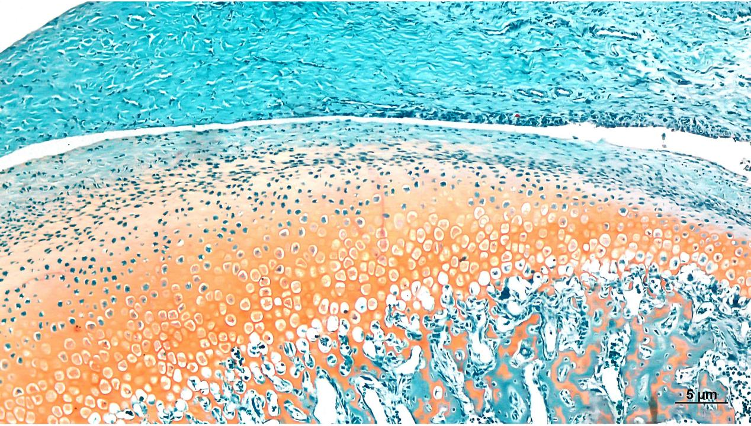
Fig1 D4: Saffron O-fast green staining in experimental group (x40)

Fig1 D3 and D4: The results of safranine O-solid green staining showed that the experimental group (injected with miR-146a-5p agomir) had improved cartilage structure, continuous "tidal line", increased number of chondrocytes and cartilage matrix.

