Original pictures in figure 2
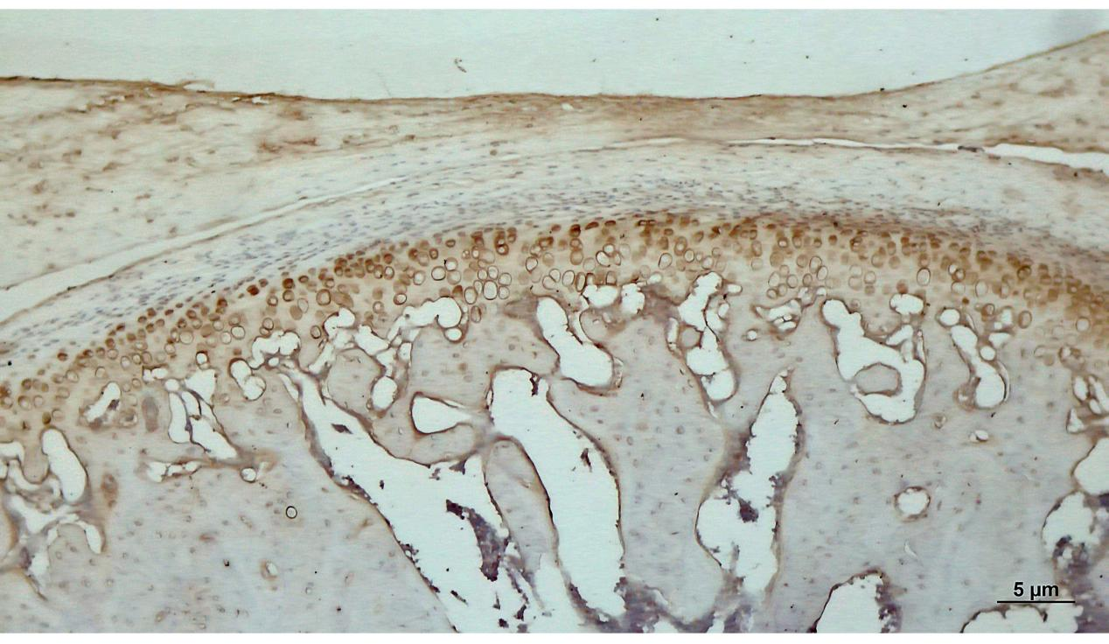
Fig2 A1: Expression of type II collagen in normal group, significant expression in the hypertrophic layer(x40).

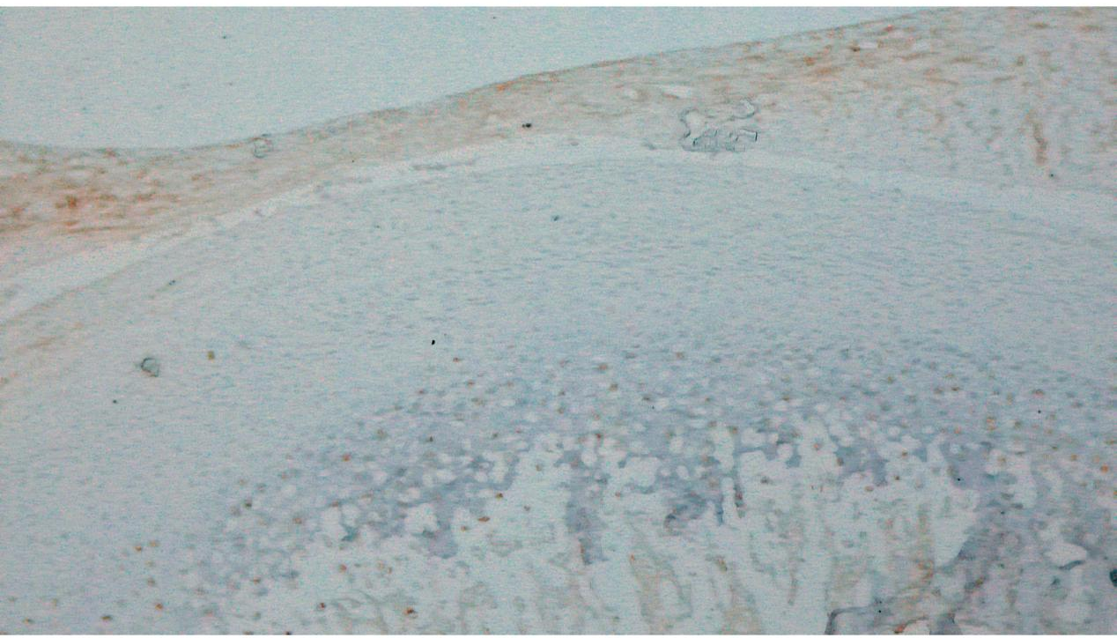
Fig2 A2: Expression of MMP9 in normal group, almost no expression in normal condylar cartilage(x40).

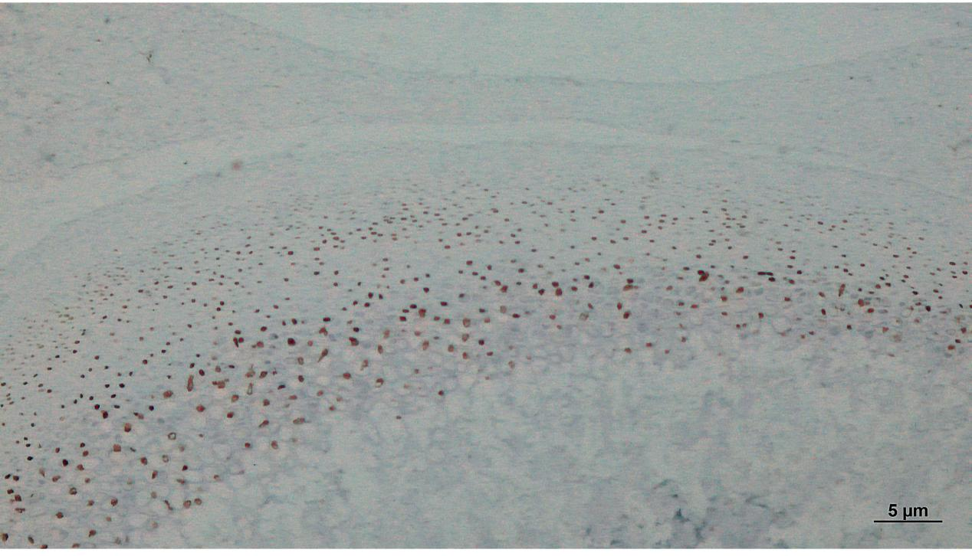
Fig2 A3: Expression of SOX9 in normal group, the nuclei of mast cells in normal condylar cartilage tissue show strong SOX9 positivity(x40).

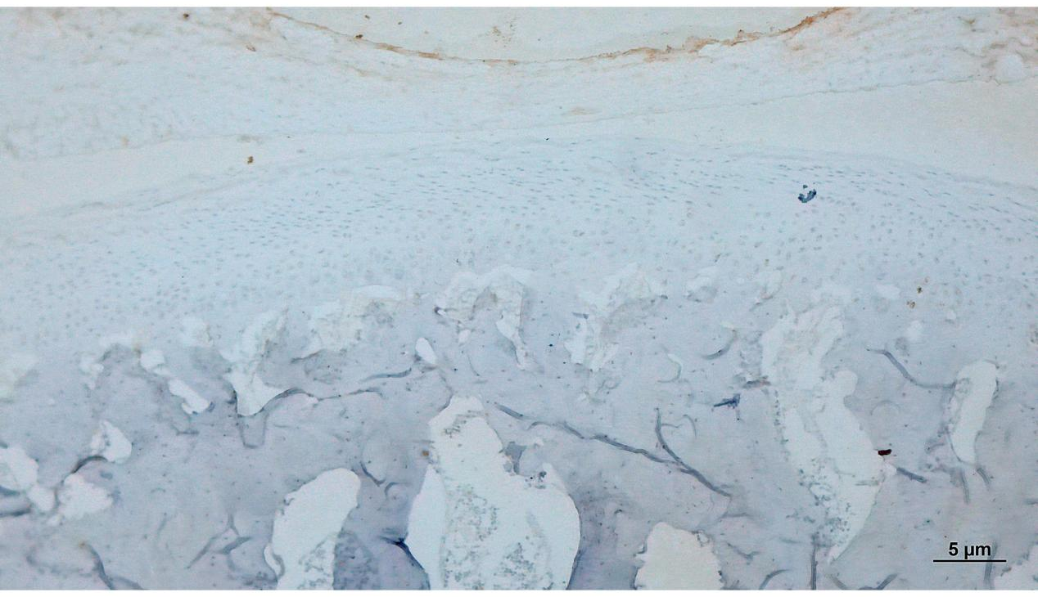
Fig2 A4: Expression of COX2 in normal group, almost no expression in normal condylar cartilage(x40).

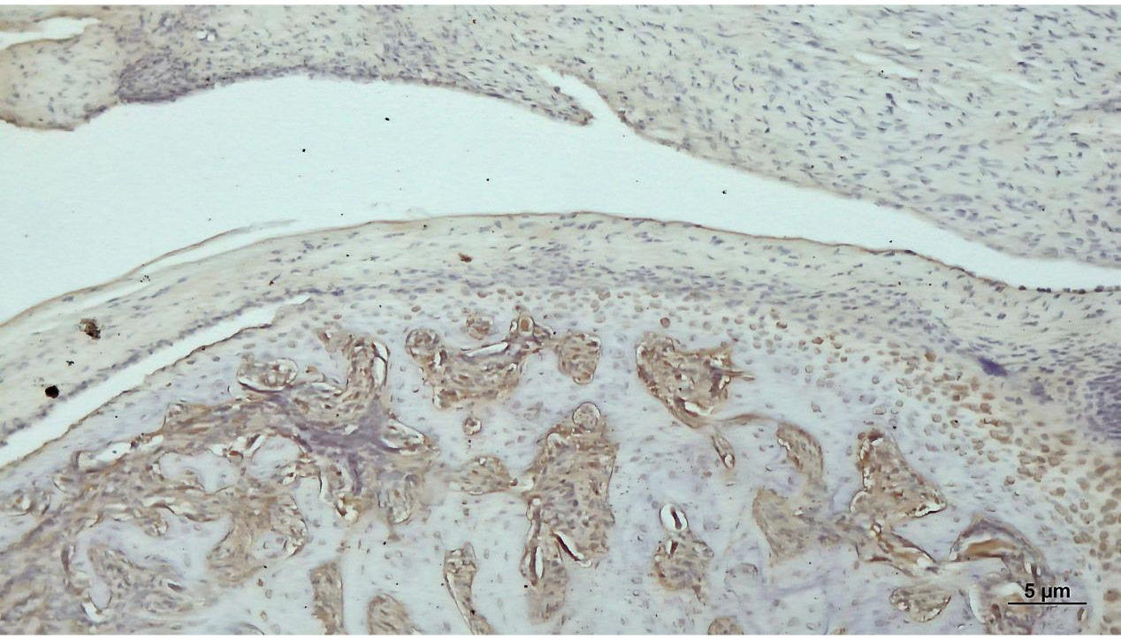
Fig2 B1: Expression of type II collagen in model group, after inflammatory stimulation, the cartilage structure undergoes significant disorder, and the expression of type II collagen in the hypertrophic layer is significantly reduced(x40).

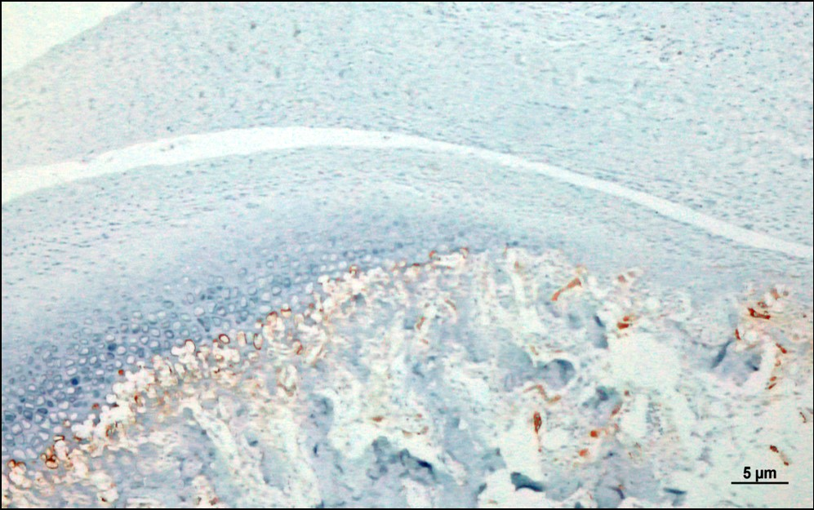
Fig2 B2: Expression of MMP9 in model group, expressed around deep mast cells and at the junction of cartilage and subchondral bone(x40).

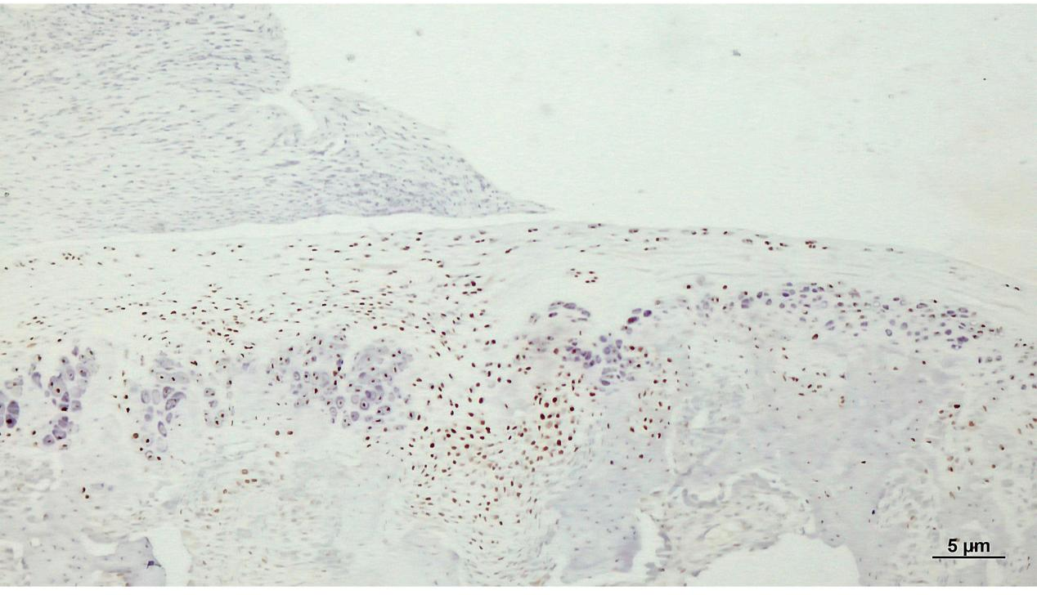
Fig2 B3: Expression of SOX9 in model group, positive expression in the nucleus of mast cells(x40).

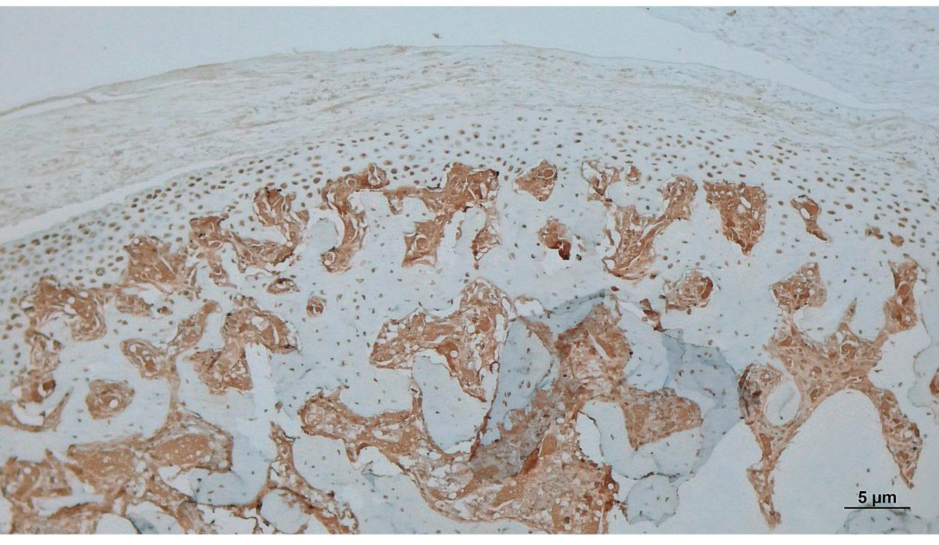
Fig2 B4:Expression of COX2 in model group, expression in the cytoplasm of condylar cartilage mast cells and subchondral bone(x40).

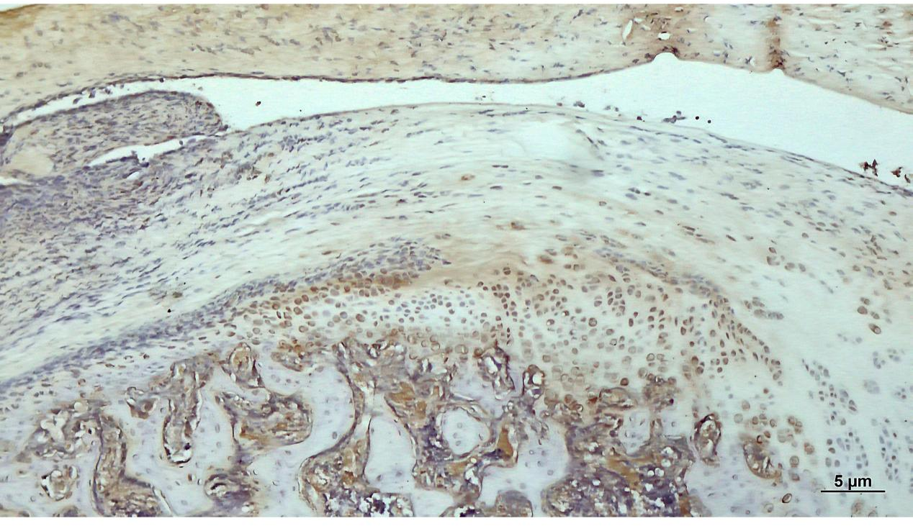
Fig2 C1: Expression of type II collagen in control group, the expression of type II collagen in the hypertrophic layer is significantly reduced(x40).

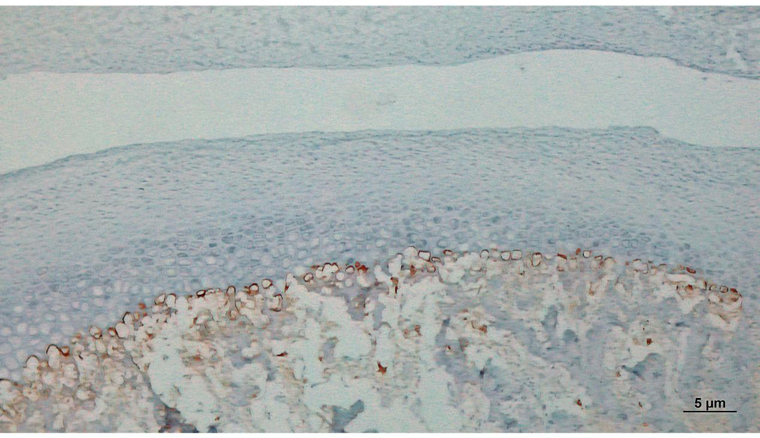
Fig2 C2: Expression of MMP9 in control group, expressed around deep mast cells and at the junction of cartilage and subchondral bone(x40).

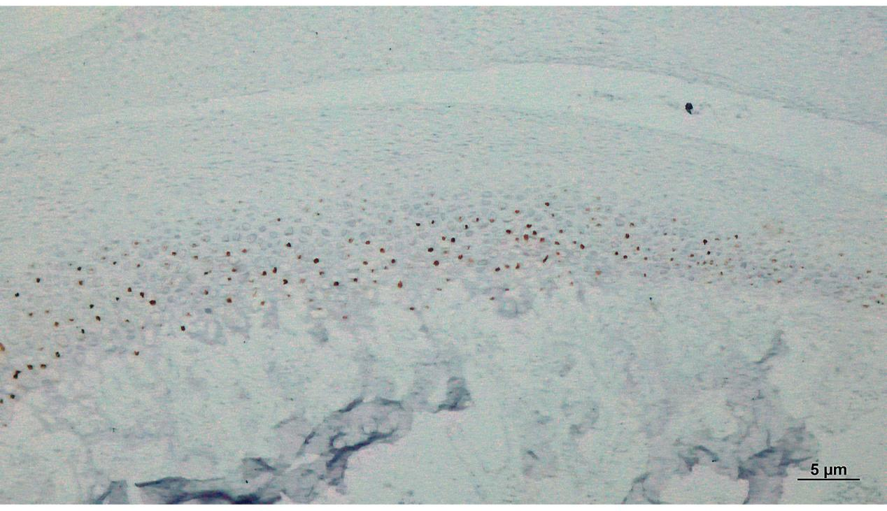
Fig2 C3: Expression of SOX9 in control group, positive expression in the nucleus of mast cells(x40).

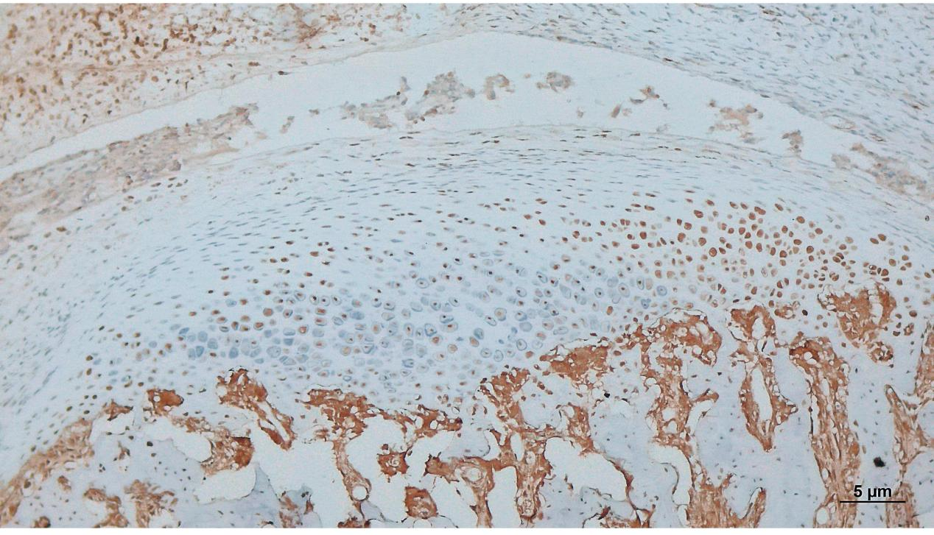
Fig2 C4: Expression of COX2 in control group, expression in the cytoplasm of condylar cartilage mast cells and subchondral bone(x40).

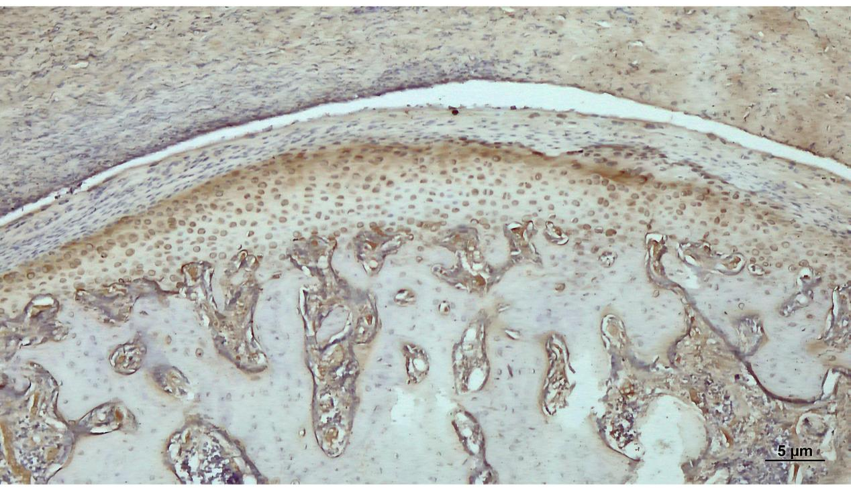
Fig2 D1: Expression of type II collagen in experimental group, after miRNA-146a-5p treatment, the expression of type II collagen in the hypertrophic layer increased significantly (x40).

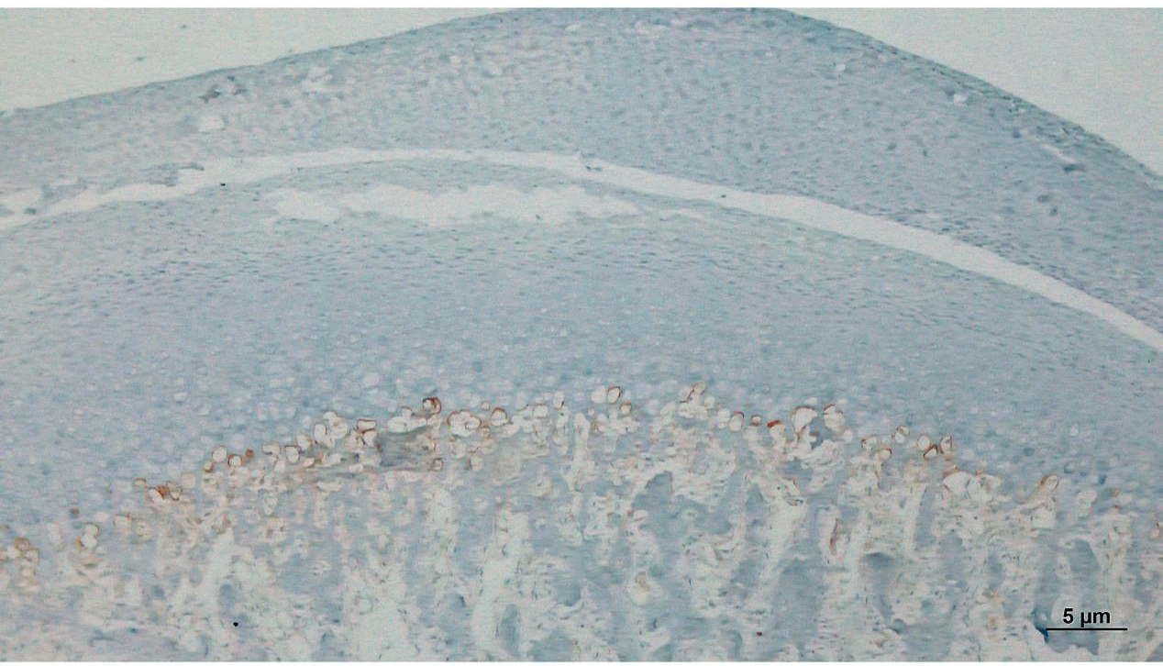
Fig2 D2: Expression of MMP9 in experimental group, after miRNA-146a-5p treatment, the expression of MMP9 was significantly reduced (x40).

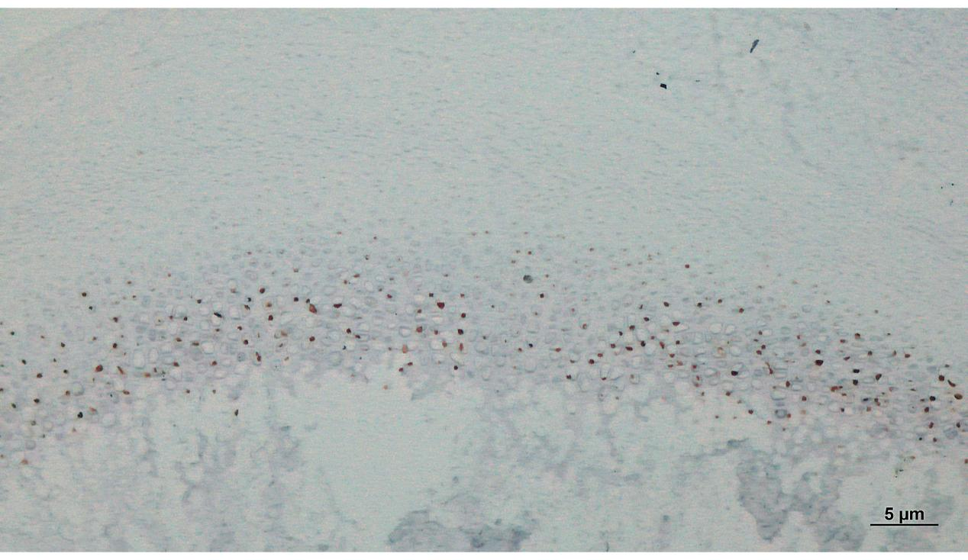
Fig2 D3: Expression of SOX9 in experimental group, positive expression in the nucleus of mast cells(x40).

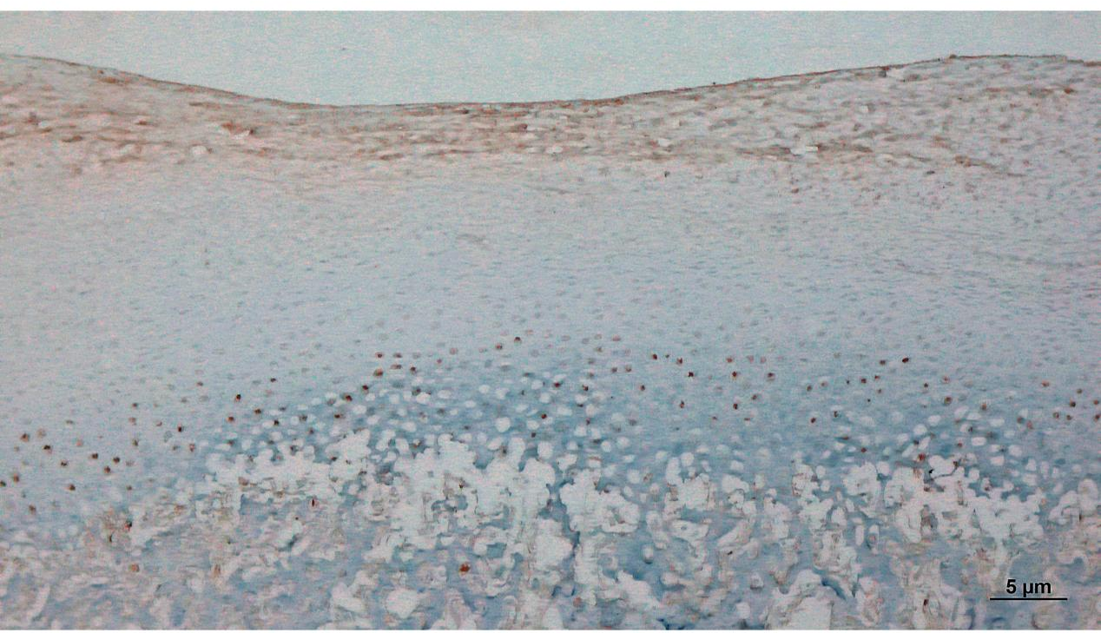
Fig2 D4: Expression of COX2 in experimental group, after miRNA-146a-5p treatment, a small amount of COX2 expression was observed in the hypertrophic layer and subchondral bone (x40).

