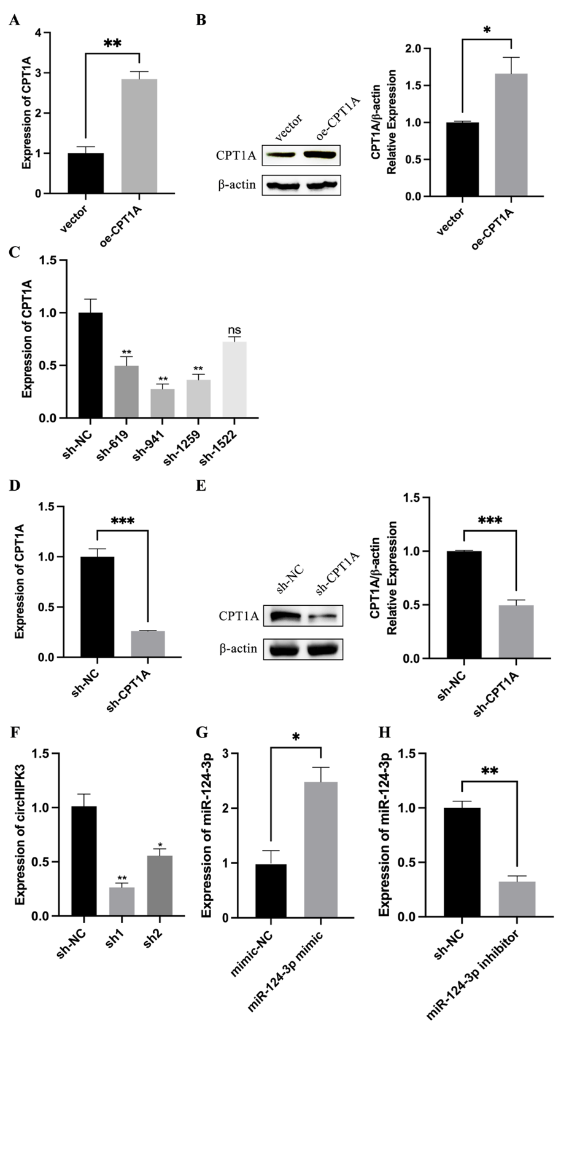
Supplementary Figure/Table
Figure S1 ECs were transfected with various plasmids and sh-RNA to effectively up- or downregulate the expression of circHIPK3, CPT1A, miR-124-3p.
(A, B) The mRNA and protein expression levels of CPT1A were measured in ECs after transfection with vector and the oe-CPT1A. (C) The mRNA expression of CPT1A was measured in ECs after transfection with sh-NC, sh-619, sh-941,sh-1259 and sh-1522. (D, E) The mRNA and protein expression levels of CPT1A were measured in ECs after transfection with sh-NC and sh-941. (F) The mRNA expression of circHIPK3 was measured in ECs after transfection with sh-NC, sh-1 and sh-2. (G,H) The mRNA expression of miR-124-3p was measured in ECs after transfection with mimic-NC, miR-24-3p mimic, sh-NC, or miR-124-3p inhibitor. The data are presented as the means ± SD of three independent experiments. * P <0.05; ** P <0.01; *** P <0.001; and **** P<0.0001 by one-way ANOVA and Student’s t-test. n.s., not significant.

Table S1. Primer sequences.
Amplicon | Primer FW (5′–3′) | Primer RV (5′–3′)
CPT1A | ATCAATCGGACTCTGGAAACGG | TCAGGGAGTAGCGCATGGT
CircHIPK3 | TCATGCTGATCTCAAGCCAGA | ACACAACTGCTTGGCTCTAC
β-actin | GATTCCTATGTGGGCGACGA | AGGACTCCATGCCCAGGAA

Primers for miR-124-3p and U6 were purchased from Sangon Biotech and were designed by the poly-A tail method.

