Supplementary Material

Supplementary Notes
Supplementary Note 1. Details of data collection and preprocessing
All images were collected on a Siemens Prisma 3-Tesla MRI scanner (Siemens Healthcare, Erlangen, Germany) equipped with a 64-channel head coil. High-resolution anatomical images were acquired using a T1w magnetization-prepared two rapid acquisitions with gradient echo (MP2RAGE) sequence (TR = 5000 ms, TI1 = 755ms, TI2 = 2500ms, TE = 3.43 ms; flip angle1 = 4°, flip angle2 = 5°; FOV = 256mm; 256 × 256 matrix; 208 sagittal slices; voxel size, 1 × 1 × 1mm³), with an acceleration factor of 3 in the primary phase encoding direction. Functional data were obtained using an echo-planar imaging pulse sequence (TR = 1000 ms, TE =33 ms; FOV = 220 mm; flip angle = 64º; 88 × 88 matrix; 65 slices; voxel size, 2.5 × 2.5 × 2.4 mm³).
RsfMRI was performed following the same procedure in each session and using the BrainSector®️ Cloud from Neural Galaxy Inc. The pipeline includes (1) slice timing correction using stc_sess from FreeSurfer version 6.0.0 software package (http://surfer.nmr.mgh.harvard.edu), (2) rigid body correction for head motion with the mc_sess from FreeSurfer (https://surfer.nmr.mgh.harvard.edu/fswiki/mc-sess), (3) normalization for global mean signal intensity across runs, (4) linear detrending and bandpass filtering (0.01 - 0.08 Hz), and (5) nuisance variables (6 motion parameters, white-matter signal, ventricular signal, global signal, and their first temporal derivatives) regression. Note that we included global signal regression (GSR) in the preprocessing pipeline, despite lacking consensus regarding whether GSR should or should not be included in resting-state data processing to date. To examine whether our results would be affected by the GSR, we also preprocessed all data without GSR and compared results from two pipelines.
Structural data was processed using the FreeSurfer version 6.0.0. Surface mesh representations of the cortical cortex from each participant’s structural images were reconstructed and non-rigid registered to a standard spherical coordinate system (fsaverage). FMRI images after nuisance variable regression were linearly aligned to the corresponding participant’s high-resolution structural images using boundary-based registration to maximize the contrast between white matter and grey matter. The functional images were registered to the FreeSurfer cortical surface template (fsaverage6), consisting of 40,962 vertices for each hemisphere, through sampling from the middle of the cortical ribbon in a single interpolation step. Next, a 6-mm full-width half-maximum (FWHM) smoothing kernel was applied to the fMRI data on the cortical surface. The surface smoothing facilitates minimization of the blurring of fMRI signals across sulci or gyri.

Supplementary Note 2. Details of the reconstructive model

Network-level z-score transformation. Each functional connectome in this study was composed of 88 pair-wise connected ROIs and 7744 ROI-level functional connectome edges. Any edge was included in one of 36 pairs of network-level functional connectomes, such as MOT-MOT, VIS-DMN, and FPN-DMN. The network-level z-score transformation decomposed the functional connectomes into the network-level means/standard deviations (STD) and the z-scores functional connectomes. Specifically, each network-level mean and STD was calculated across functional connectome edges within one of the 36 pairs of functional networks. Each z-score functional connectome edge was obtained by subtracting the mean value and dividing the STD of the pair of network-level functional connectome that the edge belongs to.

Nonlinear fitting model. The network-level mean and STD of the awake functional connectome were predicted by fitting the mean and STD of the anesthetized functional connectome into a quadratic function produced using the ordinary least square method. This function is defined as: $Y=aX^{2}+bX+c+ε$, where $X$ represents the mean or STD of the anesthetized functional connectome, $Y$ represents the mean or STD of awake functional connectome, $a$, $b$, and $c$ represent regression coefficients to be estimated, and $ε$ denotes the residuals. The process of coefficient estimation was performed independently for each network-level functional connectome.
Hierarchical Bayesian Model. An HBM was trained to predict the z-scores for functional connectome in awake state from the data of the anesthetized state (The graphic model was shown in Fig. S7). First, the intra-individual variability in functional connectome was modeled with the assumption that the observed functional connectome for a given participant, a given run was normally distributed, being subject to the random effect of run:
$$Y_{(prn)}\sim N\left(θ_{\left(pn\right)},σ^{2}\right)$$
, where $n$ ($n$ = 1, . . ., 7744) indicates the index of RSFC edges from the functional connectome, $p$ ($p$ = 1, . . ., 12) indicates different participant, and $r$ ($r$ = 1, . . ., 8) denotes different runs, Y_{(prn)} denotes the z-score of n^{th} functional connectome in the awake state from participant $p$ at run $r$, $θ_{\left(pn\right)}$ was the mean value of the z-score connectivity across different run for the n^{th} functional connectome from participant $p$, and $σ$ was the standard deviation of this distribution, capturing the intra-individual variability of z-score for functional connectome in awake state. The intra-individual variability was assumed to be generated from random effect and invariant across participants and functional connectomes. Second, a linear function was employed to model the relationship of RSFC between the anesthetized and awake state:
$$θ_{\left(pn\right)}=X_{\left(pn\right)}β_{\left(pn\right)}$$
$$=\left[X_{\left(pn\right)},1\right]\left[{a_{(pn)} \atop b_{(pn)}}\right]$$
, where $X_{\left(pn\right)}$ denotes the average z-score of the anesthetized functional connectome across runs for the n^{th} functional connectome from participant $p$ and $β_{\left(pn\right)}$ denotes a vector of free parameters for the n^{th} functional connectome from participant $p$, consisting a slope parameter $a_{(pn)}$ and a constant parameter $b_{(pn)}$. Third, the inter-individual variability was modelled with the assumption that the parameter β was randomly sampled from a population distribution, specified as below:
$$β_{(pn)}\sim N\left(μ_{β_{(n)}},Σ_{β_{(n)}}^{2}\right)$$
, where $μ_{β_{(n)}}$ represents a vector for the n^{th} functional connectome, composed of the mean values of the two free parameters across participants, and $Σ_{β_{(n)}}$ represents a matrix of standard deviations across participants, explaining inter-individual variability of free parameters for the n^{th} functional connectome.
Markov chain Monte Carlo technique was performed to sample the posterior distribution^{54,55}. The sampler used three chains, 1,000 as the number of adaptive steps, 10,000 steps for burning in the chains, and 15003 total saved steps.

Supplementary Figures

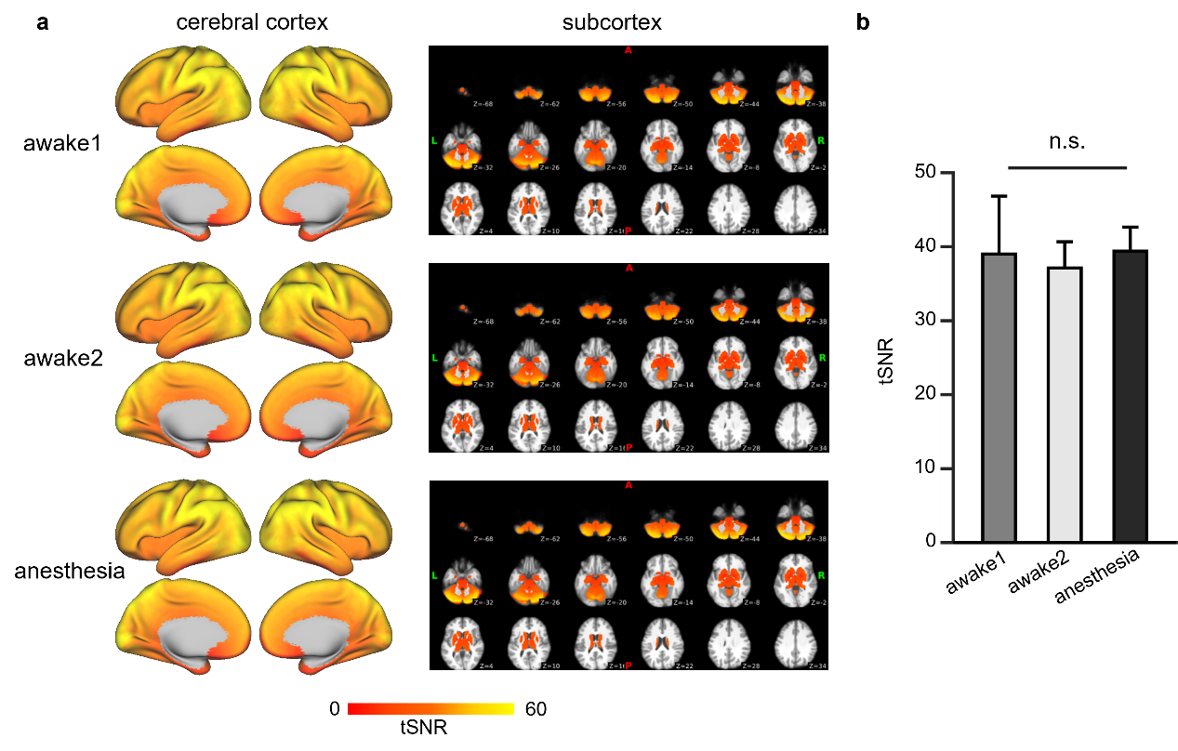

Fig. S1 The temporal signal-to-noise ratio (tSNR) of BOLD signal is comparable among three sessions. a Group-average maps of tSNR exhibited similar patterns across the awake1 (top panel), awake2 (middle panel), and anesthetized (bottom panel) sessions. Each cortical tSNR map was overlaid on the inflated cortical surface (left column), and each subcortical tSNR map was overlaid on the volumetric template (right column). The results demonstrate that cortical and subcortical tSNR maps show comparable patterns across the three sessions. b The average tSNR across voxels of gray matter during the three sessions are similar and approximately equal to 40 (39.0 for awake1, 37.1 for awake2, and 39.4 for anesthesia, respectively). Error bars represent standard deviations. The results of the ANOVA test indicate no significant differences (n.s., p > 0.05) among the three sessions.
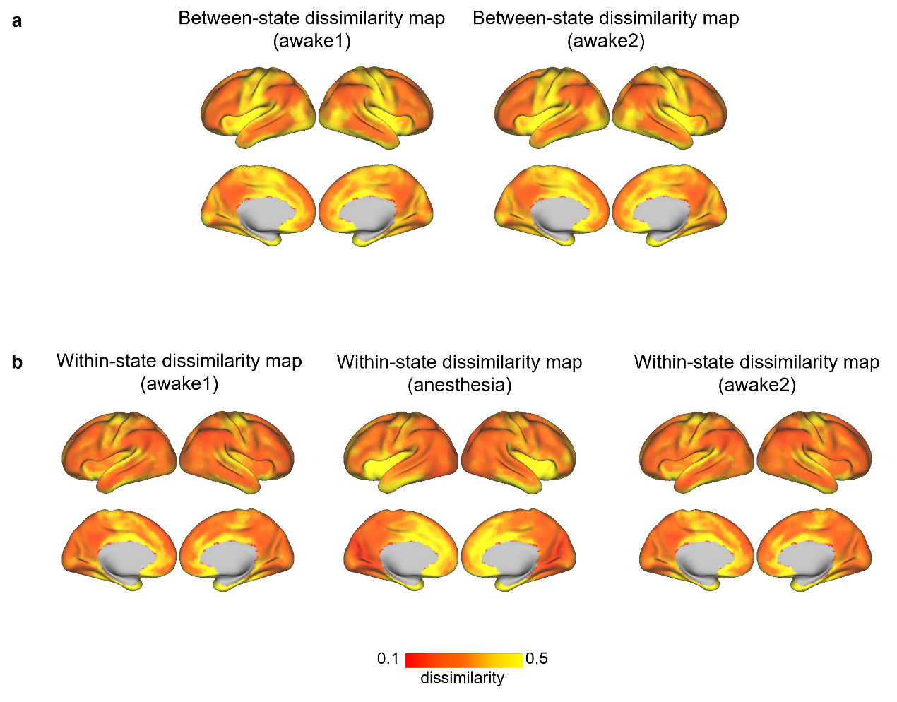
Fig. S2 The between-state dissimilarity maps without regressing within-state dissimilarity maps show similar spatial distribution to the anesthetic effect map. a The between-state dissimilarity maps were calculated between the anesthetized and awake1 session (left panel), and between the anesthetized with the awake2 session (right panel). b Within-state dissimilarity maps were calculated for the awake1 session (left panel), the anesthetized session (middle panel), and the awake2 session (right panel) respectively. The yellow-red color bar underneath illustrates the dissimilarity values.

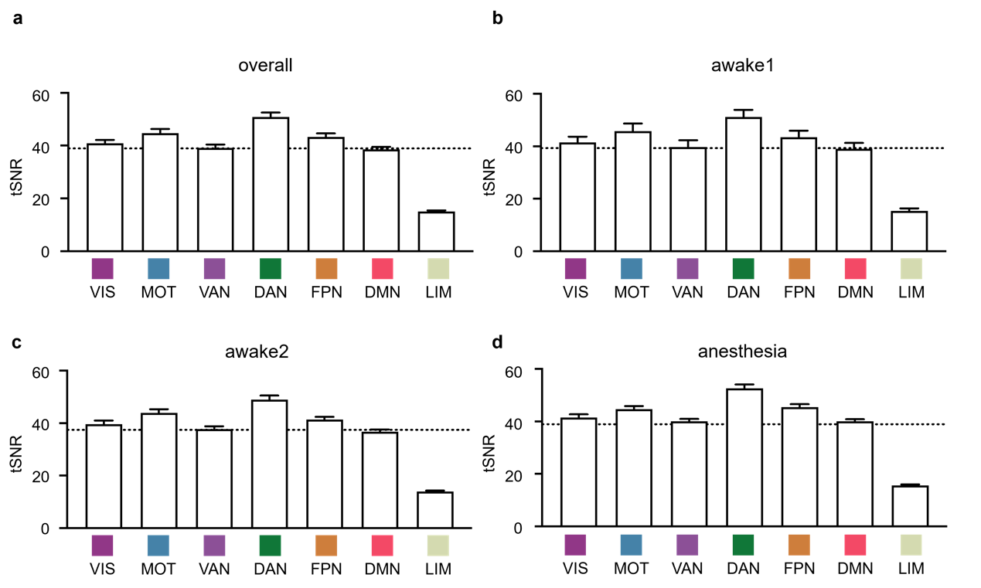

Fig. S3 The limbic network exhibits the lowest tSNR among seven functional networks in all states. a-d The tSNR of each large-scale functional network was averaged across all awake1, awake2, and anesthetized sessions, revealing a significantly lower value for the limbic network when compared across networks in the One-way ANOVA (p < 0.001). Post hoc tests further confirmed that the tSNR of the limbic network was significantly lower than all the other networks (p’s < 0.001). Similarly, the tSNR of functional networks in the (b) awake 1, (c) awake2, and (d) anesthetized sessions also showed significantly lower values in the limbic network. The error bars represent the standard deviation of the tSNR in each network across all participants. The dotted line indicates the global mean of tSNR in the entire cerebral cortex.

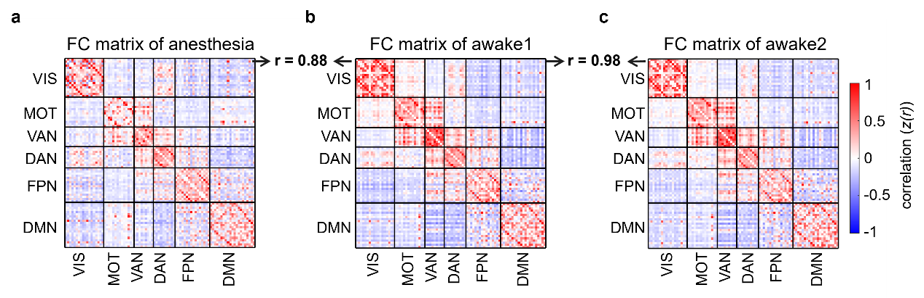

Fig. S4 The group-level RSFC under anesthetized state shows reduced similarity with awake state. a-c Group-average functional connectomes were computed by averaging the RSFC between all pairs of functional regions across all healthy participants in (a) awake1, (b) awake2, and (c) anesthesia sessions, respectively. The functional connectomes derived from the awake1 session exhibited lower similarity to the anesthetized session (r = 0.88) than to the awake2 session (r = 0.98).
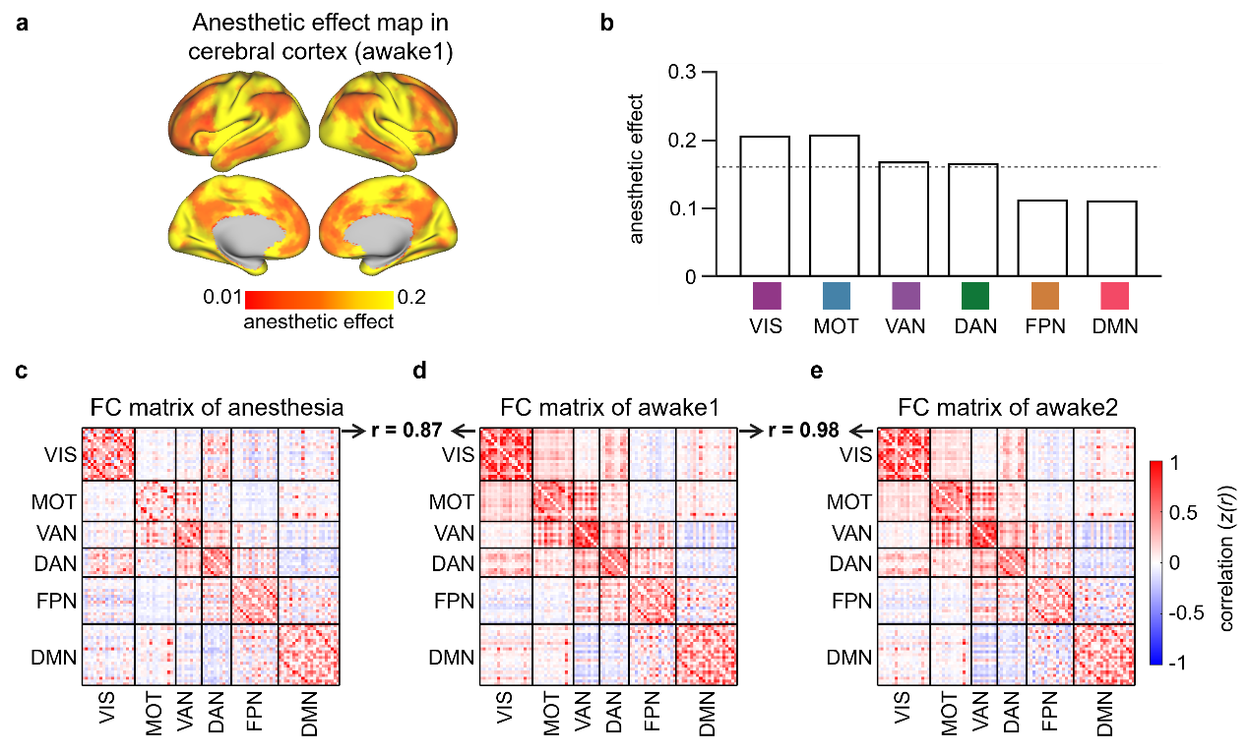

Fig. S5 Anesthetic effects on RSFC are consistent in data preprocessed with and without global signal regression (GSR). a The anesthetic effect map, estimated by the dissimilarity between two connectivity profiles, was calculated from the preprocessed data without GSR from the anesthetized and awake1 sessions. The map demonstrates a consistent pattern with the data preprocessed with GSR. The yellow-red color bar illustrates the magnitude of the anesthetic effect. b Among the 6 functional networks, anesthesia affected the primary cortex (VIS and MOT) the most and higher order cognitive networks the least. The dotted line indicates the mean of the anesthetic effect across all functional networks. c-e Group-average functional connectomes, computed between all pairs of brain regions in different sessions, revealed that the functional connectomes derived from the awake1 session exhibited lower similarity to the anesthetized session (r = 0.87) than to the awake2 session (r = 0.98), which aligns with the result of the anesthetic effect on functional connectomes from data preprocessed without GSR.
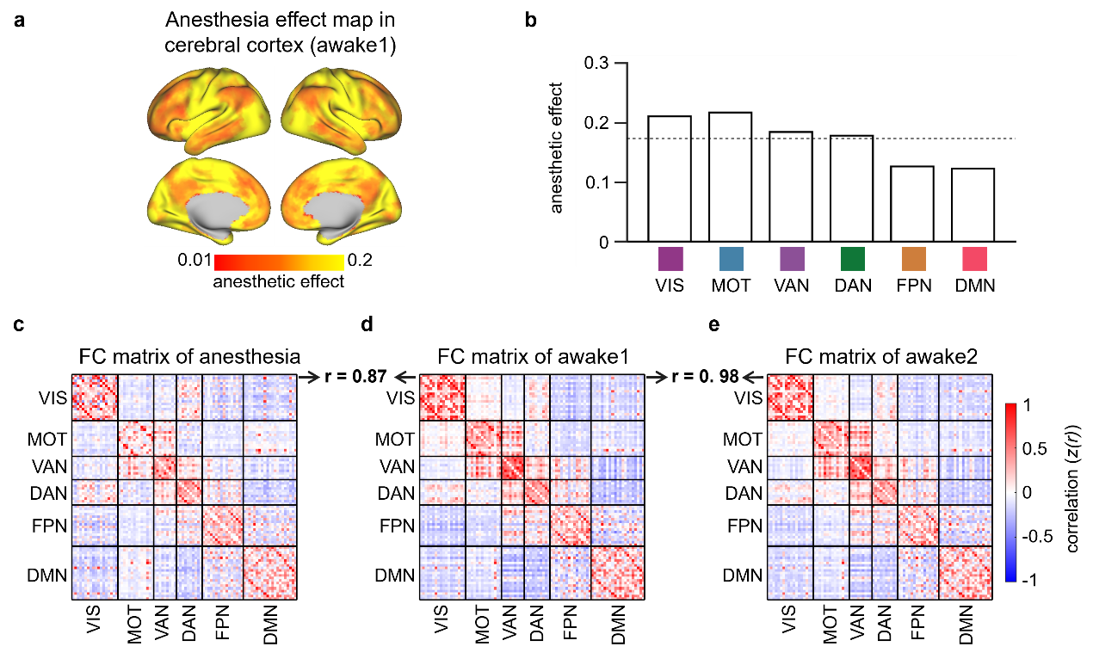

Fig. S6 Anesthetic effects on RSFC are consistent in data analyzed from all 4 runs and from the last 3 runs. a The anesthetic effect map, estimated by the dissimilarity between two connectivity profiles, was calculated from the data discarding the first run and combining only the last 3 runs from the anesthetized and awake1 sessions. The map demonstrates a consistent pattern with the full-length data. The yellow-red color bar illustrates the magnitude of the anesthetic effect. b The anesthetic effects on six functional networks show consistent results with data from all the runs, with the largest influence observed in primary networks and the least influence in higher-order cognitive networks. The dotted line indicates the mean of the anesthetic effect across all functional networks. c-e Group-average functional connectomes, computed between all pairs of brain regions in different sessions, revealed that the functional connectomes derived from the awake1 session exhibited lower similarity to the anesthetized session (r = 0.87) than to the awake2 session (r = 0.98), which is similar to the anesthetic effect on functional connectomes analyzed from the full-length data.

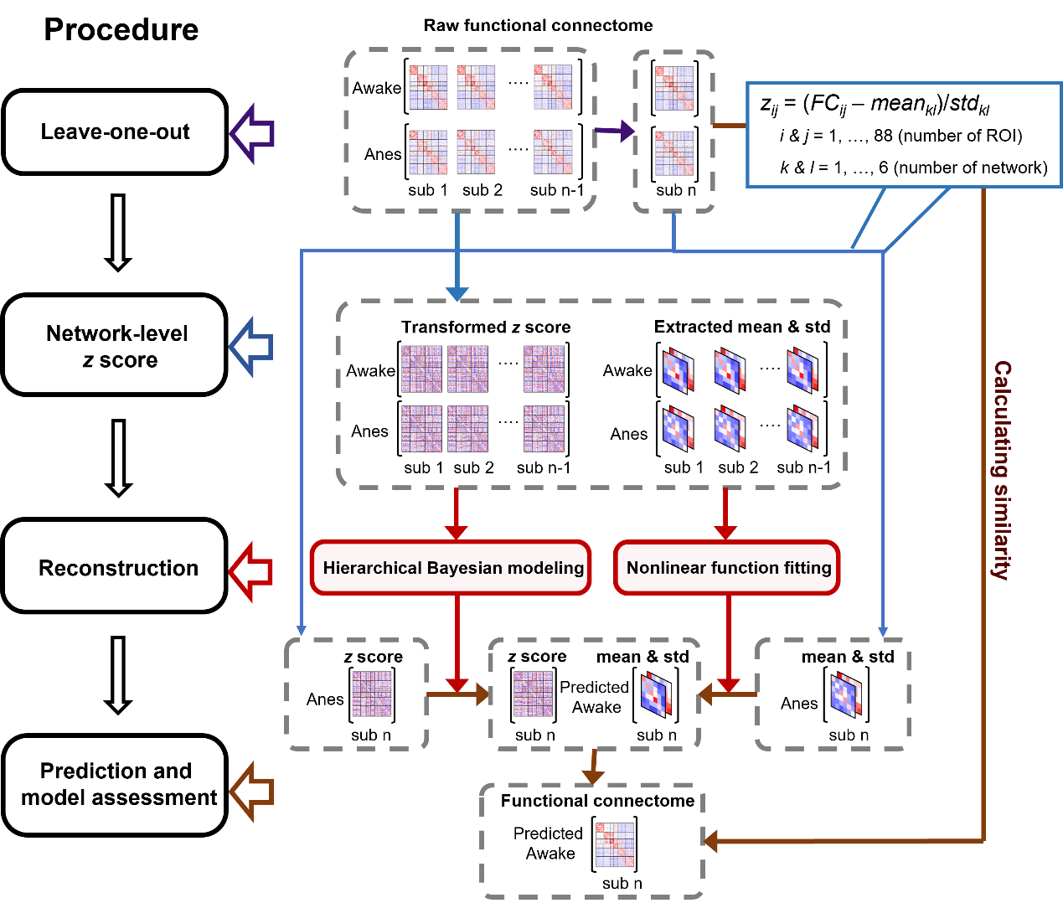

Fig. S7 Diagram of the reconstructive model. The reconstructive model involves several steps:
1. Network-Level z-Score Transformation: The functional connectomes in the awake state and in the anesthetized state were subjected to a network-level z-score transformation, which divided them into two parts: the network-level means and standard deviations, and the z-scored connectome.
2. Nonlinear Fitting Model: For participants in the training set, a nonlinear fitting model was applied to predict the mean and standard deviations of the network-level RSFC.
3. Hierarchical Bayesian Model (HBM): A Hierarchical Bayesian Model (HBM) was trained to predict each normalized RSFC edge in the awake state from the corresponding edge in the anesthetized state.
4. Reconstructed RSFC Calculation: For each participant in the test set, the reconstructed RSFC of the awake functional connectome was calculated by applying an inverse network-level z-score transformation to the predicted network-level connectivity and RSFC edges from the anesthetized functional connectome.
5. Leave-One-Out Cross Validation (LOOCV): The accuracy of predicting the awake individualized functional connectomes from the anesthetized session was evaluated using the Leave-One-Out Cross Validation (LOOCV) procedure.

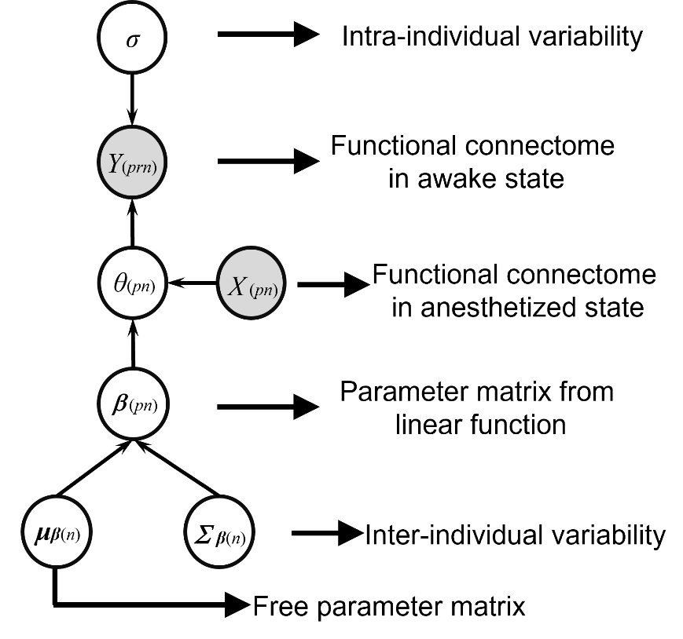

Fig. S8 Schematic depiction of the Hierarchical Bayesian Model. The goal of this model is to estimate transformation parameters $β_{\left(pn\right)}$, which describes how RSFC changes from the anesthetized state to awake state. In this graphical representation of the model, the shaded nodes represent observed variables and unshaded nodes represent latent variables. $Y_{(prn)}$ denotes the z-scored n^{th} RSFC in the awake state from participant $p$ at run $r$, which is generated from a normal distribution with parameters $θ_{\left(pn\right)}$and $σ$. $σ$ denotes the standard deviation of this distribution, representing the intra-individual variability of z-scored RSFC in awake state. While $θ_{\left(pn\right)}$ denotes the mean value of for the n^{th} RSFC from participant $p$, generated from a linear function of $X_{\left(pn\right)}$ and $β_{\left(pn\right)}$ that captures the relationship of RSFC between the anesthetized and awake state.$X_{\left(pn\right)}$ denotes the mean value of z-scored RSFC in anesthetized state across different runs for the n^{th} RSFC from participant $p$. $β_{\left(pn\right)}$ denotes a vector of free parameters for the n^{th} RSFC from participant $p$, which is generated from a distribution with parameters $μ_{β_{(n)}}$ and $Σ_{β_{(n)}}$.$μ_{β_{(n)}}$ denotes a vector of mean values of free parameters for the n^{th} RSFC across participants. $Σ_{β_{(n)}}$ denotes a matrix of standard deviations across participants, explaining inter-individual variability of free parameters for the n^{th} RSFC.

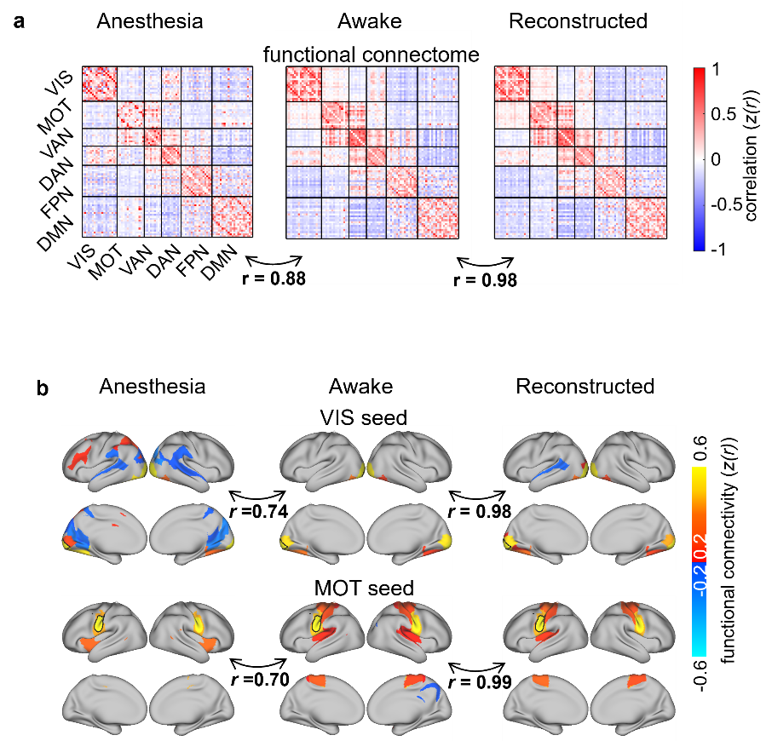

Fig. S9 The group-level reconstructed functional connectome from anesthetized state resembles that from awake state. a The group-level functional connectomes in the awake brain and the reconstructed functional connectome from the anesthetized state exhibited a high level of similarity (r = 0.98), which is significantly higher than the similarity between the awake and anesthetized states (r = 0.88). b The group-level RSFC map was calculated for the primary visual cortex (VIS/V1) and the primary motor cortex (MOT/M1) seed Regions of Interest (ROIs). A comparison was made with the seed-based RSFC map from the anesthetized state (right panel). The RSFC map from the reconstructed functional connectome (left panel) displayed higher similarity to the awake RSFC (medial panel), indicating a successful reconstruction of RSFC using the reconstructive model.

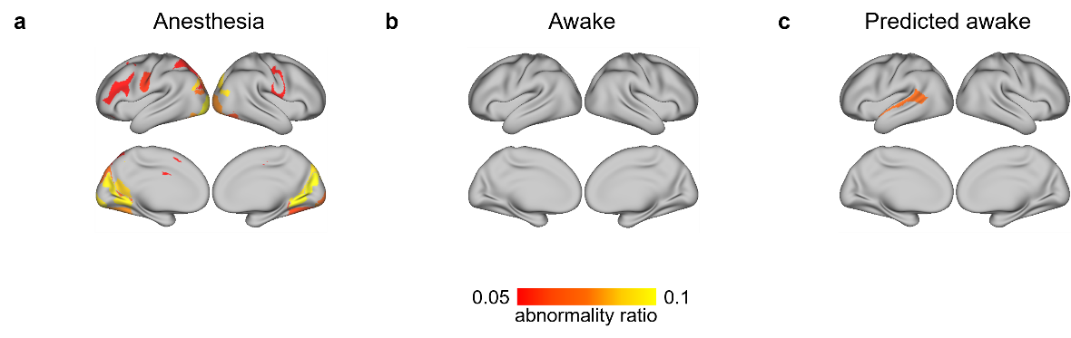
Fig. S10 Abnormality of the reconstructed functional connectome in the anesthetized state decreases and is comparable to the abnormality in the awake state. a The group-average abnormality map of RSFC across 12 healthy participants in the anesthetized state reveals regions with high abnormality, prominently in the visual and motor cortices and ventral attention network. The threshold for defining abnormality was set at AR > 0.05. b The abnormality map of RSFC derived from the awake session shows no regions with high abnormality. c The reconstructed functional connectomes from the anesthetized data exhibit fewer regions with high abnormality, suggesting a reduction in abnormal RSFC patterns compared to the anesthetized state.

Supplementary Tables
Table S1. MNI coordinates of seeds in Figure2.
Network | Original seed region | Hemisphere | MNI Coordinate
VIS | V1c | L | -13 | -100 | -8
MOT | Tongue | L | -55 | -4 | 26
VAN | VAN F | L | -31 | 11 | 8
DAN | DAN B | L | -34 | -38 | 44
FPN | FPN A | L | -40 | 50 | 7
DMN | DMN D | L | -7 | 49 | 18
Note: L = left hemisphere; R = right hemisphere; VIS = visual network; MOT = motor network; VAN = ventral attention network; DAN = dorsal attention network; FPN = frontal-parietal network; DMN = default mode network; V1c = central region of primary visual area; MNI = Montreal Neurological Institute. All the seeds are selected from high-confidence seeds reported in Yeo et al., (2011). The column of "original seed region" denoted the name of chosen seeds in Yeo et al., (2011).
Table S2. Statistics in between-network functional connectivity between anesthetic vs awake in Figure 3.
t-statistics
 | MOT | VAN | DAN | FPN | DMN
VIS | 4.84 | -0.67 | -0.24 | -8.22 | -0.03
MOT |  | 4.98 | 5.18 | -0.57 | -5.70
VAN |  |  | 2.30 | 5.30 | -6.20
DAN |  |  |  | 1.94 | -3.04
FPN |  |  |  |  | -2.88
p-values
 | MOT | VAN | DAN | FPN | DMN
VIS | 1.1×10⁻³ | 0.64 | 0.87 | 7.5×10⁻⁵ | 0.98
MOT |  | 1.0×10⁻³ | 9.1×10⁻⁴ | 0.67 | 7.0×10⁻⁴
VAN |  |  | 0.06 | 9.1×10⁻⁴ | 5.0×10⁻⁴
DAN |  |  |  | 0.11 | 0.02
FPN |  |  |  |  | 0.02
The comparison between anesthetized and awake sessions in functional connectomes were assessed using paired samples t-tests, multiple comparisons were corrected with the FDR correction was conducted for all pairs of network connections. All statistical tests were two-sided statistics. Note: L = left hemisphere; R = right hemisphere; VIS = visual network; MOT = motor network; VAN = ventral attention network; DAN = dorsal attention network; FPN = frontal-parietal network; DMN = default mode network.

