Supplementary materials

Metabolic Syndrome Increases Osteoarthritis Risk: Findings from the UK Biobank Prospective Cohort Study

Supplementary 1. Risk of osteoarthritis according to metabolic syndrome and components
 | No of cases/  Person-years | Hazard Ratio (95% CI)
 | No of cases/  Person-years | Model 1 | Model 2 | Model 3
Presence of MetS
No | 29,697/3,350,558 | Reference | Reference | Reference
Yes | 15,884/1,014,646 | 1.19(1.16,1.23) | 1.16(1.13,1.20) | 1.15(1.12,1.19)
No. of MetS components
0 | 3,925/614,597 | Reference | Reference | Reference
1 | 10,249/1,236,854 | 1.02(0.98,1.05) | 1.00(0.97,1.04) | 1.01(0.97,1.05)
2 | 12,027/1,162,151 | 1.07(1.03,1.11) | 1.05(1.01,1.09) | 1.05(1.01,1.09)
3 | 10,444/806,426 | 1.15(1.11,1.20) | 1.13(1.08,1.18) | 1.12(1.07,1.17)
4 | 6,505/413,625 | 1.27(1.21,1.33) | 1.23(1.17,1.29) | 1.22(1.16,1.28)
5 | 2,431/131,549 | 1.41(1.33,1.49) | 1.32(1.24,1.40) | 1.31(1.23,1.39)
 |  | P trend < 0.001 | P trend < 0.001 | P trend < 0.001
Central Obesity
No | 23,861/2,902,331 | Reference | Reference | Reference
Yes | 21,720/1,462,874 | 1.65(1.56,1.73) | 1.60(1.52,1.69) | 1.58(1.50,1.66)
Hypertension
No | 9,860/1,237,355 | Reference | Reference | Reference
Yes | 35,721/3,127,849 | 1.00(0.98,1.02) | 1.00(0.97,1.02) | 1.00(0.97,1.02)
Dyslipidaemia for TG
No | 20,590/2,327,860 | Reference | Reference | Reference
Yes | 24,991/2,037,344 | 1.09(1.07,1.11) | 1.08(1.05,1.10) | 1.07(1.05,1.09)
Dyslipidaemia for HDL
No | 34,948/3,471,661 | Reference | Reference | Reference
Yes | 10,633/893,542 | 1.08(1.06,1.11) | 1.06(1.03,1.08) | 1.05(1.02,1.07)
Hyperglycaemia
No | 34,836/3,594,128 | Reference | Reference | Reference
Yes | 10,745/771,075 | 1.16(1.13,1.18) | 1.13(1.11,1.16) | 1.13(1.10,1.15)
Model 1: basic model only adjusted for age, gender;
Model 2: additionally adjusted BMI, IDM, Drinking, activity, and smoking;
Model 3: additionally adjusted for NSAIDS, ASP, Fruit&vegetable, vitamin, and mineral intake.

Supplementary 2. Sensitive analysis lag for 4 years.
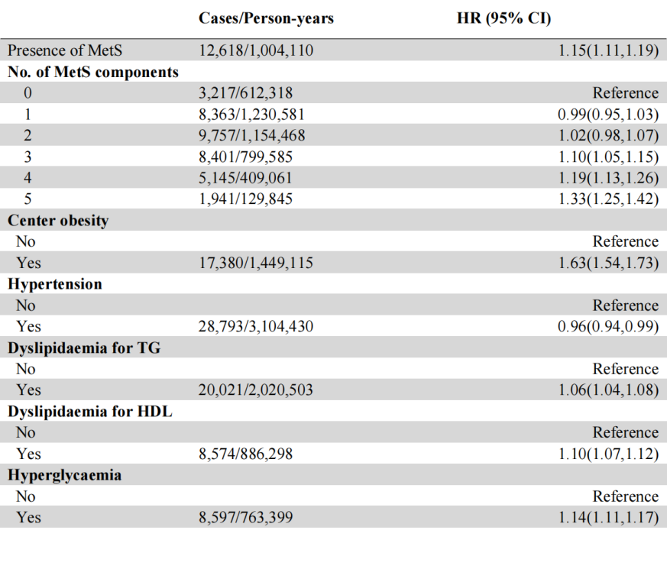
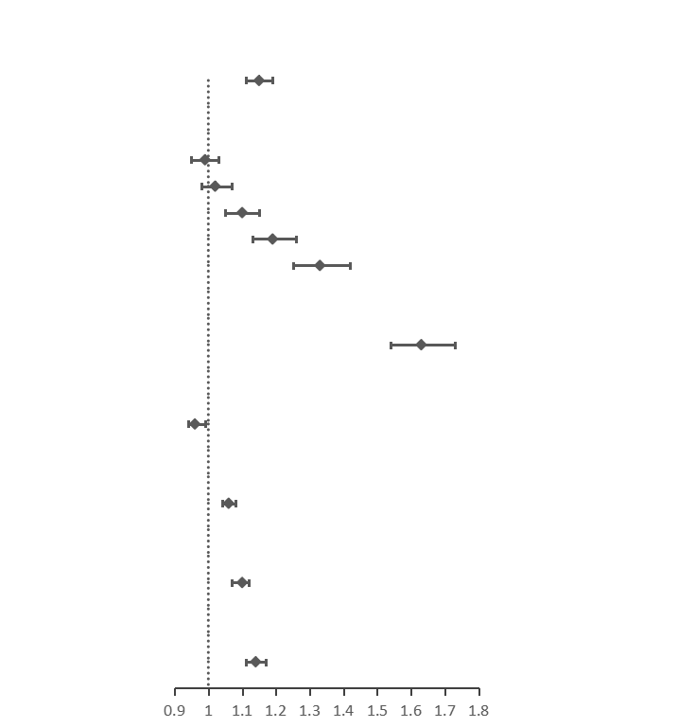

Abbreviations: MetS, metabolic syndrome; HDL, high-density lipoprotein; TG, triglyceride; BMI, body mass index.

