Supplementary Materials for
Management practices and Cost Associated with Better Diabetes Related Metrics

List of Contents
eTable 1. Durable medical equipment (DME) codes and corresponding descriptions for DME considered to be diabetes-related and used for categorization of claims/costs.
eTable 2. Names/descriptions of medications considered to be diabetes-related and used for categorization of claims/costs.
eTable 3. Qualifying values from claim fields and the corresponding logic for categorizing claims as indicating one of three types of hospital utilization: inpatient, emergency department, or outpatient hospital observation.
eFigure1. Density plot illustrating the distribution of total cost of diabetes-related care over the course of the 12-month study period, with vertical lines corresponding to the percentiles of the modes for those with high-performing physicians. Colors correspond to the range of costs for the specified percentiles of the distributions; a constant of 1 was added to costs prior to log transformation.

eFigure 2. Density histogram of CCI scores of patients whose primary care providers were classified as either high performing (coral) or low performing (green).
eFigure 3. Frequency histogram of the number of physicians within each of the participating practices that were categorized as either high performing (coral) or low performing (green).

eTable 1. Durable medical equipment (DME) codes and corresponding descriptions for items considered to be diabetes-related and used for categorization of claims/costs.
HCPCS | Description
A4230 | INFUSION SET FOR EXTERNAL INSULIN PUMP, NON NEEDLE CANNULA TYPE
A4231 | INFUSION SET FOR EXTERNAL INSULIN PUMP, NEEDLE TYPE
A4232 | SYRINGE WITH NEEDLE FOR EXTERNAL INSULIN PUMP, STERILE, 3CC
A4244 | ALCOHOL OR PEROXIDE, PER PINT
A4245 | ALCOHOL WIPES, PER BOX (100)
A4252 | BLOOD KETONE TEST OR REAGENT STRIP, EACH
A4253 | BLOOD GLUCOSE TEST OR REAGENT STRIPS FOR HOME BLOOD GLUCOSE MONITOR. PER 50
A4255 | PLATFORMS FOR HOME BLOOD GLUCOSE MONITOR, 50 PER BOX
A4256 | NORMAL, LOW AND HIGH CALIBRATOR SOLUTION/CHIPS
A4258 | SPRING-POWERED DEVICE FOR LANCET, EACH
A4259 | LANCETS, PER BOX OF 100
A9274 | EXTERNAL AMBULATORY INSULIN DELIVERY SYSTEM, INCLUDES ALL SUPPLIES
A9275 | HOME GLUCOSE DISPOSABLE MONITOR, INCLUDES TEST STRIPS
A9276 | SENSOR; SUBCUTANEOUS, DISPOSABLE, FOR USE WITH INTERSTITIAL CONTINUOUS GLUCOSE
A9277 | TRANSMITTER FOR USE WITH INTERSTITIAL CONTINUOUS GLUCOSE MONITORING SYSTEM
A9278 | RECEIVER (MONITOR); EXTERNAL, FOR USE WITH INTERSTITIAL CGM
E0607 | HOME BLOOD GLUCOSE MONITOR
E2101 | BLOOD GLUCOSE MONITOR WITH INTEGRATED LANCING/BLOOD SAMPLE
K0553 | SUPPLY ALLOWANCE FOR THERAPEUTIC (CGM), INCLUDES ALL SUPPLIES
K0554 | RECEIVER, DEDICATED, FOR USE WITH THERAPEUTIC CGM SYSTEM
S1031 | NONINVASIVE CGM DEVICE, RENTAL, SENSOR and REPLACEMENT, AND DOWNLOAD TO MONITOR
S1034 | ARTIFICIAL PANCREAS DEVICE SYSTEM, INCLUDING CGM, BLOOD GLUCOSE DEVICE, INSULIN PUMP AND COMPUTER ALGORITHM THAT COMMUNICATES WITH ALL OF THE DEVICES
S1035 | SENSOR; SUBCUTANEOUS, DISPOSABLE, FOR USE WITH ARTIFICIAL PANCREAS DEVICE SYSTEM
S1036 | TRANSMITTER; EXTERNAL, 1 DAY SUPPLY
S1037 | RECEIVER (MONITOR); EXTERNAL, FOR USE WITH ARTIFICIAL PANCREAS DEVICE SYSTEM

eTable 2. Names/descriptions of medications considered to be diabetes-related and used for categorization of claims/costs.
Medication name/description | Medication name/description | Medication name/description
1ST TIER UNIFINE PENTI | HUMALOG MIX 50-50 KWIK | ONETOUCH DELICA PLUS L
ACARBOSE | HUMALOG MIX 75-25 | ONETOUCH FINEPOINT LAN
ACCU-CHEK | HUMALOG MIX 75-25 KWIK | ONETOUCH LANCETS
ACCU-CHEK AVIVA PLUS | HUMULIN 70/30 KWIKPEN | ONETOUCH ULTRA BLUE TE
ACCU-CHEK FASTCLIX LAN | HUMULIN 70-30 | ONETOUCH VERIO
ACCU-CHEK SOFTCLIX | HUMULIN N | ONGLYZA
ADMELOG | HUMULIN N KWIKPEN | OZEMPIC
ADMELOG SOLOSTAR | HUMULIN R | PEN NEEDLE
ALCOHOL PADS | HUMULIN R U-500 | PEN NEEDLES
ALCOHOL PREP PADS | HUMULIN R U-500 KWIKPE | PENTIPS
ALOGLIPTIN | INJECT EASE LANCETS | PIOGLITAZONE HCL
APIDRA | INSULIN ASPART FLEXPEN | PIOGLITAZONE-METFORMIN
APIDRA SOLOSTAR | INSULIN LISPRO | PRANDIN
AUTOSHIELD DUO PEN NEE | INSULIN LISPRO KWIKPEN | PRECISION XTRA
AUTOSHIELD PEN NEEDLE | INSULIN PEN NEEDLE | PRODIGY TWIST TOP LANC
AVANDIA | INSULIN SYRINGE | REPAGLINIDE
BAQSIMI | INSUPEN | RYBELSUS
BASAGLAR KWIKPEN U-100 | INTEGRA SYRINGE | SAFETYGLIDE INSULIN SY
BYDUREON BCISE | INVOKAMET | SAFETYGLIDE NEEDLE
BYDUREON PEN | INVOKAMET XR | SAFETY-LOK SAFETY SYRI
COMFORT EZ INSULIN SYR | INVOKANA | SAFETY-LOK SYRINGES
COMFORT EZ PEN NEEDLE | JANUMET | SOLIQUA 100-33
CONTOUR NEXT TEST STRI | JANUMET XR | STEGLATRO
CONTOUR TEST STRIP | JANUVIA | SURE COMFORT
DEXCOM G5-G4 SENSOR | JARDIANCE | SURE COMFORT LANCETS
DEXCOM G6 | JENTADUETO | SYNJARDY
EASY COMFORT | KETO-DIASTIX REAGENT | SYNJARDY XR
EASY COMFORT PEN NEEDL | KOMBIGLYZE XR | SYRINGE
EASY TOUCH | LANCETS | TOUJEO MAX SOLOSTAR
EASY TOUCH PEN NEEDLE | LANTUS | TOUJEO SOLOSTAR
ECLIPSE SYRINGE-NEEDLE | LANTUS SOLOSTAR | TRADJENTA
FARXIGA | LEVEMIR | TRESIBA FLEXTOUCH U-10
FIASP | LEVEMIR FLEXTOUCH | TRESIBA FLEXTOUCH U-20
FIASP FLEXTOUCH | METFORMIN ER OSMOTIC | TRUE METRIX GLUCOSE TE
FREESTYLE INSULINX TES | METFORMIN HCL | TRUEPLUS INSULIN SYRIN
FREESTYLE LANCETS | METFORMIN HCL ER | TRUEPLUS LANCETS
FREESTYLE LIBRE 14 DAY | MICROLET | TRUEPLUS PEN NEEDLE
FREESTYLE LITE TEST ST | MINI ULTRA-THIN II | TRUETRACK TEST STRIP
 |  | Table continues
Medication name/description | Medication name/description | Medication name/description
FREESTYLE PRECISION NE | MONOJECT INSULIN SYRIN | TRULICITY
FREESTYLE TEST STRIPS | NANO 2ND GEN PEN NEEDL | ULTICARE PEN NEEDLE
GLIMEPIRIDE | NATEGLINIDE | ULTRACARE PEN NEEDLE
GLIPIZIDE | NOVOFINE 32 | ULTRA-FINE MICRO PEN N
GLIPIZIDE ER | NOVOFINE AUTOCOVER | ULTRA-FINE MINI PEN NE
GLIPIZIDE XL | NOVOFINE PLUS | ULTRA-FINE NANO PEN NE
GLIPIZIDE-METFORMIN | NOVOLIN 70-30 | ULTRA-FINE ORIGINAL PE
GLUCAGEN | NOVOLIN 70-30 FLEXPEN | ULTRA-FINE SHORT PEN N
GLUCAGON EMERGENCY KIT | NOVOLIN N | UNIFINE PENTIPS
GLUMETZA | NOVOLIN R | UNIFINE PENTIPS PLUS
GLYBURIDE | NOVOLOG | VEO INSULIN SYRINGE
GLYBURIDE-METFORMIN HC | NOVOLOG FLEXPEN | V-GO 20
GLYXAMBI | NOVOLOG MIX 70-30 | V-GO 30
HUMALOG | NOVOLOG MIX 70-30 FLEX | VICTOZA 2-PAK
HUMALOG KWIKPEN U-100 | NOVOTWIST | VICTOZA 3-PAK
HUMALOG KWIKPEN U-200 | OMNIPOD | XIGDUO XR
HUMALOG MIX 50-50 | ONETOUCH DELICA | XULTOPHY 100-3.6
Note. The full list of medications by national drug code (NDC) contained more than 500 rows. As such, only unique names/descriptions are given for brevity; the complete list with NDCs is available on request from the corresponding author.

eTable 3. Qualifying values from claim fields and the corresponding logic for categorizing claims as indicating one of three types of hospital utilization: inpatient, emergency department, or outpatient hospital observation.
 | Claim Fields |  |  |  | Categorization Logic
Hospitalization Type | Claim Type | CPT/HCPCs  Codes | Place of Service | Other Indicators | Categorization Logic
Emergency Department | Outpatient OR Major Medical OR Professional | 99281-99285 | - | Emergency Room (ER) indicator* equal to a value of Y (yes) | Qualifying claim type and at least one of:  - Relevant CPT  - ER indicator
Inpatient Admission | Inpatient | - | - | - | Any inpatient claim
Outpatient Observation | Outpatient OR Major Medical OR Professional | 99217,  99218-99220,  99221-99223,  99224-99226,  99231-99233,  99234-99236,  99238-99239,  99251-99255,  99291-99292,  G0378, G0379 | Ambulatory surgical center,  Off campus outpatient hospital,  On campus outpatient hospital,  Inpatient hospital,  Comprehensive outpatient rehabilitation facility | - | Claim must have a relevant value in each field listed
Note. After categorization of claims using the above criteria, they were further classified as either being diabetes-related or not using the criteria described in the main text of the paper. For claims involving visits that spanned more than one day, only characteristics of the claims from the day of admission/first day were used. *Value is based on a combination of claim type and revenue codes that collectively capture emergency services provided in various settings.

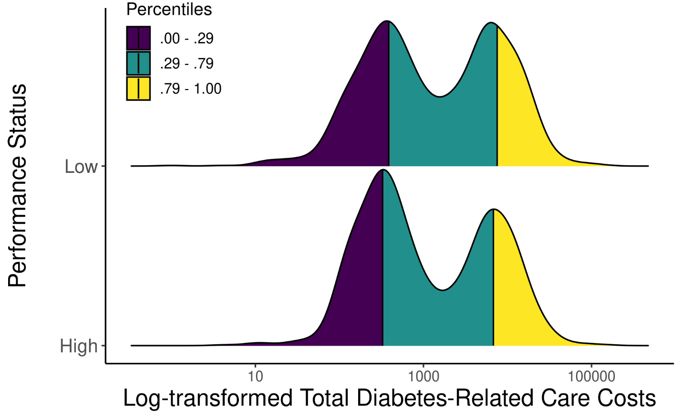
eFigure1. Density plot illustrating the distribution of total cost of diabetes-related care over the course of the 12-month study period, with vertical lines corresponding to the percentiles of the modes for those with high-performing physicians. Colors correspond to the range of costs for the specified percentiles of the distributions; a constant of 1 was added to costs prior to log transformation.

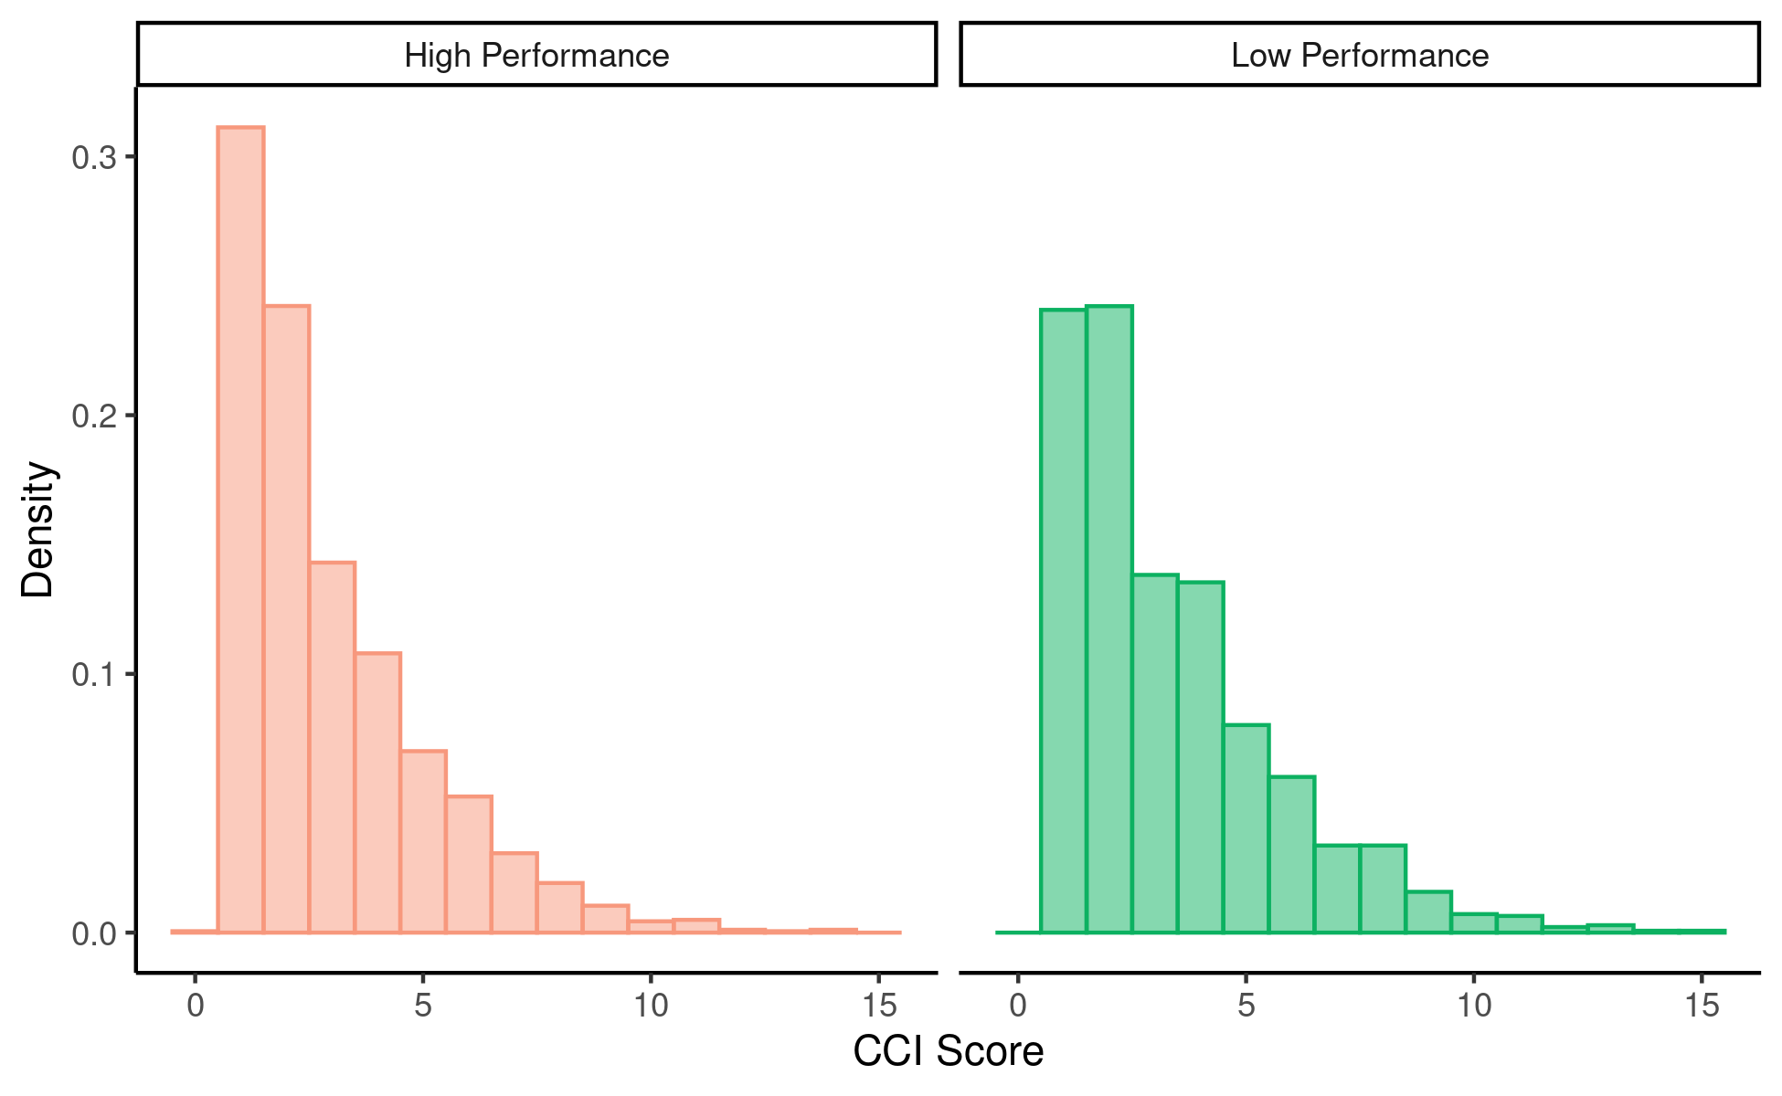 eFigure 2. Density histogram of CCI scores of patients whose primary care providers were classified as either high performing (coral) or low performing (green).

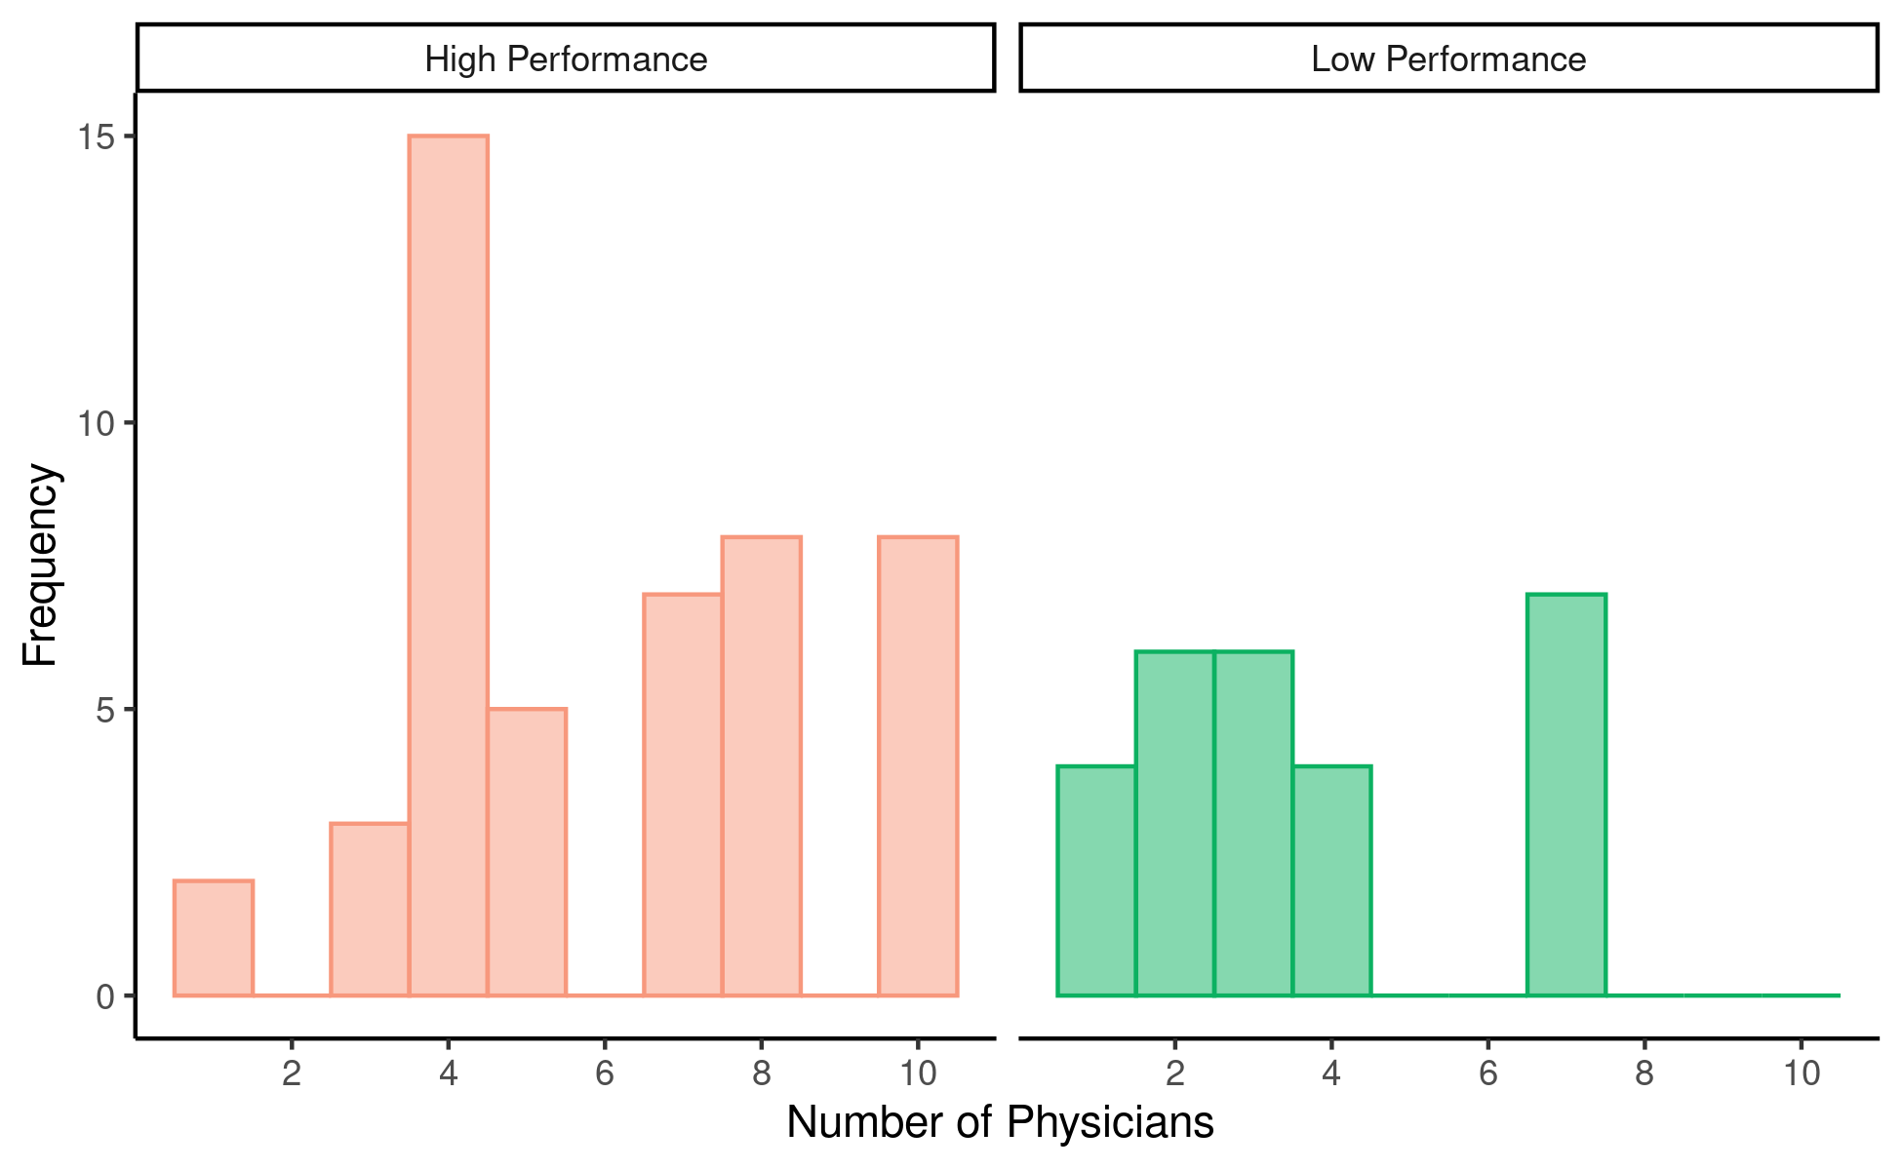
eFigure 3. Frequency histogram of the number of physicians within each of the participating practices that were categorized as either high performing (coral) or low performing (green).

