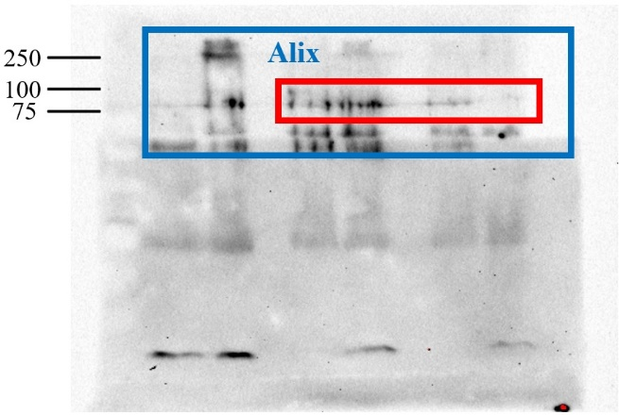
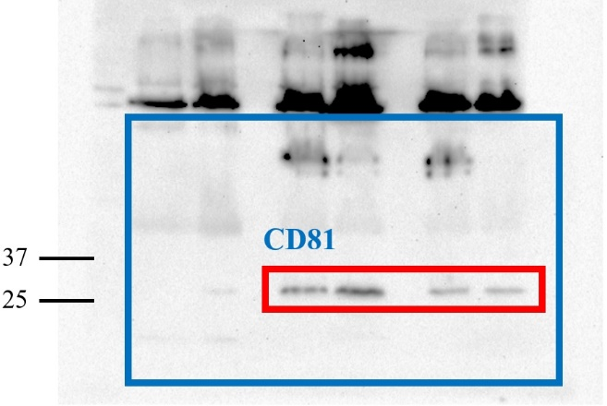
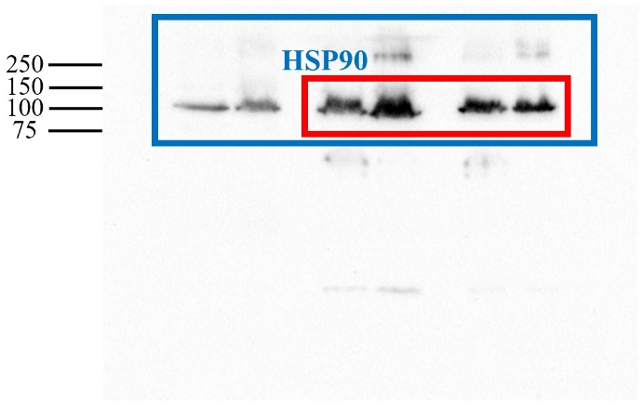
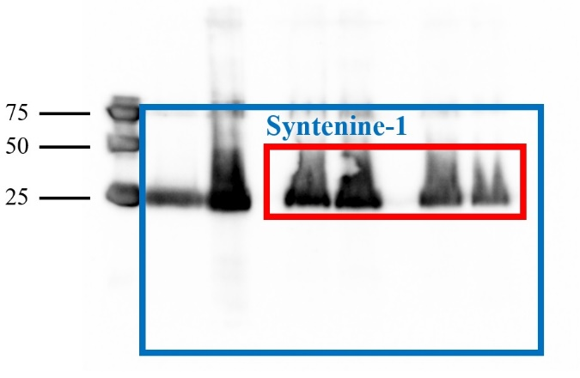
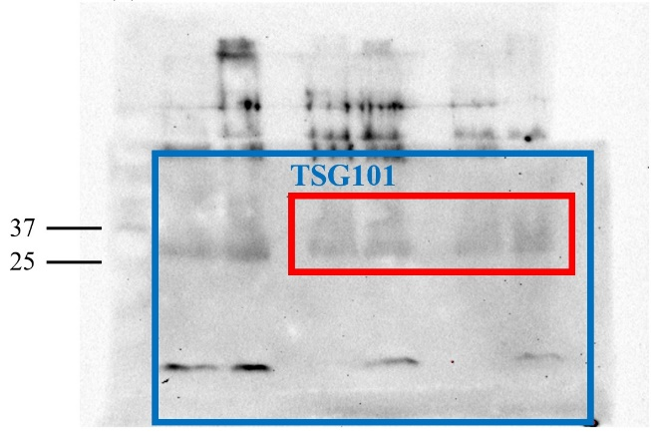
Supplementary Figures 1.
(a)
(b)
(c)
(d)
(e)

Figures S1: Original western blots images of exosomes isolated from CSF or blood from two different animals. For each western blot, the blot was cut into high and low molecular weight regions and then each used for a different antibody. For purposes of imaging the two regions were scanned as one and are shown in the supplemental figure. The blot of interest is indicated (blue box). The part marked in the red box is cropped and included in the main article. (a) probed with ALIX (95kDa); (b) probed with CD81 (26kDa); (c) HSP90 (90kDa); (d) Syntenin-1 (35kDa) and (e) TSG101 (32kDa).

