Appendix A.
The comprehensive results of the analyses are illustrated in this section. The figures show the accuracy scores of six ML algorithms on four different scaling approaches with two methods and traditional versions. The left-hand side of the Figures belongs to the Australian Credit dataset, and the right-hand side depicts the results of the German Credit dataset.
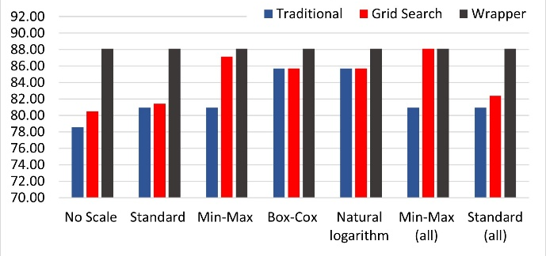
Figure A.1: Gaussian Naïve Bayes Accuracies on Australian data
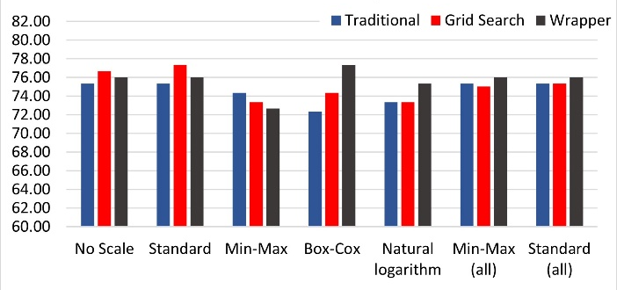
Figure A.2: Gaussian Naïve Bayes Accuracies on German data
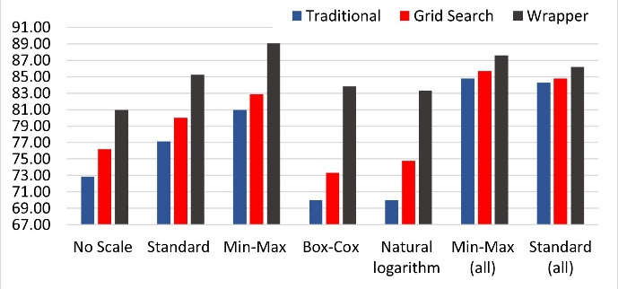
Figure A.3: K-Nearest Neighbor Accuracies on Australian data
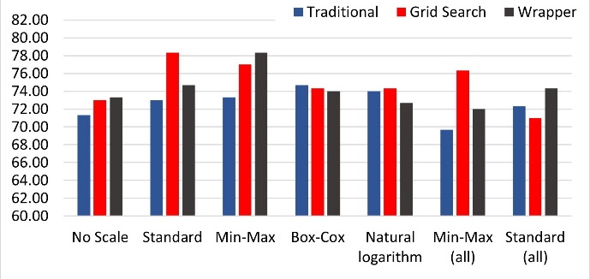
Figure A.4: K-Nearest Neighbor Accuracies on German data
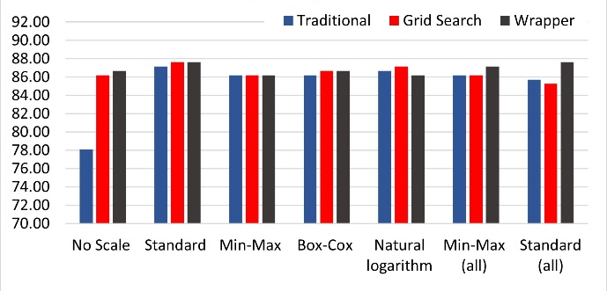
Figure A.5: Logistic Regression Accuracies on Australian data
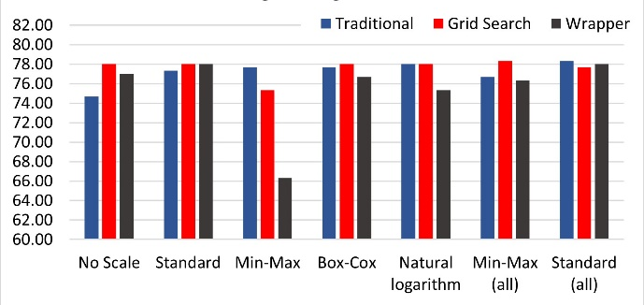
Figure A.6: Logistic Regression Accuracies on German data
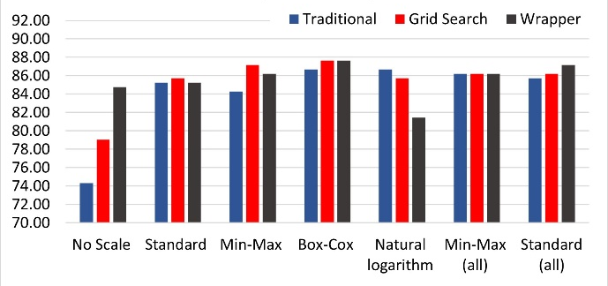
Figure A.7: Multi-layer NN Perceptron Accuracies on Australian data
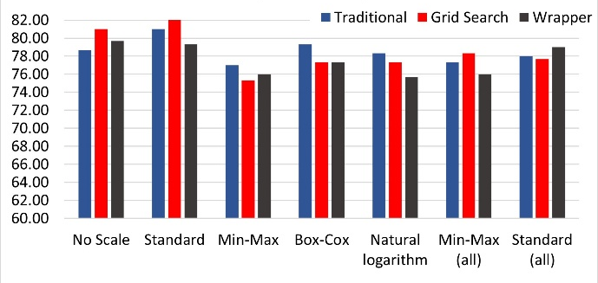
Figure A.8: Multi-layer NN Perceptron Accuracies on German data

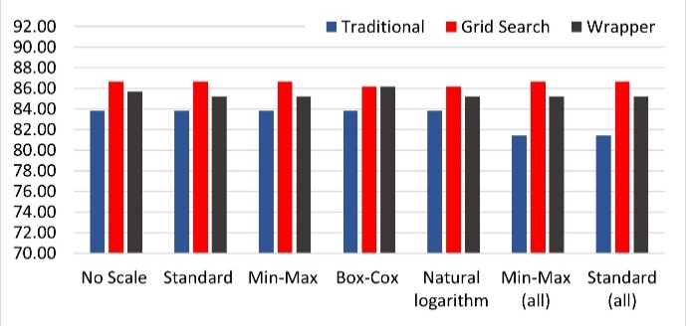
Figure A.9: Random Forest Accuracies on Australian data

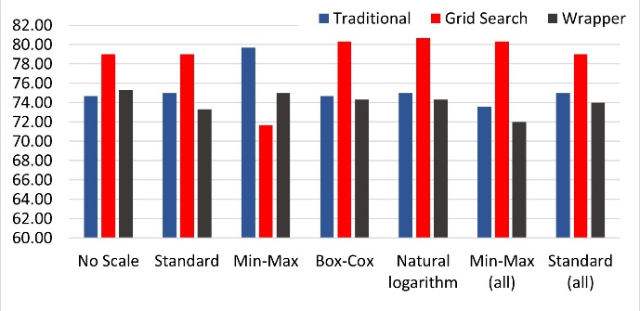
Figure A.10: Random Forest Accuracies on German data
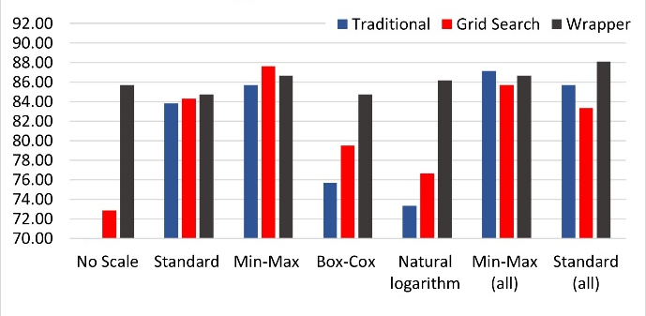
Figure A.11: Support Vector Machine Accuracies on Australian data
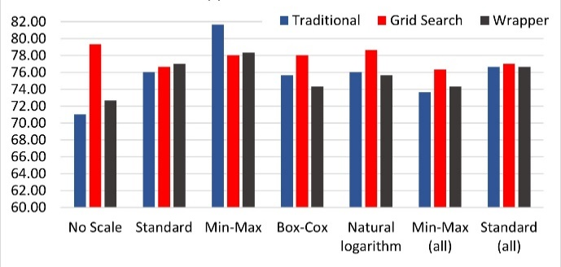
Figure A.12: Support Vector Machine Accuracies on German data

