Supplementary File 1
 | 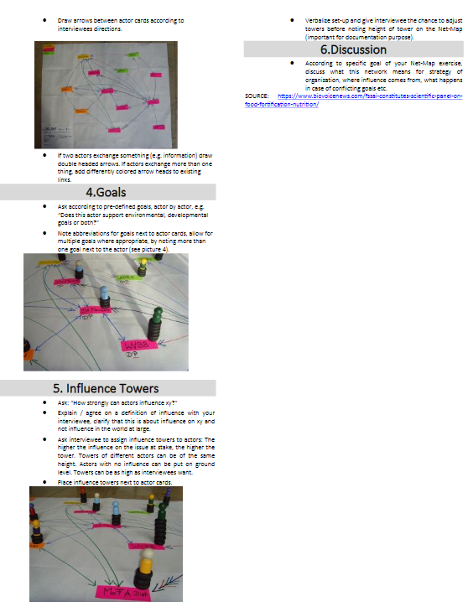

Supplementary File 2

In this study, we employed social network analysis (SNA) to explore stakeholders’ relationships and importance (Question 8). The respondents were asked to list other related organizations or actors they interacted with, and to rate the level of interaction with the actors they had listed (Question 9 and 10). The score from 1–5 of the ties indicates their relationships between individuals, groups, and institutions. A higher value would indicate that a node has a closer relationship with other nodes. It is not practical and usually not necessary to engage with all stakeholder groups with the same level of intensity all the time. Therefore, calculating stakeholders’ weights according to their relevance could promote stakeholder engagement. In social network analysis (SNA), the concept of centrality indicates the central position of the individual who has higher power, status and popularity. The centrality of a point can be determined by reference to three different structural attributes: ‘degree’, ‘betweenness’ and ‘closeness’. Degree centrality measures only the number of nodes that are directly connected to others without considering the indirect connection between nodes. Likewise, ‘betweenness’ centrality only measures the degree of ‘intermediary’ effect. The ‘closeness centrality’, which refers to the distance between nodes, primarily represents the capacity of stakeholders to analyses resources, information and methods within the network (Freeman 1978). Beauchamp (1965) used closeness to design organization with ‘optimum efficiency’ in communication. Sabidussi (1966) defined the most central point in a network as the one with the minimum cost or time for communicating with all other points. Therefore, this paper uses the concept of closeness centrality to rank stakeholder importance and the weight of them. The absolute value is the sum of the shortest distance between one node and the other nodes in the diagram over the network size minus one (Sun et al. 2015).
Once the list of stakeholders was identified, further investigations were carried out to better understand characteristics and perspectives of these stakeholders. Stakeholder Analysis or Stakeholder Mapping has evolved in recent years as a technique for analyzing the likely interests and actions of stakeholders (Johnson et al. 2008). The method of stakeholder mapping was applied in this study as a visual analysis for investigating stakeholders’ perspectives and characteristics to Pakistan nutrition in the perspective of MDGs. The network analysis was performed in the RStudio statistical program, using the MGM function with Lasso penalty. To visualize the networks, the qGraph package with the layout = “string” function was used, which corresponds to the Fruchterman-Reingold algorithm for approximation of variables. A visualized network analysis was performed in the present study. A graphical LASSO [glasso] estimated least absolute shrinkage and selection operator (LASSO) regularization. A regularized Gaussian graphical model [GGM] was estimated by utilizing glasso in combination with the extended Bayesian information criterion [EBIC] model (i.e., EBICglasso model). The EBICglasso model was calculated by using JASP. The tuning parameter was set to 0.5 for a more parsimonious and easily explainable network (i.e., fewer edges, higher specificity and sensitivity). The connection of nodes was described using edges. Edge thickness was used to indicate the strength of the association between nodes. Blue edges indicate positive correlations and red edges indicate negative correlations. The centrality of nodes in the network, which represented study variables, were calculated using measures of betweenness (degree of connectivity), closeness (distance centrality), and strength [degree centrality]. Centrality measures are reported as standardized values (z-scores). Edge-weight accuracy and centrality stability were used by the R-package bootnet (Version 1.4.3). Bootstrapped 95% confidence intervals were utilized for estimating the accuracy of edge-weight (the number of bootstrap samples was 1,000) and fewer overlaps indicated higher stability/accuracy. The stability of node attributes was estimated by using the case-dropping bootstrap procedure. If most samples can be excluded from the dataset without observing significant changes in the centrality index of the node, the network is considered to be stable. Centrality stability is represented graphically and quantified by calculating the correlation stability coefficient (CS-coefficient), which was suggested to preferably be above 0.5 and should not be below 0.25 for interpretability and stability (49). The small-wordless index (SWI) was calculated by considering both the average shortest path length and the global aggregation coefficient, SWI = (C/C') / (L/L'), where L and C are the shortest path length and the global aggregation coefficient of the network, and L' and C' are ER random networks [Erdos-Rényi model with the same number of nodes and connections. If the SWI is >1, it means that the network has small-world characteristics, i.e., high connection strength, short average paths between nodes, and strong overall connections.
Supplementary File 3: Questionare

Supplementary File 4
(Table S1 and Figure S1) are extensions of the results shown in Fig 1, presenting the centrality levels of stakeholders. Figure 2 presents the graph of centrality values examined for stakeholders’ relationships and importance. There are four centrality metrics used to identify highly influential nodes, as shown in Table 4. It can be said that nodes with a high degree of betweenness have a relatively more important position. Accordingly, it can also be said that among the variables, P&D, MoH, MoE, and Acad are the key variables that are highly active in the network (Table S1) and act as a bridge between other unconnected variables (Figure S1). As a result, the overall network consists of highly correlated variables. Accordingly, the variables with the highest degree of closeness are MoH and P&D. Since these variables can be reached in the easiest way, reaching these variables is more important than reaching other variables and when these variables are reached, other variables can be reached, too.

Table S1: Centrality Values of the Network
Nodes | Network
Nodes | Betweennesses | Closeness | Strength | Expected Influence
P_Gov | 0.094 | 0.334 | 0.481 | 0.332
MoH | 1.797 | 1.729 | 1.514 | 1.22
BoI | 0.898 | 0.605 | 1.174 | 2.629
P&D | 2.002 | 0.97 | 0.006 | 0.147
PWD | 0.395 | 0.67 | 0.468 | 0.5
AgD | -1.011 | -0.139 | -0.623 | -0.427
MoE | 1.4 | 0.496 | 0.572 | 0.332
NGOs | -0.207 | 0.223 | -0.085 | 0.026
Acad | 1.199 | 0.296 | 0.738 | -1.013
MoST | -0.709 | 0.311 | 0.036 | -0.698
Med | -1.011 | -0.51 | -1.305 | -1.625
Livestock | -0.408 | 0.192 | 0.642 | -0.328
Charity | -1.011 | 0.204 | -0.212 | 0.312
Elites | -0.408 | 0.303 | 0.403 | 0.309
Parliament | -1.011 | -1.75 | -1.776 | -0.844
Political Parties | -1.011 | -2.934 | -2.034 | -0.873

Acad=Academia; P_Gov=Provincial government; P&D=Planning and Development; MoH=Ministry of Health BoI=Board of Investment (BoI); PWD=Population Welfare Department AgD=Agriculture Department; MoE=Ministry of economics MoST=Ministry of Science and Technology; NGOs=Non-governmental Organizations (NGOs); Med=Media
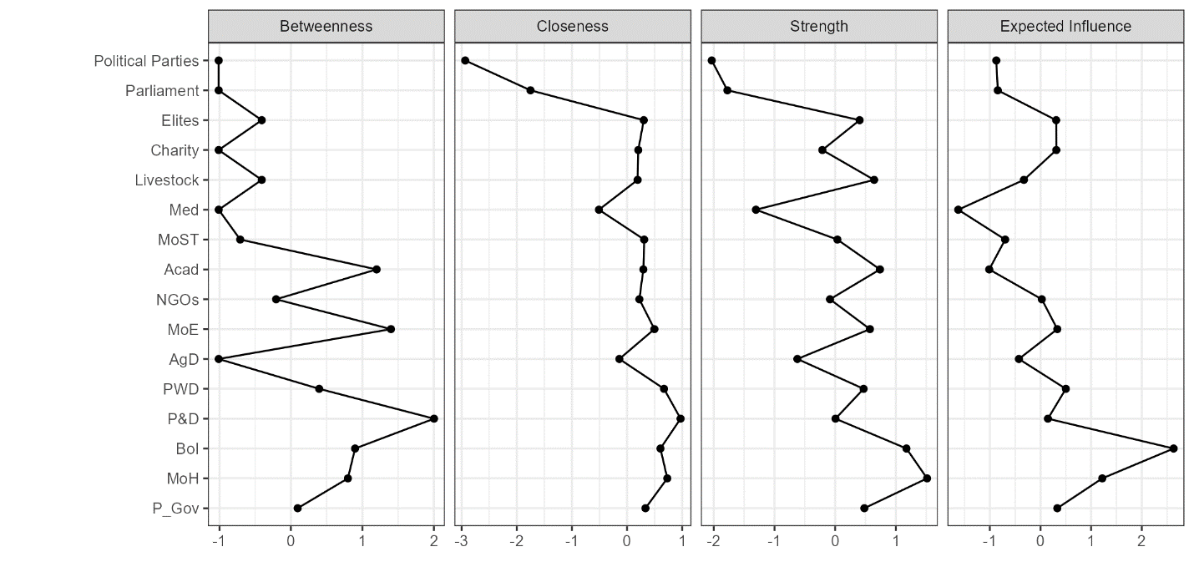
Figure S1: Centrality Graph showing centrality Values of the Network. Centrality Plots for EBICglaaso network depicting the betweenness, closeness, and degree (strength), expected influence of each node (variable).
Acad=Academia; P_Gov=Provincial government; P&D=Planning and Development; MoH=Ministry of Health BoI=Board of Investment (BoI); PWD=Population Welfare Department AgD=Agriculture Department; MoE=Ministry of economics MoST=Ministry of Science and Technology; NGOs=Non-governmental Organizations (NGOs); Med=Media

Supplementary Files 5

The clustering coefficient measures local cohesiveness and is defined as the fraction of connected neighbors for any vertex. These coefficients reveal how strongly the variables are connected with their neighbors. Clustering coefficients for the variables are given in Supplementary Files 5 (Table S2. Figure S2) shows the graphs of clustering coefficients for the variables given in Table 5. Clustering coefficients, which are used to measure the clustering tendency of the parameters in the network, are used to measure the frequency of the parameters in groups, that is, their tendency to cliques. This coefficient, which gives the frequency of connecting the parameters with which they are connected, also shows the importance of the parameter for the groups. So, a high clustering coefficient indicates a high correlation of the variables, and a low one indicates less frequent connections.

The distance from one node to other indicates the degree of the relationship between the stakeholders. A clustering coefficient measures the local group cohesiveness and is defined for any vertex as the fraction of connected neighbors. These coefficients reveal the strength of the link between the stakeholders. Table 3 presents the clustering coefficients for the products. Figure S2 presents the graphs of clustering coefficients for the stakeholders’ relationships and importance. Table 4 presents the correlation coefficients among the stakeholders.

Table S2: Clustering Coefficients for the Variables
 | Network
Variable | Barret | Onnela | WS | Zhang
P_Gov | -0.455 | -0.147 | -0.485 | -0.112
MoH | -0.831 | -0.678 | -0.704 | -0.665
Med | 0.894 | -0.892 | 0.315 | 0.57
Livestock | -0.469 | 0.113 | -0.028 | 0.357
Charity | 0.65 | 0.28 | 1.115 | -0.241
Elites | 0.18 | 1.915 | 0.115 | 0.173
Parli | 1.182 | -0.374 | 1.115 | 0.499
Pol_Part | -2.75 | -1.889 | -2.885 | -1.57
BoI | -0.212 | -0.166 | -0.1 | -0.501
P&D | 0.533 | 0.121 | 0.257 | -0.052
PWD | 0.518 | 0.098 | 0.329 | 0.192
AgD | 1.468 | 0.472 | 1.315 | 3.121
MoE | 0.468 | 0.452 | 0.715 | -0.169
NGOs | -0.118 | -0.215 | -0.028 | -0.157
Acad | -0.781 | -0.644 | -0.957 | -0.439
MoST | -0.277 | -0.447 | -0.085 | -1.006

Acad=Academia; P_Gov=Provincial government; P&D=Planning and Development; MoH=Ministry of Health BoI=Board of Investment (BoI); PWD=Population Welfare Department AgD=Agriculture Department; MoE=Ministry of economics MoST=Ministry of Science and Technology; NGOs=Non-governmental Organizations (NGOs); Med=Media
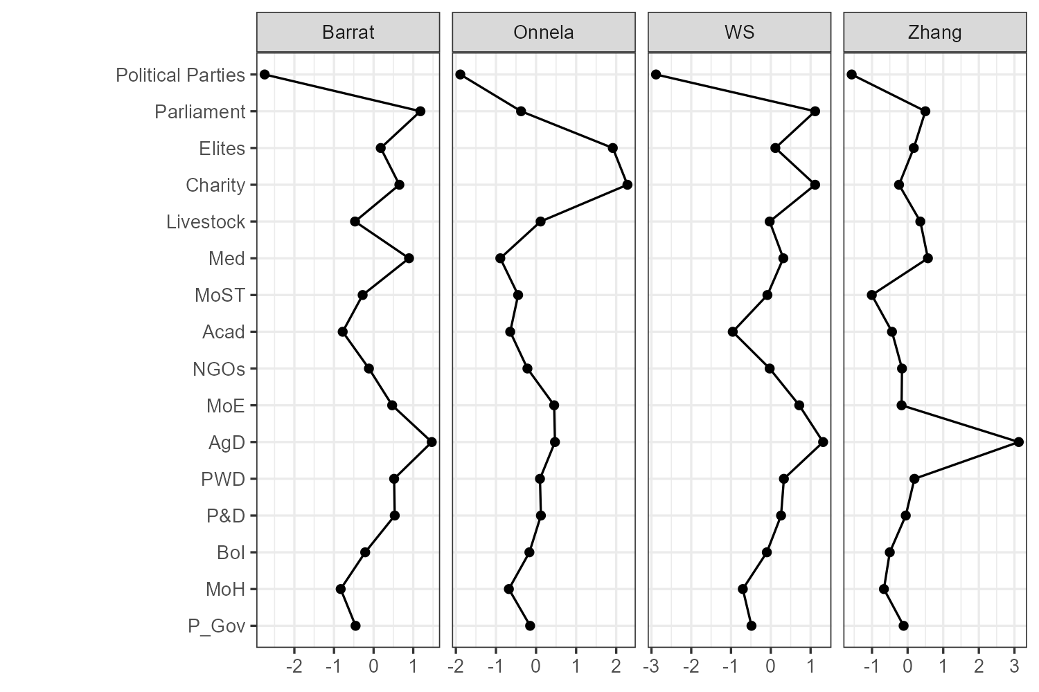
Figure S2: Clustering Coefficients for the Variables
Acad=Academia; P_Gov=Provincial government; P&D=Planning and Development; MoH=Ministry of Health BoI=Board of Investment (BoI); PWD=Population Welfare Department AgD=Agriculture Department; MoE=Ministry of economics MoST=Ministry of Science and Technology; NGOs=Non-governmental Organizations (NGOs); Med=Media

Supplementary File 6: RELATED STATISTICS FOR INTERACTION NETWORK
Table S3a: Statistics for Interaction network
ID | In-Degree | Out-Degree | Degree | Weighted in-degree | Weighted Out-Degree | Weighted | Eccentricity | Closeness Centrality | Harmonic Closeness Centrality
P_Gov | 4 | 4 | 8 | 10 | 15 | 25 | 3 | 0.5517 | 0.6146
Media | 3 | 0 | 3 | 6 | 0 | 6 | 0 | 0.0000 | 0.0000
MoH | 4 | 4 | 8 | 12 | 12 | 24 | 2 | 0.5714 | 0.6250
Parliament | 4 | 7 | 11 | 14 | 21 | 35 | 2 | 0.6400 | 0.7188
P&D | 9 | 15 | 24 | 22 | 47 | 69 | 2 | 0.8889 | 0.9375
PWD | 5 | 2 | 7 | 9 | 2 | 11 | 3 | 0.3902 | 0.4479
MoE | 4 | 2 | 6 | 9 | 2 | 11 | 3 | 0.5000 | 0.5417
AgD | 3 | 5 | 8 | 6 | 5 | 11 | 3 | 0.5517 | 0.6354
NGOs | 5 | 8 | 13 | 6 | 8 | 14 | 3 | 0.6400 | 0.7396
Acad | 6 | 2 | 8 | 6 | 2 | 8 | 3 | 0.4211 | 0.4792
MoST | 5 | 7 | 12 | 6 | 7 | 13 | 2 | 0.6400 | 0.7188
Med | 3 | 2 | 5 | 5 | 2 | 7 | 3 | 0.4324 | 0.4896
Livestock | 5 | 3 | 8 | 6 | 3 | 9 | 3 | 0.5333 | 0.5833
Charity | 2 | 1 | 3 | 5 | 1 | 6 | 4 | 0.4103 | 0.4531
Elites | 1 | 1 | 2 | 5 | 1 | 6 | 4 | 0.4103 | 0.4531
BoI | 1 | 1 | 2 | 2 | 1 | 3 | 4 | 0.4103 | 0.4531
Political Parties | 1 | 1 | 2 | 1 | 1 | 2 | 1 | 1.0000 | 1.0000

Table S3b: Statistics for interaction network
ID | Betweenness Centrality | Authority | Hub | Page Rank | Module | Inferred Class | Cluster | Eigenvector Centrality
P_Gov | 8.8333 | 0.3102 | 0.1805 | 0.0438 | 0.0000 | 0.0000 | 0.5000 | 0.4993
Media | 0.0000 | 0.0966 | 0.0000 | 0.0632 | 0.0000 | 0.0000 | 0.3333 | 0.2216
MoH | 3.6000 | 0.2762 | 0.2181 | 0.0428 | 0.0000 | 0.0000 | 0.5000 | 0.4837
Parliament | 11.1000 | 0.2547 | 0.3377 | 0.0462 | 0.0000 | 0.0000 | 0.3036 | 0.4837
P&D | 89.8000 | 0.3727 | 0.5943 | 0.1089 | 1.0000 | 0.0000 | 0.2857 | 1.0000
PWD | 15.3667 | 0.3075 | 0.0479 | 0.0720 | 0.0000 | 0.0000 | 0.3333 | 0.6289
MoE | 2.3333 | 0.2740 | 0.0895 | 0.0432 | 0.0000 | 0.0000 | 0.4500 | 0.5050
AgD | 2.6167 | 0.2346 | 0.2669 | 0.0341 | 1.0000 | 0.0000 | 0.4667 | 0.4086
NGOs | 47.6167 | 0.1925 | 0.4186 | 0.0905 | 1.0000 | 0.0000 | 0.2455 | 0.4505
Acad | 2.2000 | 0.3511 | 0.0947 | 0.0870 | 1.0000 | 0.0000 | 0.6000 | 0.6817
MoST | 29.8500 | 0.2681 | 0.3685 | 0.0850 | 1.0000 | 0.0000 | 0.3036 | 0.5780
Med | 0.0000 | 0.2309 | 0.1117 | 0.0336 | 1.0000 | 0.0000 | 0.7500 | 0.3690
Livestock | 18.8500 | 0.2566 | 0.1861 | 0.1014 | 1.0000 | 0.0000 | 0.4000 | 0.6280
Charity | 0.5000 | 0.1234 | 0.0347 | 0.0366 | 1.0000 | 0.0000 | 0.6667 | 0.2973
Elites | 0.0000 | 0.1072 | 0.0347 | 0.0182 | 1.0000 | 0.0000 | 1.0000 | 0.1973
BoI | 0.0000 | 0.1072 | 0.0347 | 0.0182 | 1.0000 | 0.0000 | 1.0000 | 0.1973
Political Parties | 1.3333 | 0.0086 | 0.0174 | 0.0427 | 0.0000 | 0.0000 | 0.0000 | 0.1239

Supplementary File 7: RELATED STATISTICS FOR INFORMATION-SEEKING NETWORK
Table S4a: Statistics for Information-Seeking network
ID | In-Degree | Out-Degree | Degree | Weighted in-degree | Weighted Out-Degree | Weighted | Eccentricity | Closeness Centrality
P_Gov | 4 | 2 | 6 | 10 | 5 | 15 | 5 | 0.3488
Media | 2 | 0 | 2 | 3 | 0 | 3 | 0 | 0.0000
MoH | 3 | 4 | 7 | 8 | 12 | 20 | 4 | 0.4545
Parliament | 2 | 2 | 4 | 4 | 9 | 13 | 5 | 0.3488
P&D | 4 | 3 | 7 | 8 | 10 | 18 | 4 | 0.3947
PWD | 2 | 2 | 4 | 3 | 2 | 5 | 6 | 0.3061
MoE | 1 | 1 | 2 | 2 | 1 | 3 | 5 | 0.3125
Elites | 1 | 1 | 2 | 5 | 1 | 6 | 4 | 0.4054
BoI | 1 | 1 | 2 | 2 | 1 | 3 | 4 | 0.4054
Political Parties | 1 | 1 | 2 | 1 | 1 | 2 | 1 | 1.0000
Livestock | 4 | 3 | 7 | 4 | 3 | 7 | 5 | 0.3846
AgD | 0 | 5 | 5 | 0 | 5 | 5 | 5 | 0.4211
Acad | 3 | 2 | 5 | 3 | 2 | 5 | 5 | 0.3333
MoST | 3 | 1 | 4 | 3 | 1 | 4 | 6 | 0.2830
Med | 2 | 0 | 2 | 2 | 0 | 2 | 0 | 0.0000
Charity | 1 | 1 | 2 | 1 | 1 | 2 | 4 | 0.4167
NGOs | 3 | 8 | 11 | 3 | 8 | 11 | 3 | 0.6250

Table S4b: Statistics for Information-Seeking network
ID |  | Harmonic Closeness Centrality | Betweenness Centrality | Authority | Hub | Page Rank | Module | Inferred Class | Cluster | Eigenvector Centrality
P_Gov |  | 0.4378 | 43.6667 | 0.2641 | 0.0691 | 0.1108 | 0.0000 | 3.0000 | 0.0000 | 0.0000
Media |  | 0.0000 | 0.0000 | 0.0196 | 0.0000 | 0.0954 | 0.0000 | 0.0000 | 0.0000 | 0.0000
MoH |  | 0.5667 | 63.5000 | 0.2427 | 0.2376 | 0.0942 | 0.0000 | 3.0000 | 1.0000 | 0.0000
Parliament |  | 0.4378 | 0.8333 | 0.2519 | 0.1335 | 0.0471 | 0.0000 | 3.0000 | 0.0000 | 0.0000
P&D |  | 0.4889 | 52.4167 | 0.4567 | 0.0808 | 0.0710 | 0.0000 | 3.0000 | 1.0000 | 0.0000
PWD |  | 0.4067 | 22.5833 | 0.1307 | 0.1165 | 0.0564 | 0.0000 | 3.0000 | 1.0000 | 0.0000
MoE |  | 0.3578 | 15.4167 | 0.0626 | 0.0000 | 0.0351 | 0.0000 | 3.0000 | 1.0000 | 0.0000
Elites |  | 0.4556 | 10.6667 | 0.0213 | 0.0000 | 0.0352 | 0.0000 | 3.0000 | 1.0000 | 0.0000
BoI |  | 0.4556 | 10.6667 | 0.0213 | 0.0000 | 0.0352 | 0.0000 | 3.0000 | 1.0000 | 0.0000
Political Parties |  | 1.0000 | 1.8333 | 0.0307 | 0.0052 | 0.0391 | 0.0000 | 1.0000 | 0.0000 | 0.0000
Livestock |  | 0.4967 | 30.7500 | 0.4117 | 0.2585 | 0.0753 | 0.0000 | 3.0000 | 2.0000 | 0.0000
AgD |  | 0.5646 | 0.0000 | 0.0000 | 0.5188 | 0.0151 | 0.0000 | 4.0000 | 2.0000 | 0.0000
Acad |  | 0.4211 | 2.7500 | 0.3941 | 0.2088 | 0.0510 | 0.0000 | 3.0000 | 2.0000 | 0.0000
MoST |  | 0.3433 | 8.7500 | 0.3810 | 0.0696 | 0.0513 | 0.0000 | 3.0000 | 2.0000 | 0.0000
Med |  | 0.0000 | 0.0000 | 0.3260 | 0.0000 | 0.0297 | 0.0000 | 2.0000 | 2.0000 | 0.0000
Charity |  | 0.4611 | 17.4167 | 0.0000 | 0.0000 | 0.0449 | 0.0000 | 3.0000 | 2.0000 | 0.0000
NGOs |  | 0.7444 | 70.7500 | 0.0000 | 0.7186 | 0.1131 | 0.0000 | 3.0000 | 2.0000 | 0.0000

Supplementary File 8: RELATED STATISTICS FOR DECISION-MAKING NETWORK
Table S5a: Statistics for Decision-making network
ID | In-Degree | Out-Degree | Degree | Weighted in-degree | Weighted Out-Degree | Weighted  Degree | Eccentricity | Closeness Centrality
Med | 0 | 1 | 1 | 0 | 1 | 1 | 6 | 0.2419
AgD | 0 | 2 | 2 | 0 | 2 | 2 | 6 | 0.3043
Political Parties | 1 | 1 | 2 | 1 | 1 | 2 | 1 | 1.0000
Charity | 1 | 1 | 2 | 1 | 1 | 2 | 5 | 0.3333
MoST | 1 | 1 | 2 | 1 | 1 | 2 | 5 | 0.2979
MoE | 1 | 1 | 2 | 2 | 1 | 3 | 6 | 0.2653
BoI | 1 | 1 | 2 | 2 | 1 | 3 | 5 | 0.3250
Acad | 2 | 1 | 3 | 2 | 1 | 3 | 6 | 0.2889
Media | 2 | 0 | 2 | 3 | 0 | 3 | 0 | 0.0000
PWD | 2 | 2 | 4 | 3 | 2 | 5 | 6 | 0.3171
Livestock | 3 | 3 | 6 | 3 | 3 | 6 | 5 | 0.3939
NGOs | 3 | 3 | 6 | 3 | 3 | 6 | 4 | 0.4483
Parliament | 2 | 2 | 4 | 4 | 9 | 13 | 4 | 0.3939
Elites | 1 | 1 | 2 | 5 | 1 | 6 | 5 | 0.3250
P&D | 3 | 3 | 6 | 7 | 10 | 17 | 5 | 0.3714
MoH | 3 | 4 | 7 | 8 | 12 | 20 | 3 | 0.5200
P_Gov | 3 | 2 | 5 | 9 | 5 | 14 | 4 | 0.3939

Table S5b: Statistics for Decision-making network
ID | Harmonic Closeness Centrality | Betweenness Centrality | Authority | Hub | Page Rank | Module | Inferred Class | Cluster | Eigenvector Centrality
Med | 0.3000 | 0.0000 | 0.0000 | 0.0000 | 0.0130 | 0.0000 | 5.0000 | 3 | 0
AgD | 0.4036 | 0.0000 | 0.0000 | 0.1057 | 0.0130 | 0.0000 | 3.0000 | 2 | 0
Political Parties | 1.0000 | 2.8333 | 0.0096 | 0.0227 | 0.0384 | 0.0000 | 1.0000 | 0 | 0
Charity | 0.3936 | 13.6667 | 0.0000 | 0.0000 | 0.0448 | 0.0000 | 2.0000 | 0 | 0
MoST | 0.3560 | 14.0000 | 0.0000 | 0.0314 | 0.0241 | 0.0000 | 4.0000 | 3 | 0
MoE | 0.3282 | 14.6667 | 0.2501 | 0.0000 | 0.0374 | 0.0000 | 2.0000 | 0 | 0
BoI | 0.3872 | 5.8333 | 0.0166 | 0.0000 | 0.0394 | 0.0000 | 2.0000 | 1 | 0
Acad | 0.3577 | 0.0000 | 0.2226 | 0.0217 | 0.0409 | 0.0000 | 2.0000 | 2 | 0
Media | 0.0000 | 0.0000 | 0.0602 | 0.0000 | 0.0839 | 0.0000 | 0.0000 | 0 | 0
PWD | 0.4282 | 37.8333 | 0.4329 | 0.0253 | 0.0598 | 0.0000 | 2.0000 | 0 | 0
Livestock | 0.5154 | 45.0000 | 0.0576 | 0.4845 | 0.0786 | 0.0000 | 2.0000 | 2 | 0
NGOs | 0.5449 | 50.3333 | 0.0000 | 0.5196 | 0.1181 | 0.0000 | 2.0000 | 1 | 0
Parliament | 0.4744 | 5.8333 | 0.4461 | 0.1455 | 0.0709 | 0.0000 | 2.0000 | 0 | 0
Elites | 0.3872 | 5.8333 | 0.0166 | 0.0000 | 0.0394 | 0.0000 | 2.0000 | 1 | 0
P&D | 0.4962 | 60.6667 | 0.6289 | 0.0439 | 0.0932 | 0.0000 | 2.0000 | 1 | 0
MoH | 0.6154 | 85.6667 | 0.3025 | 0.6631 | 0.1149 | 0.0000 | 2.0000 | 0 | 0
P_Gov | 0.4744 | 55.8333 | 0.0833 | 0.1368 | 0.0900 | 0.0000 | 2.0000 | 0 | 0

