Supplementary information

Discovery of the origin of the enormous ⁸⁸Zr neutron-capture cross section and quantifying its impact on applications

Paul E. Koehler¹, Athanasios Stamatopoulos^{1*}, Andrew L. Cooper¹,
Aaron Couture¹, Brad DiGiovine², Artem V. Matyskin³, Veronika Mocko⁴,
Jonathan Morrell⁴, Ellen O’Brien⁴, Christiaan Vermeulen⁴

^{1*}Physics Division, Los Alamos National Laboratory, Los Alamos, 87545, New Mexico, USA.
²Weapon Stockpile Modernization Division, Los Alamos National Laboratory, Los Alamos, 87545, New Mexico, USA.
³Radiation Science & Engineering Center, College of Engineering, Pennsylvania State University, 135 Breazeale Nuclear Reactor, University Park, 16801, Pennsylvania, USA.
⁴Chemistry Division, Los Alamos National Laboratory, Los Alamos, 87545, New Mexico, USA.

*Corresponding author(s). E-mail(s): thanos@lanl.gov

Supplementary information files include,
- Table S1 of DICER transmission data in Fig. 2 of main paper
- Fig. S1 showing the γ-ray spectra for the ⁸⁸Zr sample and the two ⁸⁸Y standards we fabricated.
- File Zr88ngSigsForNatureSuppl.xlsx containing table of DICER-related ⁸⁸Zr(n,γ) neutron-capture cross sections in barns shown in Fig. 3, Columns in this spreadsheet are A) Incident neutron energies in eV; B and C) 1σ minimum and maximum, respectively, cross sections calculated from fit to DICER transmission data; D, E, and F) Recommended, 1σ minimum, and 1σ maximum, respectively, cross sections from combination of DICER and Talys1.8.
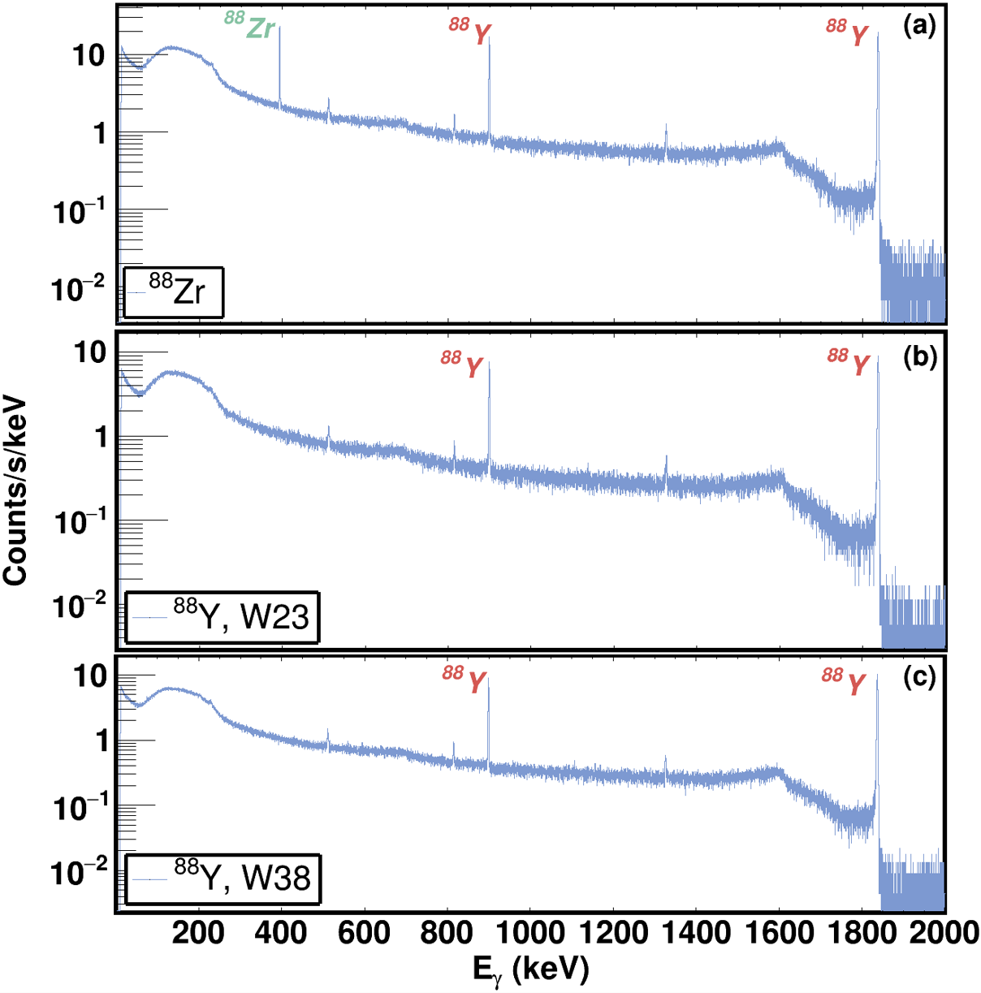
Fig. S1. Gamma-ray spectra measured with a high-purity germanium detector. Panel a) is for the ⁸⁸Zr sample measured with DICER. Panels b) and c) are for the two ⁸⁸Y calibrated samples. Peaks at 898 and 1836 keV due to the decay of ⁸⁸Y and at 393 keV from ⁸⁸Zr decay are labeled. The other small peaks are single- and double-escape peaks for the 1836-keV γ ray and the 511-keV γ ray due to positron annihilation.

Table S1. Data in Fig. 2 of main paper. Measured DICER neutron transmission through 7.44e-7 atoms of ⁸⁸Zr/barn sample and R-matrix fit to these data
Neutron energy (eV) | Transmission | 1 σ standard deviation | R-matrix transmission
0.0103 | 0.4464 | 0.0154 | 0.4545
0.0113 | 0.4800 | 0.0140 | 0.4677
0.0124 | 0.4874 | 0.0125 | 0.4804
0.0136 | 0.4937 | 0.0114 | 0.4927
0.0149 | 0.5186 | 0.0105 | 0.5045
0.0163 | 0.5289 | 0.0092 | 0.5157
0.0179 | 0.5288 | 0.0080 | 0.5263
0.0196 | 0.5428 | 0.0073 | 0.5364
0.0215 | 0.5452 | 0.0065 | 0.5457
0.0236 | 0.5498 | 0.0060 | 0.5544
0.0259 | 0.5649 | 0.0055 | 0.5623
0.0284 | 0.5724 | 0.0051 | 0.5694
0.0311 | 0.5755 | 0.0047 | 0.5757
0.0341 | 0.5776 | 0.0044 | 0.5810
0.0374 | 0.5831 | 0.0042 | 0.5853
0.0410 | 0.5808 | 0.0040 | 0.5885
0.0450 | 0.5867 | 0.0038 | 0.5905
0.0493 | 0.5871 | 0.0037 | 0.5912
0.0541 | 0.5896 | 0.0036 | 0.5905
0.0593 | 0.5873 | 0.0036 | 0.5882
0.0650 | 0.5844 | 0.0035 | 0.5841
0.0713 | 0.5810 | 0.0036 | 0.5781
0.0782 | 0.5715 | 0.0036 | 0.5700
0.0857 | 0.5618 | 0.0038 | 0.5597
0.0940 | 0.5485 | 0.0039 | 0.5471
0.1031 | 0.5337 | 0.0041 | 0.5325
0.1130 | 0.5213 | 0.0043 | 0.5164
0.1239 | 0.4997 | 0.0045 | 0.5000
0.1359 | 0.4875 | 0.0048 | 0.4854
0.1490 | 0.4754 | 0.0052 | 0.4757
0.1634 | 0.4746 | 0.0056 | 0.4754
0.1792 | 0.4874 | 0.0061 | 0.4888
0.1964 | 0.5123 | 0.0067 | 0.5192
0.2154 | 0.5572 | 0.0074 | 0.5664
0.2362 | 0.6238 | 0.0081 | 0.6256
0.2590 | 0.6953 | 0.0088 | 0.6888
0.2840 | 0.7554 | 0.0093 | 0.7486
0.3114 | 0.8140 | 0.0100 | 0.8001
0.3414 | 0.8557 | 0.0104 | 0.8418
0.3743 | 0.8769 | 0.0106 | 0.8743
0.4105 | 0.9072 | 0.0110 | 0.8991
0.4501 | 0.9315 | 0.0115 | 0.9179
0.4935 | 0.9256 | 0.0118 | 0.9320
0.5411 | 0.9514 | 0.0057 | 0.9427
0.5933 | 0.9516 | 0.0056 | 0.9509
0.6506 | 0.9575 | 0.0056 | 0.9572
0.7134 | 0.9608 | 0.0056 | 0.9620
0.7822 | 0.9770 | 0.0057 | 0.9658
0.8577 | 0.9660 | 0.0058 | 0.9688
0.9404 | 0.9680 | 0.0058 | 0.9712
1.0341 | 0.9728 | 0.0035 | 0.9732
1.3633 | 0.9757 | 0.0037 | 0.9771
1.7973 | 0.9741 | 0.0040 | 0.9794
2.3695 | 0.9756 | 0.0044 | 0.9809
3.1239 | 0.9896 | 0.0048 | 0.9820
4.1185 | 0.9765 | 0.0053 | 0.9828
5.4299 | 0.9973 | 0.0062 | 0.9836
7.1589 | 0.9834 | 0.0078 | 0.9844
9.4387 | 0.9708 | 0.0067 | 0.9851
12.4448 | 0.9661 | 0.0073 | 0.9860
16.4087 | 0.9759 | 0.0089 | 0.9869
21.6359 | 1.0016 | 0.0147 | 0.9880
28.5292 | 0.9768 | 0.0095 | 0.9891
37.6202 | 1.0083 | 0.0101 | 0.9903
49.6104 | 0.9903 | 0.0115 | 0.9916
65.4253 | 1.0087 | 0.0120 | 0.9929
86.2870 | 1.0148 | 0.0255 | 0.9941
113.8084 | 0.9670 | 0.0165 | 0.9952
150.1195 | 0.9894 | 0.0156 | 0.9963
198.0337 | 1.0102 | 0.0174 | 0.9971
261.2678 | 1.0045 | 0.0201 | 0.9979
344.7341 | 0.9788 | 0.0304 | 0.9984
454.9272 | 0.9909 | 0.0342 | 0.9989

