A Comparative Study on the Preparation and Evaluation of Solubilizing Systems for Silymarin
Zhenzhen Chen^{a,1}, Wenhao Gao^{a,1}, Xianquan Feng^{a,1}, Guizhi Zhou^{a,b}, Minxin Zhangª, Lingjun Zengª, Xiaomu Huª, Zhihong Liu^{a,*} Hongtao Song^{a,*}
ª Department of Pharmacy, Fuzong Clinical Medical College of Fujian Medical University (900 Hospital of the Joint Logistics Team), Fuzhou 350025, PR China
^{b} School of Pharmacy, Fujian University of Chinese Traditional Medicine, Fuzhou 350108, China

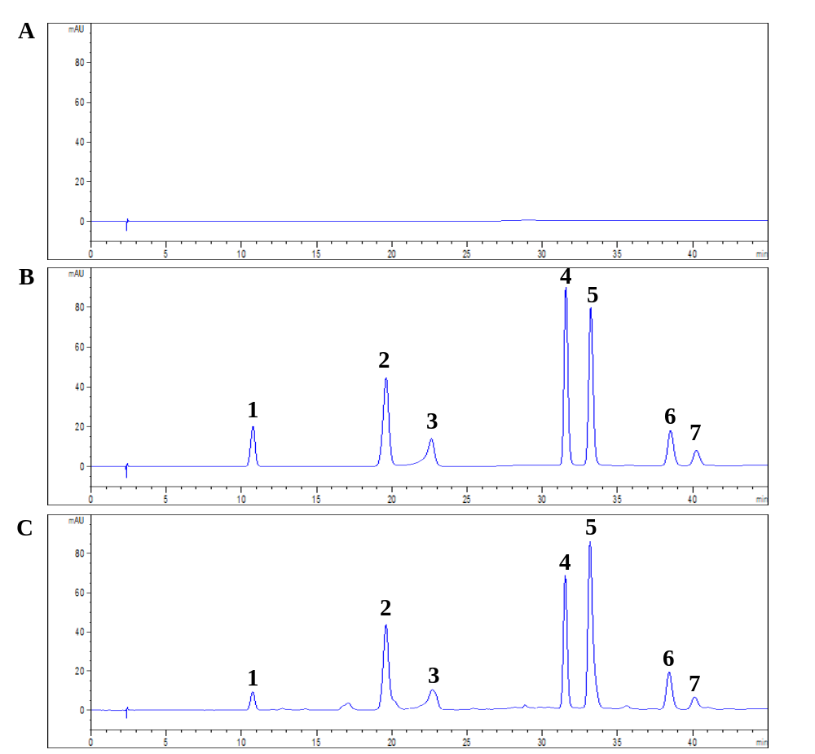
Fig.S1 High performance liquid chromatogram of (A) Blank samples, (B) Standard samples, and (C) Tested samples
Note: Where 1 refers to taxifolin (TF), 2 refers to silycristin (SC), 3 refers to silydianin (SD); 4 and 5 refer to silybin (SB); 6 and 7 refer to isosilybin (ISB)

Tab.S1 The test results of intra-day and inter-day precision
Components | Precision | Concentration (μg·mL⁻¹) | Samples |  |  |  |  | Mean  (μg·mL⁻¹) | RSD  (%)
Components | Precision | Concentration (μg·mL⁻¹) | 1 | 2 | 3 | 4 | 5 | Mean  (μg·mL⁻¹) | RSD  (%)
TF | Intra-day | 1.50 | 1.53 | 1.52 | 1.51 | 1.53 | 1.52 | 1.52 | 0.55
TF | Intra-day | 6.0 | 6.03 | 6.02 | 5.99 | 6.01 | 6.02 | 6.01 | 0.25
TF | Intra-day | 14.60 | 14.62 | 14.61 | 14.59 | 14.61 | 14.62 | 14.61 | 0.08
TF | Inter-day | 1.50 | 1.53 | 1.51 | 1.52 | 1.53 | 1.52 | 1.52 | 0.55
TF | Inter-day | 6.0 | 5.99 | 6.01 | 6.02 | 5.99 | 6.01 | 6.0 | 0.22
TF | Inter-day | 14.60 | 14.59 | 14.62 | 14.61 | 14.59 | 14.61 | 14.60 | 0.09
SC | Intra-day | 3.20 | 3.23 | 3.21 | 3.21 | 3.23 | 3.22 | 3.22 | 0.31
SC | Intra-day | 12.80 | 12.81 | 12.79 | 12.82 | 12.81 | 12.82 | 12.81 | 0.10
SC | Intra-day | 20.10 | 20.12 | 20.13 | 20.11 | 20.09 | 20.12 | 20.11 | 0.08
SC | Inter-day | 3.20 | 3.23 | 3.25 | 3.22 | 3.21 | 3.23 | 3.22 | 0.45
SC | Inter-day | 12.80 | 12.82 | 12.79 | 12.81 | 12.82 | 12.81 | 12.81 | 0.10
SC | Inter-day | 20.10 | 20.11 | 20.13 | 20.12 | 20.09 | 20.12 | 20.11 | 0.08
SD | Intra-day | 3.0 | 3.01 | 3.03 | 2.97 | 3.02 | 2.99 | 3.01 | 0.80
SD | Intra-day | 11.68 | 11.66 | 11.71 | 11.70 | 11.69 | 11.67 | 11.69 | 0.18
SD | Intra-day | 18.30 | 18.35 | 18.32 | 18.31 | 18.29 | 18.33 | 18.32 | 0.12
SD | Inter-day | 3.0 | 3.02 | 2.98 | 2.96 | 3.03 | 2.97 | 3.0 | 1.04
SD | Inter-day | 11.68 | 11.67 | 11.70 | 11.69 | 11.71 | 11.69 | 11.69 | 0.13
SD | Inter-day | 18.30 | 18.32 | 18.33 | 18.31 | 18.32 | 18.31 | 18.31 | 0.05
SB | Intra-day | 6.80 | 6.83 | 6.78 | 6.81 | 6.85 | 6.77 | 6.81 | 0.49
SB | Intra-day | 34.20 | 34.22 | 34.19 | 34.22 | 34.23 | 34.21 | 34.21 | 0.04
SB | Intra-day | 85.40 | 85.41 | 85.43 | 85.39 | 85.44 | 85.42 | 85.42 | 0.02
SB | Inter-day | 6.80 | 6.84 | 6.83 | 6.79 | 6.81 | 6.82 | 6.82 | 0.28
SB | Inter-day | 34.20 | 34.23 | 34.22 | 34.19 | 34.23 | 34.21 | 34.22 | 0.05
SB | Inter-day | 85.40 | 85.45 | 85.38 | 85.39 | 85.43 | 85.41 | 85.41 | 0.03
ISB | Intra-day | 3.70 | 3.63 | 3.71 | 3.68 | 3.66 | 3.77 | 3.69 | 1.45
ISB | Intra-day | 14.80 | 14.82 | 14.90 | 14.83 | 14.76 | 14.84 | 14.83 | 0.34
ISB | Intra-day | 23.20 | 23.18 | 23.31 | 23.26 | 23.21 | 23.29 | 23.25 | 0.23
ISB | Inter-day | 3.70 | 3.69 | 3.67 | 3.73 | 3.71 | 3.74 | 3.71 | 0.77
ISB | Inter-day | 14.80 | 14.83 | 14.78 | 14.81 | 14.82 | 14.76 | 14.80 | 0.20
ISB | Inter-day | 23.20 | 23.22 | 23.19 | 23.24 | 23.21 | 23.17 | 23.21 | 0.12

Tab.S2 The test results of recovery
Components | Content (mg) | Added (mg) | Tested (mg) | Recovery (%) | Mean (%) | RSD (%)
TF | 1.41 | 1.42 | 2.79 | 98.59 | 98.82 | 0.70
TF | 1.42 | 1.42 | 2.81 | 98.94 | 98.82 | 0.70
TF | 1.40 | 1.42 | 2.80 | 99.29 | 98.82 | 0.70
TF | 1.42 | 1.42 | 2.82 | 99.30 | 98.82 | 0.70
TF | 1.41 | 1.42 | 2.81 | 99.28 | 98.82 | 0.70
TF | 1.43 | 1.42 | 2.78 | 97.54 | 98.82 | 0.70
SC | 7.01 | 7.04 | 14.01 | 99.72 | 99.48 | 0.64
SC | 7.03 | 7.04 | 13.98 | 99.36 | 99.48 | 0.64
SC | 7.02 | 7.04 | 13.90 | 98.86 | 99.48 | 0.64
SC | 7.05 | 7.04 | 14.10 | 100.07 | 99.48 | 0.64
SC | 7.07 | 7.04 | 13.92 | 98.65 | 99.48 | 0.64
SC | 7.06 | 7.04 | 14.13 | 100.21 | 99.48 | 0.64
SD | 2.48 | 2.46 | 4.91 | 99.39 | 99.43 | 0.89
SD | 2.44 | 2.46 | 4.92 | 100.41 | 99.43 | 0.89
SD | 2.47 | 2.46 | 4.83 | 97.97 | 99.43 | 0.89
SD | 2.43 | 2.46 | 4.90 | 100.20 | 99.43 | 0.89
SD | 2.45 | 2.46 | 4.89 | 99.59 | 99.43 | 0.89
SD | 2.49 | 2.46 | 4.90 | 98.99 | 99.43 | 0.89
SB | 20.69 | 20.72 | 41.40 | 99.97 | 99.38 | 1.04
SB | 20.68 | 20.72 | 40.38 | 97.54 | 99.38 | 1.04
SB | 20.72 | 20.72 | 41.46 | 100.10 | 99.38 | 1.04
SB | 20.74 | 20.72 | 41.42 | 99.90 | 99.38 | 1.04
SB | 20.77 | 20.72 | 40.98 | 98.77 | 99.38 | 1.04
SB | 20.69 | 20.72 | 41.42 | 100.02 | 99.38 | 1.04
ISB | 3.62 | 3.62 | 7.18 | 99.17 | 99.10 | 0.99
ISB | 3.63 | 3.62 | 7.09 | 97.79 | 99.10 | 0.99
ISB | 3.64 | 3.62 | 7.28 | 100.28 | 99.10 | 0.99
ISB | 3.58 | 3.62 | 7.08 | 98.33 | 99.10 | 0.99
ISB | 3.65 | 3.62 | 7.19 | 98.90 | 99.10 | 0.99
ISB | 3.59 | 3.62 | 7.22 | 100.14 | 99.10 | 0.99

Tab.S3 The test results of stability at 25 ℃
Components | Peak area |  |  |  |  |  | RSD (%)
Components | 0 h | 3 h | 6 h | 12 h | 18 h | 24 h | RSD (%)
TF | 263.1 | 262.8 | 260.6 | 258.5 | 260.9 | 255.8 | 1.06
SC | 1225.2 | 1225.1 | 1224.8 | 1223.1 | 1220.8 | 1211.2 | 0.44
SD | 243.3 | 243.1 | 242.8 | 241.5 | 240.4 | 232.9 | 1.65
SB | 3545.2 | 3543.1 | 3540.8 | 3533.9 | 3535.6 | 3524.1 | 0.22
ISB | 633.6 | 633.4 | 632.2 | 631.9 | 631.1 | 620.5 | 0.79

Method
Phase Solubility Studies[1]
113.4 mg of β-CD, 140.3 mg of HP-β-CD, 133.3 mg of DM-β-CD, and 216.2 mg of SBE-β-CD were individually added into 100 mL flasks and then diluted with purified water to achieve a standardized concentration of 1 mM for each CD. Subsequently, varying volumes of the standard solution (0, 2, 4 , 6 , 8 , and 10 mL) were added to 10 mL flasks and further diluted with purified water to the mark, resulting in gradient concentration solutions. Following this, an excess of SM was added to each of the aforementioned solutions and shaken in a water bath for 24 h at 37℃, 100 rpm. Following centrifugation at 8000 rpm for 7 min, the supernatant's concentration was determined using HPLC after filtration through a 0.45 μm microporous membrane. The resulting phase solubility diagram was constructed by plotting the molar concentration of each cyclodextrin on the x-axis and the molar concentration of each component of SM on the y-axis.
Fig. S2 Solubility of five active components in SM at different concentrations and with different types of cyclodextrins

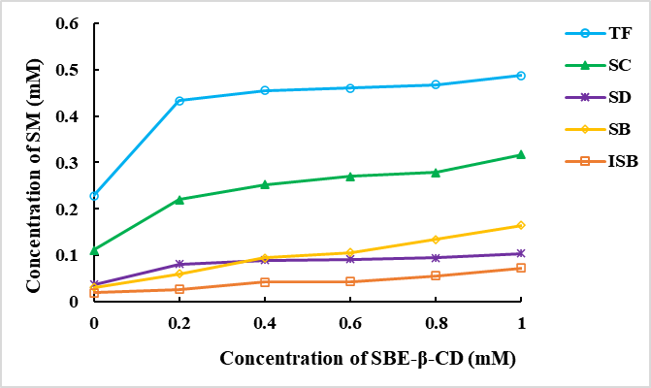
Fig.S3 Solubility of five active components in SM at different concentrations of SBE-β-CD

Tab. S4 Standard curves SC, SB, and ISB in beagle dog’s plasma
Components | Regression equation | r | Linearity range (ng/mL)
SC | Y=1.88×10⁻²X+2.83×10⁻² | 0.9987 | 20 ~ 6000
SB | Y=1.03×10⁻²X-8.61×10⁻² | 0.9998 | 20 ~ 6000
ISB | Y=9.10×10⁻³X-3.45×10⁻¹ | 0.9988 | 20 ~ 6000

Tab. S5 The results of intra-day and inter-day precision
Components | Precision | Concentration (ng‧mL⁻¹)  (ngmL⁻¹) | No. |  |  |  |  | Mean±SD | RSD  (%)
Components | Precision | Concentration (ng‧mL⁻¹)  (ngmL⁻¹) | 1 | 2 | 3 | 4 | 5 | Mean±SD | RSD  (%)
SC | Intra-day | 50.0 | 0.454 | 0.469 | 0.466 | 0.453 | 0.455 | 0.46±0.01 | 1.63
SC | Intra-day | 1000.0 | 12.30 | 12.59 | 12.32 | 12.37 | 12.49 | 12.42±0.12 | 0.98
SC | Intra-day | 3000.0 | 56.98 | 58.01 | 56.85 | 57.35 | 56.92 | 57.22±0.48 | 0.84
SC | Inter-day | 50.0 | 0.556 | 0.551 | 0.566 | 0.544 | 0.561 | 0.55±0.01 | 1.57
SC |  | 1000.0 | 13.10 | 12.85 | 12.89 | 13.11 | 12.70 | 12.94±0.17 | 1.35
SC |  | 3000.0 | 55.58 | 54.62 | 53.99 | 54.09 | 55.90 | 55.84±0.87 | 1.58
SB | Intra-day | 50.0 | 0.365 | 0.356 | 0.356 | 0.353 | 0.356 | 0.36±0.01 | 1.33
SB | Intra-day | 1000.0 | 8.75 | 8.65 | 8.54 | 8.60 | 8.59 | 8.63±0.08 | 0.94
SB | Intra-day | 3000.0 | 29.56 | 29.41 | 29.32 | 29.91 | 29.93 | 29.63±0.28 | 0.95
SB | Inter-day | 50.0 | 0.395 | 0.402 | 0.391 | 0.409 | 0.396 | 0.39±0.01 | 1.85
SB |  | 1000.0 | 8.95 | 8.77 | 8.85 | 8.68 | 8.80 | 8.81±0.09 | 1.12
SB |  | 3000.0 | 27.98 | 27.65 | 28.49 | 27.89 | 28.09 | 28.02±0.31 | 1.09
ISB | Intra-day | 50.0 | 0.289 | 0.294 | 0.294 | 0.298 | 0.297 | 0.29±0.01 | 1.14
ISB |  | 1000.0 | 7.22 | 7.12 | 7.29 | 7.20 | 7.23 | 7.21±0.06 | 0.85
ISB |  | 3000.0 | 28.21 | 28.63 | 28.53 | 28.31 | 28.62 | 28.46±0.19 | 0.67
ISB | Inter-day | 50.0 | 0.319 | 0.326 | 0.330 | 0.319 | 0.329 | 0.33±0.01 | 1.67
ISB |  | 1000.0 | 7.020 | 7.210 | 7.220 | 7.120 | 7.070 | 7.13±0.09 | 1.19
ISB |  | 3000.0 | 26.99 | 27.89 | 27.99 | 27.49 | 27.830 | 27.64±0.41 | 1.47

Tab. S6 Matrix effect of SC, SB, and ISB in beagle dog’s plasma
Components | Matrix effect
Components | 50.0 ng‧mL⁻¹ | 1000.0 ng‧mL⁻¹ | 3000.0 ng‧mL⁻¹
SC | 1.04 | 0.97 | 0.98
SB | 1.02 | 0.98 | 0.96
ISB | 1.03 | 0.97 | 0.99

Tab. S7 Stability of SC, SB, and ISB in beagle dog’s plasma at room temperature for 24 h (n=5)
Components | Concentration (ng‧mL⁻¹) | No. |  |  |  |  | RSD  (%)
Components | Concentration (ng‧mL⁻¹) | 1 | 2 | 3 | 4 | 5 | RSD  (%)
SC | 50.0 | 0.9018 | 0.9265 | 0.9173 | 0.9365 | 0.9092 | 1.49
 | 1000.0 | 0.9603 | 0.9389 | 0.9608 | 0.9585 | 0.9493 | 0.98
 | 3000.0 | 0.9705 | 0.9565 | 0.9735 | 0.9700 | 0.9674 | 0.68
SB | 50.0 | 1.021 | 1.028 | 1.017 | 0.9865 | 1.026 | 1.68
 | 1000.0 | 0.9694 | 0.9741 | 0.9597 | 0.9832 | 0.9802 | 0.96
 | 3000.0 | 1.002 | 0.9939 | 0.9902 | 0.9783 | 0.9897 | 0.89
ISB | 50.0 | 1.059 | 1.034 | 1.057 | 1.042 | 1.028 | 1.32
 | 1000.0 | 1.037 | 1.044 | 1.056 | 1.029 | 1.037 | 0.95
 | 3000.0 | 0.994 | 1.019 | 1.021 | 1.022 | 1.020 | 0.92

Tab.S8 Stability of SC, SB, and ISB in beagle dog’s plasma after three freeze-thaw cycles (n=5)
Components | Concentration (ng‧mL⁻¹) | No. |  |  |  |  | RSD  (%)
Components | Concentration (ng‧mL⁻¹) | 1 | 2 | 3 | 4 | 5 | RSD  (%)
SC | 50.0 | 1.323 | 1.402 | 1.388 | 1.328 | 1.381 | 2.65
 | 1000.0 | 1.349 | 1.328 | 1.379 | 1.322 | 1.334 | 1.72
 | 3000.0 | 1.152 | 1.124 | 1.134 | 1.132 | 1.118 | 1.14
SB | 50.0 | 1.074 | 1.105 | 1.121 | 1.097 | 1.147 | 2.46
 | 1000.0 | 1.148 | 1.177 | 1.155 | 1.145 | 1.146 | 1.13
 | 3000.0 | 1.067 | 1.043 | 1.055 | 1.039 | 1.037 | 1.18
ISB | 50.0 | 1.280 | 1.351 | 1.305 | 1.279 | 1.309 | 2.23
 | 1000.0 | 1.208 | 1.245 | 1.234 | 1.204 | 1.219 | 1.40
 | 3000.0 | 1.119 | 1.108 | 1.093 | 1.105 | 1.093 | 1.01

Tab.S9 The main pharmacokinetic parameters of SC and ISB after oral administration of test formulations in beagle dogs’ plasma, n = 6.
Formulations | Components | C_{max} (ng/L) | T_{max} (h) | t_{1/2 (h)} | AUC₀₋₂₄ (ng/L*h) | AUC_{0-∞} (ng/L*h)
SM | SC | 134.8±68.3 | 2.0 ± 1.3 | 10.1 ± 4.2 | 1226.5 ± 608.0 | 1678.7 ± 897.8
 | ISB | 155.4 ± 98.0 | 2.0 ± 1.7 | 9.5 ± 5.2 | 994.2 ± 1089.6 | 1427.8 ±1509.1
SM-SD | SC | 100.9 ± 70.4 | 2.2 ± 0.9 | 9.7 ±4.4 | 1403.4 ± 430.5 | 1983.2 ± 676.3
 | ISB | 207.9 ± 20.1 | 1.83 ± 0.2 | 6.85 ± 4.3 | 1505.9 ± 339.0 | 1820.2 ± 477.2
SM-PC | SC | 131.6 ± 26.7 | 2.3 ± 1.2 | 10.9 ± 7.8 | 1341.0 ± 244.8 | 1958.2 ± 593.7
 | ISB | 163.5 ± 81.0 | 2.8 ± 1.3 | 9.7 ± 5.8 | 1214.5 ± 911.2 | 1599.6 ± 918.9
SM-CDIC | SC | 173.0 ± 37.5 | 1.6 ± 0.4 | 10.5 ± 2.8 | 1810.9 ± 603.7 | 2069.1 ± 398.1
 | ISB | 254.8 ± 16.8 | 1.8 ± 0.7 | 8.2 ± 5.0 | 1312.6 ± 155.2 | 1751.9 ± 316.7
SM-SMEDDS | SC | 311.2 ± 67.8 | 1.5 ± 0.5 | 6.4 ± 2.2 | 2109.1 ± 633.2 | 2601.7 ± 786.6
 | ISB | 469.6 ± 210.2 | 1.4 ± 0.2 | 6.2 ± 1.4 | 1879.2 ± 822.9 | 2160.9 ± 779.7
Legalon® | SC | 96.9 ± 13.7 | 1.5 ± 0.5 | 9.6 ± 2.5 | 1357.1 ± 254.9 | 1727.6 ± 192.4
 | ISB | 227.0 ± 53.1 | 1.75±0.4 | 11.2 ± 4.5 | 1514.1 ± 962.7 | 1822.8 ± 1284.8

References
[1] M.T. Esclusa-Diaz, M. Guimaraens-Méndez, M.B. Pérez-Marcos, et al., Characterization and in vitro dissolution behaviour of ketoconazole/β- and 2-hydroxypropyl-β-cyclodextrin inclusion compounds, Int J Pharm. 143 (1996) 203-210.

