Supplementary Information for
Tunable ferroelectric topological defects on 2D topological surfaces: strain engineering skyrmion-like polar structures in 2D materials
Bo Xu^{1,#}, Zhanpeng Gong^{1,#}, Jingran Liu^{2,#}, Yunfei Hong¹, Yang Yang¹, Lou Li¹, Yilun Liu², Junkai Deng^{1,*}, Jefferson Zhe Liu^{3,*}
¹State Key Laboratory for Mechanical Behavior of Materials, Xi’an Jiaotong University, Xi’an 710049, China
²State Key Laboratory for Strength and Vibration of Mechanical Structures, School of Aerospace Engineering,
Xi’an Jiaotong University, Xi’an 710049, China
³Department of Mechanical Engineering, The University of Melbourne, Parkville, VIC 3010, Australia
E-mail address: junkai.deng@mail.xjtu.edu.cn; zhe.liu@unimelb.edu.au.
#These authors contributed equally.

Supplementary Table 1:
Table1: The mechanical parameters of PE and FE phases of monolayer PbTe
Phase | a  (Å) | b  (Å) | C₁₁  (N/m) | C₂₂  (N/m) | C₁₂  (N/m) | C₄₄  (N/m) | υ₁₂ | υ₂₁
PE | 4.638 | 4.638 | 38.064 | 38.064 | 20.554 | 31.990 | 0.54 | 0.54
FE | 4.670 | 4.580 | 6.228 | 30.476 | 8.783 | 18.983 | 0.29 | 1.41

Supplementary Figure 1:
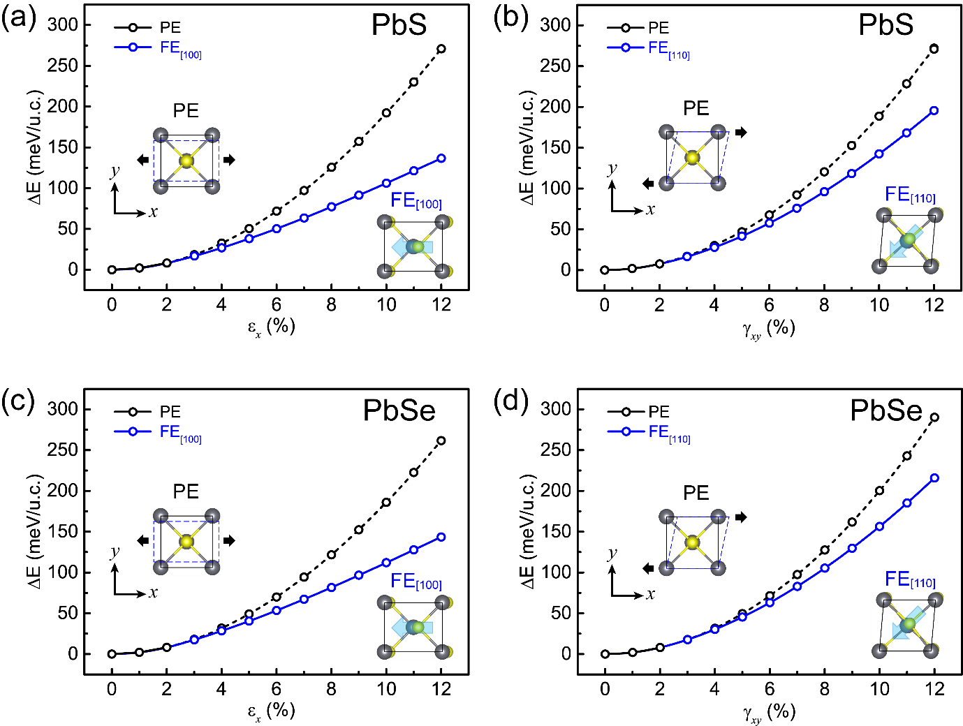
Supplementary Figure 1. The energy variation of monolayer (a-b) PbS and (c-d) PbSe under uniaxial stretch and in-plane shear. The parabolic energy curve turns into a smoother curve when the PE-to-FE phase transition occurs.

Supplementary Figure 2:
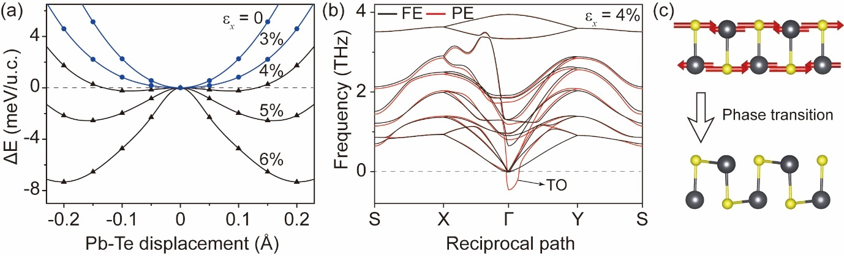
Supplementary Figure 2. The strain-induced PE-to-FE phase transition originates from the transverse optical lattice vibration mode. (a) The relative total energy as a function of Pb-Te displacement under different stretch strains. Below the critical strain of 3.5%, the PE phase is the ground state. Otherwise, two bistable FE phases are more stable than the PE phase when the strain is larger than the critical value. (b) The phonon dispersion spectra of the PE and FE phases for monolayer PbTe under the stretch strain of 4%. The black lines of the FE phase indicate its stability, while the red lines of the PE phase indicate the soft transverse optical (TO) mode at Γ point, corresponding to its instability. (c) The soft TO mode is related to corresponding atomic vibration, i.e., the inverse vibration of Pb and Te atoms along x direction.

Supplementary Figure 3:
Supplementary Figure 3. The (a) energy variation of monolayer PbTe under uniaxial stretch, and corresponding (b) first-order and (c) second-order differential of energy with respect to the strain. The first-order differential of energy is still continuous when phase transition happens, while the second-order differential is discontinued at the critical point of phase transition.

Supplementary Figure 4:
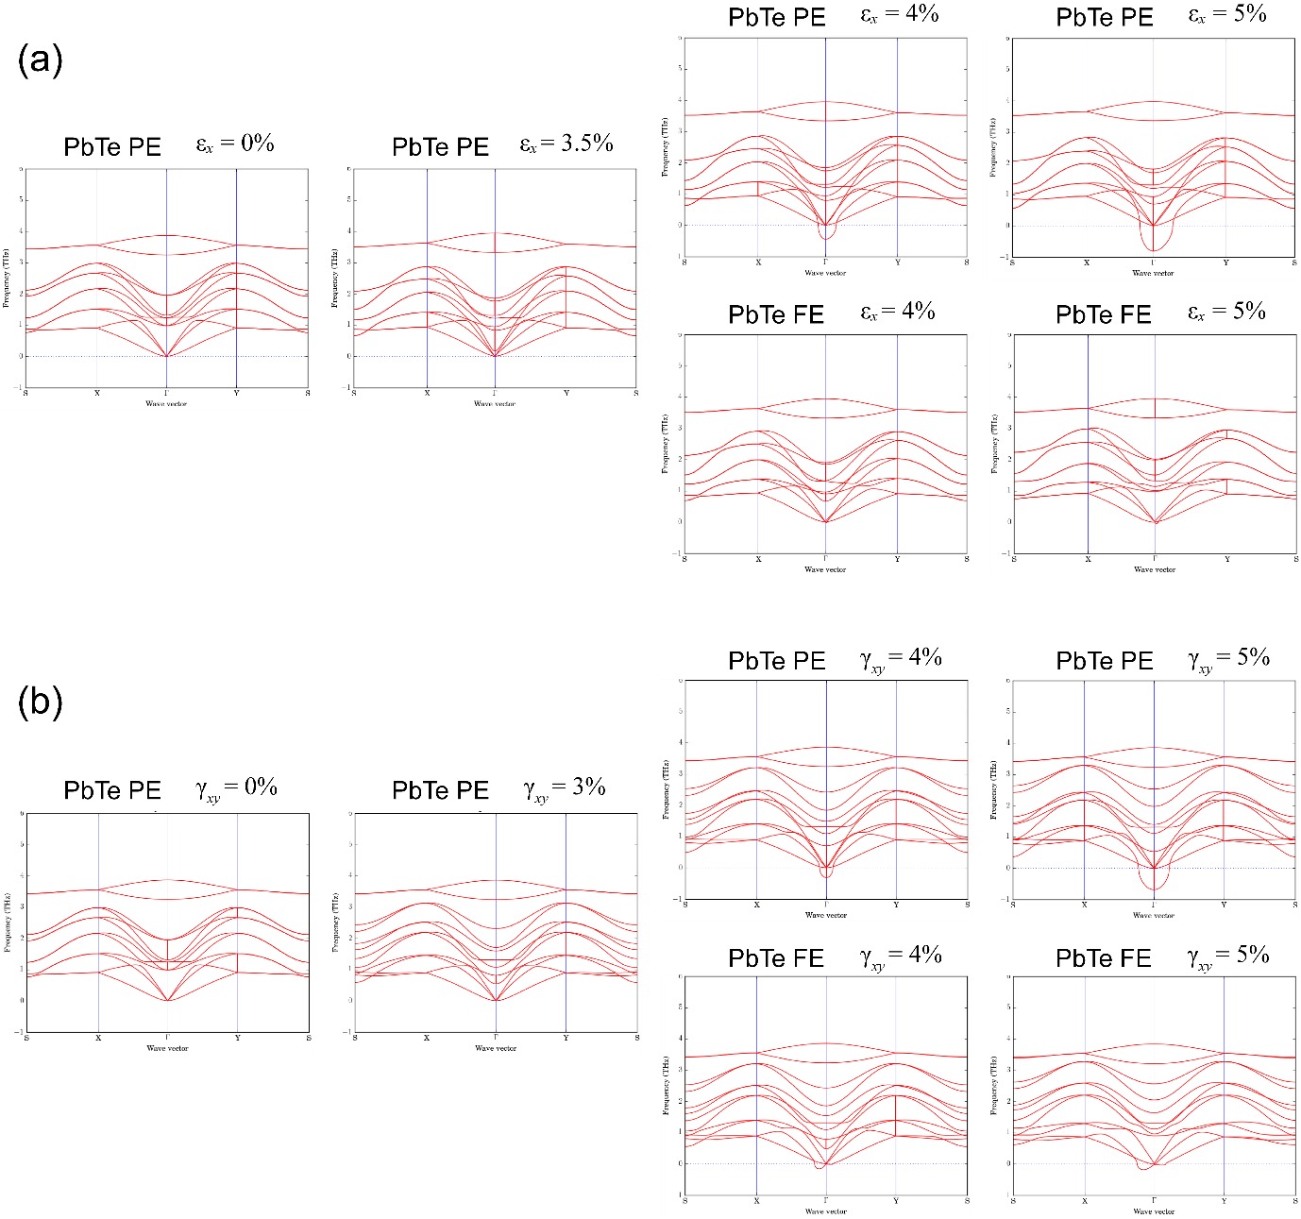
Supplementary Figure 4. The phonon dispersions of strained monolayer PbTe under different (a) uniaxial stretch and (b) in-plane shear. When the applied strain is beyond the critical point of phase transition, the negative frequency of modes arises in the phonon dispersion of the strained PE structure, indicating the instability of the PE structure under this strain condition. Whereas no soft mode appears in the phonon dispersion of FE structure under this corresponding strain, indicating its stability.

Supplementary Figure 5:
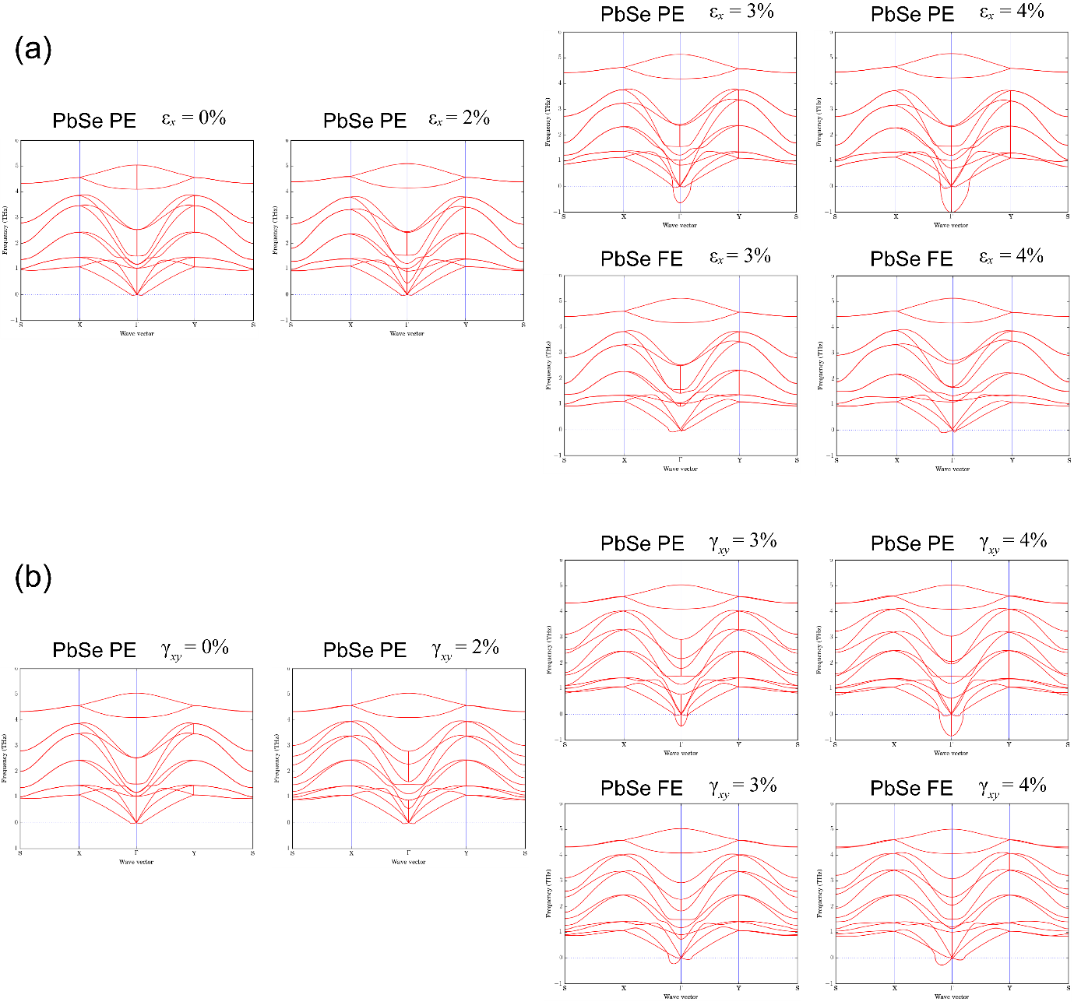
Supplementary Figure 5. The phonon dispersions of strained monolayer PbSe under different (a) uniaxial stretch and (b) in-plane shear. When the applied strain is beyond the critical point of phase transition, the negative frequency of modes arises in the phonon dispersion of the strained PE structure, indicating the instability of the PE structure under this strain condition. Whereas no soft mode appears in the phonon dispersion of FE structure under this corresponding strain, indicating its stability.

Supplementary Figure 6:
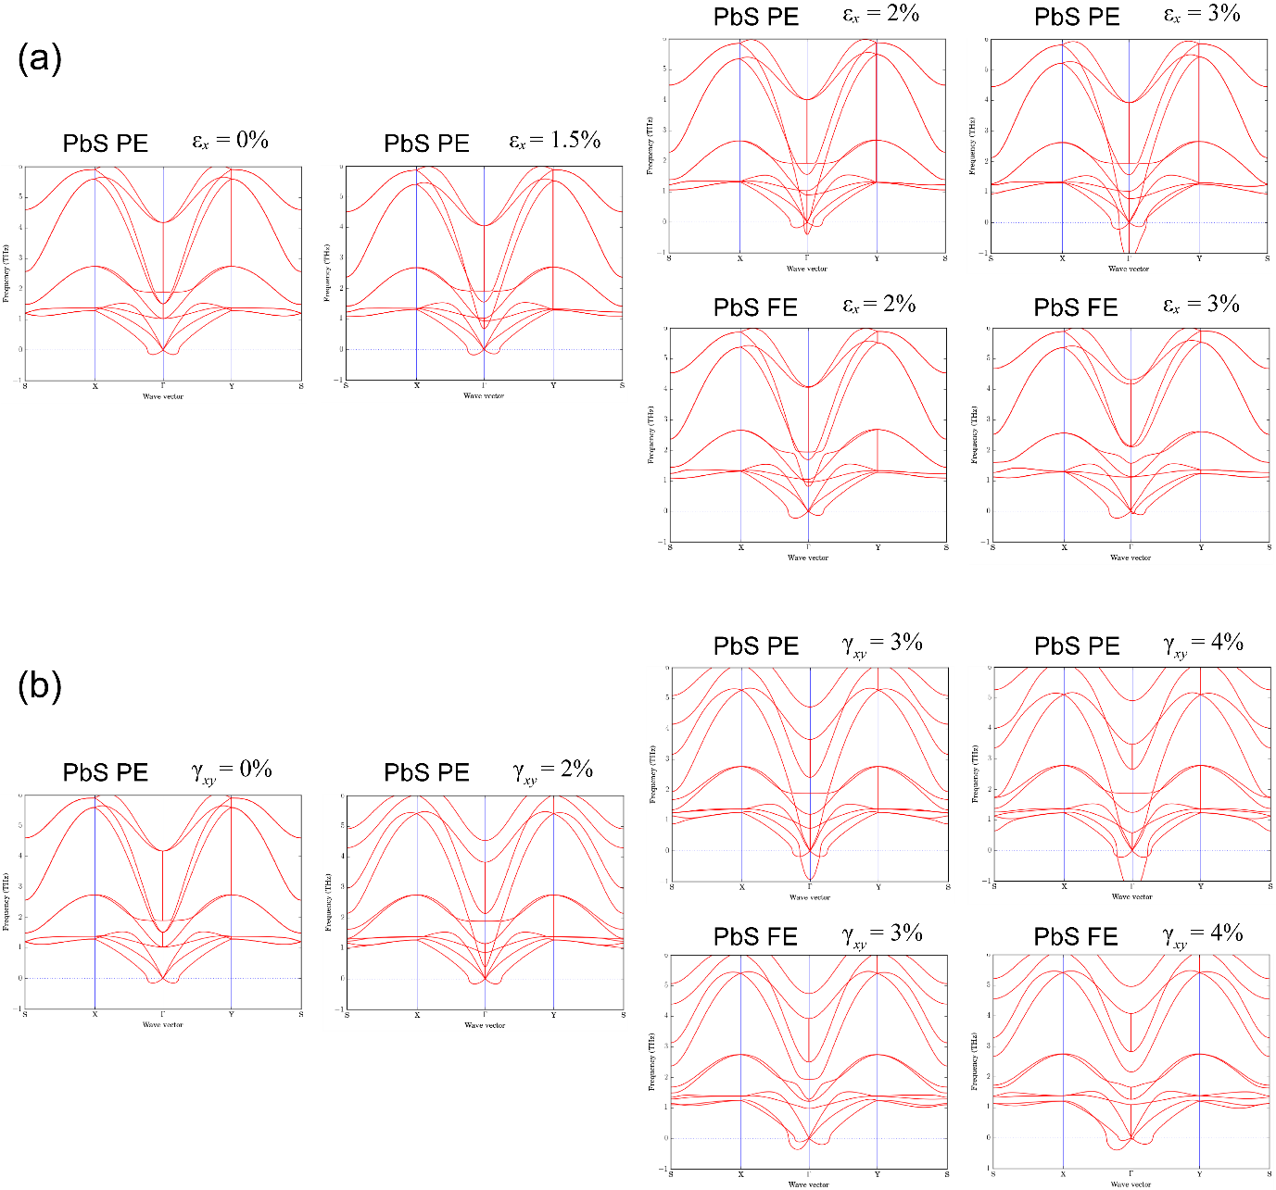
Supplementary Figure 6. The phonon dispersions of strained monolayer PbS under different (a) uniaxial stretch and (b) in-plane shear. When the applied strain is beyond the critical point of phase transition, the negative frequency of modes arises in the phonon dispersion of the strained PE structure, indicating the instability of the PE structure under this strain condition. Whereas no soft mode appears in the phonon dispersion of FE structure under this corresponding strain, indicating its stability.

Supplementary Figure 7:
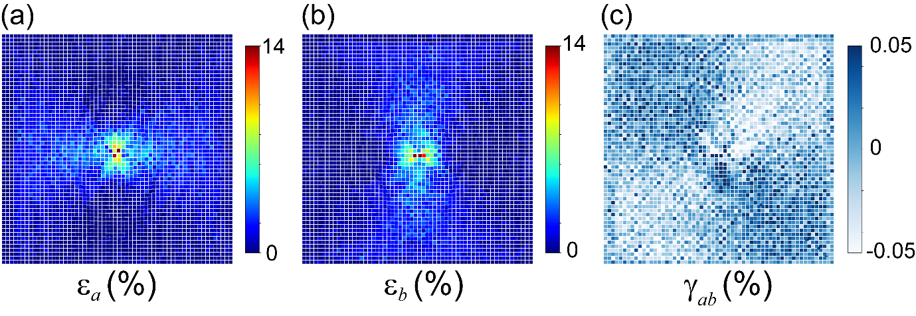
Supplementary Figure 7. The distribution of lattice distortion of whole 60 $×$ 60 units monolayer PbTe. Each block unit represents the local lattice strain of a unit-cell, including the relative change of lattice parameters a and b, and the shear distortion of the unit-cell in the local tangent plane. The three components are approximately divided along the diagonal direction of the x-y projective plane. Distortions concentrate at the center, as the Figure 4 of main text demonstrated, and give rise to special polarization patterns. In-plane shear distortion is negligible at this mechanical indention load.

Supplementary Figure 8:
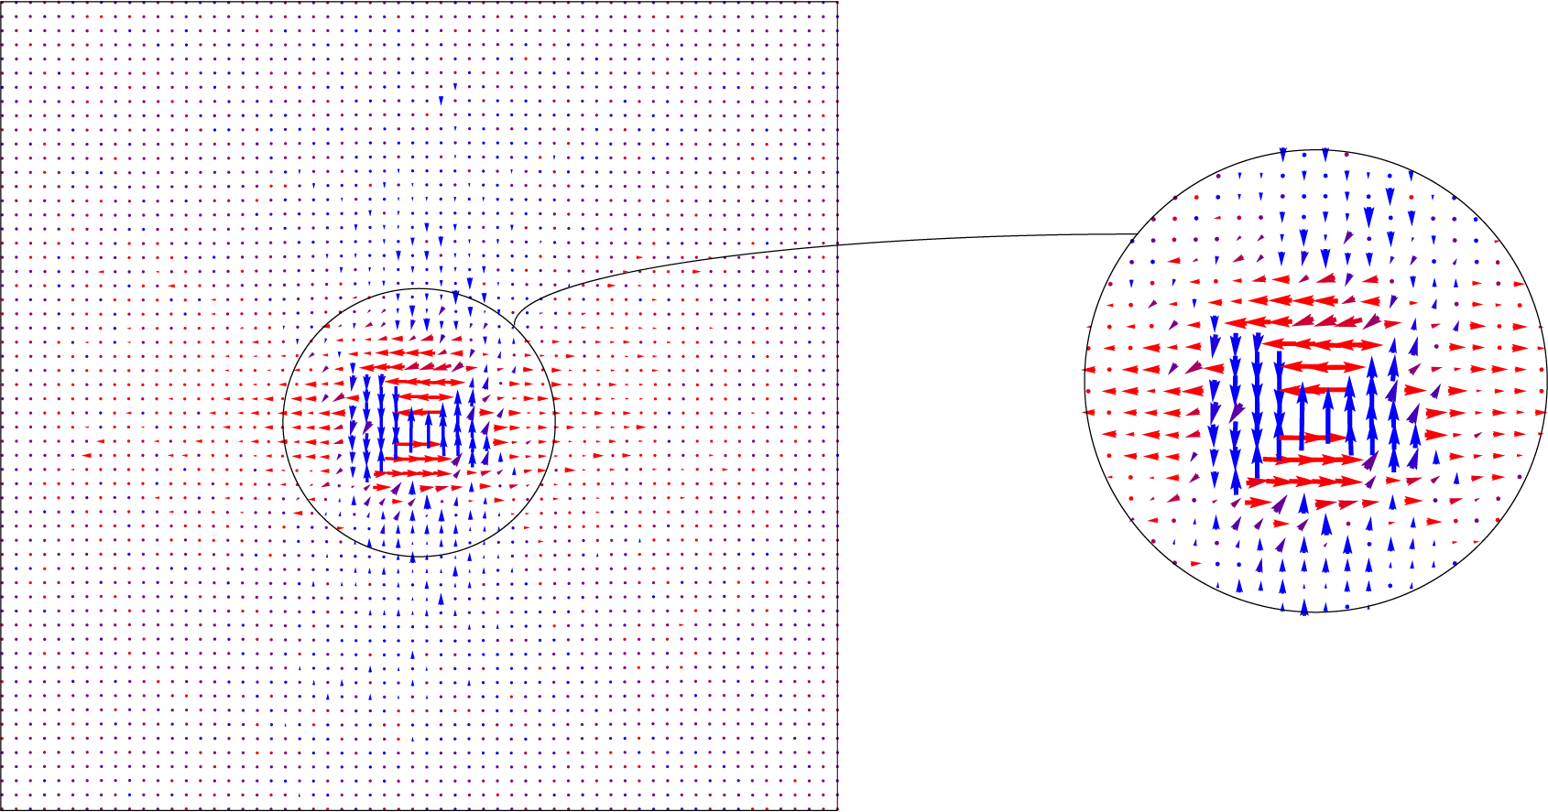
Supplementary Figure 8. The polarization map based on the lattice distortion from MD and the polarization phase diagram from DFT. Flux-closure pattern arise in the center area where strains concentrate heavily. The pattern agrees well with that derived from atomic positions in Fig. 4b of main text.

Supplementary Figure 9:
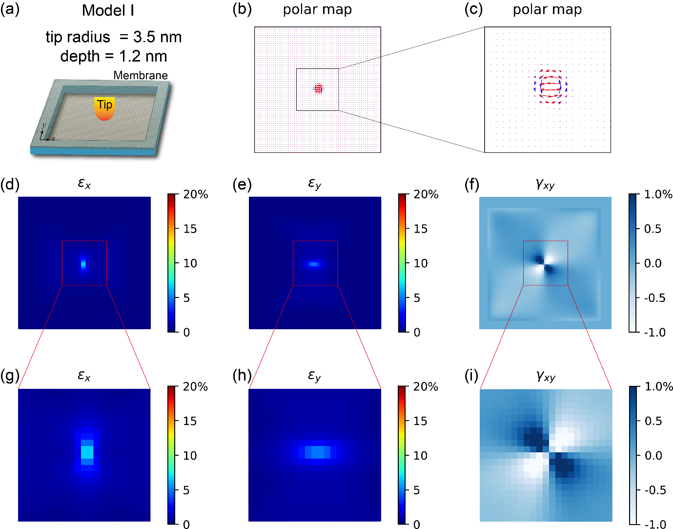
Supplementary Figure 9. The vortex polarization pattern and corresponding strain distribution of model I under tip radius of 3.5 nm and indention depth of 1.2 nm.

Supplementary Figure 10:
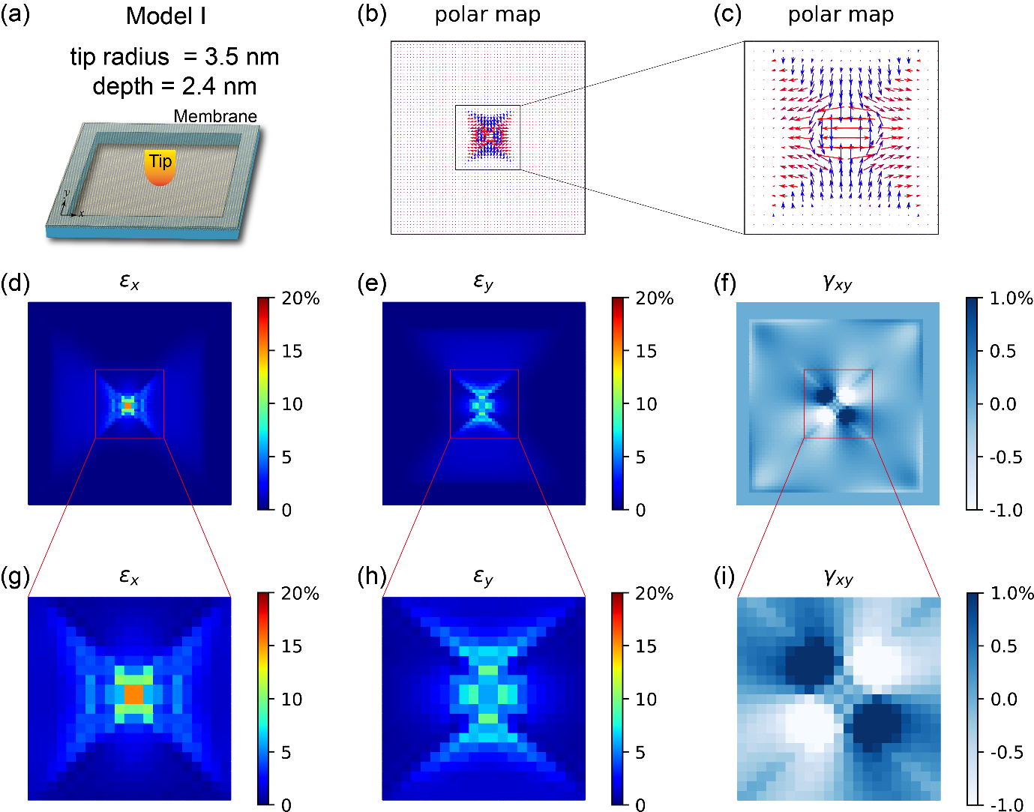
Supplementary Figure 10. The antivortex polarization pattern and corresponding strain distribution of model I under tip radius of 3.5 nm and indention depth of 2.4 nm.

Supplementary Figure 11:
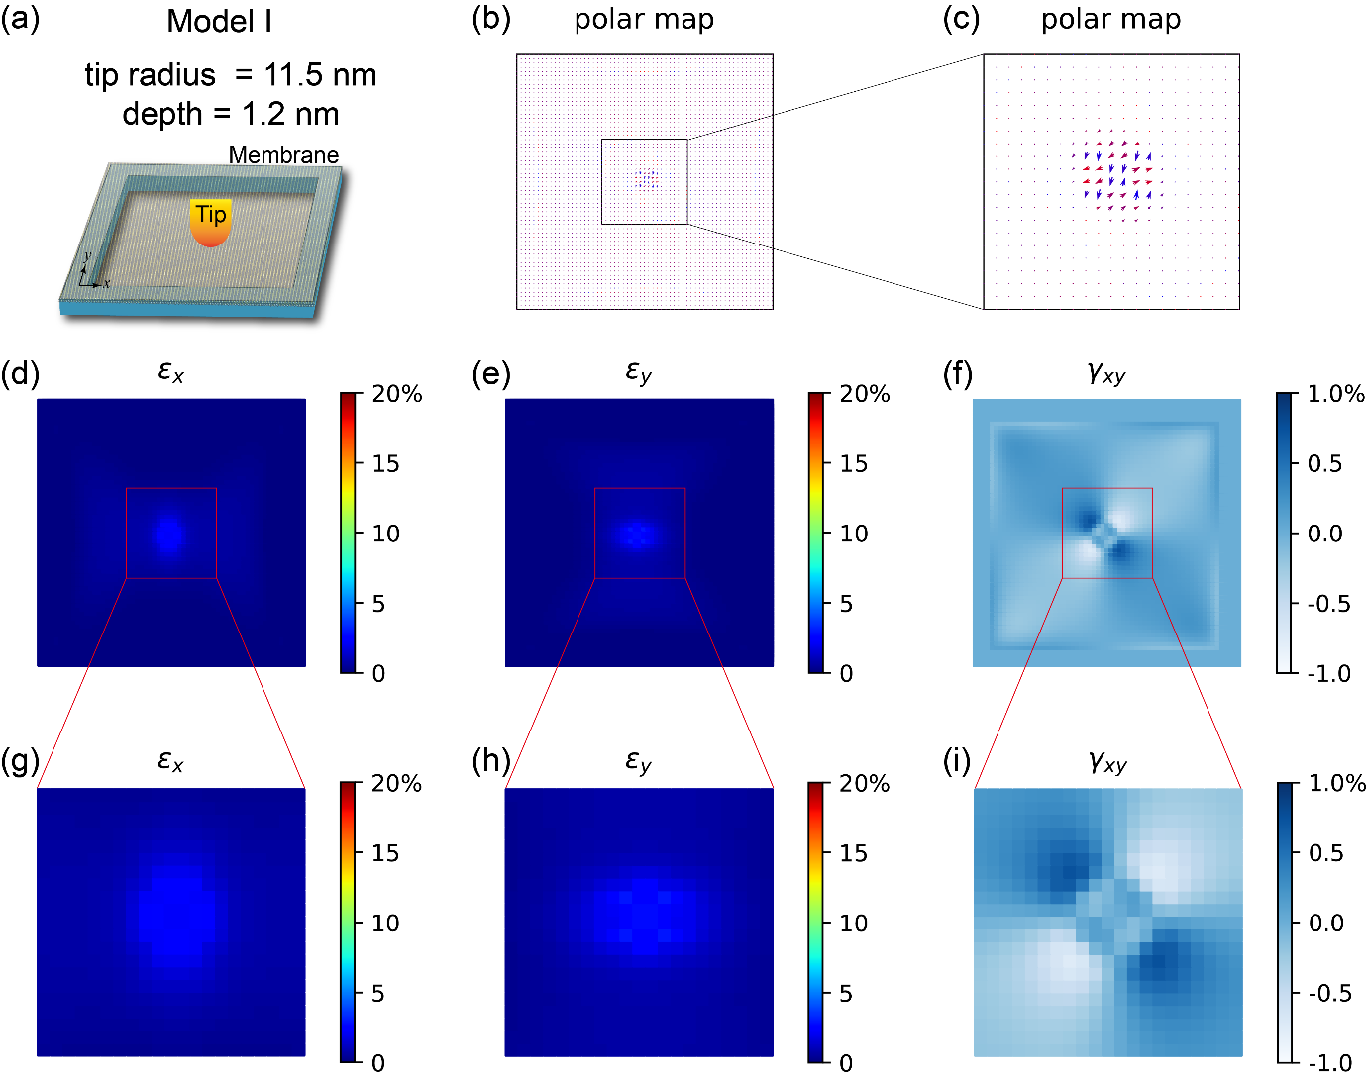
Supplementary Figure 11. The disorder polarization pattern and corresponding strain distribution of model I under tip radius of 11.5 nm and indention depth of 1.2 nm.

Supplementary Figure 12:
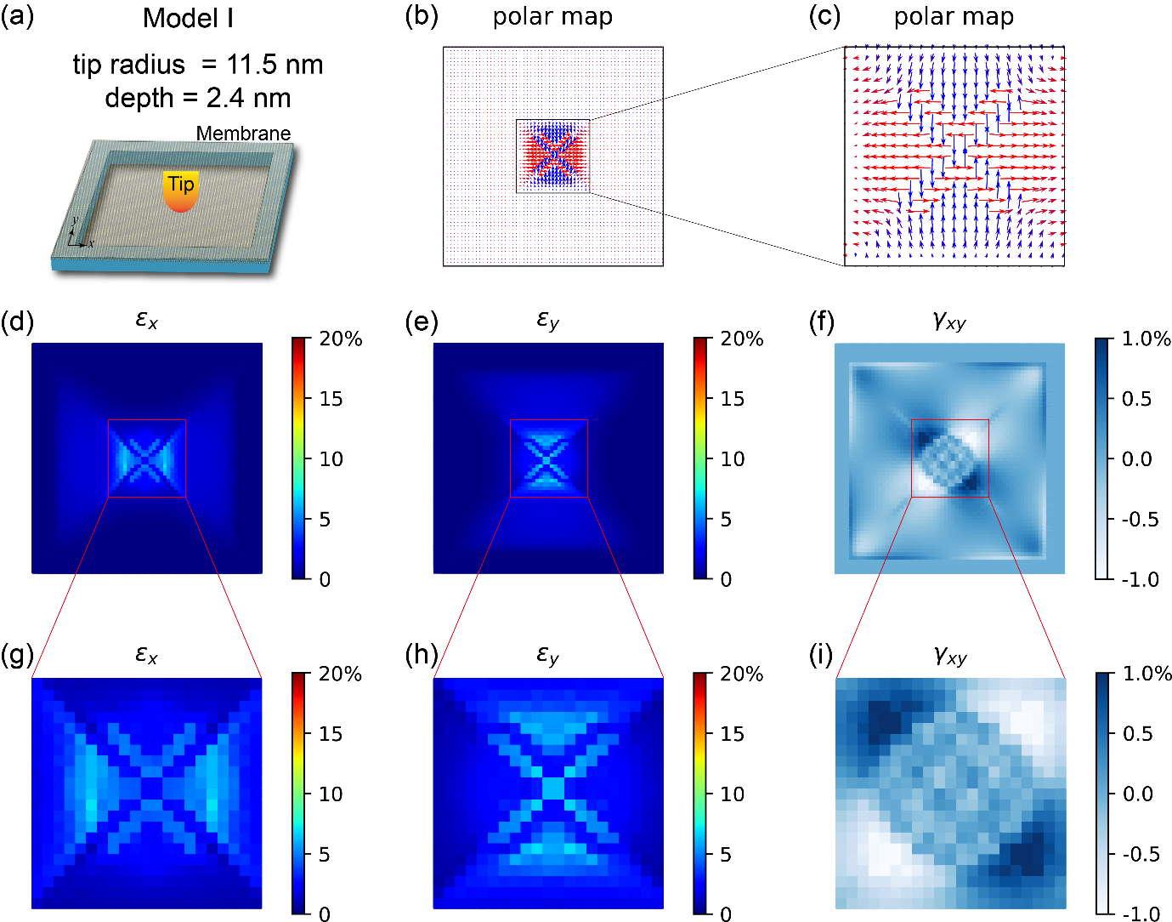
Supplementary Figure 12. The antivortex polarization pattern and corresponding strain distribution of model I under tip radius of 11.5 nm and indention depth of 2.4 nm.

Supplementary Figure 13:
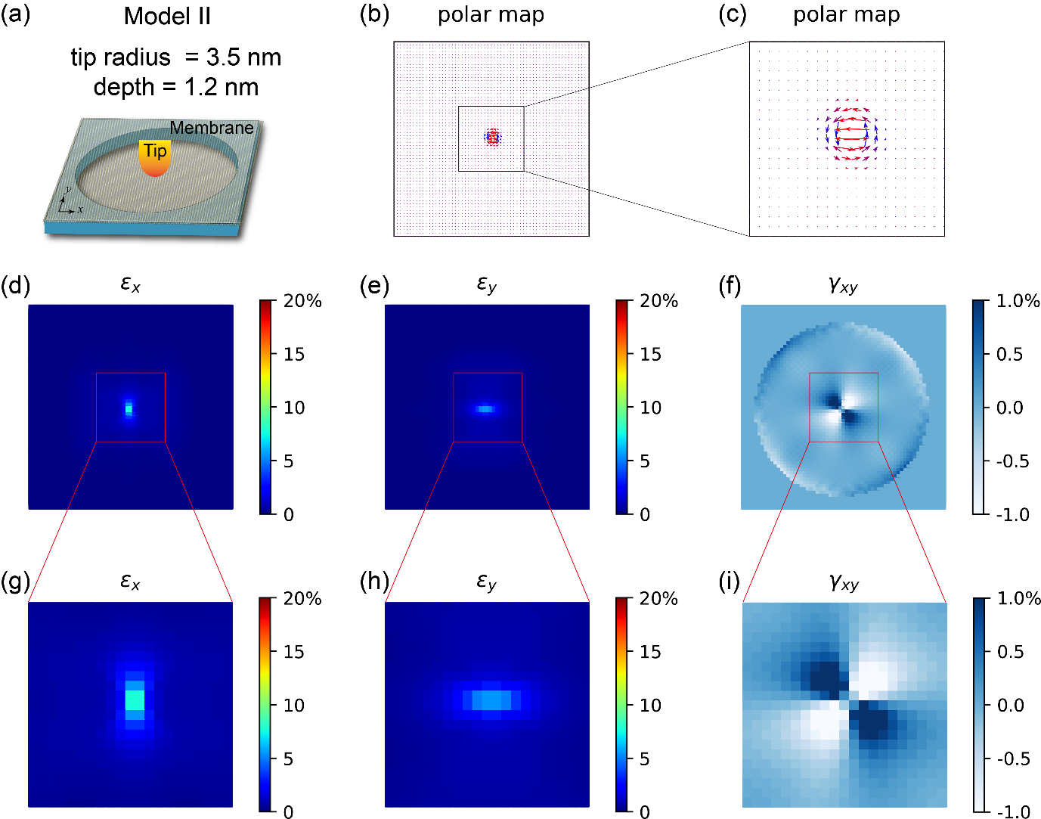
Supplementary Figure 13. The vortex polarization pattern and corresponding strain distribution of model II under tip radius of 3.5 nm and indention depth of 1.2 nm.

Supplementary Figure 14:
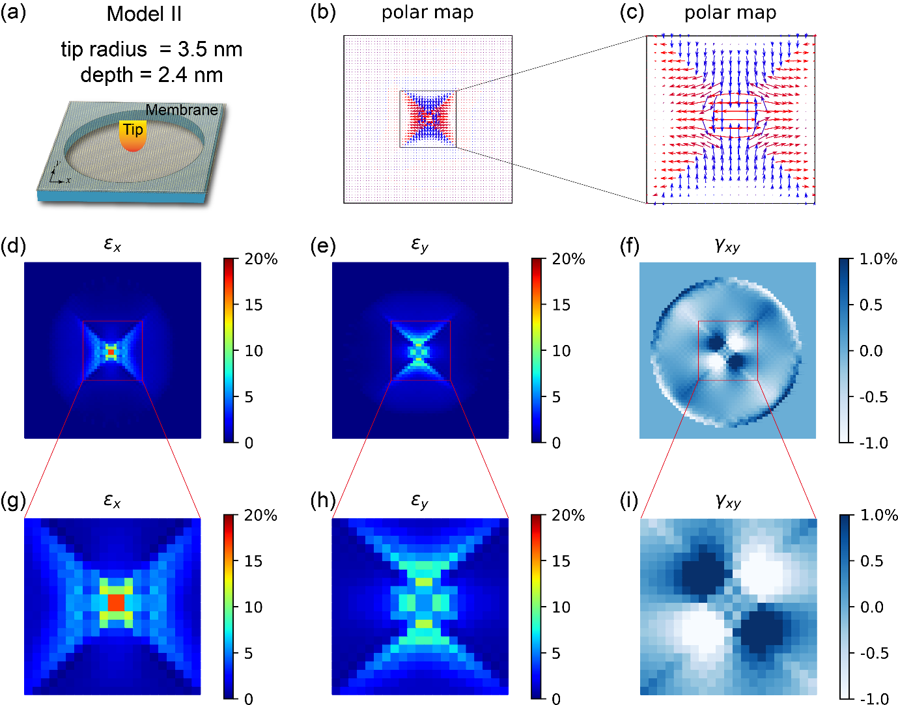
Supplementary Figure 14. The antivortex polarization pattern and corresponding strain distribution of model II under tip radius of 3.5 nm and indention depth of 2.4 nm.

Supplementary Figure 15:
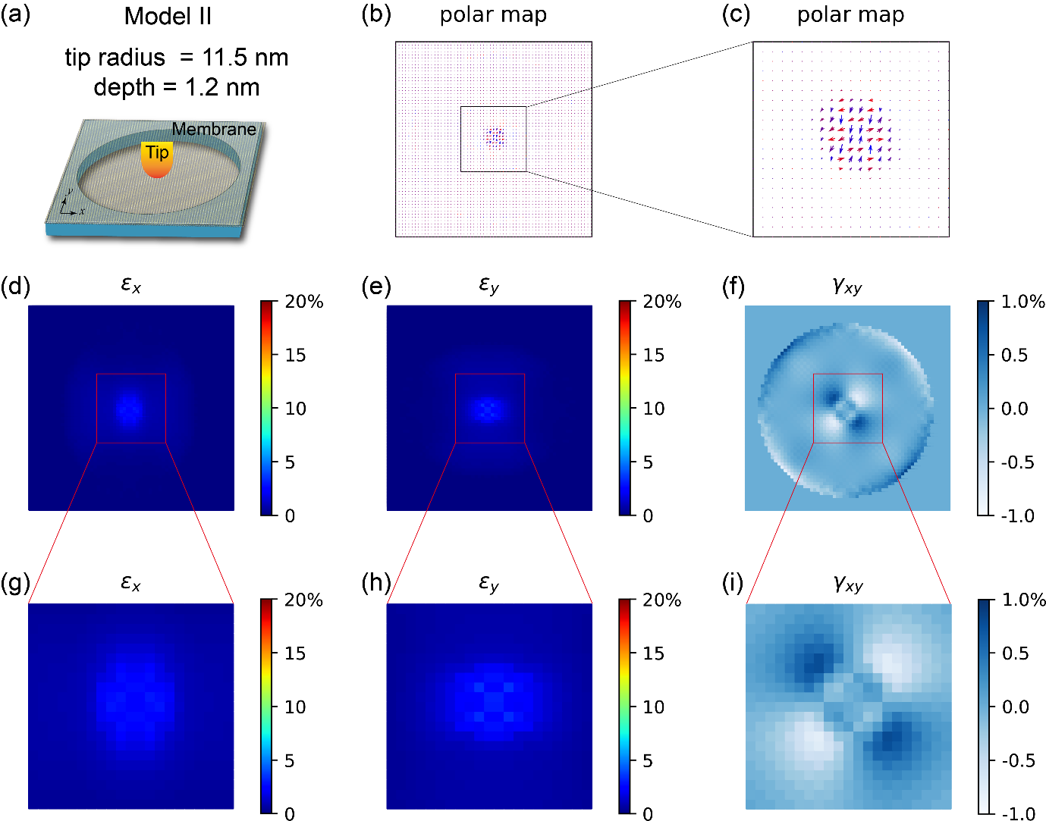
Supplementary Figure 15. The disorder polarization pattern and corresponding strain distribution of model II under tip radius of 11.5 nm and indention depth of 1.2 nm.

Supplementary Figure 16:
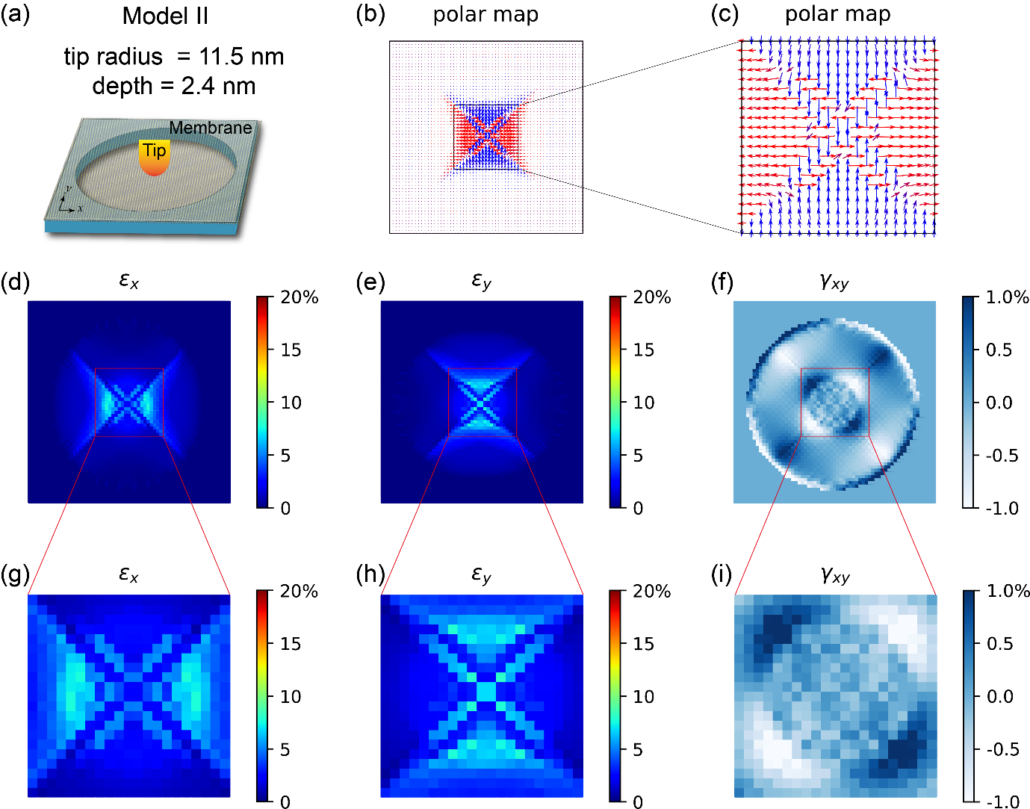
Supplementary Figure 16. The antivortex polarization pattern and corresponding strain distribution of model II under tip radius of 11.5 nm and indention depth of 2.4 nm.

Supplementary Figure 17:
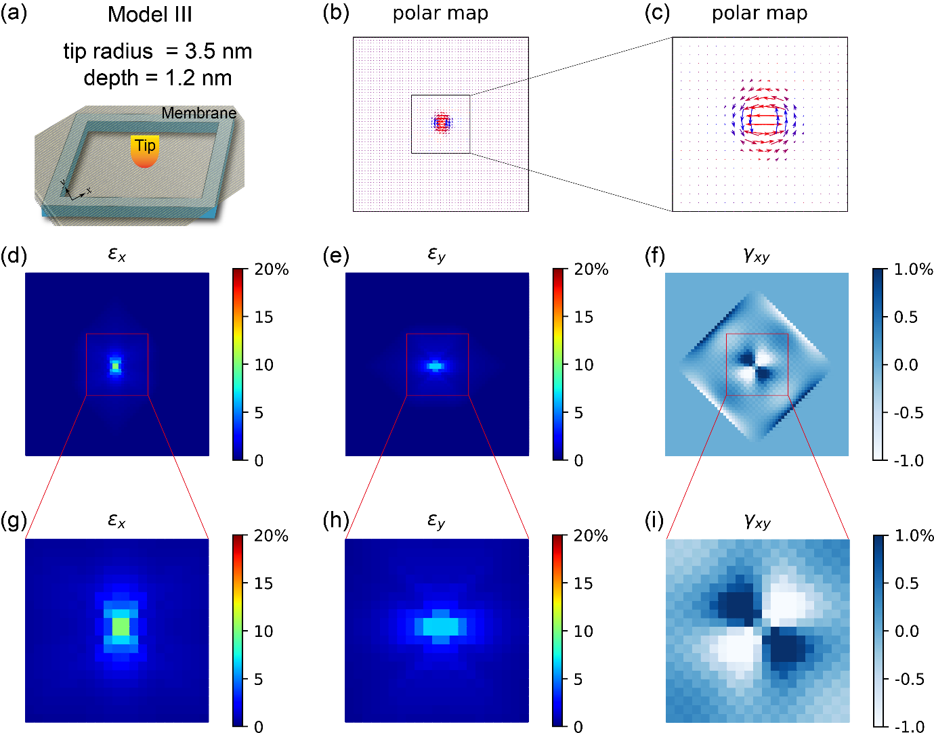
Supplementary Figure 17. The vortex polarization pattern and corresponding strain distribution of model III under tip radius of 3.5 nm and indention depth of 1.2 nm.

Supplementary Figure 18:
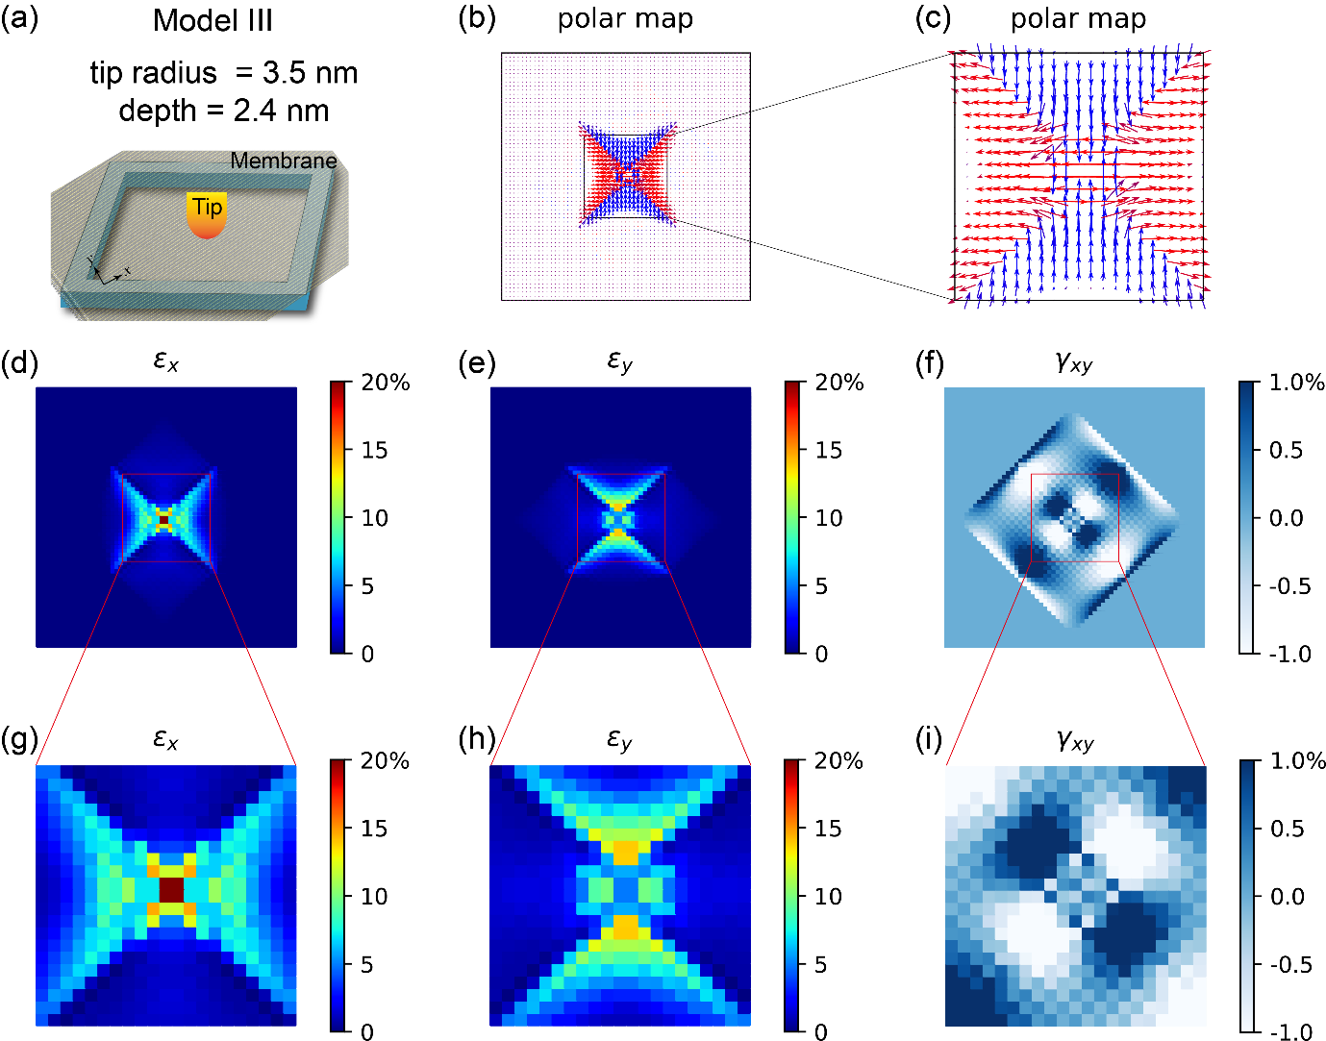
Supplementary Figure 18. The antivortex polarization pattern and corresponding strain distribution of model III under tip radius of 3.5 nm and indention depth of 2.4 nm.

Supplementary Figure 19:
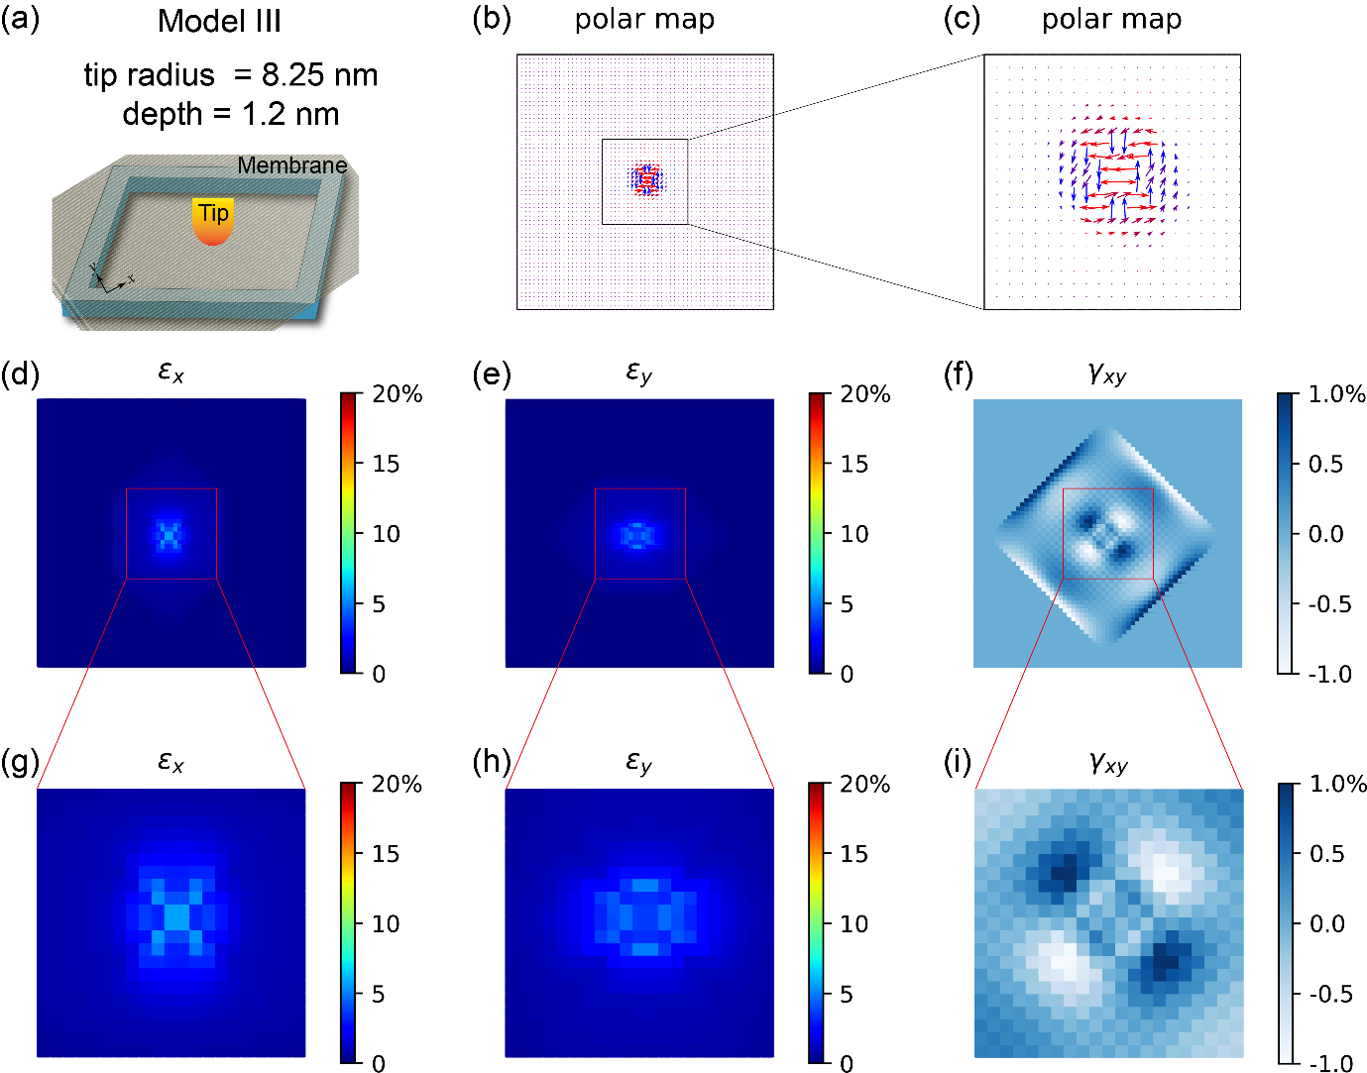
Supplementary Figure 19. The polarization pattern and corresponding strain distribution of model III under tip radius of 8.25 (11.5) nm and indention depth of 1.2 nm.

Supplementary Figure 20:
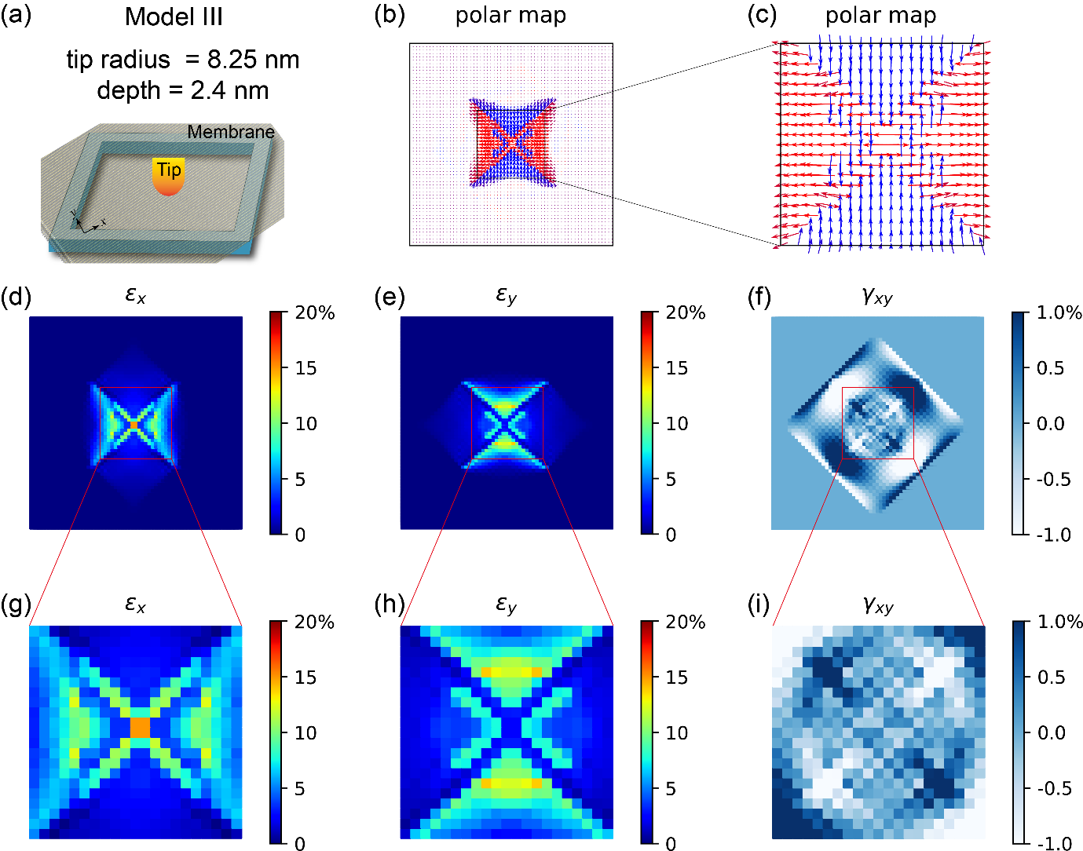
Supplementary Figure 20. The antivortex polarization pattern and corresponding strain distribution of model III under tip radius of 8.25 nm and indention depth of 2.4 nm.

Supplementary Figure 21:
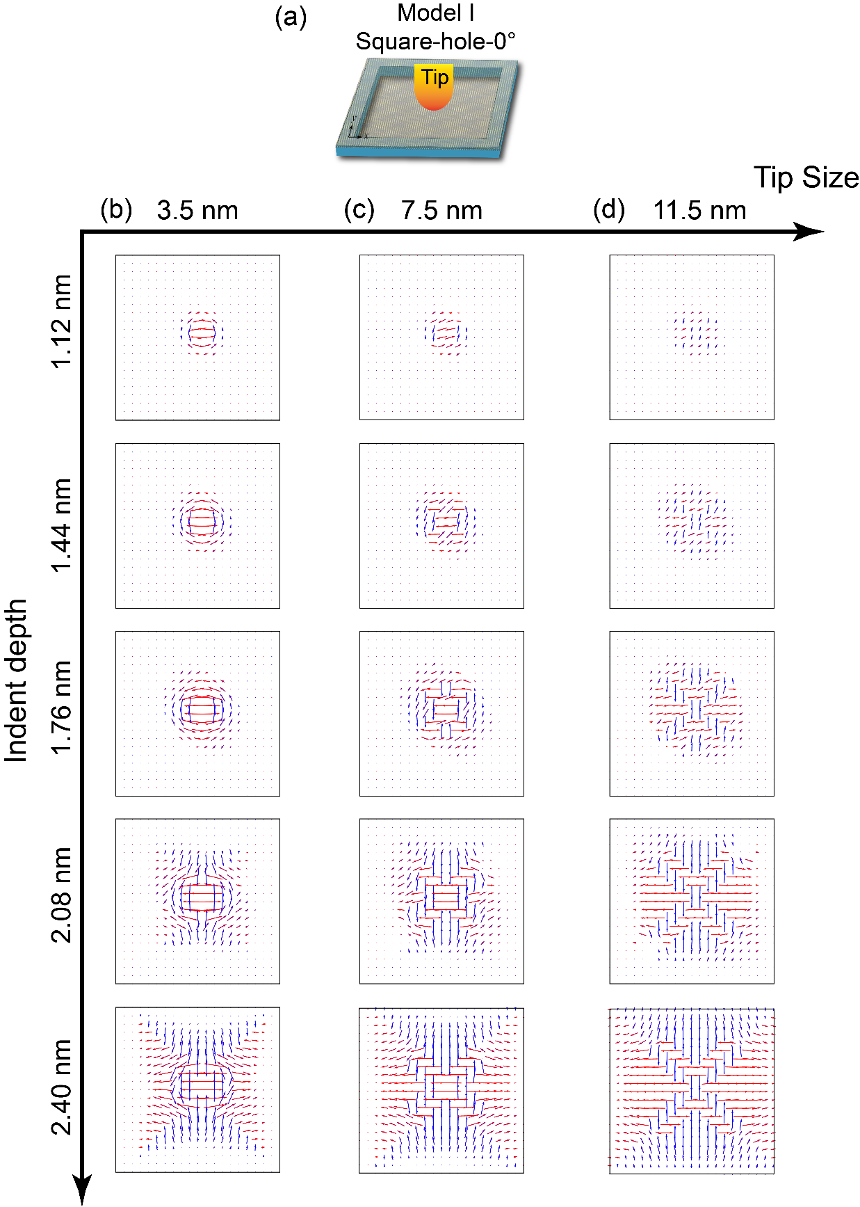
Supplementary Figure 21. The polar pattern of model I under different tip size and indent depth.

Supplementary Figure 22:
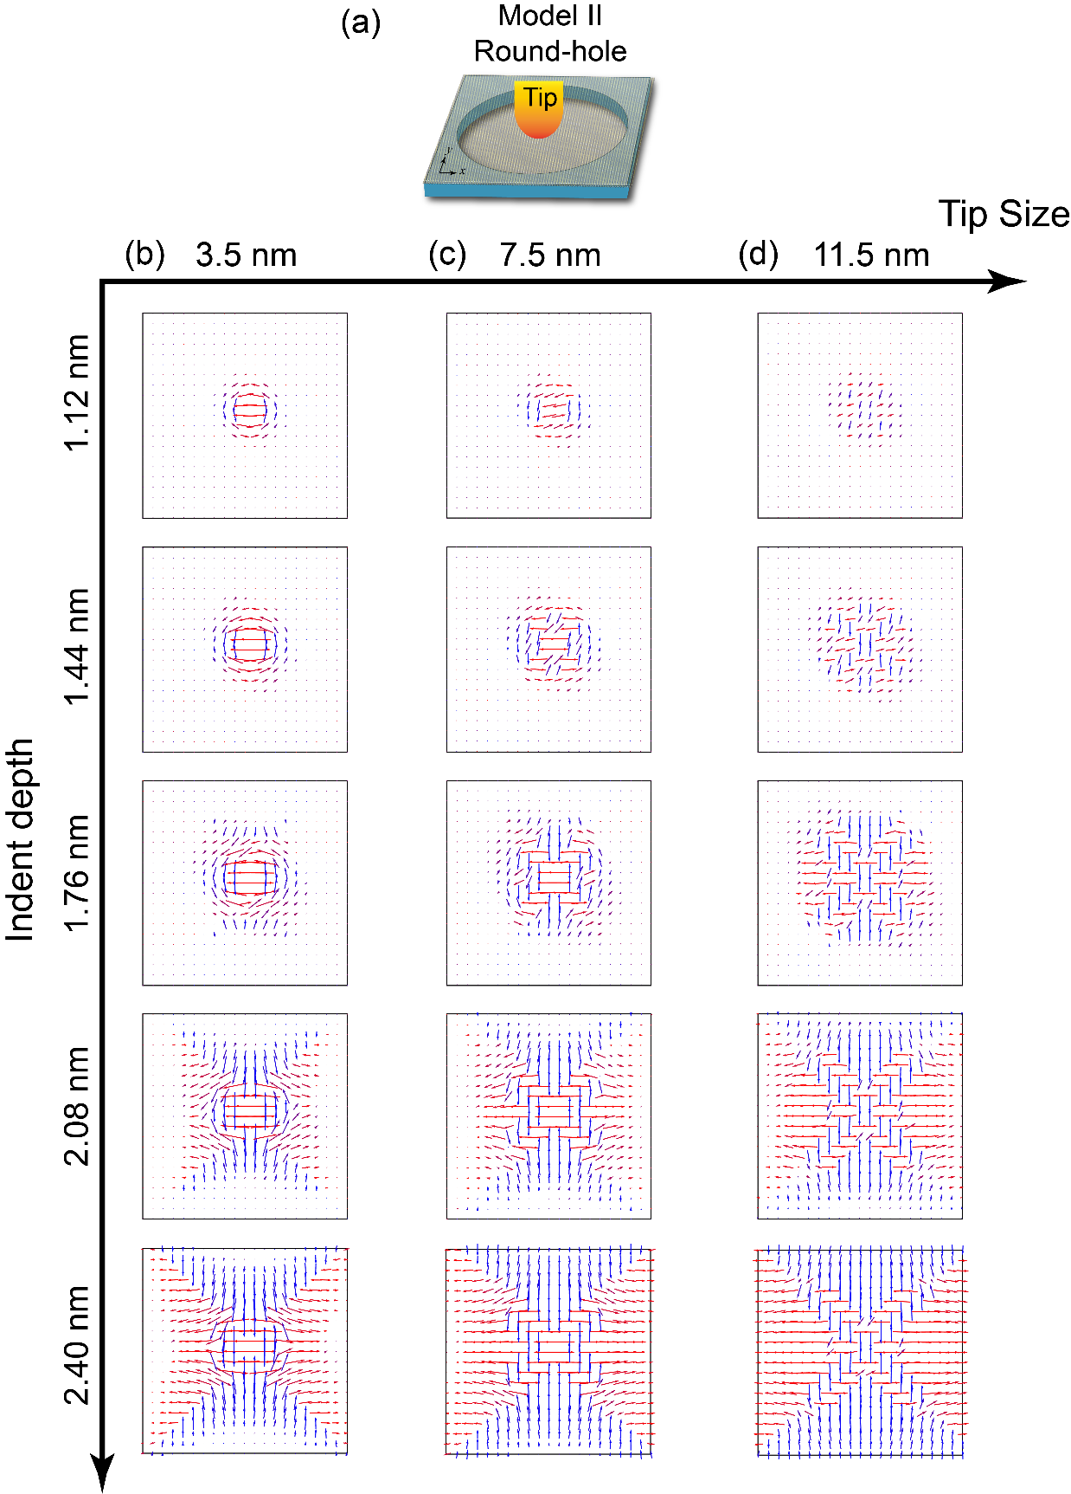
Supplementary Figure 22. The polar pattern of model II under different tip size and indent depth.

Supplementary Figure 23:
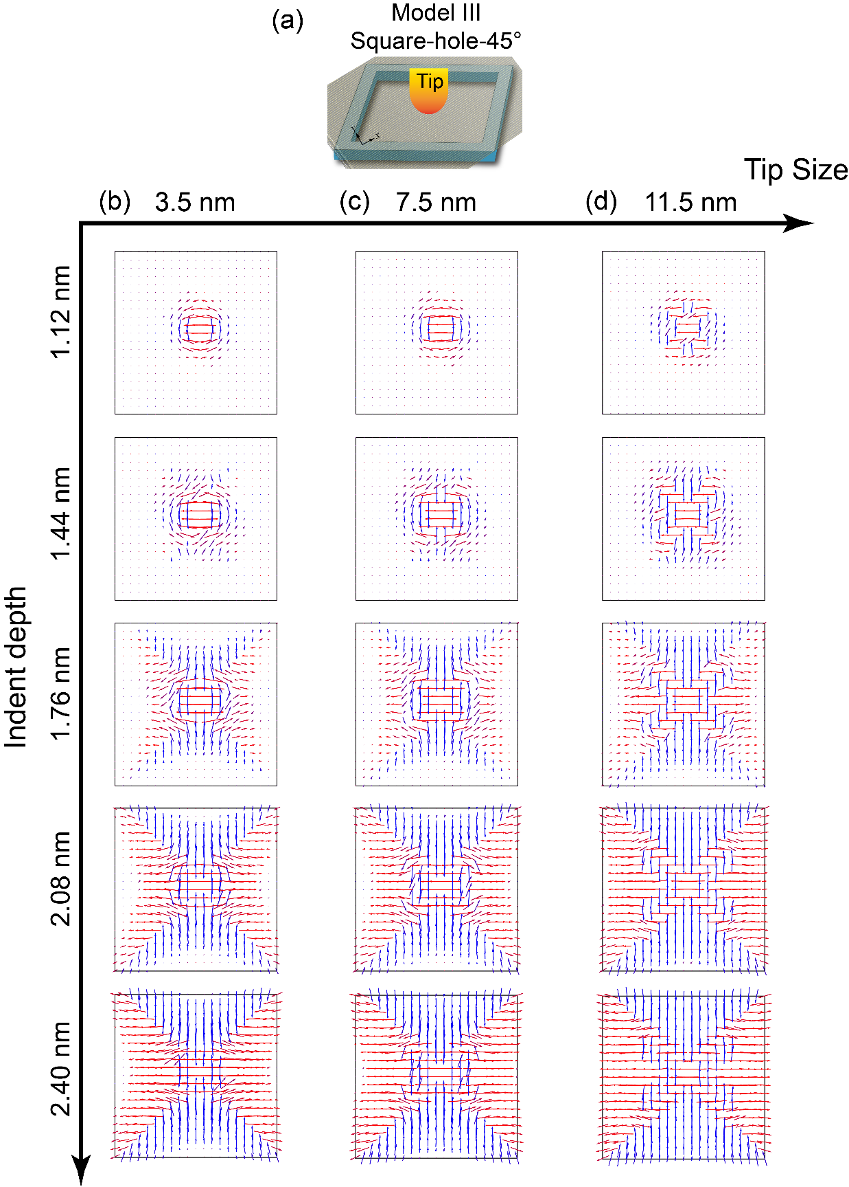
Supplementary Figure 23. The polar pattern of model III under different tip size and indent depth.

Supplementary Figure 24:
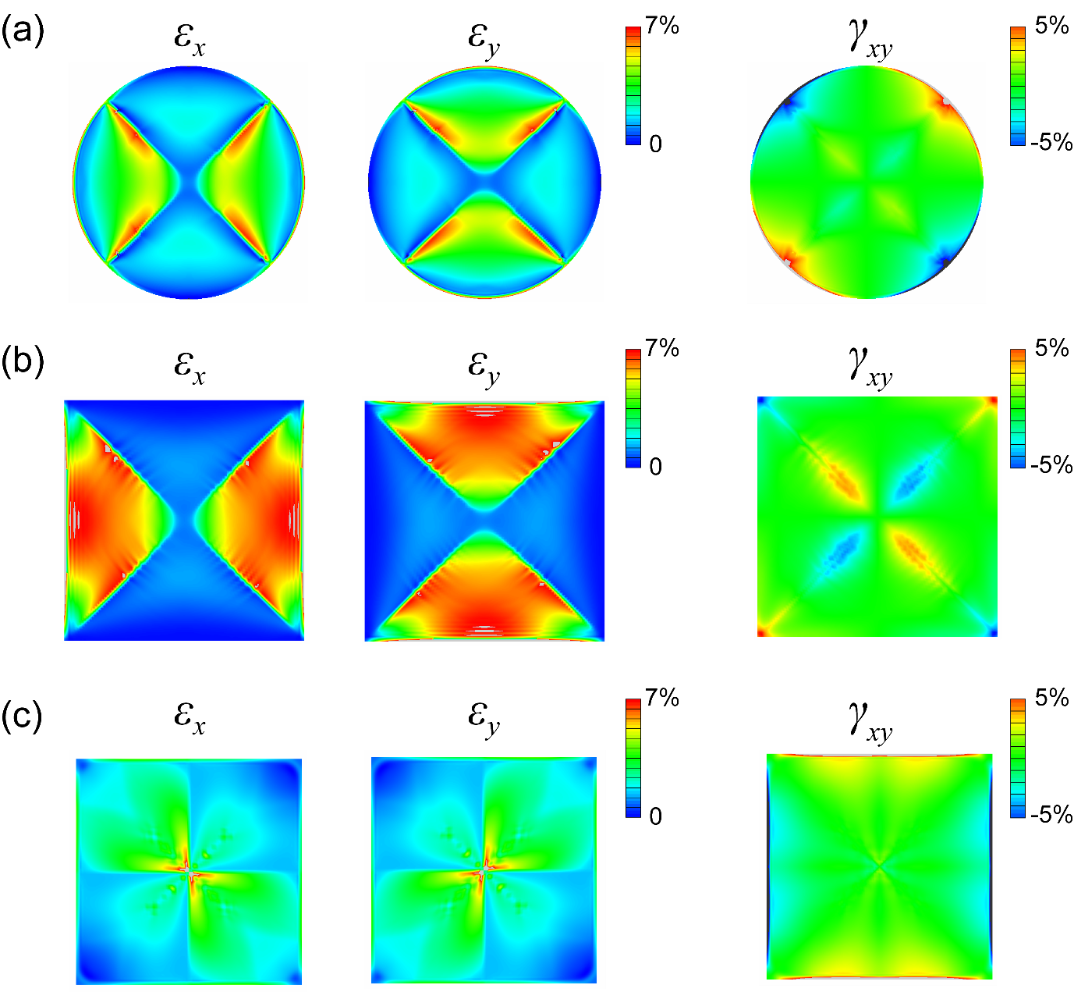
Supplementary Figure 24. The distribution of strain components along the x, y direction and shear strain in the x-y plane of PbTe membrane under loading method of blowing bubble through holes.

Supplementary Figure 25:
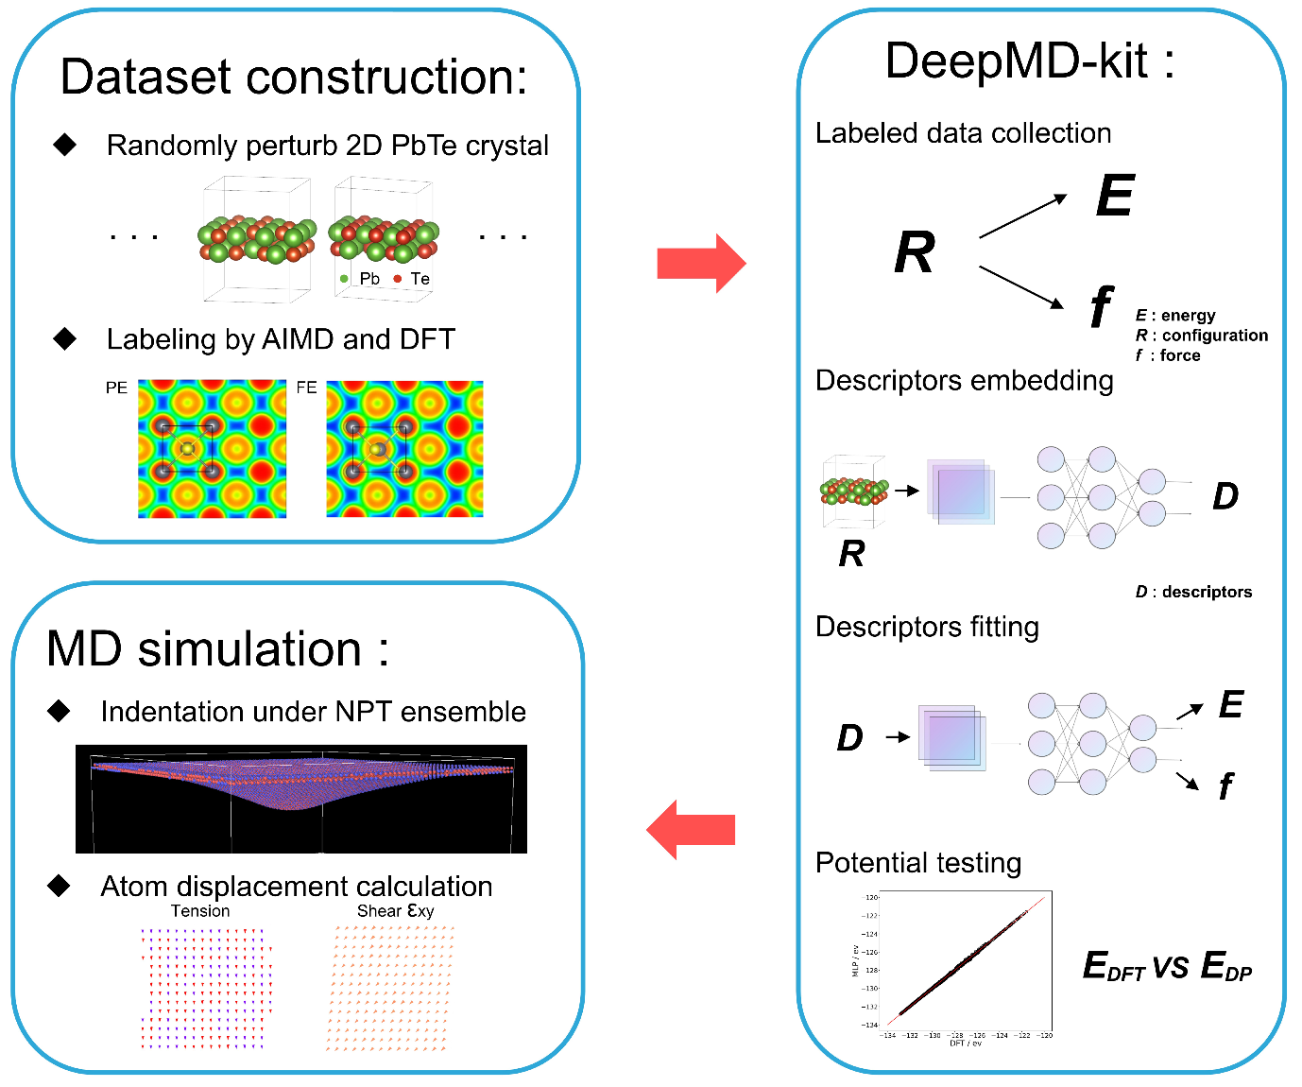
Supplementary Figure 25. The flow chart of building machine learning potential for monolayer PbTe. First, the dataset for machine learning is constructed based on the DFT-based Ab-initio molecular dynamics calculations to obtain a variety of PbTe structures, including the rippled, stretched, and sheared structures. Second, a well-developed DeepMD-kit is employed to train a deep-learning potential for monolayer PbTe. Finally, the obtained potential is used to carry out large-scale MD simulations for mechanical indentation of monolayer PbTe.

Supplementary Figure 26:
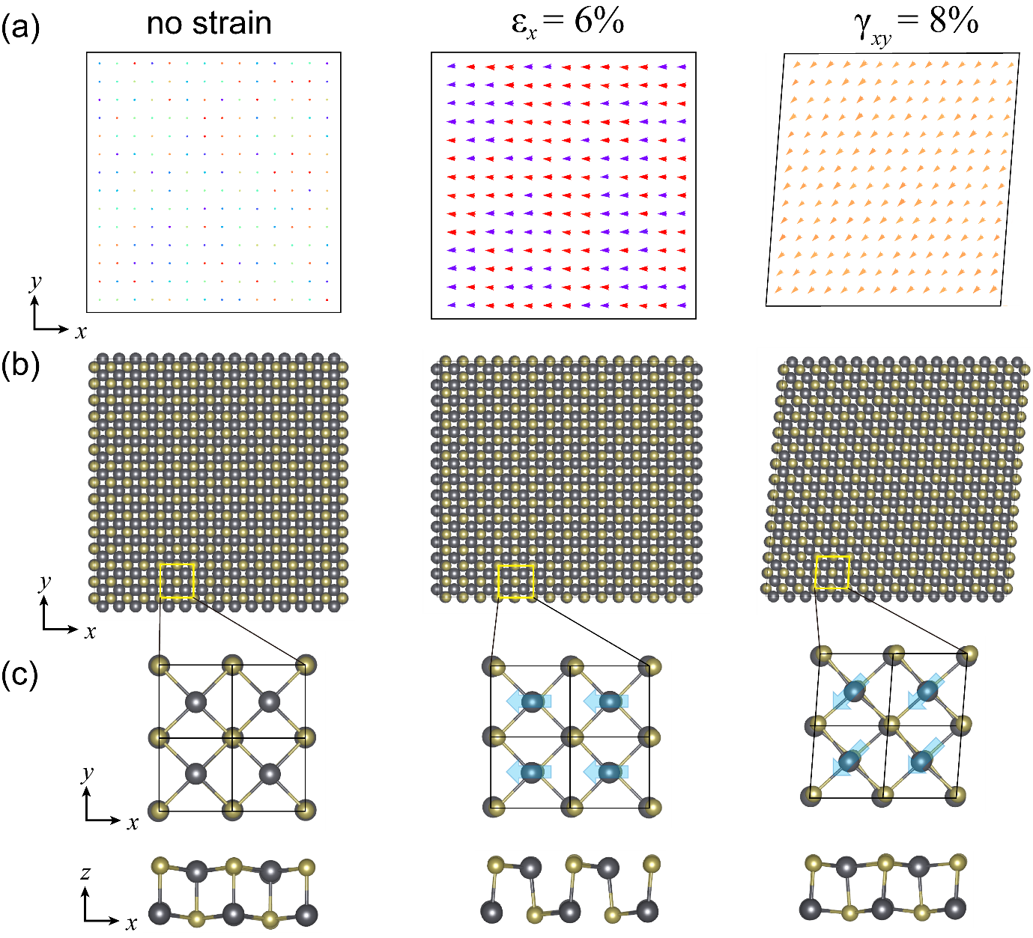
Supplementary Figure 26. The MD simulation results for the polarization and atomic structures of the pristine, stretched, and sheared monolayer PbTe, based on the deep learning potential. It demonstrates that the MD simulations based on DP-potential can reproduce the results of DFT calculations at a larger scale.

